University of Wales Trinity Saint David
Managing in Complex Environments (LCDB7002)
Lecturer’s Name: Dr. Amare Desta
Student Name: Mohammad Abu Samar
Student No. 1907390

THE TOYOTA WAY

Executive Summary

The effect of globalisation, for business entities, is nothing special. Globalisation over the past two decades has altered the company's corporate strategy. This consultancy project has attempted to examine the 'The Toyota Way’ approach as well as the scope of application in aspects of few significant people management issues in Toyota. This report is decorated as, introducing the context of this report, then pick up three peoples management issues and strengthened the context through cited some closely related literature, after that this report analyse all of those selected three peoples management issues from Toyota’s perspective such as, diversity in Toyota’s workforce, work life balance policies of Toyota, and managing diversified talent strategies accompanied by all of those three people management issues’ advantages and probable challenges for Toyota’s automobile business. The study subsequently points out several suggestions with reasoning in following section. The study advised Toyota to provide staff with guidance for recruitment and selection issues, career development program, work life balance issues, employee retention and assist the workforce in benefits of the long-term job development phase. Eventually, ensure workplace career advances contribute to educational development and leadership growth. In the following section the study discusses both the LAMP as HR analytics and MCC concept of for Toyota’s managing diversified talents. The report eventually ends with encouraging conclusion.

Table of Content
Executive Summary ii
Table of Content iii
1. Introduction 1
2. Literature Review 2
2.1. Employee diversity in organisations 2
2.2. Work-life balance in organisations 3
2.3. Talent Management practice from employee diversity viewpoint 4
3. Analysis 7
3.1. Employee diversity strategies in Toyota 7
3.1.1. Advantages 9
3.1.2. Diversity challenges 10
3.2. Work life balance practice in Toyota 11
3.2.1. Advantages 13
3.2.2. Challenges 15
3.3. Managing latent through recruitment and selection process in Toyota 18
3.3.1. Advantages 20
3.3.2. Challenges 21
4. Recommendations 22
4.1. Recommendations on employee diversity issues 23
4.2. Recommendations on work life balance issues 24
4.3. Suggestions for managing talents: 25
5. Conclusion 27
References 28

- Introduction
Toyota Motor Corporation (TMC) aims to become a good corporate leader and citizen, connect with as well as gain the confidence of its stakeholders along with to contribute in entire company’s activities to the development of a stable community (Toyota, 2020). In 2008, TMC first became the world's largest producer of vehicles, outstripping General Motors. Many of Toyota’s almost 1,000 subsidiaries as well as associates are engaged in the manufacture of cars, car components and recreational and industrial equipment. Company’s Headquarters are based at Toyota City, which is a manufacturing city located in eastern part of the city, Nagoya, Japan (Reinhardt, Yao, and Egawa, 2006). The success story of Toyota is long tale. Plenty of factors have affected on the business success of Toyota. Hence human resources practice and its management approaches are one of the noteworthy factors of Toyota’s success.

The reason behind their achievement is that TMC leadership has focused on the best option for their workforce, allowing TMC to diverse between candidates who can fulfill a specific role in order to maintain consistency and compatibility with the conditions and responsibilities of the role as well as their characteristics, qualifications and attributes along with the growth of the manpower aspect that facilitates job advancement in the company as meeting the objectives relies on what is perceived as being the most important managerial asset as well as the most powerful in profitability at all (Winfield, 1993). TMC leadership often enhances and strengthens the HR because it is the foundation for improving operational efficiency and enabling the organisation to maintain the dealing with present and potential problems because management agree that human resources are the basis for massive profits or lower revenue in any business (Saruta, 2006).

For that consequence, the objectives of this consultancy report is to illustrate the entire advantages generated from HR practices which contributes to long-term partnerships not just with the clients but with the workers, while the effort in this field in TMC appears overwhelming. This report will try to evaluate TMC’s employee diversity practice in recruitment and selection process, employees work life balance practice, and talent management issues in case of environmental challenges for TMC. Finally, suggestions for recruiting and development as well as talent acquisition will be given. The LAMP and MCC frameworks will be used to consider how TMC's talent management programs deliver on company’s investment.

- Literature Review
  - Employee diversity in organisations
As the workplace is more ethnic, organisations are placing tremendous emphasis into strategies and procedures for handling diversity of HR (human resources) (Paluch, Nishii, Khattab, and Shemla, 2017). These efforts are significant, as study has demonstrated that given the advantages that diversity could offer in respect of creativity and better decision-making, real or perceived disparities within members of the organization when kept uncontended can also contribute to class divisions, sub-group, discrimination in outgroup (Shemla, Meyer, Greer, and Jehn, 2014), as well as unconscious prejudices towards other classes (Carton and Rosette, 2011). True organizational diversity arises from the incorporation of individuals with diverse cultures, skills, and facets of life. This enables the convergence between creativity and organizational productivity. Innovation and productivity arise from the opportunity to look at a particular issue from various angles because multiple entities within the enterprise with different solutions to a given question (Bogers, Foss, and Lyngsie, 2018). Nevertheless, (Bais, 2014) argues that diversity requires not just to individuals with diverse cultures, but just to the integration of employees with varying degrees of expertise and preparation inside the organisation. Buengeler, Leroy, and Stobbeleir, (2018) claimed that to become a successful employer in any diverse community, a society must be developed in which equity must be integrated so everybody will feel a member of the community and have fair access to the organizational resources.

Rizwan, Khan, Nadeem, and Abbas, (2016) established that addressing workforce diversity seems to have a long-term effect on corporate performance because workers with diverse cultures will effectively connect with the various customer groups. For instance, workers from Asian cultures, who know their community better, may build lasting consumer connections that are beneficial for retaining customers over time. Omankhanlen and Ogaga-Oghene, (2011) also stated that the workers serve the company because as such workers migrate to various companies, they often carry the clients with them because clients consider it impossible to establish a new friendship for the organization's current employees. As a consequence, (Garces and Jayakumar, 2014) emphasized maintaining a dynamic workforce to insure that workers establish a long-term partnership with clients; hence organisation can sustain the connection even in emergency conditions such as the strategy of several automotive companies after the 2008 economic collapse. The analysis showed that while most of the automakers were introducing workforce layoffs, others did not and others who did not make sure that the clients returned to the company due to the partnership established with the personnel.

However, other aspects of workforce diversity were observed from management viewpoint as (Erasmus, 2007) established that absence of consideration, discrepancy in opinion, differences in generation as well as language issues are the main problems that could emerge from diverse workforce. Nevertheless, the report shows that these problems can be addressed by educating workers, creating a philosophy that promotes diversity in their belief system, respecting top management, as well as maintaining a cohesive and enjoyable work atmosphere.

  - Work-life balance in organisations
Work-life balance (WLB) as a significant element of human resource management has attracted the interest of several scholars who have researched the topic from various perspectives and measurements. The job-life relationship applies to the tension of employment and personal life. The aim of workplace work-life management is to lessen the workplace disagreement and personal problems (Khan, Roy, and Hossain, 2018). The policies entail flexible work schedules; home life versus work life, career sharing, multiple forms of parental leave services etc. Both activities are targeted at rising workplace stress, working family tension, and potentially contributing to reduced attrition (Arif and Farroqi, 2014). WLB officially increases the morale and productivity of workers (Mukururi and Ngari, 2014). It is noticeable that while the organisation tries to minimize the work-family dispute, family stress will be minimized and the job will be less stressful (Kirchmeyer and Cohen, 1999).

In this regard, the research of (Shey, 2012) has considered significant emphasis to the work to family and family to work balance among the woman bank executives. The analysis found that in modern days, women served more in mid-level banking jobs than comparable rates, socio economics faced by woman executives in most cases confined to their work life balance, the analysis also revealed that the employees would require modifications along with adoptions in the mindset of the banks community in the workplace. Difference outcomes are observed in case of the people who have invested more hours in job and family positions and others who have spent more hours in the home than those in the workforce having a greater standard of life than balanced persons and may transform the standard of living higher than someone who has spent greater hours in job than those in the home (Greenhaus, Collins, and Shaw, 2003).

A study by (Beauregard and Henry, 2009) suggested that, the business case replicate the forms in which work life balance activities may encourage corporate success through improved mechanisms of social interaction, improve cost efficiency and decrease attrition. Wonderful work to non-work balances alignment is beneficial for both the executive and boss, as this form of arrangement improves the efficiency of workplace performance and personal as well as corporate contact (Lazar, Osoian, and Ratiu, 2010). (Susi and Jawaharrani, 2011) explained in a research that work life balance is a threat of workplace satisfaction. Most companies witness the advent of work life balance policies (such as recruiting and retaining employees, work-family tension, career burden, a healthier personal balance, as well as job satisfaction) the activities deserve to be maintained and reassured in the atmosphere of the workforce. Well-built as well as supportive corporate culture accompanied by quality of job strengthens the goal of workers to continue supportive in the company. (Asiedu-Appiah, Dufie-Marfo, and Frempong, 2016) reported that work life balance is essential for improving the workplace efficiency both at home as well as on the job. An individual gets satisfaction from job and family positions in life. Another study by (Lockwood, 2003) also described that, work life balance as little more than the management of job and home roles. Work life provides help from colleagues, top management as well as increased efficiency and morale of staff across the work life balance initiatives.

  - Talent Management practice from employee diversity viewpoint
Scullion and Collings (2011) describe managing talents in organisations as the preparation and growth processes for management succession. This are required to acquire, grow and attract a community that will make significant improvements to the company and is distinct than recruiting as it begins out well after training before recruiting and spreads out. Managing Talent has arisen as one of the most relevant strategy among all companies, in this intensely dynamic market climate. In fact, every organization's performance is strongly linked to the resources it has, as well as how the expertise is being utilized. Talent selection is the mechanism whereby companies identify workers with potential leadership capabilities. To ensure talent management mechanism efficient, companies require a systematic framework through which several individuals will be engaged through careful communication between leadership practices along with talent in order to turn it into respected organizational habits. Many organisations who believe in managing talent will recruit and maintain the right number of employees with the right kinds of skill set (Collings and Mellahi, 2009).

Managing as well as developing talent also needs a pragmatic strategy. Managing talents is a set of tasks to be performed by managers in a systematic way, as seen in the example below

Figure-1: Components of talent management strategies
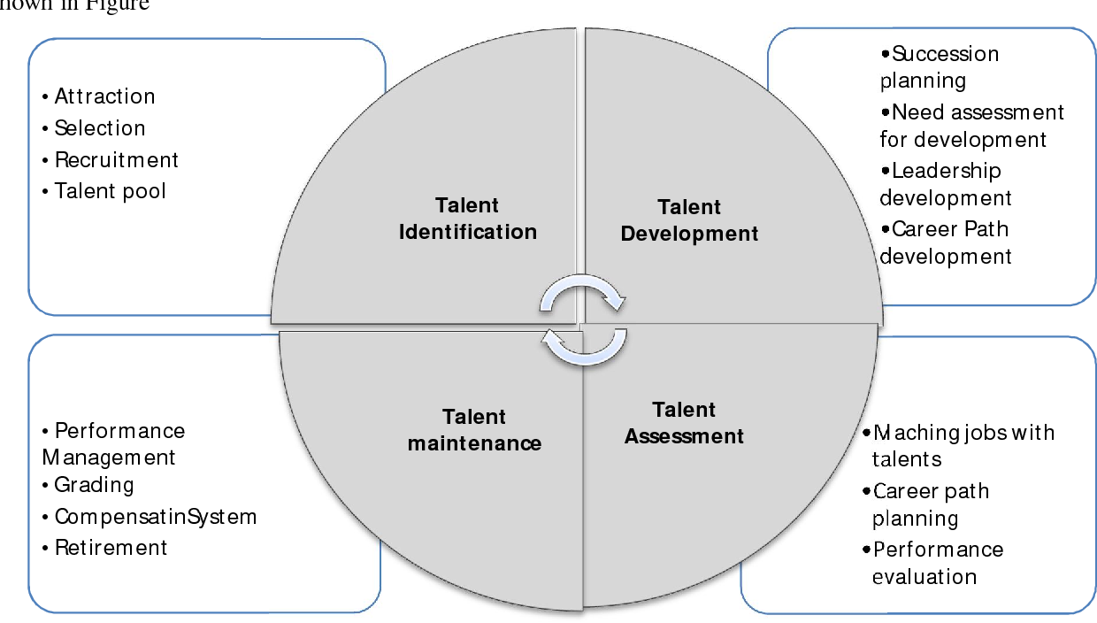
Source: Khalvandi and Abbaspour, 2013

Managing talents is more about creating a community of skilled individuals — for example pool of talent as described in the aforementioned context. This needs therefore a systematic strategy with a number of intermediate variables. The organization, in conjunction with the corporate plan, creates expertise. This contributes to the selection of the right kind of employee for the work being done by resourcing activities.
In this respect, (Joshbersin, 2010) states in his research that, talent is best developed when ability, experience and mindset suit the organizational requirements of personnel.

Figure-2: Integrated talent management in talent development perspective
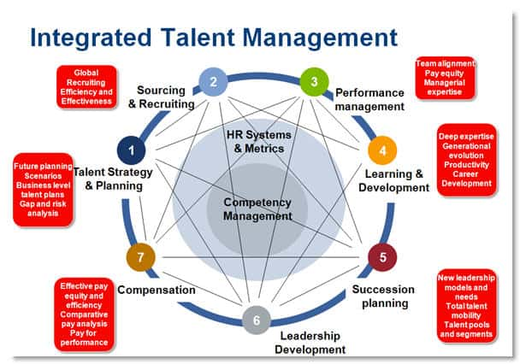
Source: Joshbersin, 2010

The purpose of creating a pool of talent is to protect the supply of talent, primarily as it is a big tool for businesses. However, the dynamic climate in which the company works has contributed to a 'Battle for Talent' circumstance in which human resources practitioners infuse attrition aim within the competing firms' core talents (Simon and Cao, 2009).

Amankwah‐Amoah (2020), therefore, concluded that talent acquisition needed a great deal of commitment and associated with huge costs as the organisation is seeking to establish connections with organisational individuals. While (Shen, 2011) claimed that people from varied backgrounds are drawn by talent acquisition because managing talent is more common in terms of preparation and ability growth, accomplishment or leadership qualities. From the other side, (Furusawa, 2014) indicated that workforce diversity is among the main facets of managing talent that serves to grow the skill needed by workers that can be inspiration, incentives, accountability, and equity-centered organisation, etc. Nonetheless, (Pandita and Ray, 2018) concluded that employee involvement does not succeed unless the workers are self-driven to build job, success or leadership else the expenditure would go in futile. A study by (Festing, Budhwar, Cascio, Dowling, and Scullion, 2013) suggest that, diversity may be an approach that every company currently uses as workforce diversity in the worldwide context requires certain talent management components, such as collaboration, to solve a given issue.

- Analysis
The concept of ‘Toyota Way’ paradigm is considered to have been a holistic system for management with two key goals: constant growth and empathy for individuals. Unlike the significant number of focus paid to lean methods as well as process-oriented development, little is understood regarding the softer facets of these activities (Gao and Low, 2015). TMC provides a healthy job atmosphere for its staff and gives them more employment prospects in addition to supplying them with diversified workforce, well maintained work life balance strategies among various functional departments, as well as managing talents through standard practice of recruitment and selection process (Toyota, 2020). In addition, the management is dedicated to educate and improve all its workers through training initiatives as they agree that learning and educating are necessary to maximize organisational and employee performance, thus TMC along with its subsidiaries offer appropriate incentives for its workers to seek higher education, learning, knowledge and expertise in their sectors (Winfield, 1993). Lots of concerns surrounding the people management issues such as diversity management, work life balance, managing talents etc. are found in TMC. The basic problem is continuing diversity endeavor based on enterprise rather than based on just the workforce. Because of this business initiative there are several advantages. In addition, the dynamic economic condition gives rise to certain challenges as well.

  - Employee diversity strategies in Toyota
Diversity as well as Inclusion (D+I) is at the core of Toyota’s growth as a versatility enterprise. Far more than, committed team leaders with diverse perceptions and experiences enable TMC to implement innovative goods, services along with solutions which attract Toyota’s buyers and enhance their communities (D+I Annual Report, 2019). Toyota's promise to (D+I) is not simply an inside or talent management initiative rather it is the part of TMC as a diversified company (Toyota, 2019). These are several of the explanations and diversified practices regarding why Toyota has been ranked a global diversity organization.

- Startegy-1: Workforce diversity is TMC’s one of the global structures where TMC establish two pillars one is ‘Respect for People’ another one is ‘continuous improvement’. These two pillars build up the TMC’s backbone and have more than 100 years since its inception. Devotion to team leader growth and D+I awareness – Creative in-house projects cultivate team leaders to their maximum potential, whilst at the same time engaging them to promote an inclusive community (D+I Annual Report, 2019).

- Strategy-2: Learning and education from each other to implement best diversity practices – TMC’s international Diversity Advisory Board (DAB) consisting of diverse members has been established to exchange expertise and develop accountability mechanisms for input, feedback as well as diversity of opinion (Gao and Low, 2015).

- Strategy-3: LGBTQ+ (lesbian, gay, bisexual, transgender, and queer) inclusive culture – According to Human Rights Corporate Equality Index (HRCEI), TMC has been awarded 12 times successive ideal scores on (Toyota, 2019).

- Strategy-4: Values the significance regarding a multicultural and diverse workplace – TMC gives continuous emphasis on workforce diversity as a part of their recruiting phase, meaning that different pools of applicants are met. Recruit and assist veterans by encouraging them to turn their combat competencies into civilian jobs (Gao and Low, 2015).

- Strategy-5: Business growth by supplier diversity – almost 40,000 employment opportunities have been generated in the United States by Toyota's Employment Exchange, seeking to establish positive partnerships with vendors operated by minorities as well as women. Share, learn and progress enterprise through participation, involvement, and access to the marketplace (Toyota, 2019).
Figure-3: Diversity in Toyota’s leadership
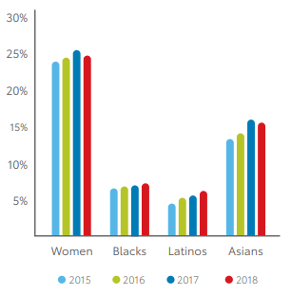

Source: D+I Annual Report, 2019

Toyota is dedicated to encouraging an open society which represents, empowers as well as values in leadership diversity. Such approach and strategy produces both advantages and challenges with the TMC. The following parts of this report will explain these challenges and advantages.

    - Advantages
- Promoting effective roles for working women: Toyota recognizes how necessary it is to highlight and encourage equal jobs inside the workplace — employment in the fields of engineering, science, math, and technology. Promoting is particularly relevant whenever it applies to young women. Toyota is working to increase visibility and the disparity in representation starts to minimize. Through developing a dynamic innovation pool, endorsing groups striving to better inform and inspire more people and acknowledging the remarkable diverse workforce to fill the talent gap (D+I Annual Report, 2019). This promoting effective roles support strong relationship among the employees and makes to explore employees by themselves (Wiscombe, 2007).
- Increase productivity: Toyota’s diversity strategies assist Toyota for increased productivity. Toyota is going to become more effective and competitive. The production period has been reduced by utilizing diverse workforce. For example, the new Camry grew 17 months relative to 23 months in compare to previous iteration utilizing an impute from staff in eight nations (Morgan and Liker, 2006). Toyota is attempting to reduce costs in the midst of raising steel as well as other products prices, and growing demand (Toyota, 2020).

- Supporting innovation: Since Toyota embraces diversity from different partners such as staff, vendors, networks and clients, that has allowed the organization foster innovation in the work atmosphere. Advanced manufacturing is not the single way of Toyota innovation platform. A cultural context that forms Toyota's innovation system and generates a diverse pool of talent in excellence comes with various backgrounds and complexities (D+I Annual Report, 2019). Inspiring colored people along with women and providing them faith to be brave, and also having advocates by Reach, allows Toyota to build and realize what it requires to push forward (Takeuchi, 2009).

- Enhanced workforce engagement and employee commitment: Unethical activities and bullying in the workforce have escalated these days, including ethnicity, class, inequality by faith, and sexual assault. Toyota maintains that all diverse workers there are handled equally in compliance with their mandatory compliance to the laws and regulations. Specifically, whether there have been any abuses in power from the boss of lower workers, they should have a spot of move to, then the Toyota’s diverse range of human resource team would include the staff then legal body as arbitrators to liaise and address this problem properly (Adler, Goldoftas, and Levine, 1997). These above activities enhanced workforce engagement and employee commitment among the Toyota’s diverse workforce (Toyota, 2019).

- Advancing mobility: Toyota hires workers from various nations, creates franchises across the globe and collaborates with a sector which is more competitive than ever. Technology enabled it easier for diverse workers from everywhere around the world to interact with each other and with the Headquarters. This mobility support Toyota for a sustainable business environment (D+I Annual Report, 2019).

    - Diversity challenges
- Cultural influence: Cultural influence is among the most important factors in Toyota’s growth. The Toyota Way, the corporate ideology of Toyota, includes the fourteen values the corporation embraces in all of its activities. This focuses on building value for clients and community (Hoseus and Liker, 2008). Hence cultural influence can be big challenge in Toyota’s workforce diversity.

- Communication concern: Diverse workforce sends Toyota in a big challenge of proper communication within the organization. Diversity-planned organizations, aim to fix the racial and age difference. Employees can consider it hard to communicate each other, whether ethnic variations cause them to utilize slang or different language forms (Angouri, and Miglbauer, 2013). Communication concern in Toyota can arise some business challenges among the diverse workforce.

- The challenges in adopting diversity: This looks fantastic on theory to build a diverse workplace but it may be difficult to execute it successfully. Although there are tons of manuals on integration around here, there is not an available size of fits for all multicultural strategy that works. This is because too many citizens diversity implies various issues (Wuthnow, 2007). Same thing can be happened in few cases of Toyota’s workforce diversity management.

- Neglecting other approaches and activities: While still relying extensively on diversity initiatives over time, investment as well as resources, Toyota lacks some of the company's main roles and objectives (Gao and Low, 2015). For instances, employee development, knowledge management, political, economic, legal etc. issues could be more significant in few situations than the diversity in Toyota’s workforce. In doing that, Toyota could get additional rewards in diversity practice.

  - Work life balance practice in Toyota
Work life balance strategy has become a big weapon for managing manpower and HR to attract and inspire workers and therefore it is very necessary to develop an appropriate work-life balance strategy under the equality policy. Toyota set a new legislation for flexible practices in working from April 2009. Main goals of Toyota’s work life balance policies are to understand the necessity for all workers to collaborate in collaboration and find practical work-life balance approaches; to work equally, regularly; to take into consideration the consequences of certain legislation adopted on equity (Toyota, 2020). Few policies are shared below.

- Health and safety policy: Guaranteeing the safety and health of the employees is placed as a work life balance policy and will proceed to become one of the greatest significant long-standing business exercises of Toyota. The workers' physical and emotional wellbeing is the guiding factor behind the strong results and management team has confirmed that Toyota is working to be a safety-first company. For work life balance, the fundamental concept is health and safety. Toyota is spreading its deep aspiration for its staff never to become involved in work related accidents (Toyota, 2020).

- Relaxing hour in work: Adult employees can relax for at least twenty minutes if they have been continued to perform for six hours on a stretch for a day if they are over eighteen years of age. At the midpoint of their working hours, they can take the break for a time in the day. In addition, if they are supposed to operate for four and a half hours on a stretch for a day, the young staffs who are under 18 but above school starting age may take 30 minutes break (Toyota, 2020).

Toyota is also committed to do the following practices under their work life balance strategies (see figure -4).

Figire-4: Commitment of Work life balance policy in Toyota
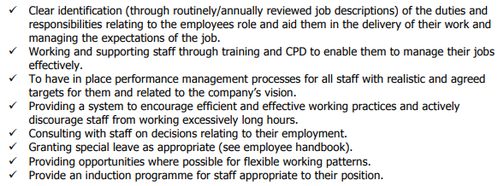
Source: Toyota, 2020

- Childcare and nursing facilities for working women: Toyota takes measures to support a work-life balance, such as developing work environments that enable women to continue working with confidence while performing childcare or nursing care duties (Toyota, 2020).

Figure-5: Most important schemes in childcare or nursing Care
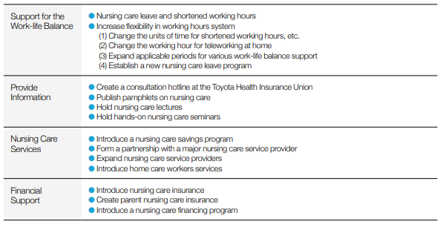
Source: Sustainability Data Book 2018
    - Advantages
- Good employee employer relationship: Toyota had traumatic encounters during the leadership problem of the 1950s, like layoffs and labour disputes, which prompted Toyota to establish the Mutual Agreement on management and labor in 1962. All sides have then sought to cultivate a partnership in which workers collaborate proactively to increase efficiency, whilst the organization seeks to preserve and enhance working conditions. The work life balance policy is one of them contributing in better employee and employer relationship (Sustainability Data Book 2018).

- Build a good working environment: At Toyota, International HR leaders explore how to build positive work conditions in which workers can function with trust, how to establish mechanisms to enhance consistent and constructive continuous improvement program, how to grow individuals and how to build a culture of cohesion for teamwork by everyday contact and frequent conferences (Sustainability Data Book 2018). Hence, work life policies of Toyota support the employees with better working environment. For instance, a working mother feel pretty relax to bring her child at Toyota’s childcare or nursing care unit (Toyota, 2020).

- Employee satisfaction: By offering its employees incentives in their jobs to gain social impact as well as self-realization as a part of work life balance, Toyota strives to allow all workforces to develop their capacity to learn, be innovative and deliver. Toyota utilizes its employee retention and satisfaction assessments to assess the effects of these activities, and uses the findings of the study to prepare and enforce steps to make the workforce healthier. A survey on employee satisfaction of administrative along with engineering workers undertaken in fiscal year 2017 showed that 78% of them were happy with their existence in the work life (Sustainability Data Book 2018). Figure-6 shows the survey result.

Figure-6: Toyota’s survey on employee satisfaction
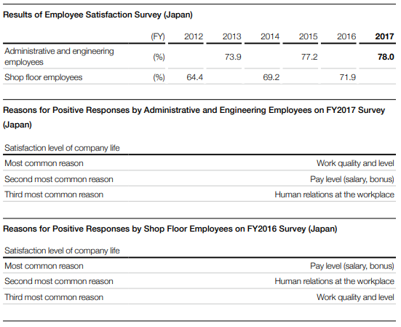
Source: Sustainability Data Book 2018

- Creating desirable areas to employment through recreation: Under this project, Toyota added ‘WE LOVE TOYOTA’ activity as a part of work life balance. Promoting different athletic events, from business units to children's schools. Currently there are 35 sports clubs. People work professionally and work well by availing these recreational activities by Toyota (Sustainability Data Book 2018). Games and sport is a part of mental wellbeing and ‘WE LOVE TOYOTA’ activity support employees for better mental health. Better mental health can build productivity, love to work, job commitment etc. (Haar, Russo, Suñe, and Ollier-Malaterre, 2014).

    - Challenges
Though Toyota has some better work life balance strategies, however the company has come big challenges in managing the policies.

- Impracticable demand from employees: The pressures may put on Toyota by work and life will quickly escalate to unprecedented heights. Unreasonable work-related requirements, schedules that consume in family time, such as weekend gatherings, and technological overload are listed as causing more burdens. Private life pressures bring strain on employment, because it requires time to meet families or mates, and feed in the lunch-time (Jansen, 2016). A survey by Toyota on 93 employees regarding work life balance satisfaction found most of the employees are not satisfied about their work life balance.

Figure-7: Employees rate on work life balance at Toyota
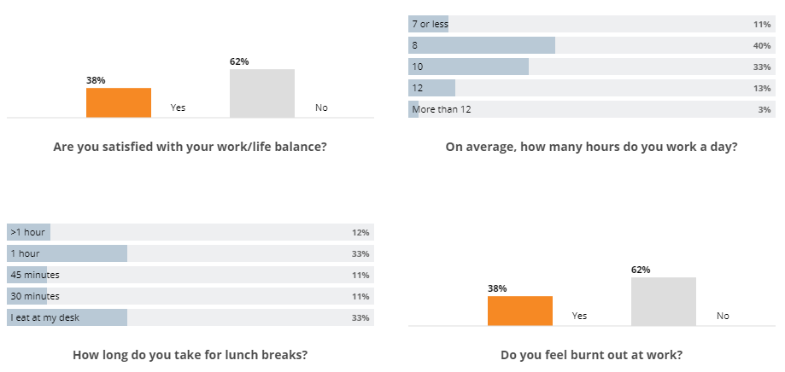
Source: Comparably, 2020

- High Job stress level: In case of stressful job, employees cannot be satisfied whatever the organisational work life policy is. If they feel stress in their job, hence work life balance will not work. A survey by Toyota on 93 employees from various departments in Toyota found employees are not those much happy about their work life balance policies in compare to work stress except the engineering department in Toyota (Comparably, 2020).

Figure-8: work life balance at Toyota from various departments

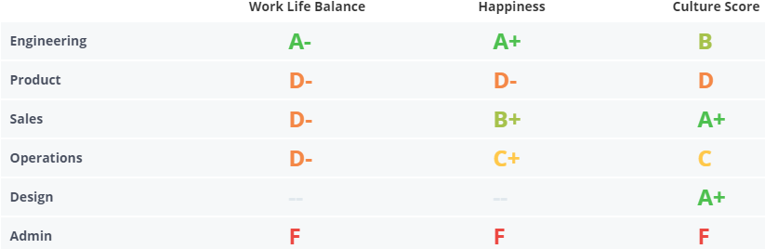
Source: Comparably, 2020

- Uncontainable workload: It's hard to cope with the unmanageable workload or the uncertainty of the company situation people are working in. Some uncontainable factors such as sickness, examinations and personal situations, children's problems may sound as though all power is lost and becomes rather frustrating (Jansen, 2016). In case of Toyota, more experienced employees are less happy about Toyota’s work life balance policies. A survey result shows as follows.

Figure-8: work life balance rating at Toyota based on employees’ experience
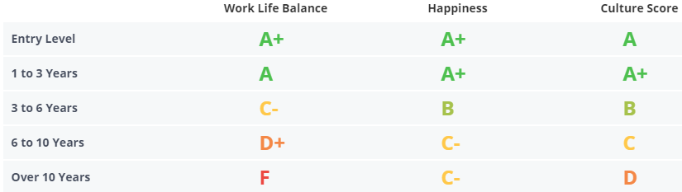

Source: Comparably, 2020

The above figure depicts that, more experienced employees are facing more unmanageable workload in compare to the less experienced employees.

- Changes in culture: The most important aspect influencing work or family life appears to be company’s corporate culture. If corporate culture has not been in reality like family friendly initiatives, it would usually have no influence on company’s work life balance policy (Varuhas, Fursman, and Jacobsen, 2003). In case of Toyota, the company believes and practice in workforce diversity; hence multicultural is obvious.

Figure-9: Cultural changes affect in Toyota’s work life balance policy

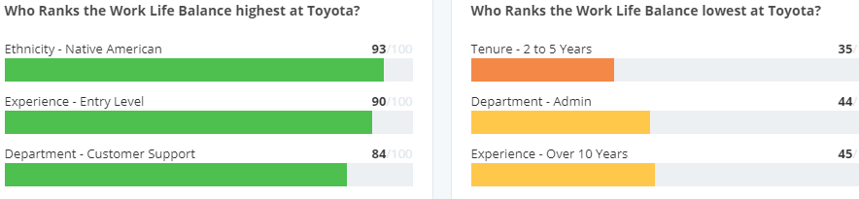
Source: Comparably, 2020

The above figure shows that, most of the Native Americans share good rating in Toyota’s work life balance policy but perception varies from culture to culture.

  - Managing latent through recruitment and selection process in Toyota
Everything here at Toyota is all about quality, about individuals. Only the right candidates for a role or feature would guarantee the finest output possible. And Toyota is persuaded that the quality of teamwork is now even growing at all levels. Deep appreciation for each personality and an enthusiasm for preparation and collaboration create a forum to be proud of from which each person will produce top results. Toyota is going to do it together happy (Toyota, 2020).

- Recruitment and selection are Toyota: Toyota trusts in their people and this is what allows Toyota different. People have been at the core of Toyota’s long-standing popularity that is why Toyota goes to considerable efforts to attract the best candidates to enter the Toyota community, and then engage deeply in training as well as development to support them understand their value.
Figure-10: Toyota’s recruitment and selection process
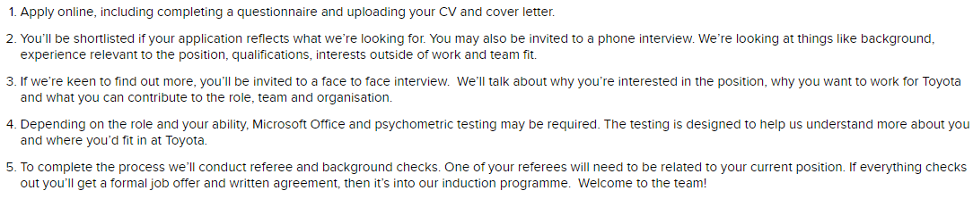
Source: Toyota, 2020

Toyota classified its talents under, service, engineering, production, sales, and corporate. Each of the segmenting talents has been recruited with based on candidate’s quality (Toyota, 2019).

- Training and development policy for managing talents: A constructive warehouse begins at a secured place of work. Because operating with material processing equipment produces a high-risk climate, the awareness rising among operators is significant. For example, understanding and training about how to start driving a chariot elevator efficiently and comfortably already lowers the risk of fatalities. This hardly contributes to the safety and well-being of Toyota’s workers, but also reduces the costs of injury and the labor costs (Toyota Material Handling, 2020). The duration of training program is 1 to 5 days and its purpose is Secure and convenient utilisation of trucks and excellent working movements. That is the way, Toyota train and develops its talents for each sector.

- Talent Development: Toyota is dedicated to talent development centered on the ideology that “developing talents." Daily advancements led by talent wisdom are fundamental for sustained development. To execute on Toyota’s ever-better automobiles and customer preferred first principles all workers need to uphold the same fundamental beliefs through cultures as well as customs (Toyota, 2020).

- Diversity in talent management: The strengths of Toyota exist in its willingness to value the right of its workers to consider and encourage changes which include each member. Concerning the transition from an automobile company into such a mobility business to exploit recent technological developments based on CASE, such capability is becoming extremely necessary as Toyota strive to continuously develop solutions in traditional fields while addressing obstacles in modern fields, and are more than ever needed to provide services and goods from varied perspectives to diversified talents of society (Toyota, 2020).

- Compensation and Benefits: Developing and administering an advantage payment scheme are Toyota’s HR Department’s responsibilities. This system acts as an incentive to ensure that the staffing along with retirement of skilled and talented employees remains in the company. The pay and benefit advisor discusses their incentive plan for the new workers by speaking either one by one or in tiny clusters. Finally, workers are expected to undertake an informed opinion and for authentication functions, their fingerprint is necessary (Besser, 1995).

    - Advantages
- Talent management supports better culture of labor and employee relationship: Unethical activities and bullying in the workforce have escalated these days, including ethnicity, gender, inequality by sexuality, and sexual assault. Toyota maintains that all workers there are handled equally in compliance with their mandatory compliance to the legislation and rules. Actually, whether there are any abuses in power from the employer of lower workers, they should have a position of move to and the Toyota talent management process will include the talents and legal body as arbitrators to liaise and settle this problem properly (Liker, and Hoseus, 2010).

- Knowledge management platform: The management of the organization is mindful of the reality that awareness development is not just an aggregate of facts but is also a diversified talent management activity that cannot be readily minimized or repeated. The administration of the organization attempts to turn data into facts that can be utilized through gathering, arranging, summarizing, evaluating, formulating and ultimate decision taking an experience for the talents. Toyota’s talent management concept is also conscious of the value of successful knowledge management which involves information development, sharing, protection and abandonment (Toyota, 2020).

- Creativity and innovation platform: The next significant factor that Toyota will recognize in enhancing its current diversified talent management activities is the incorporation of innovation and creativity, since it is crucially connected to policy. The organization would be able to retain its role in the longer run by creating a connection between talent management policy and innovation. The talent management will achieve market innovation by aligning managing talents and innovation thus it is important to recognize creativity while designing a talent management strategy (Liker, and Hoseus, 2010; Toyota, 2020).

- Suitable encouragements to talents in learning networks: Another crucial aspect of managing talents is the development of learning networks for allowing talents to learn from one another and optimize their understanding. Toyota has tried to overcome the current information exchange challenges by building knowledge sharing networks by being a learning and business organization. Talent management practice can be motivated to build classroom learning by evidencing talents with knowledge sharing benefits (Meier and Liker, 2005).

    - Challenges
- Maintain good labour management relationship: As Toyota has a diversified workforce and talents from various origins, thus maintain the good labour management relationship is a big challenge for Toyota. Earlier, when administration of certain companies might discuss with full-time labor union officials for adjustments in working terms, provisions, and conditions of work of their workers without checking over employees’ shoulders to discover whether the talent management policy of recent day would approve or to reform if what about the full time labor union official agreed (Ezzamel, Willmott, and Worthington, 2004). But now a day this is very much challenging for the talent managers and the same thing may happen for a multicultural company like Toyota.

- Challenges in talent appraisal system: Evaluation of employee's performance in order to promote the equal allocation of bonuses and relate these incentives to top management rates. Similarly, boost talents' existing output and train them and succeed in potential jobs they may occupy. It is harder solution for Toyota’s diversified talents. It is also called difficult latent management as it is focused on strategic direction, orgnizational framework and people management systems (Toyota, 2020).

- Challenges in communication: An important managing talent challenge that has arisen in many of the organisations' efforts to execute talent management policy is concerning communication failure. Good coordination is important for efficient adoption, and similarly for the Toyota. Toyota needs to establish an appropriate communication program for the efficient execution of talent management policy, which should be adequately versatile to incorporate improvements in communication style just at the period of significant production decisions. Better improved engagement strategy would also allow Toyota to improve the exchange of information and to become a learning organization (Toyota, 2020).

- Challenge in training and development: The initial of the more challenging development and training difficulties is fairly clear; what specifically will be included with the training programme? A major challenge addressed by certain managers of Toyota in development and training is a collection in courses that is too large, too unwieldy, obsolete, redundant or essentially useless (Toyota, 2020). For supporting the continuous improvement program, Toyota needs to develop an effective training and development program for managing and developing its talents.

- Challenges in selection of quality talents: Nowadays the essence to Toyota's prosperity is due to the reality that Toyota only recruits the best staff, because due to numerous extenuating conditions Toyota tries to afford good pay and wages and thereby attract and keep the best employees — far more than people employed at other organizations (Toyota, 2020). However, the challenge is obvious in selecting quality talents from its diversified workforce. As the company is global company, so it is very hard to them for adopting the best talents as per the nation’s culture.

- Recommendations
Depending on the aforementioned facts and debates on different people management factors related to Toyota, suggestions are made for following guidelines.

  - Recommendations on employee diversity issues

Toyota is dealing with issues of rising cost, complexity as well as shift of attention etc. and at the same time involving diversity in enhancing its strategic spotlight. To solve these challenges, Toyota may take the below recommendations to achieve the employee diversity of consequences.

- Out of the box recruiting: In certain sectors or places of Toyota it may be challenging to identify applicants that have specific experiences and expertise. When this is the case, Toyota has been recommended to search for new, more innovative recruitment strategies. For instance, if Toyota would like to have highly trained female engineers, it needs to extend the recruitment activities to technical organisations where the probable candidates are already might be the members.

- Need to arrange diversity-based training session: diversity based training session will encourage Toyota to simply be more welcoming, and will benefit in retention initiatives. It can enable the organisation to recognize the advantages of having much more inclusive as well as diverse workforce which one by one helps to create a friendlier workplace in Toyota.

- Diversify the workforce but recruit the best one: It does sound such as a hardly any-brainer, correct? Yet sometimes it is challenging for Toyota to get past the mindset of this really is the manner we usually do things to get to the real values of the individual seated across the organisation mostly during the interview session. Firstly, the aim should not be to enforce any arbitrary guidelines or to compel a diverse climate. When Toyona recruit the most skilled candidates, anyone with the correct combination of qualifications, expertise and abilities, so inevitably a diverse workforce strategy would result for Toyota’s diversity plan. Toyota needs to create a basement for candidates’ level playing ground of play by creating consistent and fair activities. Toyota should maintain a detailed record of any interview. In this record all candidates have to be asked the similar sort of questions on a same role. Management team may require being educated in the fundamentals of interviewing methods, paperwork and which sort of questions should or should not be asked.

- Recommend to spend in sensitivity education: Many employees of Toyota might be hesitant to step onto the new workforce bandwagon, particularly in a department or sector that has traditionally been a specific route. Though this may not be the situation in Toyota, tolerance and sensitivity program is a vital spending in Toyota’s diverse culture and is needed in some areas. All workers should be involved in the program; incorporating different management planning allows things much more meaningful. In case of physical distance, Toyota may provide online awareness instruction. If feasible, a sensitivity and tolerance training is best offered before issues arise. Sometimes, avoidance is simpler and more efficient than controlling harm.

- Pay close attention to the Toyota culture: Toyota should encourage the employees for its own culture than the place of business. It should be widespread attitudes and behavior that would inevitably split the population, make some people feel excluded. Toyota should need to be tackled those issues to retain its diverse workforce. Toyota also need to consider using staffs surveys to measure how workers feel about Toyota culture as a methods of discovering concerns before the staff retire.

  - Recommendations on work life balance issues

Based on the Toyota’s work life balance strategy analysis, it is observed that; employees have mix opinions on Toyota’s work life balance practice. In addition the retention rate of employees at Toyota is 72% (Staista, 2020) where an ideal rate should be 90% (Gering and Conner, 2002); thus supporting work life balance policy is obvious for Toyota. The following recommendations may enrich employees’ perception on Toyota’s current work life balance practice.

- Focus more on productivity rather than working hours: Toyota needs to focus on productivity instead of employee working hour. This could assist employees for better balance in their work to family life. Instead of counting the hours of work for the workers, Toyota should motivate its management to concentrate on completing a specific task. Workers may require working very long hours in the upcoming days to finish a mission, but it may compensate by the hours they should not have to perform a packed of full working hours. In additions, managers should also encourage the workers for break to reduce the mental pressures their workload in Toyota.

- Offer flexibility in work schedule and overtime issue: Several of Toyota’s staff might be anxious to obtain a greater balance in their work life. Someone else may however be comfortable with the time they have spent in working. Few might want to start their work later but are still able to complete it later as well. Others might not mind longer hours of service, because it ensures they can turn off while they return to their home. In such case, Toyota should offer a flexible work schedule and overtime a part of its work life balance policy.

  - Suggestions for managing talents:
Like the other world-class companies, Toyota should concentrate heavily on managing talent issues and providing a good view about what capabilities require to be built or gained in for Toyota to thrive, scored highest in both efficiency and effectiveness. The following recommendations are made for Toyota’s managing latent issue.

- Offer career development programs: When performance gaps have been established by Toyota’s employees, they will realize just what qualities they ought to build to succeed throughout their careers. A firm dedication to creating new skills and knowledge in established workers is needed to enable them take steps to enhance their performance (Puckett, 2015). In such case Toyota should offer various career development programs for its diversified workforce. These activities would be best suitable for managing its talents.

- Can apply LAMP framework: Toyota should consider the 'LAMP' HR analytics platform properly for potential managing latent issues. The implementation of the LAMP platform would support Toyota as follows;

Logic: Toyota’s logical perspective on strategic planning, HR policies, and other corporate concerns should enhance improved employee performance and minimize unnecessary and inflated expenses.
Analytics: Effective analytics on the issues of diversity and judgment on the employee networking will render Toyota more successful against its rivals.

Figure-11: Poroposed LAMP platform for Toyota’s talent management issue
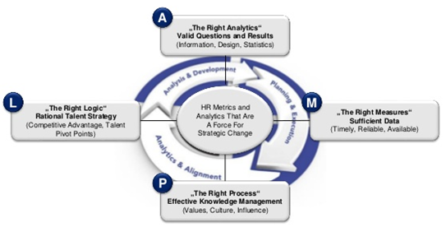
Source: Marler and Boudreau, 2017

Measure: The talent management purpose of Toyota can be achieved by accurate assessment and measurement of corporate performance and diversity in talent management issues.
Process: Success and productivity in controlling talent management systems for human resource growth at Toyota and prospective workforce availability could be supporting the talent management priorities of the Toyota.

- Mass Career Customization (MCC) framework can also be applied for talent management issues: Another significant guideline regarding the managing talent strategy for Toyota is to adopt the ‘Mass Career Customization’ system, such as the policy of managing talent was adopted by Google Inc. The MCC would empower Toyota to establish the job tempo, then encourage workers to think about their position in the company, then calculate the sum of staffs’ workload and establish a reasonable workload limit,

Figure-12: Proposed Mass Career Customization framework for Toyota’s talent management
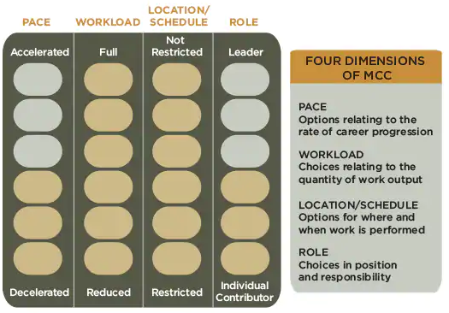
Source: Benko and Weisberg, 2007

Ultimately plan the position and scheduling of operation for Toyota’s diversified workforce. As per the above reasons, the ‘Mass Career Customization’ platform may be really useful to Toyota’s managing talent issues.

- Conclusion
The diversity oriented and environmentally sustainable approaches are being encouraged and stressed by global organisations in recent times. It is established truth that the practices of human resources would comply with the overarching goals of any organisation. Based on the aforementioned discussions as well as analyses, this can be concluded that Toyota puts focus on technology driven innovation strategies from its diversified talents. However, all the organizations across the globe having some certain benefits and drawbacks with their tactics and there is no change to such laws for the Toyota’s people management issues. The report highlights Toyota’s diverse workforce, work life balance strategies, along with managing diversified talents issues. This constancy report shows that Toyota will go a long way in global automobile market. The organisation will adjust the conventional work life balance issues and also focus on the employees’ retention and satisfaction issues. Technology centered talent management strategies is the best time-sensible approach for Toyota. Concentrating further on both the LAMP as well as MCC frameworks will strengthen Toyota’s recruiting, work life balance, employee retention, and managing talent management strategies to be successful and productive in global automobile market.

References

Adler, P.S., Goldoftas, B. and Levine, D.I., 1997. Ergonomics, employee involvement, and the Toyota Production System: A case study of NUMMI's 1993 model introduction. ILR Review, 50(3), pp.416-437.

Amankwah‐Amoah, J., 2020. Talent management and global competition for top talent: A co‐opetition‐based perspective. Thunderbird International Business Review.

Angouri, J. and Miglbauer, M., 2013. 12 Local Languages and Communication Challenges in the Multinational Workplace. Language and intercultural communication in the new era, p.225.

Arif, B. and Farooqi, Y.A., 2014. Impact of work life balance on job satisfaction and organizational commitment among university teachers: A case study of University of Gujrat, Pakistan. International journal of multidisciplinary sciences and engineering, 5(9), pp.24-29.

Asiedu-Appiah, F., Dufie-Marfo, I. and Frempong, E., 2016. Work-Life Balance as a tool for stress management in selected banking institutions in Ghana.

Beauregard, T.A. and Henry, L.C., 2009. Making the link between work-life balance practices and organizational performance. Human resource management review, 19(1), pp.9-22.

Benko, C. and Weisberg, A., 2007. Mass career customization: Aligning the workplace with today's nontraditional workforce. Harvard Business Review Press.

Besser, T.L., 1995. Rewards and organizational goal achievement: A case study of Toyota Motor Manufacturing in Kentucky. Journal of Management Studies, 32(3), pp.383-399.

Bogers, M., Foss, N.J. and Lyngsie, J., 2018. The “human side” of open innovation: The role of employee diversity in firm-level openness. Research Policy, 47(1), pp.218-231.

Buengeler, C., Leroy, H. and De Stobbeleir, K., 2018. How leaders shape the impact of HR's diversity practices on employee inclusion. Human Resource Management Review, 28(3), pp.289-303.

Carton, A.M. and Rosette, A.S., 2011. Explaining bias against black leaders: Integrating theory on information processing and goal-based stereotyping. Academy of Management Journal, 54(6), pp.1141-1158.

Collings, D.G. and Mellahi, K., 2009. Strategic talent management: A review and research agenda. Human resource management review, 19(4), pp.304-313.

Comparably., 2020. Toyota Work Life Balance. Retrieved from, https://www.comparably.com/companies/toyota/work-life-balance

D+I Annual Report., 2019. Driving Toward MOBILITY: POWERED BY PEOPLE. Retrieved from, https://toyotadiversityreport.com/wp-content/uploads/2019/06/Toyota-2019-DI-Annual-Report.pdf.

Erasmus, L.J., 2007. The management of workforce diversity and implications for leadership at financial asset services (Doctoral dissertation, University of Johannesburg).

Ezzamel, M., Willmott, H. and Worthington, F., 2004. Accounting and management–labour relations: the politics of production in the ‘factory with a problem’. Accounting, organizations and society, 29(3-4), pp.269-302.

Festing, M., Budhwar, P.S., Cascio, W., Dowling, P.J. and Scullion, H., 2013. Current issues in International HRM: Alternative forms of assignments, careers and talent management in a global context. German Journal of Human Resource Management, 27(3), pp.161-166.

Furusawa, M., 2014. Global talent management in Japanese multinational companies: the case of Nissan Motor Company. In Global Talent Management (pp. 159-170). Springer, Cham.

Gao, S. and Low, S.P., 2015. Toyota Way style human resource management in large Chinese construction firms: A qualitative study. International Journal of Construction Management, 15(1), pp.17-32.

Garces, L.M. and Jayakumar, U.M., 2014. Dynamic diversity: Toward a contextual understanding of critical mass. Educational Researcher, 43(3), pp.115-124.

Gering, J. and Conner, J., 2002. A strategic approach to employee retention. Healthcare Financial Management, 56(11), pp.40-44.

Greenhaus, J.H., Collins, K.M. and Shaw, J.D., 2003. The relation between work–family balance and quality of life. Journal of vocational behavior, 63(3), pp.510-531.

Haar, J.M., Russo, M., Suñe, A. and Ollier-Malaterre, A., 2014. Outcomes of work–life balance on job satisfaction, life satisfaction and mental health: A study across seven cultures. Journal of Vocational Behavior, 85(3), pp.361-373.

Jansen, M., 2016. The seven challenge areas for work-life balance. Retrieved from, https://www.lifecoach-directory.org.uk/memberarticles/the-7-challenge-areas-for-work-life-balance

Joshbersin., 2010. A New Talent Management Framework. Retrieved from, https://joshbersin.com/2010/05/a-new-talent-management-framework/

Khalvandi, F. and Abbaspour, A., 2013. Optimizing Talent Management Process: A Case Study in PONE Company. Journal of Applied Environmental and Biological Sciences, 3(9), pp.43-54.

Khan, M.R., Roy, M.K. and Hossain, S.K., 2018. Bankers’ Work-‐-Life Balance and Organizational Commitment: Exploring the Dominant Factors to Move on Job-‐-Family Life Balance. Economic Research, 2(10), pp.15-27.

Kirchmeyer, C. and Cohen, A., 1999. Different strategies for managing the work non-work interface: A test for unique pathways to work outcomes. Work & Stress, 13(1), pp.59-73.

Lazar, I., Osoian, C. and Ratiu, P., 2010. The role of work-life balance practices in order to improve organizational performance.

Liker, J.K. and Hoseus, M., 2010. Human resource development in Toyota culture. International Journal of Human Resources Development and Management, 10(1), pp.34-50.

Lockwood, N.R., 2003. Work/life balance. Challenges and Solutions, SHRM Research, USA.

Marler, J.H. and Boudreau, J.W., 2017. An evidence-based review of HR Analytics. The International Journal of Human Resource Management, 28(1), pp.3-26.

Meier, J.K.L.D.P. and Liker, J.K., 2005. Toyota talent. McGraw-Hill, New York.

Morgan, J.M. and Liker, J.K., 2006. The Toyota product development system (Vol. 13533). New York: Productivity Press.

Omankhanlen, A.E. and Ogaga-Oghene, J., 2011. The impact of workforce diversity on organizational effectiveness: a study of a Nigerian bank. Annals of the University of Petroşani, Economics, 11(3), pp.93-110.

Paluch, B., Nishii, L.H., Khattab, J. and Shemla, M., 2017. A Multi-Level Process Model for Understanding Diversity Practice Effectiveness. In Academy of Management Proceedings (Vol. 2017, No. 1, p. 13271). Briarcliff Manor, NY 10510: Academy of Management.

Pandita, D. and Ray, S., 2018. Talent management and employee engagement–a meta-analysis of their impact on talent retention. Industrial and Commercial Training.

Puckett, J., 2015. 4 Best Practices for Effective Talent Management. Retrieved from, http://blog.hirerabbit.com/4-best-practices-for-effective-talent-management/.

Reinhardt, F.L., Yao, D.A. and Egawa, M., 2006. Toyota Motor Corporation: Launching Prius. Harvard Business School Case 706-458. (Revised December 2006.)

Rizwan, M., Khan, M.N., Nadeem, B. and Abbas, Q., 2016. The impact of workforce diversity towards employee performance: Evidence from banking sector of Pakistan. American Journal of Marketing Research, 2(2), pp.53-60.

Saruta, M., 2006. Toyota production systems: The ‘Toyota Way’and labour–management relations. Asian Business & Management, 5(4), pp.487-506.

Scullion, H. and Collings, D., 2011. Global talent management. Routledge.

Shemla, M., Meyer, B., Greer, L. and Jehn, K.A., 2016. A review of perceived diversity in teams: Does how members perceive their team's composition affect team processes and outcomes?. Journal of Organizational Behavior, 37, pp.S89-S106.

Shen, K.F., 2011. The analytics of critical talent management. People & Strategy, 34(2), pp.50-57.

Simon, D.F. and Cao, C., 2009. Creating an innovative talent pool. China business review, 36(6), pp.34-38.

Susi, S. and Jawaharrani, K., 2011. Work-Life Balance: The key driver of employee engagement. Asian journal of management research, 2(1), pp.474-483.

Sustainability Data Book., 2018. Sustainability Data Book 2018. Retrieved from, https://global.toyota/pages/global_toyota/sustainability/report/sdb/sdb18_055-072_en.pdf

Takeuchi, H., 2009. The contradictions that drive Toyota s success. Strategic direction, Vol. 25 No. 1.

Toyota Material Handling., 2020. Operator training. Retrieved from, https://toyota-forklifts.eu/solutions/operator-training/.

Toyota., 2019. Top Reasons Why Toyota is a Leading Company for Diversity. Retrieved from, https://pressroom.toyota.com/top-reasons-why-toyota-leading-company-diversity/.

Toyota., 2020. Overview: Company Information. Retrieved from, https://global.toyota/en/company/.

Varuhas, J., Fursman, L. and Jacobsen, V., 2003. Work and family balance: An economic view. Work and Family, 3, p.26.

Winfield, I., 1993. Tracking regional HRM change: researching the Toyota effect. Human Resource Management Journal, 4(1), pp.71-78.

Winfield, I., 1993. Tracking regional HRM change: researching the Toyota effect. Human Resource Management Journal, 4(1), pp.71-78.

Wiscombe, J., 2007. Toyota: driving diversity. available at: wwwworkforce. com/section/09/feature/24/62/58/index_printer. html (accessed 5 June 2008).

Wuthnow, R., 2007. America and the challenges of religious diversity. Princeton University Press.

