

School of Sport, Health & Outdoor Education.

BA Physical Education
BA Outdoor Education

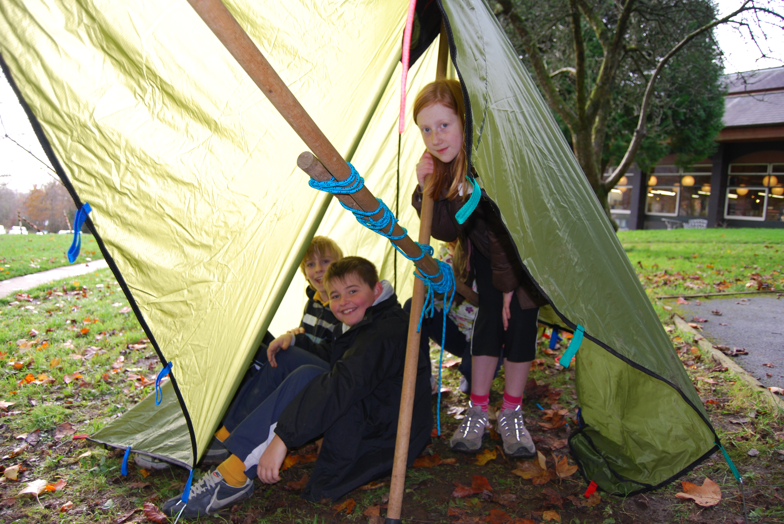
SHSS 4002 Adventurous Activities

Tutor: Geraint Forster

01267 676782 g.forster@tsd.ac.uk

Venue: TL16/Sports Hall/ College Campus

It is the intention of this module in Physical / Outdoor Education, that you become aware of the key role that the subjects play in the all round development of children and that you develop a knowledge base of how the subjects meet the needs of ALL children through effective use of a range of strategies to teach subject content.

The course consists of theory and practical sessions. Lectures and workshops consist of 25% of the course. 75% of the course is self directed study. It is imperative that you carry out the additional support tasks and reading in the handbook in order to benefit from the taught sessions.
MODULE HANDBOOK

CONTENTS Page

Introduction 4

Module Description 7

Individual session overview 10

Introduction

When taught well, Physical Education (PE) can contribute to the development of children in a number of ways, ranging from acquisition of physical skills, development of social skills, improved cognitive ability and enhanced understanding of health and fitness. PE has an important role to play in fostering a desire to participate, be physically active and to be healthy amongst children and young people.

In the primary school setting there is a need to acknowledge that a great deal of children's physical development and skill learning lies before them. PE contributes markedly in this respect, and to the overall education of young people, by providing a setting for children to widen their expressive range and improve motor competence. Furthermore, PE gives the opportunity to reinforce conceptual understanding arising from other areas of the curriculum.

In January 2005, the physical education profession issued a position statement to summarise the value, role and unique place of the subject in the school curriculum. The central features of this statement revolve around two distinct elements of the subject- “learning to move” and “moving to learn” and the concept of “physical literacy, ” especially pertinent to the primary school context.

“The aim of Physical Education is systematically to develop physical competence so that children are able to move efficiently, effectively and safely and understand what they are doing. The outcome – physical literacy – is as important to children’s education and development as numeracy and literacy.”

(Baalpe, PEAUK, CCPR, PE ITT Network, January 2005)

In the school context, PE is part of the educational process. In a wider sense, through effective club links, it can also introduce pupils to the rich cultural heritage of sport, recreation, exercise and dance in our society. In the pursuit of ensuring both the movement vocabulary and an entitlement to participation in its activities for all pupils, PE is a facilitator in providing regular and vigorous opportunities for all round learning experiences within the physical dimension.

The PE curriculum in the past has offered Outdoor and Adventurous activities as an optional activity. From September 2008 the new Wales curriculum made Adventurous Activities statutory at Key Stages 2 and 3. Working in the outdoors with children has many benefits, relating to learning, health and well-being. At a time of increased government interest in Physical Education, the use of the Outdoors and a concern over the apparent increase in childhood obesity levels and a risk adverse society, there is a growing awareness of the subject’s unique contribution across physical, cognitive and aesthetic domains (well supported through a substantial background of research literature). The focus and content of this module will be based on the premise that the provision of meaningful and worthwhile Physical Education experiences for all children in the primary age phase has become an educational priority in its own right. This is a key component of overarching aims within current national primary strategies and is fundamental to the preparation necessary for secondary school provision.

Student Health and Safety

All sessions will be a combination of theoretical and practical work involving students actively in the process of learning within Adventurous Activities. It is very important therefore that you are suitably prepared for each session, are mindful of your own ability and understand the notion of ‘working at your own level.’ This includes wearing clothing appropriate to the movement context such as tee- shirts, sweatshirts, tracksuit bottoms etc.

The sessions will include indoor and outdoor work and you should be prepared for all eventualities that the British climate can bring! You will be expected to model positively the expectations that we have for children in this regard.

Whilst it is our intention to model all aspects of high quality physical education, it is your responsibility to inform us if you have specific needs whilst working in the physical context. Please feel free to communicate these in confidence via email, telephone or in person at convenient moments during the initial sessions.

Working with children:
As part of the module, you will be working with children from a local primary school. You will be expected to behave appropriately as responsible role models. You will need to wear a college polo top so that you are distinguishable to the children and staff. You will need to ensure you are professional in the way that you speak to the children and staff, and the way you conduct yourself throughout the module.

MODULE CODE: SHSS4002
TITLE: Adventurous Activities
DATED: 09/06/2010

MODULE CO-ORDINATOR: Nalda Wainwright
LEVEL: 4
CREDITS: 10

TEACHING METHODS: Lectures 15%
Practical Activities 10%
Directed learning 75%

JACS CODE: X900

AIM(S)
- To develop awareness of the role and delivery of adventurous activities within The National Curriculum.
LEARNING OUTCOMES
By the end of this module students should be able to:
- demonstrate an understanding of the contribution of adventurous activities and outdoor learning to The National Curriculum for Physical Education and Foundation Phase;
- demonstrate an appreciation of the roles and responsibilities of different individuals/agencies in promoting safe adventurous activity learning experiences;
- design and deliver small-scale, sustainable learning experiences for inclusion within NCPE.
CONTENT
- The role and contribution of adventurous activities will be considered in respect of issues of balance and breadth within the subject area of Physical Education specifically and The National Curriculum generally.
- Safety and best practice in adventurous activities will be considered within the context of provision and legislation. Statutory legal and safety considerations will be discussed with a particular focus on the Certificate of Off Site Safety Management, the role of the Education Visits Coordinator and the Outdoor Education Advisor.
- The potential of teaching and learning in the outdoor environment will be considered and effective organisation, communication and teaching strategies introduced.
- The role of local authority and commercial outdoor/residential centres will be identified from a range of perspectives including curriculum enhancement, pupils learning and health and safety.
- The relationship between adventurous activities and environmental education will be addressed and sustainable practice identified.
- A range of introductory teaching and learning activities will provide the context for theory to be linked to practice.
ASSESSMENT
Coursework 100%
One essay (2,000 words) 70%
Exemplar assignment:
Assess the contribution and difficulties associated with adventurous activities teaching and learning in The National Curriculum.

Practical observation report (1,000 words) 30%
Observe and evaluate the quality of teaching and learning in one of the adventurous activities you have observed.
BIBLIOGRAPHY
Essential

Barnes, P. and Sharp, B. The RHP Companion to Outdoor Education, London: Russel House Pub., 2004.
DfEE. Standards for LEA’s in Overseeing Educational Visits – Part 1 – 3 Supplements to Health and safety of Pupils on Educational Visits. Suffolk: DfEE Pub., 2002.
DfEE. Health and Safety of Pupils on Educational Visits. Suffolk: DfEE Pub., 1998.
Doherty J and Brenan P. Physical Education and Development 3-11. London: Routledge, 2008
FSC. Outdoor and Environmental Education in the National Curriculum. Shrewsbury: Field Studies Council, 1993.
Hopkins, D. and Putnam, R. Personal Growth Through Adventure. London: David Fulton Publishers, 1993.
WAG. Climbing Higher: the Welsh Assembly Government strategy for sport and physical activity, Cardiff: Sports Policy Unit, Welsh assembly Government, 2005.
WAG. Climbing Higher Next Steps: the Welsh Assembly Government strategy for sport and physical activity, Cardiff: Sports Policy Unit, Welsh assembly Government, 2006.
WAG. Creating an Active Wales: the Welsh Assembly Government strategy for sport and physical activity, Cardiff: Sports Policy Unit, Welsh assembly Government, 2010.
Welsh Assembly Government. Foundation Phase Framework for Children’s Learning Cardiff: Welsh Assembly Government, 2008.
Welsh Assembly Government. Physical Education in the National Curriculum :Welsh Assembly Government, 2008.

Recommended
Adair, J. Effective Teambuilding. London: Pan Books, 1993.
AfPE, Safe Practice in Physical Education and School Sport, Leeds: Coachwise, 2008.
BCU. Canoeing Handbook. London: The Chameleon Press, 1996.
Blackwell, B. and Davis, D. Outdoor Education. Macmillan Pub., Sth. Melbourne, 1995.
Dybeck, M. A Broad River – Brathay Hall Trust – Fifty Years of Progress 1946-96, Ambleside: Brathay hall Pub., 1996.
Ewert, A.W. Outdoor Adventure Pursuits: Foundations, Theories and Models. Arizona: Publishing Horizons, 1989.
Gair, N. Outdoor Education – Theory and Practice. London: Cassell, 1997.
Greenaway, R. Playback – A Guide to Reviewing Activities. Duke of Edinburgh Pub., 1993.
Hinde, J. Outward Bound Walkers Handbook. London: Ward Locke, 1994.
Hunt, J. (ed) In Search of Adventure. Surrey: Talbot Adair Press, 1989.
Kennedy, A. The Expedition Experience. Penrith: Adventure Education, 1992.
Lockren, I. Outdoor Pursuits. Glasgow: Blackie and Sons, 1988.
Mason, B. Path of the Paddle. London: Cardee Publishers, 1980.
McNeill, C and Martland, P. Orienteering in the National Curriculum. Perthshire: Harveys Publishers, 1992.
Pickup I and Price L . Teaching Physical Education in the Primary School. London: Continuum, 2007
Miles, J.C., Priest, S. Adventure Education. California: Venture Pub., Ltd., 1990.
Mortlock, C. Beyond Adventure, Cumbria: Cicerone Press, 2001.
Mortlock, C. The Adventure Alternative. Cumbria: Cicerone Press, 1987.
Moyles J and Robinson G. Beginning Teaching: Beginning Learning in Primary Education. Buckingham: Open University Press, 1995.
N.A.O.E. The Outdoors and Personal Development: A problem solving approach. Humberside: Occasional Publications No. 1, 1984.
Ogilvie, K. Leading and Managing Groups in the Outdoors. Sheffield: NAOE Pub., 1993.
Palmer, P. Orienteering - Pathways to Excellence. Perth: Harveys, 1994.
Rohnke, K. Cowtails and Cobras II, Iowa: Kendall/Hunt Publishers, 1989.
Rohnke, K. Silver Bullets. Iowa: Kendall/Hunt Publishers, 1984.
Rousseau, J.J. Émile. London: J.M. Dent Publishers, 1991.
Ruse, D. Canoe Games. London: A. and C. Black, 1986.
Smith, A. Creative Outdoor Work with Young People. Lyme Regis: Russell House Pub., 1994.
Smith, A. Working Out of Doors with Young People. Glasgow: ITRC Publishers, 1989.
Van Matre, S. Earth Education - A New Beginning. West Virginia: Institute for Earth Education, 1990.

Journals
Bulletin of Physical Education
British Journal of Teaching Physical Education
European Journal of Physical Education
Horizons

BA PE – Schedule for SHSS4002

Session 1 – 30/1/15 | Introduction to the module, assessment, overview, expectations.  National Curriculum. Key reading.
Session 2 – 6/2/15 | Theory session – curriculum, value and importance of PE and OE. Delivery of AA in schools, support systems H&S.
Session 3 – 13/2/15 | Theory sessions – Present findings from personal research.
Session 4 – 20/2/15 | Practical activities.
Session 5 – 27/2/15 | Practical Activities.
Session 6 – date to be confirmed – during week commencing 2/3/15 | Session Planning. Checking and completing practical activity session outlines. Understand assessment 2- observation task.
Session 7 – 6/3/15 | School children in for practical sessions  Feedback from session. Essay submission.
Session 8 – 13/3/15 | School children in for practical sessions  Feedback from session
Session 9 – 20/3/15 | School children in for practical sessions  Feedback from session
Session 10 – 27/3/15 | School children in for practical sessions  Feedback from session
15/5/14 | Hand in Practical task assessment

Dylan Blain, Jan 2015.

