The Global Business Environment
Assessment 2
Environmental Analysis of an industry

Module code:LCCB4005
Module Lecturer:Alfred Mensah
Student Name:Tsvetan Chumpalov
Studen Number:2122749

Contents
Introduction 1
Major Forces Shaping The Global Business Environment 2
International Environmental Analysis with PESTEL Framework 3
Why Organisations Engage In International Trade 8
Influence of Markets In Action on Firm Strategy, Long-Run Initiatives and Major Current International Economy Features 9
Conclusion 10
References 11

Introduction
Internationalization is a term used to describe the global economy, that is usually thought of as international investment that has been going on for a long time. The COVID-19 epidemic has impacted numerous countries in various ways, causing companies to suffer an economic collapse in several countries (Tad et al., 2019). Throughout that epidemic, the UK as well as other nations-imposed shutdowns, halting all productive activity because several supply lines were disrupted during the COVID-19 scenario, particularly during the early stages of the crisis. This epidemic is affecting one of the UK's major industries, the automotive industry and a specified instance of a company named Mercedes are presented here. This study will address the impact of COVID-19 on the UK automotive industry and some strategies for dealing with this unwelcome scenario.

Major Forces Shaping The Global Business Environment
Global business is when people, processes, industries, and governments from different countries work together. Information technology assists make it easier for it to work. It's also based on foreign trade and investment. The automotive industry accounts for about 8% of all manufacturing jobs, and the UK GDP will shrink by 9% (Kim, 2020). As automotive centres can be very complicated, with a lot of different methods, quotas, turnarounds, and other things, having strong structures and techniques is very crucial to cope with the international conditions.
Cost: Automobile company’s validity and new technology in design would cut back on the facilities it offers to its customers (Kokodey et al., 2018). For instance, Mercedes is a luxury brand and always fixes its expenditure and profitability before launching in another country which is a basic structural business concept.
Market: Before the fieldwork process, seasoned research executives and fieldwork teams came together to think of problems, delays, and other issues that could affect the global market project (Kim, 2020). Global service production will be influenced by cultural, social, and technological differences in market segmentation.
Competition: Several companies are emerging day by day which has a huge impact on establishing or expanding a business project (Luthra et al., 2015). Profitability became increasingly difficult among multinational corporations due to increased competition. For instance, Mercedes is up against the stronger competition in the global automobile market than it is in the local clothing sector. Within a global scale business, more market competitors may have greater resources and expertise than Mercedes.

International Environmental Analysis with PESTEL Framework
Since the main goal of a Pestel framework is to figure out what outside variables can influence the automobile industry or how those factors can be good or bad for the business. PESTLE analysis tends to enable a car company like Mercedes to understand what is going on outside of the business right now, so executives can work with facts instead of assumptions and the following effects have been seen during COVID-19 on the automobile industry:
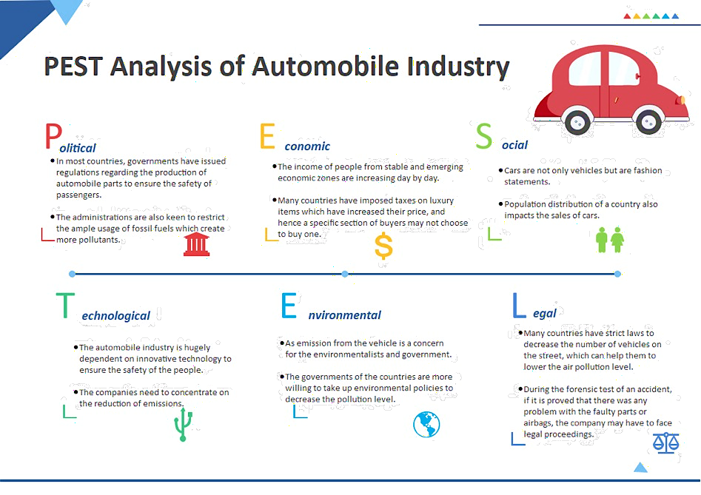
Figure 1: PESTLE Analysis Of The Automobile Industry
Source: (Freddie, 2021)
Political factor: A corporation can make a profit if it can import high-quality resources at a reasonable cost and because of COVID-19, the UK vehicle sector is unable to trade more and suffers a loss. The car sector is heavily reliant on exports and imports ratios and any country's vehicle business is heavily reliant on the government's export and import policies (Amankwah, 2021). Tariffs could be very high on goods that are transferred to the EU or brought into the UK. WTO tariff rates of up to 10% on vehicles and also up to 22% on the commercial automobile would be in place. Tariff barriers of up to 4% upon the parts for cars would be put in place. According to legal concerns and economic conditions, for example, the clearance of vehicles such as Mercedes Benz increased by two-fold digits during the situation so that it can cope with those countries it dealing with.
Economic factor: During COVID-19, the year started with a small drop in sales, but the third period from June to July saw the biggest drop, with sales going down more than 30% from 5500 to 6000 units (Nayak et al., 2022). For instance, Mercedes Benz sales for the first half of 2020 were down 18 per cent because of big changes in the economy last year.
Mercedes Benz that sales for the first half of 2020 were down 18 per cent because of big changes in the economy (Amankwah, 2021). Compared to the global economy, the UK economy, which is heavily reliant on the automotive sector, took a blow in 2020 and is expected to recover slowly until 2021. The COVID-19 dilemma produces short-term marketing issues including supply and material shortages and also the rise in 5 the cost of vehicle parts, the whole cost of autos is projected to rise. This can be a key explanation for the decline in demand for vehicles and the UK motor sector (Bauer and Weber, 2021).
Social Factor: During the COVID-19 epidemic, the UK had to obey specific physical distance regulations and at that time, people in the UK prefer automobiles to buses. Countries with fewer vehicles tend to employ public buses. Around 51% of worldwide respondents said they will travel less than previously during the COVID-19 outbreak (Freddie, 2021). Mercedes Benz tried to focus on issues that are close by, where networks can benefit and guidance can be provided. They want to improve the quality of vocational training and fill up the damage that occurred during a pandemic, build infrastructure, give better lives to people who aren't well-known, and support the local community to get flexibility with their automated systems. In a COVID-19 pandemic condition, individuals are more inclined to drive than to take buses, due to the abundance of vehicles in the UK.
Technological factor: Throughout the COVID-19 epidemic, individuals are more careful about health, safety, and the environment and limited firms' ability to innovate owing to uncertainty and environmental instability and there is the issue of employees not being at work regularly due to lockdowns around the country (Kim, 2020). For example, in a rapidly changing automotive market, traditional carmakers are challenged to keep up with shifting consumer demands in pandemic situations and Mercedes company-provided promotional marketing using the internet and attractive software technology is effective and gathered competitive advantages. Even a luxury and quality company like Mercedes have to perform more to stay competitive, and this is where test displaying comes in for that reason, the company started online communication with the employees and training facilities via the internet platform which kept their company efficient in the workplace even during the pandemic.

Legal factor: Hygiene maintenance became a major fact and regulation while facing the pandemic even in the automobile sector. The company hire an applicant who is acknowledged in automation and has the skills to solve organizational issues. There is an anti-discrimination law where automobile companies only hire because of skills not because of looks or ethnicity. Also, an insurance guarantee card over a product confirms consumer protection laws. The Management of Health and Safety Act 1974 is the cornerstone of British H&S legislation. The Act defines the general obligations of employers and workers toward each other and towards the public. (Tad et al., 2019). People and businesses can see how important it is to protect the environment throughout the COVID-19 pandemic and as a consequence, the number of sales of cars went down over time. Mercedes tended to the fact that to solve contamination concerns over the long term, they would have to revert to diesel. When measured at the BS-VI level, particle output from petroleum with diesel are comparable, while CO2 discharge from oil is significantly greater. Just like that instance, more car companies took relatable regulations to make their company more authorised and that frequently occurred during the pandemic situation.
Environmental factor: The UK Government is now encouraging car companies to come up with and utilise new technology to create battery- or electric-powered cars, which will cut down on the number of harmful gas emissions from cars. People of all kinds are worried about how much pollution cars are putting out, and this worry level rose even more throughout the COVID-19 pandemic. As the cost of making this battery-powered car is massive, the cost of making cars, in general, went up (Luthra et al., 2015). Since people remained quarantined, they could not go out frequently which caused less rate of cars on the road and it saved our air from pollution little a bit. Companies are vowing to attain net-zero emissions to assist mitigate the worst consequences of climate change. From 2019 to 2020, the proportion of enterprises aiming for net-zero roughly doubled. (Kokodey et al., 2018). Due to the obvious COVID-19 pandemic, China, Germany, and France are taking steps to make their air cleaner and the car manufacturer must follow these rules. These rules have a big impact on the potential and current profit margin for car manufacturers in the UK. There also can be new rules about how cars can be sold because more cars are causing more greenhouse gas emissions and they should also follow the rules that have been set up by the government.

Why Organisations Engage In International Trade
Businesses generally manufacture items in other countries because of reduced labour costs or tax rates, and they offer their products or services in the international market due to the obvious high likelihood of getting a broader audience, more consumers, and more money in foreign countries. Automobile industry expanding globally due to the following reason:
- Sales increase because of global expansion as more customers engage in the automobile (Nayak et al., 2022).
- When a car company launch a design globally, it gathers attention from worldwide countries, that’s why global expansion is needed.
- The possibility that a business operation would collapse is referred to as an automobile industry's competitive risk.
- Adverse financial, political, or natural catastrophes in a particular nation might cause major trouble for a company that is fully reliant on that country, whether from a supply or a market standpoint.

Influence of Markets In Action on Firm Strategy, Long-Run Initiatives and Major Current International Economy Features
To be more appealing in a business-like global company, it is necessary to have cultural affinities with others and after that pandemic, the world became a digital village where automobile companies need to focus on promotional activities (Bauer and Weber, 2021). As a result, the strategic management of the organisation must make an effort to research and train the local culture's ability to work properly. Also, the following initiative will make a short and long-term impact on global business:
In the recent year after the pandemic, most economists have concluded that the bare minimum level of efficiency in 'Manufacturing Execution System' (MES), which is defined as a data framework that attaches, analyses, and governs complex constructing frameworks and input frequency bands on the industrial production line floor, has increased the sector in size, total amount, or degree (Freddie, 2021).
The UK government is providing attractive subsidies for emergency projects and enterprises to combat the COVID-19 epidemic. This financing will end first in the UK so, the care sector should accept the funds and utilise them to grow.
Additionally, the government should reduce taxes as well as other subsidies to stimulate the automotive sector since the business cannot restore its prior growth without the people's consent.

Conclusion
The car industry is expected to grow to see tremendous expansion in the future, given the changing lifestyles and economic situations of the nations involved. Yet, there are safety, economic and environmental considerations that they must address to keep the system running smoothly. Since COVID-19 made a huge impact on every sector of business, the more automobile company can be flexible, the more they can be successful. Competitive advantages will also assist to grow that business sector according to this paper.

References
Amankwah, J., 2021. COVID‐19 pandemic and innovation activities in the global airline industry: A review. Environment International, 156, p.106719.
Bauer, A. and Weber, E., 2021. COVID-19: how much unemployment was caused by the shutdown in Germany? Applied Economics Letters, 28(12), pp.1053-1058.
Freddie Murphy, 2021. PESTEL Analysis of Mercedes-Benz. Online. Available at: <www.essay pandas.com-Mercedes-Benz-Pestel-Analysis> [Accessed on 8th April 2022]
Kim, R., 2020. The impact of COVID-19 on consumers: Preparing for digital sales. IEEE Engineering Management Review, 48(3), pp.212-218.
Kokodey, T., Gnezdova, I. and Lomachenko, T., 2018, October. Modelling the global business environment based on polycyclic theory. In The International Science and Technology Conference" Far-East-Сon" (pp. 487-499). Springer, Cham.
Luthra, S., Garg, D. and Haleem, A., 2015. Critical success factors of green supply chain management for achieving sustainability in the Indian automobile industry. Production Planning & Control, 26(5), pp.339-362.
Nayak, J., Mishra, M., Cengiz, K. and Shanmugaratnam, V., 2022. An impact study of COVID‐19 on six different industries: Automobile, energy and power, agriculture, education, travel and tourism and consumer electronics. Expert systems, 39(3), p.e12677.
Tad, N., Jeenanunta, C. and Sanprasert, V., 2019. Resilient Manufacturing: Case Studies in Thai Automotive Industries during COVID-19 Pandemic. EPPM 2021, p.53.

