Module Title- Foreign Languages & Cultural Awareness
Student Name-kincso suveg
Student ID-2225011

Executive Summary
This report has discussed a contrast between England and Italy concerning its social and cultural customs. Moreover has included a comparison of intercultural leadership differences faced by England and Italy. The challenges that are faced in the process of implementing cross-cultural leadership by the hospitality industry with additional recommendations have been included in this report.

Table of Contents
Introduction 4
Contrast of England and Italy 5
Evaluation of England and Italy’s cultural and leadership skills as per the GLOBE project 5
Challenges Faced by Intercultural Leadership in the Hospitality Industry 8
Conclusion 10
Recommendations to Overcome the Intercultural Leadership Challenges 11
Reference 12

Introduction
This report will provide a descriptive analysis presented by an Assistance General Manager of Inclusivity Hotel & Spa defining the cultural barriers, and differences between England and Italy. The basic contrast will be included in the report with further explanation of the two countries' cultures and leadership skills. These comparisons will focus on the factors as presented by GLOBE projects on its website. Graphs will be included and evaluated in this report to provide detailed insights into the issues. Additionally, the challenges faced by intercultural leadership within the hospitality industry will be discussed with a few recommendations.

Contrast of England and Italy
Social behaviour, Customs and Culture: There is a striking difference between Italian and English social behaviour, it represents the presence of an individual in the social environment. Italians are considered to be more approachable and positive to starting a conversation with a stranger. Comparatively, the English are observed to be more reserved and cold, they prefer to maintain their privacy rather than exchange greetings (Cressy, 2023). It is significantly noticed that the Italians use their hands even during talking to emphasis their speech. The English regarding this are very formal and give short-curt replies or even put their perspective to others within a simple speech.
Language diversity: Language is a common factor that creates a usual difference between two differing countries, states or nations (Abramson and Moran, 2018). Significantly in England, people are either natives or proficient English-speaking migrants. Even several locals separately learn other languages so communication is easier in England compared to Italy. However, in large cities of Italy, the natives can speak English but as they move towards more countryside there potential language barriers are faced. Even sometimes the natives are acquainted with old costumes that they do not communicate in any language other than Italian.

Evaluation of England and Italy’s cultural and leadership skills as per the GLOBE project
GLOBE is an online platform that provides a unique study of cultural and leadership practices, skills, and ideas that are followed by different countries and cultures all over the globe (Maheshkar and Sharma, 2018). It is an open platform that is accessible to all rendering important data and resources.
Cultural Aspect
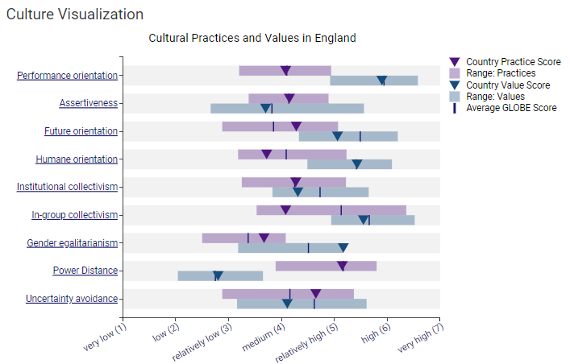
Source: (globeproject, 2024)
Figure: Cultural visualisation in England

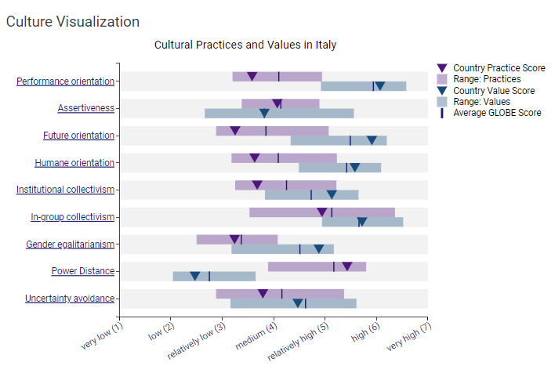
Source: (globeproject, 2024)
Figure: Cultural visualisation in Italy
Cultural visualisation has represented that the cultural practices of the English are based on various aspects such as performance, human, future orientation and assertiveness, gender egalitarianism, and power distance. The visualisation shows that performance orientation, assertiveness, and gender egalitarianism, future orientation are medium ranging from 4 to 5. On the other hand, the other aspects are higher except the power distance, for specific reasons is lower. The performance orientation, power distance, and assertiveness ranging 5 to 4 and the other aspects are lower than that. The range of the England’s cultural practices is relatively higher than the cultural visualisation of Italy.
Leadership Aspect
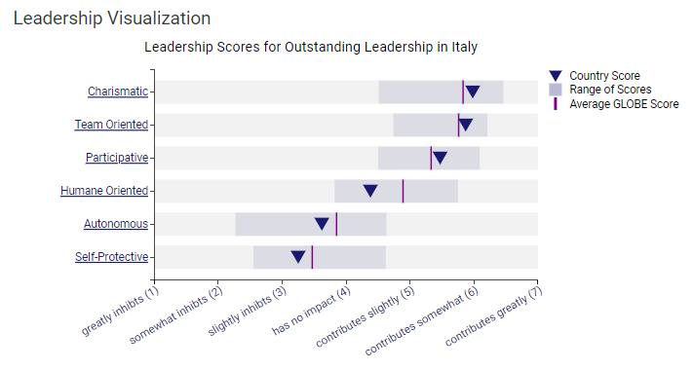
Source: (globeproject, 2024)
Figure: Leadership visualisation in Italy
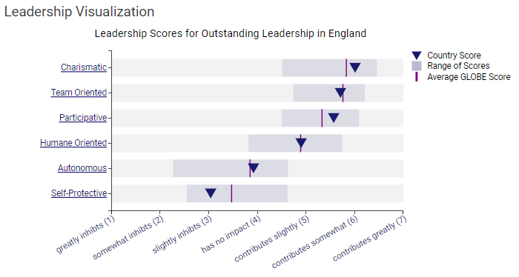
Source: (globeproject, 2024)
Figure: Leadership Visualisation in England
The leadership skills of England as represented through the leadership visualisation of Globe are in the high range. The aspects of these skills are charisma, team orientation, human orientation, autonomy, self-protection, and participation. As per the visualisation charisma, team orientation, participation and human orientation are on the higher side, ranging from 6 to 4 and autonomy and self-protection need more focus as they range between 3-2 on the scale. On the other hand, leadership skills and their effectiveness are significantly well-emphasised and implicated. The country's score of charisma is 5.98, the team orientation is 5.87, and participative is 5.47 compared to the human orientation, autonomous, and self-protective is on the lower side ranging from 3 to 4. Thus it can be interpreted that Italy is ahead of England on the global scale of leadership skills.

Challenges Faced by Intercultural Leadership in the Hospitality Industry
Cross-cultural leadership refers to a leadership style that follows diverse cultural stimulation (Holliday, 2021). In intercultural leadership, various employees of different cultural backgrounds are asked to work together to attain goals and objectives (Huertas-Valdivia et al., 2022). There are different challenges faced in implementing these leadership styles as a General Manager of Inclusivity Hotel & Spa.
Communication barriers: The difference in language leads to communication gaps in cross-cultural workplaces. If the employees are unable to understand the language of the leader the team is sure to fail the goals and vice versa (Luka et al., 2023). Thus language is an essential hindrance that impacts leadership by creating misunderstandings, and sudden issues within the workplace (Sacco and Conz, 2023). Thus, moving from England to Italy can lead to various threats to Inclusivity Hotel & Spa.
Social habits and leadership styles: There are different leadership styles followed by different cultures and regions based on their norms, values and social aspects (Innis, 2022). People are usually habituated to their cultural behaviour and leadership styles but that might not be accepted in a different culture. As the natives of England are more reserved and prefer to talk less as compared to the Italians the native employees of Italy must feel pressured or inability to work freely. Even the overly formal and strict leadership style of England’s culture might not be accepted by the Italian workers.

Conclusion
This report has discussed differences between England and Italy concerning their social and cultural customs. Further, the comparison has been included in determining the culture and leadership in England and Italy using the GLOBE Project. It is only common for two different cultures to face challenges to work together. Thus challenges such as language barriers, social habits and different leadership styles have been discussed. Additionally, recommendations have also been included within this report for future prospects.

Recommendations to Overcome the Intercultural Leadership Challenges
- It is recommended that the organisation should introduce specific leadership guidelines that will be followed irrespective of the individual worker's cultural perspectives.
- Suggestively the organisation can set effective communication modes within the workplace to remove the language barriers faced by employees (Ineta, 2023).
- It is recommended that organisations adopt local cultural values, customs, and beliefs and implement them to meet the cultural conflicts of employees.

Reference
Abramson, N.R. and Moran, R. (2018) Managing Cultural Differences: Global Leadership for the 21st Century. 10th Ed. Abingdon: Routledge.
Cressy, D., (2023). Society and culture in early modern England. Taylor & Francis.
globeproject, (2024). England. [Online] Available at: https://globeproject.com/results/countries/GBR%3Fmenu=list.html#list [Accessed 25 05 2024].
globeproject, (2024). Italy. [Online] Available at: https://globeproject.com/results/countries/ITA%3Fmenu=list.html#list [Accessed 25 05 2024].
Holliday, A., (2021). Intercultural communication: An advanced resource book for students. Routledge.
Huertas-Valdivia, I., González-Torres, T. and Nájera-Sánchez, J.J., (2022). Contemporary leadership in hospitality: a review and research agenda. International Journal of Contemporary Hospitality Management, 34(6), pp.2399-2422.
Ineta, L., (2023). Eliminating Intergenerational and Intercultural Communication Problems in Tourism and Hospitality Enterprises. Acta Universitatis Sapientiae, Philologica, 15(2), pp.14-32.
Innis, H.A., (2022). The strategy of culture. DigiCat.
Luka, I., Drozdova, V., Šakytė-Statnickė, G. and Budrytė-Ausiejienė, L., (2023). Solving intergenerational communication problems in tourism and hospitality enterprises. Journal of Education Culture and Society, 14(1), pp.207-228.
Maheshkar, C. and Sharma, V. (2018) Handbook of Research on Cross-Cultural Business Education. Hershey: IGI Global.
Sacco, F. and Conz, E., (2023). Corporate heritage communication strategies of iconic Italian brands: a multiple case study. Corporate Communications: An International Journal, 28(7), pp.19 43.

