Mikolaj Michalski (1900885)
1900885@student.uwtsd.ac.uk
Computational thinking exam

Table of Contents
Introduction 2
BPMN diagrams 2
Overall diagram 2
Red, Blue and Black scans 7
Use case diagram/document 9
Use case diagram 9
Code 9
Image of the robot 10

Introduction
This document explains how the robot was created and made to complete the tasks that have been required. Along side of this there are diagrams that helped make the code for the robot as well as the code itself.

BPMN diagrams

Overall diagram
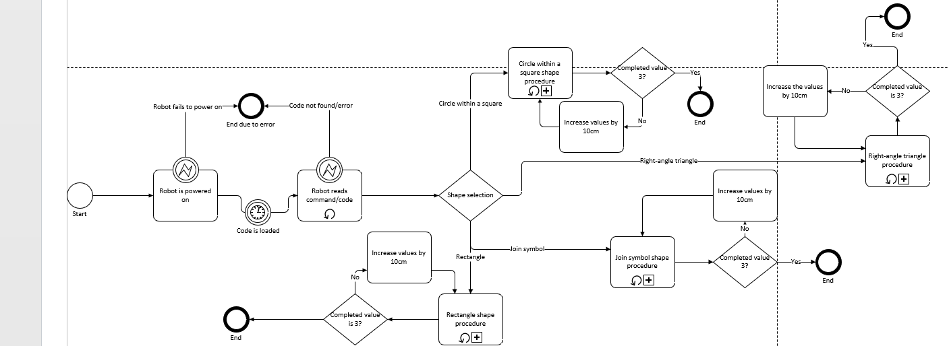
This diagram shows how the shapes will be completed. The user selects a program that contains the code for each shape. the boxes have sub process which each go in more depth of how the task would be completed.
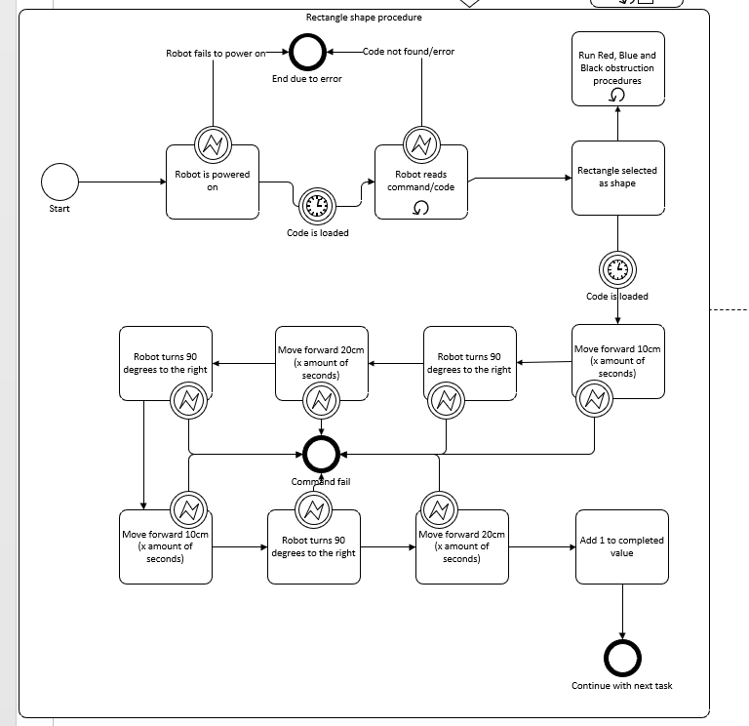
This is the sub process of the rectangle shape. it follows the same path however it runs 3 other codes “diagrams” along side the current one. These are the codes for the colour scanner to detect obstructions.

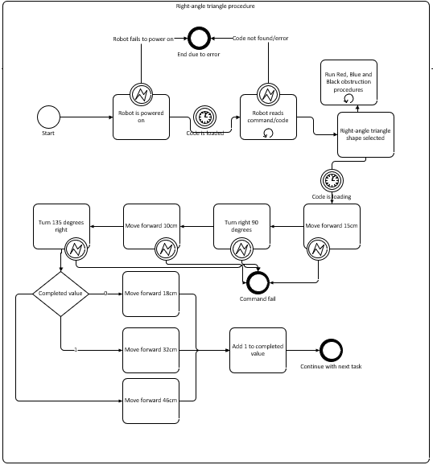
This is the sub process of the right-angle triangle. It follows the same start as it has to continuously scan for any obstructions in its path. The ending continues the with the next task. There is a completed value section in order to increase the size of the long side of the triangle. This allows it to increase along with the other sides accurately.

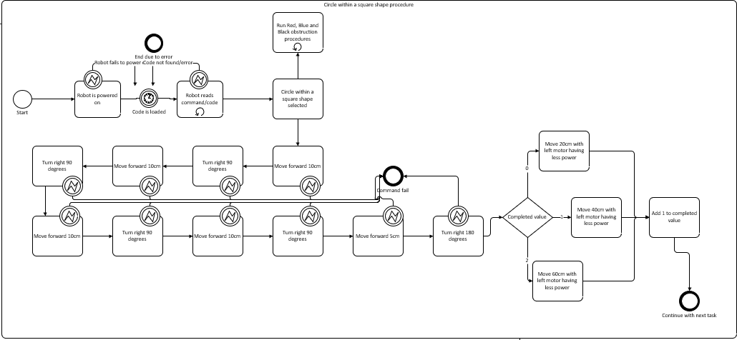
This diagram shows the circle within a square sub process. It also follows the same start however has its own way of continuing. The square is created separate to the circle that is within it and has to be done the opposite way to which the circle will be drawn. In the diagram the square is done clockwise while the circle is done anticlockwise. It uses the same value system implemented to allow the increase in size for the circle.

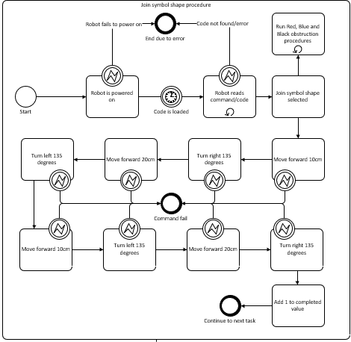
This is the final sub process which is for the Join symbol shape. This one uses the same start and ending to the other processes as it has to increase in size and run constant scans on what may be in front of it. The tasks are quite simple and allow the shape to be created with accuracy in mind.

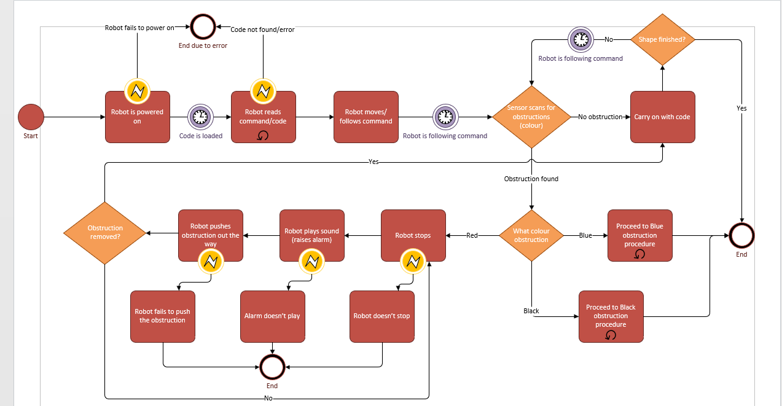
Red, Blue and Black scans
This is the red colour scan diagram which shows what the robot is to do when it encounters the red coloured tape. There is a gateway that if the colour scanned is not red it will divert it to the correct procedure.

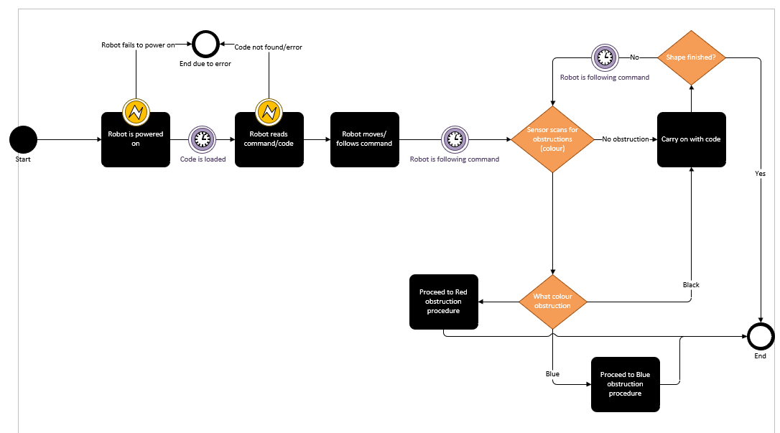
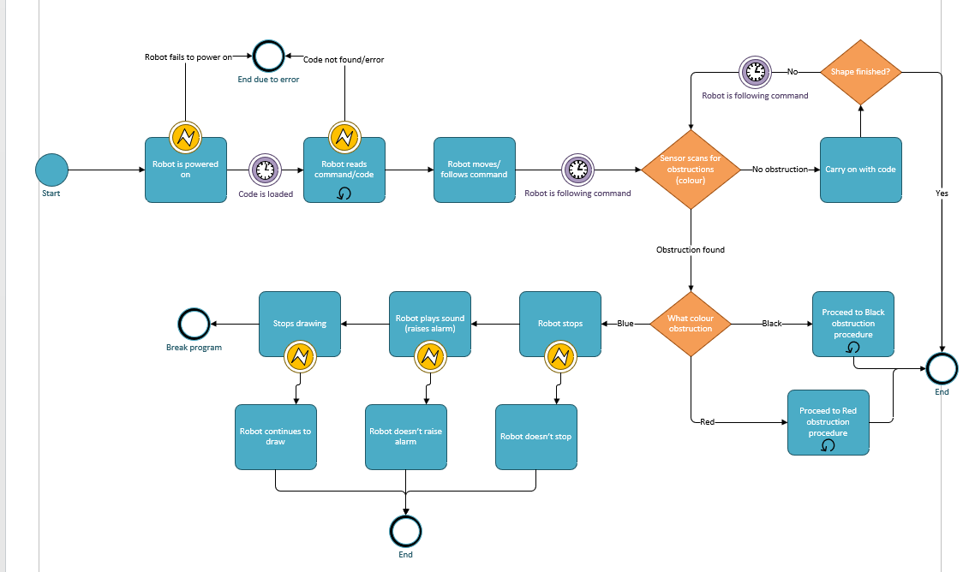
This is the diagram for the blue colour scan. It works the same way as the red scan as it diverts to other procedures when it needs to however the code breaks when the colour is found.
This is the final diagram for the black colour scan. In this it simply diverts to the other procedures as the black colour is ignored.

Use case diagram/document

Use case diagram

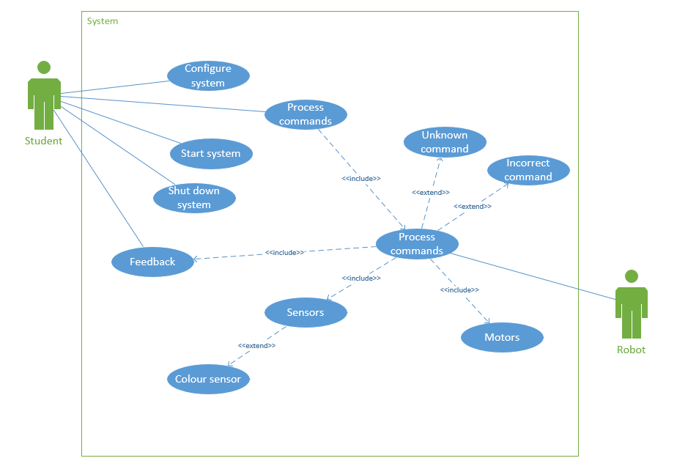
This is the use case diagram. The diagram shows all the connections that are between the actors and how they are included with each other. There are certain parts that are included and certain parts that are extended to go explain more of what there is.

Code
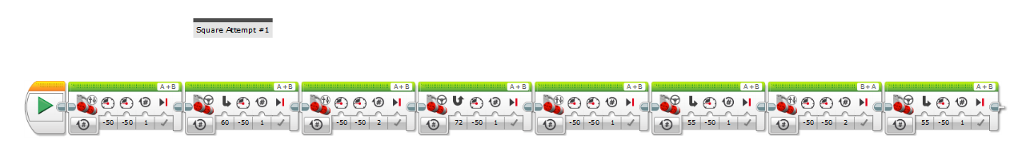
This is the code that we have within our robot.
Use case ID: |  | 1
Use Case Name: |  | Robot system
Created By: | Mikolaj Michalski | Last Updated By: | Mikolaj Michalski
Date Created: | January 23, 2020 | Date Last Updated: | January 23, 2020
Actor(s): |  | Student, Robot
Description: |  | The student and robot tie in with each other through the system that is controlled by the student.
Preconditions: |  | The user creates the code to allow the robot to work.
Postconditions: |  | The user updates the code allowing it to improve.
Normal Course: |  | Commands get sent to the robot which then get executed allowing the shapes to be created.
Extensions: |  | Motors, colour sensor

Image of the robot
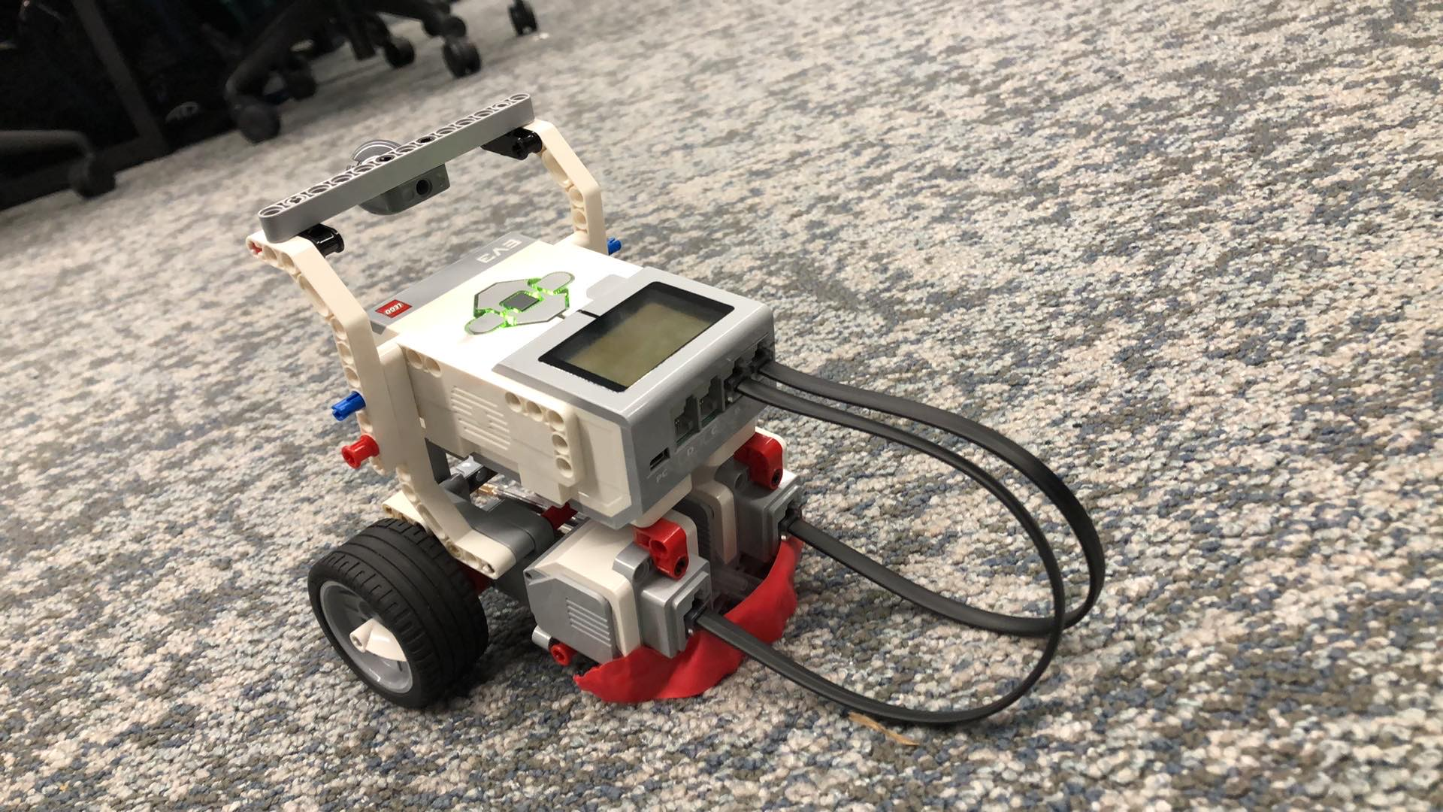
This is the picture of our robot that was created. However, the power supply we had was damaged which caused several issues through the exam.
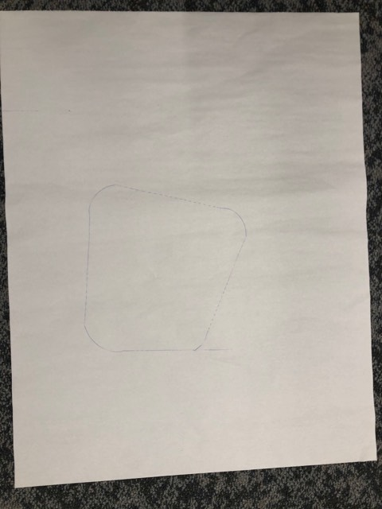
This is the picture of our tests. However, due to several errors we were unable to make massive improvements to the robot. The code we had that was pre planned by the diagrams couldn’t be implemented due to the battery dying and other errors.

