Referencing practice activity
In the following Activity you will find 9 different credible sources, comprising of books, journal articles and websites.

The actual websites and journal articles are connected to the website image with a link, so you can access the original source to look around for information if needs be. To access this please right click on the image and open the link.

For each source, please provide the citation (both variations) and the full reference.

Once complete, make sure you are happy and confident with your answers before submitting to the Turn-It-In link.
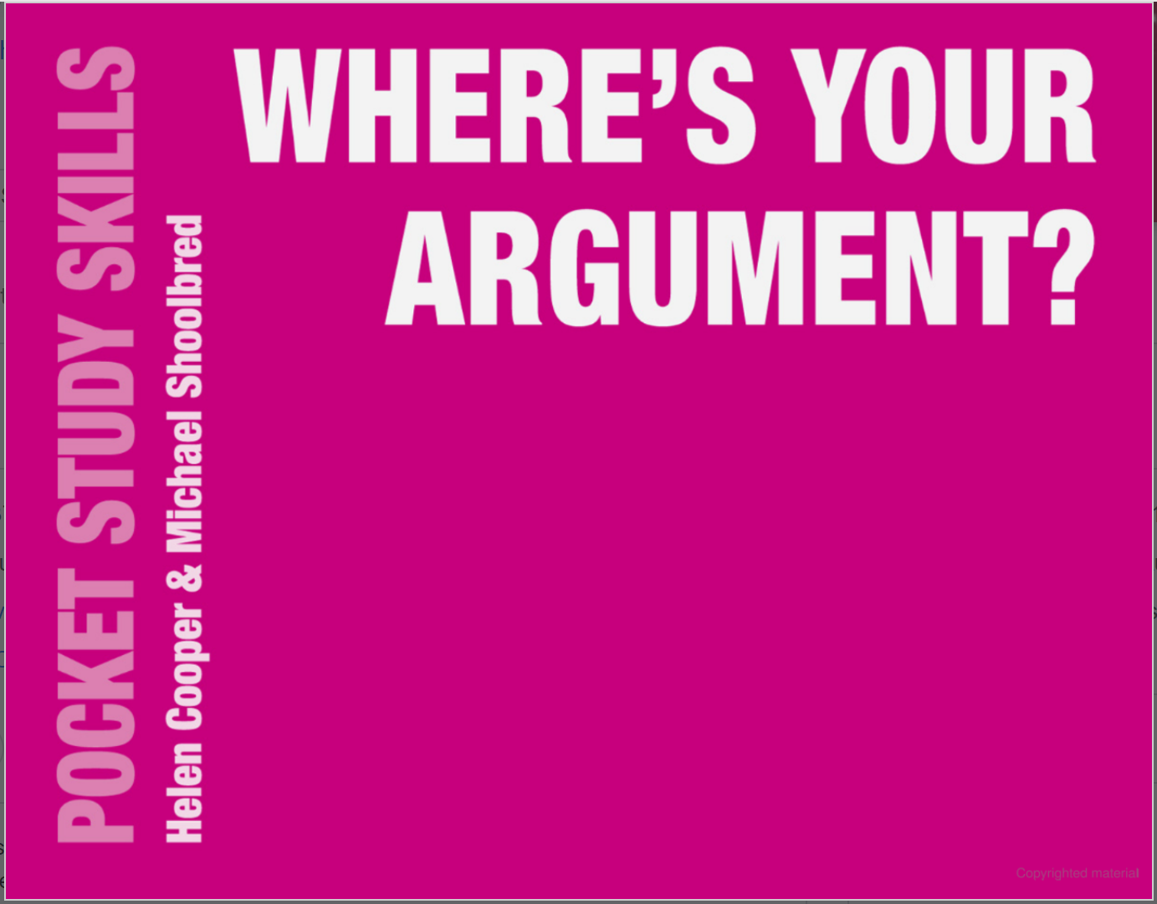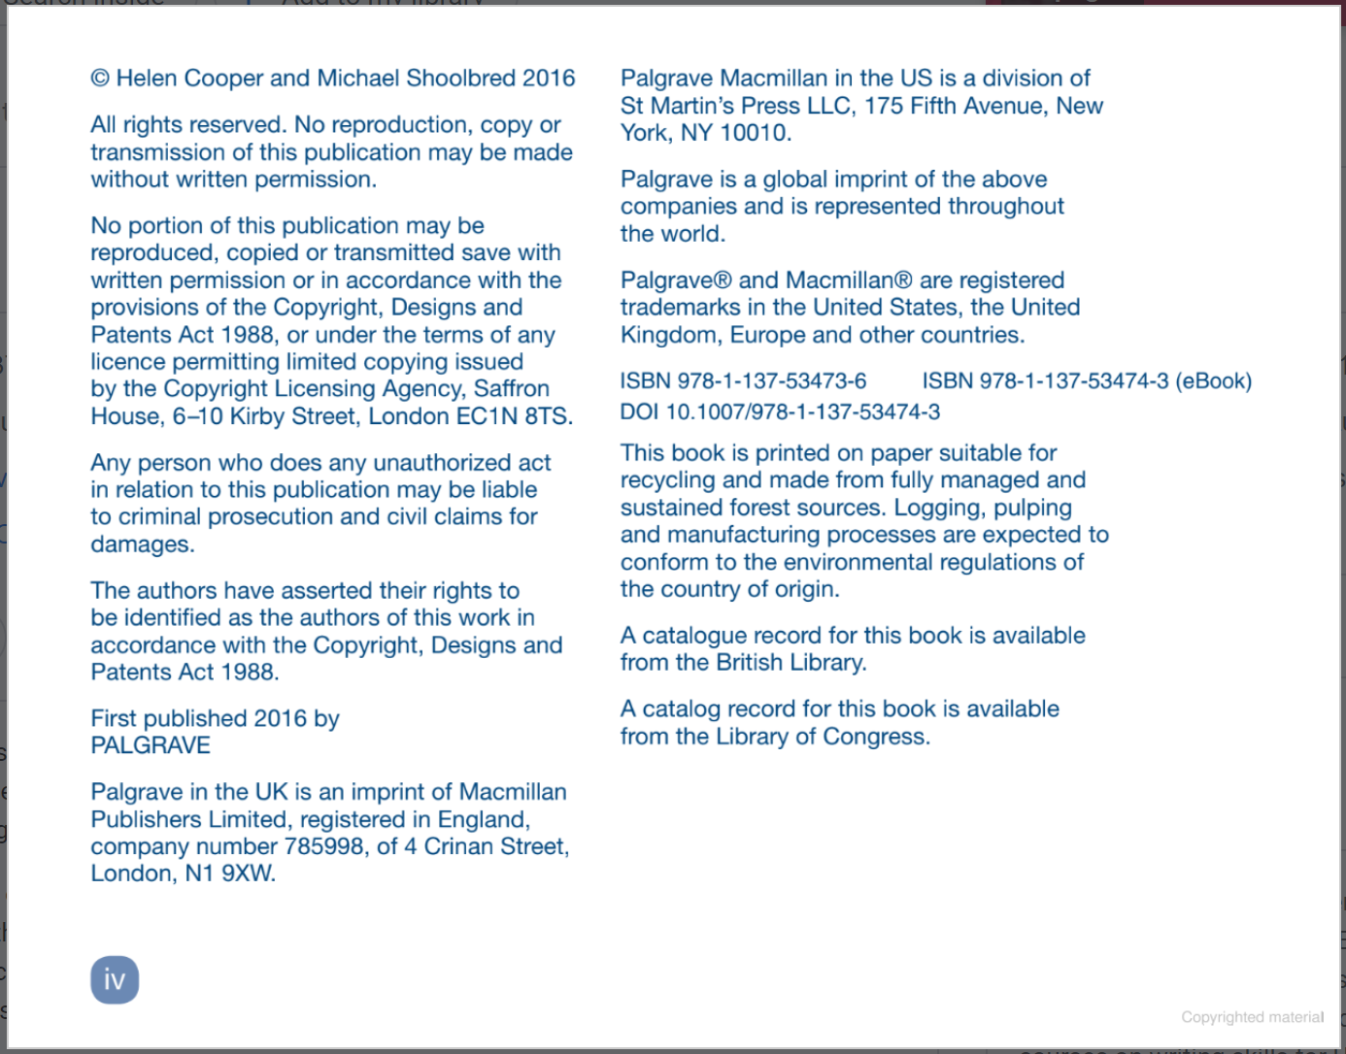

Citation: 1. (Cooper and Shoolbred, 2016) 2. Cooper and Shoolbred (2016)
Reference: Cooper, H. and Shoolbred, M. (2016) ‘Where’s your argument?’. London: Palgrave.
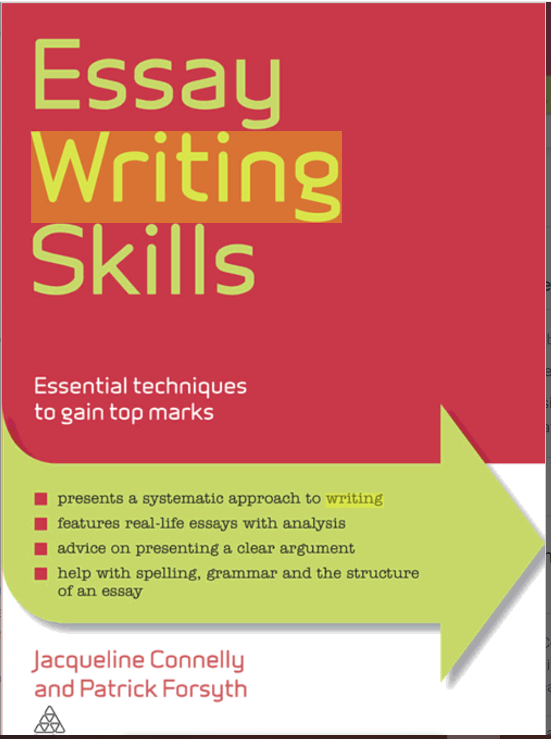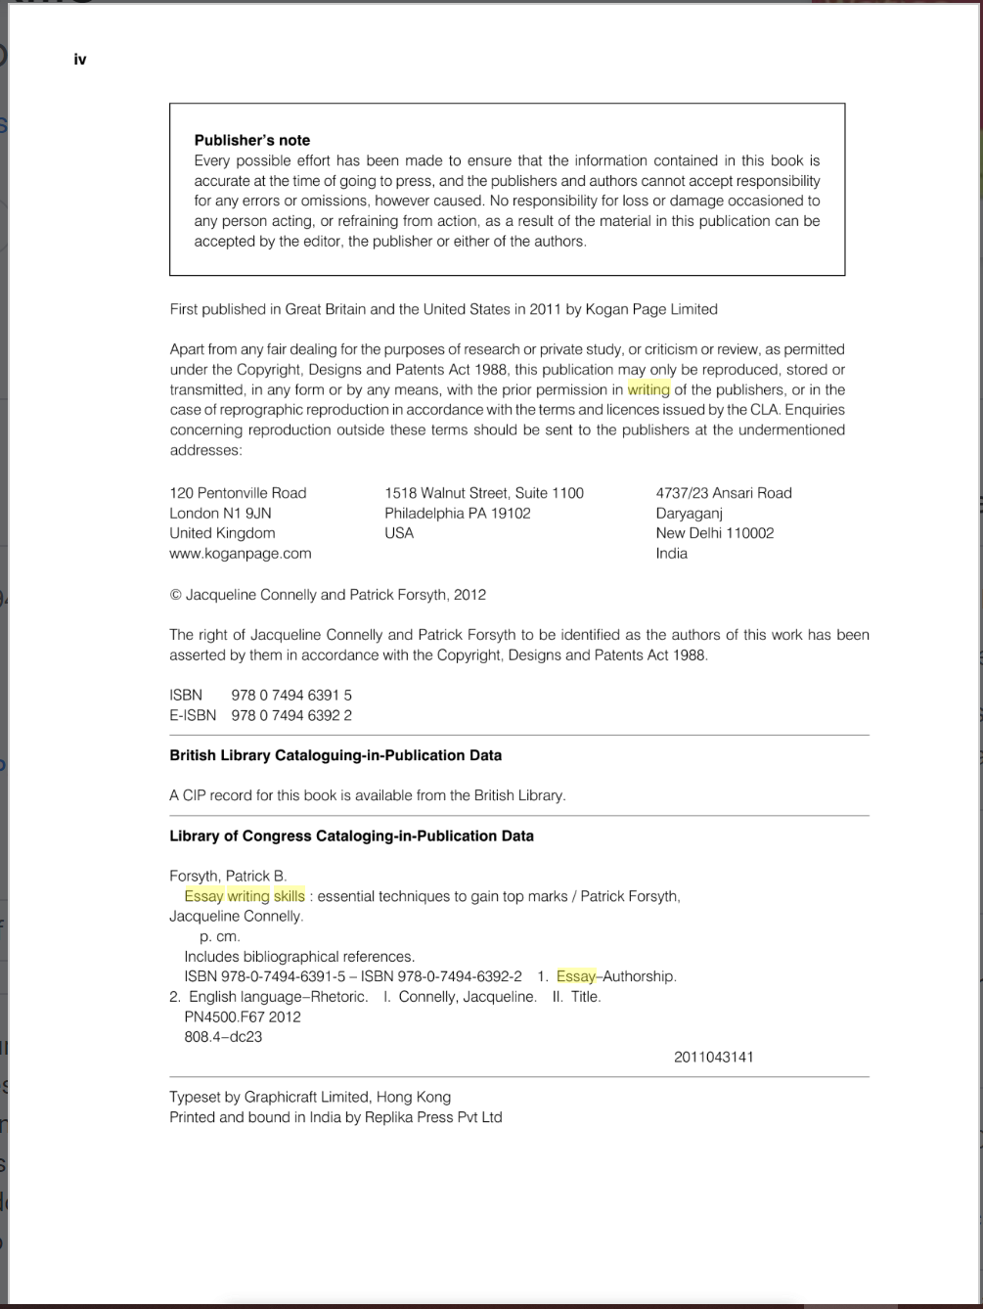
Citation: 1. (Connelly and Forsyth, 2011) 2. Connelly and Forsyth (2011)
Reference: Connelly, J. and Forsyth, P. (2011) ‘Essay Writing Skills’. Great Britain and United States: Kogan Page Limited

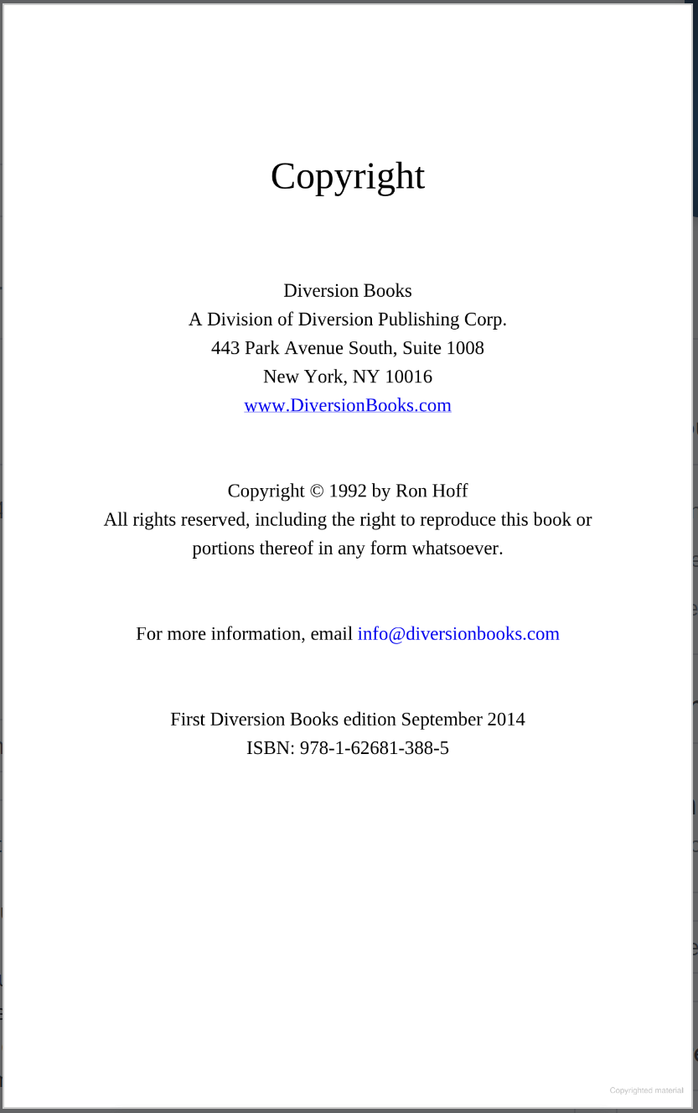
Citation: 1. (Hoff, 1992) 2. Hoff (1992)
Reference: Hoff, R. (1992) ‘I can see you naked’. New York: Diversion Books
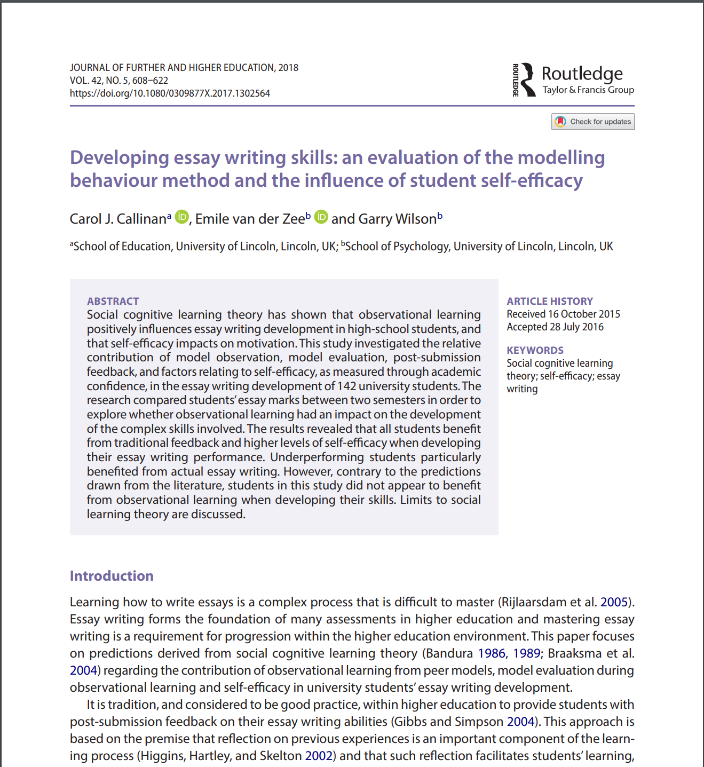
Citation: 1. (Callinan, Van der Zee and Wilson, 2018) 2. Callinan, Van der Zee and Willson (2018)
Reference: Callinan,C. Van der Zee, E and Wilson, G (2018) Developing essay writing skills: an evaluation of the modelling behaviour method and the influence of student self-efficacy. United Kingdom: Taylor and Francis Group.

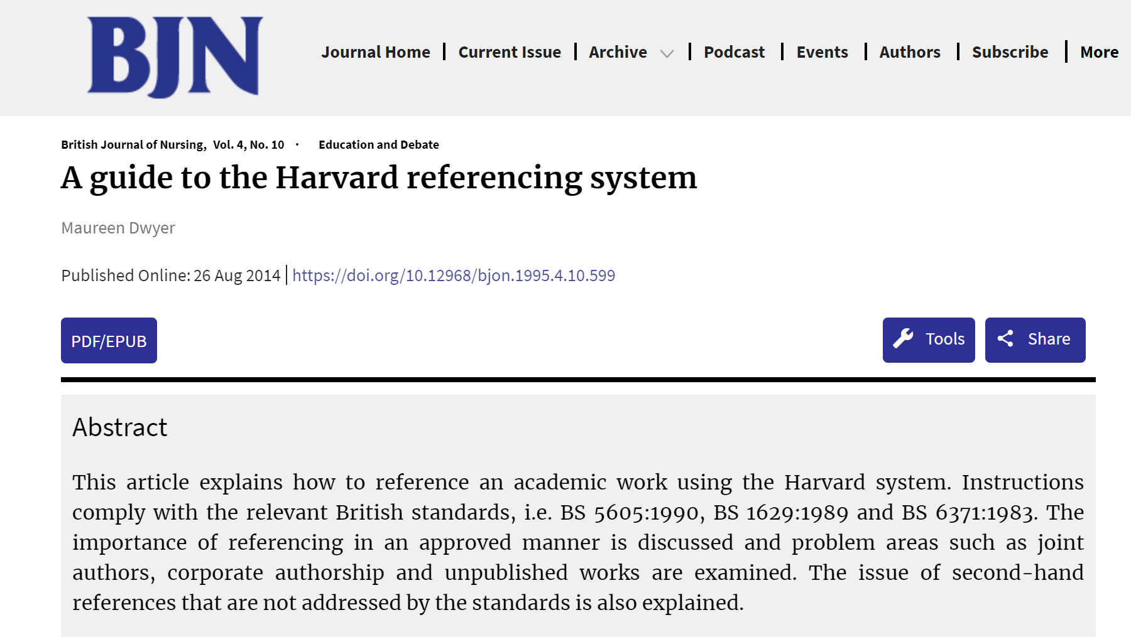
Citation: 1. (Dwyer, 2014) 2. Dwyer (2014)
Reference: Dwyer, M. (2014) ‘A Guide to the Harvard referencing system’, British journal of nursing, 4(10), pp .
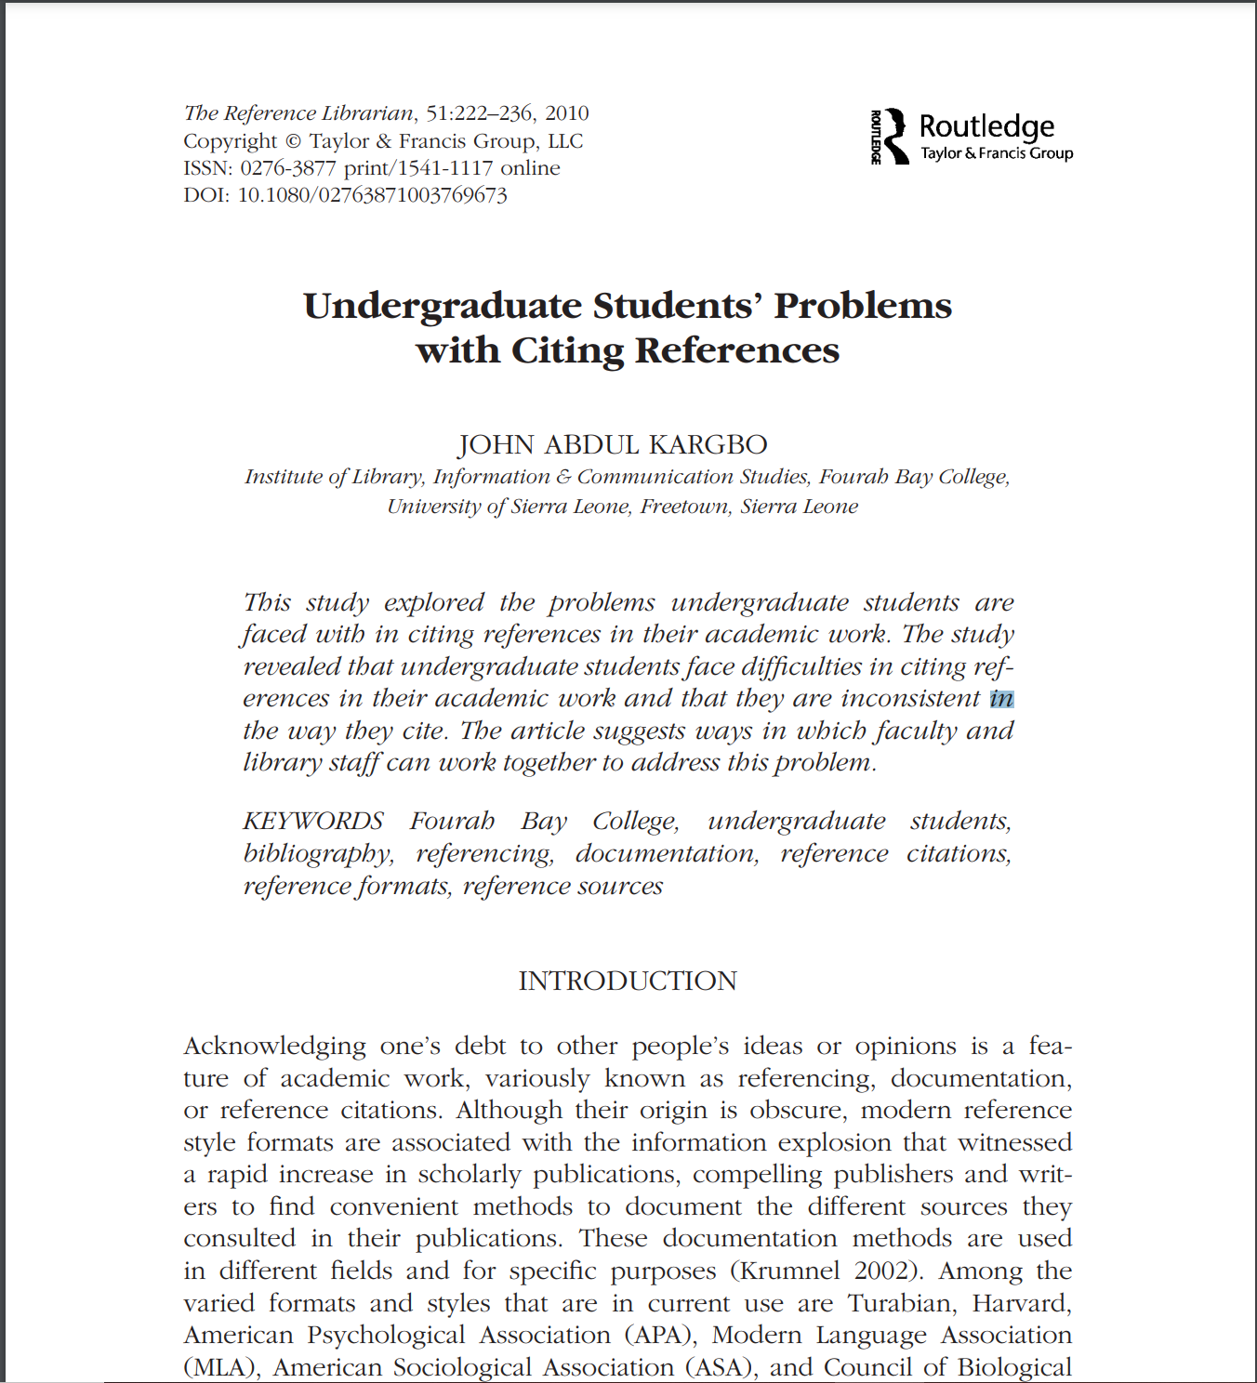
Citation: 1. (Kargbo, 2010) 2. Kargbo (2010)
Reference: Kargbo, J. (2010) ‘Undergraduate Students’ Problems with Citing References. United Kingdom: Taylor and Francis Group

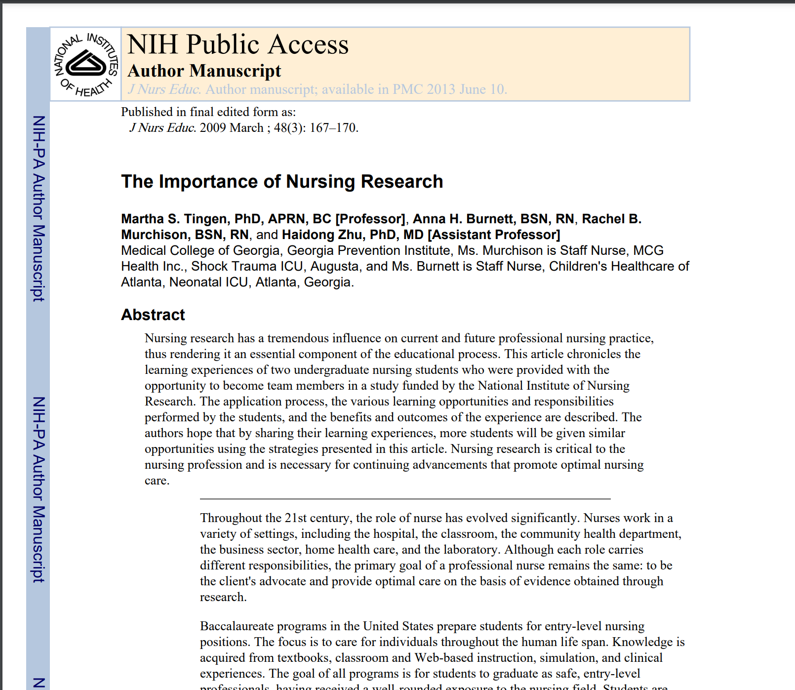
Citation: 1. (Tingen et al, 2009) 2. Tingen et al (2009)
Reference: Tingen, M. et al (2009) ‘The importance of nursing research’, NIH Public Access, 48(3), pp 167-170
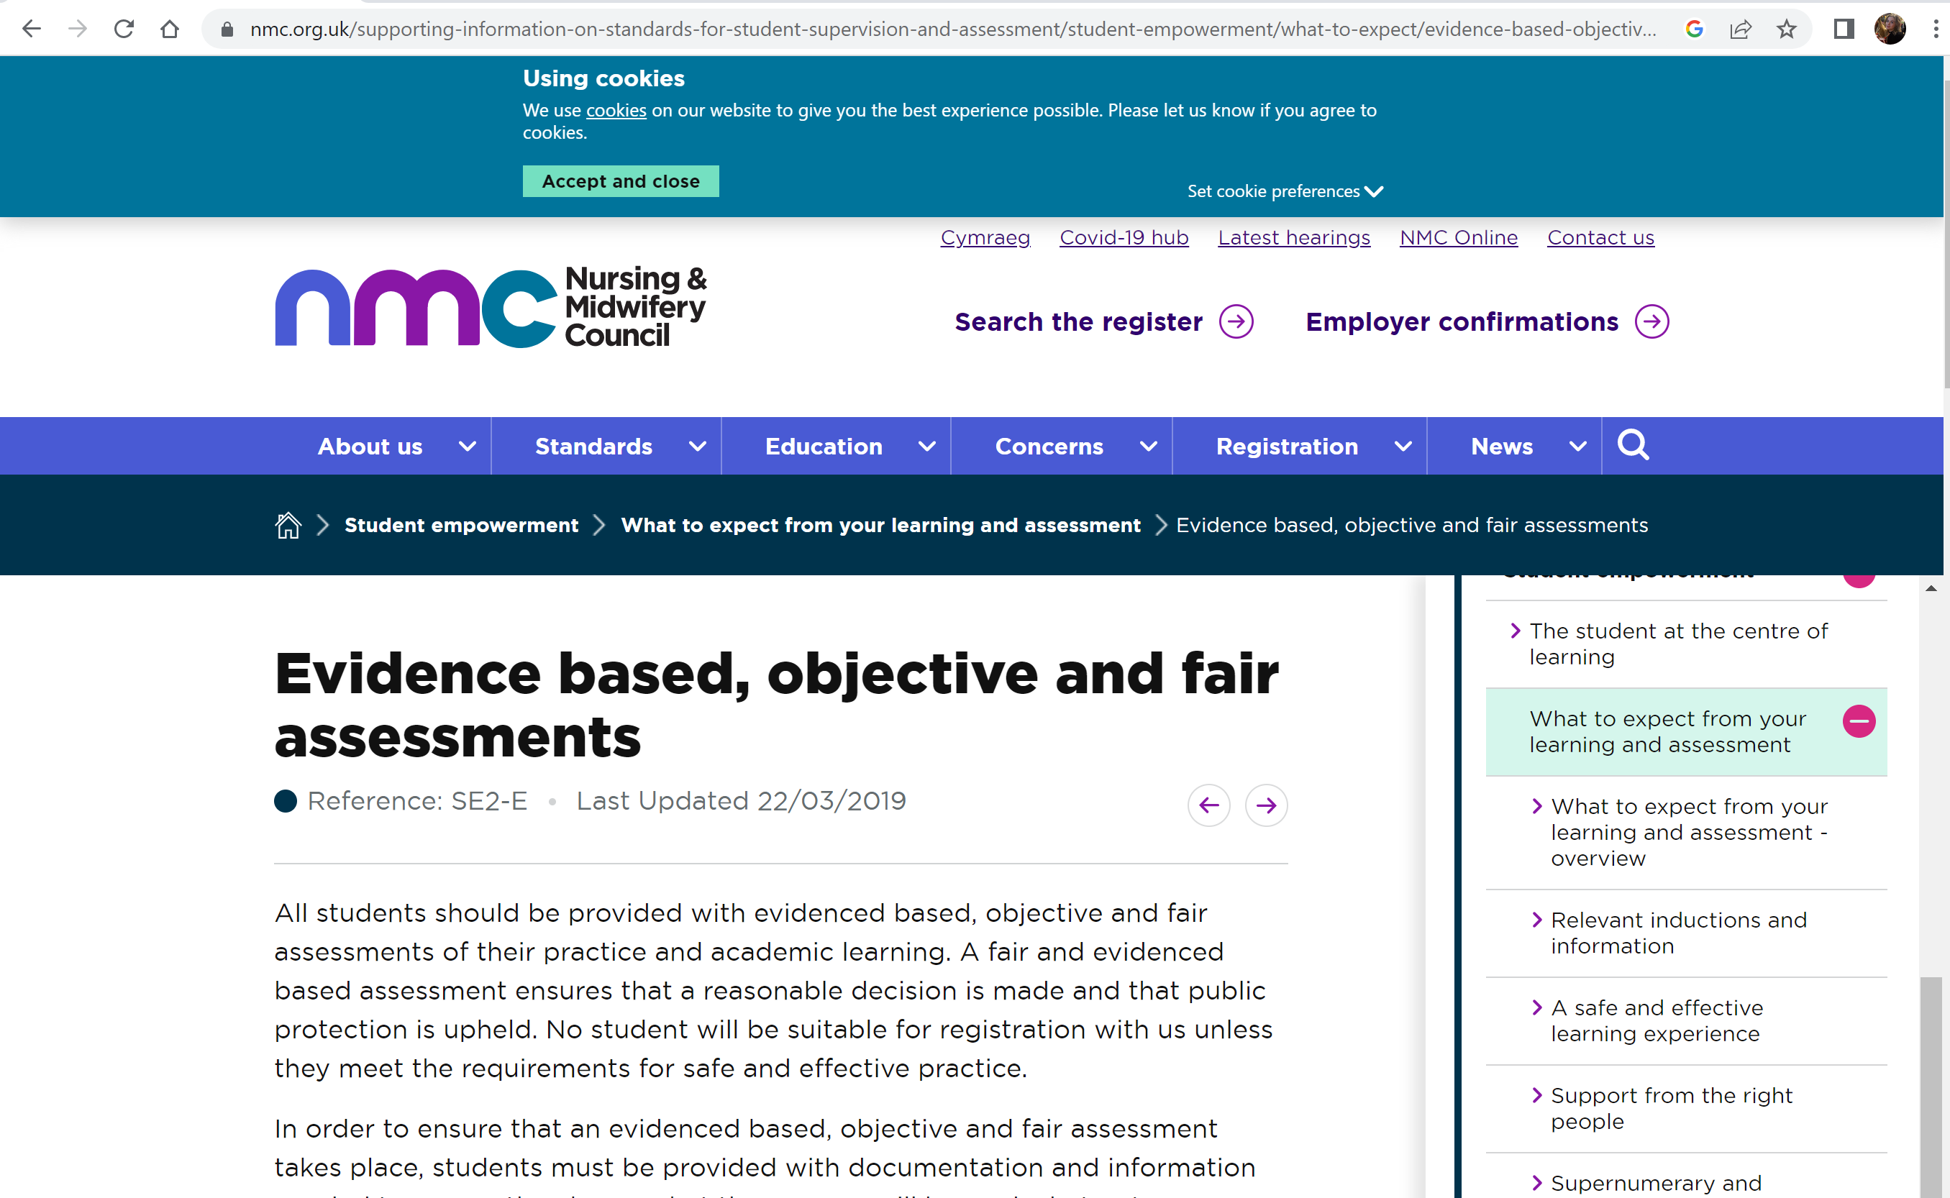
Citation: 1. (NMC, 2019) 2. NMC (2019)
Reference: NMC (2019). Evidence based, objective and fair assessments. Nmc.org.uk. Available at: https://www.nmc.org.uk/supporting-information-on-standards-for-student-supervision-and-assessment/student-empowerment/what-to-expect/evidence-based-objective-and-fair-assessments/ (Accessed 24 Sept. 2026).
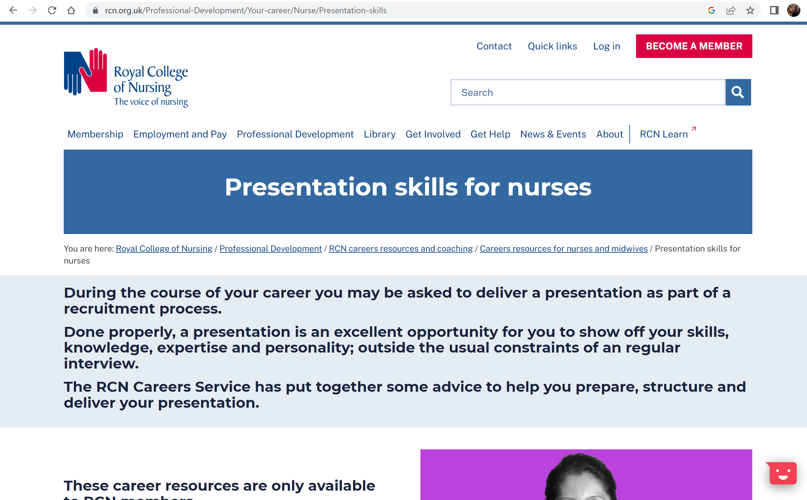
Citation: 1. (The Royal College of Nursing, 2026) 2. The Royal College of Nursing (2026)
Reference: The Royal College of Nursing. (2026). Presentation skills for nurses | Careers resources | Royal College of Nursing. Available at: https://www.rcn.org.uk/professional-development/your-career/nurse/presentation-skills (Accessed 24 Sept. 2026).

