

Assessment 1

Living with care: The older person

Student name: Aurora Copae
Student ID: 1919900
Module name: Living with care: The older person
Module code: (BMHP6009_LON)
Lecturer name: Diola Bijlhout

Contents

Introduction 3
Comparing how it feels to be an elderly person in Nigeria and in the United Kingdom 3
Statistics of the ageing population and recent changes 4
Theories of loneliness and isolation 6
Impact of loneliness and isolation on the older people living in a care setting 7
Current legislation and policies that aims to reduce loneliness and isolation within the elderly people 9
Critical comparison of the local, national and global provision of services for the older person in the UK and Nigeria 10
Local provision 10
National provision 10
Global provision 11
Examining the future prospective and the changes to be made to in the care program 11
Recommendations for improvement 12
Conclusion 13
References 14

Introduction

The following report is basically a comparison between the life of the elderly people and the care provisions as enjoyed by them in the UK and in Nigeria.
The academic report further critically evaluates the overall impact of both loneliness as well as social isolation upon most of the elderly population in these two countries. Additionally the report compares the present UK based various provisions and policies related to caring for the older people with that of Nigeria. The report further goes on to examine the required changes that needs to be undertaken in order to make the healthcare program to properly aim at addressing all the problems arising from loneliness and isolation among the elderly thus stating how technology can be an effective tool in providing provision of proper care to the lonely older persons followed by appropriate recommendations for improvement and a brief conclusion.

Comparing how it feels to be an elderly person in Nigeria and in the United Kingdom

Primary Healthcare
In the case of UK, the elderly people are thoroughly taken care of at every stage. They are also provided with regular healthcare services by the National Health Service (NHS) usually for free in most of the cases. The NHS ensures that they consistently provide the elderly people with primary care as well as acute care in the hospitals (Fakoya et al. 2018). In addition to this, intermediate care as well as preventive and public health care services like for instance screening services besides various other long-term care services are also provided. On the contrary, in Nigeria, most of the primary healthcare providers such as the nurses, care team or the doctors often face several challenges and are therefore unable to provide the elderly people with adequate healthcare and support services thus making it difficult for them to survive in the country.
Household and pension
In UK, the elderly people are provided with proper housing services along with resident warden if required. In addition to this, the life of the elderly in the UK is much simple and easy as they receive help from the local authorities who in turn receive most of their funds directly from the Central Government. Apart from these, the older people having disabilities are eligible for recieving funds directly from the Central Government (Mikulincer et al. 2021). However, the elderly people in Nigeria are mostly community residents having provision to limited institutionalised care. Unlike in the UK, they do not receive any financial support from the government through any nationalised pension system (Van Den Noortgate et al. 2022).
Psychological stress
In Nigeria, the elderly people face several challenges in regard to maintaining their overall psychological health status. Most of these challenges arise due to unprecedented changes in their family dynamics, inadequate and improper care of the healthcare workers, complete absence of elderly friendly services, growing elder abuse, absence of social security, increased economic stress etc (Freedman and Nicolle, 2020). In contrast to this, the psychological stress among the elderly population in UK is very less owing to their highly developed healthcare infrastructure and technological advances. Also, UK reportedly has almost negligible elder abuse.

Statistics of the ageing population and recent changes

The global population is rapidly ageing with nearly 900 million people who are already old and this number is growing rapidly at a rate of 3% yearly on an average (Statista. 2022). This rapid change in the population structure of both the countries has strong implications upon their well-being. Overall, UK has a highly ageing population.
Statistics of the ageing population in UK
In the United Kingdom, the total number of the ageing population is likely to rise by threefold from about 50 million in the present to about 150 million by the year 2050. There are about 12 million people above 65 years in UK (Statista. 2022). The total numbers of people who have crossed 100 years age have increased by 85% over the past two decades. By the year 2030, almost 1 in 5 people of UK will age over 65 years and the 85+ age group happens to be the fastest growing. However, the improvement in the average life expectancy is much lower in the UK than that of the EU average.
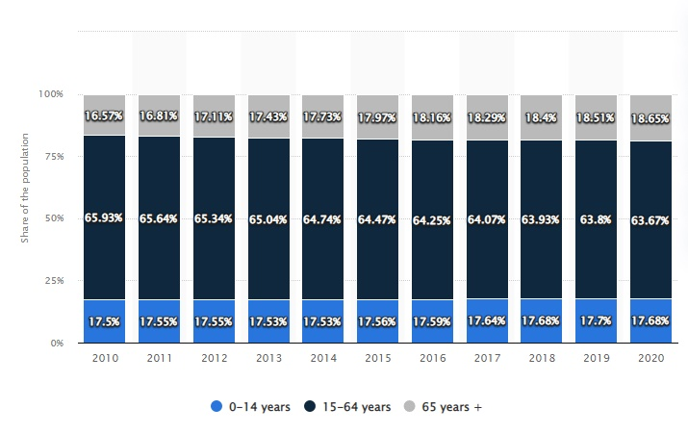
Figure 1: Ageing population in the United Kingdom
Source: Statista. 2022
Statistics of the ageing population in Nigeria
On the contrary, the number of ageing population in Nigeria is reportedly 10 million which might double in the next two decades. Nigeria's population on the whole is near to 206 million of which only 9.4 million are over 60 years (Statista. 2022). The total ageing population in Nigeria suddenly experienced a rapid increase by around 740 thousand people and this will further increase by the year 2050.
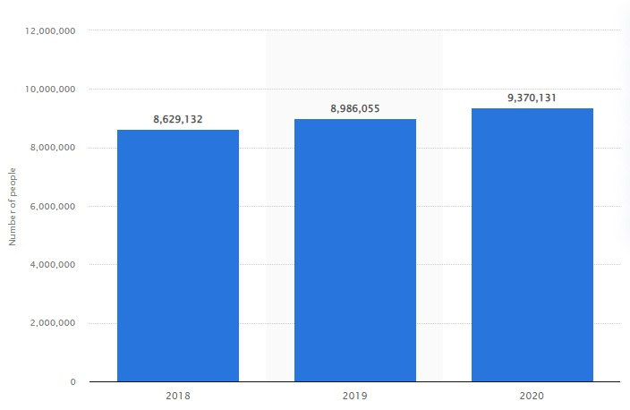
Figure 2: Ageing population in Nigeria
Source: Statista. 2022

Theories of loneliness and isolation
Both isolation and loneliness are entirely different but are related to each other. The concept of loneliness maybe defined as a subjective and unpleasant feeling which mostly is the difference between the person’s expected degree of social interaction to their actual degree of social contact in reality (Fakoya et al. 2020). Nevertheless, loneliness is not at all desired by anyone and lowering such feelings can often take a huge amount of time. On the contrary, social isolation maybe referred to as an objective measure regarding the degree of social contact which a person has. It is more about the overall quantity rather than the quality of their existing relationships. Most often, the elderly people might prefer to stay isolated by choosing to have fewer contacts.
Attachment theory
Loneliness if becomes persistent might result in a widespread negative effect upon the overall well-being and the quality of life of an individual. According to the Attachment theory of loneliness if the six major social needs such as attachment, nurturance, social integration, sense of reliability, proper guidance during difficult times and reassurance regarding worth remain unmet then it might give rise to a feeling of loneliness amongst the elderly (Poscia et al. 2018). In Nigeria, most of the elderly people have reported that they feel lonely. Such feelings often develop into critical health problems such as increased mortality rate resulting due to increased chronic diseases, lowering of functional ability as well as degrading mental health. Elderly people often feel lonely when they cannot open up to others giving them an unpleasant feeling about their existence.
Social control theory
The social control theory of isolation holds that social isolation often leads to harmful patterns among the elderly people. For instance, in the UK, social isolation is often correlated with increased social anxiety, shyness, hostility, more sadness as well as lower self-esteem among the elderly (Wang et al. 2018). This slowly hampers the ability of an individual to interact socially thereby reporting a significant lack of intimacy with their close friends or near ones.

Impact of loneliness and isolation on the older people living in a care setting
Impacts physical and mental well being
Most of the elderly people are particularly vulnerable to increased loneliness as well as social isolation. Both of these can take a serious toll upon health as they strongly involve unpleasant and negative feelings regarding one’s overall social life or sense of belonging thereby giving way to significant reduction in their overall physical as well as mental well-being causing depression.
Results in high morbidity and mortality rates
However it is highly possible that an elderly person within a care setting might often feel lonely despite not being physically alone. Both of these act as crucial risk factors thereby resulting in high morbidity as well as high mortality rates owing to lack of proper exercise, psychological stress, obesity as well as high blood pressure (Berg-Weger and Morley, 2020).
Decreased resistance to diseases
In addition to this, a feeling of loneliness within a care setting results in a decreasing will to survive among the older people. Often this is associated with a declining resistance to various infections as well as cognitive decline and deteriorating mental health conditions giving way to dementia or severe depression.
Long term illnesses
Isolation in the care setting is directly linked to several long-term illnesses among the elderly people. Studies suggest that people who feel lonely and isolated despite being among a proper healthcare setting often question their worth and existence and therefore slowly enter into a sphere where they suffer from several long-term illnesses such as increase in blood pressure, cardiac arrests etc (Odetola et al. 2020).
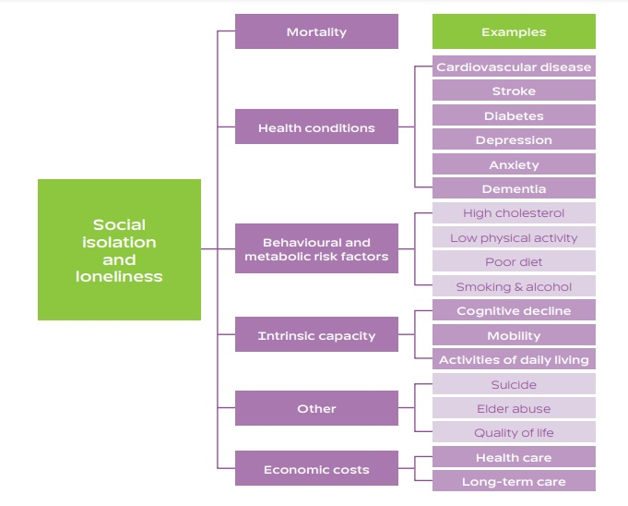
Figure 3: Impact of social isolation and loneliness upon the older people living in a care setting
Source: Berg-Weger and Morley, 2020

Current legislation and policies that aims to reduce loneliness and isolation within the elderly people

UK legislation and policies
United Nations Decade of Healthy Ageing
The ongoing decade i.e. 2021–2030 in the UK is regarded as the decade of healthy ageing where the healthcare professionals are working tirelessly to decrease social isolation as well as loneliness globally thus aiming to at offer the elderly people with an unique opportunity to live happily (Keating, 2022). This is being done by bringing together different governments as well as the civil society, various international agencies and professionals etc in a collaborative manner so as to improve the overall lives of the older people and their families as well as the communities where they live.
UNGA Open-ended Working Group for the Purpose of Strengthening the Protection of the Human Rights of Older Persons
This is an open-ended working group which was founded with the aim of increasing awareness regarding social isolation as well as loneliness as significant public health issues and moral, human rights.
LinkAge, Bristol
This programme in particular aims to enhance and promote the overall lives of the older people in the UK who are above 55 years of age by facilitating the development of various activities (Mikulincer et al. 2021). It further fosters social awareness thereby encouraging the elderly people to openly share their thoughts and skills with other people. LinkAge specifically aims to highly inspire the elderly people to socialize with others so that they do not feel isolated. Their goal is to improve the overall physical and mental health of the older people through several activities as well as enhanced social connectedness.

Healthy ageing program
Funds were raised by the UK government and the Healthy ageing program was launched in the year 2018 to combat the problem of loneliness (Şahin et al. 2019). This program aims to help the elderly people to happily live within their homes and feel wanted and valued thereby battling loneliness and increasing their wellbeing.
Nigerian legislation and policies
Cognitive behavioral therapy
A huge variety of different face-to-face as well as digital interventions are developed by the Nigerian government in order to strategically handle the issues of growing loneliness and social isolation amongst the elderly people. These mainly include various social skills training as well as community or support groups and a cognitive behavioral therapy. However, Nigeria still lacks behind in comparison to the UK as they still need to create more promising age-friendly communities so that they can help to reduce the problems of social isolation and loneliness. Additionally, more policies and laws needs to be formulated that can foster improved social connection.

Critical comparison of the local, national and global provision of services for the older person in the UK and Nigeria

Local provision
This mostly includes the healthcare services as provided by the local governing bodies or communities in the respective areas. Considering the case of the United Kingdom and that of Nigeria, the local care services in the United Kingdom is much more developed and technologically advanced as compared to that in Nigeria. This can be justified by the fact that there does not exist any noteworthy local community in the healthcare services for the elderly in Nigeria whereas Age UK is one such local community which is striving tirelessly in order to provide the elderly people with life-enhancing services as well as vital support all across the UK (Shirahada et al. 2019). Together with their local partners, Age UK delivers a wide variety of healthcare services thus improving the overall life condition and well being of the elderly people.

National provision
The NSF or National Service Framework for Older People in the UK is known to set the quality for maintaining standards related to the health as well as social care thus helping the older people to remain healthy and active besides staying independent for as long as possible (Macdonald et al. 2018). NSF ensures that the elderly people in UK are being treated with due respect. They also aim to prevent any unnecessary hospital admission thus working to decrease the rate of long term illness through specialist care. On the contrary, the Yemi Age Nigeria foundation aims to promote and boost healthy lifestyles for the elderly people in Nigeria by raising resources to be used in times of need (Tanyi et al. 2018).

Global provision
The global provisions are applicable all across the world i.e. to the elderly people residing in the UK as well as in Nigeria. One such global provision is the Integrated care for older people as introduced by the World Health Organization (WHO) in order to focus upon the needs and goals of the older people as well as follow an integrated clinical care system (Şahin et al. 2019). World Health Organization further introduced a health system in alignment with the above provision to make it easier for them to integrate proper care for the older people by technologically developing their health infrastructure, vaccines and implementing advanced technologies in their working procedures and systems.

Examining the future prospective and the changes to be made to in the care program

Restructure the care team
It is important to regularly restructure and align the teams who support the physicians in order to successfully treat the elderly people. Additionally the core workflows as well as the operational procedures need to be adjusted as per the requirement. Teams should be trained to work together in a coordinated manner for providing the elderly people with warmth, affection and organized care as per their changing needs (Shirahada et al. 2019). It is important to ensure that everyone in the team is well equipped about their role no matter how small or big.
Technological advancement
As a society or a country evolves, so does its healthcare requirement and procedures. Therefore, in order to evaluate the future prospective and changes that are needed in the care system, several factors come into play while implementing or enforcing the necessary change. Of these, the most important are the technological and environmental factors which significantly contribute to the changes in the care system. Similarly DNA chip technology and genetic fingerprinting are the two technologies which have a strong scope in the care program in the upcoming future owing to their ability to help resolve the various ongoing issues (Bayramzadeh and Aghaei, 2021). Other technological advancements in terms of electronic technology might help to boost the overall efficiency of the care program in the long run.
Educate the healthcare providers
Along with the ongoing policies and technological changes, all those people who are associated with providing healthcare services to the elderly people are also changing. There exists a huge future prospective for these healthcare providers as they play a crucial role in the healthcare system. It is important to effectively modify and upgrade their education and work experience so that they can positively impact how the patients receive care (Şahin et al. 2019). With more and more technological improvement, the information regarding the care for the elderly people will also improve.

Recommendations for improvement
- Conducting comprehensive assessments: It is recommended to focus on strengthening comprehensive assessments as they form an integral part while taking care of the elderly people (Odetola et al. 2020). In Nigeria, the local communities should focus on formulating appropriate strategies or communities that help to reduce elderly abuse thus helping the aged people to live peacefully.
- Setting care goals together with the elderly people: It is important that the elderly people feels wanted and valued. This can be effectively done by making them an important part the decision-making procedure and goal setting so that they do not feel isolated or lonely (Berg-Weger and Morley, 2020). It will also help to get a clarity regarding the older person’s special needs or preferences.
- Developing and using well developed integrated care plans: It is important that both UK and Nigeria develops proper care plans which focuses upon improving the overall physical and mental well being of the older person by considering their goals and then relating how the various sectors of the healthcare will be involved in planning a follow-up or reassessment. This care plan basically will function as a roadmap to evaluate the progress of the elderly people in the long run.
- Providing the elderly people with a regular as well as consistent follow-up: For reducing the problems of growing loneliness and social isolation among the elderly, it is important that they are actively involved in day to day activities. In Nigeria, small local communities can monitor the progress of the elderly thus providing the additional support when required.

Conclusion
In conclusion it can be stated that Nigeria lacks far behind the United Kingdom when it comes to taking proper care of the elderly people. There are many cases of elder abuse in Nigeria as compared to that in the United Kingdom. In addition to this, there exists no local or national provision to reduce isolation and loneliness among the older people in Nigeria. Thus it is important that both Nigeria and the UK upgrade their care system in order to boost the overall well being of their ageing population in the long run.

References
Bayramzadeh, S. and Aghaei, P., (2021) ‘Technology integration in complex healthcare environments: a systematic literature review’, Applied ergonomics, 92, p.103351.
Berg-Weger, M. and Morley, J.E., (2020) ‘Loneliness and social isolation in older adults during the COVID-19 pandemic: Implications for gerontological social work’, The journal of nutrition, health & aging, 24(5), pp.456-458.
Fakoya, O.A., McCorry, N.K. and Donnelly, M., (2020) ‘Loneliness and social isolation interventions for older adults: a scoping review of reviews’, BMC public health, 20(1), pp.1-14.
Fakoya, O.O., Abioye-Kuteyi, E.A., Bello, I.S., Oyegbade, O.O., Olowookere, S.A. and Ezeoma, I.T., (2018) ‘Determinants of quality of life of elderly patients attending a general practice clinic in Southwest Nigeria’, International Quarterly of Community Health Education, 39(1), pp.3-7.
Freedman, A. and Nicolle, J., (2020) ‘Social isolation and loneliness: The new geriatric giants: Approach for primary care’, Canadian Family Physician, 66(3), pp.176-182.
Keating, N., (2022) ‘A research framework for the United Nations Decade of Healthy Ageing (2021–2030)’, European Journal of Ageing, pp.1-13.
Macdonald, S.J., Nixon, J. and Deacon, L., (2018) ‘Loneliness in the city’: Examining socio-economics, loneliness and poor health in the North East of England’, Public Health, 165, pp.88-94.
Malcolm, M., Frost, H. and Cowie, J., (2019) ‘Loneliness and social isolation causal association with health-related lifestyle risk in older adults: a systematic review and meta-analysis protocol’, Systematic reviews, 8(1), pp.1-8.
Mikulincer, M., Shaver, P.R. and Gal, I.,(2021) ‘An attachment perspective on solitude and loneliness’ The handbook of solitude: Psychological perspectives on social isolation, social withdrawal, and being alone, pp.31-41.
Odetola, T.D., Akintayo-Usman, N.O., Okorie, B.N., Afolabi, T.A. and Oluwatosin, A.O., (2020) ‘ Life Satisfaction Assessment of Elderly Living in Geriatric Homes: Case Study of a Geriatric Home in Ibadan, Nigeria’, African Journal of Biomedical Research, 23(3), pp.335-341.
Poscia, A., Stojanovic, J., La Milia, D.I., Duplaga, M., Grysztar, M., Moscato, U., Onder, G., Collamati, A., Ricciardi, W. and Magnavita, N., (2018) ‘Interventions targeting loneliness and social isolation among the older people: An update systematic review’, Experimental gerontology, 102, pp.133-144.
Şahin, D.S., Özer, Ö. and Yanardağ, M.Z., (2019) ‘Perceived social support, quality of life and satisfaction with life in elderly people’, Educational Gerontology, 45(1), pp.69-77.
Shirahada, K., Ho, B.Q. and Wilson, A., (2019) ‘Online public services usage and the elderly: Assessing determinants of technology readiness in Japan and the UK’, Technology in Society, 58, p.101115.
Statista (2022) Nigeria: old population 2018-2020 | Statista. (online). Available at: https://www.statista.com/statistics/1260772/elderly-population-in-nigeria/ (Accessed 29 July 2022).
Statista (2022) United Kingdom - Age distribution 2020 | Statista. (online). Available at: https://www.statista.com/statistics/270370/age-distribution-in-the-united-kingdom/ (Accessed 29 July 2022).
Tanyi, P.L., André, P. and Mbah, P., (2018) ‘Care of the elderly in Nigeria: Implications for policy’, Cogent Social Sciences, 4(1), p.1555201.
Van Den Noortgate, N.J. and Van den Block, L., (2022) ‘End-of-life care for older people: the way forward’, Age and Ageing, 51(7), p.afac078.
Wang, J., Mann, F., Lloyd-Evans, B., Ma, R. and Johnson, S., (2018) ‘Associations between loneliness and perceived social support and outcomes of mental health problems: a systematic review’, BMC psychiatry, 18(1), pp.1-16.

