

Radio Frequency Device Detection System
By Henry Rennison 2218326

Supervisor: Dr Stephen Mosey
Second Marker: Jenifer Prince Devaraj

Project submitted as part of the requirements for the award of
BEng (Hons) Embedded Electronic Systems Design

July 2024

Table of Contents
Introduction 3
Project Overview 3
Aims 3
Objectives 3
Background Research & Literature Review 4
Potential Devices to Detect 4
Research & Development Methodology 4
Development Methodology 4
Software Selection 4
Time Management 7
Build Phase 8
Difficulties Encountered 8
GUI Testing Results 8
Evaluation 9
Conclusion 9
Future Recommendations 9
Reflection 10
Lessons Learnt 10
References 10
Bibliography 11
Reading List 11
Appendices 11
Appendix A 13
Appendix B 21
Appendix C 24
Appendix D 29
Appendix E 31
Appendix F 60
Appendix G 72
Appendix H 76
Appendix I 81
Appendix J 83

Table of Figures
Figure 1 - Gantt Chart – Project Time Management 7
Figure 10 - GUI Testing 8

Table of Tables
Table 1 - Programming Language Comparison [10] 4
Table 3 - SDR Comparison 5
Table 8 - Bill of Materials 5

Introduction

Project Overview
This project details the development of a Radio Frequency (RF) electronic device detection system for use in security scenarios such as school exam halls or prisons. The system aims to counter surveillance techniques used by those with malicious intent; reducing the risk of policy violations and electronic communication in restricted areas; and the risk of contraband items being accidentally carried into sensitive areas; such as cellular devices or other internet of things (IoT) devices.

Aims
Our project aims to determine:
Whether RF Transmission sources can be detected using a low-cost system manufactured from Commercial Off the Shelf (COTS) components
and
Whether Software Defined Radios can be used to implement real-time detection of electronic devices

Objectives
In order to satisfy these aims, the following objectives have been set:
- Background Research - Scoping of a RF detection system design
- Design - Development of an Initial Prototype to prove the design concept
- Implementation - Manufacture of a Final System Build that can be shown to our customer in a laboratory demonstration
- Analysis and Quality Assurance - Characterisation of prototype systems detection range
- Review – Discussion with customer to gain feedback that can be acted upon

Background Research & Literature Review
This section details the background research and literature reviewed during the group project, coving the topics of Legality, Ethics, Spectrum Allocation, SDR Usage and Existing Detection Methods.

Potential Devices to Detect
RF threat detection is a critical aspect of security and surveillance in modern environments. It involves identifying and mitigating unauthorized or potentially harmful RF signals that could compromise security, privacy and operational integrity. Below is a list of common RF threats, their typical frequencies, and the potential impacts they pose:
Eavesdropping Device - 10 MHz - 1 GHz
Signal Jamming - GPS: 1.575 GHz (L1), 1.227 GHz (L2), Cellular: 850 MHz, 900 MHz, 1800 MHz, 1900 MHz, 2100 MHz, Wi-Fi: 2.4 GHz, 5 GHz
RF Hacking and Cyber Attacks: Wi-Fi: 2.4 GHz, 5 GHz, Bluetooth: 2.4 GHz, RFID: 125 kHz, 13.56 MHz
Rogue Access Points - 2.4 GHz, 5 GHz
RF threats span a wide range of frequencies. RF threat detection and mitigation require a thorough understanding of the frequency characteristics of each threat type, along with advanced detection technologies.

Research & Development Methodology

Development Methodology
The main benefit of this system is its cost compared to other devices on the market. [6] This was one of the main goals of the device as the intended use is for schools and prisons. This is important as several devices would be needed. It also helps if any components stop working they would be very cheap to replace.
Possible draw backs of using cheap components can be their reliability. When deciding to use to cheaper components to keep costs down it is about weighing up the negatives and positives. In this system design if any of the parts do break they are easy to replace.
While there are benefits to using cheaper components, it is essential to balance cost savings with quality. Over-reliance on low-cost components can lead to durability issues or negatively impacting customer satisfaction. Therefore, careful selection and quality control are crucial to ensuring that cost savings do not come at the expense of product performance and reliability.

Software Selection
Programming Language
The three most used programming languages are Python, Java and JavaScript. Refer to Table 1, a brief overview of the key features of each one.
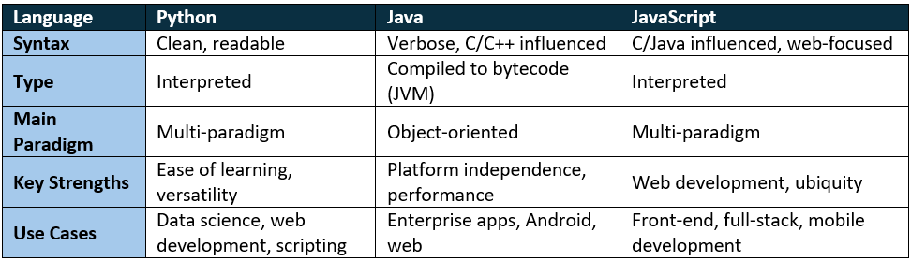
Table 1 - Programming Language Comparison [10]
In this report the language selected was Python for the following reasons [10]:
- Ease of Learning: Ideal for beginners due to its simple syntax.
- Versatility: Used in web development, data science, artificial intelligence, automation, scientific computing, and more.
- Rapid Development: Facilitates quick prototyping and development cycles.
- Support: With python being such an established programming language there is lots of support for it.
- Cross platform Compatibility: Python code can run on various operating systems (Windows, macOS, Linux) without modification, making it a versatile choice for cross-platform development.
Software Defined Radio (SDR)
HackRF is a hardware platform designed for Software Defined Radio (SDR). HackRF operates over a wide frequency range, typically from 1 MHz to 6 GHz. This makes it suitable for a wide variety of applications, including AM/FM radio, GSM, Bluetooth, Wi-Fi, and more. [17] This is very useful for this project as we will need to scan a wide range of RF devices. HackRF connects to a host computer via USB, allowing it to be controlled and powered by the computer. This makes it easy to use with a variety of SDR software. The hardware design and software for HackRF are open-source, allowing users to modify and improve the device as they see fit.
Adalm PlutoSDR, is a versatile SDR platform developed by Analog Devices. PlutoSDR is a transceiver, meaning it can both transmit and receive signals. This makes it a flexible tool for developing and testing wireless communication systems. PlutoSDR connects to a host computer via a USB 2.0 interface, which provides both data and power. [18]
RTL-SDR (Realtek Software Defined Radio) is an affordable SDR platform based on the RTL2832U chipset. Unlike some more advanced SDRs, RTL-SDR is a receive-only device. It cannot transmit signals, which makes it suitable for monitoring and listening applications rather than two-way communication. [19]
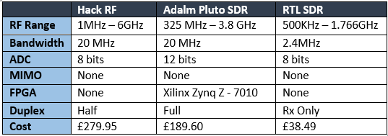
Table 3 - SDR Comparison
Table 8 - Bill of Materials
Budget for System Build
It was agreed with our customer that the budget for the system build would be £1000 per unit. The total costs of our BoM is £824.88, making this system design financially viable against the customer requirement.

Time Management
Figure 1 show a Gantt chart produced to schedule the development of the RF detection system. This supports effective time management, illustrating the project phases and provides a followable framework to ensure project deliverables are met within the dictated timescales. [22] This project management method also acts as a useful tool for stakeholder engagement; allowing them to monitor progression and clearly see when tasks are due to be completed.
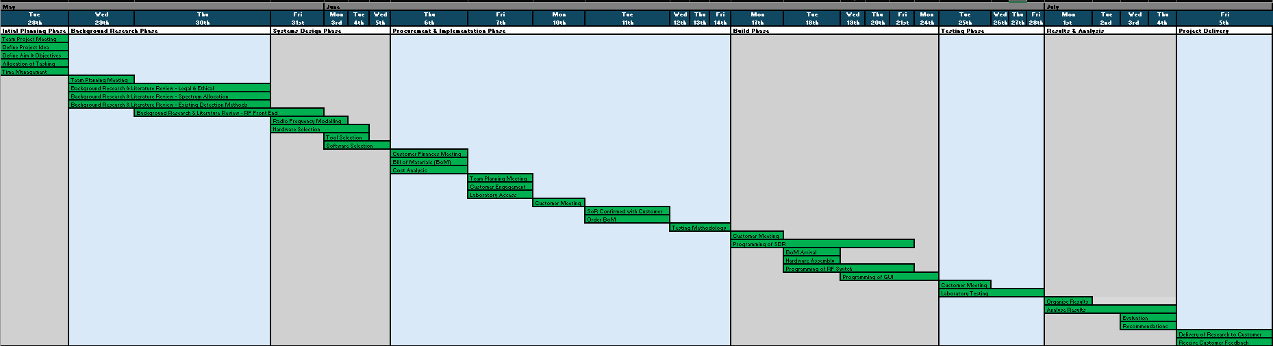
Figure 1 - Gantt Chart – Project Time Management

Build Phase

Difficulties Encountered
During this project a multitude of difficulties were encountered. Procurement issues occurred when RF Switch, SDR and Directional Antennas ordered failed to arrive from Digikey UK. The initial order was accepted on the 17th June, yet components did not arrive before our submission deadline.
This procurement issue was highlighted to the customer. We overcame this issue by repurposing similar components supplies we had stocked prior for research and RF development. However, these had to be released by Central stores; having its own unique challenges with access complications and 48-hour notice periods causing unnecessary delays.
Another significant difficulty is that of not being able to install the dependencies required to run the Pluto SDR using Ubuntu 24.04 LTS. This was firstly due to the ‘Pip’ package manager being discontinued due to Ubuntu policy issues – not being compatible with the Pi5. A workaround was to create a virtual environment, in which enables pip to be used, however we observed that the Pluto SDR drivers are unsupported, only being supported up to Ubuntu 22.04 LTS ‘Jammy Jellyfish’. This older OS version is not supported by the Pi 5, therefore we overcame this problem by using a Raspberry Pi 4B with an Ubuntu 22.04 LTS image.

GUI Testing Results
The GUI was created in python using guizero, guizero is a Python library designed to make it easy to create simple graphical user interfaces (GUIs) [25]. Initially code was created to make two boxes that are green. One on the left of the display and one on the right, each box signifies an antenna. The boxes were programmed to stay green until it picked up a frequency above a certain threshold which would then trigger the box to go red to signify a device is active in the antennas range. The image below shows that one of the antennas has picked up a device and the other has found no devices while sweeping.
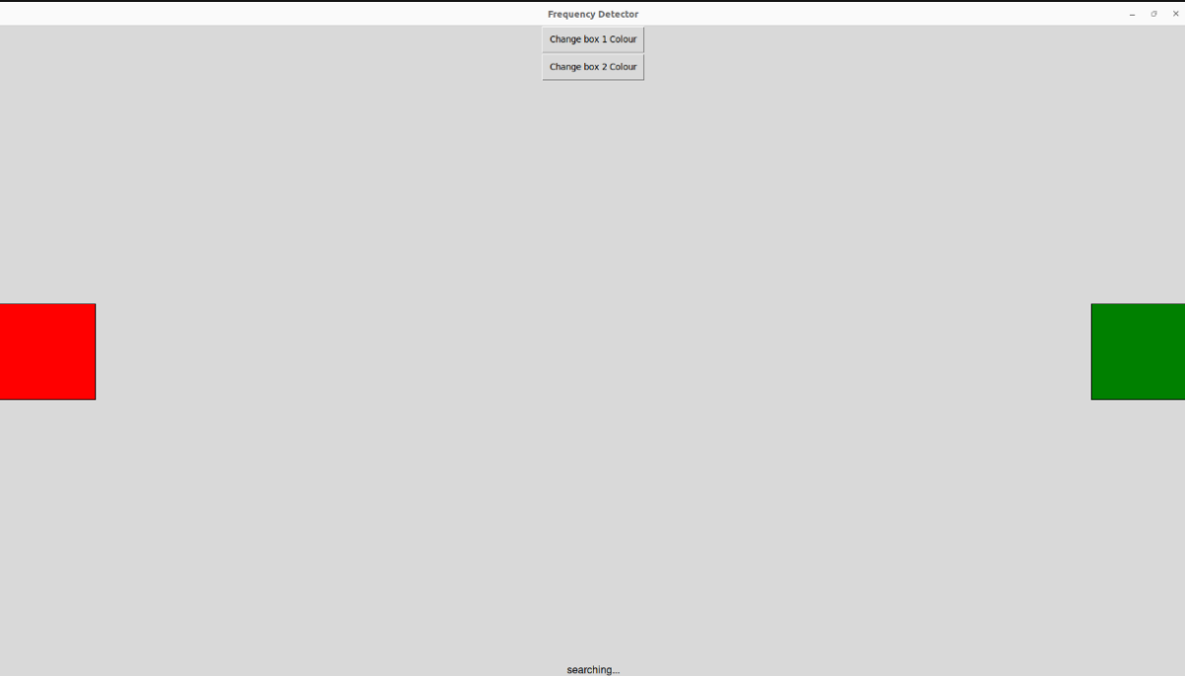
Figure 10 - GUI Testing
The initial code was tested by adding simple buttons that manually do a sweep of the antennas and then change colour accordingly. The latest version of the code does this automatically as soon as the code is run and will update frequently.

Evaluation
User Requirements Check
Comparing back to the original user requirements, the device is able to detect a transmitter from within a range of at least 20 metres, output this information to a human machine interface via a graphical user interface as well as the Linux terminal. It is then able to provide an indication of RF transmission direction. Therefore, the device meets all of the KuR.
System Requirements Check
As per the essential system requirements, the device is powered by UK mains electricity, with an RF nominal impedance of 50Ω. The SDR used does not transmit at any point in time making the device completely passive with its detection. As per the BoM, the total cost was £824.88 which meets the cost requirement.
However, for the non-essential requirements – no categorisation was done as this is a highly complex process that was not achievable within the timescales given. Whilst the device is able to be moved from room to room, due to the mains powered nature a portable version was not possible. On the other hand, these were additional system requirements that were not necessary in order to meet the customer requirements.
Aims Check
Whilst improvements could be made to the system as detailed below, overall the project was able to achieve the desired aim of the project as it was a low-cost system manufactured from COTS components that utilised an SDR to implement real-time detection of electronic devices.
Conclusion & Recommendations

Conclusion
The main benefit of this work is that of providing a RF detection device at a lower price point that commercially available systems, being a more financially viable option for use in school examination hall, prison monitoring and commercially sensitive area contexts. The development of this system has potentially reduced the time taken to detect electronic devices for the customer.
Whilst the build and test process was hampered by procurement issues, once these were resolved the project continued smoothly and on-time with the timescale. Software and hardware was cooperative with the efforts of the team and all the testing was smooth and went as expected. All project team members were present and contributed towards the development throughout the process.

Future Recommendations
More optimisation could have also occurred within the software domain, in order to implement faster processing speeds and algorithms which would in turn reduce the time taken for detection to occur. This could also be achieved through the use of higher grade and more expensive processing technology although this would have to be balanced against the user cost requirement.
Whilst current the system is portable to a degree, it is still a mains powered device and cannot be taken to far from UK mains powered. A more portable battery powered system could be developed which would result in a wider range of potential use cases.

Reflection

Lessons Learnt
Reflection – Molly Scarlet
Reflection – Henry Rennison
After completing the project, I can say that on a personal level I have improved my background knowledge in RF and programming languages and what programming languages to apply in particular scenarios. In Particular I created a GUI for the first time in python from start to finish. I have also gained a lot of knowledge of SDRs and their use cases.
I also was part of project planning which involved working out timescales and budgets for the project as well as meeting the customer to make sure we get the customer needs before starting the project so that I had a clear end goal for the project.
If I was to change anything about the project or steps that were taken it would be to do with the procurement side as this was the biggest struggle. I think the simplest way to improve this side of things would have been to order the equipment much earlier or if it was for a very important project with strict deadlines ordering two of everything from different suppliers to increase the chances of all the kit arriving in a timely manner.

References
ethical-approval [accessed Jul. 02, 2024]

[10] C. M. Simple, “Top 3 Programming Languages To Learn in 2021,” Geek Culture, Jul. 07, 2021. [Online] Available: https://medium.com/geekculture/top-3-programming-languages-to-learn-in-2021-7b2b41dc7484 [accessed: Jun. 20. 2024]

[17] M. Ossmann, “Hack RF One Software Defined Radio” in Greatscott Gadgets, 2009 [Online] Available: https://greatscottgadgets.com/hackrf/one/ [accessed Jun. 25 2024]

[18] Analog Devices Inc, “Adalm-Pluto” in Software-Defined Radio Active Learning Module, 2024, [Online] Available: https://www.analog.com/en/resources/evaluation-hardware-and-software/evaluation-boards-kits/adalm-pluto.html#eb-overview [accessed Jun. 25 2024]

[19] RTL-SDR, “RTL-SDR Blog V3 Datasheet”, Feb. 2018, [Online] Available: https://www.rtl-sdr.com/wp-content/uploads/2018/02/RTL-SDR-Blog-V3-Datasheet.pdf [accessed Jun. 25 2024

[25] L. Sach, “guizero: Python module to allow learners to easily create GUIs,” PyPI. , [Online] Available: https://pypi.org/project/guizero/. [accessed: Jun. 21. 2024]

Bibliography

Reading List
[A] D. J. Barrett, Efficient Linux at the Command Line, 2022, O’Reilly Media, [Online] Available: https://reconshell.com/wp-content/uploads/2022/01/Efficient-Linux-at-the-Command-Line.pdf
[B] T. Williams, EMC for Product Designers: Meeting the European EMC Directive, Jan. 1995, ‎Butterworth-Heinemann, ISBN-13: 978-0750612647
[C] W. F. Egan, Practical RF System Design, Apr. 2003, Santa Clara University, Wiley-IEEE Press, ISBN-13: 978-0471200239.
[D] D. Grini, RF Basics for Non-RF Engineers, MSP430 Advanced Technical Conference 2006, Texas Instruments Inc [Online] Available: https://www.ti.com/lit/ml/slap127/slap127.pdf?ts=1717709628871&ref_url=https%253A%252F%252Fwww.google.com%252F

Appendices
Technical Datasheets
Appendix A – Technical Datasheets & Component Pugh Decision Matrices [20][21]
Mathematical Derivations
Appendix B – RF Near Field Calculations [26][27][28]
Appendix C – RF Power Budget & Free Space Path Loss Calculations [29][30]
System Design
Appendix D – Additional Design Considerations [31]
Ethics Review
Appendix E – Application for Ethical Approval
Test Plan
Appendix F – HS&E Risk Assessment Form
Appendix G – Test Plan
Source Code
Appendix H – Source Code
Meeting Notes
Appendix I – Group Meeting Minutes
Appendix J – Customer Meeting Minutes

Appendix A


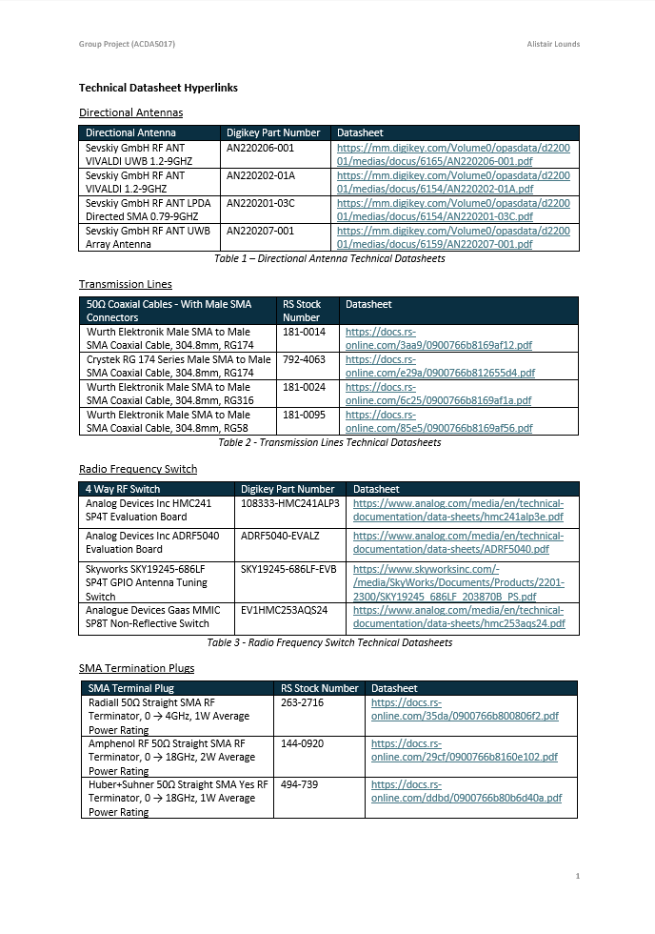
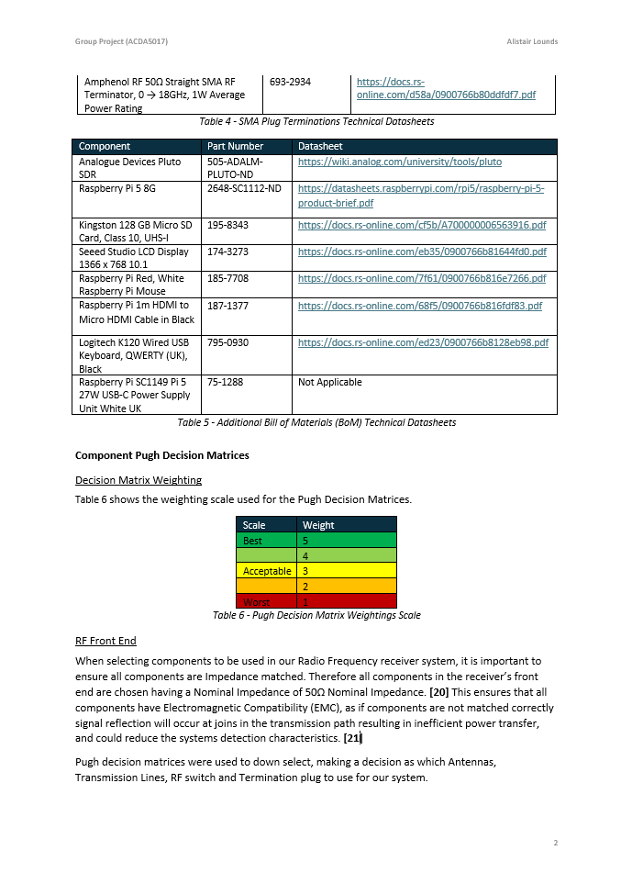

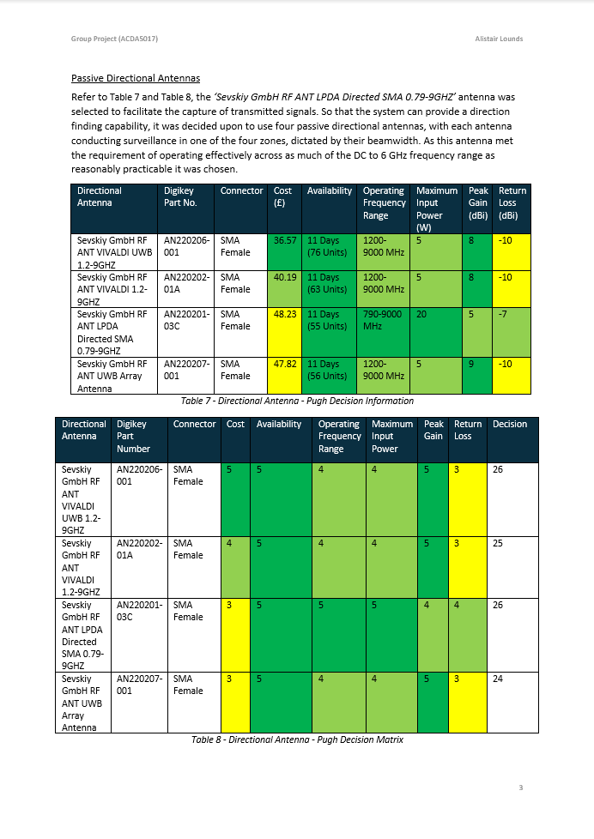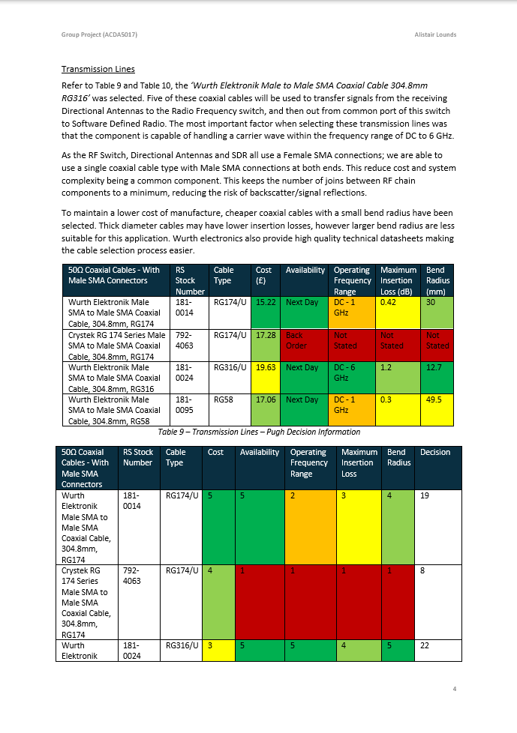
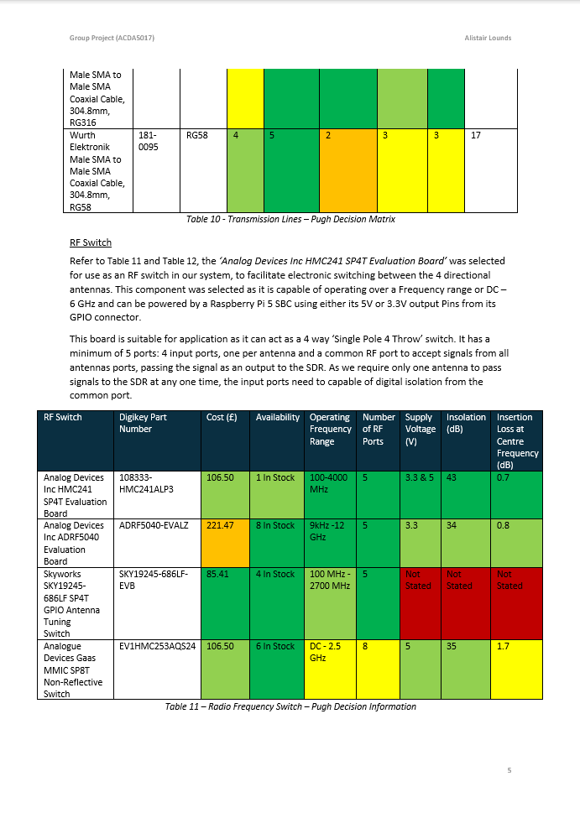
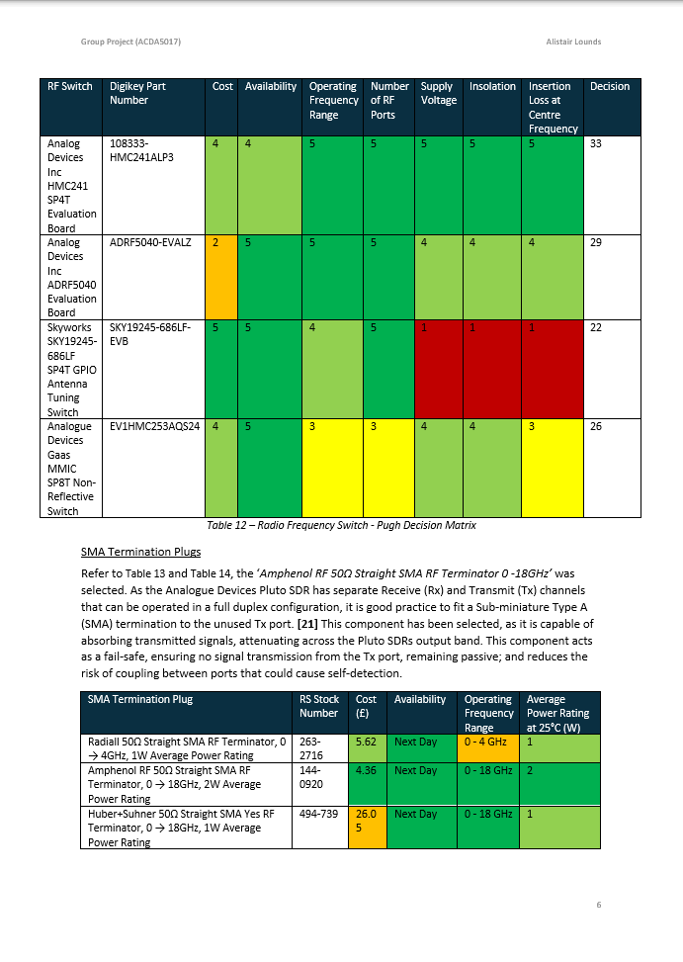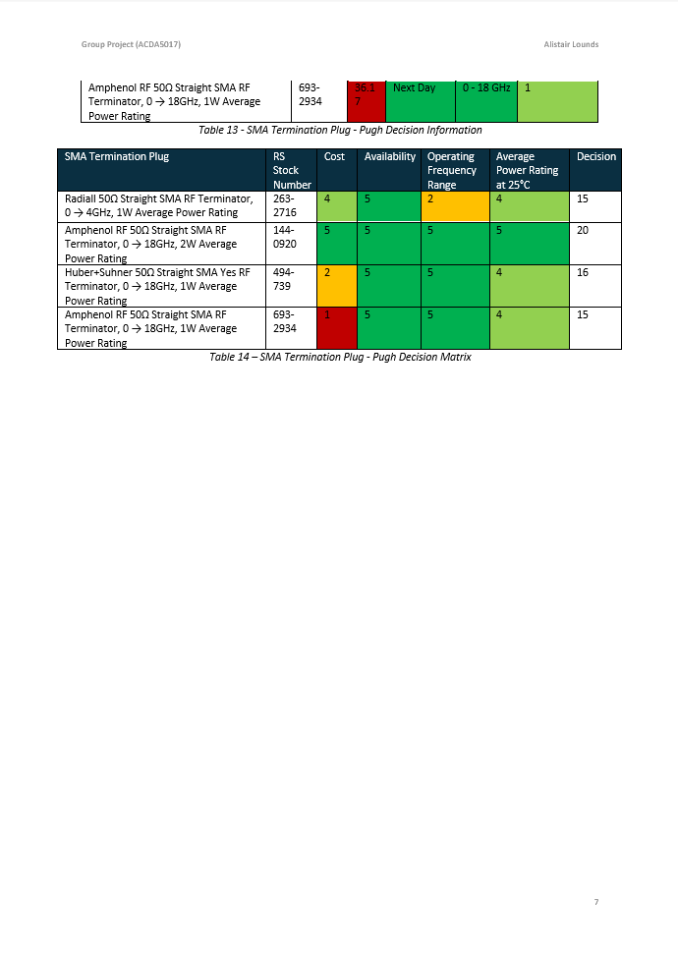

Appendix B


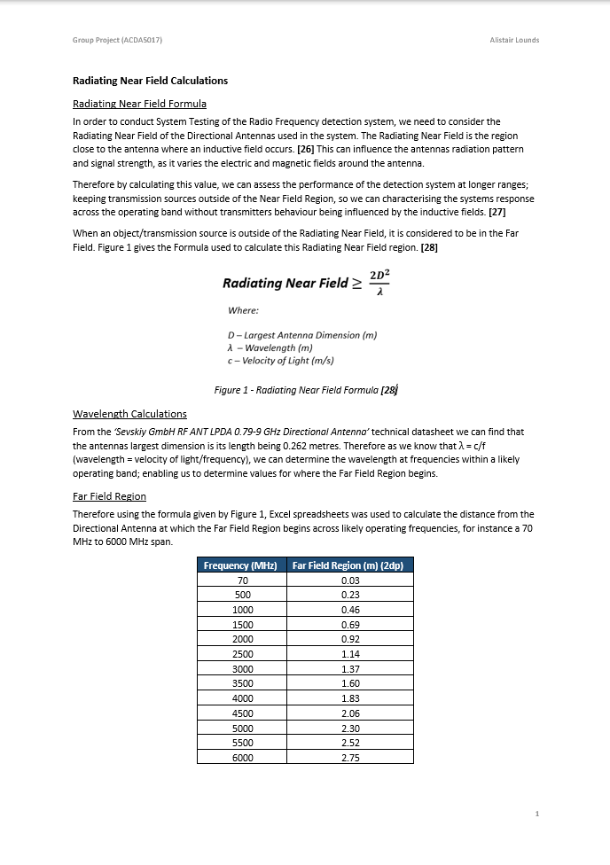

Appendix C


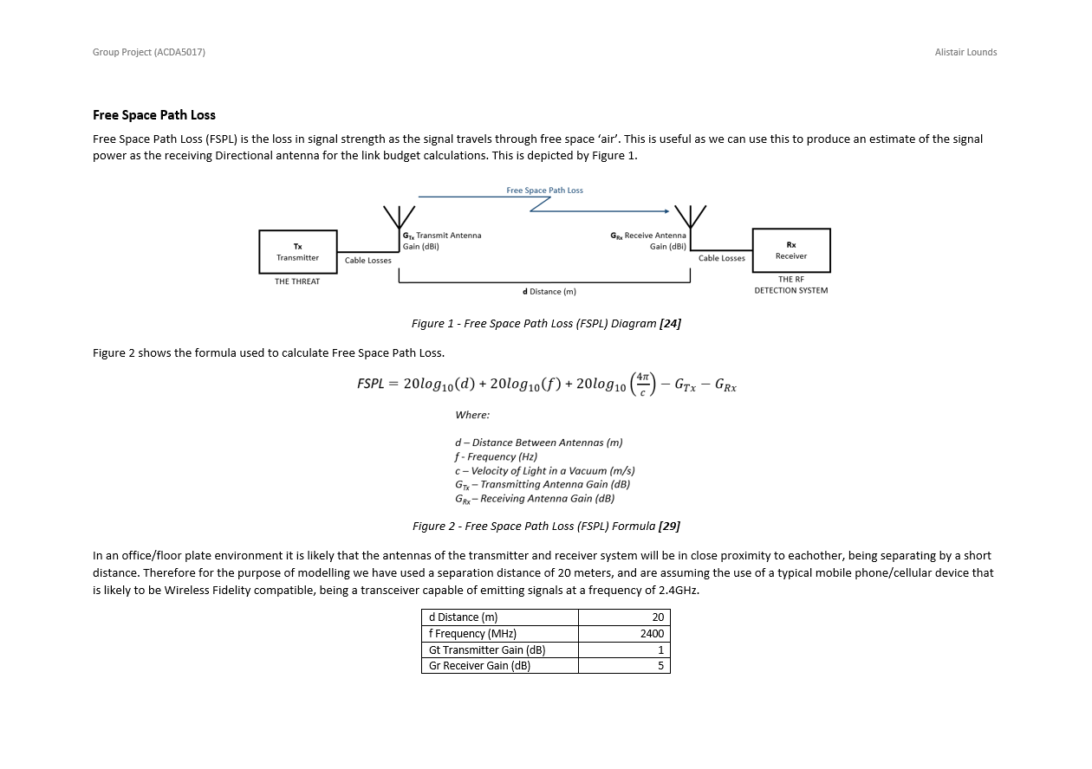
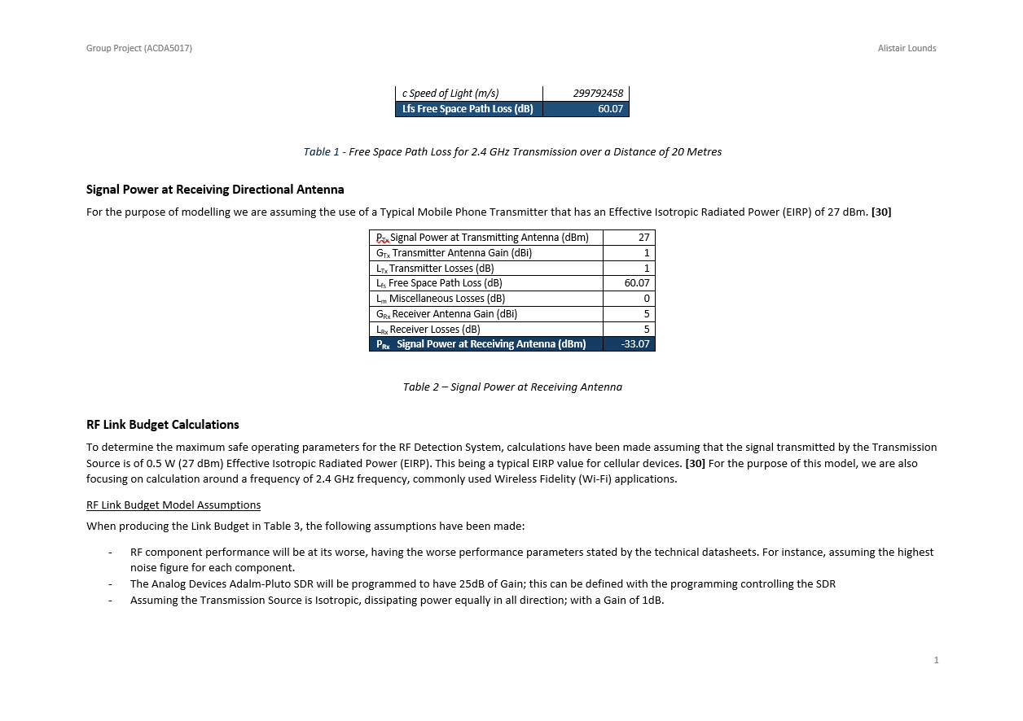
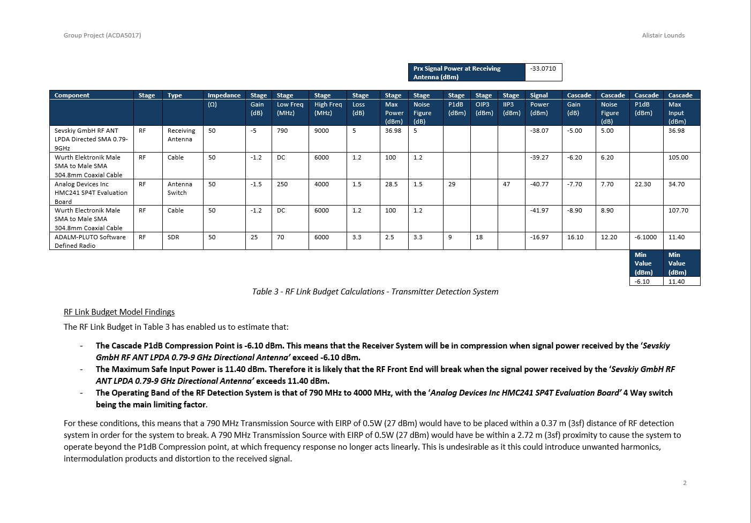
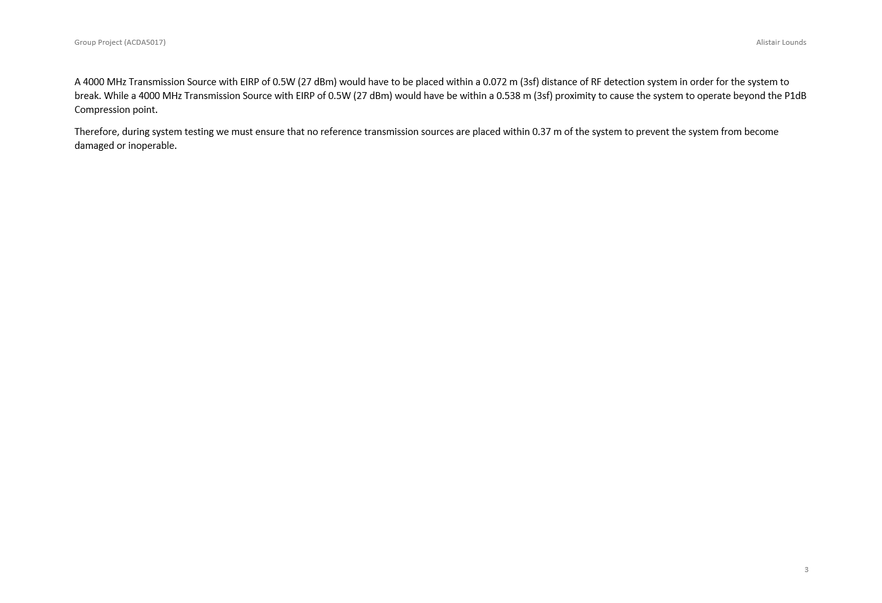

Appendix D

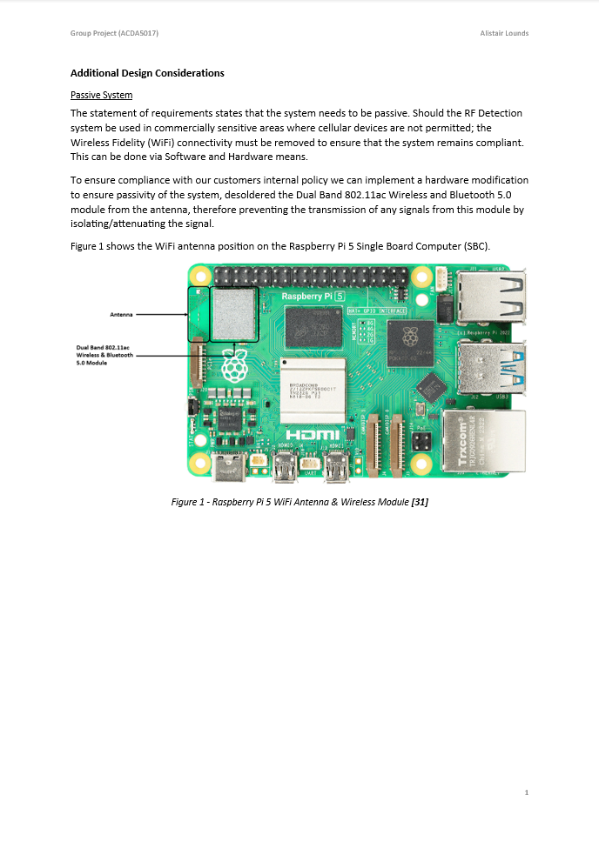

Appendix E

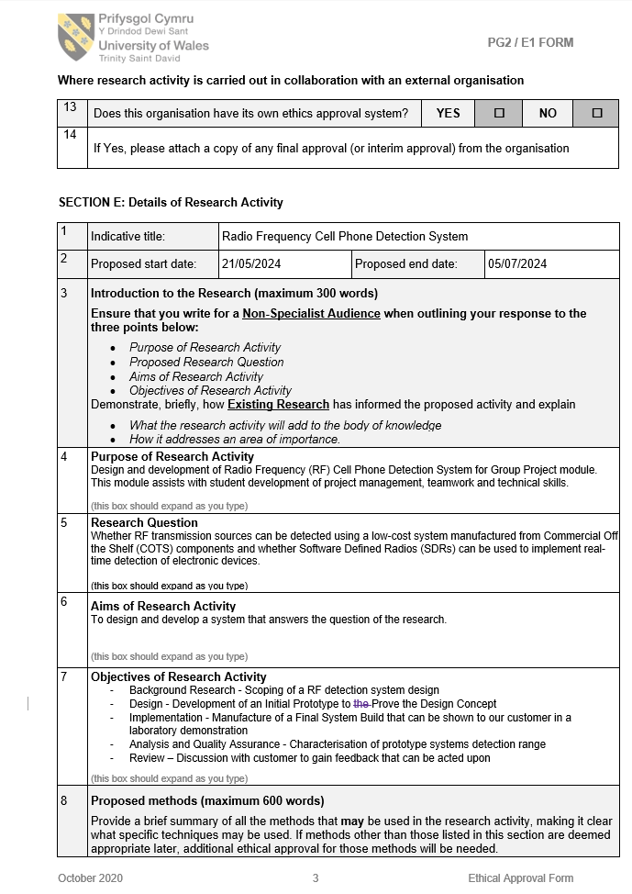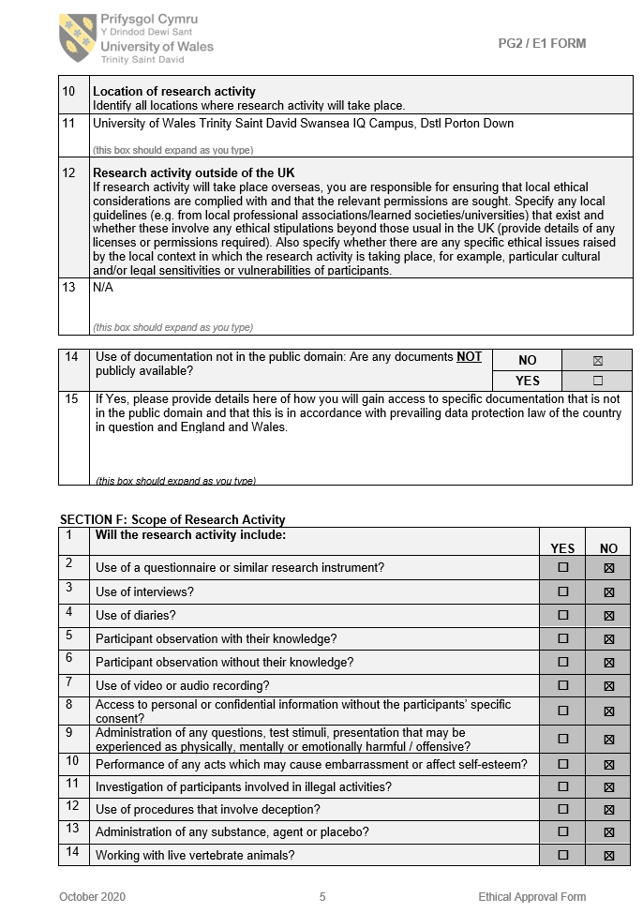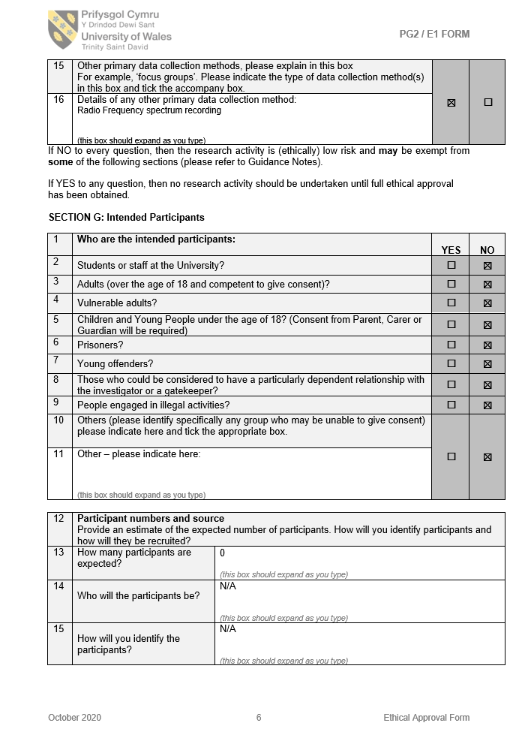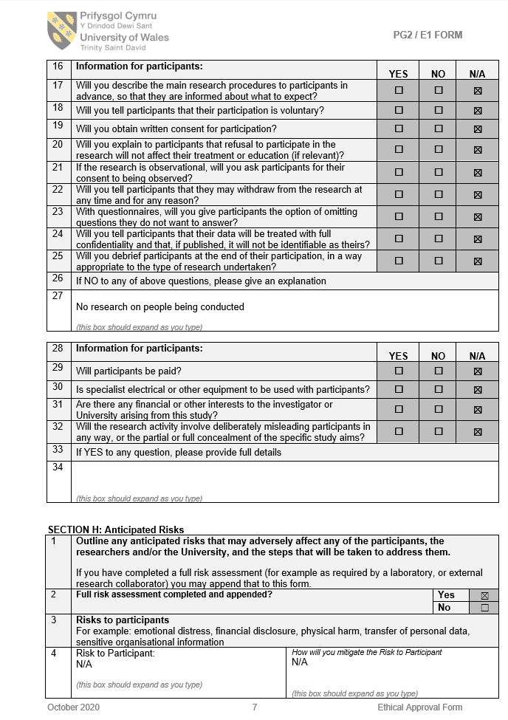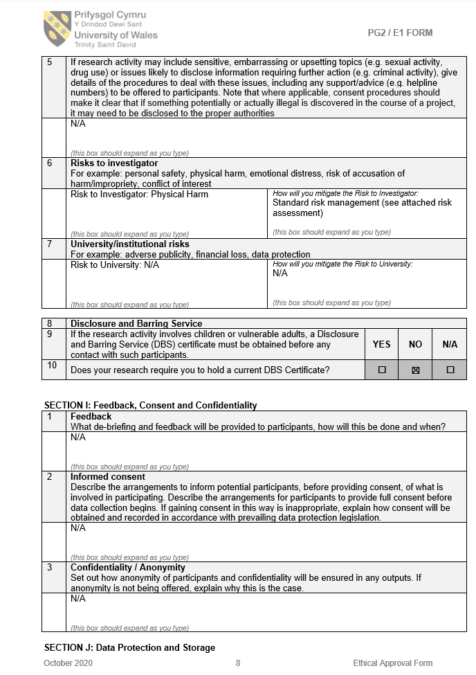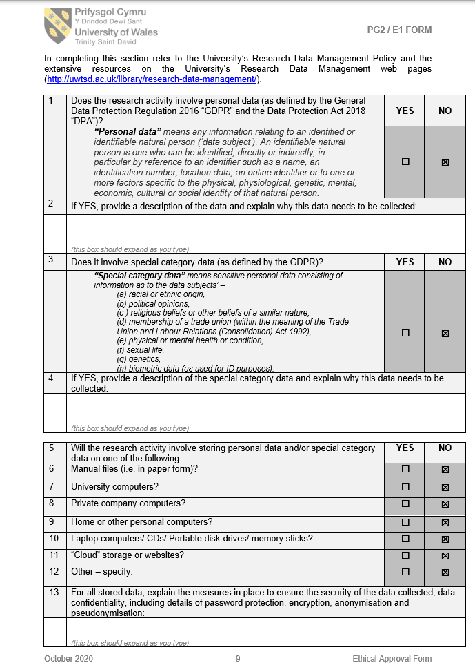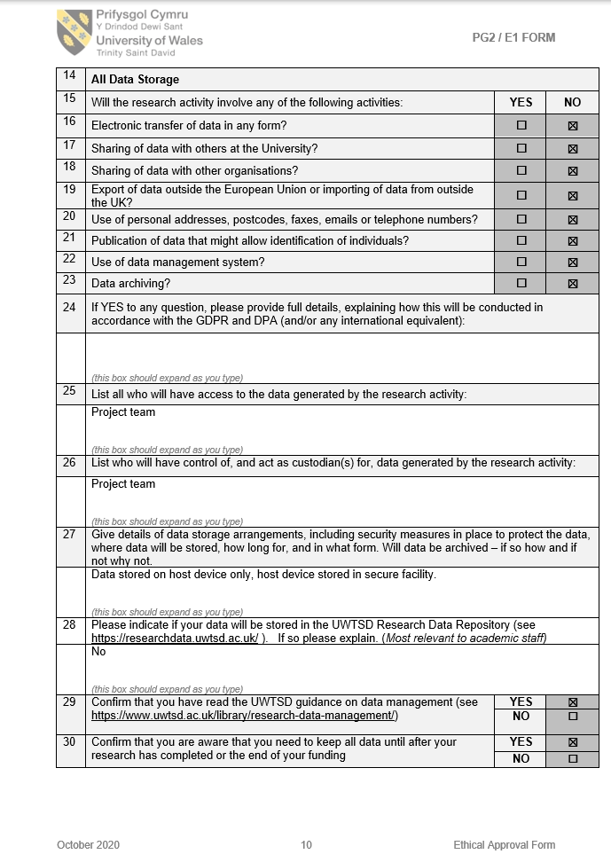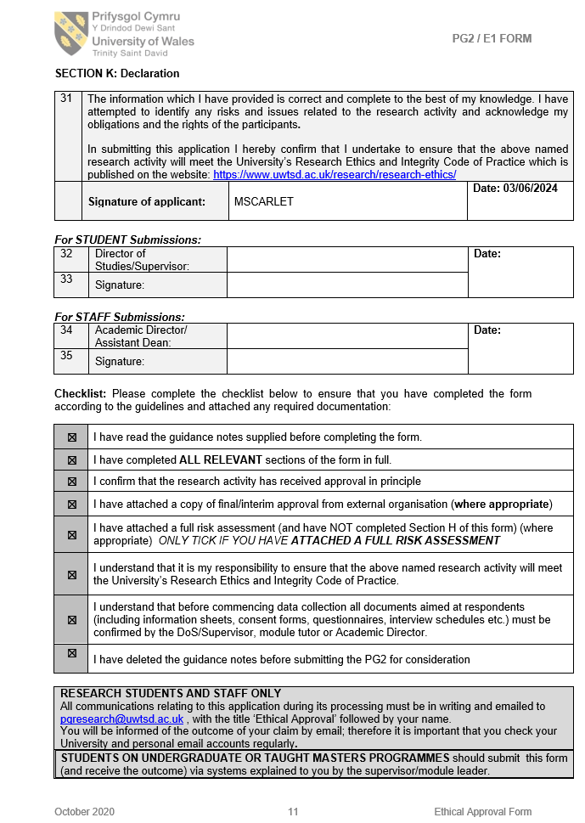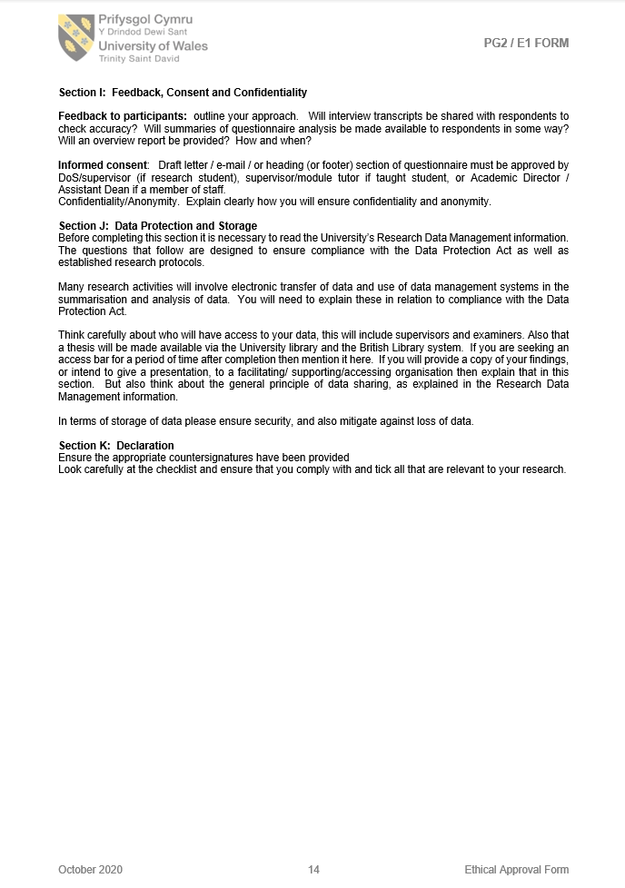

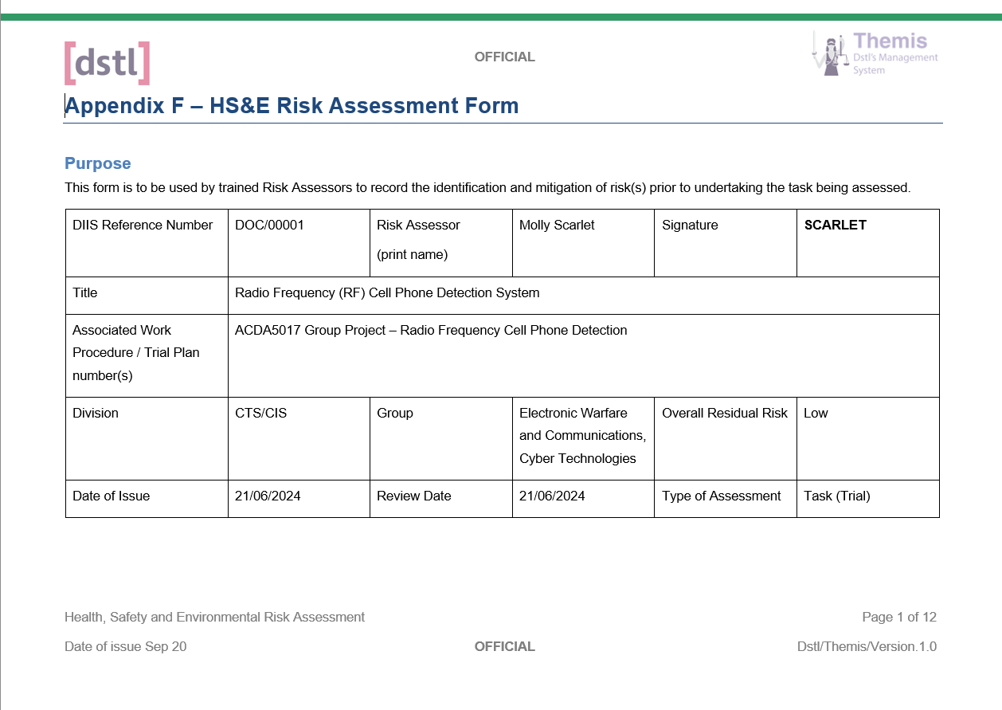
Appendix F
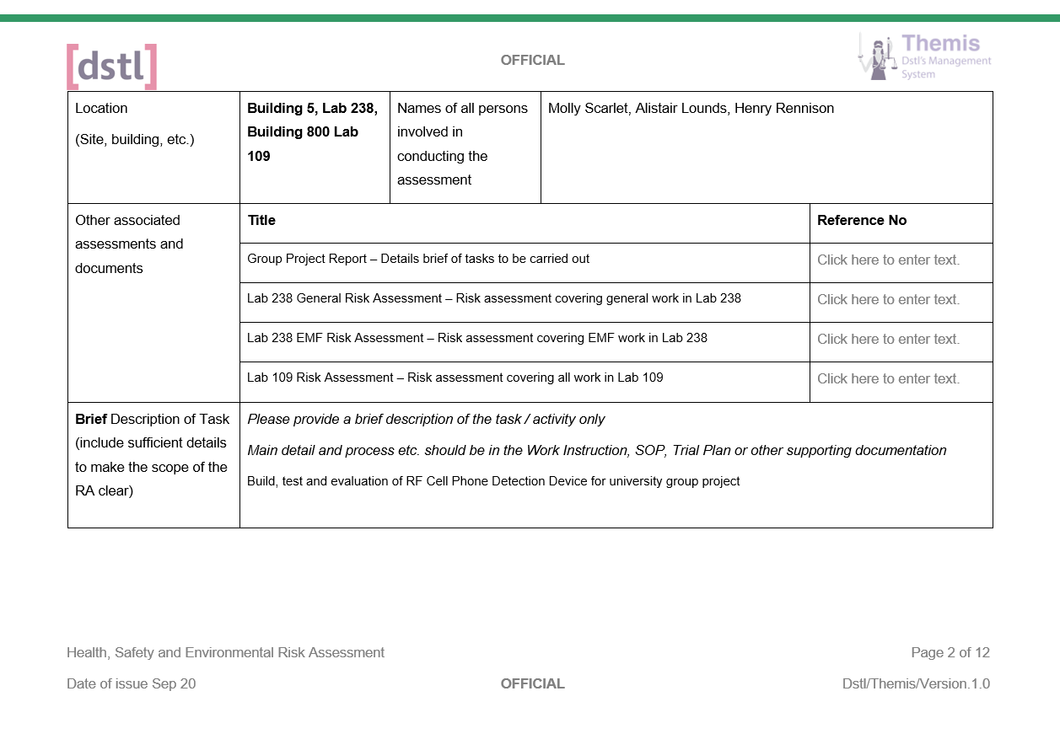
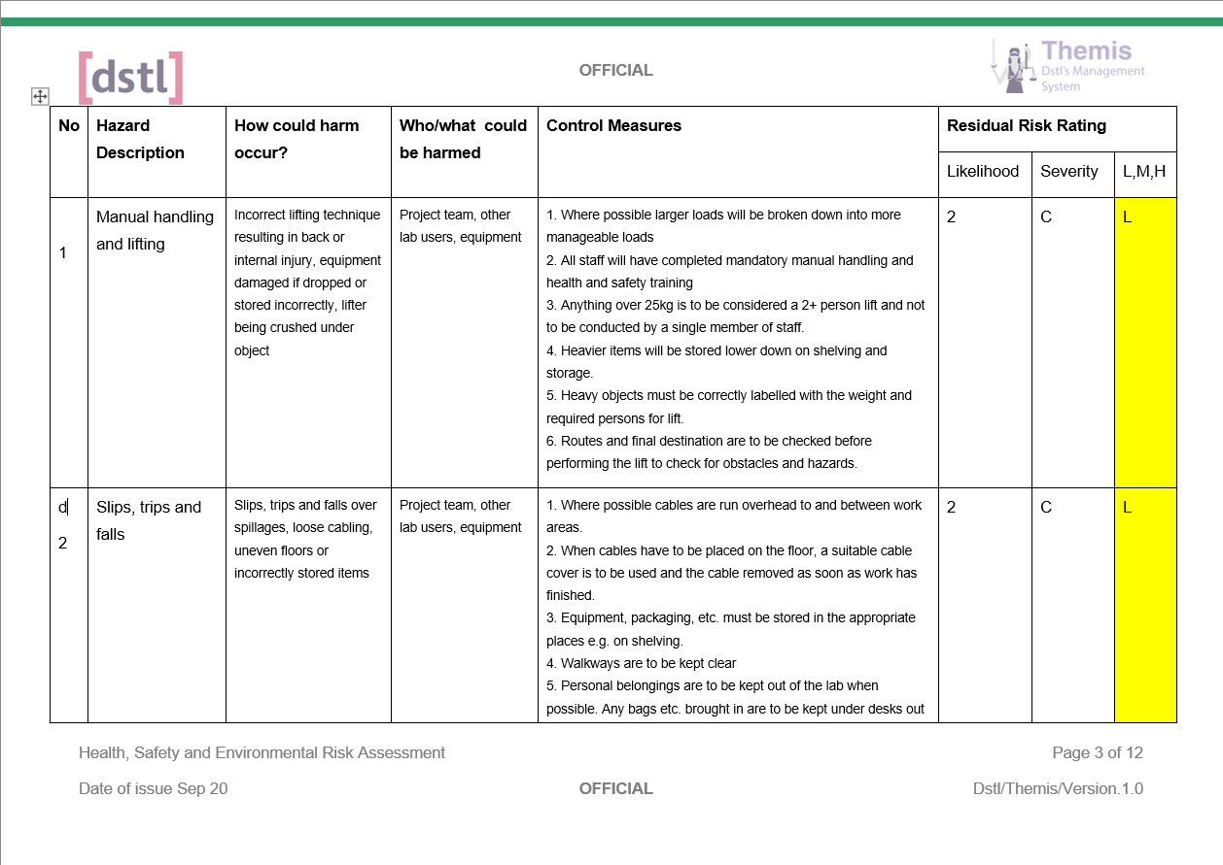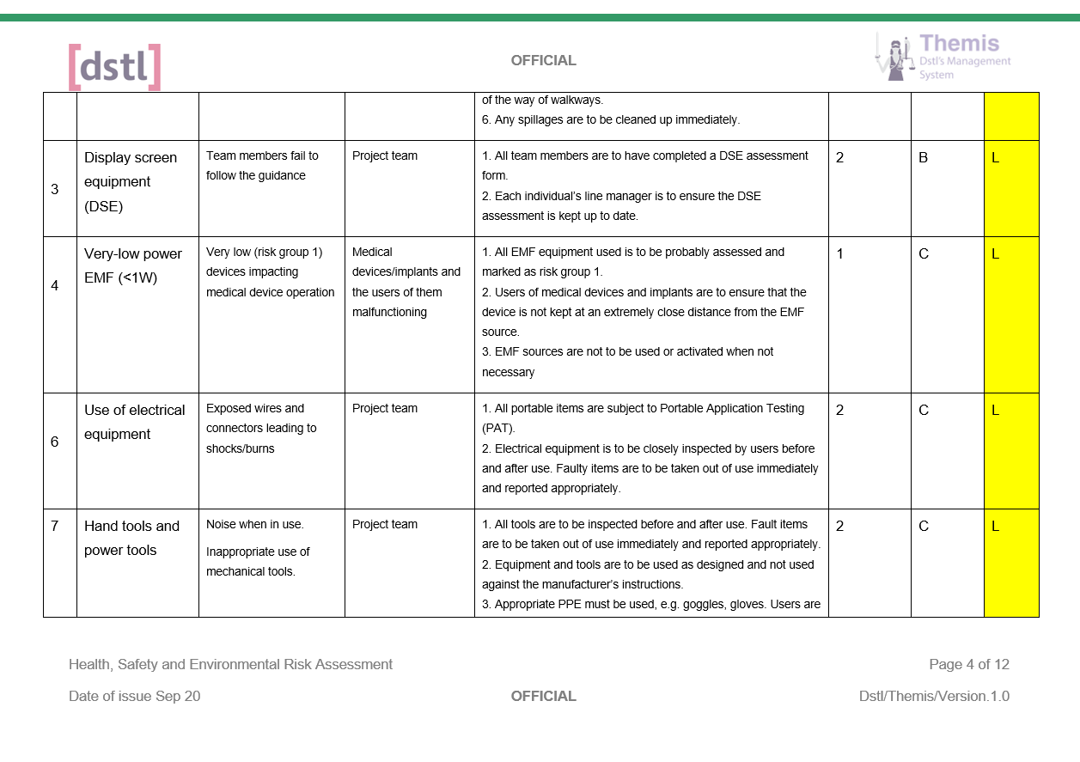
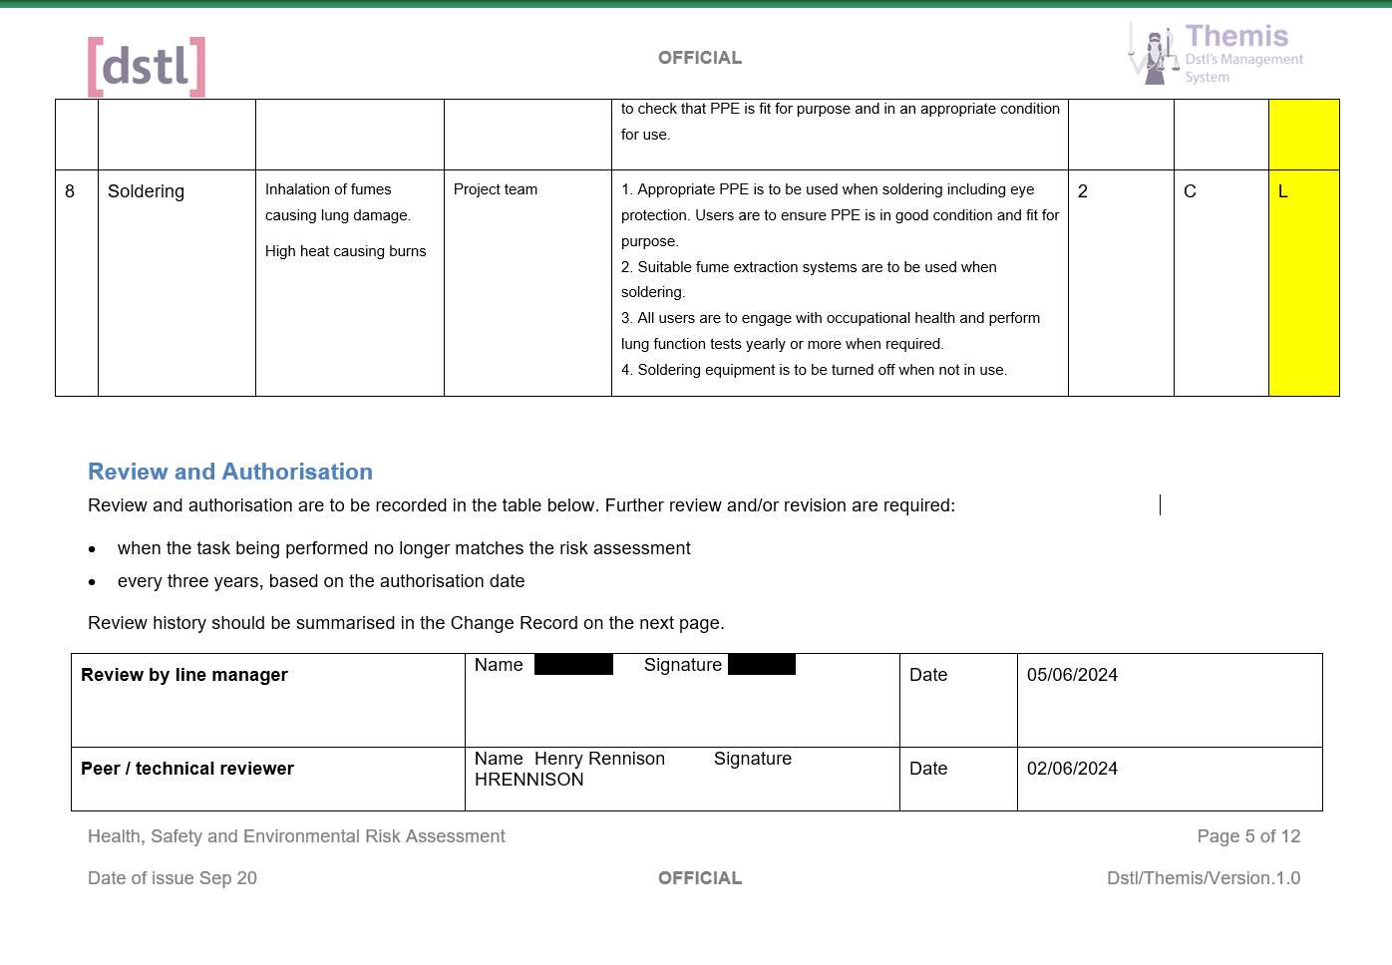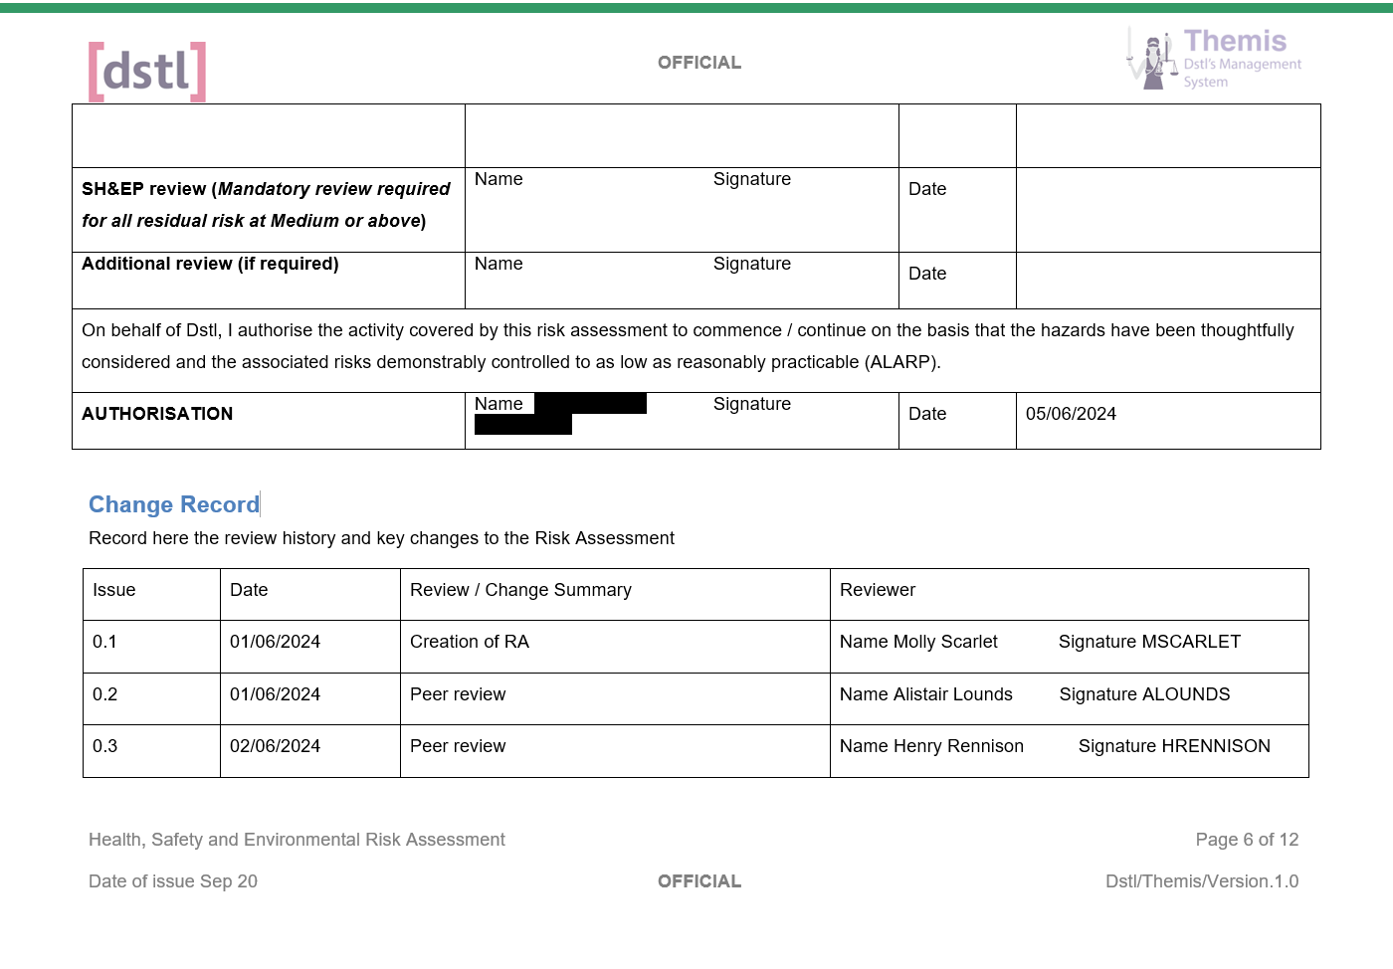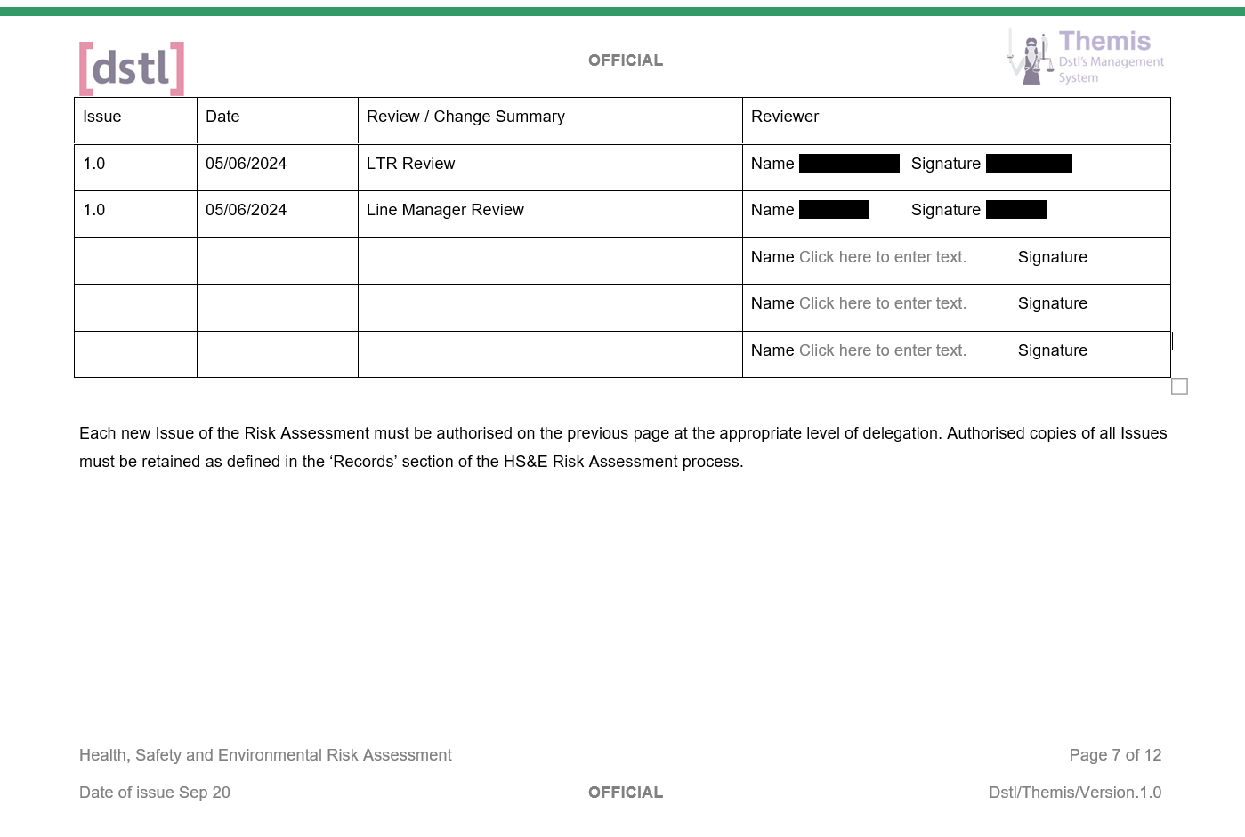
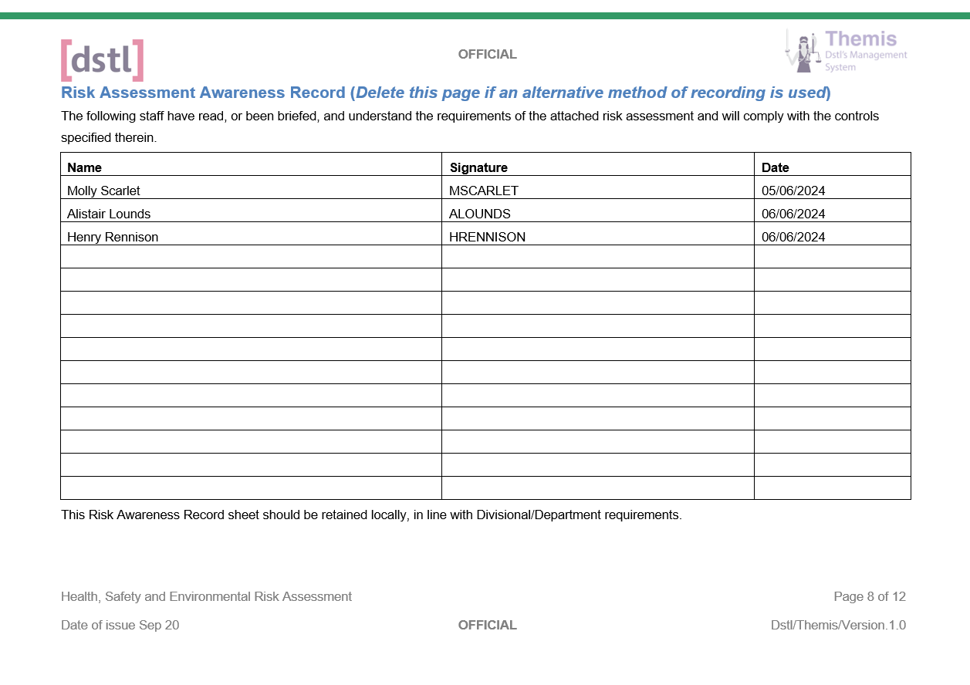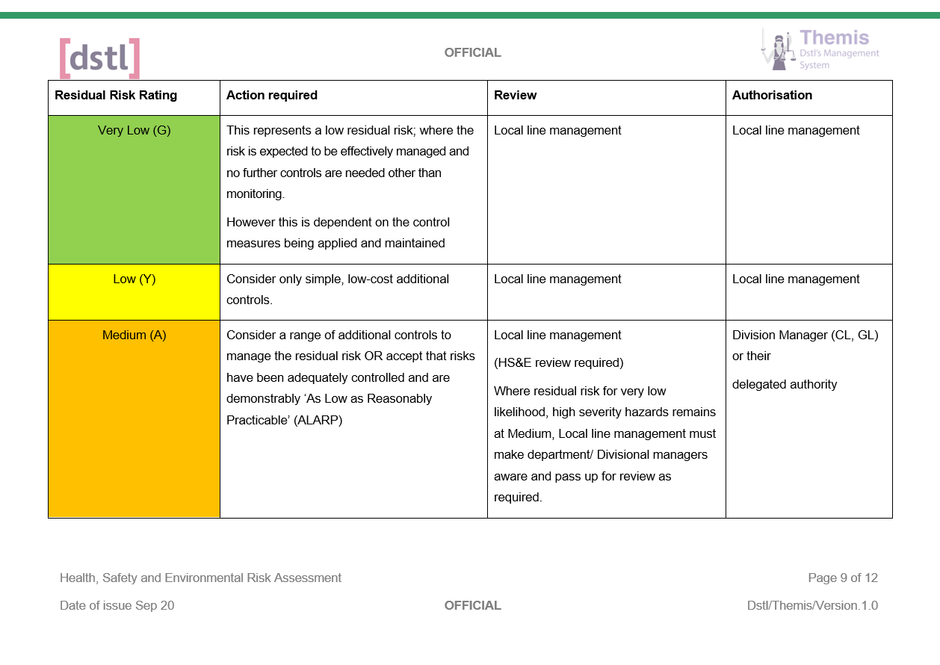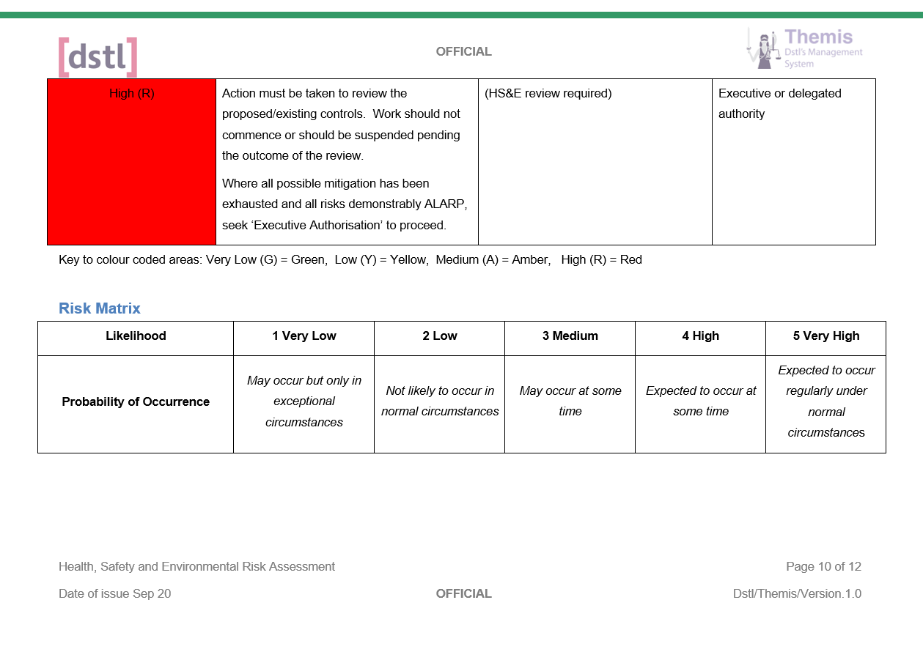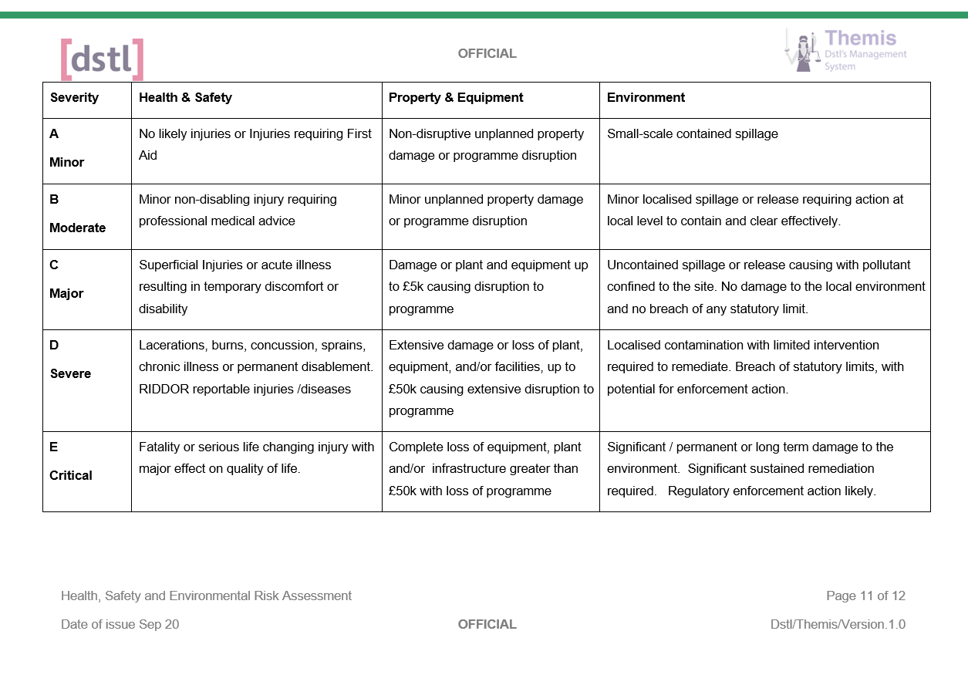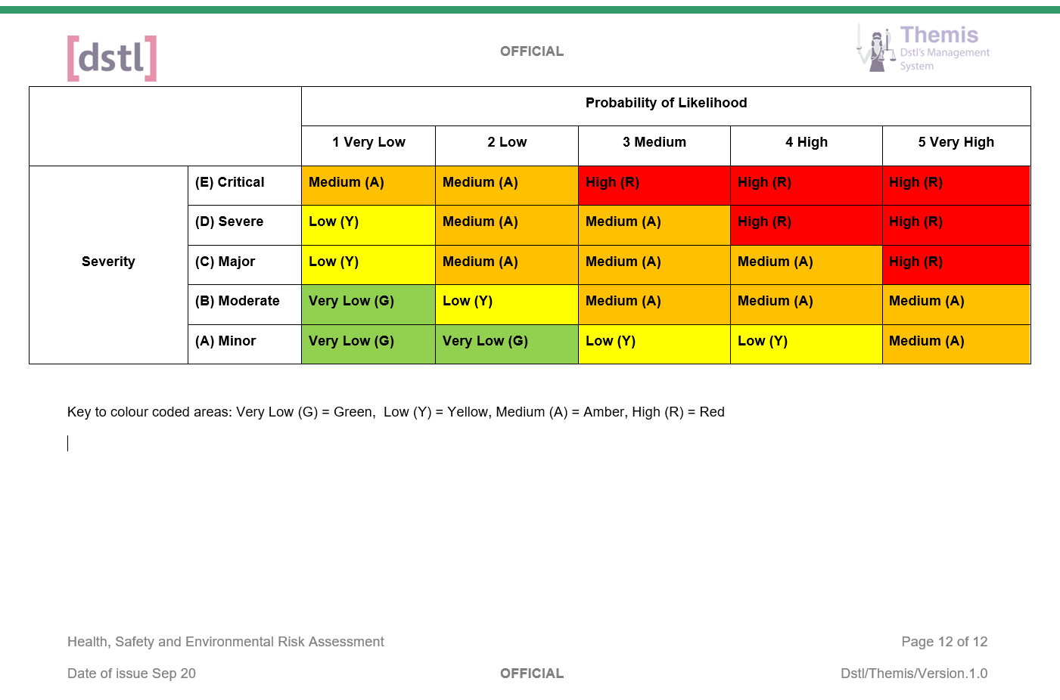

Appendix G

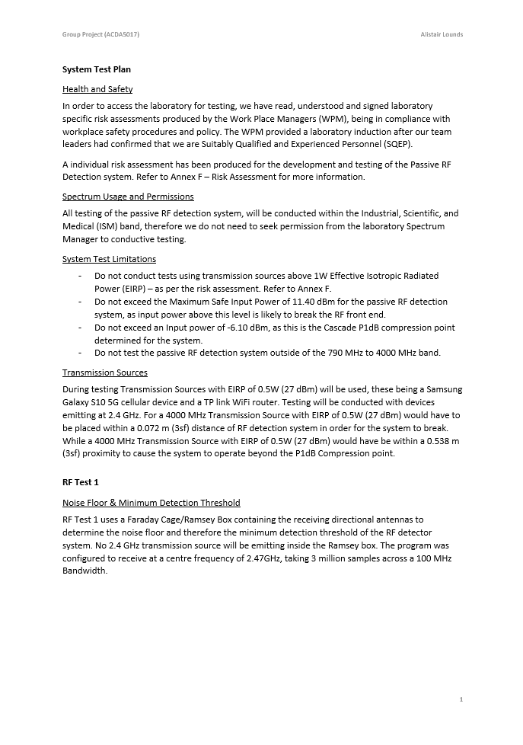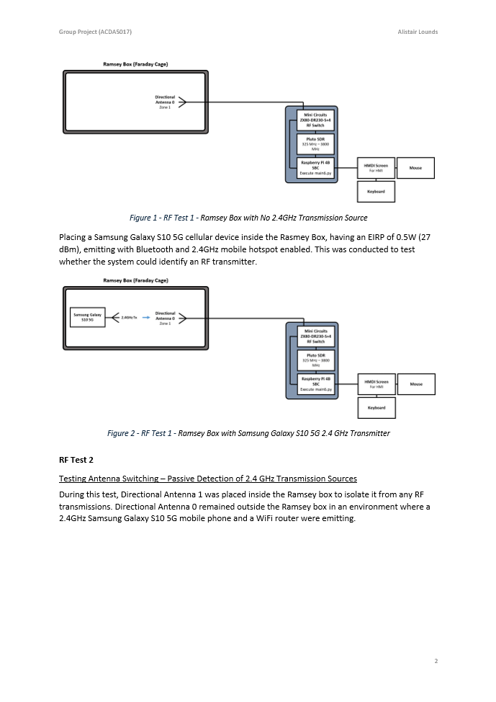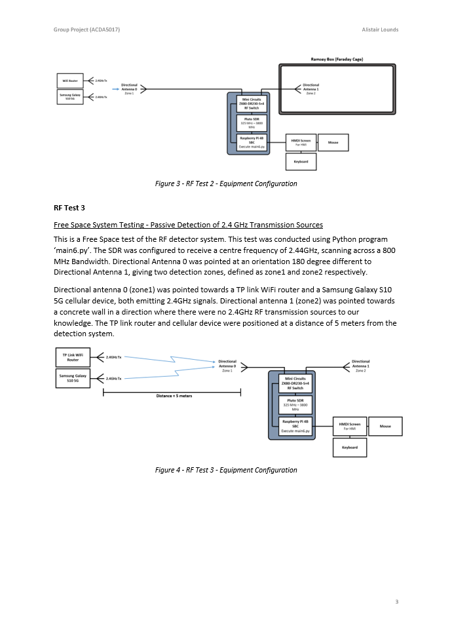

Appendix H

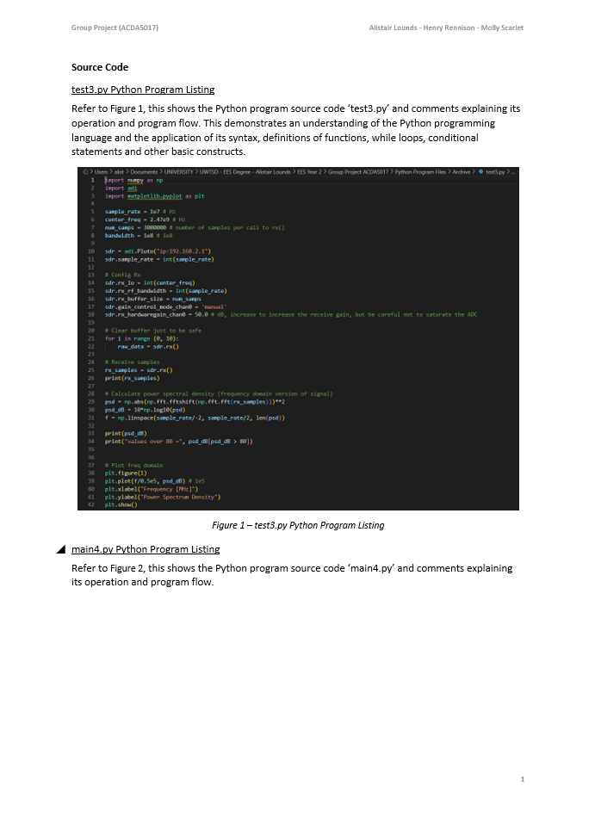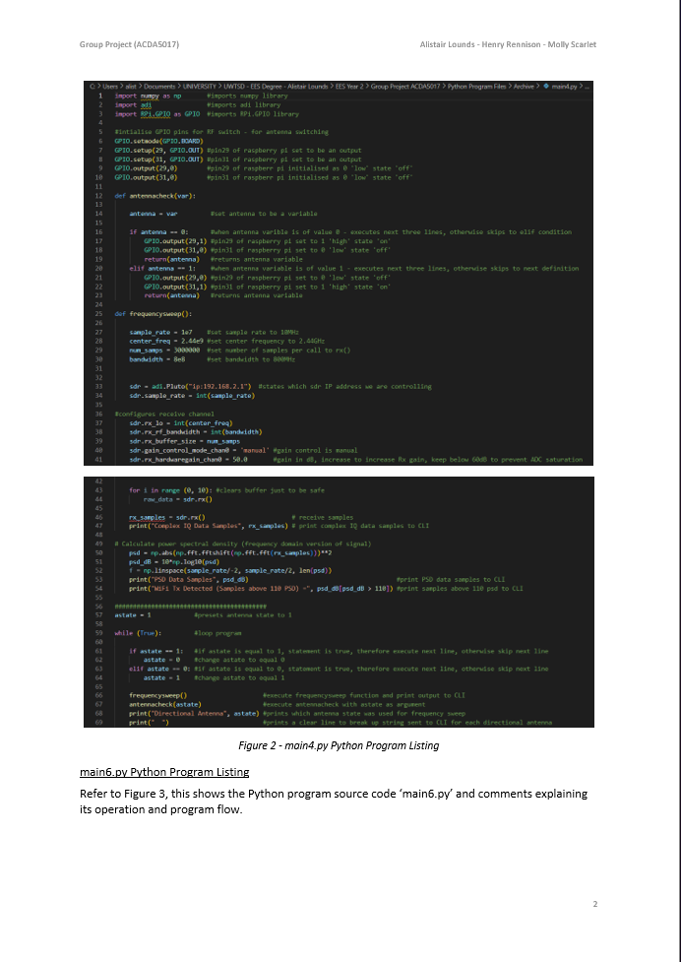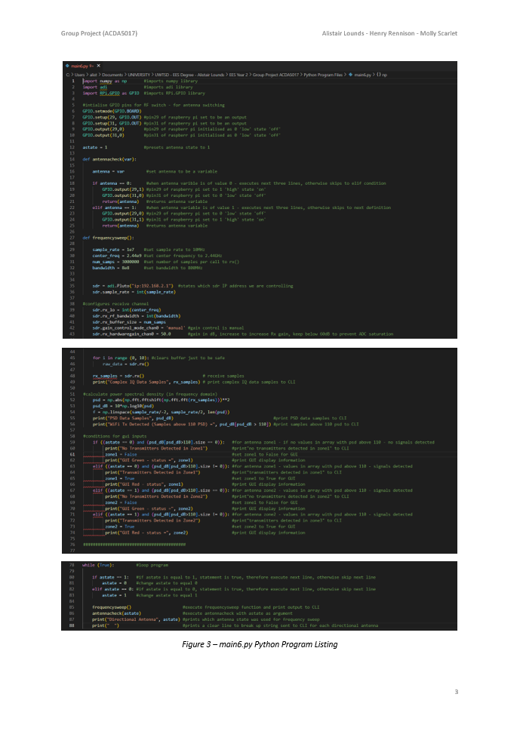
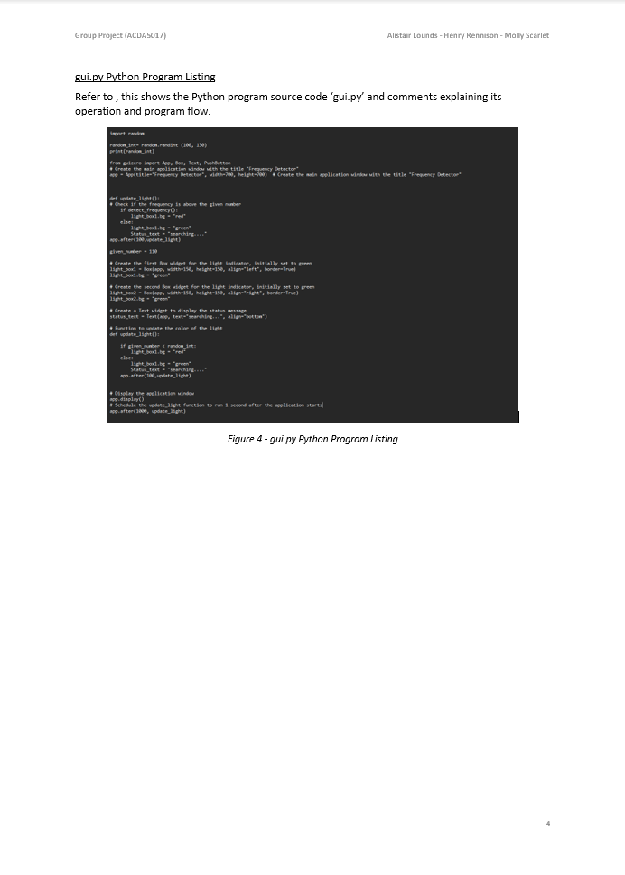

Appendix I

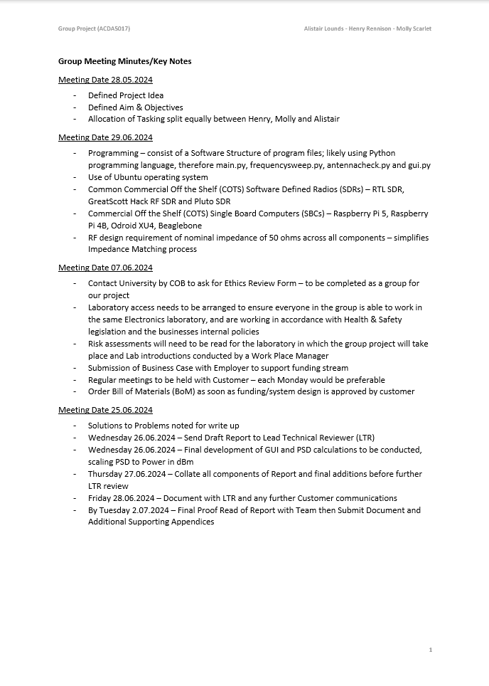

Appendix J



