Task 1: Analysing Partitions for anomalies - Capture 1
Partition 1:
00 – Boot Indicator
0x00 = non-bootable
00 02 00 – Starting CHS Values
EE – Partition Type Descriptor
0XEE = MS GPT
FE 7F 99 – Ending CHS Values
01 00 00 00 – Starting Sector
0x01 – 1 (Hex to Decimal)
FF FF FF FF – Partition Size
0Xffffffff = 4294967295
4294967295 * 512 = 2,199,023,255,040

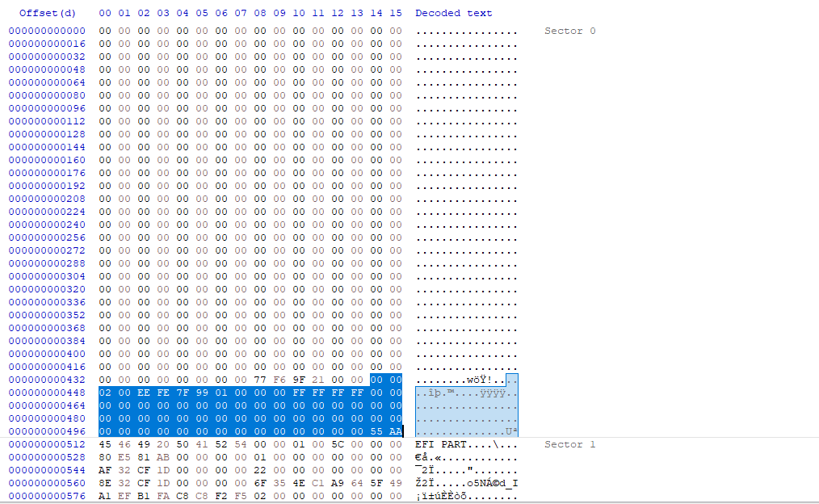

Capture 2
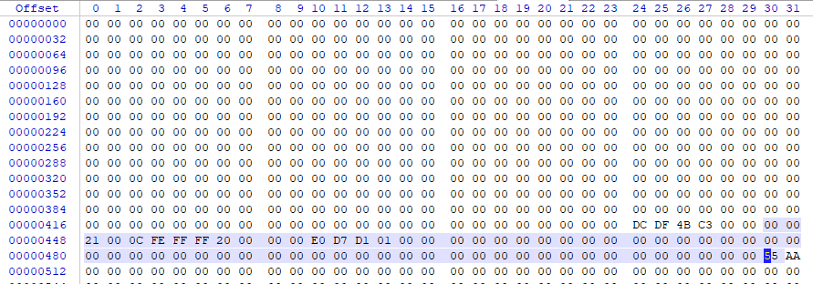
Partition 1:
00 – Boot Indicator
0x00 = non-bootable
00 21 00 – Starting CHS Values
0C – Partition Type Descriptor
0X0C = FAT32 LBA
FE FF FF – Ending CHS Values
20 00 00 00 – Starting Sector
0x20 – 32 (Hex to Decimal)
E0D7D101 – Partition Size
0X01d1d7e0 = 4294967295
30529504 * 512 = 15,631,106,048
15 GB

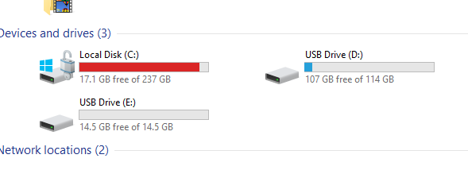
Worksheet
(c) Michael Wilkinson, this document may be freely distributed provided this notice remains intact, the original is located at http://www.writeblocked.org/resources. 08/05/2018
 | 0 | 1 | 2 | 3 | 4 | 5 | 6 | 7 | 8 | 9 | A | B | C | D | E |  | F
0 | Master Boot Code
….
1A0
1B0 |  |  |  |  |  |  |  |  | Disk Signature |  |  |  |  |  |  | Boot |  | Start
 |  |  |  |  |  |  |  |  |  |  |  |  |  |  |  | ind¹ |  | head
1C0 | start  Sect² | start  Cyl² | Sys  ID³ | End  Head | End  sect² | End  Cyl² | Relative Sectors |  |  |  | Total Sectors
1D0
1E0
1F0 |  |  |  |  |  |  |  |  |  |  |  |  |  |  | 55 |  | AA

- Boot indicator 0x00 = non-boot, 0x80 = bootable

- Starting sector & starting cylinder are allocated bits, not bytes (0x1C0-0x1C1) same goes for end head and end sector
BIT | 0 | 1 | 2 | 3 | 4 | 5 | 6 | 7 | 8 | 9 | A |  | B | C | D | E | F
Value | Starting sector |  |  |  |  |  |  | Starting Cylinder

- Common partition values.
0x01 | FAT12 <32MB |  | 0x84 | Windows hibernation partition
0x04 | FAT16 <32MB |  | 0x85 | Linux extended
0x05 | MS Extended partition using CHS |  | 0x8E | Linux LVM
0x06 | FAT16B |  | 0xA5 | FreeBSD slice
0x07 | NTFS, HPFS, exFAT |  | 0xA6 | OpenBSD slice
0x0B | FAT32 CHS |  | 0xAB | Mac OS X boot
0x0C | FAT32 LBA |  | 0xAF | HFS, HFS+
0x0E | FAT16 LBA |  | 0xEE | MS GPT
0x0F | MS Extended partition LBA |  | 0xEF | Intel EFI
0x42 | Windows Dynamic volume |  | 0xFB | VMware VMFS
0x82 | Linux swap |  | 0xFC | VMware swap
0x83 | Linux
See http://en.wikipedia.org/wiki/Partition_type for more types and http://technet.microsoft.com/en-us/library/bb457122.aspx for more details on the MBR

GPT Disk layout
Protective MBR | Sector 0
Primary GUID partition table header | Sector 1
GUID partition entry 1 | Sector 2
GUID partition entry 1 | ...
.... | ....
GUID partition entry 128 | Sector 33
Partition 1
Partition 2
.........
Backup GUID partition entry 1
Backup GUID partition entry 1
....
Backup GUID partition entry 128
Backup GUID partition table header | Last Sector

Protective MBR
 | 0 | 1 | 2 | 3 | 4 | 5 | 6 | 7 | 8 | 9 | A | B | C | D | E | F
0 | Master Boot Code
….
1A0
1B0 |  |  |  |  |  |  |  |  |  |  |  |  |  |  | Boot ind  0x00 | Starting head¹
1C0 | start Sect¹ | start Cyl¹ | Sys ID  0xEE | End Head²  0xFF | End sect²  0xFF | End Cyl²  0xFF | Relative Sectors 0x01000000 |  |  |  | Total Sectors 0xFFFFFFFF |  |  |  | 00 | 00
1D0 | 00 | 00 | 00 | 00 | 00 | 00 | 00 | 00 | 00 | 00 | 00 | 00 | 00 | 00 | 00 | 00
1E0 | 00 | 00 | 00 | 00 | 00 | 00 | 00 | 00 | 00 | 00 | 00 | 00 | 00 | 00 | 00 | 00
1F0 | 00 | 00 | 00 | 00 | 00 | 00 | 00 | 00 | 00 | 00 | 00 | 00 | 00 | 00 | 55 | AA
  - Starting LBA sector should be the second sector on the disk
  - Ending LBA sector, if value is too large for 1-byte 0xFF is used.

Primary GUID Partition Table Header
 | 0 | 1 | 2 | 3 | 4 |  | 5 | 6 | 7 | 8 | 9 | A | B | C | D | E | F
0 |  | Signature |  |  |  |  |  |  |  | Revision |  |  |  | Header Size  0x5C000000
10 | CRC32 Checksum of GPT  header |  |  |  |  | Reserved 0x00000000 |  |  |  | MyLBA – sector containing this header
20 |  | AlternateLBA – sector containing copy of this header |  |  |  |  |  |  |  | First usable sector
30 |  | Last usable sector |  |  |  |  |  |  |  | Disk GUID (16 bytes)
40 |  | Disk GUID |  |  |  |  |  |  |  | First Partition Entry, 0x0200000000000000
50 | Number of Partition Entries |  |  |  |  | Size of partition entries |  |  |  | Partition Entry Array CRC32 |  |  |  | Reserved (must be zero, if used)

MS GUID Partition Entry
 | 0 | 1 | 2 | 3 | 4 | 5 | 6 | 7 | 8 | 9 | A | B | C | D | E | F
10 | Partition Type GUID
20 | Unique Partition GUID
30 | Start LBA |  |  |  |  |  |  |  | End LBA
40 | Attribute Bits |  |  |  |  |  |  |  | Partition Name (72 bytes, 32 Unicode characters)
50 | Partition Name ........

See http://www.uefi.org/sites/default/files/resources/UEFI%20Spec%202_7_A%20Sept%206.pdf for official documentation of GPT

Common GUID partition types (more here: http://en.wikipedia.org/wiki/GUID_Partition_Table#Partition_type_GUIDs )
GUID Value | Partition Type
00000000–0000–0000–0000–000000000000 | Unused entry
0657FD6D-A4AB-43C4-84E5-0933C84B4F4F | Linux Swap partition
0FC63DAF-8483-4772-8E79-3D69D8477DE4 | Linux filesystem data
16E3C9E3–5C0B–B84D–817D–F92DF00215AE | Microsoft Reserved partition
21686148-6449-6E6F-744E-656564454649 | BIOS Boot partition
28732AC1–1FF8–D211–BA4B–00A0C93EC93B | Microsoft EFI System partition
48465300-0000-11AA-AA11-00306543ECAC | Hierarchical File System Plus (HFS+) partition
55465300-0000-11AA-AA11-00306543ECAC | Apple UFS
A0609BAF–3114–624F–BC68–3311714A69AD | MS LDM Data partition on a dynamic disk
A19D880F-05FC-4D3B-A006-743F0F84911E | Linux RAID partition
A2A0D0EB–E5B9–3344–87C0–68B6B72699C7 | MS Primary partition on a basic disk
AAC80858–8F7E–E042–85D2–E1E90434CFB3 | MS LDM Metadata partition on a dynamic disk
EBD0A0A2-B9E5-4433-87C0-68B6B72699C7 | MS basic data partition

Task: Use Hex Editor or other similar tools to capture and analyse the partitions for any anomalies/ hidden partition from your acquired images
Deliverables:
- Image Captured
- Analysed data (include the number of partition, their Boot Indicator, Starting CHS Values, Partition Type Descriptor, Ending CHS Values, Starting Sector, Partition Size) –
- Write a report to prove the found anomalies/ or no anomalies found.

