Component 2 - Research Report
Student Name:Nadeie Saeied
Student Number:2212621
Lecturer Name: Chuen Leung
LCHS4002_BIRM
Digital Skills and Research Methods.

Contents
1. Introduction 3
2. Research design 3
2.1. Research Question 3
2.2. Method 3
2.3. Ethical Considerations 3
3. Results 3
4. Discussion 3
5. Conclusion 3
6. Reference List 3
7. Appendix A – A blank copy questionnaire. 3

Introduction
This essay will cover different opinions of how different students on how they feel about using technology to collaborate. Questions were issued to many different students regarding the confidence of students in using technology to collaborate. Most students have a fundamental knowledge of technology. Applying that knowledge in the classroom can make people feel as though they have already grasped it. Having online discussions or assignments encourages participation from students who are reluctant to speak up in class. Shy students are more likely to participate in your course if they have the option to privately respond to questions or doublecheck the answers before sharing them. Most students will get more confident and comfortable through frequent online interactions and eventually start contributing and getting involved with discussions are happening in class. Digital skills are very important in this society learning the fundamentals of technology is the first step to learning a ton of other new things. This can help individuals feel more comfortable and confident using technology for job, school, and daily life. Today, a lot of professions require digital abilities even for positions that might not even require a lot of education or work experience it still may be needed.
We noticed other students having difficulties to access and use the university applications.
This research will aim to look at confidence level around using technology to collaborate and the impact it has on students at UWTSD, questionnaire response from a small selective group to highlight currents trends and support my hypothesis.
These findings seem to suggest that in order for collaborative proactive learning across distances to take place, student must master collaboration concepts in addition to the technology, and that a diversity of technologies is required to take into account culture and personal differences among students.

Students working together on activates or learning tasks in a group small enough to insure that everyone participated.

Research design
The analyst of the research topic is done using quantities approach. Quantitively research. Which place an impasse is on in deep with interviews and free from conversation is one method of doing market research. This approach focuses on the watch and why of people’s conversation consider that you are on inconvenience story and are attempting to increase your customer base.
There are several aspects around the topics using collaborative technology, we were a group off 3 we decided to focus on this subject how student confidence in using technology to collaborate in UWTSD.

We highlighted opinions, trends, and perspective around collaborate technology.
Therefore, supporting my initial non-directional hypnotises and corresponding external articles.

Research Question

My chosen research question was “how confident are students in using technology to collaborate?” This was a great question because it can relate to so many people including students as social media and technology is so popular, advance and worldwide. This question is very important and vital because a major benefit of incorporating technology into course design is the ability to create a more engaging learning environment for students. There is no denying the impact technology has on how we teach and learn; this is important because it plays a major role in the current learning environment of students.
Using this kind of questions will provide quantile data, allowing statical analysis of the response.
Time to complete the question air is greatly reduced as participants only need to select pre-set answers, resulting in a greater chance of completion.
By standardizing the question, we can ensure all participants are asked the same exact same questions maintain consistency of opportunity to validate the research by replicating the questionnaire. To ensure participants understood the question minimum questions was adapted making the question simple and straightforward.

Method
The method I used was a questionnaire which is a survey tool that contains a list of questions to be answered by a group of people which in my case was the students in my class. It is used to collect proper information to help get clear results during research. Because they provide a quick, effective and audible way to gain a lot of data from huge sample sizes, questionnaires are a common research approach. These equipment’s are very useful for checking their behaviour, choice. I sent the survery to my class to 10 people by email and I got 7 feedbacks.
. Relatively easy to administer,
. Gain a wider range from other study with our own,
. Cost-effective,
. Promoting and mandating,
. Expresses,
We are aware that this approach can result in date error or non-responses.
All question will ask will be closed structured. This will requiring a single answer from selection.
We are aware that this approach can result in data error due to incorrect responses, as well as unusual trend as both question and answers could be interpreted differently be each student.
We decided our students will be from our digital skills class, the students ranged from different background.
The students were using the same technical platform and collaborate technology. These tools excellent for evaluating subject’s academy performance intention options and worldwide the questionnaire results would give contents to the interpreter the goals of the questionnaire research in qualitative quality contact analysing. And are used to organise the new data into categories or topics analysing reasoning the research uses their approach to search for patterns and generalisation in the data that results through and close compromise station however quality contact analyse should also include inference. Post additional an online classroom environment that is made into interact with the circle cuticle isolation and achievement many objects many students don’t even need their own device to benefit from technology. Students could respond in a way that seemed appropriate to them and had a wide range of possibilities to pick from as no two people are not the same, I enlisting participants pressed my classmates by emailing a link to every student in my class. Making it simple as possible for them to access it and jump right through the questionnaire because not all the student’s response to my email because something might not have been available, I also printed some copies of my questionnaire.

Ethical Considerations

It is a crucial component of the ethical problems with the digital technologies it allows individuals to connect to servers that are connected to one other add to users through a network while using their own hardware.
Operating system and software tools.
There is a high volume of data or information transfer which increase the potential for
Information leaks and privacy violations, against specific or group.
The privacy issues also include procedure to protect the accuracy of data and accidental
Exposure to improper parties.
In the context of computer ethics, harmful behaviour has been defined as any conduct
That causes harm, to I.T, including the loss of sensitive data, the theft or destruction of
Property, the loss of ownership, or other negative significant effects.

- Results
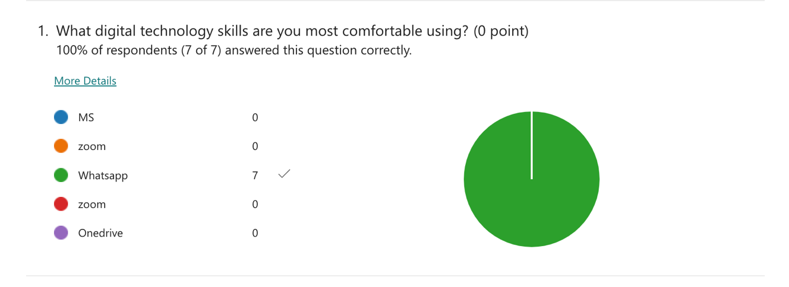
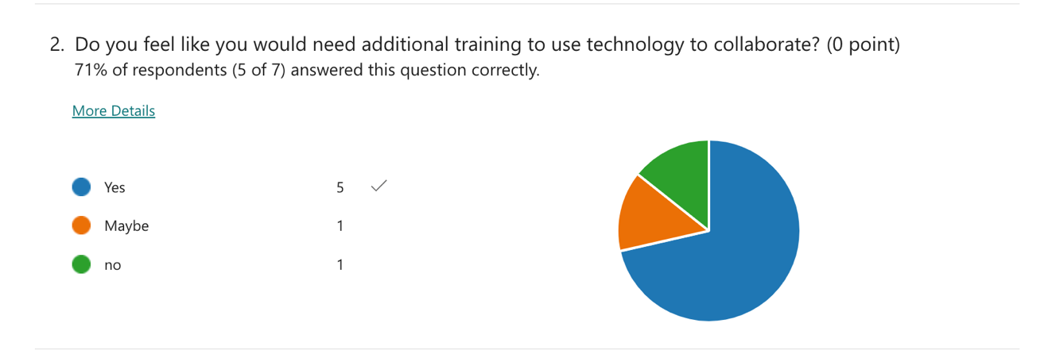
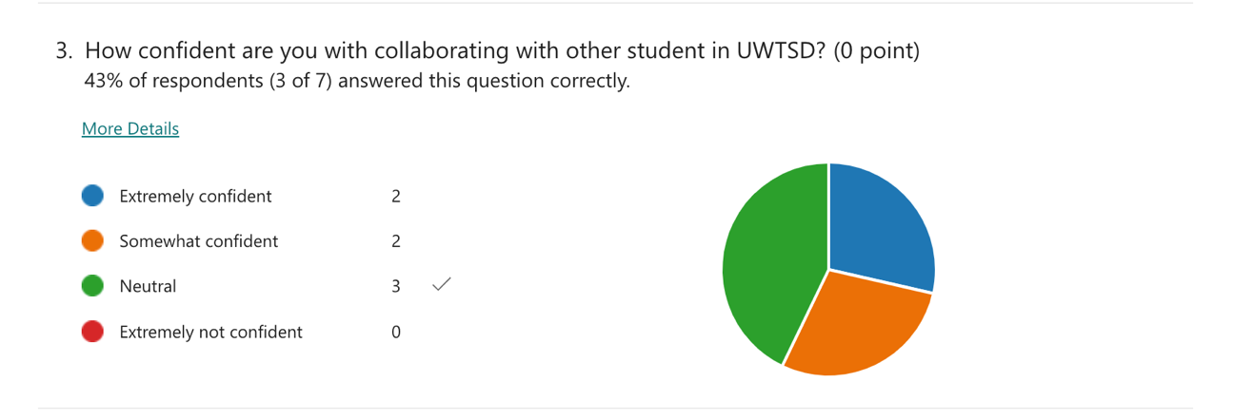
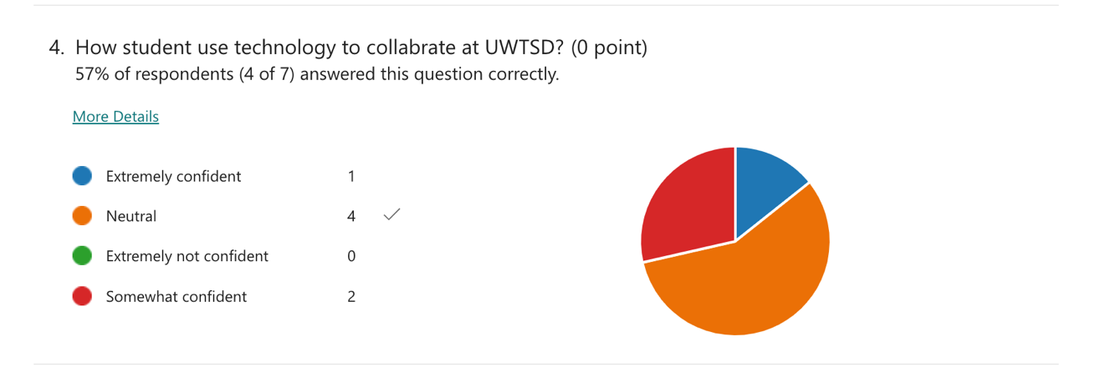
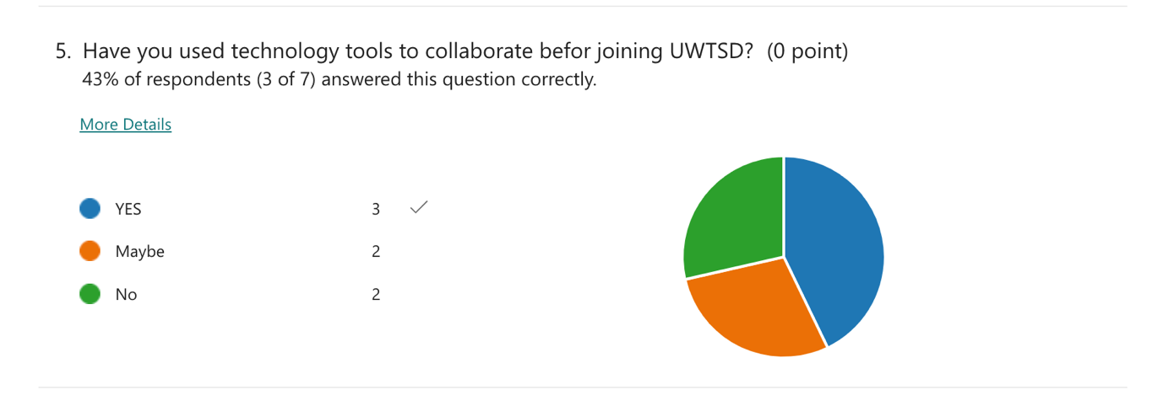
These findings suggested that a range of technologies, including telephone and email, should be accessible to students to consider their cultural and personal preferences. Although the technology's usability might get better with time. student interaction, and other conventional teaching approaches. These findings also suggest that schools should think about adding activities that promote social communication across distances while also teaching collaboration ideas. These questionnaire was sent to 10 students in our digital class but only seven came back as our response.
Possible methods for achieving this include reading assignments, class discussions about collaboration, and activities that encourage students to interact with one another and get to know one another. It's possible that the discussions and activities will take up more training time than usual. The results weren't far from what I have already expected other than a small portion of students in my class as my class many others who were similar ages and religions had so many similar ideas and opinions on technology and different apps and how confident each student was using it to connect with family, friends and doing assignments and other works.in (2017), the digital era has had a huge impact on how we make decision.

Discussion
Collaborate were the main challenges that came out of the students qualitive,
Reflective reports. It’s a communication was finally possible, and teamwork always needed a significant amount of dedication the way pupils write the technology to flex these difficulties. according to survey celebrities always allow for significant social influence or involvement many students find it more challenging to use the other devices. evaluation of various technology these patterns point to both culture and personal differences gender that the course and the collaborative tools employed. Give
the students a meaningful educational experience as Seen by the observational studies, survey results and finish course task students gain both theory and experience regarding their work new technologies and both. Hey people rate the technology to flex the suppresses according to surveys calibrated technology does not always allow for the significant social influence or in-flight involvement many people find it more challenging to use than other devices.

The term confidence belief that one can rely on their skills, can easily be impacted when an activity does not work as intent ended or the same technology is use for a different purpose.

MS teams being used daily to join a class and listen to the lecturer but being asked to send documents or share a screen could Knock someone confidence.

Students are confident in using collaborative tools such as,
OneDrive, whichever students feel very anxious and not confident enough using specific
Functions such as Excel, Word and power point.

We also came to the realization that while system is always adapting to changing circumstances isn’t always adequate because the system could change in unexpected ways.

Through the findings of this research our aim was to confirm our hypotheses the data we
Have selected ourselves with the data generated by reset bodies

- Conclusion
In conclusion, the majority of the students do you feel confident to use technology as they are using it during their education process such as to create a presentation for upcoming assembly which they might participate in or to collaborate in certain tasks, as well as using technology to submit their online tasks and the online websites as a lot of professions require digital.
In addition, the role of school in preparing the students to use technology daily, this has greatly raised the student confidence. The method which I have used which was the questionnaire strongly supported all the statements above and I do believe that this was an accurate way to be able to assess if the students feel confident to use technology and collaborate. The best method to demonstrate this was the questionnaire this method was quick and affective in order to gather the information required, the result of the extremely supported all the statements above and I do believe that this was an accurate way to be able to assess if the students feel confident to use technology to collaborate. The above proves our hypotheses and supports our findings around use of technology to cut and colour to create in UWTSD it is we need to tap abilities of our academic and institutes to provide their knowledge and resources to build confidence and use calibrated technologies.

- Reference List
Lynch, M. (2017). 9 Ways That Technology Boosts Student Confidence in the Classroom - The advocate. (online) The Advocated. Availabhttps://www.theedadvocate.org/9-ways
Lynch.(2022) Difference Between independent and Dependent Variable.Avaliable at:https//www.theedadvocate.org/9-ways-technology-boosts-student-confidence-classroom/
Best,J.(2020 ) 10 unbeatable benefits of technology in the classroom.
Available at: https://www.3pleaaning.com/blog/technology-in-the-classroom/.
(PDF)Collaborative Learning using collaboration technology: Report …
(no date). Available at: https://www.researchgate.net/publication/
28805135_collaborative_Learning_Using _Collaboration_Technology_Repoert_from_the_field (accessed :November17,2022).

7.Appendix A – A blank copy questionnaire.


