[1]System Monitoring Lesson Tutorial
Contents
Introduction 2
Task 1 3
Admin Tools 3
EVENT VIEWER 3
PERFORMACE TOOL 5
Resource Monitor 6
Reliability monitor 7
Task Manager 8
WINDOWS SYSINTERNALS SUITE 9
SYSINFORMER 10
RAMMAP 12
Group Policy Management 14
SYSTEM FILE CHECKER 15
FILE SYSTEMS 16
System Monitoring & Management with a CLI 17
Back-up and Restore system files 18
TASK 2 POWERSHELL! 18
Task 3 22
TASK 4 Batch Lecture 26
Example of batch code 27
User Input, if & Goto commands 28
BATCH SCRIPT WRITING TASK 4 29
Menu Based Program Scripting PowerShell 30
TASK 5 Lecture Bash 32
Cisco, Operating Systems Basics 37
Bibliography 39

Introduction
This will be covering many types of computer languages that are made and designed to help the user and navigate their computer/network on, whether that be creating small little programs on Bash or bigger programs on Batch, this will help!
This also covers some windows monitoring tools such as RAMMAP or Event viewer

Task 1

Admin Tools

EVENT VIEWER
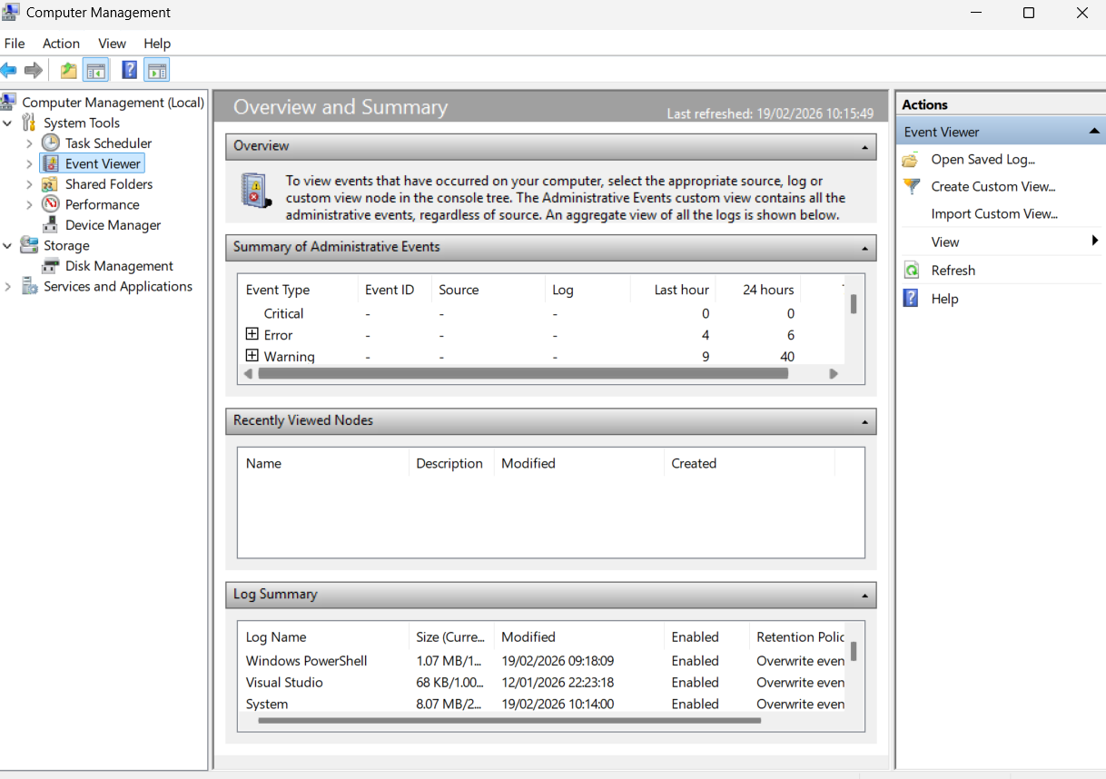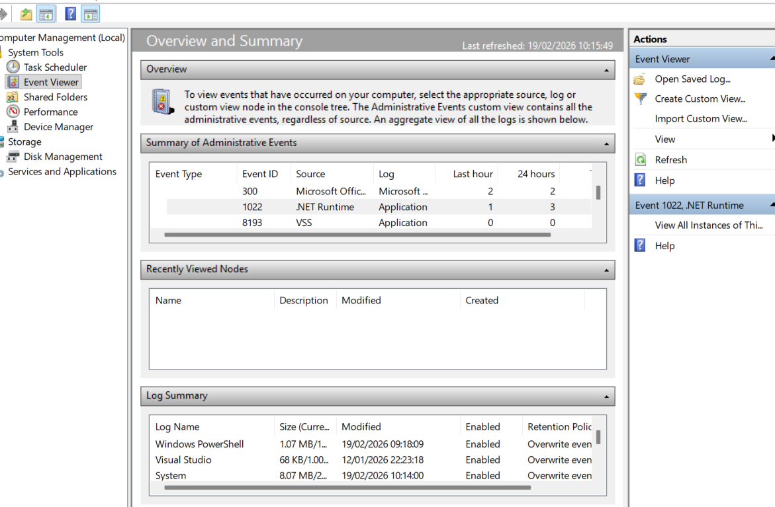
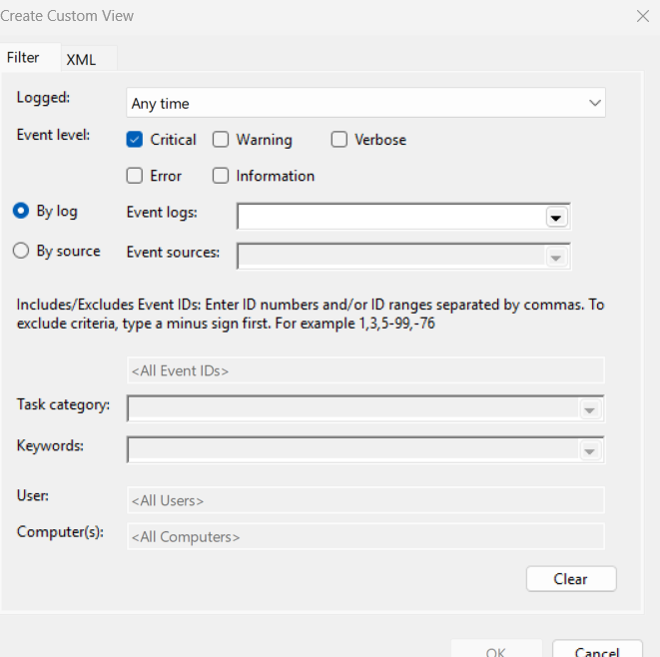
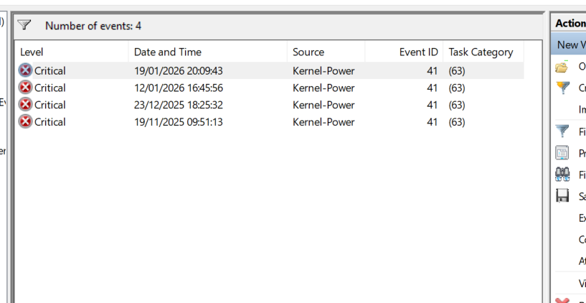
[2]Event viewer allows to identify errors as well as what is happening with the computer, in the last screen shot it shows that I have a Kernal Power issue and it has its ID code (41) displayed which then I can search to look more into the problem

PERFORMACE TOOL

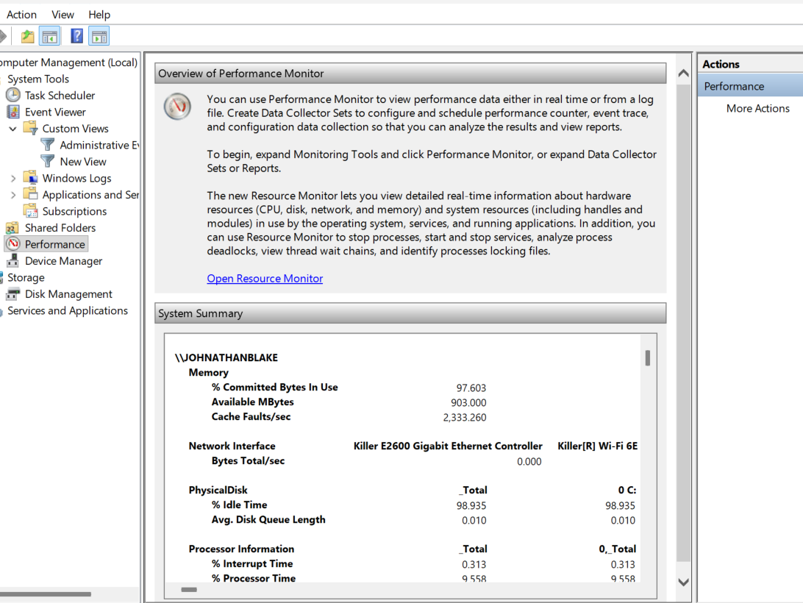

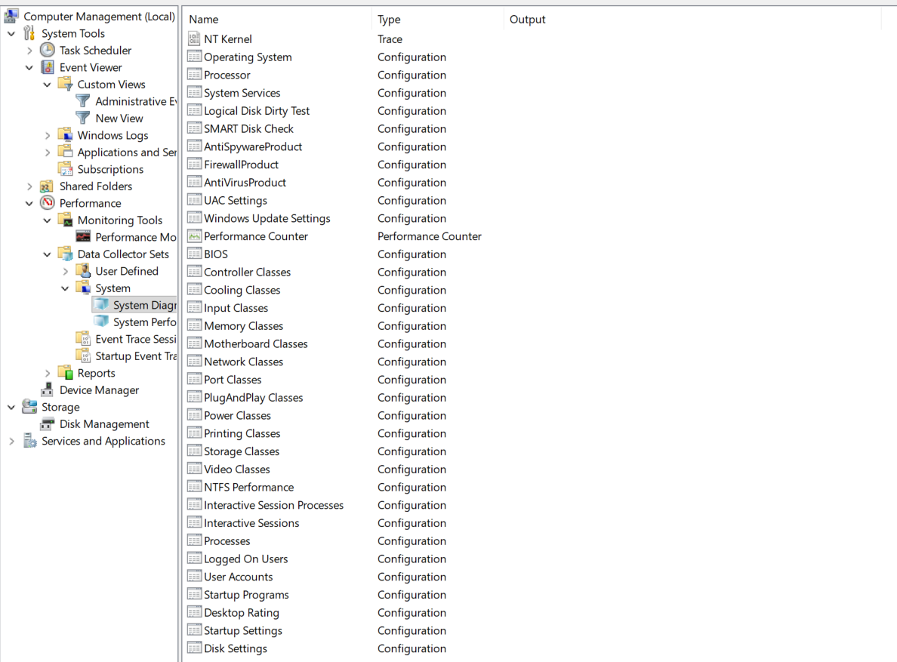
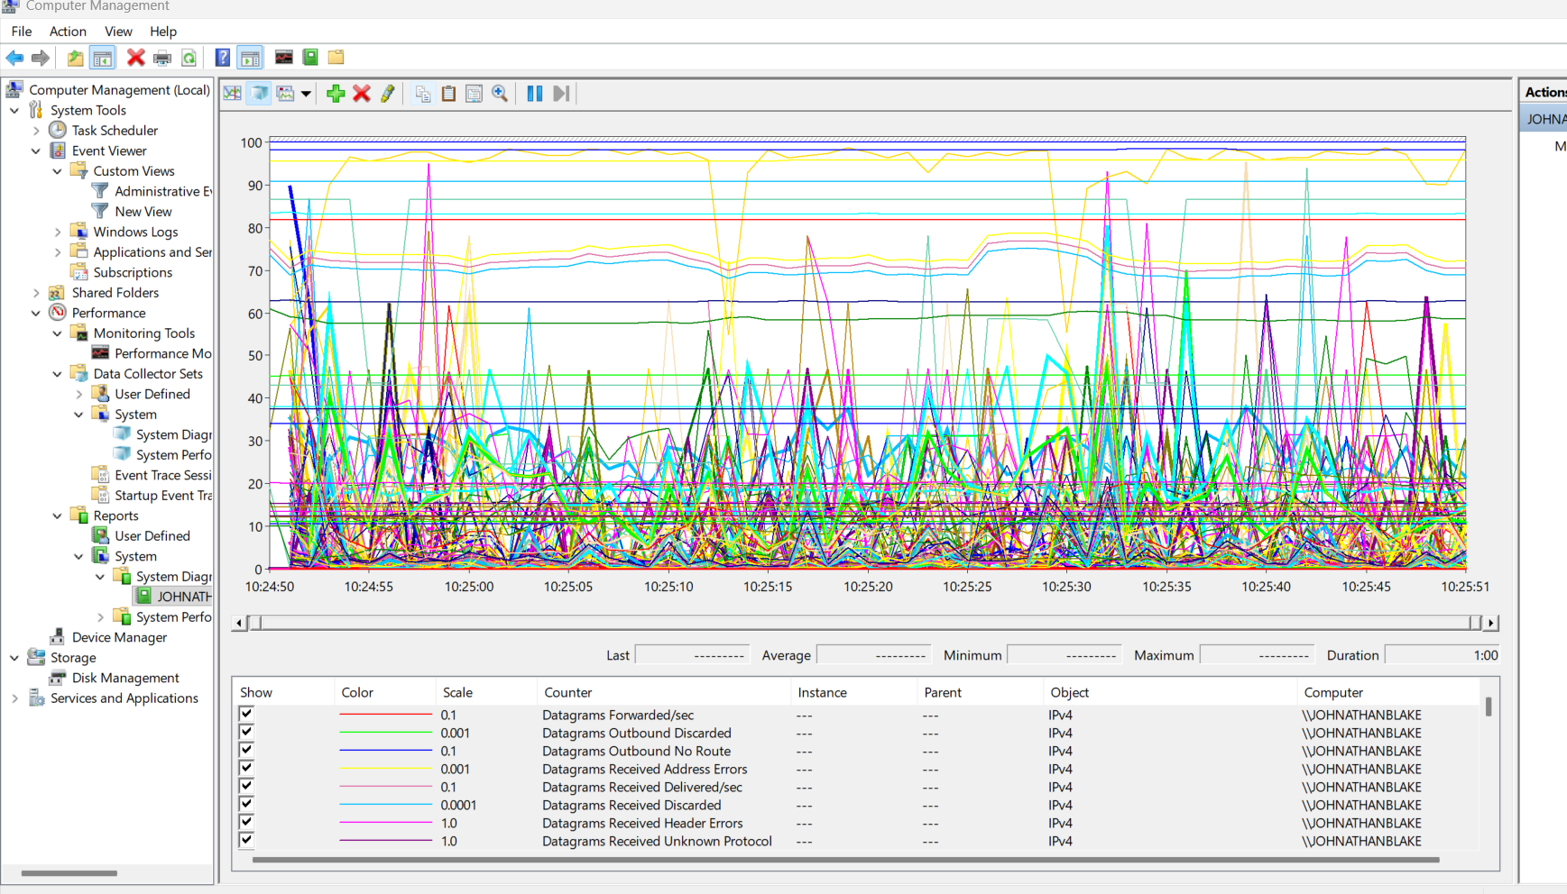
[3] This allows to record and monitor system performance in real time, this can be RAM, CPU, NETOWORK/WIFI, DISK USGAE/ACTIVITY, this can help troubleshoot issues and perfect performance effectively

Resource Monitor
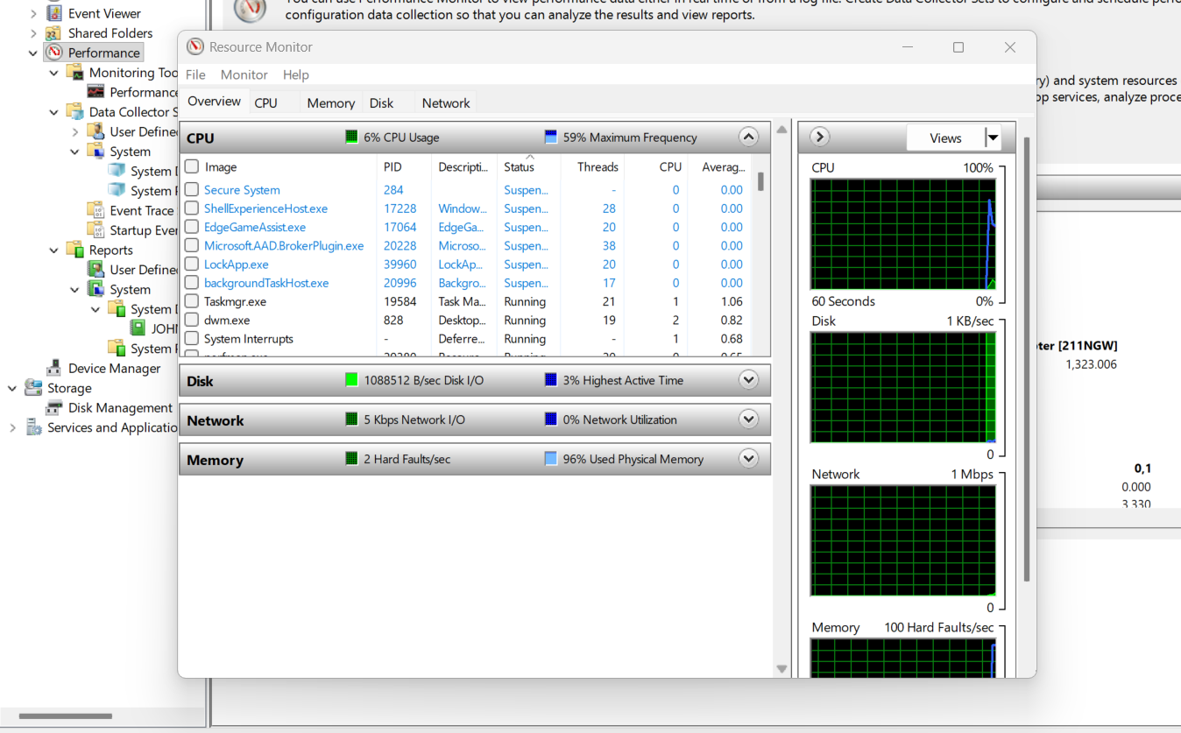
[1] [4]This utility gives ability to monitor the usage of the hardware and software that are being used up in real time, it is a more advance tool than ‘Task Manager’ as it provides more details for its usage of CPU, DISK, NETWORK, and MEMORY/RAM,

Reliability monitor
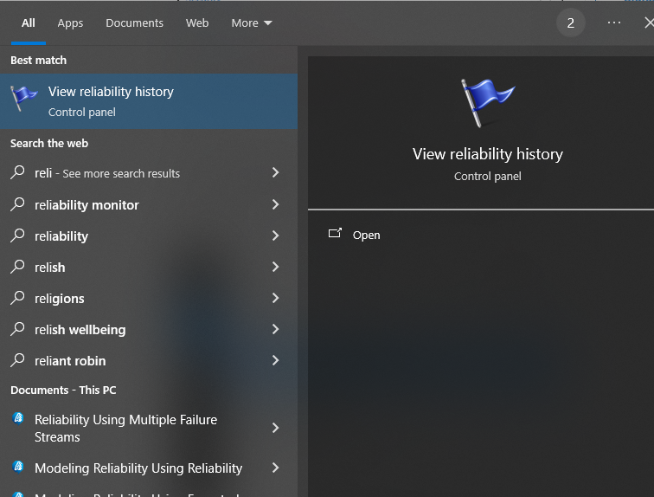
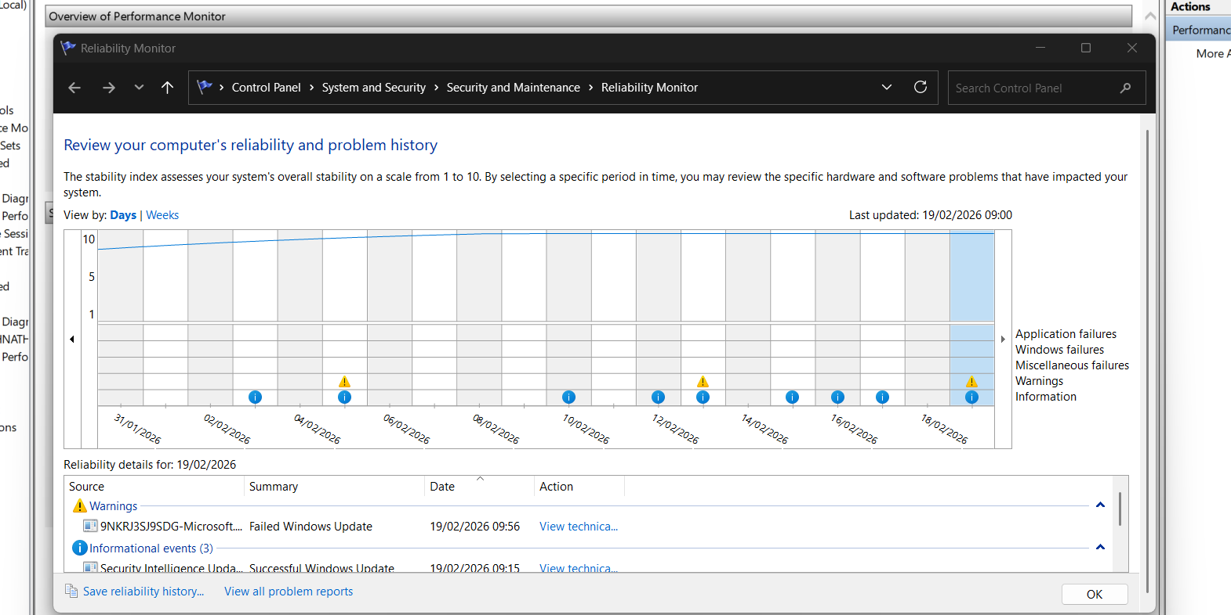
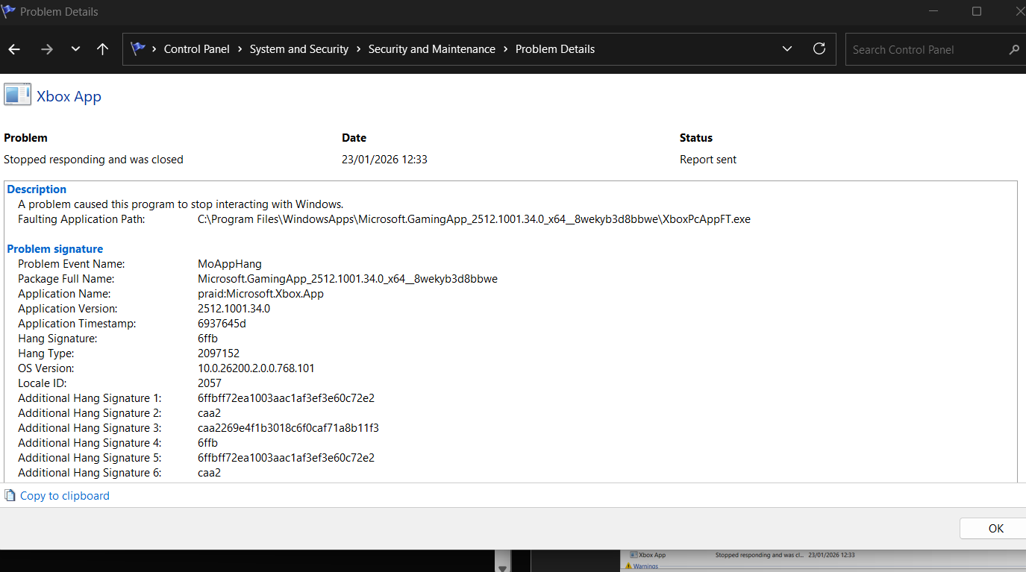
[5]The monitor identifies software problems which could affect the system’s performance and reliability!

Task Manager
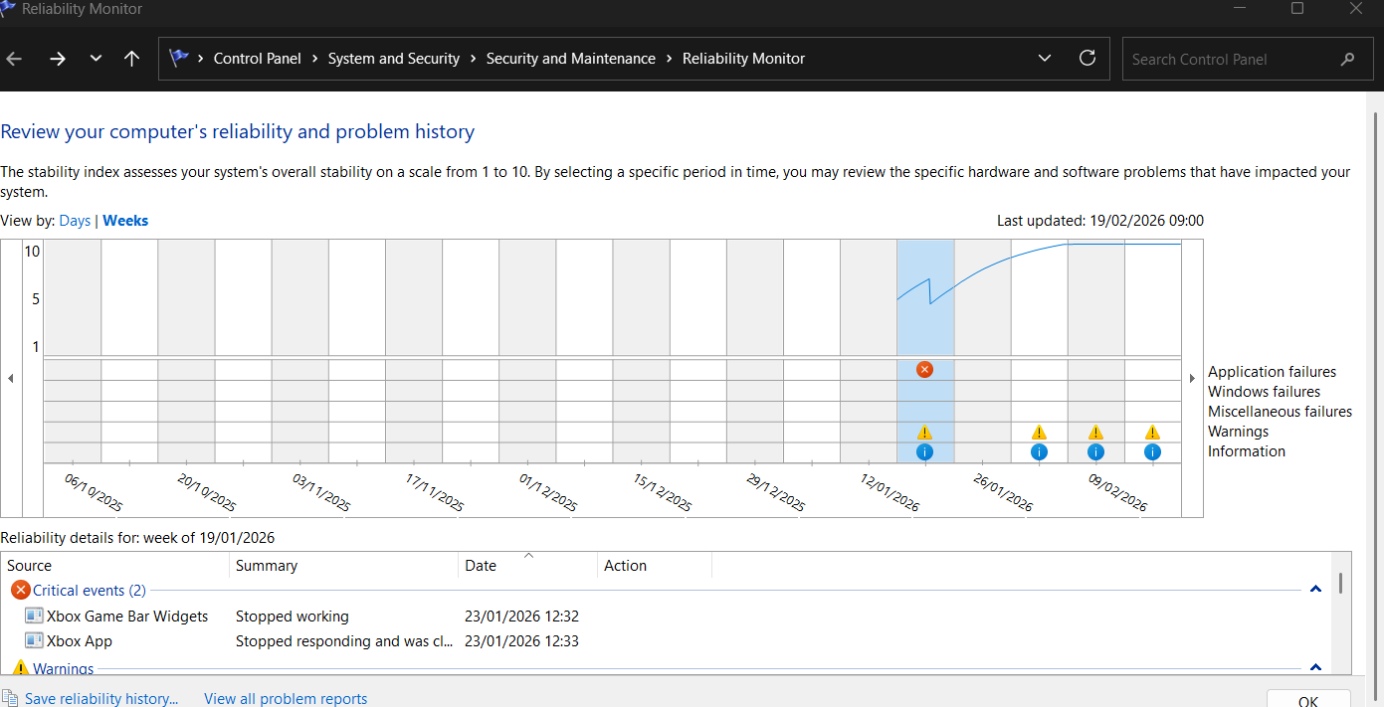
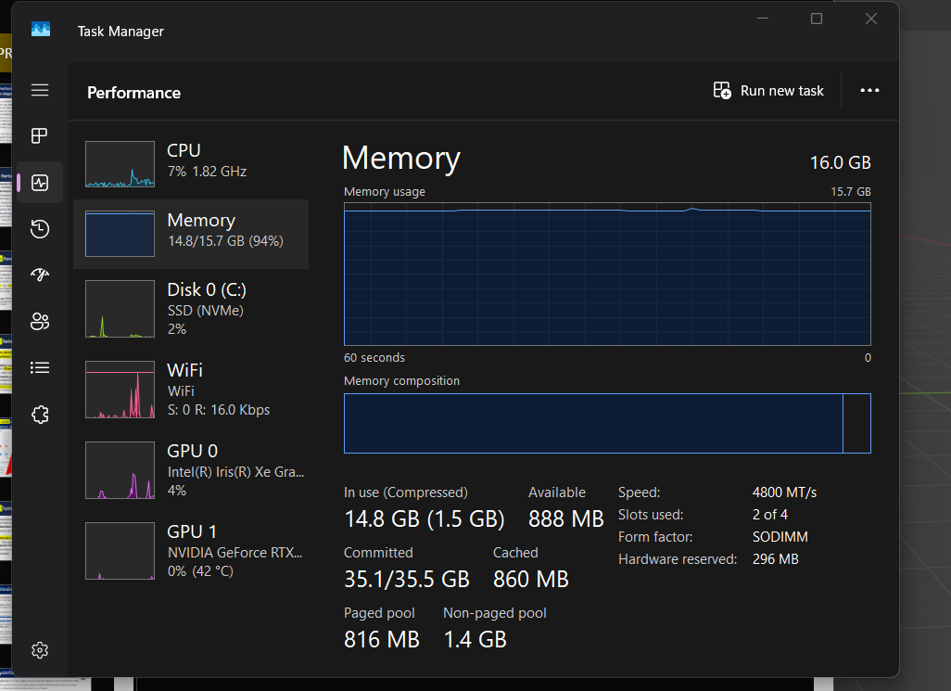
[6]Like resource manager it will show the user how much resources are being consumed in real-time, seeing from software and hardware too. It’s a much cleaner and user-friendly looking piece of software that is normally used for basic things like seeing what’s being run right now, it can also force close programs too

WINDOWS SYSINTERNALS SUITE
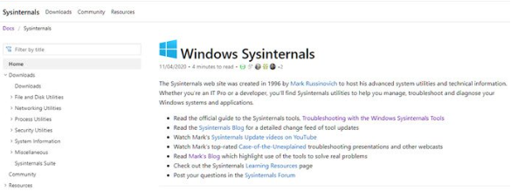
[7]It’s a set of utilities as well being a website which was created by Mark Russinvich and Bryce Cogswell, hosting the utilities for the system and technical information, mainly developer’s and IT would be the one’s using this sort of thing as it is used to diagnose and troubleshoot windows systems and applications

SYSINFORMER
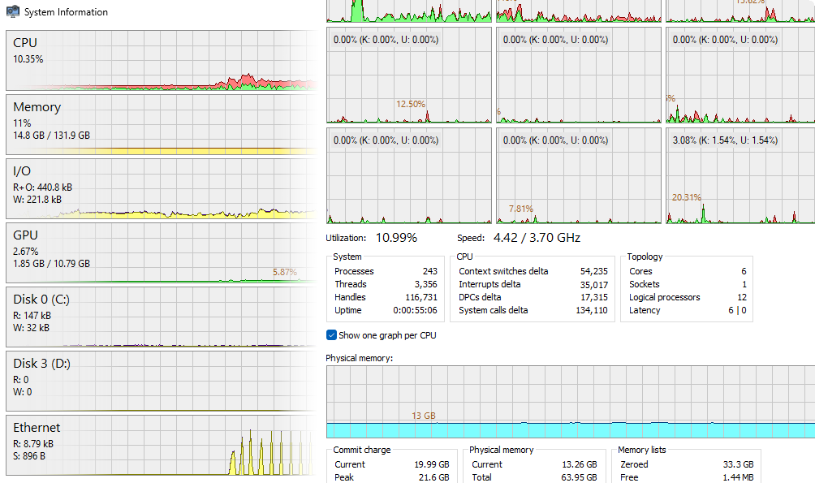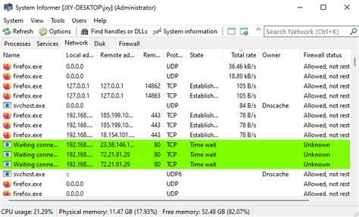
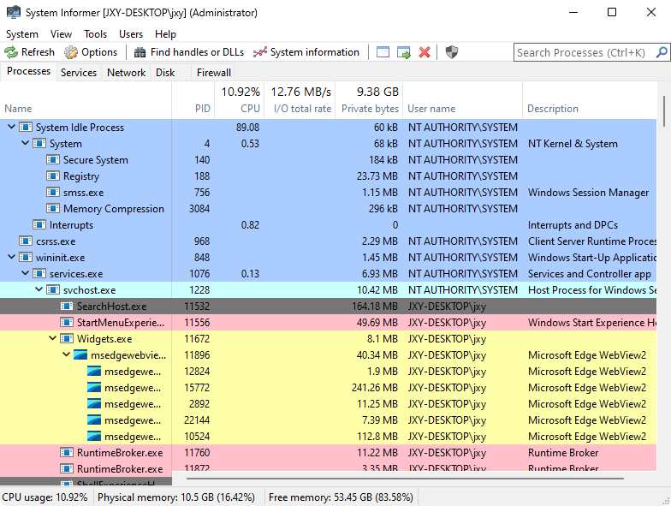
[8] A tool to download that’s a multi-purpose tool that monitors system resources, debug software and detecting any malware/viruses, it is like task manager and resource manager, but it is more detailed and will provide detailed graphs and statistics in to help tracking resource usage and more

RAMMAP
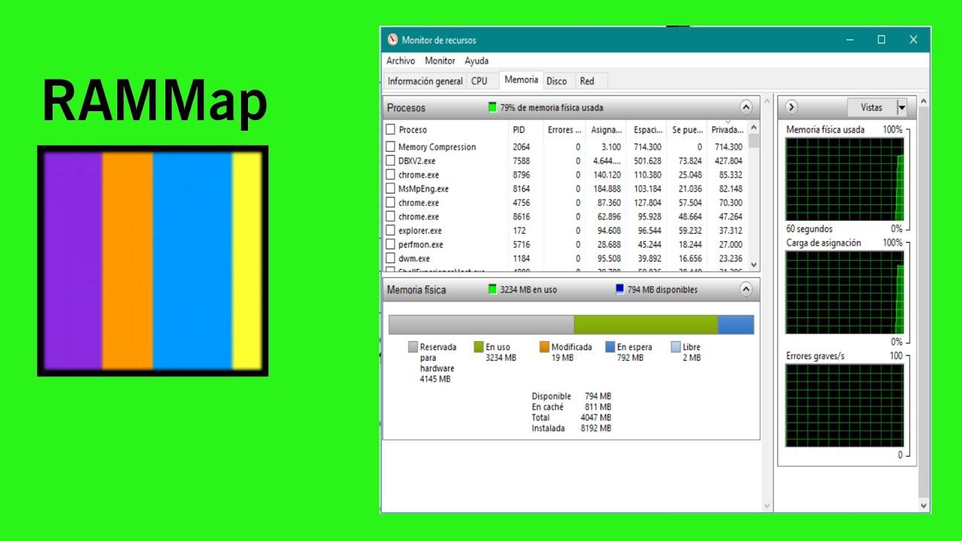
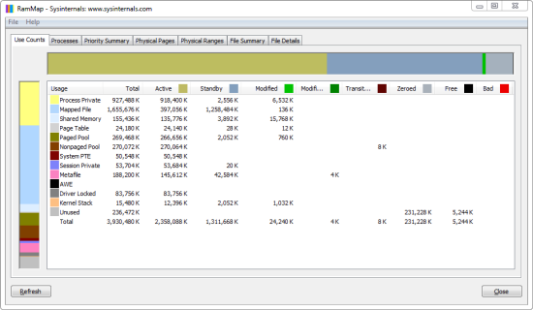
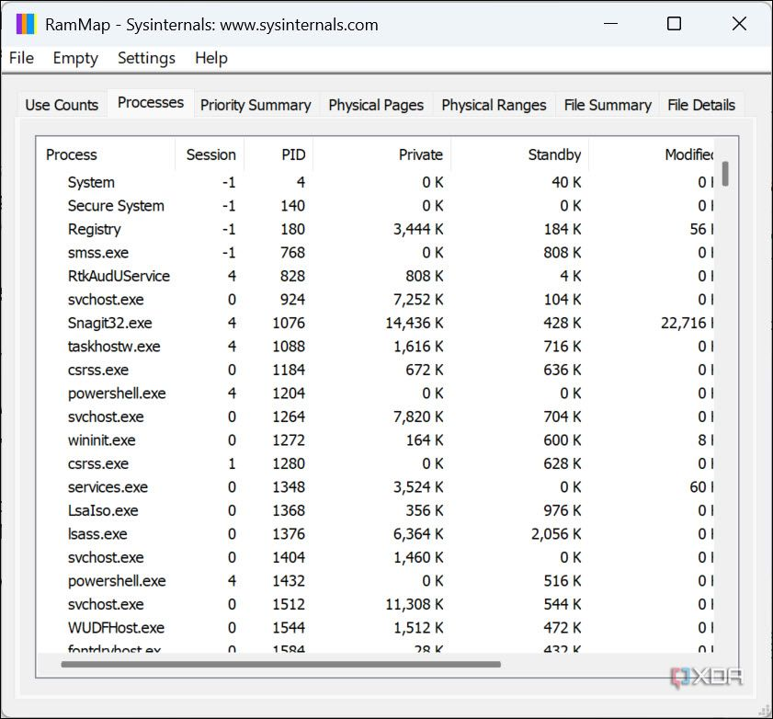
[9]An analysis tool utility tool, provides detailed insights on how Windows allocates, manages RAM (Physical memory), and a great detailed way to look at the memory usage, a great tool for administrators, developers and IT

Group Policy Management
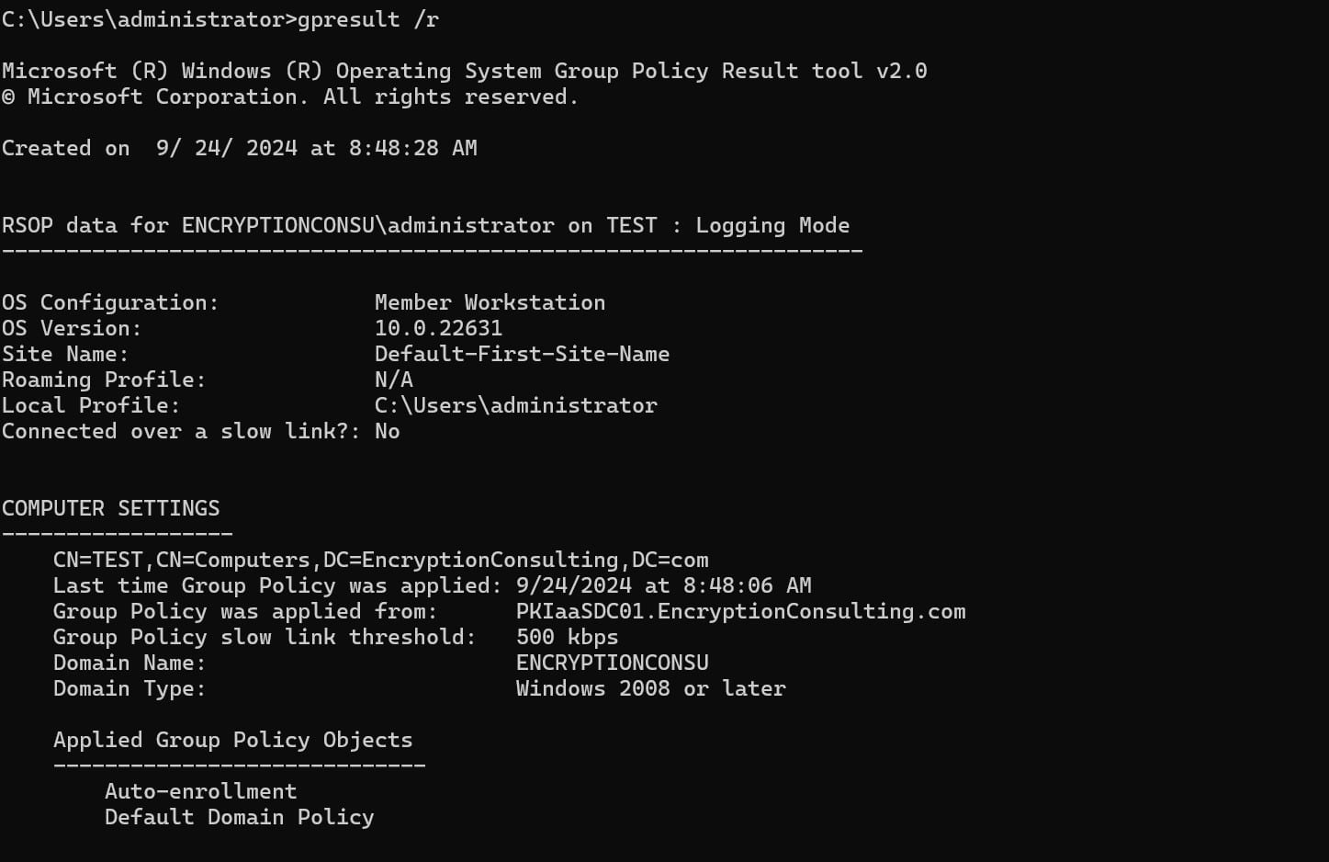
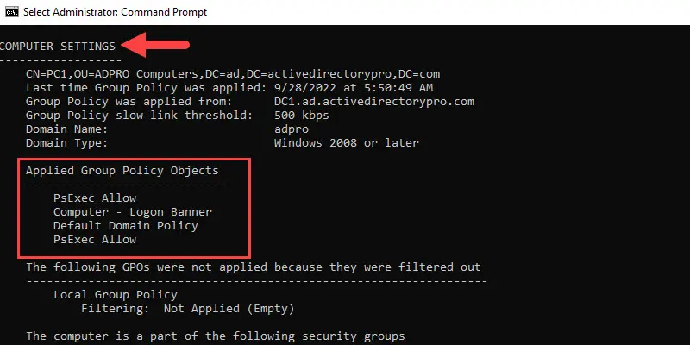
[10]A powerful tool to help manage group policy across anyone on the network connected, it contains lots of group policy management functionalities into a single console, easier to manage GPOs, WMI’s filters and other related permissions

SYSTEM FILE CHECKER
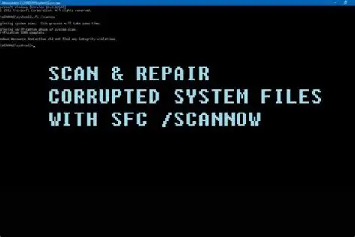
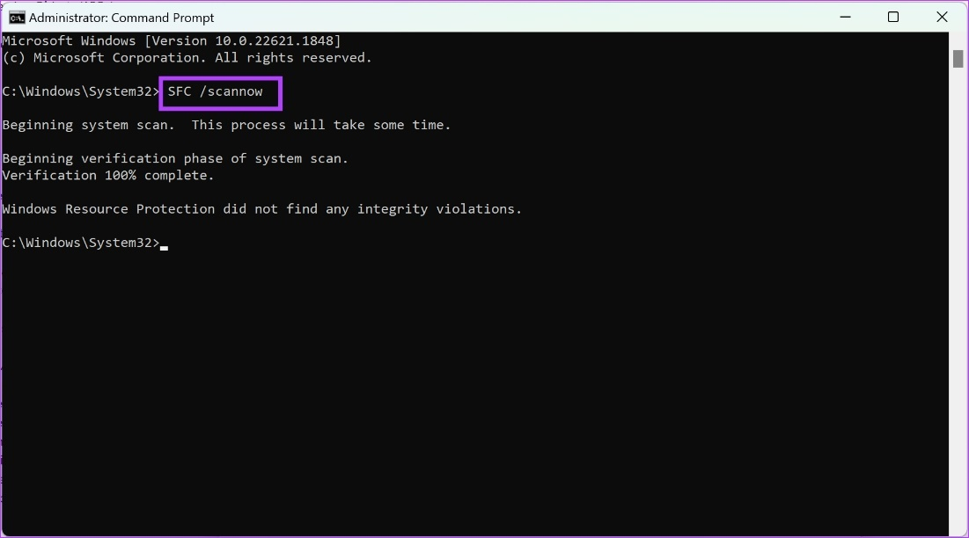
[11]This tool here using CMD (command line) we can scan system files which if any corrupted files are present then they can be replaced with a cached copy that is in a folder at “%WinDir%\System32\dllcache”

FILE SYSTEMS
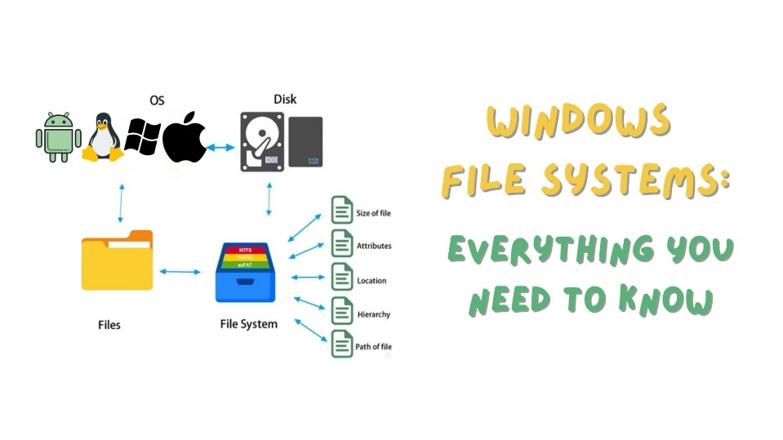
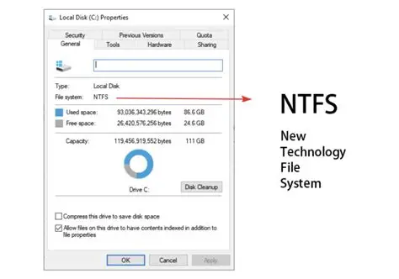
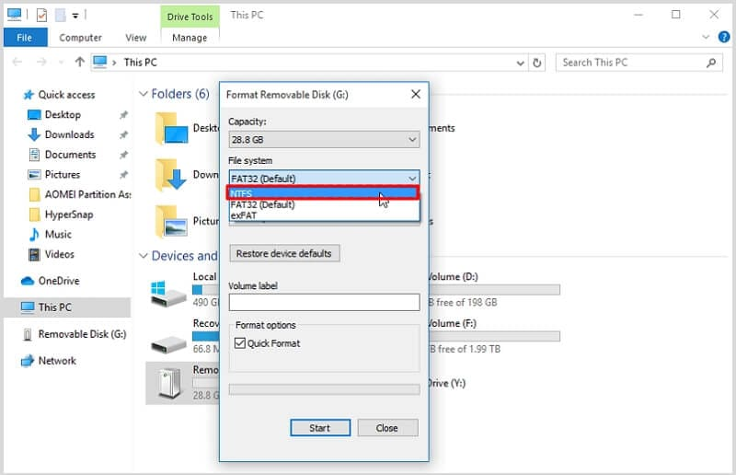
[12]it manages and organizes files and its directories on storage devices it is a bridge to ‘Operating System’ and physical storage devices like SSD’s and HDD’s; it has multiple types of file systems that are used in the world with some being NTFS for Modern Windows! And EXT for it being used for Linux and Unix based operating systems

System Monitoring & Management with a CLI
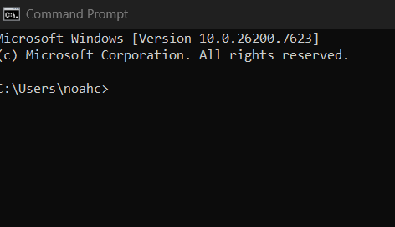
[13]Using commands such as systeminfo to check specifications of the system and using netstat to track network activity

Back-up and Restore system files
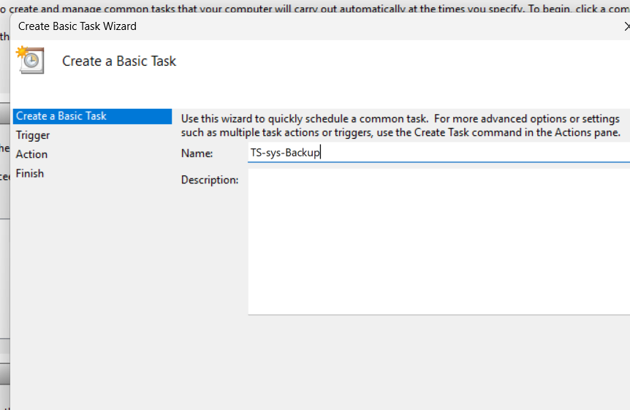
[14]Critical tool for managing and protecting files from being corrupted!
Backing up files is one way in improving life and mental health when folder gets corrupted and have an exact copy that is automated to be done (depending on when scheduled it) at that time! can do this in multiple ways, but this is one of them!

TASK 2 POWERSHELL!

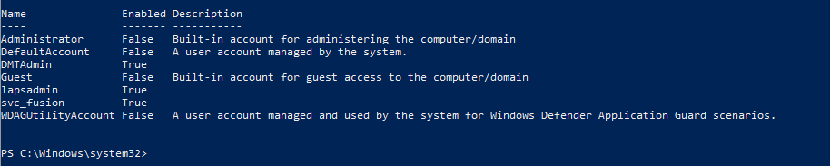
Get-ScheduledTask
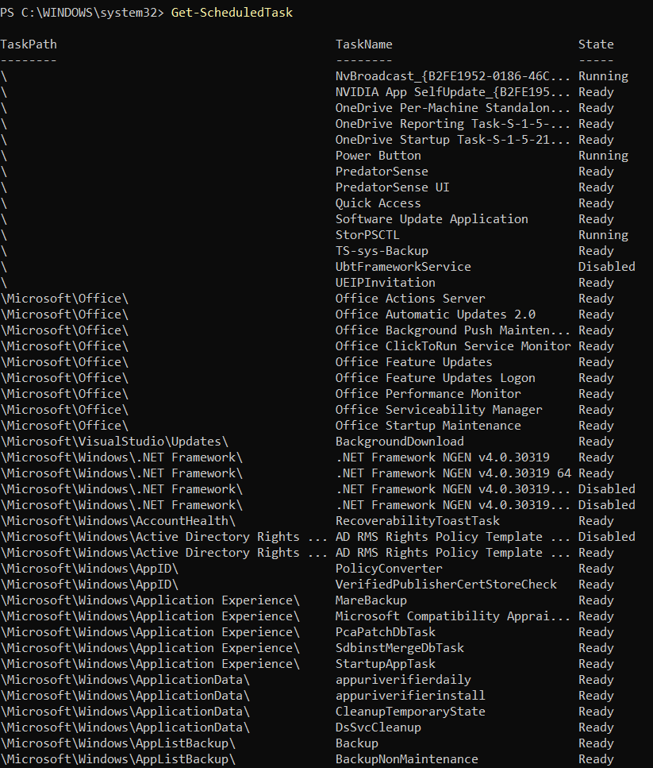
[15] this will grab all scheduled tasks that are currently on the computer and will list them out saying if they are running or not (for example would be asking if Google chrome is running on the computer).
Get-ScheduledTask | Get-ScheduledTaskInfo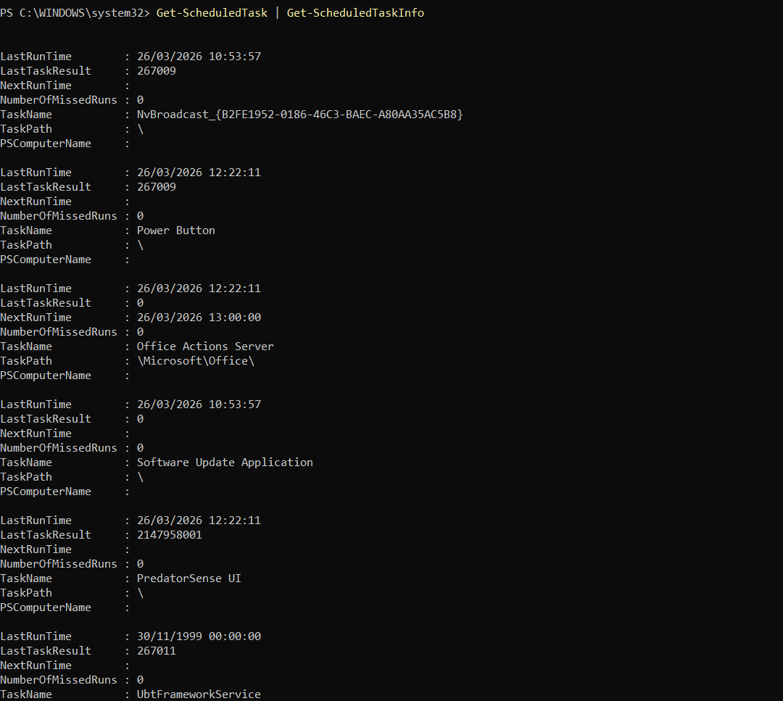
[16] this manages and monitors all the scheduled tasks on the computer which with these 2 commands combined “Get-ScheduledTask” and “Get-ScheduledTaskInfo” will give information about the scheduled tasks, making it more detailed but however messier and more difficult to find specific tasks due to the amount listed.

Get-ScheduledTask -TaskName “InsertNameHere”
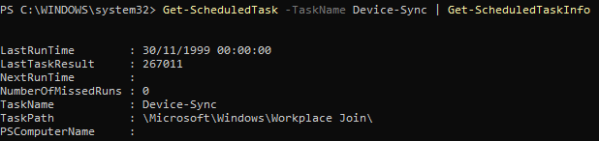
[17] This finds a specific Task that will want to investigate onto (Such as Device-Synce and has a few details about it as well as its path)
It shows its “LastRunTime” its name “TaskName” and its path (where it belongs) “TaskPath.
Smaller than the previous instruction which can be useful if you are only needing to find certain tasks

Get- ScheduledTask | Format-list TaskName, TaskPath, State
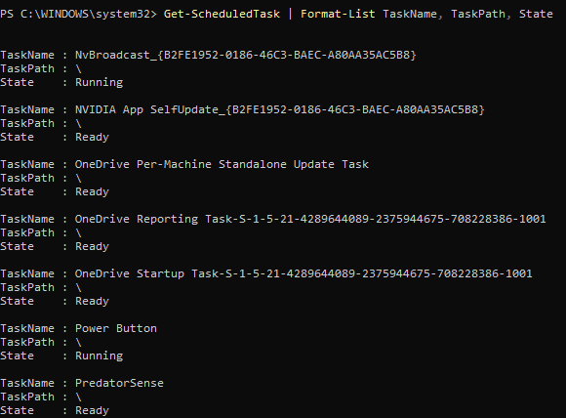

[18] the command will give a list to all the scheduled tasks that are on the device which then formats the outputted display the task’s name, path, and its current state of each task
This also shows id that task is currently on, this is measured in the “State” section of the output
It is the same as copying and pasting a file put with PowerShell/commands which is quick if had multiple files with multiple directories.
Think of it as Ctrl+C Ctrl+V scripting, this is great for saving a bit of time doing this way than compared to looking into files through a GUI,

Task 3
- ls -la
this command lists the files and its directories which gives us the first part “ls” whilst ‘-l’ means it will give detailed information such as the size, date, owner etc and the ‘a’ will mean ALL the files including any hidden ones such as some system files and potentially some more higher-level malware
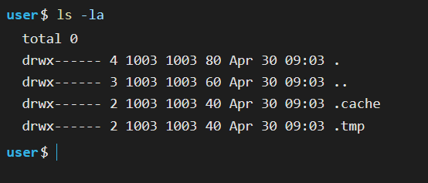
- cd
this stands for “change directory” which is how can navigate through the Linux files using the terminal
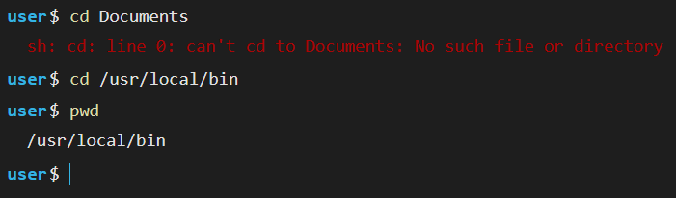
- pwd
it shows the currently where are in the files, this would be useful if had forgotten the line, are on when navigating through the terminal
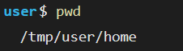
- echo -e “hello\nWorld”
this allows me to use special characters in my “” such as \n \b or \i, these are great for having data looking more presentable and readable on screen
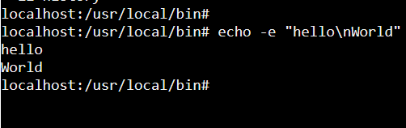
- whoami
this tells the user what their name is, if there are in a company they can see who is logged onto their machine or to see if they are in the correct account
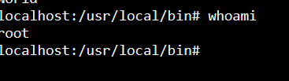
(since I am using the website version of the Linux, I cannot make my own username thus giving me the name “root”)

- rm -f file.txt
“rm” means deleting files or directories whilst the “-f” will not prompt the user if they want to delete the file, however the lower case “i” will ask the user of they are sure
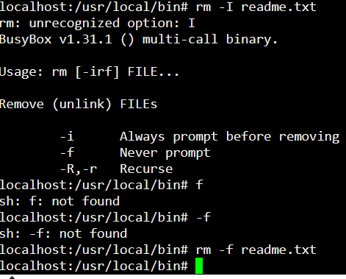
- ps aux
the “ps” will list all processes that are currently running on the system, and the aux is a combination of many instructions but in short, it shows all in a user-oriented format’ and includes processes without a controlling terminal
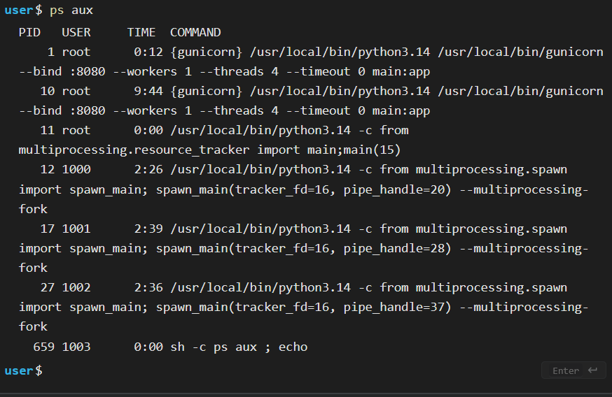

- netstat -tuln
“netstat” displays network connections (such as connectToMe123 or FreeWifi) and any listening ports, and the -tuln is a combination but in short “t” is for TCP connections, “u” is for UDP connections, “l” shows listening ports, “n” shows numeric values e.g. IP Addresses and the port numbers
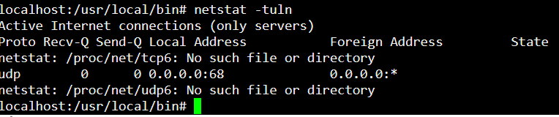
(this may have happened due to me using a browser version of this command line interface instead of the Linux operating system itself)
- ps aux | grep firefox
the “PS” will mean process status which it could give the user details on usage of the memory or PID (Process ID), the aux is a combination, “a” is for listing the processes that are for all “u” an detailed format for the details given by PS, “x” will include the background processes (but not the terminal)
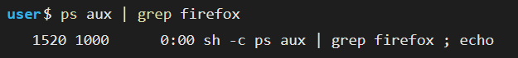
- clear
will clear the screen to make it look more reedable
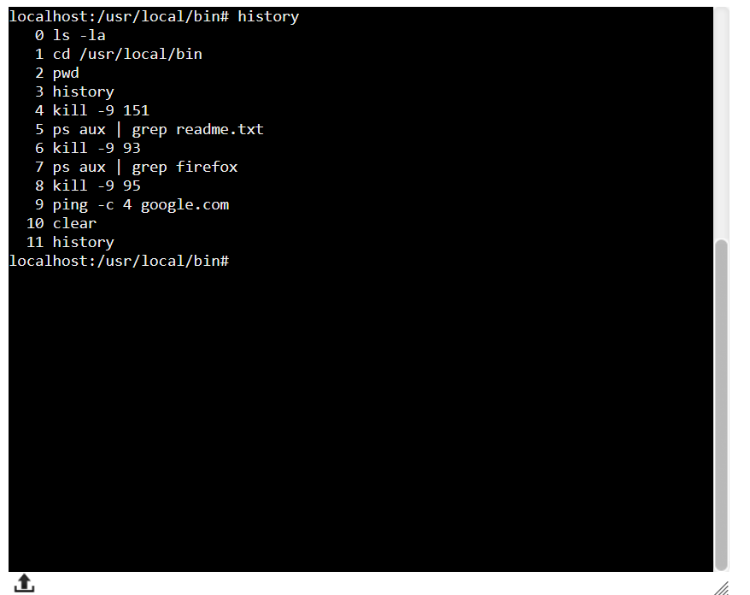
- Ping -c 4 google.com
This allows to check if a site is up as well as to see if ’re networking is up and connected to the internet
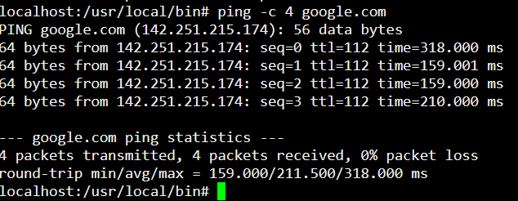

- History
This shows the history of commands have used in the program which allows to look back and see what they have might entered
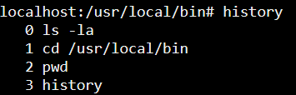

TASK 4 Batch Lecture

•Bat/Batch is a very useful, easy to use, powerful, little retro language.
•It is still used in industry and has seen a resurgence in recent years.
•It is ‘Easy to learn’ (can learn the syntax in a day) useful for and used by experienced programmers and system administrators.
•Windows OS has two command-line shells: the Command Shell (CMD) and PowerShell.
•The Command shell (CMD) is the original Windows OS shell / CLI built into Windows to automate admin tasks such as device & network troubleshooting, user account management or creating nightly backups, with batch (.bat) files.
•Batch scripting is a simple yet powerful way to automate tasks in Windows.
•Although Microsoft’s new CLI & scripting language ‘PowerShell’ (covered soon in the module) is more powerful and allows greater functionality. Batch’s simplicity and ease of use result in its continued popularity and is still used today.
•Historically Bat has and is used to create command line Games and Animation.
•Although somewhat of a legacy tech, it is still popular and used in today.

• [19]A bat file is a text file with a .bat file extension and is written using a text editor e.g. Notepad++.
•Bat files open the ‘Command Prompt’ when they are executed i.e. when double click on them or run them from the CLI.
•Pretty much any task needs to do on a Windows OS can be done with a Bat command or script. They are used by system administrators for more advanced functionality.
•Bg. Bat scripts are used by System Administrators to run programs, perform system updates, system scanning, automation to execute common/repetitive tasks e.g., back up files, batch processing tasks, to review processes & log files, run system diagnostics etc.
[19]Tip: cls clears in the cmd CLI.

Example of batch code

@ echo off

Set name=Tom
Set /A age=21
Echo %name%
Echo %age%
Set info=My Name is: %name%, Age: %age%, I an adult :o).

Pause

User Input, if & Goto commands

@echo off
set var=1
if %var%==1
goto code1
goto code2

: code1
echo the variable is 1
goto end
: code2
echo the variable is not 1
: end
echo End of program :)

BATCH SCRIPT WRITING TASK 4
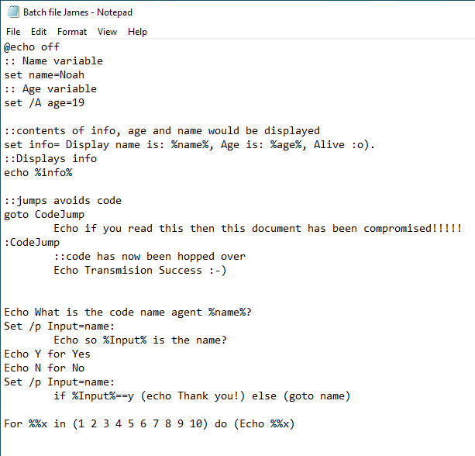
This is an account system where if you have gotten the wrong name, you wouldn’t have access the secret files/account, with the variables storing age and name

Menu Based Program Scripting PowerShell
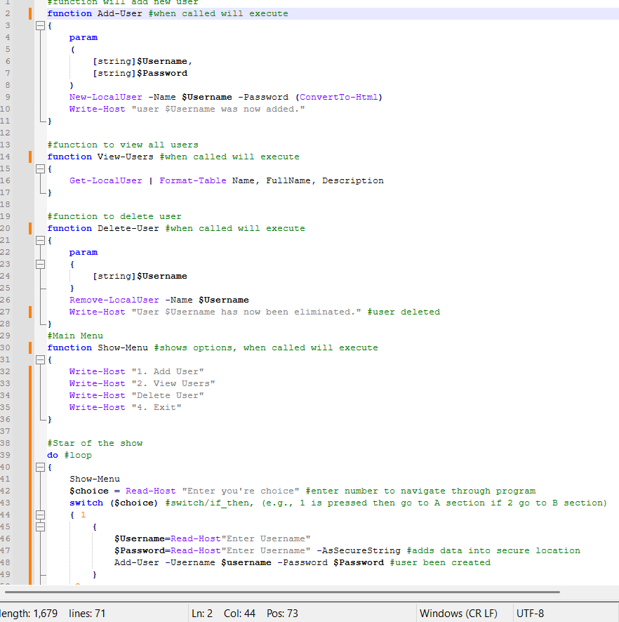
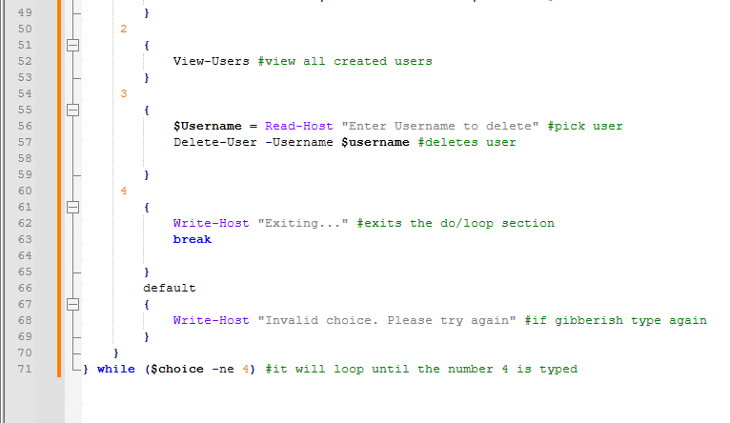
This is a script that is made to create , view , and delete . create them by giving them Usernames and “Password’s”, after that can see how many have created and can also try then deleting them too
[20] On line 47 “AsSecureString” this will encrypt the text typed down into a series of random letters, numbers, and special characters which will make It difficult to try and crack down on.
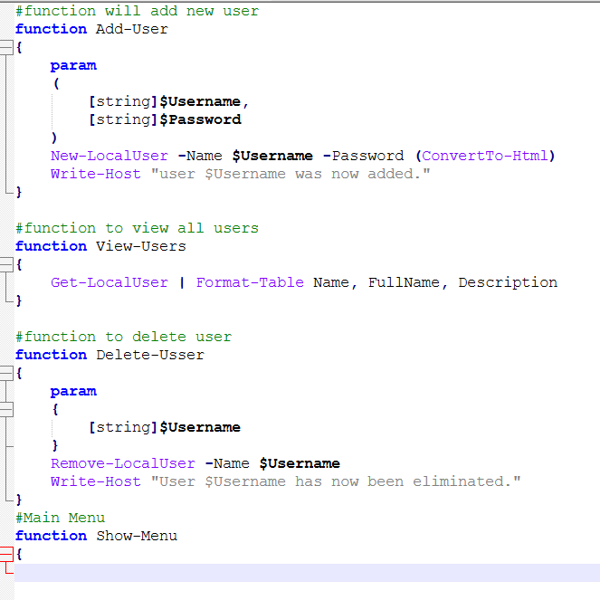

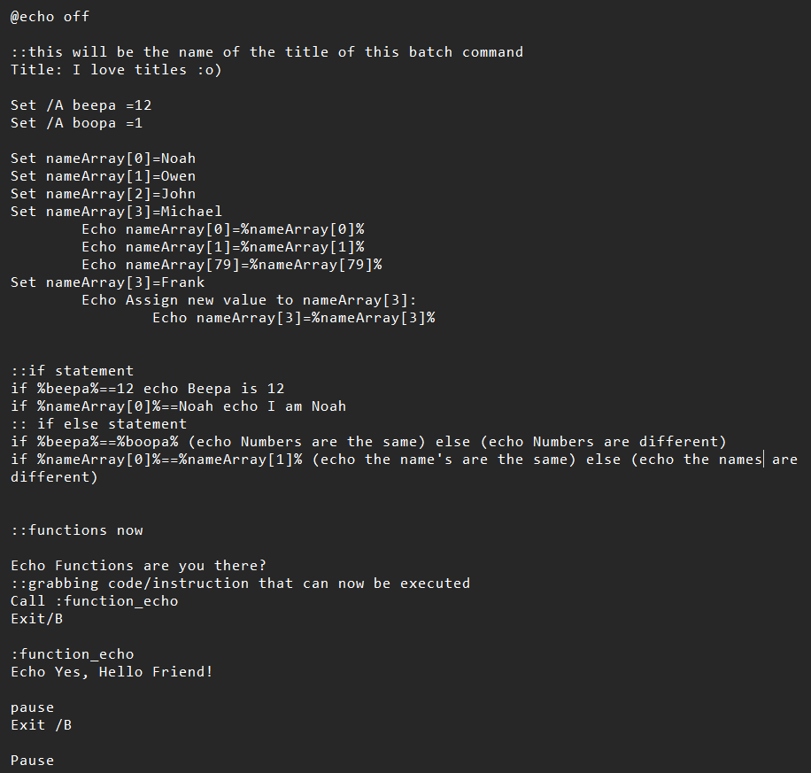
This was use of this was to create arrays of names with variables Beepa and boopa, with its if statements, arrays, variables, and functions

TASK 5 Lecture Bash

Bash (Bourne Again SHell) is a command script language used
For pc’s

Multiple choice Menu
Hello world!
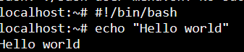
[21]Basic variable which stores data temporarily inside of the RAM
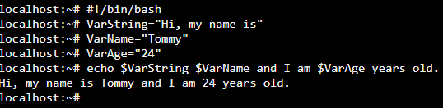
[22]User Input which allows to feed the program data and perhaps store into ram or into a disk drive
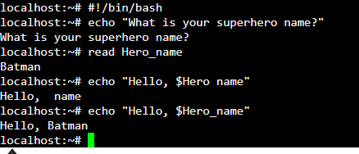
[22]User input –p option, prompting a string of arguments using “read -p”
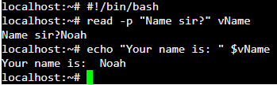
Arithmetic Cont
Num1=”8”
Num2=”9”
Echo $(( num1+ 1 ))
#Gives us 9
# :o)
Echo $(( num2 + 1))
#gives us 10
#:o)
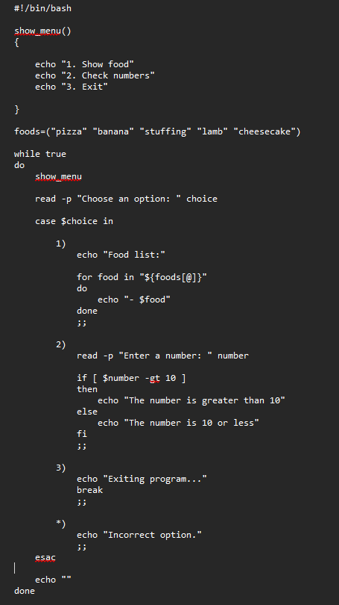
#!/bin/bash

show_menu()
{

echo "1. Show food"
echo "2. Check numbers"
echo "3. Exit"

}

foods=("pizza" "banana" "stuffing" "lamb" "cheesecake")

while true
do
show_menu

read -p "Choose an option: " choice

case $choice in

1)
echo "Food list:"

for food in "${foods[@]}"
do
echo "- $food"
done
;;

2)
read -p "Enter a number: " number

if [ $number -gt 10 ]
then
echo "The number is greater than 10"
else
echo "The number is 10 or less"
fi
;;

3)
echo "Exiting program..."
break
;;

*)
echo "Incorrect option."
;;
esac

echo ""
done

Cisco, Operating Systems Basics

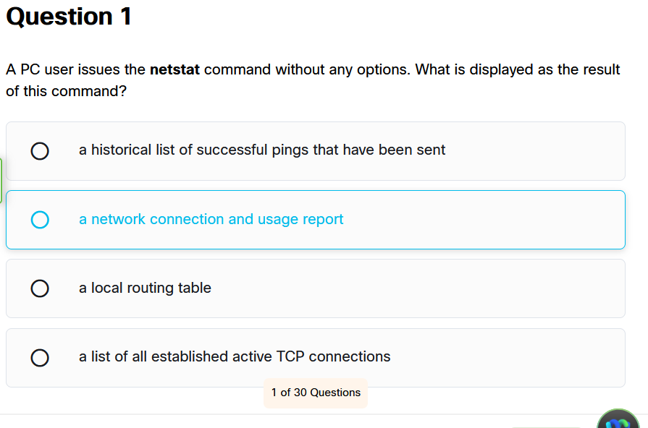

Bibliography

[1] | WikiPedia, “Resource Monitor,” Wikipedia, 15 1 2023. [Online]. Available: https://en.wikipedia.org/wiki/Resource_Monitor. [Accessed 26 2 2026].
[2] | A. Khanse, “How to use Event Viewer in Windows 11,” Thewindowsclub, 2 2 2025. [Online]. Available: https://www.thewindowsclub.com/how-to-use-event-viewer-in-windows. [Accessed 14 5 2026].
[3] | Lenovo, “What is a performance monitor,” Lenovo, [Online]. Available: https://www.lenovo.com/us/en/glossary/what-is-performance-monitor/. [Accessed 19 2 2026].
[4] | HemantS@TWC, “How to use Resmon or Resource Monitor in Windows 11,” TheWindowsClub, 25 8 2017. [Online]. Available: https://www.thewindowsclub.com/use-resource-monitor-windows-10. [Accessed 26 2 2026].
[5] | Dell Technologies, “How to Use Windows Reliability Monitor to Identify Software Issues,” Dell, 21 7 2025. [Online]. Available: https://www.dell.com/support/kbdoc/en-uk/000178177/how-to-use-windows-reliability-monitor-to-identify-software-issues?msockid=1948677aa7e06a711e9d7076a6ac6b80. [Accessed 26 2 2026].
[6] | T. Fisher, “Task Manager: What It Is & How to Use It,” Lifewire, 22 9 2022. [Online]. Available: https://www.lifewire.com/task-manager-2626025. [Accessed 26 2 2026].
[7] | AshishMohta@TWC, “Sysinternals Suite: Manage, troubleshoot, diagnose Windows OS,” The Windows Club, 17 11 2022. [Online]. Available: https://www.thewindowsclub.com/microsoft-sysinternals-suite-manage-troubleshoot-diagnose-windows-systems-and-apps. [Accessed 26 2 2026].
[8] | System Informer, “System Informer,” Systeminformer.com, 2026. [Online]. Available: https://www.systeminformer.com/ . [Accessed 26 2 2026].
[9] | M. Russinovich, “RAMMap - Sysinternals,” learn.microsoft.com, 4 2 2026. [Online]. Available: https://learn.microsoft.com/en-us/sysinternals/downloads/rammap. [Accessed 26 2 2026].
[10] | O. Thomas, “Group Policy Management Console in Windows,” learn.microsoft.com, 22 4 2024. [Online]. Available: https://learn.microsoft.com/en-us/windows-server/identity/ad-ds/manage/group-policy/group-policy-management-console. [Accessed 26 2 2026].
[11] | Microsoft, “Use the System File Checker tool to repair missing or corrupted system files,” support.microsoft.com, 2018. [Online]. Available: https://support.microsoft.com/en-us/topic/use-the-system-file-checker-tool-to-repair-missing-or-corrupted-system-files-79aa86cb-ca52-166a-92a3-966e85d4094e. [Accessed 26 2 2026].
[12] | geeksforgeeks, “File Systems in Operating System,” geeksforgeeks, 10 2 2017. [Online]. Available: https://www.geeksforgeeks.org/operating-systems/file-systems-in-operating-system/. [Accessed 26 2 2026].
[13] | Nova, “Top 10 Ways to Monitor Windows Command Line Tools in Windows 11,” glarysoft, 21 7 2025. [Online]. Available: https://www.glarysoft.com/how-to/top-10-ways-to-monitor-windows-command-line-tools-in-windows-11-2/. [Accessed 18 5 2026].
[14] | Handy Backup, “Image Backup Software for Windows 11, 10,” Handy Backup, [Online]. Available: https://www.handybackup.net/windows-image-backup.shtml. [Accessed 18 5 2026].
[15] | Microsoft, “Get-ScheduledTask,” [Online]. Available: https://learn.microsoft.com/en-us/powershell/module/scheduledtasks/get-scheduledtask?view=windowsserver2025-ps#description. [Accessed 26 3 2026].
[16] | AI, what does Get-ScheduledTask | Get-ScheduledTaskInfo do?, N/A: DuckDuckGo, 2026.
[17] | AI, what does Get-ScheduledTask -TaskName "InsertNameHere" do?, N/A: DuckDuckGo, 2026.
[18] | Microsoft, “Functions/Get-ScheduledTask.ps1,” Microsoft, [Online]. Available: https://www.powershellgallery.com/packages/Carbon/2.1.0/Content/Functions%5CGet-ScheduledTask.ps1. [Accessed 26 3 2026].
[19] | L. Madhu, “What is a BAT file and what is it used for?,” SuperOps, 10 3 2026. [Online]. Available: https://superops.com/tech-hub/what-is-a-bat-file. [Accessed 14 5 2026].
[20] | Microsoft, “ConvertTo-SecureString,” Microsoft, [Online]. Available: https://learn.microsoft.com/en-us/powershell/module/microsoft.powershell.security/convertto-securestring?view=powershell-7.6. [Accessed 7 5 2026].
[21] | W3Schools, “Bash Variables,” W3Schools, [Online]. Available: https://www.w3schools.com/bash/bash_variables.php. [Accessed 18 5 2026].
[22] | geeksforgeeks, “Bash Script - Read User Input,” geeksforgeeks, 17 11 2025. [Online]. Available: https://www.geeksforgeeks.org/linux-unix/bash-script-read-user-input/. [Accessed 18 5 2026].
[23] | geeksforgeeks, “Linux System Monitoring Commands and Tools,” geeksforgeeks, 17 1 2024. [Online]. Available: https://www.geeksforgeeks.org/linux-unix/linux-system-monitoring-commands-and-tools/. [Accessed 26 2 2026].

