Community Care and Management of Longer-term Conditions

Managing Chronic Obstructive Pulmonary Disease in Adults
  - An information booklet for health and care professionals in England
Community management with Greater Manchester as the local policy example.
LCHS7003 | Component 1
MSc Public Health and Social Care in Practice
17 October 2026
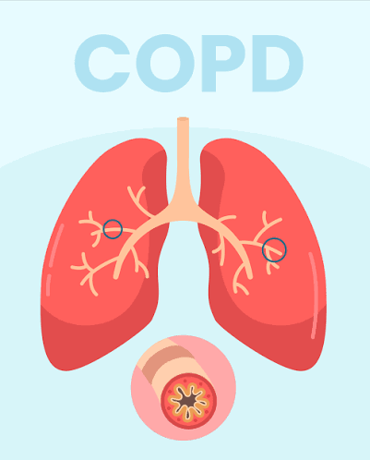

Table of Contents
Introduction 3
Understanding COPD and Its Burden 3
Definition and Diagnosis 3
Worldwide and UK Burden 3
Causes and Unequal Exposure 4
The Impact on Individuals and Families 4
Physical Function and Treatment Burden 4
Psychological Wellbeing 5
Social Participation and Inequality 5
Family Carers 5
Evidence-Based NHS Treatment and Support 6
Prevention and Medicines 6
Rehabilitation and Integrated Management 6
Exacerbations and Specialist Assessment 6
Whole Person Community Care Models 7
The UK House of Care framework 7
The International Chronic Care Model 7
Compare and Critically Use 8
National and Local Policy Implementation 8
England’s National Agenda 8
Greater Manchester as A Local Example: 9
Recommendations and Conclusion 9
Enhance Access and Support Self-Management 9
Integrate Carers and Palliative Care 10
Assess Improvement 10
References 11

Introduction
The management of chronic obstructive pulmonary disease (COPD) needs continuous support from primary care, hospitals, and community services. This booklet is for health and care professionals working with adults in England, and Greater Manchester was identified as giving an example of a policy in the area. The wider burden is set out in UK-wide and international evidence, and recommendations are placed in the context of England's health and social care system. The main point is that management needs to take into account not only physical issues but also psychological well-being, social issues, and family support. The prescription of drugs is not sufficient to provide whole-person care (Global Initiative for Chronic Obstructive Lung Disease (GOLD), 2026).
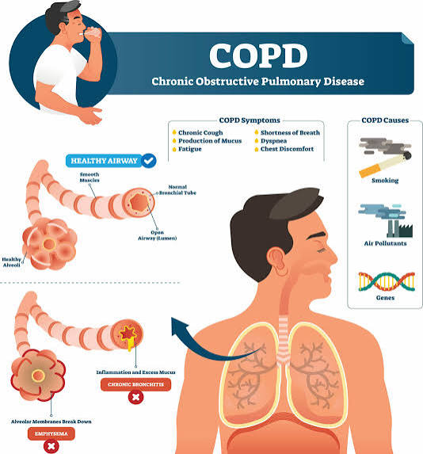
The booklet reviews treatments, the framework of the UK House of Care and the international Chronic Care Model, and policy implementation. This type of model organizes care but does not supersede clinical guidelines. Recommendations are based on published evidence and on identifying measures that can be taken in order to assess improvement.

Understanding COPD and Its Burden

Definition and Diagnosis
COPD involves persistent respiratory symptoms and airflow obstruction associated with abnormalities of the airways and alveoli. This may be complicated by chronic bronchitis and emphysema. Symptoms are usually characterized by breathlessness, cough, sputum, and fatigue. The clinical evaluation and post-bronchodilator spirometry are necessary to make a diagnosis, not symptoms or smoking history alone (National Institute for Health and Care Excellence (NICE), 2018a). Diagnostic accuracy is important, as breathlessness can also be caused by cardiac disease, asthma, or other disease, and an appropriate label may be delayed until the correct diagnosis is made.
GOLD (2026) acknowledges that COPD is not a single entity and that there is more to be assessed than just airflow limitation. A spirometry result reflects the person's breathing capacity, but not how well they can wash, work, or relate to others. Thus, there is a need for practitioners to complement physiological assessments with symptom burden, exacerbation history, and the person's priorities. This prevents the act of measuring a student without speaking to the student's disability.

Worldwide and UK Burden
In 2019, 391.9 million, or 10.3%, of the population aged 30 to 79 years were estimated to have COPD worldwide by using the GOLD spirometric definition (Adeloye et al., 2022). The alternative lower-limit-of-normal definition produced an estimate of 292.0 million. This marked difference highlights the importance of defining diagnostic thresholds and making modelling assumptions, as neither does a direct count of all the people affected.
According to the World Health Organization (WHO, 2026), 3.4 million people died from COPD in the whole world in 2023, and it is the third leading cause of death. The terms “mortality” and “prevalence” refer to different dimensions of burden and should not be used interchangeably. Asthma + Lung UK (2025b) state that there are around 1.7 million people living with COPD in the UK. In addition, an estimated 600,000 people live with undiagnosed asthma and lung conditions (Asthma + Lung UK, 2025a). These estimates should not be reported as one directly measured prevalence rate of the population. However, they mark an important need for prompt diagnosis and ongoing long-term assistance.

Causes and Unequal Exposure
Smoking is a major risk factor that can be prevented, while other factors that contribute to COPD include occupational dust and fumes, air pollution, impaired lung development and, less commonly, alpha-1 antitrypsin deficiency (WHO, 2026). It is therefore incorrect to say that all cases are attributable to their personal smoking behavior. Work history and childhood and home environment should be included.
Prevention requires both individual support and action on unequal exposure. Advice to avoid harmful environments has limited value when employment or housing restricts choice. In community assessment, modifiable risks should be identified, without blame, and linked to clinical care with relevant occupational, housing, and welfare support.

The Impact on Individuals and Families

Physical Function and Treatment Burden
Dressing and preparing food and leaving home may be challenging due to breathlessness. Less activity can lead to deconditioning, thereby limiting independence even more. Exacerbations can cause disruptions in daily life and may need treatment immediately. Additionally, COPD frequently occurs in combination with other diseases, and it is important to recognise deterioration in the light of other and interacting factors (GOLD, 2026).
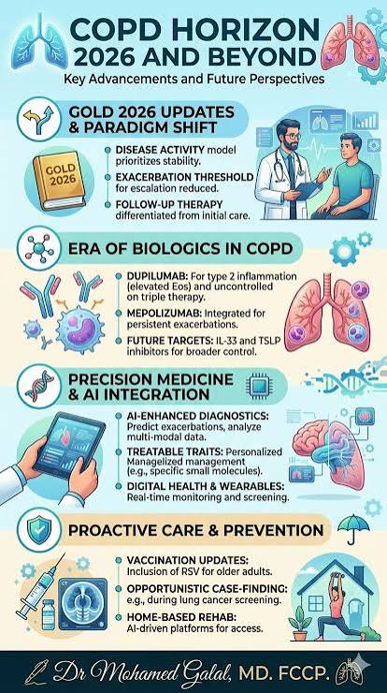
Pulmonary rehabilitation targets function by using exercise, education and behaviour change. The American Thoracic Society (ATS) Guideline strongly recommends rehabilitation for stable COPD and after hospitalisation for COPD exacerbation (Rochester et al., 2023). However, clinical effectiveness does not equal practical availability: a referral is not very effective if the person is unable to attend. Assessment should not be used to determine that a child or young person is not motivated to attend when transport arrangements are in place or mobility is a limitation, or when communication difficulties are present.
Treatment can bring about work itself. Fatigue, other illnesses, and caring responsibilities can be a distraction from multiple devices, appointments and instructions. A longer treatment period does not always mean a better quality of care, and professionals should ask what they can do and agree on priorities. Shared decisions should communicate the benefits, risks and alternatives in a way that is understandable to the person (NICE, 2021).
Assessment must also acknowledge that the effectiveness of a treatment could vary between outcomes. Better exercise tolerance does not mean there is no longer any shortness of breath or employment. Thus, the activities home to rehabilitation goals should be patient-centred, and determination of whether gains are maintained should be attempted. Rochester et al. (2023) agree with rehabilitation but are less confident the recommendations are for maintenance. Clarification of these questions allows practitioners to discuss realistic expectations without devaluing any functional improvement found.

Psychological Wellbeing
Breathlessness can cause anxiety, which makes it more distressing, and depression can cause less engagement with care and with day-to-day life. Xie et al. (2023) found that those with COPD had higher odds for depression than those without. A single pooled estimate is however limited by differences in sampling and assessment instruments. Observational associations are also unable to prove that depression is solely due to COPD. Assessment should focus on symptoms and circumstances, not psychological needs derived from lung function.
The anxiety was shown to be improved as a result of the respiratory nurse delivered cognitive behavioural therapy as compared to providing anxiety self-help leaflets in a randomised trial (Heslop-Marshall et al., 2018). This helps to incorporate psychological services into respiratory care. Its delivery required trained staff; however, without equivalent support, disseminating information cannot be taken to mean reproducing the results. Patients with psychological problems should be appropriately assessed and referred, and respiratory symptoms treated.

Social Participation and Inequality
COPD may interfere with a person's job, social life and meaningful activities. Financial strain and barriers to travel make it more challenging to keep treatment. The connection is significant: less physical ability could mean less time spent at school, and less time spent at school could make it harder to cope. Patients' choices should be found out rather than success judged on attendance or prescribing.
Chronic respiratory disease is identified as a priority for targeting inequalities in health and care within the NHS by NHS England's Core20PLUS5 approach (NHS England, n.d.a). It has a population focus, alongside individual assessment, but being a member of a deprived group does not mean that the individual has specific preferences or needs. Practitioners should feel free to enquire about language, finances, housing and support directly: do not assume from postcode or ethnicity.
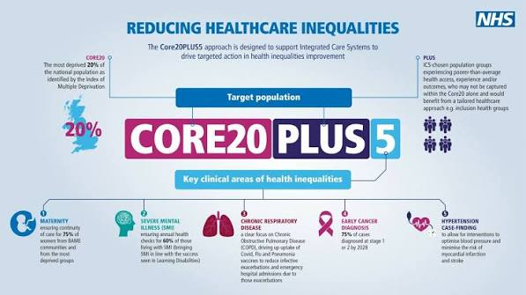

Family Carers
Families may assist with medications, transportation, household duties and addressing worsening symptoms. The physical strain, fear, uncertainty, financial burden and relationship tension were among the COPD carers identified by Zhang et al. (2024). Their integrative review combines multiple types of evidence; however, they find that the effectiveness of any one support intervention varies by setting.
In an interview with 21 family members of individuals with severe COPD, Johansson et al. (2023) reported that their roles in the family changed, their personal lives were delayed, and they felt excluded. The findings suggest experiences not captured in the typical clinical data but do not provide the prevalence picture for England in a small qualitative sample. The studies are complementary in that they recommend the consideration of the needs of carers. The Care Act 2014 outlines the requirements for assessment if a carer has support needs, but this should not necessarily mean that the person is entitled to all the services they have requested (Great Britain, 2014).

Evidence-Based NHS Treatment and Support

Prevention and Medicines
Discussion about quitting smoking should be sensitive combined with access to behaviour-change and drug support that is suitable for the individual. NICE (2025) offers evidence-based treatment recommendations for people who want to quit using tobacco. It is better to repeat offers for help than to blame if a first help offering fails. Relevant vaccination should also be considered, and NHS England has specifically made a connection between COPD vaccination and preventing infective exacerbations (NHS England, n.d.a).
Bronchodilator treatment should be tailored to symptoms and to circumstances of exacerbation and should be increased as per clinical assessment. Choosing a device and checking the demonstrated technique and actual use of an inhaler are key to not assuming the device is not being used correctly (NICE, 2018). There will also need to be discussion of adverse effects for escalation. In the ETHOS trial, triple inhaled therapy lowered the amount of moderate to severe exacerbations compared to dual therapy, and pneumonia occurred more often in the corticosteroid-containing groups (Rabe et al., 2020). The results cannot be used as justification for the use of triple therapy for every COPD patient, as participants were moderate to very severe cases of COPD and had previously had exacerbations.

Rehabilitation and Integrated Management
Pulmonary rehabilitation is not a "bolus" add-on to community management but should be a part of it. It is an exercise and education intervention, and NHS England strongly recommends that services engage with national audit (NHS England, n.d.b). International guidance also endorses its clinical use whilst recognising that delivery models and maintenance arrangements need to be considered (Rochester et al., 2023).
Cox et al. (2021) identified that selected participants can benefit from similar outcomes in a telerehabilitation programme to those received in a centre-based programme. There is, however, limited evidence of long-term effects and different delivery systems which make it difficult to compare the same online programmes. The provision of remote provision should offer choice but provide alternatives for those who are unable to access or have a lack of confidence in technology.
Integration of disease management was shown to have a positive effect on several outcomes by Poot et al. (2021) such as disease-specific QOL, exercise capacity, and reducing hospitalisation for respiratory complications. There is uncertainty about which parts of the programmes provide benefit due to variation between programmes. The services must, therefore, clarify roles to be played by staff and track results, not simply call a pathway “integrated” and presume that it will be effective.

Exacerbations and Specialist Assessment
Exacerbation plans must contain information on recognised changes, agreed actions and access to clinical advice. Not all exacerbations will warrant antibiotics; NICE (2018) suggest taking into account clinical features, severity and risks (such as antimicrobial resistance). When there is serious deterioration, it is important to assess quickly and not continue to give rescue medication without supporting the children.
Appropriate selection of oxygen is also important. However, the Long-Term Oxygen Treatment Trial Research Group (2016) showed that long-term oxygen for moderate COPD (COPD) desaturation did not reduce the time to death or first hospitalisation. This does not exclude its proven indication in specific patients with severe resting hypoxaemia. The distinction highlights the importance of treatment according to the actual need and not as though more is always better.

Whole Person Community Care Models
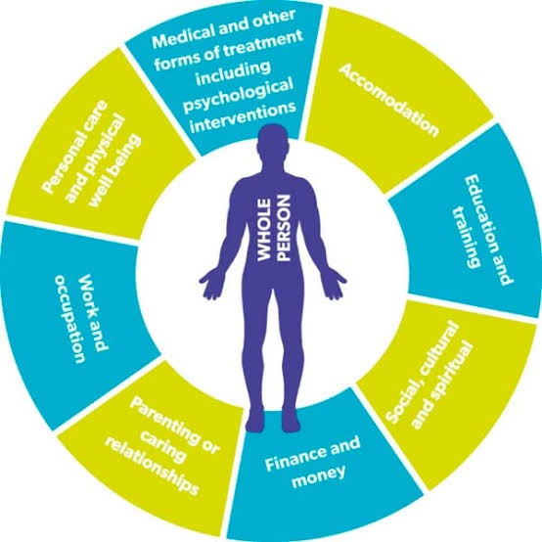

The UK House of Care framework
Collaborative care planning is at the heart of House of Care, underpinned by patient engagement, professional partnerships and systems and responsive commissioning. It is adapted by Coulter et al. (2016) for primary care in the UK. Applied to COPD, this involves doing what is needed to prepare the people for reviews, setting realistic priorities and ensuring the support of rehabilitation, psychological care and community resources is in place to support the priorities.
It's powerful because it bridges the consultation and the system to make decisions actionable. The British Heart Foundation's programme is an example of the implementation of collaborative conversations in the care of long-term conditions (British Heart Foundation, n.d.). Evidence from wider or cardiovascular programmes does not necessarily constitute proof of the effectiveness of these programmes in the treatment of COPD. A conceptual framework can outline the services that should be offered but not prove that they are offered successfully.
For implementation, a COPD review should link the agreed goal with a responsible person and a service that is readily available. If not, the expectation can be raised through collaborative discussion without alterations to the support. This is particularly pertinent to the framework's commissioning foundation, which is that access to voluntary organisations cannot automatically replace missing statutory services. Its purpose is to highlight interdependencies between the roles of patient participation, professional skills and resources, rather than suggesting that an empowered patient can fill in structural gaps on their own (Coulter et al., 2016).

The International Chronic Care Model
The US-developed Chronic Care Model is a mix of self-management support, delivery-system design, decision support, clinical information systems, healthcare organisation and community resources It aims for collaboration among informed patients and well-ready clinical teams (Wagner et al., 2001). Planned multidisciplinary reviews, reliable recall systems, and evidence-based treatment support, including links with rehabilitation and community services, are examples of applications in COPD.
The model provides more of an organisational map than a standalone educational intervention. However, it does make an assumption of capacity for collaborative working and sharing of information. Implementation research identified some barriers to the implementation of its general principles into action changes (Hroscikoski et al., 2006). The movement of the model across health systems, then, needs to be adapted to the local health system workforce, funding and governance structures.

Compare and Critically Use
These frameworks are connected, but not a contending alternative theory (Coulter et al., 2016): House of Care builds on the Chronic Care Model, not as an alternative theory. The former puts the care-planning conversation and the context of commissioning in the UK on the spotlight, while the latter refers to broader organisational elements. This common focus on supported participation can be compromised when the responsibility for it is passed on to patients without adequate professional and material support.

Framework | Main emphasis | COPD application
House of Care | Collaborative planning within UK primary care and commissioning | Agree individual priorities and connect them with available support
Chronic Care Model | Organisation of proactive care and supported patient participation | Coordinate planned reviews, clinical information and community resources
Framework comparison based on Coulter et al. (2016) and Wagner et al. (2001).
The most powerful application for COPD is the coordination of the organisation along with the actual negotiation of individual goals. Poot et al. (2021) argue that programmes that combine these two should be assessed, but neither of the named models are better. The effectiveness of an individual strategy or plan should be evaluated on the basis of functioning, experience, equity and appropriate service use. Completed care plans indicate only documentation; they do not indicate whether the person received useful support or achieved a valued outcome.

National and Local Policy Implementation

England’s National Agenda
The 2025 10-Year Health Plan suggests a transition from hospital to community, analogue to digital, and sickness to prevention (Department of Health and Social Care, 2025). For COPD, these priorities underpin the earlier intervention and closer-to-home care. But making settings change does not necessarily improve care. When moving activity without appropriate staffing, coordination and escalation plans, this may shift the workload to families. The plan should thus be treated as a policy statement, and expected results should be measured.
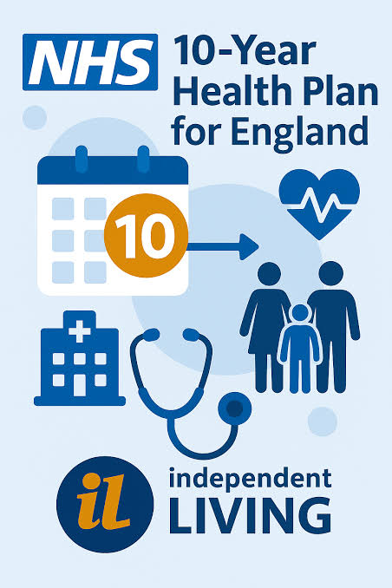
NHS England has prioritised the following aspects of the respiratory programme: diagnosis and treatment improvement (NHS England, n.d.c). Core20PLUS5 includes a targeted inequality lens (NHS England, n.d.a). But the national ambition is not enough to ensure the results. A respiratory review by Asthma + Lung UK, which draws on data gathered in 2024, showed that half of integrated care systems (ICS) in England failed to meet demand for diagnostic testing (Asthma + Lung UK, 2025a). This highlights an implementation issue, but not a measure of all patient experiences or of subsequent performance.

Greater Manchester as A Local Example:
Greater Manchester's Joint Forward Plan commits to quality-assured community spirometry, increasing the accuracy of diagnosis and increasing access to pulmonary rehabilitation and decreasing variation. It also highlights indicators of progress as accreditation, waiting times and delivery choice (Greater Manchester Integrated Care Partnership, n.d.). These commitments link prevention and diagnosis to long-term support and provide tangible parameters to assess implementation.
The plan contains actions that are planned to take place in previous years, though. Their presence on the site does not confirm the completion or current performance. Local evaluation should be based on a comparison of stated commitments with dated delivery reports and service level data. No waiting time or admission reduction is stated here, except with supporting evidence of outcomes.
The Royal College of Physicians (2026) has published a respiratory audit report that highlights the state of hospital care and pulmonary rehabilitation in England and Wales in 2026. This type of audit should be used to inform benchmarking but should not be reported as Greater Manchester-specific outcomes, where national coverage and participating-service data are combined. Changes in the denominators, completeness and changes in case mix should be considered before making conclusions about service quality based on the difference.

Recommendations and Conclusion

Enhance Access and Support Self-Management
Community teams should provide a coordinated review, including the identification of priorities for the patient, assessment of treatment knowledge, and integration of physical, psychological, and social support. Explain decisions in an accessible way; do not assume understanding; check for understanding (NICE, 2021). Document a named person and make it clear who is responsible for follow-up on referrals for them to have a practical role to play.
Supported skills development and agreed exacerbation actions and opportunities for review are part of the self-management process. Schrijver et al. (2022) reported a positive effect on quality of life and less admission for respiratory problems, but uncertainty in the evidence and the variety in interventions prevented conclusions on the most effective components. A leaflet or an application MUST not therefore be offered as an alternative intervention. Assess knowledge and competence in addition to clinical results.
The obstacles to referral, attendance, and completion of rehabilitation services should be explored. Provide appropriate delivery options and practical support for accessing, such as interpreting and transport facilities if required. Analyze achievements and outcomes among relevant population groups. Telerhabilitation should be used in addition to available provision and should be considered on a case-by-case basis (Cox et al., 2021).
Commissioners should be able to differentiate between patients who were not offered rehab, those who refused an accessible offer, and those who could not attend. They suggest different reactions, either referral improvement, better explanation, or practical support. Using a single attendance percentage can conceal the reason for unequal access. Consideration of provision can be based on the National Respiratory Audit Programme, and local review should take account of feedback from people who have not been assessed (Royal College of Physicians, 2026). This proposed use of an audit is an improvement suggestion, not a statement that an audit is already completed at the local level.

Integrate Carers and Palliative Care
Where appropriate, involve carers in education and planning and also consider their readiness and ability to support the child separately. Provide details on carer assessment and community services. Family engagement should complement and enhance professional services and not be a substitute for them (Zhang et al., 2024).
Palliative care should address unmet needs in conjunction with active respiratory care. It is recommended by the European Respiratory Society to be part of the management of COPD patients and also support carers (Janssen et al., 2023). An integrated service for respiratory and palliative care has been shown to improve mastery of breathlessness in a sample of patients with a range of diagnoses (Higginson et al., 2014); the limited scale and sample do not allow for COPD-specific generalization. Discuss sensitively with people nearing the end of their lives their preferences, review plans as circumstances change, and coordinate care across settings (NICE, 2018).
Advance care planning should address the person's values, who and how decisions will be shared. The discussions must be open to revision but not be a one-off administrative requirement. NICE (2019b) highlights the importance of coordination and whole person assessment in adults at the end of life. More importantly, it is important to communicate and assess needs carefully when uncertainty exists and to exclude them from supportive services. The ability to predict the time of death should not be the main requirement for accessing palliative care services (Janssen et al., 2023).

Assess Improvement
Services should be tracking diagnostic confirmation, rehabilitation access/completion, patient-reported functioning, and carer support/emergency use. Interpret changes in conjunction with the level of the disease and the requirement of the population. In conclusion, person-centered COPD care needs evidence-based care in a responsive community care. Whether support is accessible and meaningful should be used to assess its quality; it need not be judged solely on the basis of the presence of policies, prescriptions, or care plans.

References
Adeloye, D. et al. (2022) ‘Global, regional, and national prevalence of, and risk factors for, chronic obstructive pulmonary disease (COPD) in 2019: a systematic review and modelling analysis’, The Lancet Respiratory Medicine, 10(5), pp. 447–458. Available at: https://doi.org/10.1016/S2213-2600(21)00511-7 (Accessed: 17 October 2026).
Asthma + Lung UK (2025a) ICS Respiratory Review 2024/25. Available at: https://www.asthmaandlung.org.uk/healthcare-professionals/ics-respiratory-review (Accessed: 17 October 2026).
Asthma + Lung UK (2025b) What is chronic obstructive pulmonary disease (COPD)?. Available at: https://www.asthmaandlung.org.uk/conditions/copd-chronic-obstructive-pulmonary-disease/what-chronic-obstructive-pulmonary-disease (Accessed: 17 October 2026).
British Heart Foundation (n.d.) BHF House of Care programme. Available at: https://www.bhf.org.uk/for-professionals/healthcare-professionals/innovation-in-care/person-centred-care-and-the-house-of-care/the-bhf-house-of-care-programme (Accessed: 17 October 2026).
Coulter, A., Kramer, G., Warren, T. and Salisbury, C. (2016) ‘Building the House of Care for people with long-term conditions: the foundation of the House of Care framework’, British Journal of General Practice, 66(645), pp. e288–e290. Available at: https://doi.org/10.3399/bjgp16X684745 (Accessed: 17 October 2026).
Cox, N.S. et al. (2021) ‘Telerehabilitation for chronic respiratory disease’, Cochrane Database of Systematic Reviews, 1, CD013040. Available at: https://doi.org/10.1002/14651858.CD013040.pub2 (Accessed: 17 October 2026).
Department of Health and Social Care (2025) Fit for the future: 10 Year Health Plan for England. Available at: https://www.gov.uk/government/publications/10-year-health-plan-for-england-fit-for-the-future (Accessed: 17 October 2026).
Global Initiative for Chronic Obstructive Lung Disease (GOLD) (2026) Global strategy for the diagnosis, management, and prevention of chronic obstructive pulmonary disease: 2026 report. Available at: https://goldcopd.org/wp-content/uploads/2026/01/GOLD-REPORT-2026-v1.3-8Dec2025_WMV2.pdf (Accessed: 17 October 2026).
Great Britain (2014) Care Act 2014, c. 23, section 10. Available at: https://www.legislation.gov.uk/ukpga/2014/23/section/10 (Accessed: 17 October 2026).
Greater Manchester Integrated Care Partnership (n.d.) Joint Forward Plan. Available at: https://gmintegratedcare.org.uk/greatermanchester-icp/icp-strategy/joint-forward-plan/ (Accessed: 17 October 2026).
Heslop-Marshall, K. et al. (2018) ‘Randomised controlled trial of cognitive behavioural therapy in COPD’, ERJ Open Research, 4(4), 00094-2018. Available at: https://doi.org/10.1183/23120541.00094-2018 (Accessed: 17 October 2026).
Higginson, I.J. et al. (2014) ‘An integrated palliative and respiratory care service for patients with advanced disease and refractory breathlessness: a randomised controlled trial’, The Lancet Respiratory Medicine, 2(12), pp. 979–987. Available at: https://doi.org/10.1016/S2213-2600(14)70226-7 (Accessed: 17 October 2026).
Hroscikoski, M.C. et al. (2006) ‘Challenges of change: a qualitative study of chronic care model implementation’, Annals of Family Medicine, 4(4), pp. 317–326. Available at: https://doi.org/10.1370/afm.570 (Accessed: 17 October 2026).
Janssen, D.J.A. et al. (2023) ‘European Respiratory Society clinical practice guideline: palliative care for people with COPD or interstitial lung disease’, European Respiratory Journal, 62(2), 2202014. Available at: https://doi.org/10.1183/13993003.02014-2022 (Accessed: 17 October 2026).
Johansson, H., Berterö, C., Jonasson, L.-L. and Berg, K. (2023) ‘The experience of caregiver burden when being next of kin to a person with severe chronic obstructive pulmonary disease: a qualitative study’, Chronic Respiratory Disease, 20, 14799731231168897. Available at: https://doi.org/10.1177/14799731231168897 (Accessed: 17 October 2026).
Long-Term Oxygen Treatment Trial Research Group (2016) ‘A randomized trial of long-term oxygen for COPD with moderate desaturation’, New England Journal of Medicine, 375, pp. 1617–1627. Available at: https://doi.org/10.1056/NEJMoa1604344 (Accessed: 17 October 2026).
National Institute for Health and Care Excellence (NICE) (2018) Chronic obstructive pulmonary disease (acute exacerbation): antimicrobial prescribing. NG114. Available at: https://www.nice.org.uk/guidance/ng114 (Accessed: 17 October 2026).
National Institute for Health and Care Excellence (NICE) (2019b) End of life care for adults: service delivery. NG142. Available at: https://www.nice.org.uk/guidance/ng142 (Accessed: 17 October 2026).
National Institute for Health and Care Excellence (NICE) (2021) Shared decision making. NG197. Available at: https://www.nice.org.uk/guidance/ng197 (Accessed: 17 October 2026).
National Institute for Health and Care Excellence (NICE) (2025) Tobacco: preventing uptake, promoting quitting and treating dependence. NG209. Updated 4 February 2025. Available at: https://www.nice.org.uk/guidance/ng209 (Accessed: 17 October 2026).
NHS England (n.d.a) Core20PLUS5 (adults): an approach to reducing healthcare inequalities. Available at: https://www.england.nhs.uk/about/equality/equality-hub/national-healthcare-inequalities-improvement-programme/core20plus5/ (Accessed: 17 October 2026).
NHS England (n.d.b) Pulmonary rehabilitation. Available at: https://www.england.nhs.uk/ourwork/clinical-policy/respiratory-disease/pulmonary-rehabilitation/ (Accessed: 17 October 2026).
NHS England (n.d.c) Respiratory disease. Available at: https://www.england.nhs.uk/ourwork/clinical-policy/respiratory-disease/ (Accessed: 17 October 2026).
Poot, C.C. et al. (2021) ‘Integrated disease management interventions for patients with chronic obstructive pulmonary disease’, Cochrane Database of Systematic Reviews, 9, CD009437. Available at: https://doi.org/10.1002/14651858.CD009437.pub3 (Accessed: 17 October 2026).
Rabe, K.F. et al. (2020) ‘Triple inhaled therapy at two glucocorticoid doses in moderate-to-very-severe COPD’, New England Journal of Medicine, 383, pp. 35–48. Available at: https://doi.org/10.1056/NEJMoa1916046 (Accessed: 17 October 2026).
Rochester, C.L. et al. (2023) ‘Pulmonary rehabilitation for adults with chronic respiratory disease: an official American Thoracic Society clinical practice guideline’, American Journal of Respiratory and Critical Care Medicine, 208(4), pp. e7–e26. Available at: https://doi.org/10.1164/rccm.202306-1066ST (Accessed: 17 October 2026).
Royal College of Physicians (2026) Room to breathe: a longitudinal review of respiratory data. Clinical audit report 2024/25. National Respiratory Audit Programme. Available at: https://www.rcp.ac.uk/improving-care/national-clinical-audits/national-respiratory-audit-programme-nrap/current-nrap-reports/room-to-breathe-clinical-audit-report-202425/ (Accessed: 17 October 2026).
Schrijver, J. et al. (2022) ‘Self-management interventions for people with chronic obstructive pulmonary disease’, Cochrane Database of Systematic Reviews, 1, CD002990. Available at: https://doi.org/10.1002/14651858.CD002990.pub4 (Accessed: 17 October 2026).
Wagner, E.H., Austin, B.T., Davis, C., Hindmarsh, M., Schaefer, J. and Bonomi, A. (2001) ‘Improving chronic illness care: translating evidence into action’, Health Affairs, 20(6), pp. 64–78. Available at: https://pubmed.ncbi.nlm.nih.gov/11816692/ (Accessed: 17 October 2026).
World Health Organization (WHO) (2026) Chronic obstructive pulmonary disease (COPD). 10 June. Available at: https://www.who.int/news-room/fact-sheets/detail/chronic-obstructive-pulmonary-disease-(copd) (Accessed: 17 October 2026).
Xie, H., Jiang, Y., Liu, L., Peng, H., Li, J. and Chen, Z. (2023) ‘Global prevalence and risk factors of depression in patients with chronic obstructive pulmonary disease: a systematic review and meta-analysis from 2000 to 2022’, Journal of Psychosomatic Research, 175, 111537. Available at: https://pubmed.ncbi.nlm.nih.gov/37907038/ (Accessed: 17 October 2026).
Zhang, N., Tian, Z., Liu, X., Yu, X. and Wang, L. (2024) ‘Burden, coping and resilience among caregivers for patients with chronic obstructive pulmonary disease: an integrative review’, Journal of Clinical Nursing, 33(4), pp. 1346–1361. Available at: https://doi.org/10.1111/jocn.16954 (Accessed: 17 October 2026).

