ACADEMIC DISCIPLINE OF HOSPITALITY AND TOURISM MANAGEMENT
MODULE HANDBOOK WINTER TERM 2024
BMIH4006

Table of Contents
Component one: Learning Log 3
Component two: Assessment of practical task Scenario 5
Importance of health and safety factors in the hotel industry 7
Challenges and regulations associated with the housekeeping departments 8
Precautions taken to prevent accidents and injuries 8
Essential procedures for cleaning the rooms incorporated as safety measures 9
Equipment and tools that should be used by the staff during room cleaning 9
Different kinds of hazards and Hazard Mitigation 10
Component three: Presentation 11
Health and safety importance in the hotel industry 11
Relevance of training and development for the hose-keeping staff to ensure the health and safety 11
The role of managers is to incorporate best practices regarding housekeeping safety 11
The challenges housekeeping staff faces in the hotel industry regarding safety 12
References 13

Component one: Learning Log
I would like to express my personal experiences by using Gibb’s reflective model. Gibb’s Reflective Model is cyclic (Adeani et al., 2020).
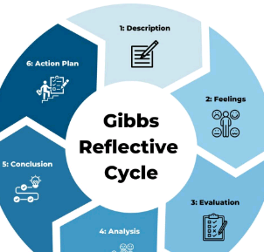
Figure 1: Gibb’s reflective model
(Inspired by Adeani et al., 2020)
Description
I would like to share my personal experience of working in the Burlington Folkestone hotel in the housekeeping department and this experience has helped me a lot to identify the skills and strengths of my career. Along with that, this experience has also helped me to analyse the areas which I have to enhance further to ensure the development and growth of my career. The housekeeping section of a hotel is a dynamic area and it requires the active participation of the staff. While studying at the university I have already learnt about various aspects of health and safety and the relevance of maintaining it in the hotel sector. Some of my strong skills and efficiencies have helped me to perform successfully and I have always tried to follow the instructions of my supervisors. From an overall analysis, this working experience has been highly helpful for me in enhancing my weaknesses and determining the growth of my career.
Feelings
After joining Burlington Folkestone, firstly I felt nervous then communicated with my seniors and team leads. I have gathered enough confidence and courage to perform effectively in the company. Moreover, using my leadership skills I have also built a strong and good relationship with my team members. However I realised that I have to improve some of my existing skills and also I have to adapt and enhance some new skills like critical thinking skill, problem-solving and the use of technologies to determine the career development and growth of my career as a manager or efficient housekeeping staff.
Evaluation
In this placement and working experience, I realised that my effective communication skill is highly required. Applying these essential skills and strengths I have communicated with members who belong to various backgrounds and religions. It has helped me a lot to interact with my customers and understand their needs and choices. Moreover implementing my leadership skills I have successfully built a team and have analysed their performances. Being in a dynamic section like housekeeping of a hotel I have learnt the process of interacting with various members and visitors successfully. However, I realised that by enhancing my critical thinking skills I will be able to identify the problem successfully and think reasonably and logically.
Analysis
During these working hours, my strong communication skills have helped me a lot in the process of communicating with my team members and the customers. I have used the principles of the Social Cognitive Theory of Communication to interact with others. According to this theory, the behavioural aspects of an individual depend on the interaction process with others (Bandura, 2009). Along with that in implementation of the leadership skills I have followed the transformational theory of leadership, which suggests that the empathy and behavioural factors of the leaders have a significant impact on the motivation of the employees (Schunk and DiBenedetto, 2020). These aspects will be highly beneficial for me to become a successful leader and work professionally in future.
Conclusion
I have realised that I have to improve my ICT skills as it is highly necessary in the era of technological development. Along with that, I have to develop critical thinking or analytical thinking skills to identify the problems existing in the workplace and mitigate them carefully.
Action Plan

Objectives | Improvement Way | Analysis | Time bound
To improve Problem-solving skill | It helps to determine the sources of a problem and find effective solutions. Depending on the strong technical knowledge with the additional course work and help to acquire depth knowledge. | This skill will help to solve the problems of others. It can be developed through practice and role pay and will be a useful tool while learning to develop problem solving skills | 3 months
To develop ICT Skill | It is the ability to understand and operate a wide range of technology and software. Experimenting with the technology through hands-on experience will help to develop ICT skills. | There are different courses on LinkedIn that still help to develop ICT skills. It will be a gain with direct experience by offering services to others. | 6 months
To identify the problem with the help of critical thinking skill | It is the ability to describe the question and test myself by holding assumptions. It will help to make good decisions in the workplace. | It can be developed by asking questions to colleagues and mentors about a particular topic and resolving the conflicts. | 3 months
Table 1: Action Plan
(Created by Learner)

Component two: Assessment of practical task Scenario
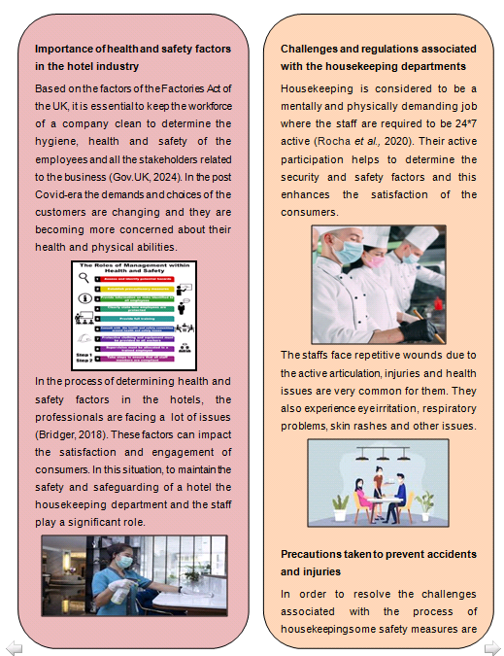
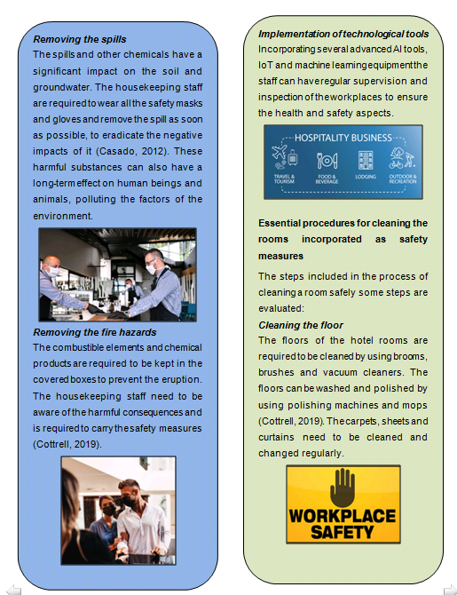
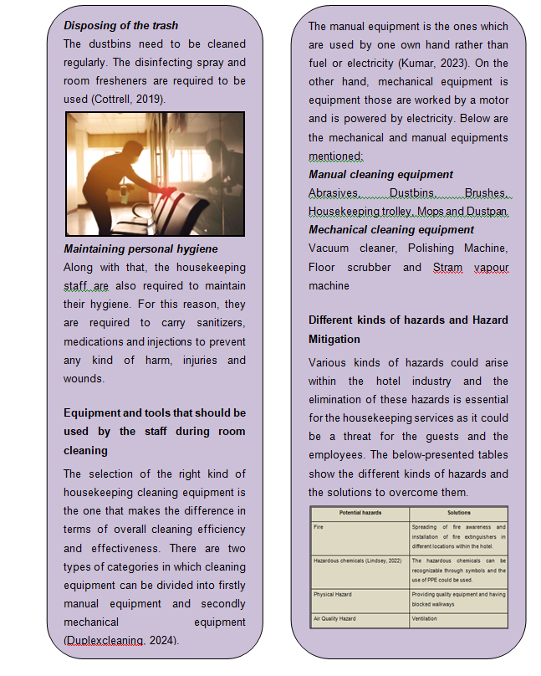

Importance of health and safety factors in the hotel industry
Based on the factors of the Factories Act of the UK, it is essential to keep the workforce of a company clean to determine the hygiene, health and safety of the employees and all the stakeholders related to the business (Gov.UK, 2024). In the post Covid-era the demands and choices of the customers are changing and they are becoming more concerned about their health and physical abilities. In the process of determining health and safety factors in the hotels, the professionals are facing a lot of issues (Bridger, 2018). These factors can impact the satisfaction and engagement of consumers. In this situation, to maintain the safety and safeguarding of a hotel the housekeeping department and the staff play a significant role.

Challenges and regulations associated with the housekeeping departments
Housekeeping is considered to be a mentally and physically demanding job where the staff are required to be 24*7 active (Rocha et al., 2020). Their active participation helps to determine the security and safety factors and this enhances the satisfaction of the consumers. The staffs face repetitive wounds due to the active articulation, injuries and health issues are very common for them. They also experience eye irritation, respiratory problems, skin rashes and other issues.

Precautions taken to prevent accidents and injuries
In order to resolve the challenges associated with the process of housekeeping some safety measures are followed:
Removing the spills
The spills and other chemicals have a significant impact on the soil and groundwater. The housekeeping staff are required to wear all the safety masks and gloves and remove the spill as soon as possible, to eradicate the negative impacts of it (Casado, 2012). These harmful substances can also have a long-term effect on human beings and animals, polluting the factors of the environment.
Removing the fire hazards
The combustible elements and chemical products are required to be kept in the covered boxes to prevent the eruption. The housekeeping staff need to be aware of the harmful consequences and is required to carry the safety measures (Cottrell, 2019).
Implementation of technological tools
Incorporating several advanced AI tools, IoT and machine learning equipment the staff can have regular supervision and inspection of the workplaces to ensure the health and safety aspects.

Essential procedures for cleaning the rooms incorporated as safety measures
The steps included in the process of cleaning a room safely some steps are evaluated:
Cleaning the floor
The floors of the hotel rooms are required to be cleaned by using brooms, brushes and vacuum cleaners. The floors can be washed and polished by using polishing machines and mops (Cottrell, 2019). The carpets, sheets and curtains need to be cleaned and changed regularly.
Disposing of the trash
The dustbins need to be cleaned regularly. The disinfecting spray and room fresheners are required to be used (Cottrell, 2019).
Maintaining personal hygiene
Along with that, the housekeeping staff are also required to maintain their hygiene. For this reason, they are required to carry sanitisers, medications and injections to prevent any kind of harm, injuries and wounds.

Equipment and tools that should be used by the staff during room cleaning
The selection of the right kind of housekeeping cleaning equipment is the one that makes the difference in terms of overall cleaning efficiency and effectiveness. There are two types of categories in which cleaning equipment can be divided into firstly manual equipment and secondly mechanical equipment (Duplexcleaning, 2024). The manual equipment is the ones which are used by one own hand rather than fuel or electricity (Kumar, 2023). On the other hand, mechanical equipment is equipment those are worked by a motor and is powered by electricity. Below are the mechanical and manual equipments mentioned:
Manual cleaning equipment
Abrasives
Dustbins
Brushes
Housekeeping trolley
Mops
Dustpan
Mechanical cleaning equipment
Vacuum cleaner
Polishing Machine
Floor scrubber
Stram vapour machine

Different kinds of hazards and Hazard Mitigation
Various kinds of hazards could arise within the hotel industry and the elimination of these hazards is essential for the housekeeping services as it could be a threat for the guests and the employees. The below-presented tables show the different kinds of hazards and the solutions to overcome them.
Potential hazards | Solutions
Fire | Spreading of fire awareness and installation of fire extinguishers in different locations within the hotel.
Hazardous chemicals (Lindsey, 2022) | The hazardous chemicals can be recognizable through symbols and the use of PPE could be used.
Physical Hazard | Providing quality equipment and having blocked walkways
Air Quality Hazard | Ventilation
The list of hazards and potential solutions

Component three: Presentation\

Introduction
Healthy and safe procedures are the set of standard actions that will take every step that needs to be used for the safety of the guests and customers. The study will discuss the need for health and safety protocols in the hotel industry with the relevance of training and development for housekeeping staff to ensure health and safety protocols.

Health and safety importance in the hotel industry
- The health and safety protocols within the would help the hotels could help minimise the risky events which may result in lawsuits (World Health Organization, 2020).
- By having health and safety measures within the health industry, the business is also able to protect their reputations.
The health and safety protocols within the would help the hotels could help minimise the risky events which may result in lawsuits. Additionally, the hotel could also face hazards such as fall slips, fire and exposure to explosive heat which could lead the business to incur financial losses and even to some extended shutdown.

Relevance of training and development for the house-keeping staff to ensure the health and safety
- With a lack of training the employees may become prone to accidents if they in any way are careless about the procedures, equipment and chemicals (Rajkala, 2023).
- Providing housekeeping training would help in ensuring the employees know when, where and how to utilise the different equipment.
The nature of the work in which the housekeeping staff within the hotel are involved is such that the employees may become prone to accidents if they in any way are careless about the procedures, equipment and chemicals (Rajkala, 2023). Providing housekeeping training would help in ensuring the employees know when, where and how to utilise the different equipment for the cleaning methods.

The role of managers is to incorporate best practices regarding housekeeping safety
- All of the heads of departments within any organisation have the responsibility to ensure that the employees face safe job procedures, take adequate time for performing the job and use the correct unsafe conditions so that accidents are not caused.
- The managers of housekeeping are responsible for planning, organising and developing the overall operations (Tra, 2020).
All of the heads of departments within any organisation have the responsibility to ensure that the employees face safe job procedures, take adequate time for performing the job and use the correct unsafe conditions so that accidents are not caused. The managers should provide the housekeeping staff with the ‘safety manual’ which would provide the staff with the list of rules which they would need to take care of and follow. The managers of housekeeping are responsible for planning, organising and developing the overall operations. With this, the managers can ensure that the employees can take adequate breaks during their work so that they are not tired and negatively impact their safety.

The challenges housekeeping staff faces in the hotel industry regarding safety
- One of the challenges that the housekeeping staff faces is the high workload (Chela-Alvarez et al., 2021).
- Lack of proper guidance is also one more challenge that the housekeeping staff could come across if the managers of the hotels fail to perform their role effectively it could lead to a poor understanding of the manner to operate within the hotel sector.
There are various challenges which the housekeeping staff faces concerning maintaining safety procedures. One of the challenges that the housekeeping staff faces is the high workload. The hotel's housekeeping staff has to ensure that the customers who are visiting the hotel are fully satisfied with the hotel's services. Therefore, to meet the expectations of the customers the housekeeping staff need to work very hard and it could lead to safety concerns such as the risks of life slipping or tripping. Lack of proper guidance is also one more challenge that the housekeeping staff could come across if the managers of the hotels fail to perform their role effectively it could lead to a poor understanding of the manner to operate within the hotel sector.

Types of training programs for housekeeping team members regarding safety issues
- The training program is important for ensuring safety and well-being within the workplace
- First and foremost importance is the introductory session that will focus on familiarising team members (Nephew and Sunasee, 2020).
- Specialised team module shall be developed to address the safety concerns within the housekeeping domain
- It also includes proper lifting techniques and the use of personal protective equipment.
- Interactive training sessions will allow the members to practice safety procedures in realistic scenarios.
- Fostering a culture of open communication is important for maintaining a safe working environment (Shapoval et al., 2022).
From the actual techniques to the desired result during the housekeeping training can be established as a common ground for the housekeeping team. Continues learning and evolving so that team can develop their skills at the time of developing their skills at the time of housekeeping training. This program needs to encompass different types of elements for addressing the diverse challenges faced by the housekeeping staff. Through this training, the staff can be given role-playing exercises which will stimulate the needs of the staff in emergency situations. This type of refresher course shall be conducted to reinforce safety knowledge and update staff on the new protocols for COVID-19.

The step-by-step process during the room cleaning process through safety measurements
- First, the staff needs to wear appropriate personal protective equipment.
- It includes gloves and eye protection glasses.
- Ventilation is also important so windows and doors should be opened to allow the fresh air in.
- Beds and linen should be made and replaced before the guest stays.
- It is also important to remove the rubbish left behind by the previous guest before inviting another guest into the room.
- Housekeepers should clean the shower and toilets in hotels before the guest arrives (Eid‐Lidt and Farjat Pasos, 2021).
Ventilating the room is important because the guest expects a clean and fresh-smelling room when they check in. This also disburses any chemical smells that may linger after deep cleaning. It is also important to check for these hidden areas such as under the bed and on the shelves where any rubbish was left behind by the previous guest.

Conclusion
The health and safety protocols within the would help the hotels could help minimise the risky events which may result in lawsuits. The training program is important for ensuring safety and well-being within the workplace. Lack of proper guidance is also one more challenge that the housekeeping staff could come across if the managers of the hotels fail to perform their role effectively it could lead to a poor understanding of the manner to operate within the hotel sector.

References
Component One:
Bandura, A., 2009. Social cognitive theory of mass communication. In Media effects (pp. 110-140). Routledge.
Schunk, D.H. and DiBenedetto, M.K., 2020. Motivation and social cognitive theory. Contemporary educational psychology, 60, p.101832.
Adeani, I.S., Febriani, R.B. and Syafryadin, S., 2020. Using GIBBS’reflective cycle in making reflections of literary analysis. Indonesian EFL Journal, 6(2), pp.139-148.

Component Two:
Bridger, E. (2018) Employee engagement: a practical introduction. 2nd ed. HR Fundamentals. London: CIPD and Kogan Page.
Casado, M. (2012) Housekeeping Management. London: Wiley.
Cottrell, S. (2019) The Study Skills Handbook. 5th ed. London: Red Globe Press.
Kumar, 2023 Manual: Cleaning Equipments Available at: https://hmhub.in/manual-cleaning-equipments/ [Accessed on: 08 February 2024]
Lindsey, 2022 7 Risks Involved in the Hospitality Industry Available at: https://www.primeis.com/education-center/articles/7-risks-involved-in-the-hospitality-industry/ [Accessed on: 08 February 2024]
Rocha, M.R.A., Marin, M.J.S. and Macias-Seda, J., 2020. Living, working conditions and mental health: a study with Brazilian and Spanish workers who work in hospital cleaning services. Ciência & Saúde Coletiva, 25, pp.3821-3832.
Safety Storage Systems, 2024. Chemical spill response [Online] Available at:<https://safetystoragesystems.co.uk/blog/chemical-spill-immediate-response/#:~:text=Aside%20from%20the%20initial%20environmental,inhabitable%20for%20flora%20and%20fauna.> [Accssed on 8 February 2024]
Component Three:
Chela-Alvarez, X., Bulilete, O., García-Buades, M.E., Ferrer-Perez, V.A. and Llobera-Canaves, J., 2021. Perceived factors of stress and its outcomes among hotel housekeepers in the Balearic Islands: A qualitative approach from a gender perspective. International Journal of Environmental Research and Public Health, 18(1), p.52.
Eid‐Lidt, G. and Farjat Pasos, J.I., 2021. Patient care protocols and personal safety measures for health care professionals in cardiac catheterization rooms during the COVID‐19 outbreak in the National Institute of Cardiology. Catheterization and Cardiovascular Interventions, 97(5), pp.E686-E691.
Nephew, S. and Sunasee, R., 2020. An Engaging and Fun Breakout Activity for Educators and Students about Laboratory Safety. Journal of Chemical Education, 98(1), pp.186-190.
Rajkala, 2023 35 Safety and security Available at: https://ebooks.inflibnet.ac.in/hsp04/chapter/safety-and-security/#:~:text=The%20nature%20of%20work%20that,equipment%2C%20chemicals%2C%20or%20procedures.&text=The%20overall%20objective%20of%20a,they%20cause%20any%20serious%20accidents. [Accessed on: 08 February 2024]
Shapoval, V., Sönmez, S., Hsieh, Y.C. and Apostolopoulos, Y., 2022. Occupational health and safety of immigrant hotel housekeepers. Workplace Health & Safety, 70(12), pp.566-573.
Tra, T., 2020. Action plan for training new Housekeeping Employee: case: Hotel Indigo Helsinki.
World Health Organization, 2020. Operational considerations for COVID-19 management in the accommodation sector: interim guidance, 31 March 2020 (No. WHO/2019-nCoV/Hotels/2020.1). World Health Organization.

