CFD and Emissions Modelling
JIAN SONG
Abstract：Stricter emission standards and worsening air quality have intensified the search for environmentally friendly vehicle fuels. Combustion of fossil fuels is a primary source of pollutants such as nitrogen oxides (NOX), carbon monoxide (CO), carbon dioxide (CO2), and particulate matter (PM). Ethanol emerges as a promising alternative energy source among eco-friendly fuels due to its compatibility with conventional petrol engines and ease of blending. To assess the impact of ethanol on exhaust emission compositions, various proportions of ethanol blends were tested. The findings indicate that petrol blended with ethanol markedly reduces emissions of PM and CO, while significantly altering the levels of NOX and CO2 emissions.

Introduction
Ethanol is becoming a cleaner, more efficient, and renewable fuel that is utilized more and more globally as fuel consumption and emissions restrictions tighten. China, the United States, and Brazil are using more ethanol. Ethanol is frequently utilized as a fuel substitute or additive for gasoline-powered vehicles. Compared to gasoline, ethanol exhibits a lower equivalency ratio, a faster flame propagation rate, a higheroctane number, and a greater latent heat of vaporization (LHV). Additionally, because ethanol is an oxygenated fuel, it encourages a more thorough burning of the gas mixture and increases combustion efficiency, both of which increase engine power output and lower emissions.^{[1]}. A lot of research has been done on the characteristics of ethanol/gasoline fuels. In particular, the cooling effect of ethanol fuels can be measured by temperature sensors using the high latent heat of vaporisation of the ethanol fuel, but this requires a very fast response time.^{[2]}. Therefore, measurement of parameters related to the cooling effect is currently used to quantify the advantages of the inflation effect, e.g. indirect analysis of in-cylinder pressure, inflation efficiency, resistance to detonation, etc. Wyszynski et al. tested the inflation efficiencies of methanol, ethanol, and gasoline on an inlet injection combined with a direct injection system. ^{[3]}. Ahn et al. demonstrated the cooling effect of ethanol fuels through changes in in-cylinder pressure ^{[4]}.Kasseris et al. used the onset of detonation to determine the inflation cooling effect of blends with different ethanol/gasoline ratios^{[5,6]}. Therefore, although there is no uniform quantitative test method for the filling effect in the related studies, they all show that the cooling effect due to the high latent heat of vaporisation of ethanol improves the engine's ability to suppress detonation and improves engine performance.
The high octane characteristics of ethanol fuels are another important factor in the use of ethanol fuels to improve performance. As the level of downsizing of petrol engines increases further, higher compression ratios, higher boost pressures and earlier ignition timing will be required. Ford Anderson Ford Corporation Anderson et al^{[7]} find higher octane fuels have been found to allow for higher compression ratios, higher boost pressures, miniaturisation and ignition timing, resulting in higher thermal efficiencies; higher octane fuels are effective in suppressing end-mixture autoignition, improving anti-knock characteristics and further enhancing petrol engine performance^{[8]}. Balki et al^{[9]} investigated the effect of different compression ratios on the performance, combustion and emission characteristics of pure ethanol fuels in a thermodynamic engine, and found that ethanol fuels have better anti-detonation properties, which can significantly improve the dynamics of the engine. Related studies have shown that latent heat of vaporisation and octane number have considerable ability to suppress detonation and improve thermal efficiency. ^{[10]}. In addition, the faster flame propagation speed of ethanol fuels compared to petrol further increases engine combustion efficiency and improves combustion stability; Dirrenberger et al. and Jerzembeck et al. tested the initial flame speed of ethanol and petrol fuels under different initial conditions and found that the laminar flame speed of ethanol was faster than that of petrol. ^{[11,12]}. Catapano et al^{[13]} further compared the spray and flame propagation processes of ethanol and gasoline on a direct injection SI optical engine and found that ethanol combustion resulted in a less diffuse combustion flame, leading to less carbon soot, and Wang et al. concluded that higher flame speeds were conducive to higher combustion efficiency and lower cyclic fluctuations^{[14]}. He use of ethanol fuels can advance the ignition time, the moment of knock ignition, and the robustness of the intake flow due to the faster flame propagation^{[15,16]}. Ethanol fuel has many advantages, but it has a lower calorific value of combustion, which means that more mass of ethanol fuel is needed to release the same amount of power. Also, ethanol is an oxygenated fuel and has a lower chemical equivalent than gasoline. The calorific value of ethanol combustion per kilogram of ethanol and gasoline mixture is 2.69 MJ and 2.72 MJ, respectively, when compared to the energy density of the gasoline mixture. for a fixed-displacement engine, ethanol-fuelled engines don't lose much power compared to gasoline, but they need to inject more ethanol fuel. Injecting more fuel in the same injection time requires higher injection pressures, which may lead to fuel walling, and higher HC and CO emissions due to localised supercooling at high ethanol ratios^{[17-19]}.
The relatively high latent heat of vaporisation (LHV) of ethanol also leads to a lower evaporation rate of the fuel, resulting in lower thermal efficiency. At the same time, due to the poor volatility, low calorific value and high latent heat of vaporisation of ethanol, it is not suitable for engine operation at low temperatures. Sales et al[20] showed that pure ethanol-fuelled engines could not be cold-started below 13 °C, but petrol engines could be cold-started down to -40 °C. Zhuang et al [21]from the University of Technology Sydney (UTS) tested the conventional and non-conventional emissions of different ethanol-to-petrol mixtures in a WLTC cycle and found that the addition of ethanol fuel was effective in reducing the conventional emissions. It was found that the addition of ethanol fuel could effectively reduce the conventional emissions.Previous tests have shown that ethanol and gasoline blending can improve engine thermal efficiency and reduce emissions, but as engine operating conditions change, the optimal performance of the engine requires different ethanol/gasoline ratios. Therefore, there is an urgent need for a flexible and controllable dual-fuel injection system to meet the demand for different ethanol/gasoline ratios under different operating conditions.
Maintaining a clean environment has grown in importance in industrialized civilizations. Maintaining a clean environment has become crucial in industrialized nations. Cars and motorcycles that create air pollution Air pollution resulting from motorbikes and vehicles is one of the major environmental issues that requires attention. a significant environmental concern. Given that using ethanol-containing gasoline mixes can reduce Many researches have shown that using ethanol gasoline mixes can reduce air pollution and the amount of petroleum fuel used^{[22,23]}. have been working on the effects of these alternative fuel alternative fuels on engine performance and pollutant emissions. The effect of emissions. Palmer^{[24]} conducted engine tests using ethanol petrol fuels with different blending rates of rates. The results showed that the results showed that the addition of 10% ethanol can increase the power output of the engine by 5% and the octane rating can be increased by 5%. A 5% increase in power output and a 10% increase in octane can be 5% increase in octane per 10% addition of ethanol.Abdel Rahman and Osman^{[25]} recently tested 10%, 20%, 30% and 40% blends of ethanol. Ethanol blends of 10%, 20%, 30% and 40% were tested in variable compression ratio engines. They found that increase in ethanol content increased the octane number but decreased the calorific value. Adding 10% ethanol had the most significant effect on increasing octane. Octane rating. The optimum blend rate was 10% ethanol to 90% gasoline at different compression ratios for engines with different compression ratios. The optimum blend rate of ethanol with 90% petrol
Ethanol has been shown to have some degree of CO and UHC emission reduction. Ethanol's oxygenation and flammability are thought to be the cause of the decrease in CO emissions. Palmer[26] demonstrated that a 10% ethanol addition to gasoline resulted in a 30% reduction in CO emissions. It was demonstrated by Alexandrian and Schwal that the air-fuel ratio significantly affects CO emissions. Particularly in situations when there is an abundance of fuel, using ethanol-gasoline blends rather than gasoline alone can lower CO and NOx emissions. Although using ethanol as fuel increases aldehyde emissions, burning gasoline releases far more polynuclear aromatic hydrocarbons (PAHs) into the atmosphere, which causes far more environmental harm. Consequently, compared to gasoline, using a larger percentage of ethanol in a fuel blend can enhance air quality. We know from the literature assessment that ethanol-gasoline blends may efficiently lower emissions of pollutants without requiring significant changes to engine design. Furthermore, biomass may be used to make ethanol. We in Taiwan are drawn to these features. Thus, we looked at how varied ethanol gasoline fuel mixing rates affected engine performance and pollution emissions using engine test equipment.

Simulation modelling
Forte modelling
Different meshes for various piston cylinder shapes will be available via the ANSYS Forte fan mesh generator. Give the piston rod profile specifics first. Enter the engine's specifications, like the cylinder diameter and stroke. If required, choose a mesh topology and indicate where the mesh topology's control points are located. Indicate the number of cells that separate the mesh's control points. In ANSYS Forte, create the mesh and import it.
Initial modelling
Once the chemical mesh is set up, the next step is to assign the model. Use the Chemistry option of the model to assign the chemistry and use the Import Chemistry option to select the Gasoline_1comp_49sp.cks file from the ANSYS Forte data catalogue. View the chemical source, pre-treatment log, gas phase input, gas phase output, thermodynamic input, transport input, and transport output for the nozzle injection spark ignition engine. here the settings are as shown in Fig. 1.Since this simulation uses a petrol engine with a dual fuel engine model blended with ethanol, a different spark plug ignition method is used than the diesel engine, turn on the option for spark plug ignition and Set up the spark plug model and also place the spark plug in Fig. 2
.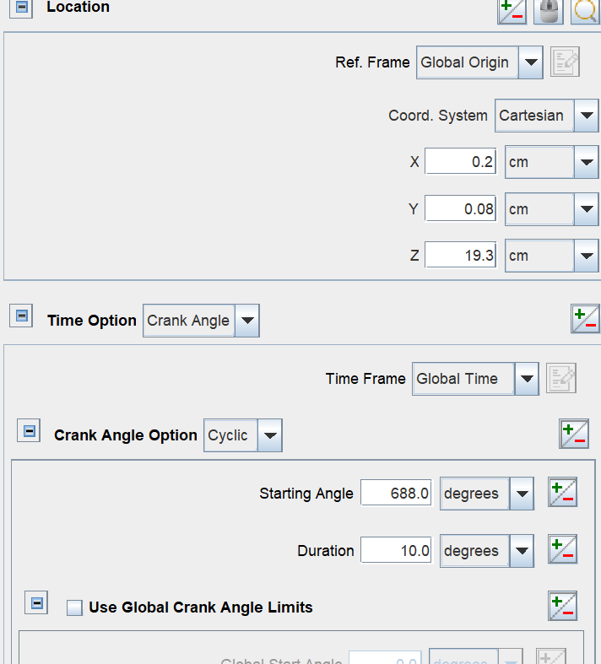
Figure 1 Nozzle Setting

Figure 2 Spark Plug Placement Points
Next the initial conditions are set up, in which the ratio of ethanol to petrol is combined in the general species setting of the control simulation. Fuel data input species included diesel, C2H5OH (ethanol), O2, N2, CO2, H2O, ON, and C8H18. fuel species were set up with reference to the mass fractions shown in Fig. 3. In this study, ethanol was blended with diesel fuel at 10% mass fraction. Also compared with pure petrol fuel without ethanol, initial temperature 2.215 bar, initial in-cylinder temperature 362 K. Set the ignition advance angle. Around -32 deg.
Finally, the output product control is set up. Some waste gases such as CO, CO2 and NO were included in the measurements because of the need to compare the engine performance and emission properties after the addition of ethanol.
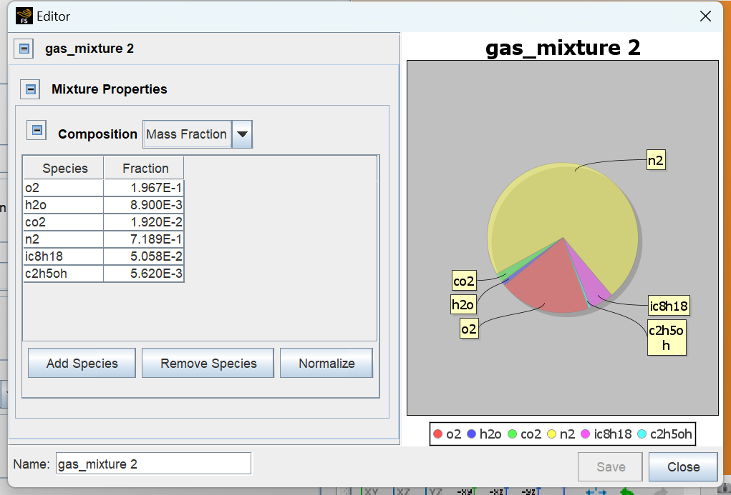
Figure 3 Ethanol Gasoline Dual Fuel Ratio

Forte result and discussion
Pressure: Fig. 4, Fig. 5 shows the in-cylinder pressure of petrol, petrol plus ethanol mixture in variation with crank angle. It is observed that the peak pressure is higher for the mixture of ethanol with petrol as compared to petrol. The peak pressures of petrol, petrol with ethanol at maximum load are 18.2 bar and 19.1 bar respectively. The maximum peak pressure was observed for ethanol with petrol as compared to gasoline. This is due to the presence of OH radicals in ethanol. This has an impact on combustion since it takes less energy to break the bonds and produces more free radicals during combustion. As a result, for both ethanol and gasoline, the peak and maximum pressures happen earlier. Furthermore, once free radicals are generated during combustion, the oxygen improves the combustion process. The combustion process is accelerated when there is an overabundance of oxygen present.
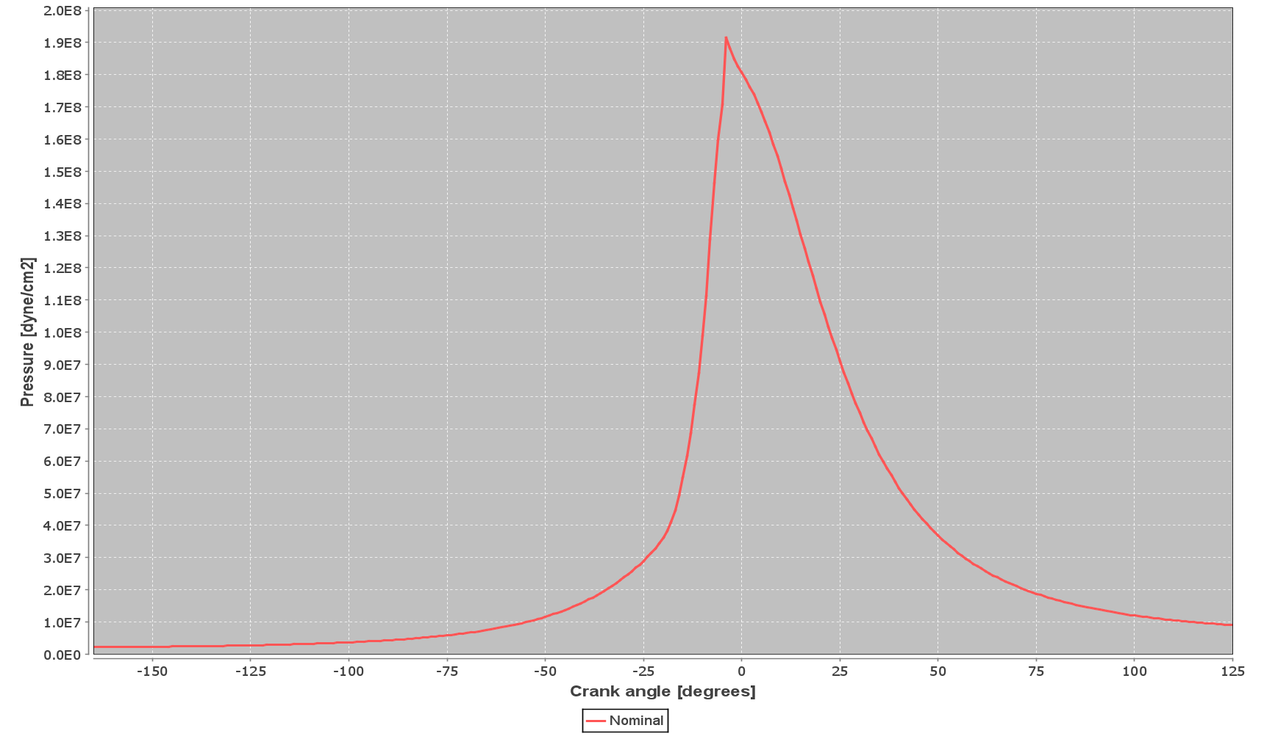
Fig. 4 In-cylinder pressure of ethanol petrol engine
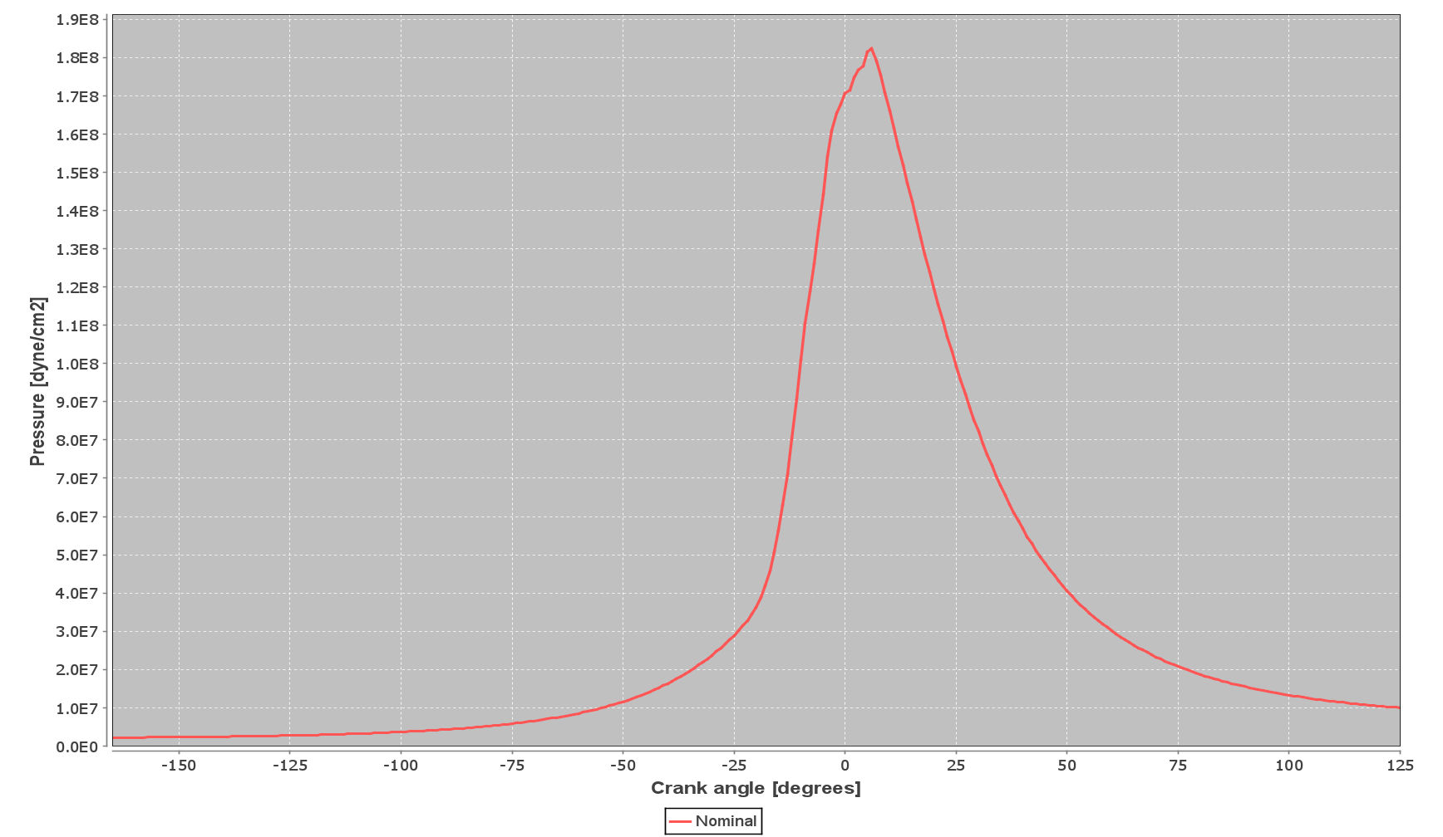
Figure 5 Gasoline engine in-cylinder pressure
Emissions: Since ethanol only has one oxygen atom in its basic state, it can be regarded as a partly oxidized hydrocarbon. Ethanol increases the amount of oxygen that is burned during combustion when it is mixed with fuel. The depletion effect will result in a large reduction in CO emissions, and under certain operating circumstances, NOx emissions will also be decreased. We talk about how fuel mixes affect the way engines run and how much pollution they emit. A 10% increase in ethanol concentration results in a marginal rise in CO emissions. Figure 6 Figure 7 shows the effect of fuel blending on reducing CO emissions. The figure shows the effect of fuel blending on reducing CO emissions. This shows that the addition of ethanol is effective in reducing the concentration of CO emissions. The graph further shows the increase in CO2 emissions with the addition of ethanol. It is clear that as the ethanol content in the fuel blend increases, the CO2 emissions also increase. However, the change in carbon dioxide emissions is not as pronounced as the change in carbon monoxide emissions, which depends on the operating conditions and the ethanol content, which in this simulation is 10 per cent by mass fraction, and by speculation, an increase in the ethanol content will ultimately lead to an increase in the concentration of carbon dioxide emissions. With these parameters we can predict the effect of fuel blending on the reduction of HC emissions. By increasing the ethanol content in the fuel compared to pure petrol, the HC emission concentration will be reduced accordingly. However, by analysing the NOX content in the graph, the blended fuel with increased ethanol shows an increase in the emission of NOX after combustion, so we can predict that there is no significant correlation between the fuel type and the ability to reduce emissions, and that the emission of NOx is dependent on the operating conditions of the engine, rather than the ethanol content.
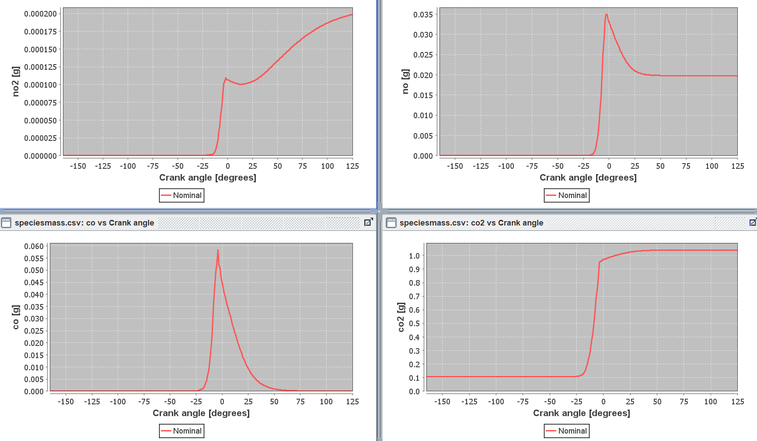
Fig. 6 NO_{X} O, O₂Emission Content in Ethanol Gasoline Engine
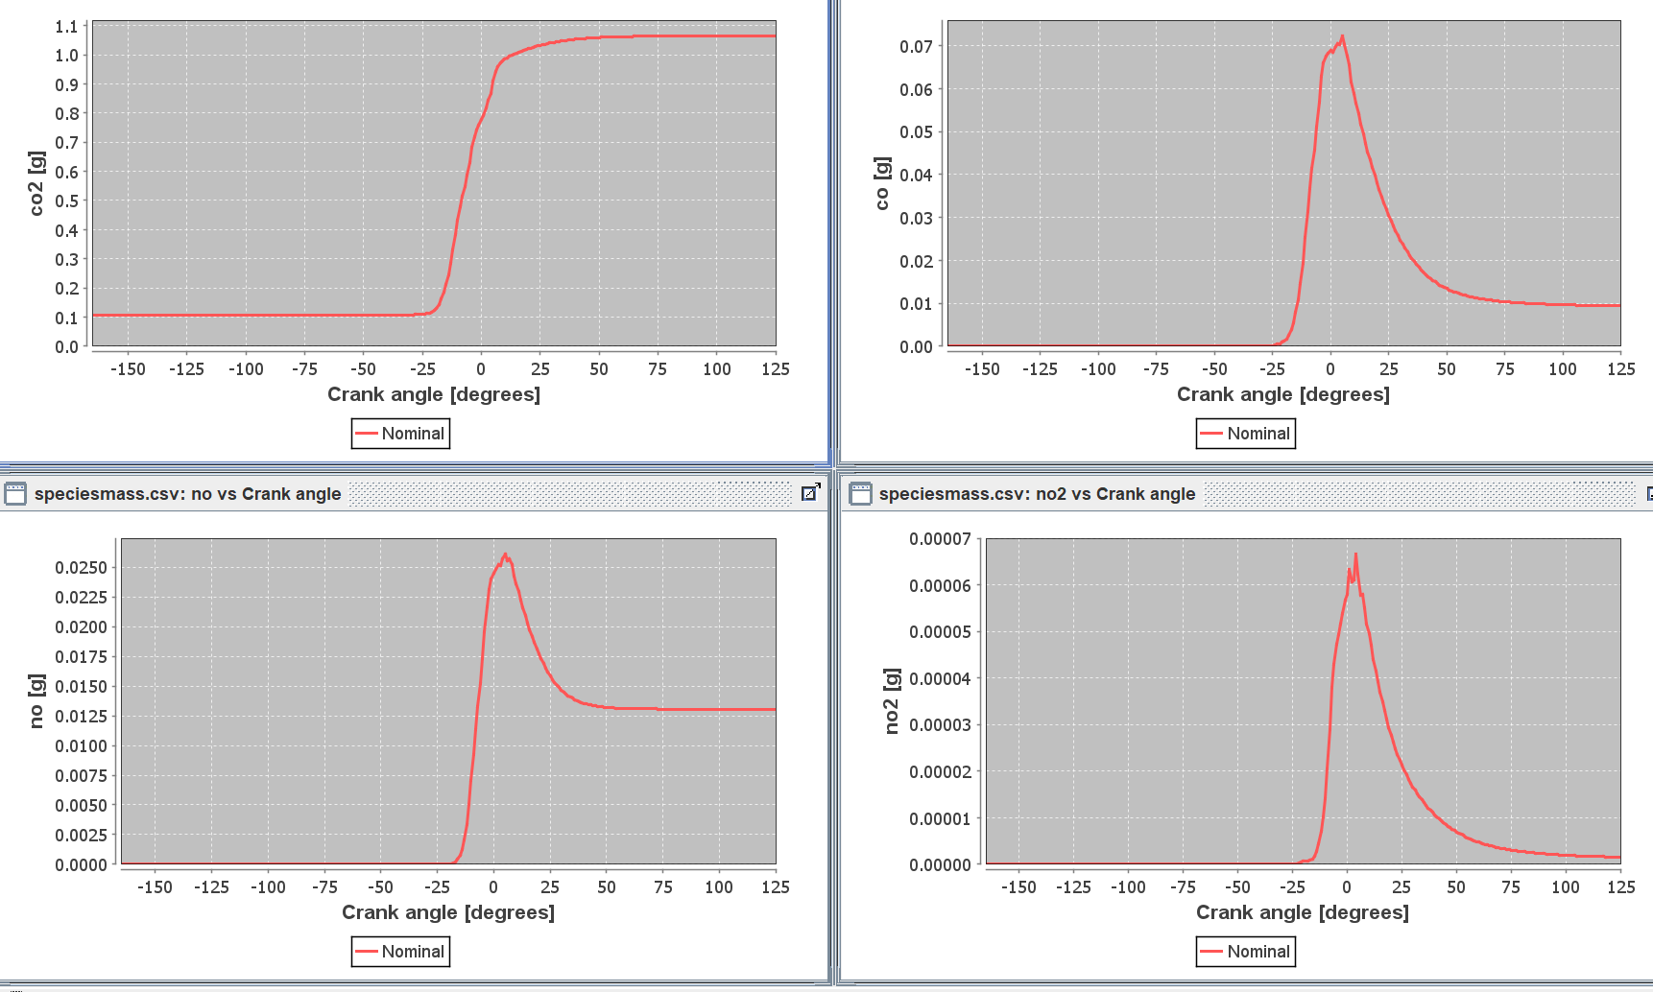
Fig. 7 OX O, O2 mission Content in Gasoline Engine

WAVA modelling
The intake subsystem leading to the intake manifold consists of a snorkel tube, air cleaner, zip ties and throttle body. The nose plug tube and zip tie tube are easily modelled with just pipe and orifice connections to connect the air cleaner and filter. Define the connections and piping, add a throttle body, which is represented as a throttle orifice containing a butterfly valve.
The exhaust manifold consists of runners with simple collectors. The collector is connected to a close-coupled catalytic converter. The exhaust manifold can be created using the same technique used for modelling the intake system. The catalytic converter consists of an inlet cone, which will be modelled using volumes, and an outlet cone, which can be modelled using a catalyst duct. The catalyst pipe inputs typical catalyst measurements that represent the geometry of the catalyst brick. The resonator is simply a perforated tube surrounded by a larger concentric tube. The resonator acts as a muffler to suppress certain frequencies in the exhaust stream. The final model is shown in Figure 8.
Creating Cylinder and Fuel Files in Wave
By creating a cylinder block module connected to the intake and exhaust module, the gasoline with 10% ethanol is created as a new fuel file, the new fuel file is imported into the model, and finally the results are calculated to compare with the results of the pure gasoline engine without ethanol added.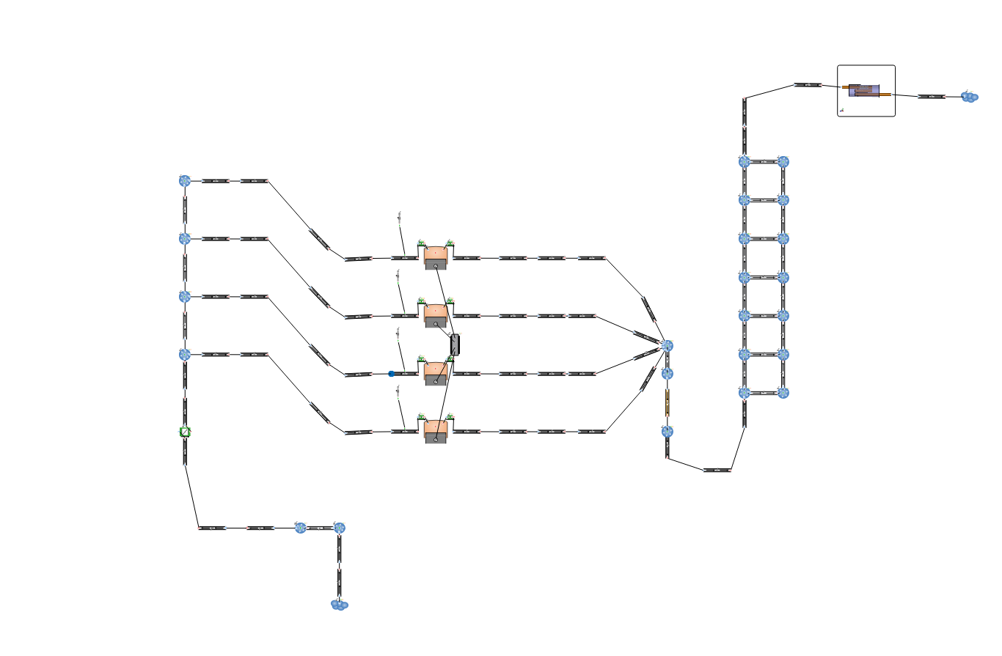
Fig. 8 WAVA simulation model

WAVA result and discussion
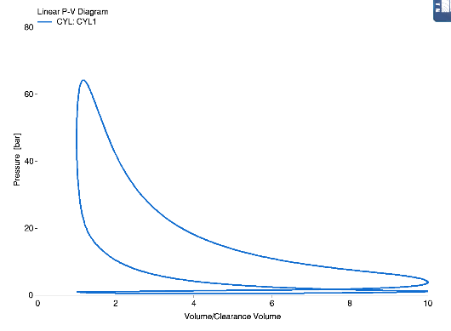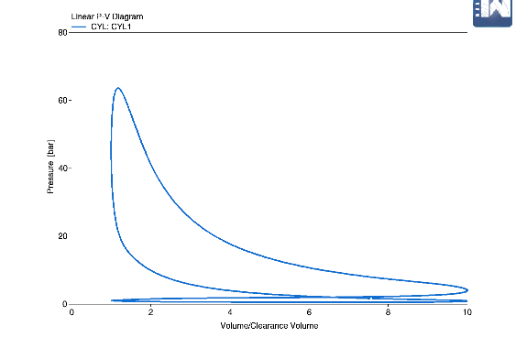
Figure 9 Ethanol Gasoline P-V Graph Figure 10 Gasoline P-V Graph
From the observation of Fig. 9 Fig. 10, we can see that the volumetric pressure value of ethanol petrol dual fuel engine is more and the peak and maximum pressures of ethanol and petrol appear earlier, we can judge that the ethanol petrol fuel is more stable and more combustible.
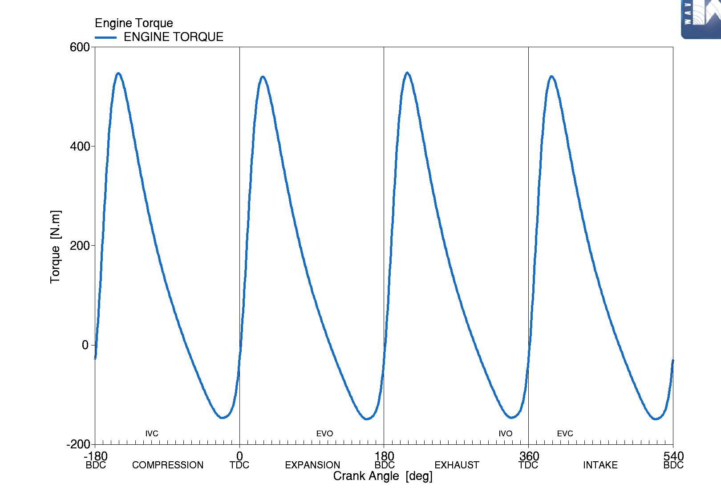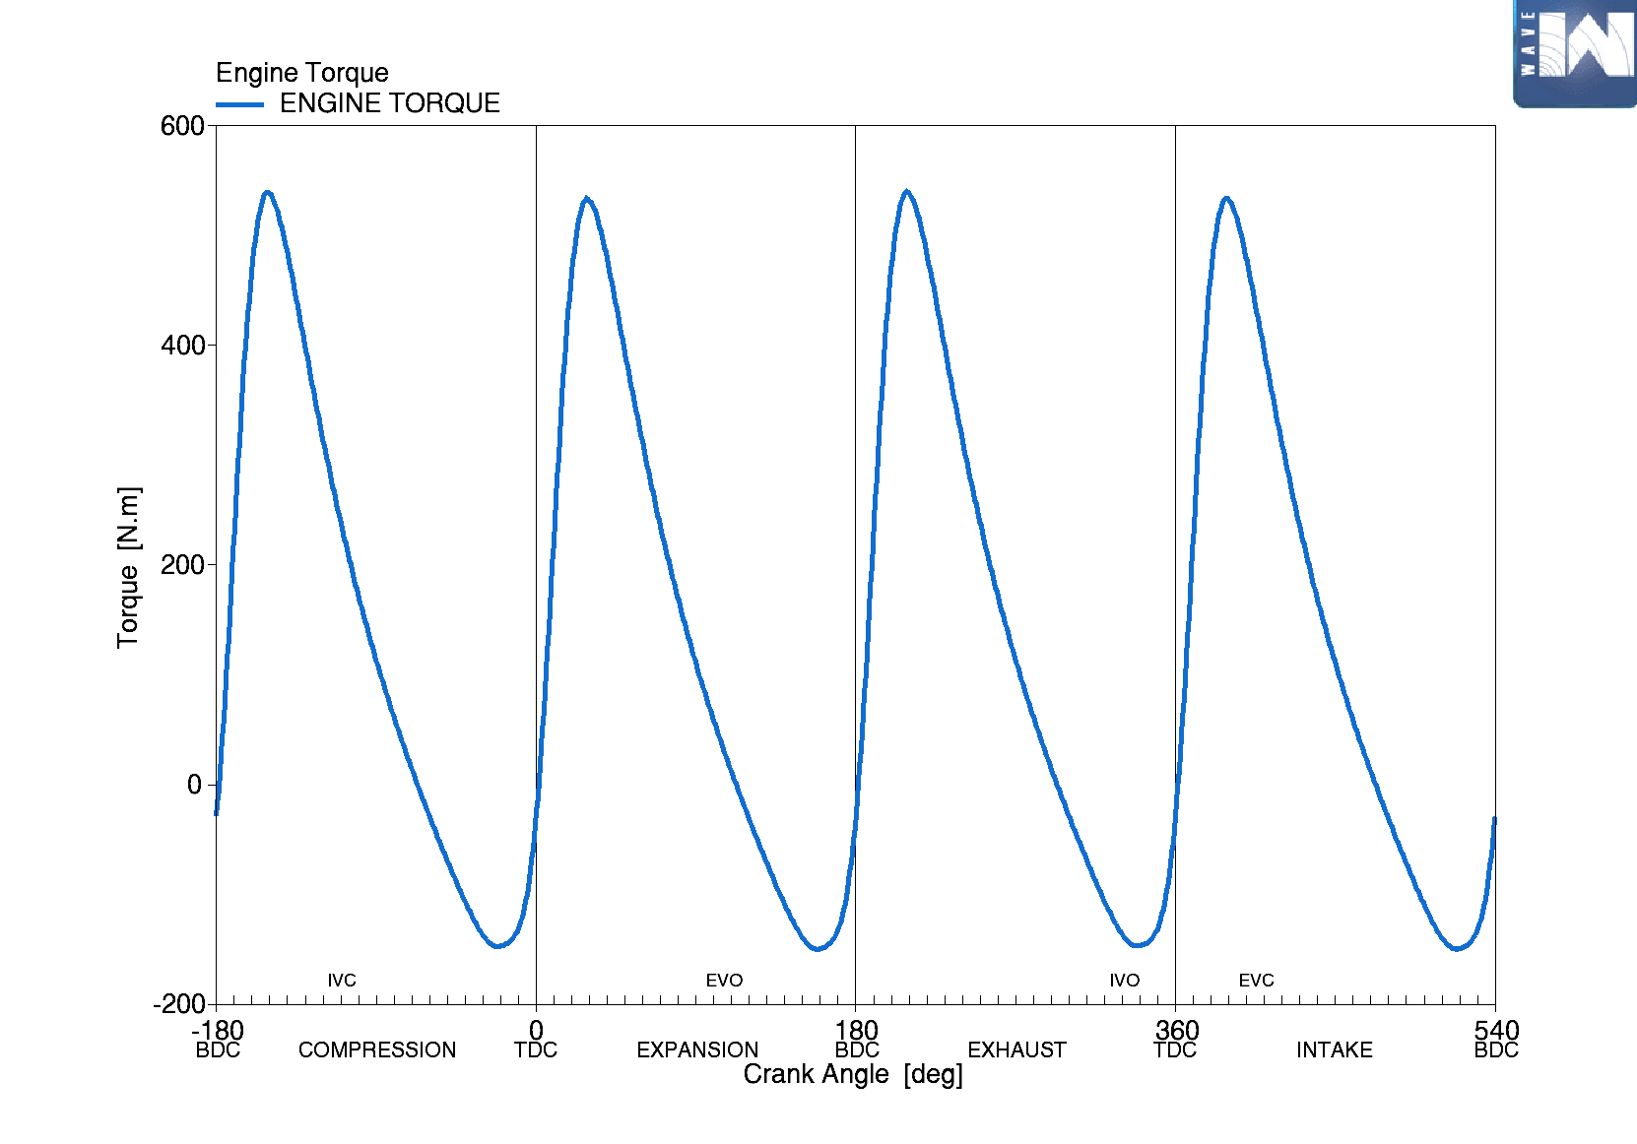
Fig. 11 Torque diagram for ethanol petrol engine Figure 12 Torque diagram for petrol engines
From Fig. 11, Fig. 12 we can observe that the peak of torque is greater in pure petrol engines than in ethanol petrol engines, and the energy density of pure petrol is higher than that of ethanol. Petrol contains more energy per kg (about 44 MJ/kg) whereas ethanol has a lower calorific value of about 26.8 MJ/kg. this means that in the same mass of fuel, petrol can release more energy and thus theoretically provide more torque. Ethanol contains 35 per cent oxygen, which helps to improve combustion efficiency, but also reduces the amount of energy per unit volume of fuel. Whilst this makes ethanol burn cleaner and reduces some emissions, it also means that on a volume basis, ethanol provides less energy compared to petrol.

Conclusion
The engine's performance and pollutant emissions were simulated using an ethanol-petrol blend. The results indicated a slight reduction in the engine's torque output when fueled by the ethanol-petrol blend. However, CO emissions were significantly reduced due to the leaning effect caused by the addition of ethanol. Conversely, CO2 emissions increased as a result of enhanced combustion efficiency. Our findings also revealed that NOx emissions were closely associated with the equivalence ratio and depended more on the engine's operating conditions than on the ethanol content in the fuel.
References
[1] Huang Yuhan. Study on the combustion process of ethanol direct injection plus gasoline inlet injection ignition engine [D]. Wuhan: Huazhong University of Science and Technology, PhD thesis, 2016.
[2] ]Key K, T L, C H, et al. Measurement of Vapor Pressures and Enthalpies of Vaporization of Gasoline and Ethanol Blends and Their Effects on Mixture Preparation in an SI Engine [J]. SAE International Journal of Fuels & Lubricants, 2008, 1(1):132-144.
[3] Kalghatgi G T, Wyszynski L, Stone C R. The volumetric efficiency of direct and port fuel injected engines with different fuels [J]. SAE Technical Paper, 2002.
[4] Ahn K H, Stefanopoulou A, Jiang L, et al. Ethanol Content Estimation in Flex Fuel Direct Injection Engines with Fault Detection Under Fuel Injector Drifts [J]. IFAC Proceedings Volumes, 2010, 43(7):123-130.
[5] Kasseris E, Heywood J. Charge cooling effects on knock limits in SI di engines using gasoline/ethanol blends: Part 1-quantifying charge cooling [J]. SAE Technical Papers, 2012, 5(2):844-854.
[6] Kasseris E, Heywood J B. Charge Cooling Effects on Knock Limits in SI DI Engines Using Gasoline/Ethanol Blends: Part 2-Effective Octane Numbers [J]. SAE Technical Papers, 2012, 5(2):844-854.
[7] Anderson J E, DiCicco D M, Ginder J M, et al. High octane number ethanol– gasoline blends: Quantifying the potential benefits in the United States [J]. Fuel, 2012, 97(7):585-594.
[8] SHEN Yitao, WANG Jianzhong, SHAOI Shijin, et al. Influence of octane number on the performance of petrol engine [J]. Internal Combustion Engine Engineering, Ref. 58 2008,(05):52-56.
[9] Balki M K, Sayin C. The effect of compression ratio on the performance, emissions and combustion of an SI (spark ignition) engine fueled with pure ethanol, methanol and unleaded gasoline [J]. Energy, 2014, 71:194-201.
[10] Milpied J, Jeuland N, Plassat G, et al. Impact of Fuel Properties on the Performances and Knock Behaviour of a Downsized Turbocharged DI SI Engine-Focus on Octane Numbers and Latent Heat of Vaporization [J]. SAE International Journal of Fuels & Lubricants, 2009, 2(1):118-126.
[11] Dirrenberger P, Glaude P A, Bounaceur R, et al. Laminar burning velocity of gasolines with addition of ethanol [J]. Fuel, 2014, 115(1):162-169.
[12] Jerzembeck S, Peters N, Pepiot-Desjardins P, et al. Laminar burning velocities at high pressure for primary reference fuels and gasoline: Experimental and numerical investigation [J]. Combustion and Flame, 2009, 156(2):292-301.
[13] Catapano F, Sementa P, Vaglieco B M. Optical characterization of bio-ethanol injection and combustion in a small DISI engine for two wheels vehicles [J]. Fuel, 2013, 106:651-666. [14] Wang Jinhua, Zuohua H, Haiyan M, et al. Characteristics of direct injection combustion fuelled by natural gas–hydrogen mixtures using a constant volume vessel [J]. International Journal of Hydrogen Energy, 2008, 33(7):1947-1956.
[15] Sementa P, Maria Vaglieco B, Catapano F. Thermodynamic and optical characterizations of a high performance GDI engine operating in homogeneous and stratified charge mixture conditions fueled with gasoline and bio-ethanol [J]. Fuel, 2012, 96:204-219.
[16] Daniel R, Tian G, Xu H, et al. Ignition timing sensitivities of oxygenated biofuels compared to gasoline in a direct-injection SI engine [J]. Fuel, 2012, 99:72-82.
[17] Zhao F, Lai M C, Harrington D L. Automotive spark-ignited direct-injection gasoline engines [J]. Progress in Energy & Combustion Science, 1999, 25(5):437-562.
[18] Huang Y, Hong G, Huang R. Numerical investigation to the dual-fuel spray combustion process in an ethanol direct injection plus gasoline port injection (EDI+GPI) engine [J]. Energy Conversion and Management, 2015, 92:275-286.
[19] Huang Y, Hong G, Huang R. Investigation to charge cooling effect and combustion characteristics of ethanol direct injection in a gasoline port injection engine [J]. Applied Energy, 2015, 160:244-254.
[20] Monteiro Sales L C, Sodré J R. Cold start characteristics of an ethanol-fuelled engine with heated intake air and fuel [J]. Applied Thermal Engineering, 2012, 40:198-201
[21] Suarez-Bertoa R, Zardini A A, Keuken H, et al. Impact of ethanol containing gasoline blends on emissions from a flex-fuel vehicle tested over the Worldwide Harmonized Light duty Test Cycle (WLTC) [J]. Fuel, 2015, 143:173-182.
[22]Gorse Jr., R.A., 1992. The effects of methanol/gasoline blends on automobile emissions. SAE Paper 920327.
[23] Chandler, K., Whalen, M., Westhoven, J., 1998. Final result from the state of Ohio ethanolfueled light-duty fleet deployment project. SAE Paper 982531.
[24] Palmer, F.H., 1986. Vehicle performance of gasoline containing oxygenates. International conference on petroleum based and automotive applications. Institution of Mechanical Engineers Conference Publications, MEP, London, UK, pp. 33–46.
[25] Abdel-Rahman, A.A., Osman, M.M., 1997. Experimental investigation on varying the compression ratio of SI engine working under different ethanol–gasoline fuel bl
[26] Alexandrian, M., Schwalm, M., 1992. Comparison of ethanol and gasoline as automotive fuels. ASME papers 92-WA/ DE-15.

