

Understanding Opportunities and Constraints of Online Financing for Micro and Small Enterprises (MSEs) in Jiujiang

Student Number: 1806564

Module Title: Qualitative Research (LCDB7003)

Module Lecturer: Dr. Suman Saha

Abstract
Micro and small enterprises (MSEs) play an important role in many countries’ economic, however, financing difficulties are still the main factors that constrain their growth. The development of online financing has provided some opportunities for MSEs’ financing. This research will adopt a qualitative-multiple case study method to explore how online financing facilitates MSEs to access capital and what constraints they will encounter in Jiujiang. Interviews, documentation and observation will be adopted to collect data from MSEs, banks, the local government and online lending platforms. This study will complement the literature gap of how online financing alleviates the extent of MSEs’ information asymmetry and provide some useful information to help MSEs selecting the appropriate financing mode of online loans.

1 Introduction
According to the OECD (2016), SMEs account for 45% of total employment, 33% of GDP and create 70% to 95% of jobs in emerging economies (World Bank Group, 2017). In China, medium, small and micro enterprises contribute over 50% of tax revenue, 60% of GDP, 70% of technological innovation and 80% of urban labor employment (People’s Bank of China, 2018).

In recent years, the government of China has promulgated many inclusive credit policies specifically aimed at small and micro enterprises, for example, the People’s Bank of China (2018) decided to increase the amount of loans by 50 billion yuan, focusing on supporting small and medium-sized banks to expand credit to micro and small enterprises. However, it has not produced obvious results in solving MESs’ financing difficulties, access to financing is still one of the most important constraints on their survival and growth (Abdulsaleh and Worthington, 2013; Cheng and Tang, 2015; J. Schmidt et al., 2017; Luo and Jin, 2012; Osei-Assibey, Bokpin and Twerefou, 2012).

Berger, Saunders and Scalise (1998) believed that information opacity will have an impact on financing of MSEs. According to Stiglitz and Weiss (1981), the information availability of enterprises is positively related to the scale of enterprises, it is difficult to collect and process information from small enterprises. With the rapid development of Fintech, the use of online loans to solve the financing constraints of micro and small enterprises has attracted the attention of many scholars. Dai (2014) presented that online lending rely on big data, cloud computing and other information technologies to implement various financial services on an open Internet platform. Xie and Zou (2012) proposed that online finance solves the problem of information asymmetry, reduces transaction costs, not only improves the efficiency of resource allocation, but also solves the financing problem of small and medium-sized enterprises. Tan and Zhao (2012) demonstrated that e-commerce platform can collect information through the platform to help enterprises display their various information.

Although there are many studies on the online financing of small and micro enterprises, there is still a lack of empirical research from the perspective of online finance. Based on the asymmetry information theory, this paper explores how online financing support MSEs to obtain funds and reveal what constraint MSEs will experience when they access finance from online lending platforms.

Previous studies only stated that online loans solve MSEs’ information asymmetry, this paper will take an in-depth exploration on how online financing mitigate the extent of MSEs’ information asymmetry. In practice, this study would provide a reference for MSEs to choose the appropriate online financing pattern.

This research will adopt case study design, multiple cases follow the principle of replication logic. In order to collect rich and validity data, a triangulation of data sources (interviews, documentation and direct observation) would be adopted in this study, so as to generate expanding knowledge of the phenomenon.

The paper is structured as follows. Section one review the literature on MSEs’ financing and online financing, list the main research perspectives, and critically evaluate the existing research results. Section two discusses the research method, and how to conduct data collection and data analysis. Section three emphasizes the expected results and limitation of this research.

2 Literature review

2.1 Financing Constraints of Micro and Small Enterprises
Some international organizations have defined and classified small and micro enterprises. The most common scale thresholds define small businesses as companies with fewer than 10 or 50 employees (ILO International Labor Organization, 2017). In 2011, the government of China issued the “Circular Concerning the Standards for the Distribution of Small and Medium-sized Enterprises”, which further refined the SMEs into medium, small and micro scale enterprises based on three indicators: operation revenues, employees and total assets (Appendix 1). This policy Emphasizes the importance of small and micro enterprises.

Although MSEs continuously enhance the economic activity of a country, the serious problem is that micro and small businesses continue to experience constraints in accessing finance, which slows down their growth and development. Kamunge, Njeru and Tirimba (2014) argued that financing constraints of MSEs include lack of information sources for financing, insufficient financing channels (Ibrahim and Verliyantina, 2013), inadequate mount of loans, and lack of collaterals (Mishra, 2013), high lending rates (Ramlee and Berma, 2013), higher transaction costs, complexity of credit procedures (Lawson, 2007). Ba (2013) pointed out that about 60% of MSEs’ financing costs are between 6% and 10%, and 40% of their financing costs are above 10%.

Information asymmetry is the root reason of financing constraints of SMEs (Beck and Demirguc-Kunt, 2006). A survey from Anne et al. (2014) found most MSEs have opaque information, some of them have no credit history, some have incomplete or inaccurate information. Bouazza, Ardjouman and Abada (2015) believed that the lack of reliable credit rating is an important reason for the financing difficulties of MSEs.

Plenty of studies have found that the problems of MSEs themselves are the causes of their financing constraints. These include small size, non-standard management, non-standard statistics information, lack of reliable collateral (Gullifer and Tirado, 2018), while banks require small enterprises to provide simple but accurate accounts in order to control risks (Chimucheka and Mandipaka, 2015). Financial institutions were reluctant to provide loans to small businesses because of high credit costs and high-risk (Chen, Lai and Lin, 2014). When examining and approving long-term loans, banks have stricter standards, complicated procedures and many documents needed. As a result, MSEs are unable to obtain long-term credit, forcing them relying on high-cost and short-term credit (de Mel, McKenzie and Woodruff, 2011). Moreover, Small entrepreneurs also lack the knowledge to identify external sources of financing, they do not know where and how to get loans (Abiola, 2012; de Mel, McKenzie and Woodruff, 2011; J. Schmidt et al., 2017).

In addition, some studies found that the finance system and policies also affect MESs accessing to credit. Zamberi Ahmad (2012) conducted a survey on 177 SMEs financing, the results showed that the main reason of financing difficulties is bureaucracy, insufficient credit options and unfriendly business environment. J. Schmidt et al., (2017) stated that although government agencies were an active source of financing for SMEs, their application procedures were considered too bureaucratic and not always transparent or fair. (Huang and Wang, 2015) found the fundamental reason for financing difficulties of MSEs in China is the institutional reason, the characteristics of MSEs do not match the current financing system dominated by commercial banks.

2.2 Online financing
The in-balance of credit supply led to financing difficulties for millions small and micro businesses, which makes MSEs find other financing channels besides traditional bank and capital markets to meet their growing financing demands.

Online financing, also known as P2P lending, P2P investing or social lending. It is usually defined as the act of lending funds to individuals or organizations without going through a traditional financial intermediary such as commercial banks. This lending takes place through various online platforms and credit checking tools (Wang, Xu and Ma, 2015). Luo and Li (2016) stated that online finance is a new financial service model that utilizes a series of modern information technology to achieve financing, such as Internet and mobile communication technology.

In China, scholars believe that there are mainly three types of Internet financing patterns, P2P lending, crowdfunding and big data financing (Dai, 2014; Shi, 2016).

The lenders and borrowers from P2P lending platforms can be individuals or institutions. Factors that SMEs choose to borrow from P2P platform include simpler loan processes, lower interest rates, lower process costs, flexible loan amounts and loan applications (Saini, 2011). Ozili (2018) stated that the development of P2P lending facilitates MSEs’ financing, they are active participants in the P2P lending market. Lu (2018) explained that P2P lending platforms have no geographical constraints, MSEs can obtain funds from individual investors, institutional investors and government institutions worldwide.

Crowdfunding refers to the mode that borrowers use the crowdsourcing platform on the Internet to finance their projects to a wide range of investors in the form of return in equity, options (Eldridge, Nisar and Torchia, 2019). Entrepreneurs who start business raise external capital from crowdfunding platforms (Cordova, Dolci and Gianfrate, 2015). Liu and Zhao (2019) divide crowdfunding model into four types: donation, reward, loan, and equity. If the project reaches the target amount within the specified time limit, the fundraising is successful, the platform will return the funds to the investors when the project is unsuccessful. Entrepreneurs can raise a small amount of money from a large group of investors to start their new businesses. Courtney, Dutta and Li (2017) demonstrated that the intensity of positive emotions in supporters’ comments increases the possibility of crowdsourcing success.

Big data financing mainly has two modes, e-commerce platform finance and supply chain finance. These two models transform the traditional financial mortgage model into a credit loan model, financing can be obtained according to credit behavior in the platform or supply chain, so it is also commonly referred E-commerce online loan (Yu, 2013). Xu, Kui and Xiaowen (2014) took Alibaba, Amazon as research objects, they proposed that e-commerce finance need the comprehensive participation of big data, e-commerce platform, fund suppliers and fund demanders, big data is the basis of operation. Zhao and Tan (2012) proved that the introduction of e-commerce platform has improved the transparency of SME information by using theoretical models, which help SMEs show their credit record and attract more investors. Ru (2014) collected a lot of data from the survey of the financing amount and financing cycle of MSEs, and further demonstrated the matching relationship between supply of Internet finance and MSEs’ fund demand.

2.3 Opportunities and constraints of online financing for MSEs
Ibrahim and Verliyantina (2013) expressed that online loans considered to be the key way to solve the financing constraints of small and micro enterprises due to the innovation of fintech. Dai (2014) agreed and complimented that online lending will have a subversive impact on financing model, which will differ from indirect financing from commercial banks and direct financing from the capital market.

Ozili (2018) expressed that online loans have many advantages over traditional ways, such as more secure, more flexible, faster, more transparent and riskless. Therefore, online lending is more in line with MSEs’ financing needs. Ren et al. (2018) argued that the key issue of MSEs’ financing constraints is asymmetry information, online loans can significantly reduce information asymmetry through powerful information processing mechanism, increasing access to finance for MSEs (Brammertz and Mendelowitz, 2018). As online finance no longer relies on financial credit history information but uses big data collection technology to integrate financial and non-financial information, which may come from business, government, social media and the Internet. Online finance collects a large amount of data by big data, cloud computing and other technologies to form a “data factory” and make full use of it. Zhang and Zhang (2015) found that on the P2P platforms, borrowers’ social capital significantly impacts on their financing availability. Among them, the bidding of friends and the identity of group members have significant impact on the credibility of borrowers’ social capital. Martina and Wang (2010) also proved that the embedding of social capital relations among MSEs could reduce the asymmetry information in transactions, reduce interest rates and improve the success rate of borrowing. Geho and Frakes (2013) pointed out that observing borrowers from blogs, personal reviews, personal exchanges and chats can effectively reduce the problem of information asymmetry while reducing the phenomenon of loan defaults. Therefore, comprehensive evaluation can help MSEs reduce the adverse selection problem caused by information asymmetry, improve their financing availability and reduce their financing costs (Fleming and Sorenson, 2016).

Although there are many advantages of online finance, they are not fully penetrated into MSEs (G20 Summit, 2013), which indicates that there is a gap between the availability and usability of online finance. As a financial innovation, there are some rationalities in the existence of various types of online lending models, however, in the early stages of development, there are inevitably various problems.

Wang and Chen (2011) presented that online financing has not been able to fully utilize the benefits of financing for MSEs due to problems such as the imperfect credit system and the non-standardization P2P sector in China. Chen, Lai and Lin (2014) stated that there is distrust between borrowers and online financing platforms. Sybirianska et al. (2018) confirmed that online financing platforms could not share MSEs’ information, and could not acquire enough information of MSEs. They believe that it is necessary to establish an information sharing platform. Iman (2018) suggested that some MSEs have insufficient understanding of online financing platforms, and they do not understand how to obtain funds through online loans. Ru (2014) demonstrated that there is an information security risk of the borrowers, which leads entrepreneurs to distrust online lending.

2.3 Theorical lens: Asymmetric Information Theory
The theory of information asymmetry refers to that in the market economic activities, people have different understandings of relevant information, those who own enough information are always in a more advantageous position, however, those who are short of information are in a more disadvantageous position (Spence, 2002).

Stiglitz and Weissn (1981) believed that if there is information asymmetry, credit rationing would occur. Information asymmetry leads banks to raise interest rates, which leads to the withdrawal of low-risk borrowers from the credit market (adverse selection behavior). Information asymmetry also induces borrowers to choose high risk projects for investment (moral hazard behavior). As a result, the average risk of bank loans rises and the expected return decreases because of the increase of bad debts that may occur, thus would not lead to an increase in bank profits. Therefore, banks will reject some loans at higher interest rates and generate excess demand in the credit market.

Abe, Troilo and Batsaikhan (2015) considered that information asymmetry between banks and SMEs hinder the process of loan application and approval. The “opacity” and “internalization” of information in small and micro enterprises make the extent of MSEs’ information asymmetry much more serious than large enterprises’, and the adverse selection and moral hazard caused by asymmetry information are also more serious, thus the finance gap of MSEs expand.

2.4 Research question, research gap, contributions and conceptual framework
The objective of this research is to understand opportunities and constraints of online financing for MSEs, so the main research question is “How does online financing facilitate micro and small enterprises to access finance and what are the constraints of online financing for MSEs in Jiujiang?”
Sub-questions:
- In generally, what constraints will MSEs experience when they access to finance?
- What financing patterns do online financing support MSEs access to capital?
- What factors hinder MSEs from using online financing?

The extant research gaps of literature are summarized following. First, previous studies focused more on the analysis of the existing financing constraints on MSEs and the mechanism of using online financing to support MSEs in accessing capital, while there is no-depth understanding of how to reduce the information asymmetry of SMEs by online financing. Second, there were few studies on online financing constraints of MSEs, the existing literature just concentrated on policy and regulatory levels, rare exploration on the understandings of online financing constraints from the entrepreneurs’ perspective.

So, the possible contributions of this research will follow. First, deeply explore the methods that online finance mitigates the extent of MSEs’ information asymmetry, the ways that MSEs and online lending platforms acquire information from each other, and understand MSEs’ online financing constraints from the perspective of entrepreneurs. Second, the government of Jiujiang is preparing to establish a credit system of small and micro enterprises, this study would provide some suggestions on how to acquire various information of MSEs and the results would provide a reference for MSEs to choose an appropriate financing mode of online loans.

The conceptual framework is proposed that online lending reduces MSEs’ asymmetric information, ultimately mitigate financing constraints of micro and small enterprises (Figure 1).

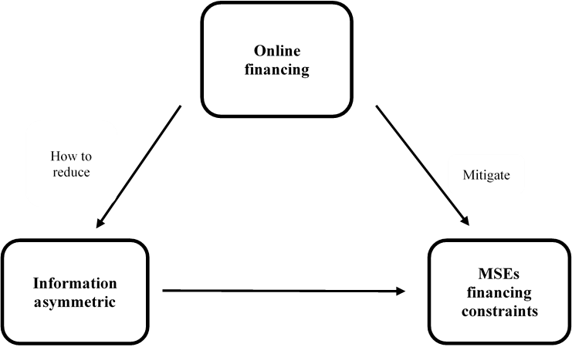

Figure 1: Conceptual framework from the author

3 Research Method
Plenty literature on MSEs’ online financing is conducted in the previous part, the research question, research gap, contributions and conceptual framework are formulated. In this part, the research method will be explained in detail. A qualitative, multiple case study research design will be adopted in this research; theoretical sampling strategy will be used to select the cases and snowball sampling strategy used to choose interviewees; a triangulation of data sources (interviews, documentation and direct observation) would be adopted to collect rich and validity data; with-case and cross-case analysis would be conducted in the phase of data analysis (Figure 2).
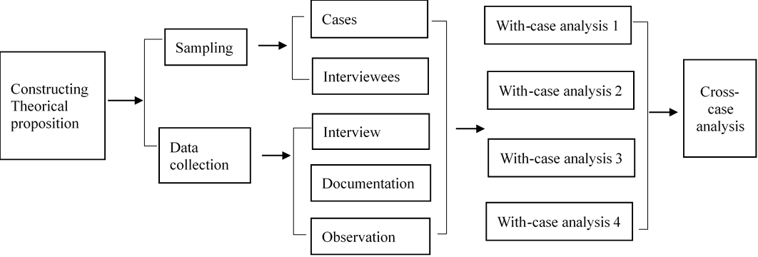

Figure 2: Multi-case study method procedures

3.1 Research philosophy - Interpretivism
Philosophical thinking influence research practice and can help researchers explain why they choose qualitative, quantitative or mixed methods for research (Creswell, 2014).

3.1.1 Ontology
Research should be based on the concept of ontology, which is the way the researcher identifies truth and reality. Ontology is the study of existence, which concerned with the nature of the reality (Saunders, Lewis and Thornhill, 2016, p109). The ontology of positivists believe that things exist objectively and are not influenced by subjective consciousness. Interpretivists adopt a relativistic orientation to explain the possibility of multiple facts (Yin, 2018). The ontology of interpretivists believe that reality is not objective existence, but social construction, which is given meaning by people in their daily interactions with others, a separation of researcher and research object is not feasible (Mir and Watson, 2000).

The financing constraints of small and micro enterprises are caused by the interaction of all levels of society, including external factors, such as economic, government policies, financial system; internal factors, like entrepreneurs’ resources and capabilities, information asymmetric. In addition, the emergence of online finance is due to the development of technology. Therefore, the phenomena of MSEs’ financing constraints and online lending discussed in this paper do not exist objectively. The ontology of this paper is the same as that of the interpretivism.

3.1.2 Epistemology
Epistemology helps researchers understand the best way to explore the nature of the world (Easrerby-Smith, Richard and Jackson, 2015, p46). Epistemology refers to the theory of knowledge and how to acquire knowledge (Burrell and Morgan 1979). Positivists believe that the truth must be verified by experience. However, interpretivists believe that the way people understand the world is to share experiences with others through language media, they focus on the complexity of human perception when situations arise (Watzlawich, 1984; Shotter, 1993). Interpretivists insist that assumptions are subjective while the created knowledge depends on the interaction between the research and respondents (Sun, Yunguo and Fang, 2004).

The financing problems of small and micro enterprises are complicated. Researchers believe that in order to understand MSEs’ financing problem in depth, it is necessary to communicate and interact with relevant personnel from MSEs, governments, banks and so on. In addition, online lending is a new phenomenon, how the researcher can get entrepreneurs’ understanding of online lending also require the researcher talking and interacting with the entrepreneurs. Therefore, the issue studied in this paper need to generated in the interaction, which is consistent with the interpretivist’s epistemology.

3.2 Research approach - qualitative
Guba and Lincoln (1994) indicated that the worldview is not only embodied in ontology and epistemology, but also in the choice of research methods. In the process of reading the literature, it is found that some scholars use qualitative research methods (interpretivism), quantitative research methods (positivism) and a small number of mixed methods (realism) to study similar issue. Unlike quantitative researchers who seek to generalize the definitions, predictions, and conclusions of causal relationships, qualitative researchers seek inspiration, understanding, and extrapolation of similar situations (Hoepfl, 1997). Interpretivists usually adopt qualitative research method.

The purpose of qualitative research is to understand specific social situations, events, roles, or interactions, with a focus on the perception and experience of participants and how they understand their lives. A qualitative research engages in the exploration of deeper understanding rather than examining surface features (Johnson, 1997). This paper is to understand the opportunities and constraints of online financing for MSEs, the research plan to understand the entrepreneurs’ deep-rooted views through contacting and communicating with them. Qualitative approach is more in line with the research theme and research goals of enterprises’ growth, it can discover and excavate important phenomena and information (Li and Li, 2006). Furthermore, the flexibility of qualitative research method and the number of participants involved are also factors for the adoption of qualitative research in this study.

3.3 Research design - multiple case study
Easrerby-Smith, Richard and Jackson (2015, p84-89) introduces six qualitative research design in the book” Management and business research”, there are action research, archival research, ethnography, narrative methods, case method and ground theory.

According to Yin (2018, p96), The most important condition for determining research designs is to find out what types of questions the research will answer. Questions like how and why always apply in case study, this study mainly takes questions like how and why. Yin also emphasizes that the focus of case study is to seek explanations for some existing phenomena, such as how some social phenomena are formed and how they work. MSEs’ Financing constraints are the current social imagination, and online lending is also hot recent years. This study explores how MSEs’ financing constraints are formed and how online loans promote small and micro enterprises to access to fund. Third, the most important value of case study lies in their prominent context, presentation process and revealing relationship. Compared with other research methods, case study is applicable to researching current phenomena in real-life situations (Yin, 2003, p29). The topic of this paper is also in a certain context. China is taking a series of measures to vigorously promote the development of small and micro enterprises, compared with the developed cities in China, Jiujiang belongs to the economically underdeveloped area, MSEs’ financing constraints may be more prominent. In addition, Jiujiang is preparing to construct a credit system of small and micro enterprises. In this context, it is very meaningful to study the financing problem of MSEs. The topic in this paper is consistent with the above characteristics, so that the selection of case study method is appropriate (Yin, 2018).

3.4 Sampling

3.4.1 Cases selection
The first step in data collection preparation is to develop a sampling strategy to select potential participants and data collection methods (Creswell, 2014, p239). The purpose of qualitative sampling strategy is to identify reasonable examples of phenomena in research (Luker, 2008). Therefore, case study follows the principle of theoretical sampling, that is, the selected case is for the purpose of answering the research questions rather than the statistical sampling.

The case study can be a single case design or a multiple case design. Single case study is suitable for unusual or unique phenomena, representative or typical events. Eisenhardt and Graebner (2007) believed that multiple case study could more comprehensively understand and reflect different aspects of the cases, support the conclusions of the study through case repetition, thereby increasing the validity of the study. Yin (2009) stated that the conclusions summarized in multiple cases will be more solid and more convincing than those from a single case. Therefore, this study adopts a multi-case study design, tell the story of each case and use replication logic to compare multiple cases.

Multiple cases should follow the replication principle, which includes literal and theoretical replication. Literal replication refers to the fact that selected cases can produce the same results. Theoretical replication refers to the result that is different from that of the previous study for predictable reasons (Yin, 2018, p74). This study plans to select 4 cases, which follow literal replication. Case 1 and 2 as similar cases to verify the theoretical proposition, which is, the two companies solve their financing constraints through online lending. Case 3 and 4 verifies the inconsistent results with the theoretical proposition that the two companies access credit from banks, which follows theoretical replication (Table 1; Figure 3).

Table 1: Introduction of the selected cases

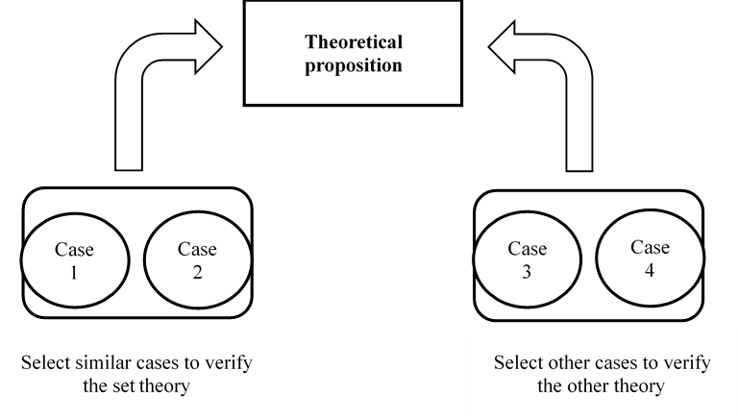
Figure 3: Cases verification model

3.4.2 Interviewees selection
After the cases are confirmed, the interviewees need to be sampled. This research plans to adopt snowball sampling to access data, the first respondent recommends other potential respondents. For example, through the entrepreneurs to contact their financial managers, employees, managers from local banks and government officer. Compared with other methods, snowball sampling can acquire abundant and difficult materials (Easrerby-Smith, Richard and Jackson, 2015, p26). This method is more effective in China and more culturally acceptable in culture perspective (Chen, 2001). The specific sampling plan is showing in Table 2.

Table 2: Interviewees sampling plan
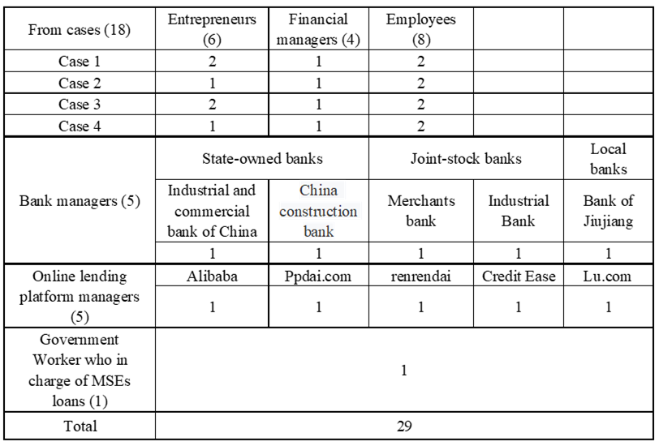

3.5 Data collection
This paper adopts multiple data collection methods, interview, observation and documentation, interview is the most important method of data collection. Triangulation data resource provides stronger evidence for construction and assumptions (M. K. Eisenhardt, 1989).

3.5.1 Individual interviews

Designing and planning the interviews
Interviews have always been a useful data collection method used by various types of qualitative research, they are very basic and directional conversations (Lofland and Lofland, 1995). Through face-to-face language communication with the respondents, researchers can obtain real insights in specific context and understand some phenomena that are difficult to observe (Rowley, 2012). Interviews can better understand the historical background of small and micro enterprises. Therefore, in the process of interviews, the whole interaction between interviewers and participants is very important.

Interviews would be either individual interviews or focus group interviews (Easrerby-Smith, Richard and Jackson, 2015, p62). In this paper, individual interviews will be applied. The sensitivity of discussing money topics makes individual interviews a better choice, as interviewees may be reluctant to disclose their financial information in a group discussion.

The forms of interviews include structured, semi-structured and unstructured interviews (Mason, 2002). Structured interviews are rigorously questioned in a predetermined order, some of which have a small range of answers, thus suit for market research. Unstructured interviews are based on limited topics, with a focus on encouraging respondents to talk around a topic without an interview guide. Unstructured interviews require the researcher with good skill and rich experience. As a novice, semi-structured interviews are more appropriate. Qu and Dumay (2011) argue that semi-structured interviews are the most common type of interview, and it is a well-phrased combination of questions based on interview design (Easrerby-Smith, Richard and Jackson, 2015, p146).

The research needs to ensure that all the questions are relevant to the research topic, ambiguous, repetitive and inductive questions should be avoided. By searching, sorting out and understanding the literature, modifying and supplementing the interview guides of other researchers, the preliminary draft is submitted to a scholar to examine and modify, who has rich research experience in small and micro enterprises.

Conducting the interviews
Before the interviews begin, the research should thanks to the interviewees, briefly explain what the research is, why do the research take place, then present a recommendation letter and project description to all participants. Confidentiality assurance and permission of recording should be made (Rowley, 2012).

The research invites respondents to talk about their own views, attitudes, behaviors or experiences and express feelings that may not be accepted in other relationships and environments (Chen, 2001), ensuring that interviewees are able to talk freely and without interference. The research should not impose their subjective consciousness on participants to avoid prejudice. For the academic terms in the interview guide, the investigator should explain to the participants the meanings, such as what is online financing, what is information asymmetry. The interviewer needs to listen to the participants what they want or don’t want to say. When identifying these situations, they can collect non-verbal data, such as eye contact or changes in facial expressions (Rowley, 2012).

At the end of the interviews, the research should thank again and arrange follow-up contacts. Each interview will last approximately 30-60 minutes.

3.5.2 Documentation
Yin (2018, p114) stated that text information is used in almost every case study, and documents can be expressed in various forms, such as files, meeting record, bulletins, and news reports.

Before conducting interviews, some information can be obtained on the internet, such as documents of loan conditions from commercial banks, application procedures and relevant government policies. The researcher deduces the documents as details can test the information provided in the interview. At the beginning of the interviews, obtain documents from the companies with the consent of the entrepreneurs, for instance, organizational structure chart, documents of rules and regulations, meeting records, agenda and even their financing reports, information and other materials. There are obvious advantages of documents data, such as nature, authenticity, stability and wide coverage, but some human factors will affect the acquisition of data.

3.5.3 Direct observation
The essence of observation is to systematically observe, record, describe, analyze and explain human behavior (Saunders, Lewis and Thornhill, 2008, p289). Observation includes participatory observation and direct observation. Participant observation is the main data collection method in ethnographic research (Easrerby-Smith, Richard and Jackson, 2015, p164). This study adopts direct observation method, which means that the researcher avoiding any interaction with the field of observation, without requiring the participants to explain their own behaviors. It takes a more independent position, which can accurately depict the specific activities of the workplaces of four enterprises, so that obtaining some information that is not available in interviews. Direct observation can be embedded in interviews, information such as office location, conditions, furnishings, staff situation, company rules and regulations can be directly observed in the cases. Data can be collected by means of written records, audio recordings and videos. It should be noted that non-participatory observation must also be allowed.

3.6 Data analysis
Eisenhardt (1989) argued that the analysis of data is the core of theory construction and the most difficult part in case study research. She emphasized that data collection and analysis can be carried out alternately during the survey process, using flexible methods and on-site notes to collect and analyze data repeatedly until data collection and analysis becomes increasingly impossible to reveal new or relevant information, that is, the saturation strategy proposed by Glaser and Strauss (1967).

3.6.1 With-case and cross-case analysis
Multiple case study consists of two analysis steps, with-case analysis and cross-case analysis (Eisenhardt, 2007). Yin (2018, p212) identified five main models of in-case analysis techniques: pattern patching, pxplanation building, time series analysis, logic models and cross-case synthesis. The cross-case analysis is to break through the initial impressions and conception of the researchers through continuous comparison, and then draw the theory that strictly matches the data, and test the possibility whether the relationship is consistent between the proposition and the evidence.

This study will adopt with-case and cross-case analysis, applying pattern matching method. Eisenhardt (2007) emphasized that the main task of with-case analysis is to answer research questions for each case. Miles and Huberman (1994) demonstrated pattern matching is one of the optimal analysis strategies. The technology will compare the empirical model with the predictive model, which can improve the research internal reliability.

3.6.2 Operations of data analysis
Spiggle (1994) proposed that the operation of qualitative data consist of seven steps: categorization, abstraction, comparison, dimensionalization, integration, iteration, and refutation. Through these operations, the researcher organizes the data, extracts the meaning, draw the conclusions, and generates or validates the conceptual schemes and theoretical proposition.

(1) Categorization is the process of classifying or labeling data units. In the coding procedures, the researcher classifies the data into categories they are interested in and label them. Four cases in this study were divided into two groups, and then the similarities and differences between the two groups were found. (2) Abstraction groups more specific identified categories into more general conceptual categories (Miles and Huberman, 1994, Page 69-71). (3) Glaser and Strauss (1967) emphasized comparison referred that the use of constantly comparing methods for analysis, for example, comparing records and events at different times, locations, and interviews. The researcher looks for differences in seemingly similar cases, as well as finding similarities in seemingly different cases. (4) Eisenhardt (1989) stated that dimensionalization can be defined by research questions or existing literature, or can be simply selected by the researcher, or summarized by the collected data. (5) Corbin and Strauss (1990) proposed that the categories and structures defined by the analyst could be integrated by axial coding and selective coding. (6) Iteration means that the investigator moves back and forth through different stages of the research, for example, iteration can occur between data collection and data analysis phases of the research and switch back and forth relating a part of a text to the whole within the analytic procedure (Hirschman, 1986). Iteration would perform a more unified interpretation of the data. (7) Refutation means that the analyst should constantly test the data of the analysis, redesign and modify the analysis (Spiggle, 1994).

3.7 Trustworthiness and Soundness
Patton (2002) indicated that validity and reliability are two factors that any qualitative researcher should pay attention to when judging the quality of research. The following strategies will be addressed to increase the quality of case study in this paper (Yin, 2018, p128) (Table 3).

Table 3: Quality assessment of case study

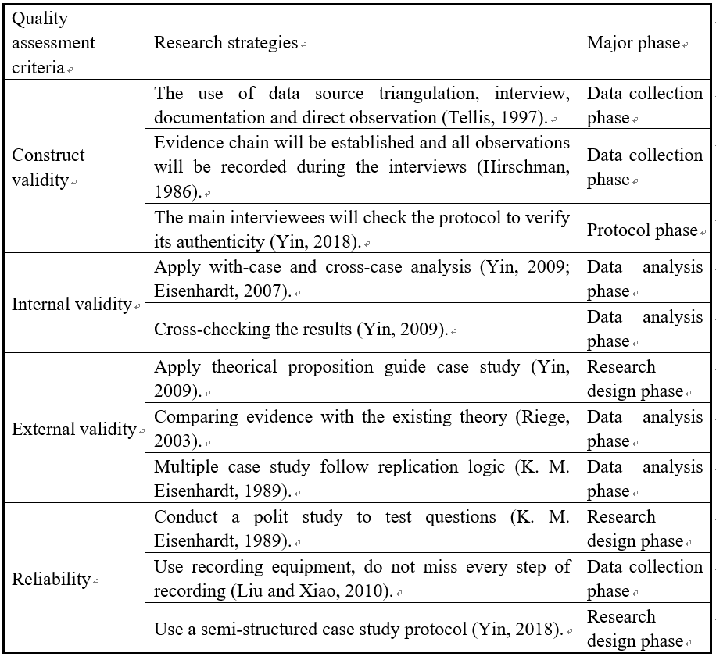

3.8 Ethical issues
The researcher also need to predict ethical issues that may arise in the research (Easrerby-Smith, Richard and Jackson, 2015, p178). This study will follow these principles. (1) Consent principle: the research will obtain permission from the University. In the process of data collection, record, visit, observation will be permitted from the participants. (2) Confidentiality principle: the researcher will ensure that all the information of MSEs would not be disclosed to others, the participants will be respected to the greatest extent in the whole process of the research (Sutton and Staw, 1995). (3) Fairness principle: all of participants will spend a lot of time talking to the investigator, they provide information, even involve their privacy issues. The researcher will be grateful for the help equally.

4 Conclusion and limitation
The development of online finance brings feasibility and convenience to the financing of small and micro enterprises. Jiujiang is underdeveloped in China, the application of online financing for MSEs begins to be concerned in recent years, which is not mature. This study attempts to explore how online financing promotes small and micro enterprises to access capital and what constraints they will experience in Jiujiang city. By review plenty of literature, it is known that online financing brings opportunities for MSEs as it solves the problem of information asymmetry. So, the key issue is this study is that how online financing mitigate the extent of MSEs’ information asymmetry, which is also the gap of existent literature. Besides, few articles mention online financing constraints of small and micro enterprises. This article will explore the understanding of online financing constraints from the perspective of entrepreneurs, rather than from the perspective of policy and regulation in the existing literature. The practical significance of the study is also significant. Jiujiang is establishing an information sharing platform for MSEs, the results of this study may provide suggestions on how to obtain MSEs’ information for the government and provide reference for MSEs to select the most suited pattern of online loans.

Limitations
- The samples maybe not representative by using of snowball sampling method. The universality of research results may be challenged due to the limitation of sample conditions.
- There may be situation in which some entrepreneur from the cases conceal the true financial information, which will affect the validity of the research.
- As a novice, insufficient research experience and limited skills may affect the quality of the research results.

Reflective Essay

Quantitative and qualitative methods are the two most important methods in academic research, they study the essence of the same thing from different perspectives. The problems of different nature in real society are complex and diverse,

Concepts of the quantitative and qualitative research
The essence of quantitative research is to use statistical methods to test the correlation between independent and dependent variables, and to use deduction method to verify whether the theoretical assumptions are correct (Easrerby-Smith, Richard and Jackson, 2015).

Qualitative research take researcher as the research tool, a variety of data collection methods are adopted to explore social phenomena, inductive method is used to analyze data and construct theory, then and an interpretative understanding would be obtained by interacting between investigator and participants (Chen, 2001).

Quantitative research method finds the commonness and universality of things, focusing on using numbers to describe and reveal events, phenomena, and problems. Qualitative research methods explore the personality, complexity, and particularity of things, focusing on the use of language to describe and explore events, phenomena, and problems.

Advantages and Disadvantages of Quantitative Research:

Quantitative research methods are more objective and scientific, they can greatly advance the abstraction and generalization of the theory, and promote the accurate analysis of the causal relationship between variables. But it also has a lot of limitations, such as the difficulty of obtaining in-depth and extensive information, moreover, establishing the causal relationship between the two variables is not easy.

Advantages and Disadvantages of Qualitative Research:

In the process of qualitative research, participants can express themselves more freely, so that it is possible for the research to get a deeper understanding of the insight thoughts of participants. the insights can be obtained by the researcher. This kind of research method is more flexible, and it is more likely to construct new theories and concepts.

The drawbacks of qualitative method are subjective and subjective factors, which are inevitably biased by various research conclusions. In addition, the universality of research results is often not universal due to the limitations of sample conditions. The defect of qualitative method lies in its strong subjectivity as the investigator is the research tool. Due to the interference of subjective factors, various research results are inevitably biased. In addition, the research results are not universal and generalizable due to the limitation of sample conditions.

Differences between quantitative and qualitative research method
The differences between quantitative and qualitative research are mainly reflected in the philosophy, research strategies, research tools and role of researchers.

Different research philosophy
Research design is based on how researchers understand the social world. The theoretical basis of quantitative research is positivism philosophy, while the theoretical basis of qualitative research contains constructivism, post-positivism, interpretivism and other schools.

Positivists have the ontology that the reality is objective, the subject and object are independent, the researchers are neutral (Easrerby-Smith, Richard and Jackson, 2015). Constructivists believe that the essence of social reality is not objective existence, and the social phenomena are generated by the interaction between people, the subject and object are not separate.

Positivists have the epistemology that knowledge can be learned only through scientific methods. If the researcher follows certain methodology, the results of the study can be extended to a wider range. Constructivists have the epistemology that knowledge constructed from the interaction between the subject and object, and then the process of rebuilding the object.

In terms of methodology, positivists usually test assumptions through the hypothesis-deduction model. It focuses on statistical calculation of data, including experimental, questionnaire survey method and so on. Interpretivists believes that attention should be paid to the value, attitude and understanding of life. Researchers, as the main research tool, penetrate the research context. Qualitative research main uses observation, interviews and other strategies to obtain primary data, and uses induction, then through transformation, finally form a theory.

Different data collection strategies
The research design of quantitative include survey and experiments. The research design of qualitative mainly consist of case study, Action research, Grounded theory, Ethnography and Archival research. Questionnaire is the main data collection method, questionnaires can be collected from different ways, such as office interview, telephone interview and email survey. There are various data evidences collection methods of qualitative research, interview (individual interview and group focus), observation (participant and non-participant observation), documentation and archival records.

Different data analysis methods
Quantitative research makes use of statistical test to analyze collected data, such as probability distribution, significance test, correlation test, linear regression analysis, structural equation model, etc. Researchers usually adopted software tools for data analysis, like SPSS, Python. Qualitative data analysis includes logical deduction, historical comparison and other methods. There are several data analysis operations: categorization, abstraction, comparison, dimensionalization, integration, iteration and refutation. Coding runs through the whole analysis process. In qualitative research, researchers are the main analytical tools, and software tools assist researchers in their analysis.

Difference of relationship between researchers and participants
Quantitative research emphasizes objectivity and requires researchers to take a value-neutral stand in order to avoid bias. Qualitative research focuses on understanding the phenomenon from the researchers’ own point of view. The background of the researcher and its relationship with participants will affect research process and results. The distinction among different researchers are not only reflected in aspects of research questions, research design, the interpretation of research results, but also in the specific methods and technical levels of participation in observation, individual interviews, data analysis and so on.

Obviously, quantitative and qualitative research are two distinct methods, but they are not antagonistic. They have their own strengths; they can support and complement each other. Qualitative research is the basic premise of quantitative research, and quantitative research is the further deepening of qualitative research. Qualitative method can help the researcher find the key issue to the problem, meanwhile quantitative method can allow researchers to confirm the objective content of the problem and test the reliability of existing theories.

Which one is easier?
In my opinion, quantitative research is relatively easy, as it has a unified paradigm and requirements, and it can verify the causal relationship between variables step by step. Quantitative research method mainly uses questionnaire survey, it is easier to collect data, which can access large sample of respondents in a very short time. In the aspect of data analysis, quantitative analysis tools have been used in my previous papers writing, so I am familiar with the whole procedure.

Qualitative research method lacks systematic operation method. It pays more attention to the individuality, complexity and particularity of phenomenon. Therefore, qualitative research requires high sensitivity to personal interview skills, communication skills, information and knowledge perception. Researchers themselves, as research tools, will affect the quality and results of research if they lack these skills or fail to use them well.

The methodological choice of my future research and why?
Both quantitative and qualitative methods have their own strengths and weaknesses. In the future doctoral dissertation research, the researcher’ world outlook, interests, research topics and purposes should be considered as affecting factors to decide which research method to use.

First, I think the reality of society is constructed by people in the process of interaction, subject and object should not be inseparable. Maybe I am a constructivist.

Secondly, in terms of interest, I prefer qualitative research method. I like to talk with others, I like to understand people's insightful thoughts through interviews. I prefer to explore the individuality, complexity and particularity of social phenomena. I think such a study is more profound and meaningful. But I think qualitative research is more difficult and requires higher personal research competence of investigator.
Moreover, the topic of graduation thesis has not been determined so far, so which research method to use needs to be decided after the topic is determined. Although I prefer qualitative methods, I consider using mixed research methods because of some shortcomings of qualitative research. Mixed research method combines qualitative and quantitative research methods and applies them in the same article, which strengthens the advantages of the two research methods and weakens their respective weaknesses (Creswell, 2014, p265). It can generate a deeper and more comprehensive academic understanding.

Appendix 1: Industry classification standards for small and micro enterprises in China

Industry category | Index | Small enterprise | Micro enterprise
Farming, forestry, animal husbandry, and fishery | Operation revenue (10 thousand Yuan) | 50-500 | ＜50
Manufacture | Operation revenue (10 thousand Yuan) | 300-2000 | ＜300
Manufacture | Employees (number) | 20-300 | ＜20
Construction | Operation revenue (10 thousand Yuan) | 300-6000 | ＜300
Construction | Total assert (10 thousand Yuan) | 300-5000 | ＜300
Wholesale | Operation revenue (10 thousand Yuan) | 1000-5000 | ＜1000
Wholesale | Employees (number) | 5-20 | ＜5
Retail | Operation revenue (10 thousand Yuan) | 100-500 | ＜100
Retail | Employees (number) | 10-50 | ＜10
Transportation | Operation revenue (10 thousand Yuan) | 200-3000 | ＜200
Transportation | Employees (number) | 20-200 | ＜20
Postal service | Operation revenue (10 thousand Yuan) | 100-2000 | ＜100
Postal service | Employees (number) | 20-300 | ＜20
Hotel and lodging | Operation revenue (10 thousand Yuan) | 100-2000 | ＜100
Hotel and lodging | Employees (number) | 10-100 | ＜10
Catering | Operation revenue (10 thousand Yuan) | 100-2000 | ＜100
Catering | Employees (number) | 10-100 | ＜100
Software and information technology | Operation revenue (10 thousand Yuan) | 50-1000 | ＜50
Software and information technology | Employees (number) | 10-100 | ＜10
Real estate | Operation revenue (10 thousand Yuan) | 100-1000 | ＜100
Real estate | Total assert (10 thousand Yuan) | 2000-5000 | ＜2000
Leasing | Operation revenue (10 thousand Yuan) | 100-8000 | ＜100
Leasing | Employees (number) | 10-100 | ＜10
Others | Employees (number) | 10-100 | ＜10

Source: National Bureau of Statistics, China, 2019

Reference:
Abdulsaleh, A. M. and Worthington, A. C. (2013) ‘Small and Medium-Sized Enterprises Financing: A Review of Literature’, International Journal of Business and Management, 8(14), pp. 36–54. doi: 10.5539/ijbm.v8n14p36.
Abe, M., Troilo, M. and Batsaikhan, O. (2015) ‘Financing small and medium enterprises in Asia and the Pacific’, Journal of Entrepreneurship and Public Policy, 4(1), pp. 2-32. doi: 10.1108/JEPP-07-2012-0036.
Abiola, B. (2012) ‘Effects of Microfinance on Micro and Small Enterprises (MSEs) Growth in Nigeria’, Asian Economic and Social Society, 2(3), pp. 463-477.
Anne, J. et al. (2014) ‘Challenges Facing Micro and Small Enterprises in Accessing Credit Facilities in Kangemi Harambee Market in Nairobi City County, Kenya’, International Journal of Scientific and Research Publications, 4(1), pp. 2250-3153. Available at: www.ijsrp.org.
Ba, S. (2013) ‘Big Data Solves the Financing Bottleneck of Small and Micro Enterprises’, China Economic Report, 6, pp. 29-31.
Beck, T. and Demirguc-Kunt, A. (2006) ‘small and Medium-size Enterprises: Access to Finance as a Gmwth constmint’, Journal of Banking and Finance, 30(11), pp. 31-43.
Berger, A. N., Saunders, A. and Scalise, J. M. (1998) ‘The Efkcts of Bank Mergers and Acquisitions on small Business Lending’, Journal of Financial Economic, 50(2), pp. 187-229.
Bouazza, A. B., Ardjouman, D. and Abada, O. (2015) ‘Establishing the Factors Affecting the Growth of Small and Medium-sized Enterprises in Algeria’, American International Journal of Social Science, 4(2), pp. 101-115.
Brammertz, W. and Mendelowitz, A. I. (2018) ‘From digital currencies to digital finance: the case for a smart financial contract standard’, Journal of Risk Finance, 19(1), pp. 76–92. doi: 10.1108/JRF-02-2017-0025.
Chen, D., Lai, F. and Lin, Z. (2014) ‘A trust model for online peer-to-peer lending: a lender’s perspective’, Information Technology and Management, 15(4), pp. 239-254. doi: 10.1007/s10799-014-0187-z.
Cheng, M. ’e and Tang, Y. (2015) ‘Small and Medium-sized Enterprise Financing Channel Construction’, Management & Engineering, 19, pp. 1838-5745. doi: 10.5503/J.ME.2015.19.011.
Chimucheka, T. and Mandipaka, F. (2015) ‘Challenges Faced By Small , Medium And Micro Enterprises In The Nkonkobe Municipality’, International Business & Economics Research Journal, 14(2), pp. 309-317.
Corbin, J. and Strauss, A. (1990) ‘Grounded Theory Methodology: Procedures, Canons, and Evaluative Criteria’, Qualitative Sociology., 13(1), pp. 3-21. Available at: https://med-fom-familymed-research.sites.olt.ubc.ca/files/2012/03/W10-Corbin-and-Strauss-grounded-theory.pdf.
Cordova, A., Dolci, J. and Gianfrate, G. (2015) ‘The Determinants of Crowdfunding Success: Evidence from Technology Projects’, Procedia - Social and Behavioral Sciences. Elsevier B.V., 181, pp. 115–124. doi: 10.1016/j.sbspro.2015.04.872.
Courtney, C., Dutta, S. and Li, Y. (2017) ‘Resolving Information Asymmetry: Signaling, Endorsement, and Crowdfunding Success’, Entrepreneurship: Theory and Practice, 41(2), pp. 265–290. doi: 10.1111/etap.12267.
Creswell, J. W. (2014) Research Design. 4th edn. London: SAGE.
Dai, D. (2014) ‘Financing of Small and Micro Enterprises by Internet Finance Supporting Theory and Practice-Analysis from the Perspective of Financing for Small and Micro Enterprises’, Economic Forum, 4, pp. 91-96.
Easrerby-Smith, M., Richard, T. and Jackson, P. R. (2015) Management and Business Research.
Eisenhardt, K. M. (1989) ‘Building Theories from Case Study Research’, The Academy of Management, 14(4), pp. 532-550.
Eisenhardt, K. M. (2007) ‘Eisenhardt and Graebner 2007 theory building from cases .pdf>’, 50(1), pp. 25-32.
Eisenhardt, K. M. and Graebner, M. (2007) ‘Eisenhardt Graebner Theory Building From CasesAMJ2007.pdf’, Academy of Management Journal, 50(1), pp. 25-32. doi: 10.1002/job.
Eisenhardt, M. K. (1989) ‘Building theories from cases study research’, The Academy of Management Review, 14(4), pp. 532-550.
Eldridge, D., Nisar, T. M. and Torchia, M. (2019) ‘What impact does equity crowdfunding have on SME innovation and growth? An empirical study’, Small Business Economics. doi: 10.1007/s11187-019-00210-4.
Fleming, L. and Sorenson, O. (2016) ‘Financing by and for the Masses: An Introduction to the Special Issue on Crowdfunding’, California Management Review, 58(2), pp. 5-19. doi: 10.1525/cmr.2016.58.2.5.
Geho, P. R. and Frakes, J. (2013) ‘Finnancing for Small Business in a Sluggish Economy Versus Conflicting Impulses of the Enterpreneur’, Entrepreneurial Executive, 18, pp. 89-102.
Glaser, B. G. and Strauss, A. L. (1967) ‘Grounded theory: The discovery of grounded theory’, Sociology the journal of the British sociological association, 12(1), pp. 27-49.
Gullifer, L. and Tirado, I. (2018) ‘A Global Tug of War: A Topography of Micro-Business Financing’, SSRN Electronic Journal. doi: 10.2139/ssrn.3055421.
Hirschman, E. C. (1986) ‘Humanistic Inquiry in Marketing Research: Philosophy, Method, and Criteria’, Journal of Marketing Research, 23(3), p. 237. doi: 10.2307/3151482.
Hoepfl, M. C. (1997) ‘Choosing Qualitative Research: A Primer for Technology Education Researchers Marie’, Journal of Technology Education, 9(1), pp. 47-63. Available at: https://vtechworks.lib.vt.edu/bitstream/handle/10919/8633/hoepfl.pdf?sequence=1.
Huang, Z. and Wang, L. (2015) ‘Big Data, Internet Finance and Credit Capital:Solving the Paradox of Financing for Small and Micro Enterprises’, Journal of Finance and Economics, 30(1), pp. 55-61.
Ibrahim, N. and Verliyantina (2013) ‘The Model of Crowdfunding to Support Small and Micro Businesses in Indonesia Through a Web-based Platform’, Procedia Economics and Finance. The Authors, 4(Icsmed), pp. 390–397. doi: 10.1016/s2212-5671(12)00353-x.
Iman, N. (2018) ‘Assessing the dynamics of fintech in Indonesia’, Investment Management and Financial Innovations, 15(4), pp. 296–303. doi: 10.21511/imfi.15(4).2018.24.
J. Schmidt, H. et al. (2017) ‘Access to finance problems for small retail businesses in South Africa: comparative views from finance seekers (retailers) and finance providers (banks)’, Banks and Bank Systems, 12(2), pp. 20-30. doi: 10.21511/bbs.12(2).2017.02.
Johnson, R. B. (1997) ‘Examining the validity structure of qualitative research’, Education, 118(2), p. 282. doi: Retrieved from http://www.nova.edu/ssss/QR/QR4-3/winter.html.
Kamunge, M. S., Njeru, A. and Tirimba, O. I. (2014) ‘Factors Affecting the Performance of Small and Micro Enterprises in Limuru Town Market of Kiambu County , Kenya’, 4(12).
Li, Z. and Li, X. (2006) ‘Applyin g Grounded Theory in the M odels and Determinants Study of Mengniu’s Fast Growth’, Management Science in China, 19(3).
Liu, M. and Zhao, L. (2019) ‘Solving the Financing Constraints on Small and Micro Enterprises from the Perspective of Internet Finance’, Management Review, 31(3), pp. 39-49.
Lu, L. (2018) ‘Promoting SME Finance in the Context of the Fintech Revolution: A Case Study of the UK’s Practice and Regulation’, Banking & Financial Law Review, 33(3), p. 317.343.
Luo, H. and Li, M. (2016) ‘Analysis on the Influencing Factors of Financing Demand and Financing Availability of Small and Micro Enterprises’, Research on Economics and Management, 37(2), pp. 52–60.
Luo, P. and Jin, L. (2012) ‘Management & Engineering Study on the Construction of SME Folk Capital Financing Channel’, Management & Engineering journal, 08, pp. 67-71. doi: 10.5503/J.ME.2012.08.010.
Martina, G. and Wang, H. (2010) ‘Building Consumer-to-consumer Trust in E-finance Marketplaces: An Empirical Analyis’, International Journal of Electronic Commerce, 15(2), pp. 105-136.
Mason, J. (2002) Qualitative Researching. second. Trowbridge, Wiltshire: The Cromwell Press.
de Mel, S., McKenzie, D. and Woodruff, C. (2011) ‘Getting credit to high return microentrepreneurs: The results of an information intervention’, World Bank Economic Review, 25(3), pp. 456-485. doi: 10.1093/wber/lhr023.
Miles, M. B. and Huberman, A. M. (1994) Qualitative data analysis: An expanded sourcebook. London: SAGE.
Mir, R. and Watson, A. (2000) ‘Strategic management and the philosophy of science: The case for a constructivist methodology’, Strategic Management Journal, 21(9), pp. 941-953.
Mishra, B. (2013) ‘Financing of Micro, Small and Medium Enterprise: Challenges and Strategies’, Asia Pacific Journal of Management & Entrepreneurship Research, 2(2), pp. 129–138.
Osei-Assibey, E., Bokpin, G. A. and Twerefou, D. K. (2012) ‘Microenterprise financing preference: Testing POH within the context of Ghana’s rural financial market’, Journal of Economic Studies, 39(1), pp. 84-105. doi: 10.1108/01443581211192125.
Ozili, P. K. (2018) ‘Impact of digital finance on financial inclusion and stability’, Borsa Istanbul Review. Elsevier Ltd, 18(4), pp. 329-340. doi: 10.1016/j.bir.2017.12.003.
Patton, M. Q. (2002) Qualitative evaluation and research methods. 3rd edn. Thousand Oaks: SAGE.
Ramlee, S. and Berma, B. (2013) ‘Financing Gap in Malaysian Small-Medium Enterprises: a Supply-Side Perspective’, SAJEMS Specil Issue, 16(16), pp. 115-126.
REN, B. et al. (2018) ‘the Financial Exclusion in the Development of Digital Finance -a Study Based on Survey Data in the Jingjinji Rural Area’, The Singapore Economic Review, 63(01), pp. 65-82. doi: 10.1142/s0217590818500017.
Rowley, J. (2012) ‘Conducting research interviews’, Management Research Review, 35(3-4), pp. 260-271. doi: 10.1108/01409171211210154.
Ru, L. (2014) ‘New Choice of Financing Channels for Small and Medium-sized Enterprises under the Background of Internet Finance’, Economic Review Journal, 10, pp. 88-91.
Saunders, M., Lewis, P. and Thornhill, A. (2008) Research Methods for Students, Research methods for business students. doi: 10.1007/s13398-014-0173-7.2.
Saunders, M. N. K., Lewis, P. and Thornhill, A. (2016) Research methods for business students. doi: 10.1520/MNL10373M.
Shi, Z. (2016) ‘Study on the Financing Availability of Small-micro Enterprises: Based on P2P’, Reform of Economic System, 2, pp. 155-159.
Spence, M. (2002) ‘Informational aspects of market structure: An introduction’, The Scandinavian Journal of Economics, 104(2), pp. 195-211.
Spiggle, S. (1994) ‘Data in Consumer Research’, Journal of Consumer Research, 21(December), pp. 491–504. doi: 10.1086/209413.
Stiglitz, J. E. and Weiss, A. (1981) ‘Association Credit Rationing in Markets with Imperfect Information Author (s): Joseph E . Stiglitz and Andrew Weiss Published by : American Economic Association Stable URL : https://www.jstor.org/stable/1802787 Credit Rationing in Markets with Imperfect’, American Economic Association, 71(3), pp. 393-410.
Sun, H., Yunguo, L. and Fang, L. (2004) ‘Theoretic foundation and operational procedure of case study Sun’, Science Research Management, 25(2), pp. 108-112.
Sutton, R. I. and Staw, B. M. (1995) ‘What Theory is Not Author ( s ): Robert I . Sutton and Barry M . Staw Published by : Sage Publications , Inc . on behalf of the Johnson Graduate School of Management , Stable URL : http://www.jstor.org/stable/2393788 Rerences Linked references are avail’, Administrative Science Quarterly, 40(3), pp. 371-384. doi: 10.1177/0090591701029005004.
Sybirianska, Y. et al. (2018) ‘Fintech platforms in sme’s financing: eu experience and ways of their application in Ukraine’, Investment Management and Financial Innovations, 15(3), pp. 83-96. doi: 10.21511/imfi.15(3).2018.07.
Tan, Z. and Zhao, Y. (2012) ‘Empirical Analysis of Enterprise Scale and Financing Source Based on the Perspective of Financing Inhibition of Small Business Banks’, Journal of Financial Research, (3), pp. 166-179.
Wang, J., Xu, H. and Ma, J. (2015) Introduction to Online Lending. Berlin: Springer.
Wang, Y. and Chen, Y. (2011) ‘Financing Models Study of Small and Medium-sized Textile and Garment Enterprises Based on SCF’, Proceedings of the Third International Symposium on Regional Management Science and Engineering, 07, pp. 461-465. doi: 10.5503/J.
World Bank Group (2017) ‘MSME finance gap: Assessment of the shortfalls and opportunities in financing MSMEs in emerging markets’, pp. 1-80. Available at: https://www.smefinanceforum.org/sites/default/files/Data Sites downloads/MSME Report.pdf.
Xie, P. and Zou, C. (2012) ‘Research on internet Finance Model’, Financial Research, 12, pp. 11-22.
Xu, J., Kui, B. and Xiaowen, J. (2014) ‘Research on M odelInnovation ofInternetFinance and SmallM icro Enterprises Financing’, Journal of Business Economics, 270(4), pp. 92-96.
Yin, R. K. (2009) Case Study Research:Design and Methods. 4th edn, London:SAGE.
Yin, R. K. (2018) Case Study Research and Applications:Design and Methods. 6th edn, Los Angeles: SAGE.
Zamberi Ahmad, S. (2012) ‘Micro, small and medium‐sized enterprises development in the Kingdom of Saudi Arabia’, World Journal of Entrepreneurship, Management and Sustainable Development, 8(4), pp. 217-232. doi: 10.1108/20425961211276606.
Zhang, L. and Zhang, S. (2015) ‘Research on Financing Model of Internet Finance Supporting Small and Micro Enterprises’, Science and Technology Management Research, 17(21), pp. 114-118.

