Stephanie jones 1712162 Jayne Griffith-Parry
1st May BMPH4010

Title Page

A Report into The Effectiveness of The Current Structure of NHS Wales.


(NHS Wales Wikipedia, 2020).

Contents Page
Page 1
  - Abstract
  - Introduction
Page 2
  - Aneurin Bevan
  - Swansea Bay University Health Board
  - Cardiff and Vale University Health Board
  - Hywel Dda University Health Board
  - Cwm Taf University Health Board
Page 3
  - Betsi Cadwaladr University Health Board
  - Powys Teaching Health Board
Page 4
  - Map
  - NHS Wales
Page 5
  - NHS Wales
  - Four Trust in Wales
Page 6
  - Statistics and Guides
  - Funding
Page 7
  - Structure
  - Recommendations
  - Conclusion

Abstract

This is an overview of NHS wales Report is going to cover the Seven Health Boards, and the Four Trusts in what way the NHS works in Wales how management works within each Health Board, where the funding comes from, and who influenced it.

Introduction

NHS in wales was founded in 1948, By Aneurin Bevan he is minister for health in 1945

General Election. NHS is publicly funded by National Health Service of Wales providing health care to 3 million people who live in the country. The NHS have a key principle that good health should be free to everyone nether the less of wealth. The National Health Service act was published in 1946. This act is to help progress the individuals Physical and Mental health along with other serious illnesses, this will provide free prescriptions unless any delivery of this Act clearly supplies making improvement of fees. NHS wants to provide free care on point of delivery, this means that Specialised Equipment and resources are used on patients for their care. Bureaucratic Levers- perform management, targets, and direct control. Basic Health Care use levers. (Doheny, 2015).

(Seven Health Boards, (2018). Declared that the seven health boards and four trusts must take plausible actions in NHS Wales to lower the numbers in agency and locum deployment and expenditure through beneficial and practicable change, at the same time safeguarding services, monitoring efficiently for the safety of others.

Aneurin Bevan University Health board
Aneurin Bevan University Health Board is the effective name of Aneurin Bevan University Local Health Board. The Health Board was created on the 1st October 2009 this includes areas of Blaenau Gwent, Caerphilly, Monmouthshire, Newport, Torfaen and South Powys.
It has over 14,000 staff, two thirds of who are included in patient care. The Health Board has more than 250 consultants in a total of over 1000 hospital and general practice doctors, 6,000 nurses, midwives, allied professionals and community workers. (Aneurin Bevan University Health Board, 2020)
Swansea Bay University Health Board
Swansea Bay has 390,000 people in Neath Port Talbot and Swansea region, and has a cost of about 1 billion in health and has round 12,500 in staff. They have three main hospitals which take place at Moriston, Singleton, and Neath Port Talbot. (News and Board, 2020).

Cardiff and Vale University Health Board
Cardiff and Vale University Health Board is Graham Shortland he is the Medical Director. This Health Board delivers a large Health service to local people in wales. They teach the Health Board a core of quality for many areas, they hire some of the clinicians in their area. (Reporter, 2020).

Hywel Dda University Health Board
Hywel Dda University Health Board provides a service of health care to a wide range of people in Carmarthenshire, Aberystwyth, Llanelli, and Haverford west. It has four large hospitals that carries 384,000 of people in different health. Community. (Hywel Dda University Health Board - MediWales, 2019).

Cwm Taf Morgannwg University Health Board
On April 1st 2019, Cwm Taf Morgannwg University Health Board altered its name to Cwm Taf Morgannwg University Health Board (UHB) as it chooses to take charge of supplying healthcare facilities for the individuals in the Bridgend County Borough section.
Cwm Taf Morgannwg UHB now offers essential, community, hospital and mental health services to the 450,000 individuals living in the area of three County Boroughs – Bridgend, Merthyr Tydfil and Rhondda Cynon Taf. (Stats Wales, (2016).

Betsi Cadwaladr University Health Board
Betsi Cadwaladr University Health Board has a responsibility for improving Public Health of a population of 678,000 to people in North Wales that is six countries this is Anglesey, Gwynedd, Conwy, Denbighshire, Flintshire and Wrexham. This prevents deaerating health and to treat illnesses, and to provide the best health care service. This health board has a responsibility to support mental health. There are three main hospitals in Wrexham Mailer Hospital, Community Hospital has a Network with Health Centres, Clinics, Mental Health units which are Community based. This Health Board has 105 GP Centres, and provides a Service for Dentists, Opticians and NHS Services in North Wales. (Annual Reports and Accounts, (2018).

Powys Teaching Health Board
Powys Teaching Health Board covers a large rural area from Machynlleth in the North, to Ystradgynlais in the South. The current organisation was established on 1 October 2009 and encompasses 10 Community Hospitals, 17 main GP Surgeries and 13 branch surgeries, 25 dental practices, 22 ophthalmic practices and 23 pharmacies. This Rural Health Board provides many Local Services, with 133,000 living in Wales that is a quarter of population, that has a large district hospital within Powys. This Health Board pay residents to receive Specialist Treatments in Hospitals outside of this County. (Powys Teaching Health Board, 2020).

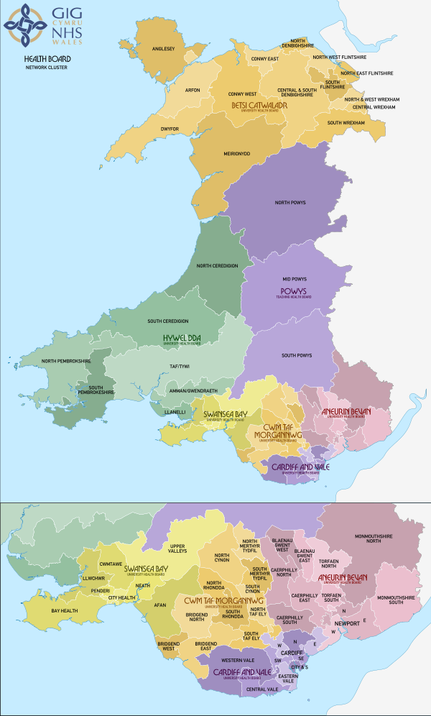

NHS Wales, (2020).

It was originally called Abertawe Bro Morgannwg University Health Board, on April 1st, 2019 SBUHB covers Swansea and Neath port Talbot. In February 2019 it was agreed it was to be renamed as Swansea Bay University Health Board and to change border alongside Cwm Taf University Health Board
390,000 people are employed by 12,500 staff with Swansea Bay University Health Board. They have a budget of £1 billion and has authorised the University to link up with Swansea University and are trained at Singleton Hospital, Moriston Hospital and Phillip’s Parade Children’s Orthopaedic Clinic. (Swansea Bay University Health Board, 2020).

Four Trusts in Wales
The four NHS Trusts in Wales are Welsh Ambulance Services for Emergency, Valandra University NHS Trust, and Public Health Wales. Specialist Service in Cancer Care, and a range of National Support Services, The NHS Wales has the facility’s to provide within the Seven Health Boards and Four NHS Trusts in Wales. In 2009 the NHS carried out a massive change and place a better set up and Health Care to the people of Wales in 21st Century. NHS Trusts were initially in England and Wales by Section 5 of the National Health Service and Community Care Act of Parliament 1990.
In April 2018, a new Statutory Body Health Education and Improvement Wales will sit alongside Health Boards and Trusts and will be the Eleventh Member of the NHS Wales family. NHS Wales Structure in 2009 plans a delivery of Primary, Secondary, and Tertiary Care on a Geographical Basis, so then the Seven Local Health Boards has no Purchaser-Provider Split. (Bevan et al, (2014).

Statistics and Guides

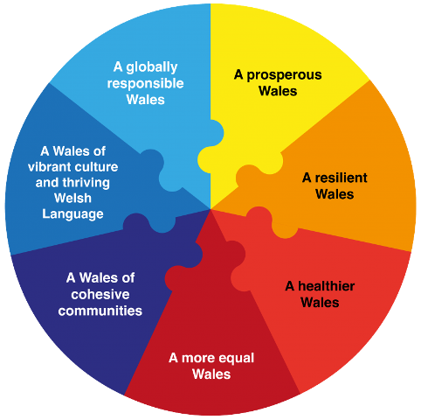 (Cardiff & Vale University Health Board - CVUHB | The Wellbeing of Future Generations Act, 2015)
Welsh Assembly Government, (2011). Has set up a Welfare Generation act 2015 for their future, this Act is to aim for improving Healthier Social, Economic, Environmental and Culture Wellbeing Future in Wales by Supporting 7 Health Boards in Wales and 4 Trusts. Communities need to work together in order to develop less problems, that could present into Bankruptcy, Health Problems and Climate Change.
The NHS Wales has had contact with Patients in Wales and had 20 million extra each year, with 80% outside of the Hospital, related to GP Practises and a Community Health Services. NHS Wales each year, also starts at least 700,000 appointments for Out-Patients, 600,000 impatient on a day to day basis and 1 million individuals are at the Accident and Emergency Department Around 1900 family Doctors in Wales, more than 1000 Dentists and some 600 Opticians.

Funding
(Future Funding, (2018). States that £6n or 40% of budgets a year the Welsh Government spends in Health and Social Services, a lot of it is used directly to Local Health Boards and Trusts. Wales in leaders NHS Wales, have Funding for Health and Social Care in 2019-20 which is a current budget, this contains the £192 million for the Operation of a Healthier Wales. However, it identifies a funding and has increased every year by 4% since 1978. According to (Crawford and Emmerson, (2012). The NHS has risen twice the amount form being 3.5% in 1949/50 to 7.9% in 2007/08, in 2010/11 Wales received a sum of 13.2 Billion for the public, this works out to be 4,360 per person. There is pressure of funding on the NHS Wales is increasing rapidly by 2025/26 Wales could face a lot of cost of 2.5 Billion because of a lot of hospital admission with increased illnesses. (Roberts and Charlesworth, 2014).

Structure
Welsh Labour Government in 2009, replaced a system that Combined Market and Bureaucratic Levers in the NHS, with a new arrangement that cut off most Market Levers. It is to develop and focus more on Patient Care and Structure, this will improve Patients and Staff. It’s about developing a Service Based on Co-operation and partnership that works. This involves a Balance of Care, looking at systems rather than just Hospitals. There is a high impact on Public Health and durable preparation. The Minister for Health and Social Services, Edwina Hart, argued that the replacement of market levers requires room for the NHS to focus on developing, teamwork, participation, and to cheer the public to think about ‘whole systems rather than just hospitals’. (Health in Wales Structure, 2020).

Recommendations
1… Higher pressure each day is rising on NHS Wales, more hospital admissions and chronic illnesses, which is giving a massive increase and more cost to the NHS, Government funding should be regular but is not a routine for the NHS which in this case really should be.
2… Department of health to do monthly reports on each hospital keeping up to date with training, staff support, and patient involvement.
3…. More Staff, and more Pay for what they do in their job, as they don’t get payed enough for the work that they do, the services are increasing a lot more because of the rise in all health.

Conclusion
This report has shown what is needed, that has an impact on NHS healthier wales, all individuals need to participate to maintain sustainable health services that consolidate prevention.
In addition, the seven local health boards, NHS Wales, and Four Trusts has recognised there is a possibility there could be a lot of questions that may come up, this needs to be in place that peoples Health is improved now and near future in Wales and is not weakened at any time and continues to be a strength. The Local Government is making sure that NHS are doing the best they can, to keep the individuals in Wales healthy, this means by NHS keeping their communication skills, IT and Social Marketing, this always means working hard together at a team, this shows it can provide good service that meets peoples future in health. (Transforming Health Improvement in Wales Working together to build a healthier, happier future, 2013).

References

En.wikipedia.org. 2020. Aneurin Bevan University Health Board. [online] Available at: <https://en.wikipedia.org/wiki/Aneurin_Bevan_University_Health_Board> [Accessed 25 April 2020].

2018. Annual Reports and Accounts 2018/19. Betsi Cadwaldr University Health Board. [online] St Asaph: NHS Wales, p.37. Available at: <https://bcuhb.nhs.wales/about-us/governance-and-assurance1/annual-report-and-accounts/annual-reports-and-accounts/annual-report-and-accounts-2018-19/> [Accessed 24 May 2020].

Bevan, G., Karanikolos, M., Exley, J., Connelly, S. and Mays, N., 2014. The Four Health Systems Of The UK: [online] The Nuffield Trust. Available at: <https://www.nuffieldtrust.org.uk/research/the-four-health-systems-of-the-uk-how-do-they-compare> [Accessed 22 May 2020].

Cardiffandvaleuhb.wales.nhs.uk. 2015. Cardiff & Vale University Health Board - CVUHB | The Wellbeing of Future Generations Act. [online] Available at: <http://www.cardiffandvaleuhb.wales.nhs.uk/the-wellbeing-of-future-generations-act> [Accessed 29 April 2020].

Doheny, S., 2015. The Organisation of The NHS In The UK: Comparing Structures In The Four Countries. 1st ed. [ebook] Cardiff: The National Assembly for Wales, p.8. Available at: <https://senedd.wales/research%20documents/15-020%20-%20the%20organisation%20of%20the%20nhs%20in%20the%20uk%20comparing%20structures%20in%20the%20four%20countries/15-020.pdf> [Accessed 20 April 2020].

Evidence for better health care, 2014. A Decade of Austerity In Wales. The Funding Pressures Facing the NHS in Wales to 2025/26. [online] London: Nuffield Trust, p.7. Available at: <https://www.nuffieldtrust.org.uk/files/2017-01/decade-austerity-wales-web-final.pdf> [Accessed 24 May 2020].
En.wikipedia.org. 2020. Healthcare in Wales. [online] Available at: <https://en.wikipedia.org/wiki/Healthcare_in_Wales> [Accessed 22 May 2020].
Mediwales.com. 2019. Hywel Dda University Health Board - Mediwales. [online] Available at: <https://www.mediwales.com/members/hywel-dda-university-health-board/> [Accessed 25 May 2020].

Hduhb.nhs.wales. 2017. Home - Hywel Dda University Health Board. [online] Available at: <https://hduhb.nhs.wales/> [Accessed 22 May 2020].

Lewis, M., 2015. Integrated Care in Wales. London Journal of Primary Care, [online] 7(3), pp.49-54. Available at: <https://www.ncbi.nlm.nih.gov/pmc/articles/PMC4494466/> [Accessed 29 April 2020]. (Lewis, 2015)

News, S. and Board, H., 2020. Hello to Swansea Bay University Health Board - Swansea Bay University Health Board. [online] Sbuhb.nhs.wales. Available at: <https://sbuhb.nhs.wales/news/swansea-bay-health-news/hello-to-swansea-bay-university-health-board/> [Accessed 20 April 2020].

Nhsconfed.org. 2018. The Future of Funding the Welsh NHS. [online] Available at: <https://www.nhsconfed.org/-/media/Confederation/Files/Wales-Confed/The-Future-Funding-of-Welsh-NHS.pdf> [Accessed 25 May 2020].

Google.com. 2020. Images of NHS Wales - Google Search. [online] Available at: <https://www.google.com/search?sxsrf=ALeKk03deWsgoKj-kpcfujNJ4d3uW4DlFQ:1588523025515&source=univ&tbm=isch&q=images+of+nhs+wales&sa=X&ved=2ahUKEwjZ0py1jZjpAhVku3EKHTCcBzAQ7Al6BAgKEDI&biw=1536&bih=722&dpr=1.25#imgrc=DJ40BsM40dIrcM> [Accessed 24 March 2020].

Wales.nhs.uk. 2020. Health in Wales | Structure. [online] Available at: <http://www.wales.nhs.uk/nhswalesaboutus/structure> [Accessed 29 April 2020].

En.wikipedia.org. 2020. NHS Wales. [online] Available at: <https://en.wikipedia.org/wiki/NHS_Wales> [Accessed 18 April 2020].

Wales.nhs.uk. 2020. NHS Wales Governance E-Manual | NHS Wales Funding. [online] Available at: <http://www.wales.nhs.uk/governance-emanual/nhs-funding> [Accessed 22 May 2020].

Powysthb.wales.nhs.uk. 2020. Powys Teaching Health Board. [online] Available at: <http://www.powysthb.wales.nhs.uk/> [Accessed 30 April 2020].

Primarycareone.wales.nhs.uk. 2020. Primary Care One. [online] Available at: <http://www.primarycareone.wales.nhs.uk/home> [Accessed 16 April 2020]. (Primary Care One, 2020)

Primarycareone.wales.nhs.uk. 2016. BMA. [online] Available at: <http://www.primarycareone.wales.nhs.uk/sitesplus/documents/1191/Brief%20how%20is%20healthcare%20in%20Wales%20structured.pdf> [Accessed 16 April 2020]. (BMA, 2016)

Publichealthwalesobservatory.wales.nhs.uk. 2016. Public Health Wales Observatory | Overview. [online] Available at: <http://www.publichealthwalesobservatory.wales.nhs.uk/demography-overview> [Accessed 16 April 2020]. (Public Health Wales Observatory | Overview, 2016)

News, S. and Board, H., 2020. Hello to Swansea Bay University Health Board - Swansea Bay University Health Board. [online] Sbuhb.nhs.wales. Available at: <https://sbuhb.nhs.wales/news/swansea-bay-health-news/hello-to-swansea-bay-university-health-board/> [Accessed 20 April 2020].

Roberts, A. and Charlesworth, A., 2014. Funding Pressures Facing the NHS In Wales To 2025/26. This report explores rising cost pressures on the NHS in Wales, and options for reducing the funding gap. [online] London: Research Report. Available at: <https://www.nuffieldtrust.org.uk/research/a-decade-of-austerity-in-wales-the-funding-pressures-facing-the-nhs-in-wales-to-2025-26> [Accessed 24 May 2020].

Reporter, G., 2020. Cardiff and Vale Plays Key Role in NHS National Recruitment Drive. Tindle Newspaper LTD, [online] Available at: <http://www.barry-today.co.uk/article.cfm?id=109320&headline=Cardiff%20and%20Vale%20plays%20key%20role%20in%20NHS%20national%20recruitment%20drive&sectionIs=news&searchyear=2016> [Accessed 20 May 2020].
En.wikipedia.org. 2020. Swansea Bay University Health Board. [online] Available at: <https://en.wikipedia.org/wiki/Swansea_Bay_University_Health_Board> [Accessed 12 May 2020].

Wales.nhs.uk. 2020. Health in Wales | Structure. [online] Available at: <http://www.wales.nhs.uk/nhswalesaboutus/structure> [Accessed 29 April 2020].
2013. Transforming Health Improvement in Wales Working Together To Build A Healthier, Happier Future. Public Health Wales. [online] PHW Health Improvement Review, Final Report, p.46. Available at:<http://www.wales.nhs.uk/sitesplus/documents/986/PHW%20Health%20Improvement%20Review%20Final%20Report%20-%20260913.pdf> [Accessed 27 May 2020].
Law.gov.wales. 2016. Law Wales - NHS Trusts. [online] Available at: <https://law.gov.wales/publicservices/health-services/health-service-bodies/nhs-trusts/?lang=en#/publicservices/health-services/health-service-bodies/nhs-trusts/?tab=overview&lang=en> [Accessed 16 April 2020]. (Law Wales - NHS Trusts, 2016)

Longley, M., Riley, N., Davies, P. and Quevedo, C., 2012. Health Systems In Transition. 1st ed. [ebook] United Kingdom Wales: Health System Review, pp.1-84. Available at: <http://www.euro.who.int/__data/assets/pdf_file/0006/177135/E96723.pdf> [Accessed 16 April 2020]. (Longley, Riley, Davies and Quevedo, 2012)

Wales.nhs.uk. 2020. Health in Wales | Our Services. [online] Available at: <https://www.wales.nhs.uk/ourservices> [Accessed 14 April 2020]. (Health in Wales | Our Services, 2020)

Wales.nhs.uk. 2020. Health in Wales | Structure. [online] Available at: <http://www.wales.nhs.uk/nhswalesaboutus/structure> [Accessed 10 April 2020]. (Health in Wales | Structure, 2020)

Hywelddalhb.wales.nhs.uk. 2020. Hywel Dda Local Health Board. [online] Available at: <http://www.hywelddalhb.wales.nhs.uk/> [Accessed 14 April 2020]. (Hywel Dda Local Health Board, 2020)

En.wikipedia.org. 2020. NHS Wales. [online] Available at: <https://en.wikipedia.org/wiki/NHS_Wales> [Accessed 10 April 2020]. (NHS Wales, 2020)

Rivett, G., 2020. NHS Reform Timeline. [online] The Nuffield Trust. Available at: <https://www.nuffieldtrust.org.uk/health-and-social-care-explained/nhs-reform-timeline?gclid=CjwKCAjwhOD0BRAQEiwAK7JHmJ4DsPv7cWhZJogtfus0I4Vu6xPOjvZtJe891fqQWA-zIcCQtr3UeBoCoCEQAvD_BwE> [Accessed 10 April 2020]. (Rivett, 2020)

Sbuhb.NHS.Wales. 2020. Swansea Bay UHB - Swansea Bay University Health Board. [online] Available at: <https://sbuhb.nhs.wales/about-us/swansea-bay-uhb/> [Accessed 14 April 2020]. (Swansea Bay UHB - Swansea Bay University Health Board, 2020)

En.wikipedia.org. 2020. Swansea Bay University Health Board. [online] Available at: <https://en.wikipedia.org/wiki/Swansea_Bay_University_Health_Board> [Accessed 12 April 2020]. (Swansea Bay University Health Board, 2020)

Abuhb.nhs.wales. 2020. The Health Board - Aneurin Bevan University Health Board. [online] Available at: <https://abuhb.nhs.wales/about-us/the-health-board1/> [Accessed 14 April 2020]. (The Health Board - Aneurin Bevan University Health Board, 2020)
Nhsconfed.org. 2018. The Future of Funding The Welsh NHS. [online] Available at: <https://www.nhsconfed.org/-/media/Confederation/Files/Wales-Confed/The-Future-Funding-of-Welsh-NHS.pdf> [Accessed 25 May 2020]. (The Future of Funding the Welsh NHS, 2018)

