Today, Ayurveda companies have begun to structure themselves in alignment with technological advancements, people’s health conditions, environmental changes in the ecosystem and evidence based research methodologies.

- 1.0. Introduction:

Biotique is an organisation that produces a wide range of skin care products which are made of 100% organically-pure, preservative-free ingredients and renewable resources—
cultivated gathered, blended and manufactured in the foothills of the Himalayas.

- 2.0. Executive Summary:

Biotique – Advanced Ayurveda has made a decision to expand its business overseas and hence a report has been generated to illustrate the International Business plan for successfully utilising the business opportunities and mitigating the future risks. A research has been conducted in order to understand the market for natural and organic cosmetics across the globe and a specific market has been selected based on the customer demand. Effective evaluation of an organisation’s competitive position comprises of both the external as well as internal business environmental analysis. There are several frameworks which can be used for analysis. PESTEL analysis is used for gaining an understanding of Biotique’s business potential, operational direction and to forecast future market position. According to Porter (1985), Industry analysis should be performed in order to find effective sources of competitive advantage. Hence, Porter’s five forces analysis has been performed as part of the competitor analysis. SWOT Analysis has been conducted as it depicts the strategic capabilities of an organisation. Market entry mode decision has been taken based on the internal and external factors. International business planning supports the company vision and values and strategic plan is developed to achieve the vision. Furthermore, a suitable international marketing mix in terms of product, price, promotion and place has been advised for Biotique. Some recommendations have been provided in the report in order to successfully enter a foreign market and boost sales.

- 3.0. Global Vision and Goals:
Biotique’s mission is to personify advanced, bio-energetic, naturally therapeutic treatments to suit every skin type and age in order to satisfy the diverse beauty needs of customers and cultures who seek natural beauty products that are as effective as they are environmentally responsible and educate its customers globally on the exceptional natural cosmetic products based on authentic ayurveda recipes. Hence, Biotique is focussing on targeting new audience by expanding its business in the USA considering the demand for ayurvedic cosmetic products.

Vision is to become one of the leading advanced ayurvedic skin-care brand in the world by gradually extending its international foot print.

- 4.0. International Business:
Now that Biotique has made a decision to expand its business overseas, it has to further focus on analysing the current international environment and make a right choice of country for expansion.

According to Herald Keeper’s Wiseguy Reports, 2018, ‘Global Ayurvedic Market is growing at a CAGR of 16.2% from 2015 to 2022. Some of the key factors favouring the market growth include, increasing demand for natural and organic products, rising consumer awareness and growing demand for ayurvedic cosmetics products.

“A growing number of consumers are rejecting chemical-filled cosmetics for pricey, plant-based alternatives. It’s a thriving sector—one that some experts think could change the beauty industry for good. Brands with a natural and/or botanically derived clinical orientation now represent the largest combined share of prestige skin care sales.”, says Rina Raphael, 2017, Biotique could definitely encash on the changing consumer behaviour of the millennial from cosmetics that are chemical based to organic plant based cosmetics.

As per Research and Markets, 2018, “Rising number of natural and organic personal care products with herbal extracts and antioxidant properties is also fuelling the growth of this market. The market is projected to grow at a consistent rate owing to the increase in shelf space and retail stores globally. Moreover, increasing number of aging female population followed by increased purchasing power of women aged twenty-five and above is also expected to drive the demand for various anti-aging products.”

- 4.1. Market Selection:
Factors driving consumer preference for Ayurvedic products are raising awareness regarding their benefits and increasing cognizance about ill-effects of allopathy. Increase in knowledge about natural ingredients in health and personal care products in developed countries like U.S. offers growth opportunity for Ayurvedic product manufacturers.

The immense size and elevated growth rate of the US personal care and beauty market represents a striking growth opportunity for natural and organic beauty brands. According to Enoch Minn, 2017,’The US is the largest market globally for beauty and personal care — more than five times the size of the largest European markets, including Germany, France and the UK (Figure 1). The industry also is expected to grow at a steady pace, driven by the premium segment, which is forecasted to increase at a higher rate through 2020’.
: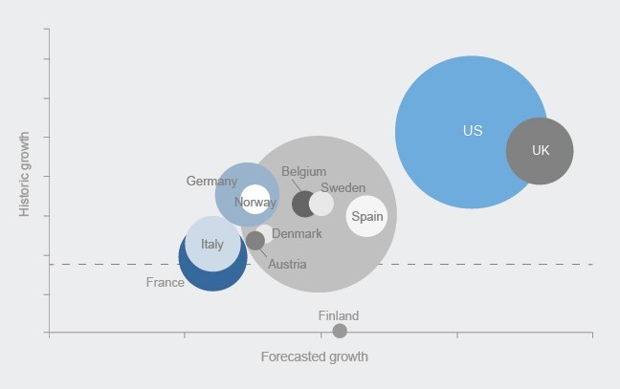
Expanding a business across national boundaries entails further to just exporting a business model which is successful in home country. It is a key factor to bridge cultures in order to succeed in a foreign land. As per Hofestede cultural dimension, US consumers have a fair degree of acceptance for new ideas, innovative products and a willingness to try something new or different and Biotique could certainly capitalise from this point.

Source: EY-Parthenon, Boston, 2017

All these factors indicate that the US market would be a better choice for Biotique to expand internationally. While the prospective for achieving success is significant in the US market, Biotique must understand the essential market structure, growth drivers and growing consumer demographic changes that equips for success when entering the rising, yet extremely competitive, US market.

4.2. International Environmental Analysis:
:
Some of the external and internal factors affecting the entry mode decision are

4.2.1. SWOT Analysis:

4.2.2. PESTEL Analysis:

4.2.3. Porter’s Five Forces Model:

Current political advancements might impact the business expansion in the US. According to Manya Gupta, Donald Trump, the famously protectionist American President, informed Congress on 5 March, 2019 that he intends to end India’s preferential trade treatment under Generalized System of Preferences (GSP). The United States Trade Representative Office (USTR) further confirmed that this was on account of India’s “failure to provide United States with assurances that it will provide equitable and reasonable access to its market in numerous sectors”. As per Game theory or the prisoner’s dilemma, a mutual and fair trade agreement between India and the United states creates a win-win situation and encourage successful business expansion.

According to FIEO Director General Ajay Sahai, 2019 "Protectionism will continue to rise and it will impact global demand for goods and the other two challenges include fluctuation in commodity prices and inadequate availability of credit as banks are not coming
forward to lend exporters. These challenges would impact India's exports, so we need to gear up for this. Timely support by the government would help deal with these issues". However current Indian Prime Minister Narendra Modi’s government promotes exports as it would help the country in creating jobs, increase manufacturing and produce additional foreign exchange. As per The Hindu Business Line, 2018, “Prime Minister Narendra Modi has set a new challenge before various government departments and the industry of doubling India’s share in world exports to 3.4 per cent from 1.6 per cent and reducing the dependence on imports by at least 10 per cent to create more jobs and increase the per capita income”.

Due to the fact that Organic surface-active hair and skin products, in liquid or cream that is put up for retail is included under GSP program, it might impact the price of some of the Biotique products in the US due to the variation in tariff rate. However the price points and the efficacy of the Biotique products are key differentiators when compared to its other competitors across the globe and hence that should not make a huge difference for its business.

As per Federal Food, Drug and Cosmetic Act (FD&C Act), cosmetics must not be adulterated or misbranded. For example, they must be safe for consumers under labelled or customary conditions of use, and they must be properly labelled. Any colour additives they contain must be approved for the intended use. Packaging and labelling must not be deceptive. The manufactured or marketed cosmetics should possess a legal responsibility for the safety and labelling of its products. Biotique products are 100 % vegetarian, environmentally friendly, biodegradable, dermatologist tested for safety, and are made to EEC and FDA standards, incorporating the principles of preventive medicine for everyday use thereby compliant to FD&C Act.

According to Vinita Jain,`2016, “A privately held company, Biotique is internally funded, and a zero-debt cash-rich company, Jain said. While it has been approached by private equity players and investors, she said the company is not looking for external investors.” Due to the fact that the size of the company is not that huge and the resource requirement for a foreign expansion would be high. Hence, a huge investment for foreign entry would be risky. According to the resource base theory, the size of a firm indicates the firm’s resource availability such as financial and human resources (Koch, 2001; Hollensen, 1988). Smaller firms generally have more limited resources (Root, 1994). Therefore, SMEs may not have enough management potential and skills to enter a foreign market through an entry mode that require a high level of resource commitment by themselves (Koch, 2001). Biotique does not have the in house resources in order to establish reputed overseas partner. However, when the firm’s resource availability increases, this provides the basis for increased international involvement or resource commitment in the market (Root, 1994).

- 5.0. International Business Strategy

According to Research and Markets, 2018, Hypermarket/supermarket held the largest market share in 2017. Distribution through hypermarket and supermarket is a key success factor in natural and organic personal care market. The manufacturers are shifting to mainstream mass retailers that include hypermarkets and supermarkets from niche distribution channel due to the increasing consumer demand for natural and organic personal care products. Hypermarkets such as Target Brands, Inc. and Wal-Mart Stores, Inc. followed by supermarkets that includes Safeway Inc. and Loblaw Companies Limited are focusing on expanding their product portfolio and introducing innovative natural and organic personal care products in their current product portfolio. By geography, North America held the largest share in the global natural and organic personal care market followed by Europe and Asia Pacific.

According to Enoch Minn, 2017, US markets demand a localized distribution strategy. There are ample opportunities for companies to further penetrate the skin care, hair care and oral care categories in the US by addressing specific unmet multicultural needs. Companies developing multicultural beauty offerings are likely to outpace the growth of the overall beauty market as this diverse consumer population seeks products to address specific unmet needs. Finally, beyond these demographic shifts, consumers’ increasing preference for plant-based, organic and natural beauty products has spurred investment and innovation as companies race to capture market share in this growing category. Natural products appeal to these consumers, both from ethical considerations (concern for environment and sustainability) as well as health concerns (fear of harmful ingredients). Globally, the natural and organic beauty market is estimated at $11 billion in 2016, and is likely to double by 2024, with the US acting as a significant growth catalyst.

‘With more international experience in a foreign market, a firm is more able to forecast its costs and returns, to evaluate the market or customer demands and to better respond to a dynamic environment ‘Koch, 2001. Considering the fact that Biotique does not have an international experience apart from selling few of its products through e-commerce, it is advisable to hold off investments infrastructure and other hard costs until their international operation is fully established in the US in order to justify expenses. Hence making use of external partner’s expertise might prove advantageous in order to bridge the gap.

The Heckscher Ohlin model proposes an international trade between two countries by taking comparative advantage. The concept of comparative advantage not only supports the country to make money out of the resources available abundantly or specialised in producing what they are good at, but also promotes importing the resources which are scarce helping the country to increase the accessibility for more and better goods. This in fact creates a win- win situation for both the countries. The origin of Ayurvedic products dates back to Vedic era and India is acclaimed for its ayurvedic products and treatment. According to Vinita Jain, 2010, “Fortunately in India, we have a lot of natural resources. We have a whole team of people [in the company] who actually go out and gather a lot of forest-grown herbs which are then organically grown and pesticide-free, because in the forest, there are no artificial fertilizers and pesticides. We have a team of people who look into this.”. Moreover, Biotique could export the products through buying low and selling high logic by which it could gain comparative advantage as it is capable of manufacturing the products using raw materials with lower price due to its abundance in the home market and cheap labour compared to the foreign economy even with restricted trade. This could also prove the point that retaining the manufacturing plant in the domestic country is more advantageous than have it in the target country. Also, exporting would favour higher flexibility as Biotique could be able to pull the plug on their US adventure if the business does not prove to be as successful as expected. Evaluating all these factors, it would indicate that the business should move towards externalization i.e. direct export and enter the US market through distributers, wholesalers and retailers.

Some of the potential distribution channel that could be considered includes Full-fledged E-Commerce, Supermarkets, Pharmacy & Drug Stores, Direct Selling, Beauty Salons, Specialty Stores, Departmental Stores and Ayurveda Centers. Direct Export is the suitable entry strategy for Biotique in order to access the vats, mature and complex US market place and engage in a long-term growth in the US market as it enables to gain in-depth knowledge of the foreign market and build distribution channels for further decision on future investment in the US market facilities such as licensing, franchising, joint venture and so on. It also helps in instantly leveraging local resources and networks with minimal investment. By opting for a direct export entry mode, Biotique could also gain control over its manufacturing processes based out of the home country on how its product is positioned thereby evading the risks involved with the overseas production. Direct exporting could prove to be successful for Biotique due to the fact that the US market is readily available with the increased demand for natural and organic cosmetics from the consumers.

A significant amount of time has to be invested in researching the US market information and build marketing strategy so that the products can be priced and promoted appropriately. Lack of experience and skills in exporting could result in expensive errors. Direct exporting offers an opportunity for higher profits however it is time consuming and inaccuracy might end up in serious trade losses as it involves export sale, shipping arrangement and insurance, managing licences and permits and all the paper work associated with it.

- 6.0. International Marketing Mix:

Entering an international market is an expensive and time consuming affair which could
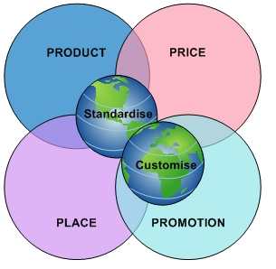
result in delaying the internationalisation process. It would be a wise decision for Biotique to look for suitable degree of standardisation as it is cost effective and adapt to some of the factors based on the conditions and characteristics prevailing to the target market. Hence, the best strategy for Biotique is following a hybrid marketing mix which is a combination of standardisation as well as adaptation according to the foreign market condition.

Source: Learn Marketing

6.1. Product:

According to Jain, 2010, “Biotique is a unique blend of the 5,000-year-old science of ayurveda and 21st century biotechnology. Biotique is truly a unique brand globally because it combines East and the West, the ancient and the modern and brings to you a platform for total health, well-being and beauty. We go to the base level — right from the seed, to the type of soil, to the organic fertilizers. So from that level we grow the crops and we see that the active ingredients in each of the herbs are tightly monitored. ““Biotique has been in the market for 20 years. Our R&D investment over the last two years has been `450 crore. We have a time-tested legacy. It is difficult for a start-up to have both authenticity and ‘affordable luxury’ price points. Besides, Biotique has its own R&D and manufacturing facility. The whole cycle of creating and packaging the product happens within our organisation, says Jain, 2018.

Biotique could standardise its existing product range for exporting it to the US and also offer some level of customisation of the products based on the customer preference. Exploring the overseas market would help in understanding the consumer behaviour and alter the products according to the target country. Adaptation is required as the US market includes a variety of socio-cultural, economic and political differences. Presence of local and global rivals who adapt locally would add to the competition making it favourable for adaptation. For Instance: Biotique could manufacture vegan based cosmetics and hair care products. According to Food Revolution, 2018,” There’s been a 600% increase in people identifying as vegans in the U.S in the last three years.” Hence some degree of adaptation is required to match the expectation of the potential customers.

6.2. Price:

Biotique is a health and well-being company, with affordable luxury as its positioning. It has a full control on its supply chain which has helped in passing on the price benefits to its customers. According to Jain, 2016, “Our high quality products are available at a reasonable price and placed across leading retailers and distributors in the market. We will keep increasing our distribution and make it available to a larger base of consumers.”
Biotique follows Bowman’s hybrid strategy which combines comparatively affordable price and differentiation. They focus on price to customers and offer their products at affordable cost but with a superficial value. They also offer its customers with the wide variety of product range. For Instance: Biotique has 8 different recipes of face washes which are made from a variety of organic ingredients and the prices are affordable. This offers its customer with a wide range of products to choose from based on their skin types and preferred ingredient. Biotique could continue with the standard pricing strategy for existing products (customs and tariffs included) and may offer special pricing for customised products subject to the raw material availability.

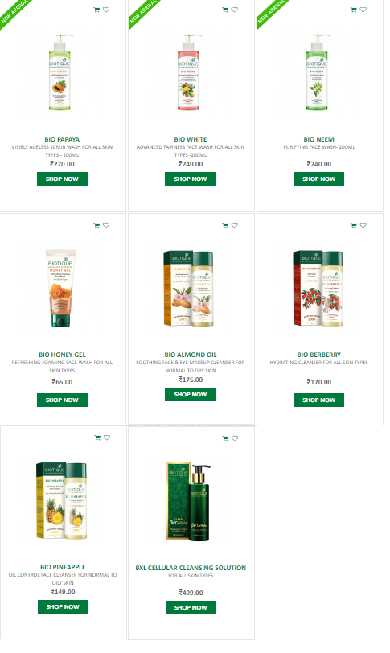

6.3. Promotion:

The main focus of Biotique in terms of promotion is to create brand awareness with the consumers in the US. Adverts could gain exposure however it could be expensive. Digital marketing is one of the best way to get the brand noticed by the consumers and social media outlets is the cheapest and quickest way to reach millions of consumers at a touch of a button.

Moreover, due to the widespread onset of the digital era of marketing over the last few years, Biotique has had to adapt to be able to improve its digital presence to meet the evolving needs of consumers and attract more customers. By engaging the followers with their website and their social media channels such as Facebook, Twitter, Pinterest, Instagram and Google+, Biotique could gain unprecedented online presence reaching a vast audience in a short period of time which would also help in boosting sales.

According to Vinita Jain, 2018, “we have used influencer marketing as a tool for brand awareness and promotions. Communication is planned keeping in mind the younger audience. We have collaborated with content creators like FilterCopy, POPxo and TVF, to create unique, brand-aligned content. We have a team of experts working for our social media platforms like Facebook, Instagram and Twitter.” The best way to build brand awareness is to get the consumers to experience the products and make them to include the brand into their day-to-day life routines and practices. Biotique offers free samples of its products in the hotels and SPA in order to bring awareness in the customers and all these promotional strategies could be standardised with the US customers as well. Due to the fact that Biotique is already an established brand in the home country and hence it does not require rigorous promotion however it has to focus on extensive promotional activities in the US in order to build awareness and attract customers.

6.4. Place:

Biotique caters to its customers through dealers, distributors, wholesalers and e-commerce. According to Jain, 2018, “E-commerce contributes 10-15% to our sales.” “Biotique has a huge retail presence both online and offline. We have an e-commerce website and the brand also retails through a variety of popular online platforms like Nykaa, Amazon and Flipkart, to name a few. In terms of stores, as of now, we have 1,000 stores in India. We retail from over 1,50,000 multi-brand outlets pan India, says Ishaan Jain, Director of Biotique, 2018. Biotique could continue to reach the customers through Supermarkets, Pharmacy & Drug Stores, Beauty Salons, Ayurveda Centers and so on. However, most of the products are not available for the international customers through e-commerce and there is a potential to increase the e-commerce sales in future. Hence Biotique should focus on developing a full-fledged e-commerce micro-site for the target region which could cart top priority products according to the consumer preferences.

- 7.0. Recommendations:

- According to Lisa Lacy, 2018, “Forrester’s 2018 Retail Best Practices: Mobile Web study found smart phones will be used in over one-third—or more than $1 trillion—of total U.S. retail sales at some point in the process of buying something in 2018, including research, price comparisons and purchases.” Many cosmetic retailers have already developed their official mobile apps, and some even offer the possibility of mobile shopping, whilst Biotique is still limited to its traditional marketing strategies even in the domestic country. The development of an official smart phone app where customers would be able to see the new collections, check the availability of products or just create a personal wish list would be of great benefit for the brand. Nonetheless, through the successful implementation of a smart phone purchasing platform supported by social media, Biotique would seize the opportunity to grasp much more impulse purchases and reach out to customers anywhere, anytime.

- Ayurveda concept might be well known and part of the culture with most of the domestic customers of Biotique, however, not everyone would be aware of this concept in the foreign market. Hence Biotique could focus on having print ads and visuals educating the consumers on the history, restorative treatment, ingredients and their benefits over other synthetic cosmetics in order to bring awareness which could attract more customers towards the ayurvedic products. These print ads and visuals can be posted on social media to start with and could also be displayed in the possible yoga centers and health clubs. Biotique could also provide an approachable way for the consumers to try their products and experience them by offering free samples.

- Due to the fact that Biotique does not have enough experience in international business; legal and business environment in the US is extremely complex and the custom rules and regulations which govern US exports are tough to pursue, obtaining a local proficient advice about the laws, compliance and taxes would help in mitigating the risks.

- Standards and regulations not only determine the terms of market entry but also the extent to which Biotique position themselves in global value chains in a manner that provides for socially and environmentally sustainable income growth. Contradicting to Porter’s view in creating resources for social sustainability, Biotique could focus on earning reputation before getting into the market economy though social sustainability. Hence Biotique could look for opportunities that address social and environmental issues with minimal monitory investment thereby attracting clients/customers and improving sales.

