Caffion Hamilton-Collar
BSc Health and Social Care
Mental Disorders and Psychopathology
BMHP6006_BIRM
Chloe Harries

Content page
Introduction---------------------------------------------------------------------------------Page 3
Definition of Autism--------------------------------------------Page4
History of autism disorder-------------------------------------------------------------page 5
Diagnosis of autism-----------------------------------------------------------------------page 6 to7
Treatment of autism-----------------------------------------------------------------------page 8
Rehabilitation of autism and recommendation for the future improvement of autism provision --------------------------------------------------------------------------------------page 9
Schizophrenia disorder can Define and History of Schizophrenia in the 20^{th century} ---------------------------------------------------------------------------------------------page 10 to11
Diagnosis and Treatment schizophrenia, Treatment and Prognostic------------------------------------------------------------------------------------------------------------------------------page 13
Medications, Side effect with medication, Rehabilitation and The Recommendation for the future improvement of Schizophrenia provision--------------------------------------------------------------------------------------------------------------------page 14 to 15
Generalized anxiety disorder defines and the history of generalized anxiety--------------------------------------------------------------------------------------------------------------- page 16
The cause and risk for generalized anxiety disorder, Diagnosis of generalized anxiety disorder and treatment-------------------------------------------page 17
Rehabilitation for generalized anxiety disorder, home remedies and Recommendation----------------------------------------------------------page 18

Reference------------------------------------------------------------------------page 19 to 24

Introduction
This report is based on three different mental disorders General Anxiety Disorder, Schizophrenia and Autism. The report will explain the different treatments, diagnosis, and measurements of rehabilitation and how an individual's cope with the disorder.

Definition of Autism disorder.

According to ICD-10 2010 Autism is a pervasive developmental disorder with normal development before the loss of previously and acquired skills in several areas of development over months. This will happen to an individual interest loss in environment, by repetitive, stereotyped, motor mannerisms. They get overwhelming or stressful with distinctive characteristics, communication, and social interaction. An individual whose has autism has a disorder linked with a disease which affects the brain and the body. This will lead to a mental state you will get confused. This is called encephalopathy which is made up of several disorders when the brain swollen if untreated can be long are short term brain damage. Brain structure for autism differs between people with and without autism down below with diagram show.

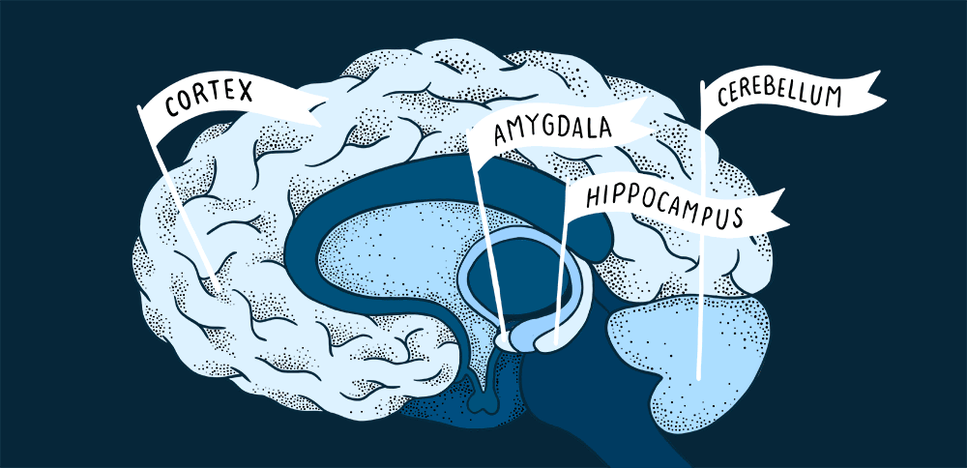
Figure 1 - (Askham, 2021).
Hippocampus: is for forming and storing memories, but Children and adolescents had always carried enlarger hippocampus (Askham, 2021).
Amygdala: individuals without the disorder will carry normal size but individuals with the disorder will have a smaller amygdala than people without autism especially if they affected by anxiety. Some experts found that some do carry normal for over a period than it changes (Askham, 2021).
Cerebellum: cognition, social interaction, movement, and base of the skull (Askham, 2021).
Cortex: the pattern of thickness the layer of the brain this is a single type of neuron this is individuals with or without the disorder (Askham, 2021).
History of Autism Disorder
The early history of autism was introduced in the 1935 by Leo Kanner an Austria born psychiatrist he observed eleven children and noticed the different behaviors and wrote a journal describing the distinctive characteristics. During 1935 autism was classified as schizophrenic, Kanner made distinguishing which he recognised and created tension and criticism in his theory study (Neumarker,2003:Wolff,2004). Hans Asperger was a psychiatrist he wrote about the different characteristics in similar ways, but he observed four boys to see the behaviors. During his study is learned they had lack empathy, form a friendship, their movement was clumsy, speech, communication was a challenge. When he passed his work became more recognised he noted that some may be genius and could flourish in their behaviors (Neumärker, 2003).

Lorna Wing a British psychiatrist introduced the different spectrum of the disorders but Kanner believed Asperger had different behaviors. There was a disagreement from Kanner stated that they are no single factor to explain the disorder during the early years. The psychoanalysis and influence were very strong and had a powerful promotion as the theory was based on culture, which they targeted mothers for their child disability. There was different characteristic identified in Bruno Bettelheim and Kanner theory. Both author had different arguments particularly Kanner who believe mother’s were the cause of their children disability. Due to showing less affection to their child during pregnancy shutting down their child emotionally needs (Asperger, 1944). Bernard Rimland and Bruno Bettelheim the two disagreed over the role that autism is a mental illness or behavioural disturbance which may been one of the factors. Rimland then suggested it is neurological development, but Bettelheim says it lacks access to good nutrition. Even today some people still blame mothers because of the parental burden even this is neurodevelopmental. There are criticisms surrounding this disorder. Psychoanalytic views overlook by predominant explanatory framework this has biological origin, but some mothers say that they felt sense of anguish that they are blame for their children's autism. (Ritvo, 1970)

Diagnosis of autism
Standardised manuals in the twentieth century with autism this were crucial it was influence classification of the diseases has physical illness this is a method for professional. Individuals working in mental health helped classify full range of the condition and to define the illness default implies and normality (Diagnostic and Statistical Manual of Mental Disorders).
The American Psychiatric association as viewed on the psychiatry and the Diagnostic and Statistical Manual of Mental Disorders. A book was published in (1952) paradigmatic, conceptualisation and the change in mental illness and the different diagnostic categories. There are two group in the brain as follows; dysfunction and aetiology. Environmental circumstances second version 193 diagnostic categories this has on impact on the psychiatry. In 1968 the book was launched publishing concerns about the boundaries and normality. In that time psychopharmacology was more biological and explanations neurological of mental illness, therefore the distinctive symptoms all have characteristics it was criteria they were a plan was put forward to ensure that standardisation could be reached. (First, 2013)
Between autism and mental slowing development of an individual to help the professional to determine whether the individual who is suspected of having autism. They would examine and score by using a questionnaire, observation and report from teachers, family and parent to determine the diagnosis. This is called childhood autism rating scale the experts who developed this scale are R Reichier, Barbara Rochen Reiner and Eirc Shopler (Schopler, Reichler, DeVellis, & Daly, 1980). The development of autism literature started developing 1966 and was published in the 80s about childhood autism spectrum scale. Experts from the University of Texas Health Science Center did studies surrounding autism in children and adolescents it shows 98% in accuracy rating in diagnosing and show result to diagnosing adolescents which was encouraging (Rubinstein,2004). The spectrum scale was included in the principal studies what took place (1943) by Leo Kanner and Creak study in (1964) has distinctive characteristics of autism disorder which is in childhood (Schopler and Dalldorf, 1980).
The disorder has characteristics and over ten categories of behaviors and abilities their development is different than normal if the symptoms of autistic present these are the categories:
- Verbal and nonverbal communication
- nervousness
- smell and touch response
- Taste
- Listening response
- Visual response
- Adaptation
- Emotional response
- Object use
- Body use
- Imitation
- Relating to people
- Activity level
- Level and consistency Intellectual response
- General impressions
When using the scale to score from one to four for a child normal range for a child age is one and severely abnormal scoring is four. (Mayes et al., 2009)
Autism rates over the past decade have been pediatrics released on October 5, 2009, age 3-17 have Autism Spectrum in the US Autism Spectrum Center for Disease Control reported boys are diagnosed four times more often than girls this was in 2007(Kogan, 2009).

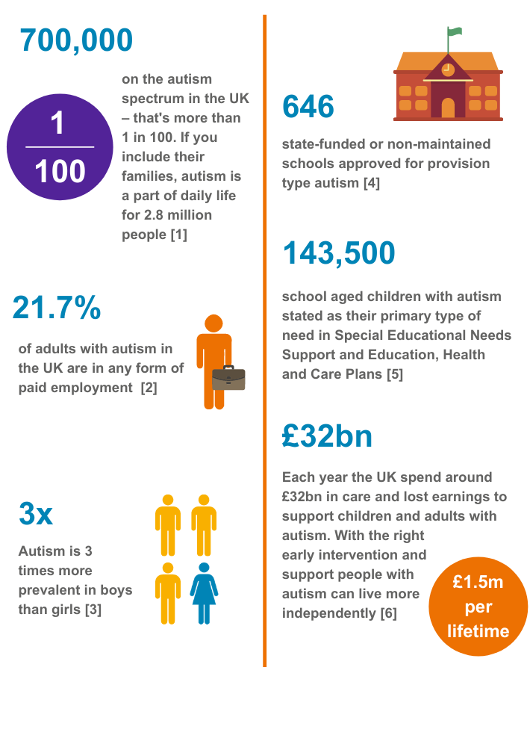Figure 2 (Statistics - BeyondAutism, 2021)

Treatment of Autism

An individual with autism has difficulty with communication skills and the effectiveness of their speech. Treatment is more protocols the learning opportunity it covers a range of communication which is wide and with a positive effect the different language which use morphology, phonology, and syntax. These are all social use language which helps to semantics and pragmatics they need to be influenced to control and use they ability to understand and try to interaction with other. In 1943 when autism was known to experts it has come a long way and been developed to help individuals with disorders according to Sigmund Freud. Parent who don’t try converse with the child who has the disorder, they do not see no progress in the child if they do not have a bond with their child. This will help with the autism according to Freud's theory, they have been information which was critical that no interaction from a parent and genetically personality. Also, if a child was moved from their residence where they live to see if they would recover. An expert's study found that facilitated communication will help a child to communicate and control his or her emotions today. The team of professionals who help with the disorder are:
- Occupational Therapy
- Physical Therapy
- Pivotal Response Training
- Applied Behavior Analysis
- Sensory Integration Therapy
Other treatments which may use Dietary intervention, medication, vitamins, Music and Art Therapy, Minerals, Dolphin Therapy, Social Skills Groups.
There are good and bad points in treatment according to Burrhus Skinner theories they were operant conditioning by giving children toys or treats for their good behavior as a reward. However, behavior analysis showed satisfactory results in progress next method are rigid structure different stage and step. According to Karl Reichelt the pioneer by getting rid of gliadin, glance and casein from the children diet who may be fueling Autism. Today research studies carrying out in more than four countries supporting this finding, but this is hard to implement. They were reported to have published research since 1965 about autistic children and adults and the amount of vitamin B6 what they have (pyridoxine) if it is safe, and the brain needs it and mineral magnesium this is serotonin. Dr. Edwin Cook wrote a book in 1990 about hyperserotonemic , neurochemistry of autism and children and adolescents (Alvarez and Reid, 1998).

Rehabilitation of autism
Exercise sessions for up to 16 weeks (about 3 and a half months) have testing session to follow up data make sure they are resistance components. Cardio each session should be approximately one hour these are high and intensity training like core activities to see the intervals and speed calories expended this will recorded on each of machine. The individual will have the benefit of this program to the maximum to hear the heart rate can monitor by the exercise machine, heart rate monitor can do by manually. The Reward Systems to Facilitate Exercise Participation some individual used visual. For example there are pictures with the activities and have a period how long it lasts some engage in without treats other different. Post-Intervention Testing Session after all the session they will be re-assessed after weeks by doing questionnaires about positive and negative in all their behaviors and protocol of testing (Aksay and Alp, 2014).

The Recommendation for the future improvement of autism provision is.
This shows that individuals who are affected by autism disorder will receive help from different exercise programs to improve their disorder by reducing their behaviors and making it more improving. This is an intervention that has potential and effective to help today they are more awareness on autism they more attention gain, expectations on treatment and social interaction learning for the future.

Schizophrenia disorder can Define as.
According to ICD-10 2010 Schizophrenia it is a psychological development which is a disorder that is occasionally or always. Childhood these are infancy and delay in the function of the brain making it impairment. This is a biological maturing of the main nervous system in some cases they can have a relapse if they do not have a steady course of their treatment. Some will have delay in visuo-spatial skills, motor coordination and language because of their function delay from a child grows older to adulthood in some cases, they might be mild deficits still are in adult life.

History of Schizophrenia in the 20th Century
The last two hundred years an individual with psychiatric conditions were put in institution it was like jail where they had place them it was happening in Europe and American. These asylums where Trans Allegheny Lunatic Asylum hospital in West western USA patients did not allow to leave the grounds are given the opportunity. These cruelty to mental health patient were the same at Bethlem Royal Hospital in London, they treated them with unspeakable cruelty. Victorian period in Britain, the treatment for women they were abused they fail to exercise good judgment of patriarchal they say women were unbalanced and hysterical because of post-partum depression, anxiety, menstrual-related anger, chronic fatigue. All these are classified as mental illness they would end up in a mental facility. They were many experts who started to write and explain about erratic social behavior about schizophrenia it a physical impairment the new research tried to find evidence of what is pointed to mental health.

Back in the 19th centuries they found out more about mental health on patients by doing autopsies on them. Some experts say that syphilis and brain tumors are the cause of mental abnormalities. The 1900 asylums they treatment was somatic, electrical stimulation, hydrotherapy, and other methods. Coming to the end of 19 century according to Sigmund Freud a founder of psychoanalysis he has study about the treatment method of psychopathology he believes dream were part of subconscious and that there in every human meaningless action that they are meaning (The Psychopathology of Everyday Life (1901) by Sigmund Freud, 2021). They were a small group of physicians formed around 1867-1923 by Dr. Boris Sidis about the approach and treatment of the illness this was in United States his argument was more about the responsiveness and subconscious of hypnosis. According to his theories say that memories would eliminate their symptoms later. He wrote an abnormal psychology journal and founder of the Psychopathic Institute. Today the 21st century individuals who has mental illness they are more treatment available to them to help with the improvement of illness, no more mental institution there are policies and legislation put in place to safeguard patients from harm to others and their self, modern facility they can leave as and when they want, and they are counseling available to them (SCULL, 2020).
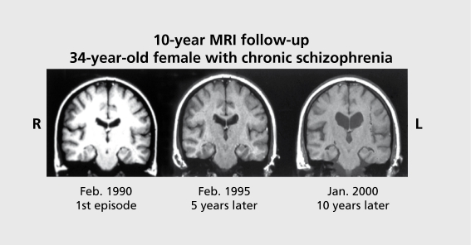
Figure 3 shows the difference episode of the brain of individual who has schizophrenia

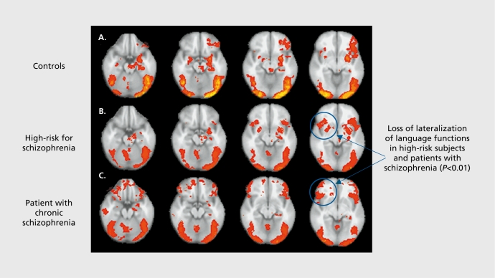
Figure 4 this is scan of how the brain worked
(Understanding structural brain changes in schizophrenia, 2006)

Diagnosis and Treatment schizophrenia
Diagnosis a person with schizophrenia the professional need to ruling out any more other disorder which it is mental illness, any substance use, medication, or any other condition to diagnose this disorder they are several test and examination need to do for example:
- screening test MRI
- CAT scan
- drugs test
- alcohol test

This will help to rule out any other symptoms or condition.
Mental health doctors who are in the field will use the Statistical Manual of Mental Disorders. This will classify the full range of the condition define the illness default implies and normality according to American Psychiatric association.
The evaluation of the psychiatric needs to do seeing the individual asking question what they are thought right now if they have been experiencing delusion, what are they mood like, if they use substance which is drugs if yes what kind, hallucinations, if they any violence against others are self-harm, they personal history and family.
They will be a physical examination by the doctor to rule out any problem that may cause symptoms (First, 2013: Blackman, 2016).
Treatment
The disorder requires treatment for lifelong aside with psychosocial therapy this will help with their condition but every individual different may be needed to be hospitalised. A patient who has been diagnosed with schizophrenia. They would be referral to a case manager organise their care with the multidisciplinary team who handle mental health (Schizophrenia, 2021).
Prognostic
Prognostic of schizophrenia they are no cure but there is treatment available. These are effective to help reduce the individual symptoms if occur of new episodes of the illness of psychosis the duration will be less than normal. They can be very productive and function well in their life. This can be done if medication is taken properly and support from other professionals where they can get counseling these individuals are optimistic. They were around 50% of different individual was diagnosed with disorder of schizophrenia after it was ten years diagnosis. 25% percent of individuals have improved because of the good support network around them and was able to function. Others who are unimproved will be hospitalised get stressed only at the end of their pain to take their own life, but statistics show that women able to sustain the disorder and recovery better than man from their symptoms (Reichenberg, 2012).
In most cases individuals who have schizophrenia often go on to suicide through anxiety and fear and try to take their own life. You do not know who is more suicidally extremely hard to predict this is a temporary right treatment and counselling they have a chance to overcome these behaviors and have good balanced (Caldwell and Gottesman, 1990).

Medications
The most common drugs are used for treatment for schizophrenia is antipsychotic this has an impact on the brain neurotransmitter dopamine to help to control symptoms of the individual. The lowest possible dose combinations over time other drugs what can help name is anti-anxiety or antidepressants you will notice the different change in the patient gradually over the weeks.
Side effect with medication
- Reluctant do not want take treatment
- Willingness to cooperate with the treatment what are given to them to take
- Resistance to taking medication, doctors would offer them the injections instead other than pills.
- First-generation antipsychotics have significant neurological side effects which an individual may experience movement disorder reversible depending on the patient sometime which is called tardive dyskinesia.
- Perphenazine
- Haloperidol
- Fluphenazine
- Chlorpromazine
Second-generation of antipsychotic enervation has a lower risk of serious side effects are:
- Ziprasidone (Geodon)
- Aripiprazole (Abilify)
- Asenapine (Saphris)
- Brexpiprazole (Rexulti)
- Cariprazine (Vraylar)
- Clozapine (Clozaril, Versacloz)
- Iloperidone (Fanapt)
- Lurasidone (Latuda)
- Olanzapine (Zyprexa)
- Paliperidone (Invega)
- Quetiapine (Seroquel)
- Risperidone (Risperdal)

long- acting injections which are given every two to four weeks.
- Medication injection what are available are:
- Haloperidol decanoate
- Paliperidone (Invega Sustenna, Invega Trinza)
- Aripiprazole (Abilify Maintena, Aristada)
- Risperidone (Risperdal Consta, Perseris)

(Schizophrenia - Diagnosis and treatment - Mayo Clinic, 2021)

Rehabilitation
They are individual therapy what are available for patient with Schizophrenia this is call psychosocial intervention to help them to cope with stress to know the signs. When they are going to have a relapse, this is a manage skill of their illness try to communicate more and interact with family and others do, they daily activites (2021 friends-family-members). They are support available for individual who has schizophrenia to help with employment and prepare for work they are programs in communities what their Aswell to help with diverse needs are any other crisis this is called Vocational rehabilitation (Bond, Dietzen, McGrew and Miller, 1995).

The Recommendation for the future improvement of Schizophrenia provision is.
When an individual has Schizophrenia its serious illness, they normal be diagnosed in the late teen years to the early thirties they have different moods swings they cannot function very well. For now, the future show that Schizophrenia has wider ranges of drugs, injections to help to improve the disorder to help individual to function more better and be more stable.

Generalized anxiety disorder can Define as.
According to ICD-10 2010 generalized anxiety disorder is not restricted its strongly predominating in many circumstances. An individual would worry about day-to-day life and the fear of having any accident is a very variable symptom such as:
- Sweating
- Dizziness
- muscular tension
- Trembling
- Lightheadedness
- persistent nervousness
- epigastric discomfort

The history of generalized anxiety disorder
Robert Burton was a writer who wrote the anatomy of melancholy in (1621) about the different symptoms of generalised anxiety disorder. According to Burton he said that man will get cold and hot all over is body they would go pale and start to tremble that it is a pathological anxiety and social phobia all humans to have this in them. Today psychologist have many opinions about anxiety with all the approach or characteristics in many cases this has been a widespread and increased over the years.
It became economic, political, and societal. Individual who has this disorder they are normal be an outpatient at the hospital their psychiatrist may give them less attention because the risk is lower because it is dealing stress and emotion if it were bipolar, schizophrenia they would be more attention because the risk is higher, they intend to have behavior and characteristics or unconscious assimilation.
Bandelow, (2017) in (1843) Soren Kierkegaard he produced the concept of anxiety and wrote books he said that anxiety is an impulse which is positive to pull them from sin. He goes on saying that it is a self –conscious and Immanuel Kant said that in every individual has self-awareness and ethical choices. George Miller (1869) states to bear he recognise anxiety is a neurasthenia which only affect the upper class of people because they cannot cope, they have more stress. Sigmund Freud was the founder of term anxiety in (1859) in his theories he showed automatic and in voluntary said that when s individual feels threatened, they will protect themselves fright by anxiety (Anxiety in Our Times, 2018).

The cause and risk for generalized anxiety disorder
Brain chemistry: the nerve cell of an individual what is connect to certain part of the brain this part of the brain is use for thinking and emotion. This is call neurotransmitters a chemical the nerve cell depends. These cells send information to others cell if the brain regions this do not work well it make an individual be goes in different moods. They are genetics side to it can be a family trait this can passed down to other family member experts has not identified anxiety if it is genes. Environmental these factors can be a passed of a loved one, changing jobs and your comfort zone, being abuse, are divorce from long term partner these are stressful and become a trauma to an individual all these can contribute to the disorder and get worsen (Schmidt, 2008).

Diagnosis of generalized anxiety disorder
The doctor will have full evaluation of medical, personal and psychiatric questions physical examination. If needed a few blood tests will be done to see the overall health of the individual. Doctors do not use this evaluation to determine if the individual has anxiety disorder. For an individual to be diagnosis with the disorder they need to have symptoms six months and over and daily life becomes incredibly stressful (Learn More About General Anxiety Disorder, 2021).
Treatment
They are no cure for the disorder of anxiety, but they are medication there to help to give an individual relieve of their symptoms. Psychiatrist doctors who can prescribe these drugs but in other countries psychologists can prescribe but they need to have training in psychiatric medications. Common drugs are used to give relieve to symptoms beta-blockers used to treat hypertension and for symptoms of anxiety to help to keep symptoms under control and to reduce anxiety (Anxiety Disorders, 2021).

Benzodiazepines was the first treatment for generalized anxiety disorder this medication can be taken over a period time this will help the individual to build up tolerance. They can become dependent on this drug there are different dosage of it which will give you the same feeling and result. Psychiatrist can prescribe this medication for a period if suddenly stop symptoms of anxiety will return the individual will have withdrawal symptoms of this medication. They need to decrease dosage in stage before stopping this is a second treating drug the disorder because of the wide range of antidepressants. Buspirone is used for chronic anxiety. This medication does not help everyone disorder and its non-benzodiazepine. Antidepressants this is used to treat people who has anxiety disorder and to control their moods it takes time to work in the system to get the full effect of the medication before stop take this medication need to consultation with your doctor because of the side effects (Anxiety Disorders, 2021).

Rehabilitation for generalized anxiety disorder
Special management needed to be put in place to avoid a relapse of anxiety disorder the individual needs to have a better lifestyle. This will lower the risk though the condition is treated this will help with stable the disorder they would be a tool to help deal with stress. Cognitive therapy is behavioral therapy give good outcome this is intervention it is very effective on patient they need to have regular monitoring and exercise this will help reduce the disease symptoms if it occurs. The treatment focuses more on fear, worry and the negative side of the disorder (Johnson and Hoffart, 2019).
Home remedies
- Relax and take deep breaths
- Do some meditation
- No drugs are alcohol only drugs are the medication what is prescribe from doctor
- No caffeine
- Have enough rest
- And try to diet
(Anxiety Disorders, 2021)

The Recommendation for the future improvement of generalised anxiety disorder provision is.
Generalised anxiety disorder has been more common now than in the past few decade's doctors can relate to individual condition and to understand the nature of the disorder, do more research and try to expand on the knowledge of generalized anxiety disorder.

Conclusion
Autism and schizophrenia have been linked from the older day's children were misdiagnosed by having schizophrenia. Diagnosed methods show the difference between both but they have similar origins, fetal development, genetically and opposite from one another Generalized anxiety disorder imbalances of an individual brain which has chemicals serotonin, noradrenaline and controls the regulation of their mood

Reference

Alvarez, A. and Reid, S., (1998). The History of Ideas on Autism: L. Wing, Autism, (1997), 1(1): 13-23. Autism, 2(1), pp.95-95.

Asperger, H., (1944). Die „Autistischen Psychopathen” im Kindesalter. Archiv für Psychiatrie und Nervenkrankheiten, 117(1), pp.76-136.

Askham, A., (2021). Brain structure changes in autism, explained | Spectrum | Autism Research News. [online] Spectrum | Autism Research News. Available at: <https://www.spectrumnews.org/news/brain-structure-changes-in-autism-explained/#:~:text=Autistic%20people%20have%20decreased%20amounts%20of%20brain%20tissue> [Accessed 25 November 2021].

Aksay, E. and Alp, A., (2014). "The effects of a physical activity rehabilitation program on the motor skills and physical performance of children with autism spectrum disorder (ASD)" movement therapy and ASD. International Journal of Academic Research, 6(1), pp.12-19.

Bandelow, B., (2017). Comparison of the DSM–5 and ICD–10: panic and other anxiety disorders. CNS Spectrums, 22(5), pp.404-406.

Rubinstein, B.,( 2004). Evidence-Based Psychotherapies for Children and AdolescentsEvidence-based Psychotherapies for Children and Adolescents. Edited by Alan E. Kazdin and John R. Weisz . The Guilford Press, New York, 2003, 490 pages. ISBN: 1–57230–683–1, $52.00 (hardcover). Journal of Child and Adolescent Psychopharmacology, 14(3), pp.488-491.

BeyondAutism. (2021). Statistics - BeyondAutism. [online] Available at: <https://www.beyondautism.org.uk/about-autism/understanding-autism/statistics/> [Accessed 25 November 2021].

Blackman, J., (2016). Review of Diagnostic and Statistical Manual of Mental Disorders (5th ed.), Clinical Handbook of Psychological Disorders: A Step-by-Step Treatment Manual, 5th Edition, and Essentials of Psychiatric Diagnosis: Responding to the Challenges of DSM-V. Psychoanalytic Psychology, 33(4), pp.651-663.

Bond, G., Dietzen, L., McGrew, J. and Miller, L., (1995). Accelerating entry into supported employment for persons with severe psychiatric disabilities. Rehabilitation Psychology, 40(2), pp.75-94.

Caldwell, C. and Gottesman, I., (1990). Schizophrenics Kill Themselves Too: A Review of Risk Factors for Suicide. Schizophrenia Bulletin, 16(4), pp.571-589.

Dialogues in Clinical Neuroscience, (2006). Understanding structural brain changes in schizophrenia. 8(1), pp.71-78.

(2014). Diagnostic and Statistical Manual of Mental Disorders: DSM-5 (5th edition). 28(3), pp.36-37.

Europenowjournal.org. (2018). Anxiety in Our Times. [online] Available at: <https://www.europenowjournal.org/2018/07/01/anxiety-in-our-times/> [Accessed 1 December 2021].

First, M., (2013). Diagnostic and Statistical Manual of Mental Disorders, 5th Edition, and Clinical Utility. Journal of Nervous & Mental Disease, 201(9), pp.727-729.

Mental Health (2017). Available at: <https://www.mentalhealth.gov/talk/friends-family-members> [Accessed 30 November 2021].

Mental Health (2017). Available at: <https://www.mentalhealth.gov/talk/people-mental-health-problems> [Accessed 30 November 2021].

Howlin, P., (1998). Handbook of Autism and Pervasive Developmental Disorders (2nd Edn.) Edited by D. J. Cohen & F. R. Volkmar. Wiley, New York, 1997. pp. 1092. £70.00 (hb). Journal of Child Psychology and Psychiatry, 39(5), pp.789-792.

Icd.who.int. (2010). ICD-10 Version:2010. [online] Available at: <https://icd.who.int/browse10/2010/en#/F84.3> [Accessed 23 November 2021].

Johnson, S. and Hoffart, A., (2019). Moderators and predictors of outcome in metacognitive and cognitive behavioural therapy for co‐morbid anxiety disorders. Clinical Psychology & Psychotherapy, 26(4), pp.399-408.

Kogan, M., Blumberg, S., Schieve, L., Boyle, C., Perrin, J., Ghandour, R., Singh, G., Strickland, B., Trevathan, E. and van Dyck, P., (2009). Prevalence of Parent-Reported Diagnosis of Autism Spectrum Disorder Among Children in the US, 2007. PEDIATRICS, 124(5), pp.1395-1403.

Mayes, S., Calhoun, S., Murray, M., Morrow, J., Yurich, K., Mahr, F., Cothren, S., Purichia, H., Bouder, J. and Petersen, C., (2009). Comparison of Scores on the Checklist for Autism Spectrum Disorder, Childhood Autism Rating Scale, and Gilliam Asperger’s Disorder Scale for Children with Low Functioning Autism, High Functioning Autism, Asperger’s Disorder, ADHD, and Typical Development. Journal of Autism and Developmental Disorders, 39(12), pp.1682-1693.

Mayoclinic.org. (2021). Schizophrenia - Diagnosis and treatment - Mayo Clinic. [online] Available at: <https://www.mayoclinic.org/diseases-conditions/schizophrenia/diagnosis-treatment/drc-20354449> [Accessed 30 November 2021].

National Institute of Mental Health (NIMH). (2021). Schizophrenia. [online] Available at: <https://www.nimh.nih.gov/health/topics/schizophrenia> [Accessed 30 November 2021].

National Institute of Mental Health (NIMH). (2021). Anxiety Disorders. [online] Available at: <https://www.nimh.nih.gov/health/topics/anxiety-disorders> [Accessed 1 December 2021].

Neumärker, K., (2003). Leo Kanner: His Years in Berlin, 1906-24. The Roots of Autistic Disorder. History of Psychiatry, 14(2), pp.205-218.

Psychological Medicine, (1981). Diagnostic and Statistical Manual of Mental Disorders. DSM-III. (Pp. 494; $25.00 hb, $20.00 pb.) American Psychiatric Association: Washington, D.C.1980. 11(1), pp.215-215.

Reichenberg, A.,( 2012). PREMORBID INTELLECTUAL FUNCTIONING AND SOCIAL ADJUSTMENT AND RISK OF DEVELOPING SCHIZOPHRENIA, PSYCHOTIC OR NON-PSYCHOTIC BIPOLAR DISORDER: A POPULATION LONGITUDINAL STUDY. Schizophrenia Research, 136, pp. S36-S37.

Ritvo, E., (1970). Increased Blood Serotonin and Platelets in Early Infantile Autism. Archives of General Psychiatry, 23(6), p.566.

Rubinstein, B.,( 2004). Evidence-Based Psychotherapies for Children and AdolescentsEvidence-based Psychotherapies for Children and Adolescents. Edited by Alan E. Kazdin and John R. Weisz . The Guilford Press, New York, 2003, 490 pages. ISBN: 1–57230–683–1, $52.00 (hardcover). Journal of Child and Adolescent Psychopharmacology, 14(3), pp.488-491.

Schmidt, L., (2008). Social anxiety disorder: A review of environmental risk factors. Neuropsychiatric Disease and Treatment, p.123.

Schopler, E., Reichler, R., DeVellis, R. and Daly, K., (1980). Toward objective classification of childhood autism: Childhood Autism Rating Scale (CARS). Journal of Autism and Developmental Disorders, 10(1), pp.91-103.

Schopler, E. and Dalldorf, J., (1980). Autism: Definition, Diagnosis, and Management. Hospital Practice, 15(6), pp.64-73.

SCULL, J., (2020). Psychology and Psychiatry in the 20th and 21st Century. [online] Owlcation. Available at: <https://owlcation.com/social-sciences/Mental-Illness-Part-Two-History-and-Treatments-From-20th-Century-and-Today> [Accessed 28 November 2021].

Sigmundfreud.net. (2021). The Psychopathology of Everyday Life (1901) by Sigmund Freud. [online] Available at: <https://www.sigmundfreud.net/the-psychopathology-of-everyday-life.jsp> [Accessed 30 November 2021].

WebMD. (2021). Learn More About General Anxiety Disorder. [online] Available at: <https://www.webmd.com/anxiety-panic/guide/generalized-anxiety-disorder> [Accessed 1 December 2021].

Wolff, S., (2004). The history of autism. European Child & Adolescent Psychiatry, 13(4).

