Hospitality Expo at Trinity Hotel– Sustainability Event

Student Name: Ummad Tariq

Student Number: 2122723

Tutor Name: Kathryn Flynn

Slide 1
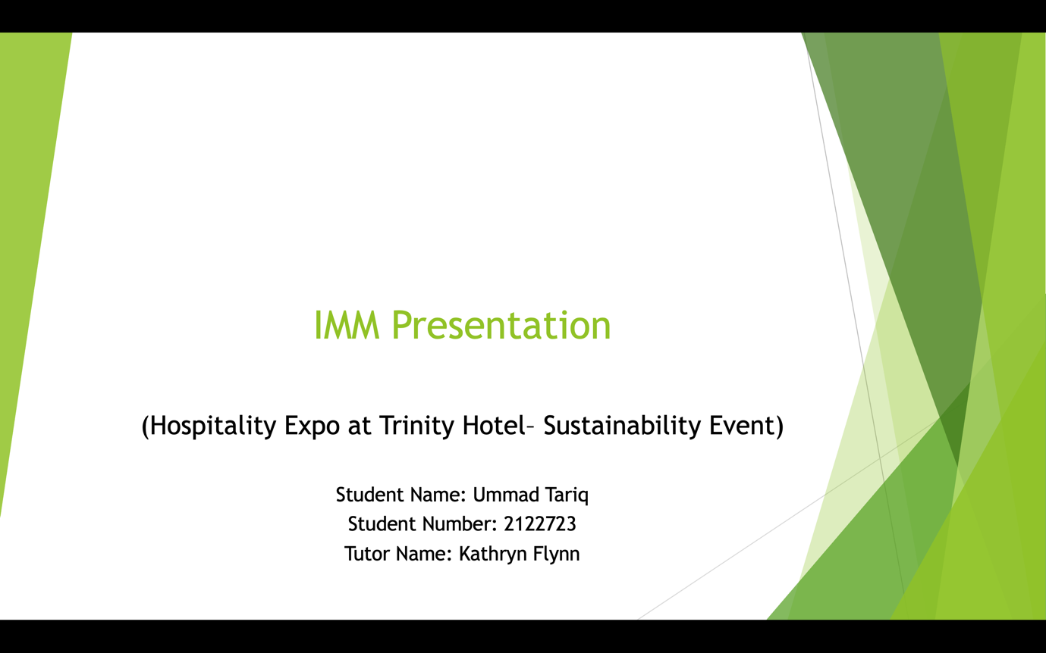
Slide 2

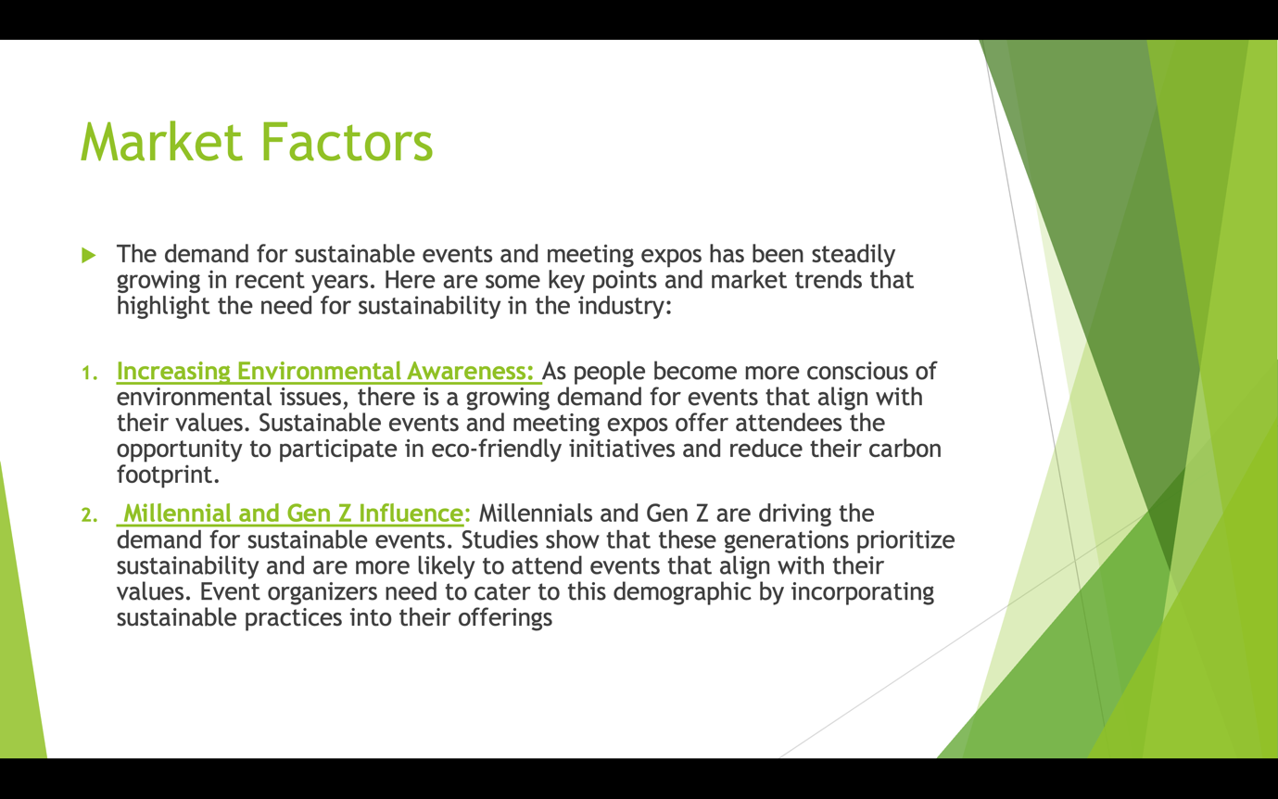

Slide 4
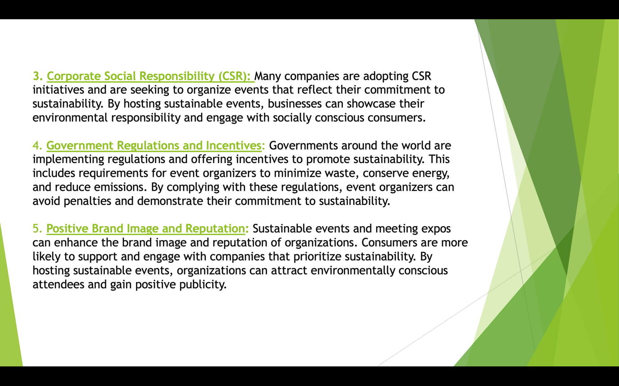

Slide 5
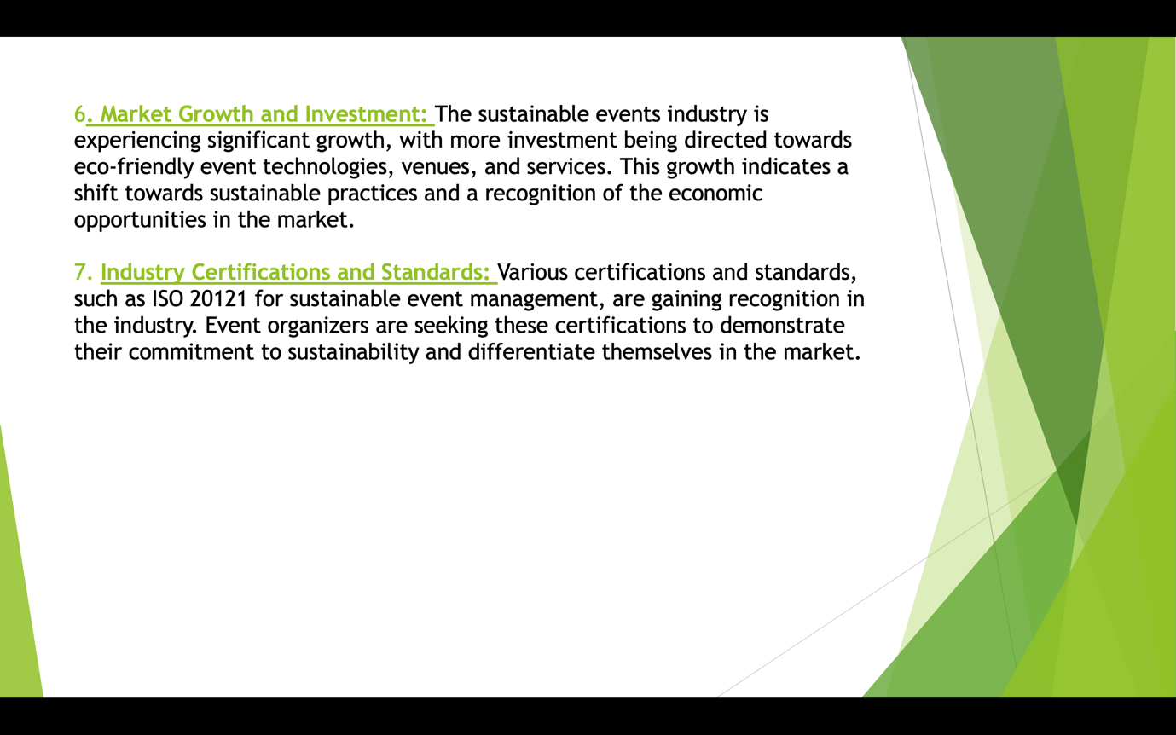

Slide 6
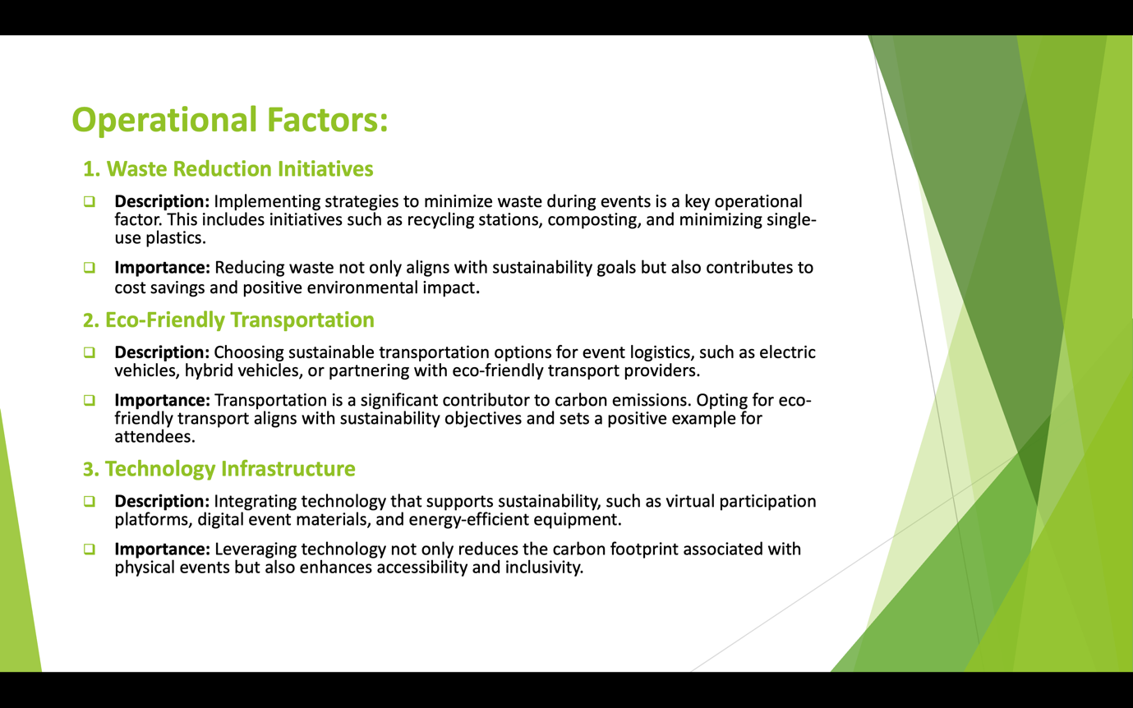

Slide 7

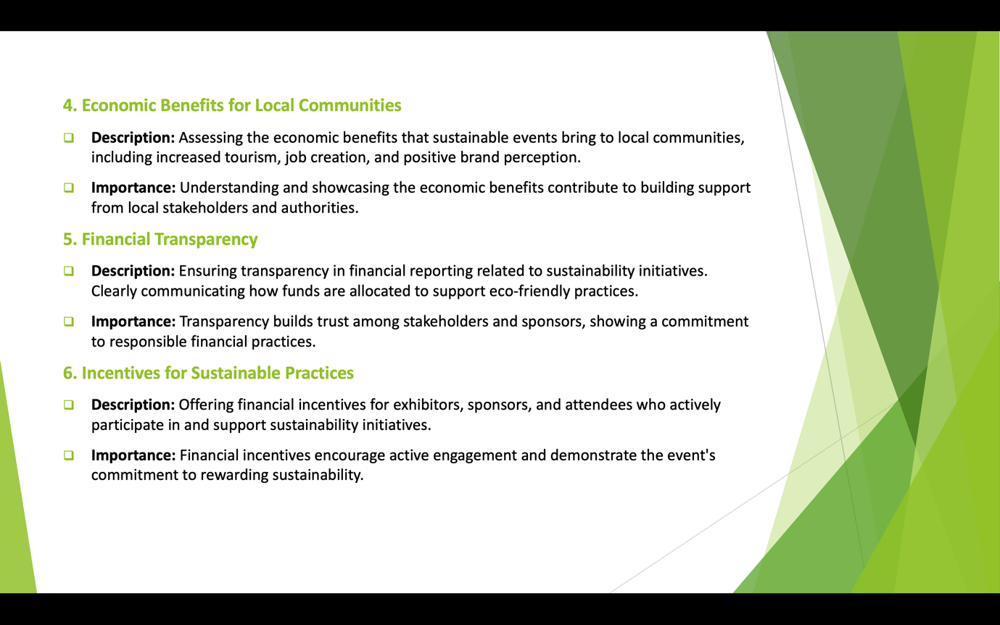

Slide 8
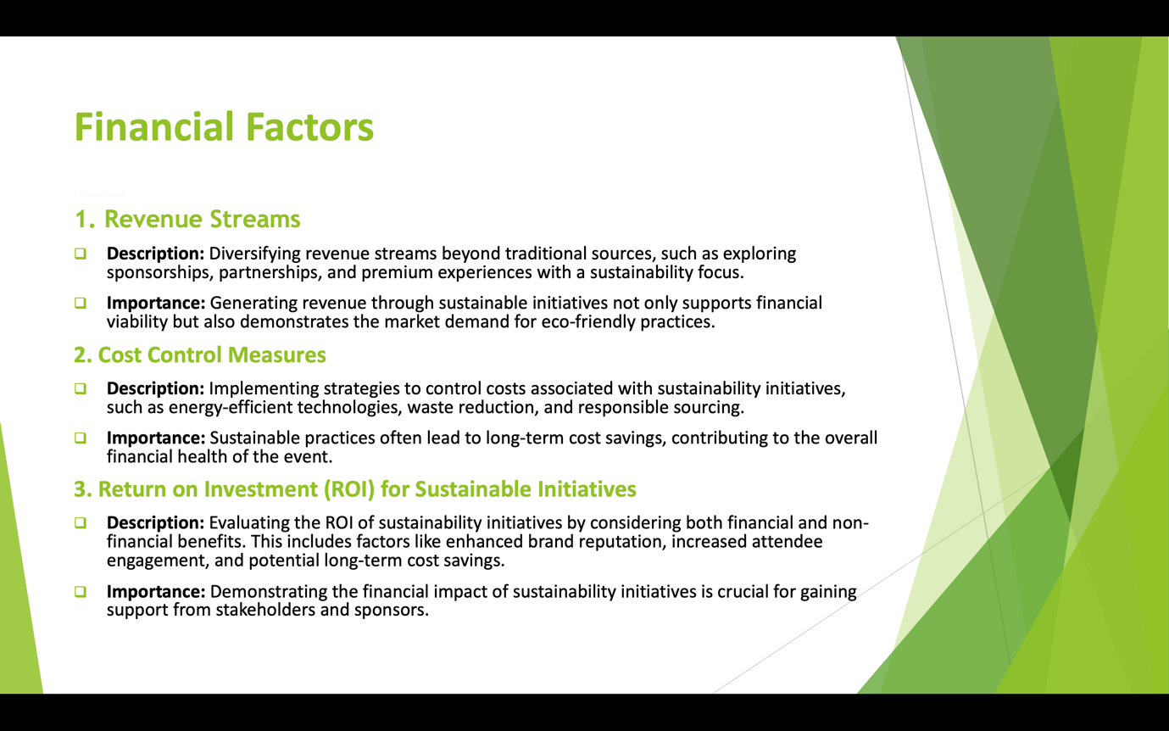
Slide 9

Slide 10
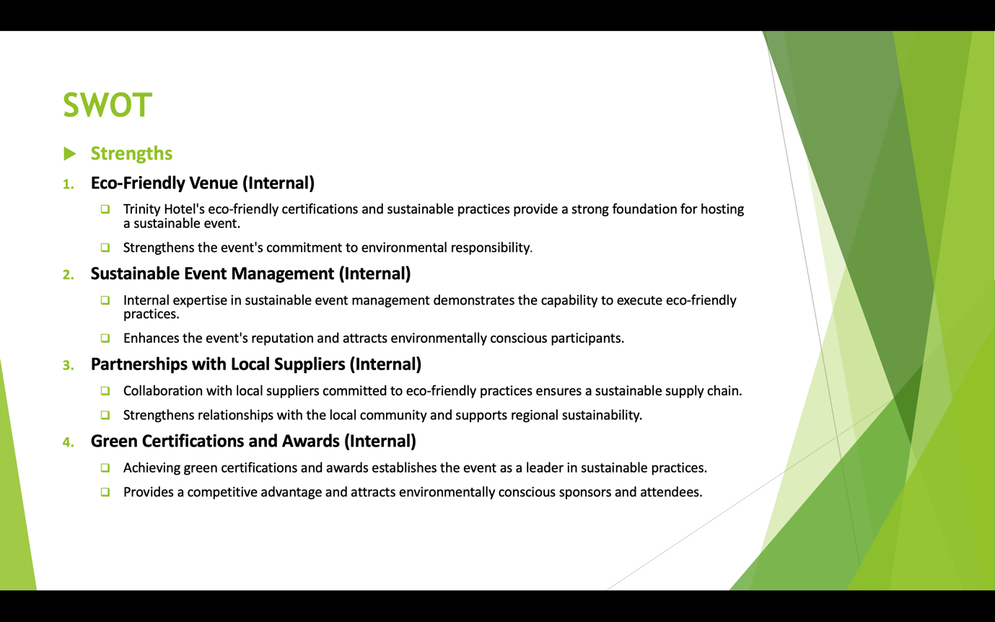

Slide 11

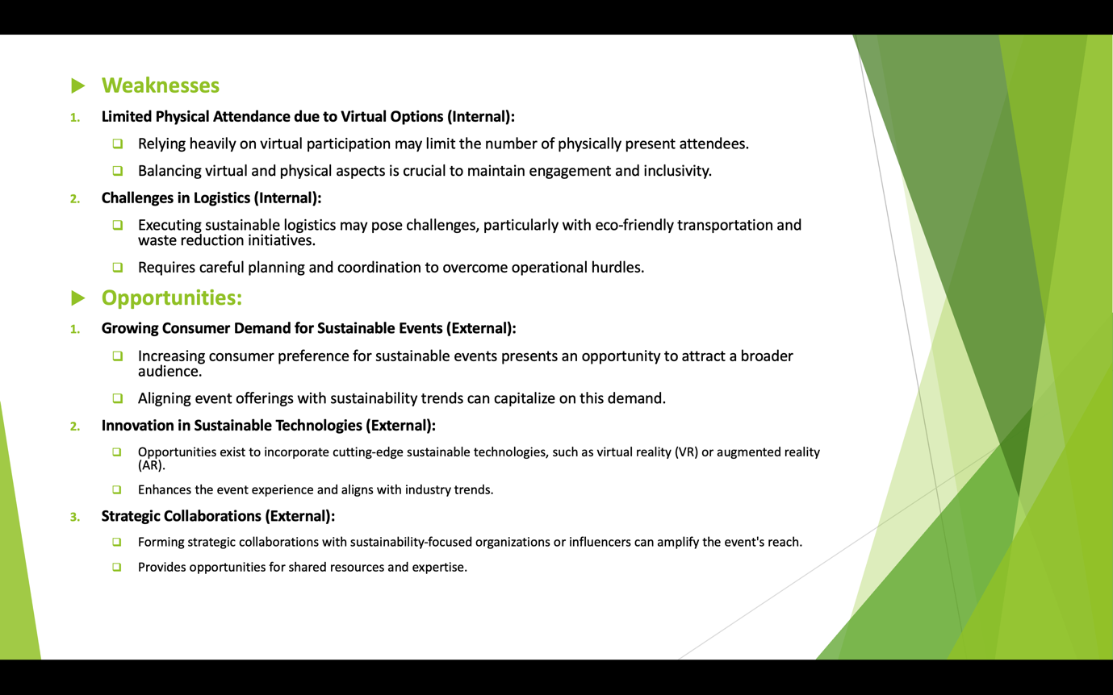
Slide 12
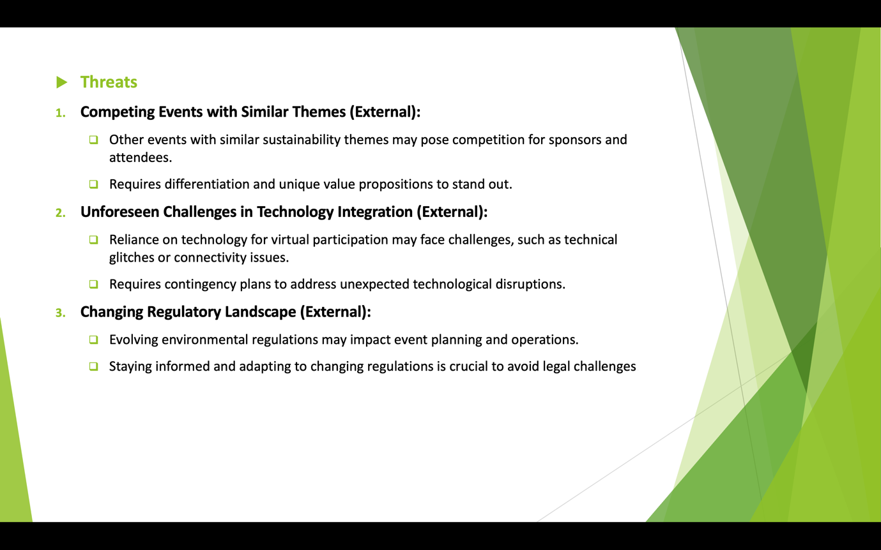
Slide 13
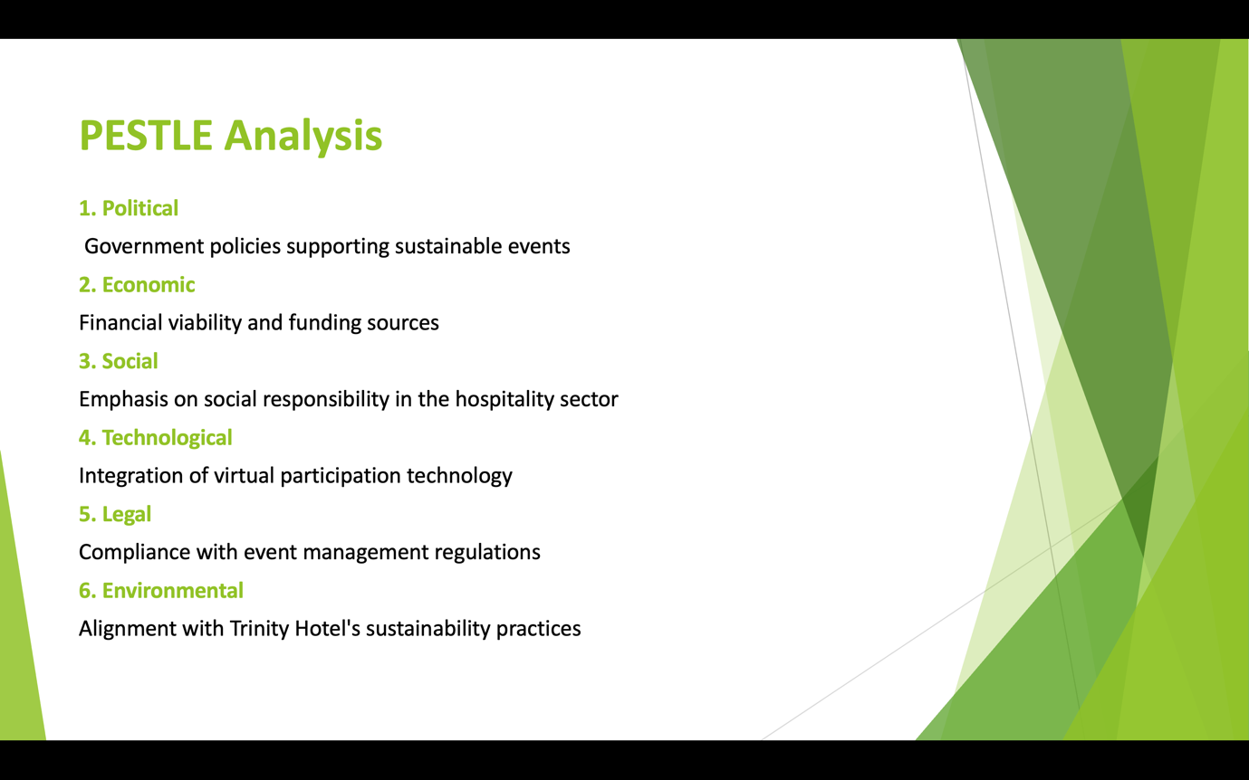
Slide 14



Slide 15

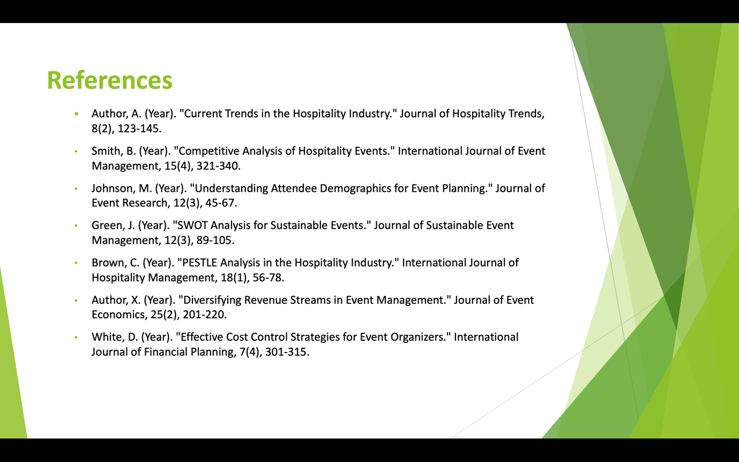

Slide 16


https://uowtsd-my.sharepoint.com/:v:/g/personal/2122723_student_uwtsd_ac_uk/EdgMY7JW-0BCgSBADPO8a2YB--jjWuq04TfsqPlh6_sdnA?referrer=Teams.TEAMS-ELECTRON&referrerScenario=MeetingChicletGetLink.view.view

