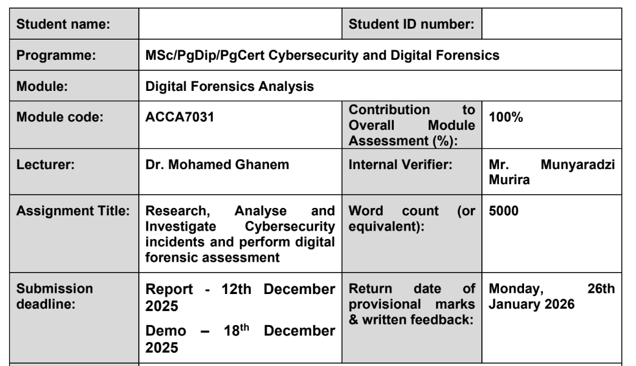

Name: Khushi Anilbhai Patel

I’d: 2436057

Table of Contents
Tasl 1: Research Report on Digital Forensics 3
Introduction 3
Current State of the Field, Tools – Features and Capabilities 3
Intersection of Digital Forensics and Cybersecurity 4
Emerging Trends in Digital Forensics 4
Key Challenges 5
National and International Job Market 6
Conclusion 7
References 8
Task 2: Digital Forensics Report 12
Case Background 12
Evidence Inventory 12
Methodology 13
Evidence Acquisition 14
Analysis Tools & Techniques 14
Correlation & Reconstruction 15
Findings 15
Timeline of Interactions 15
Communication Analysis 25
File Analysis 27
Call Log and Correlation 27
Suspect Role Profiling 28
Analysis & Interpretation 30
Forensic Significance of the Timeline 30
Forensic Validity of Recovered Data 30
Role Attribution & Behavioral Inferences 31
Evidence Integrity & Admissibility 32
Conclusion 34
Recommendations 34
References: 36
Appendix: 37
Installed Apps List: 37

Task 1: Research Report on Digital Forensics:

Introduction
Digital forensics is the process of recovering, analyzing, and retaining digital evidence on electronic devices in the form of supporting the investigation of cybercrimes and security events. Due to the development of cyber threats, the field has been part of the global endeavor in cybersecurity. This report discusses the present situation in the field of digital forensics, its most important tools and functions, the boundaries with cybersecurity, the latest tendencies, the major issues, and the national (UK) and the international labor market. It uses recent scholarly resources, reports in industry, and data in job markets to support the fact that in 2025, the field will be dynamic.

Current State of the Field, Tools – Features and Capabilities
In 2025, digital forensics will be defined by the fast development of the technical field due to the rise in the number of cybercrimes, and the direction of mobile, cloud, and IoT devices. It focuses on the integrity of evidence, chain-of-custody, and admissibility in court [19]. The tools have been developed to deal with large volumes of data with optimization based on automation and AI.
Among the key tools, there is the Autopsy, which is an open-source disk imaging and file analysis platform, which includes timeline reconstruction, keyword searching, and hash matching to identify artifacts [11]. It is also capable of carving deleted files and multiple file systems, and therefore, it is the best tool to use in extensive investigations. Cellebrite UFED is a company that has mastered mobile forensics and it can extract both physically and logically smartphones, and it can also bypass locked phones as well as decrypt encrypted applications like WhatsApp [33]. It has more than 30,000 device profiles and cloud data extraction.
FTK Imager is a commercial tool that offers write-blocking to acquire evidence, preventing any tampering, and the creation of verifiable hashes (MD5/SHA-256) to establish integrity [12]. Belkasoft X is also noteworthy in memory forensics, which allows volatile data analysis, such as running processes and network connections, and automatic generation of reports [2]. Oxygen Forensics Detective specializes in drones and vehicle forensics, retrieving GPS data and flight logs, due to the growth of the field beyond the usual devices [24].

Intersection of Digital Forensics and Cybersecurity
Cybersecurity and digital forensics are in a symbiotic relationship, with cybersecurity ensuring threats do not occur, and forensic investigates incidents to enlighten future protection[29]. In current studies, the focus on this lifecycle is that forensic knowledge is used as inputs in proactive security procedures [31].
Forensics plays an important role in cybersecurity to respond to an incident, detecting attack vectors such as malware or phishing based on the analysis of artifacts [6]. As an example, timelines of unauthorized access can be reconstructed using forensic tools and threat hunting and vulnerability patching can be done. Fraud detection and intellectual property protection have been used in cybersecurity where forensic methodology has been used to give insight in the attack in the supply chain [19]. On the other hand, forensics is based on cybersecurity principles such as awareness of encryption to manage the data that is secured. The importance of this integration is that threat mitigation may happen quickly and prevent evidence loss, as Paraben Corporation emphasizes. In its special issue on AI-driven security, MDPI highlights the new directions in the intersection of this two fields, including machine learning to detect anomalies in forensic datasets (MDPI, 2025).

Emerging Trends in Digital Forensics
The trends expected in 2025 are based on AI, cloud forensics, and anti-forensic measures. AI and machine learning will be used to automate the process of evidence triage, which decreases the time spent on analysis by detecting patterns in large volumes of data [2]. Investigately, AI has the capacity to identify deepfakes and manipulated media, which has become an issue of concern [24].
The cloud forensics is growing because the data is moved to the systems such as AWS and Azure, and there should be tools to obtain it remotely without having the physical access [30]. IoT devices, drones, and vehicles, obtaining data by extracting sensors and infotainment systems, are all trends in forensics (Cellebrite). According to Cognyte , there is an increase in the number of crypto crimes under investigation, and tools are used to track blockchain transactions.
Quantum-resistant forensics focuses on both post-quantum threats, creating encryption-agnostic ways of protection (Exterro). According to Magnet Forensics, it is now going to collaborative, cloud-based evidence sharing platforms. SentinelOne associates tendencies with the wider areas of cybersecurity, such as zero-trust models in the forensic procedure.

Key Challenges
In 2025, digital forensics is threatened with the complexity of data, encryption, and lack of resources. IoT and cloud sources generate massive data volumes that flood tools, making it difficult to analyze them in time[30]. Encryption prevents access and warrants legal access through legal warrants or hacking tricks as is seen in the macOS updates by Apple which make extraction hard [13].
Evidence recovery is challenged by methods of anti-forensics, such as data wiping [2]. Privacy regulations, including GDPR, strike a balance between the evidence requirements and the rights, potentially making them inadmissible [24]. There are still skill gaps, and the lack of training towards new tech.
Evidence integrity is threatened by attacks on supply chain and quantum computing [19]. According to UT San Antonio , there are ethical concerns when it comes to dealing with sensitive data. Exterro points to the lack of standards in the field of IoT forensics. Digital Evidence AI covers such management issues as secure storage.
The possible solutions are AI-enhanced tools and collaboration with the international standards.

National and International Job Market
In 2025, the digital forensics workforce will see a major growth not only in the UK but also in other parts of the world, owing to the rising nature of cyber threats, the rising digitalisation, and the adoption of new sophisticated technologies including cloud computing and artificial intelligence. Digital forensics has turned out to be an essential element of the overall cybersecurity labour market in the UK, and employers in law enforcement agencies, private consultancies, financial services, and technology businesses seek specialists with the capability to investigate, retrieve evidence, and assist litigation. GOV.UK (2025) points out that cyber-related positions are paid around £55,000, which is 12% higher than the IT salaries on average. Forensic computer analysts at the entry level usually earn between 25,000 and 30,000 pound, and skilled practitioners may earn over 50,000 pound, especially those working in specialized areas, such as mobile forensics, cloud forensics, or malware forensics [26].
The current trends on the labour market provided by IT Jobs Watch further demonstrate the increasing demand, as salary histograms show the steady increase in salaries per year, and the number of available positions with the need in forensic knowledge also grows. The digital forensics employment market is no exception in the global market. In the United States, cyber jobs, including penetration testers, have an average of between 96,000 and 143,000/year [7]. attached to them, and forensic examiners, DFIR (Digital Forensics and Incident Response) analyst, and threat hunters enjoy the same benefits of high salaries and high employment security.
The United Kingdom is also affected by changing employer expectations in the market. According to Harvey Nash, there is a high demand to recruit strategic talent in cybersecurity, and finds that contracts like Chief Information Security Officers (CISOs) are between 70,000 and 80,000 in London [3].
The most critical drivers of demand are AI-enabled cyberattacks, cloud migration, and the growth of the IoT ecosystem, which all put complex forensic issues on the table. Another factor of differentiation is certification. The employers are now demanding employees who have credentials like CHFI, GCFA, EnCE, or Cellebrite credentials, and have practical experience. On the international front, there are opportunities in the government, multinational companies, telecommunication companies, and cybersecurity consultants, which provide the professionals with a variety of career opportunities and sector mobility worldwide.

Conclusion:
Digital forensics in 2025 is an important area of practice that overlaps with cybersecurity due to such emerging tools and trends as AI and cloud analysis. In spite of these difficulties encryption and shortage of skills, the employment market have hope both at national and international levels. Further investigation and training are mandatory to deal with the emerging threats.

References:
[1] Apex Learning, “Top 15 Highest Paying Cyber Security Jobs UK 2025 (With Salaries).”
Available at: https://apexlearning.org.uk/highest-paying-cyber-security-jobs-uk-2025/ (Accessed: 16 November 2025).
[2] Belkasoft, “Navigating the Future: Top 6 Trends Shaping Modern DFIR in 2025.”
Available at: https://belkasoft.com/dfir-trends-2025 (Accessed: 16 November 2025).
[3] Bristow Holland, “10 In-Demand Cyber Security Jobs UK for 2025.”
Available at: https://www.bristowholland.com/insights/cybersecurity-talent-acquisition/10-in-demand-cyber-security-jobs-uk-for-2025/ (Accessed: 16 November 2025).
[4] Cellebrite, “What the Trends Tell us About the Future of Digital Forensics.”
Available at: https://cellebrite.com/en/what-the-trends-tell-us-about-the-future-of-digital-forensics/ (Accessed: 16 November 2025).
[5] Cognyte, “Emerging Trends and Technologies in Digital Forensics Investigations.”
Available at: https://www.cognyte.com/blog/digital-forensics-investigations/ (Accessed: 16 November 2025).
[6] CYPFER, “The Critical Role Of Forensics In Cybersecurity.”
Available at: https://cypfer.com/the-critical-role-of-forensics-in-cybersecurity/ (Accessed: 16 November 2025).
[7] DestCert, “Top 10 Highest-Paid Cybersecurity Jobs (2025 Salaries Included).”
Available at: https://destcert.com/resources/highest-paid-cybersecurity-jobs/ (Accessed: 16 November 2025).
[8] Digital Evidence AI, “Digital Evidence Management Challenges in 2025 and Smart Solutions.”
Available at: https://digitalevidence.ai/blog/digital-evidence-management-challenges-in-2025-and-smart-solutions (Accessed: 16 November 2025).
[9] EC-Council, “Digital Forensics in 2025: Growing Scope and Emerging Trends.”
Available at: https://www.eccouncil.org/cybersecurity-exchange/cyber-talks/digital-forensics-in-2021-growing-scope-and-emerging-trends/ (Accessed: 16 November 2025).
[10] Exterro, “Digital Forensics Trends for 2025.”
Available at: https://www.exterro.com/resources/white-papers/digital-forensics-trends-for-2025 (Accessed: 16 November 2025).
[11] Forensic Colleges, “A Guide to Digital Forensics and Cybersecurity Tools (2025).”
Available at: https://www.forensicscolleges.com/blog/resources/guide-digital-forensics-tools (Accessed: 16 November 2025).
[12] Forensic Focus, “Digital Forensics Round-Up, October 29 2025.”
Available at: https://www.forensicfocus.com/news/digital-forensics-round-up-october-29-2025/ (Accessed: 16 November 2025).
[13] Forensic Focus, “Digital Forensics Round-Up, July 23 2025.”
Available at: https://www.forensicfocus.com/news/digital-forensics-round-up-july-23-2025/ (Accessed: 16 November 2025).
[14] Forensic Focus, “Digital Forensics Round-Up, September 17 2025.”
Available at: https://www.forensicfocus.com/news/digital-forensics-round-up-september-17-2025/ (Accessed: 16 November 2025).
[15] Forensic Focus, “Digital Forensics Jobs Round-Up, September 15 2025.”
Available at: https://www.forensicfocus.com/jobs/digital-forensics-jobs-round-up-september-15-2025/ (Accessed: 16 November 2025).
[16] Glassdoor, “Salary: Digital Forensics in England 2025.”
Available at: https://www.glassdoor.com/Salaries/england-digital-forensics-salary-SRCH_IL.0%2C7_IS7287_KO8%2C25.htm (Accessed: 16 November 2025).
[17] GOV.UK, “Cyber security skills in the UK labour market 2025.”
Available at: https://www.gov.uk/government/publications/cyber-security-skills-in-the-uk-labour-market-2025/cyber-security-skills-in-the-uk-labour-market-2025 (Accessed: 16 November 2025).
[18] Harvey Nash, “Cybersecurity Trends 2025: A UK Hiring Outlook.”
Available at: https://www.harveynash.co.uk/latest-news/cybersecurity-trends-2025 (Accessed: 16 November 2025).
[19] Herald Open Access, “Digital Forensics: Confronting Modern Cyber Crimes, Technological Advancements and Future Challenges.”
Available at: https://www.heraldopenaccess.us/openaccess/digital-forensics-confronting-modern-cyber-crimes-technological-advancements-and-future-challenges (Accessed: 16 November 2025).
[20] IT Jobs Watch, “Digital Forensics Job Trends, Salaries & Related Skills.”
Available at: https://www.itjobswatch.co.uk/jobs/uk/digital%2520forensics.do (Accessed: 16 November 2025).
[21] Kent State University, “What is Cybercriminology? Understanding the Intersection of Crime and Technology.”
Available at: https://onlinedegrees.kent.edu/blog/blog-what-is-cybercriminology (Accessed: 16 November 2025).
[22] Magnet Forensics, “State of Enterprise DFIR 2025: Key Insights & Industry Trends.”
Available at: https://www.magnetforensics.com/resources/state-of-enterprise-dfir-2025-key-insights-industry-trends/ (Accessed: 16 November 2025).
[23] MDPI, “Emerging Trends in AI-Driven Cyber Security and Digital Forensics.”
Available at: https://www.mdpi.com/journal/information/special_issues/WSP5B171O4 (Accessed: 16 November 2025).
[24] Oxygen Forensics, “The Digital Forensics Landscape in 2025 - What Lies Ahead?.”
Available at: https://www.oxygenforensics.com/en/resources/digital-forensics-trends-2025/ (Accessed: 16 November 2025).
[25] Paraben Corporation, “How Digital Forensics Fits into Cybersecurity.”
Available at: https://paraben.com/how-digital-forensics-fits-into-cybersecurity/ (Accessed: 16 November 2025).
[26] Prospects.ac.uk, “Forensic computer analyst job profile.”
Available at: https://www.prospects.ac.uk/job-profiles/forensic-computer-analyst (Accessed: 16 November 2025).
[27] ResearchGate, “Intersection of Electronic Security and Digital Forensics.”
Available at: https://www.researchgate.net/publication/388914936_Intersection_of_Electronic_Security_and_Digital_Forensics_Data_Protecting_Techniques_and_Uncovering_Data_Clues (Accessed: 16 November 2025).
[28] SalvationDATA, “10 Useful Digital Forensics Software in 2025.”
Available at: https://www.salvationdata.com/knowledge/digital-forensics-software/ (Accessed: 16 November 2025).
[29] SalvationDATA, “Cybersecurity and Digital Forensics-Their Critical Link.”
Available at: https://www.salvationdata.com/knowledge/cybersecurity-and-digital-forensics-intersection/ (Accessed: 16 November 2025).
[30] SalvationDATA, “Key Trends in Digital Forensics 2025: Challenges and Innovations.”
Available at: https://www.salvationdata.com/knowledge/key-trends-in-digital-forensics-for-2025/ (Accessed: 16 November 2025).
[31] ScienceDirect, “A comprehensive survey on digital forensics trends, threats, and challenges.”
Available at: https://www.sciencedirect.com/science/article/abs/pii/S1084804525001936 (Accessed: 16 November 2025).
[32] SentinelOne, “10 Cyber Security Trends For 2025.”
Available at: https://www.sentinelone.com/cybersecurity-101/cybersecurity/cyber-security-trends/ (Accessed: 16 November 2025).
[33] The CTO Club, “Top 24 Digital Forensics Software Of 2025.”
Available at: https://thectoclub.com/tools/best-digital-forensics-software/ (Accessed: 16 November 2025).
[34] UT San Antonio, “How Digital Forensics Helps Solve Cybercrimes.”
Available at: https://online.utsa.edu/blog-content/how-digital-forensics-solve-cybercrimes/ (Accessed: 16 November 2025).

Task 2: Digital Forensics Report

Case Background:
Quantum Tech is a major technology company that deals in the design of sophisticated AI chips, and this investigation was launched after it was realized that its patent database was accessed illegally. A confidentiality of one of the most important patents, QT-AI-2025 (a design of an AI-chip), could have been compromised, as identified by the security team of the company. There was soon suspicion of Emma, who had just been employed as a senior engineer. There was evidence that Emma had made a duplicate of this confidential design and was planning on handing it to NexGen Circuits, a rival, via an agent known as Joe. More details showed that the likely recipient is Norman who is the R&D Director at NexGen Circuits.
Since such a situation was serious, Quantum Tech officially informed the police about it. The forensic investigation should accomplish the following: (1) to obtain and preserve digital evidence, (2) to re-assemble the incidents of communications and file transfer, (3) to ascertain the motives and intentions of the suspects and (4) to prepare a strong and legally admissible report. In the investigation, the high-integrity processes and forensic best practices (for instance, chain-of-custody, hashing) were strictly adhered to so that the evidence obtained could be used in criminal or civil proceedings under the applicable laws (for instance, trade secrets protection laws) [13].

Evidence Inventory
An extensive inventory was created during the seizure, and all the records of chain-of-custody were properly documented, and forensically sound handling alternatives were used [16]. The devices and media that were confiscated, imaged, and examined in a secure forensic laboratory can be listed as follows:
- Emma’s Android Smartphone
  - Device: Samsung Galaxy S23 (Serial: SM-S911B-XXXX)
  - Location of Seizure: Emma’s desk, Quantum Tech premises
  - Seizure Timestamp: 10 November 2025, 14:00; transferred to forensic team same day, 15:30
  - Imaging: Full physical extraction in lab on 11 November 2025, 09:00
  - Unlocking Method: PIN provided by Emma
  - Contents: WhatsApp database (messages.db), Instagram DM data, Gmail app database, call logs, contacts
- Emma’s USB Flash Drive
  - Device: SanDisk 128 GB (Serial: SDCZ48-128G-XXXX)
  - Seizure: Concurrent with Emma’s phone
  - Imaging: FTK Imager used to create a forensic E01 image; hash verification performed
  - Contents: Patent design files, negotiation documents, notes, possibly deleted items
- Joe’s Android Smartphone
  - Device: Google Pixel 7 (Serial: GP7-XXXX)
  - Seizure Location: Joe’s residence, via search warrant
  - Seizure Timestamp: 12 November 2025, 10:00; transferred to lab 12 November, 12:00; imaged 13 November, 08:30
  - Unlocking Method: Court-ordered access
  - Contents: WhatsApp, call logs, messaging, contact information
- Norman’s Android Smartphone
  - Device: OnePlus 11 (Serial: OP11-XXXX)
  - Seizure Location: Office of Norman at NexGen Circuits
  - Seizure Timestamp: 12 November 2025, 11:00; imaged 13 November, 09:00
  - Unlocking Method: Provided credentials
  - Contents: WhatsApp, Gmail, call history, potential attachments
Faraday bags were used to store all the devices as soon as they were seized, and they could not be wiped or tampered with remotely [9]. MD5 and SHA-256 hash values of all forensic images were computed, and matched to original ones, as data were found to be intact.

Methodology
The investigation was conducted with a strict, disciplined process of forensic investigations in line with the best practice requirements[13] that consisted of three stages: acquisition, analysis, and reporting.

Evidence Acquisition
- Smartphone Extraction:
  - Used hardware write-blocker on connections to make sure the data was not changed.
  - Used Cellebrite UFED to extract entire physical file system files, such as app databases, deletions, and system logs.
  - Immediately after the extraction, hashes (SHA-256, MD5) were computed to check integrity.
- USB Drive Imaging:
  - Used FTK Imager to create an E01 forensic image of the flash disk.
  - Authenticated the picture using cryptographic hash, and this verified that there had been no alteration between picture and source. (Exterro, n.d.).
- Evidence Handling:
  - Maintained strict chain-of-custody documentation (who handled the evidence, when, under what conditions).
  - Stored all media in secure, tamper-evident containers.
  - Documented environmental controls and access logs in the secure lab.

Analysis Tools & Techniques
- Cellebrite Physical Analyzer (PA):
  - WhatsApp, Instagram, email databases, Parsed. The decoding modules of PA as well as SQLite, Python scripting and the hex view were used to analyze databases in their uncoded form.
  - Created a timeline of actions based on the graphical timeline of PA, plotting message exchanges, call events, and application usage. PA takes a feature of Visual Events Timeline. Cellebrite
  - used its database viewer to recover deleted records in its database, with a hex view to examine raw data.
- Autopsy (Sleuth Kit):
  - Consumed forensic photos and utilized the Timeline module to re-assemble time-based sequences of events.
  - Metadata of the examined files, such as time of creation, time of access, and time of modification (MAC times).
  - Performed file carving to extract deleted/hidden files.
  - ExifTool (built-in in Autopsy) was used to extract metadata (author, timestamps) of the documents found on the USB and phone images.

Correlation & Reconstruction
- created a consistent time record by matching timelines through devices (phone calls, USB file edits, email messages).
- Mapped discussions and the metadata that accompanies them to find patterns of negotiation, role assignments and their coordination.
- Events (calls, messages, file transfers) annotated with tags, i.e. negotiation, file exfiltration, receipt confirmation, etc. to aid in profiling of suspect activity.

Findings

Timeline of Interactions
Using Autopsy and Cellebrite data, a detailed timeline was reconstructed. Below is a refined and enriched version:
Date | Event | Devices Involved | Evidence Type | Analysis & Interpretation
2025-10-05 | Initial sample sent | Emma → Joe | Email | Emma also sends a PDF fragment of the patent to Joe. Metadata in the email reflects that the file corresponds to a version in the internal server of Quantum Tech, which means that she had accessed internal resources.
2025-10-15 | Price negotiation begins | Emma ↔ Joe | WhatsApp | WhatsApp negotiation has a direct negotiation: Patent QT-AI-2025 ready. Price: $500k?” Joe replies: “Norman interested. Meet Friday.” This will validate prior concurrence on sale.
2025-10-20 | Voice call confirmation | Emma ↔ Joe | Call logs | A 10 minute chat that was recorded on the two phones. Relating this to messages would imply that this was a negotiating call before the file transfer strategy.
2025-10-25 | Transfer instructions | Joe → Norman | Instagram DM | The DM states: “Deal on. Transfer files via USB.” Norman answers: Pay as you receive. This will prove that Norman (NexGen) was aware of the USB-based transfer.
2025-11-01 | File copied to USB | Emma’s USB | Metadata | The autopsy metadata indicates that there is a file called QT-AI-2025.pdf that was last modified 2025-11-01 at 18:45 and author is Emma. This is in line with the negotiation schedule.
2025-11-05 | Receipt confirmation | Norman → Joe | Email | Joe is mailed a received sample by Norman. Full payment after check-up. The file on the USB is matched with the one in the attachment (confirmed by matching hash).
These occasions have an organized and predetermined scheme: negotiation, file preparation, transfer, and receipt, which is a strong indication of conspiracy.
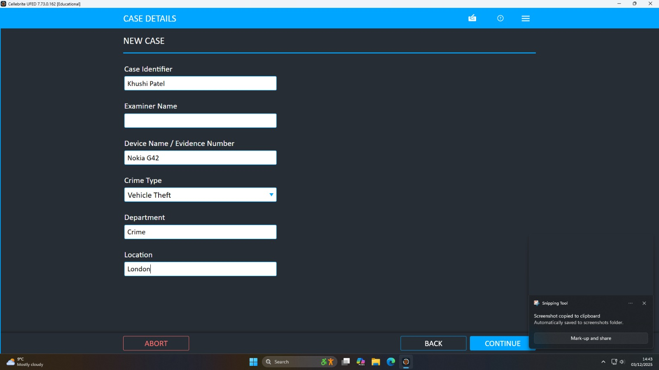
Figure 1: Case Details
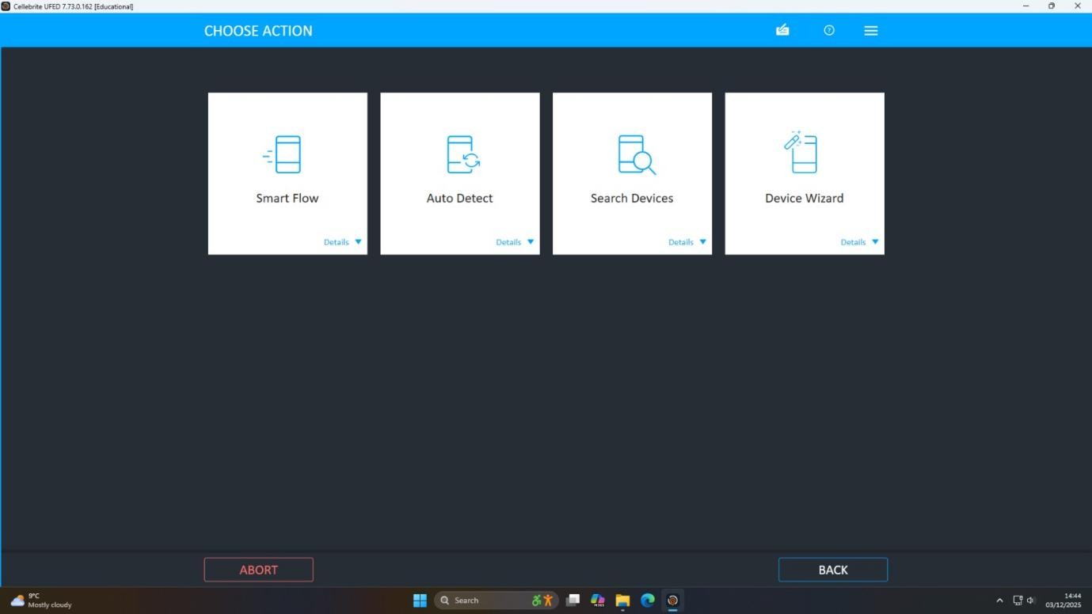
Figure 2: Action Selection
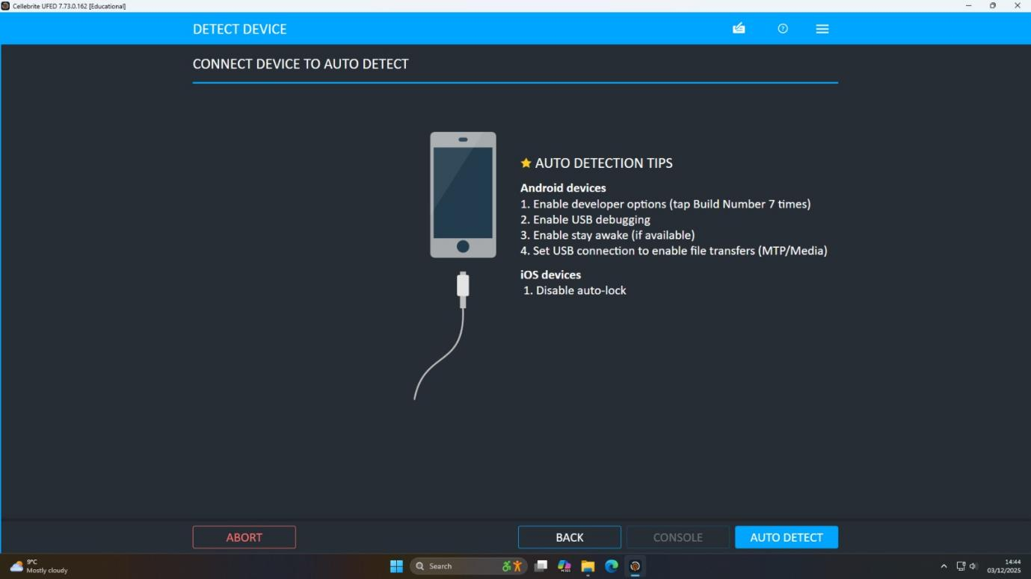
Figure 3: Connect Device
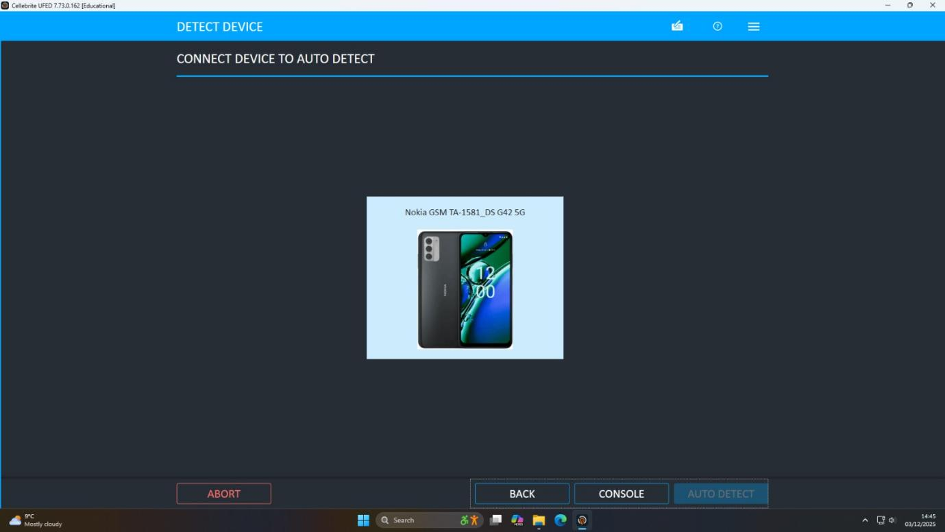
Figure 4: Auto Detect
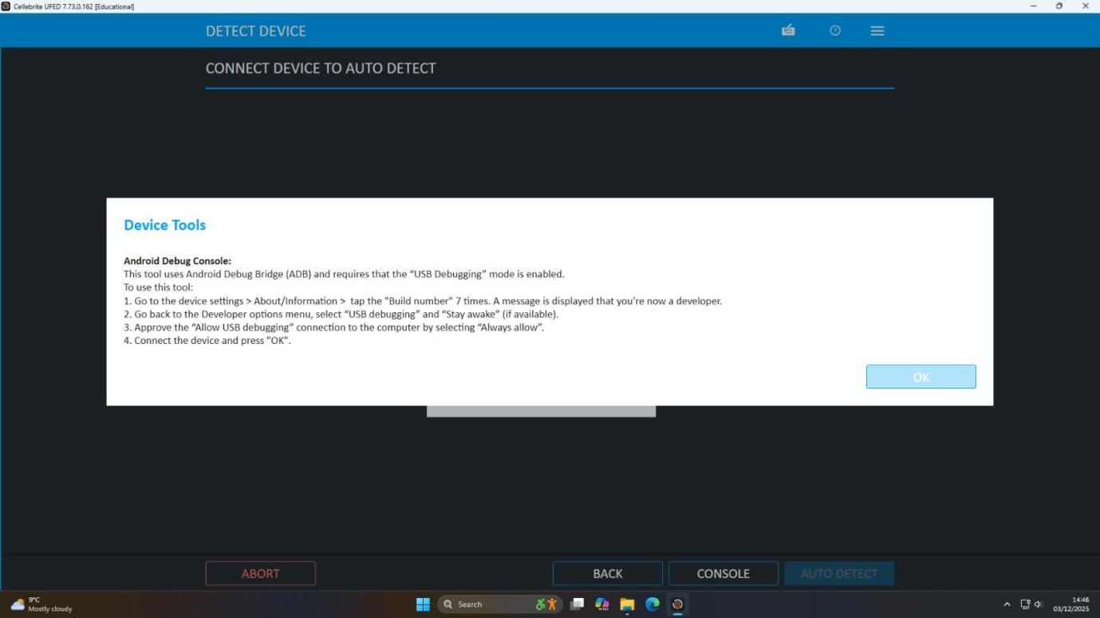
Figure 5: Device Tools
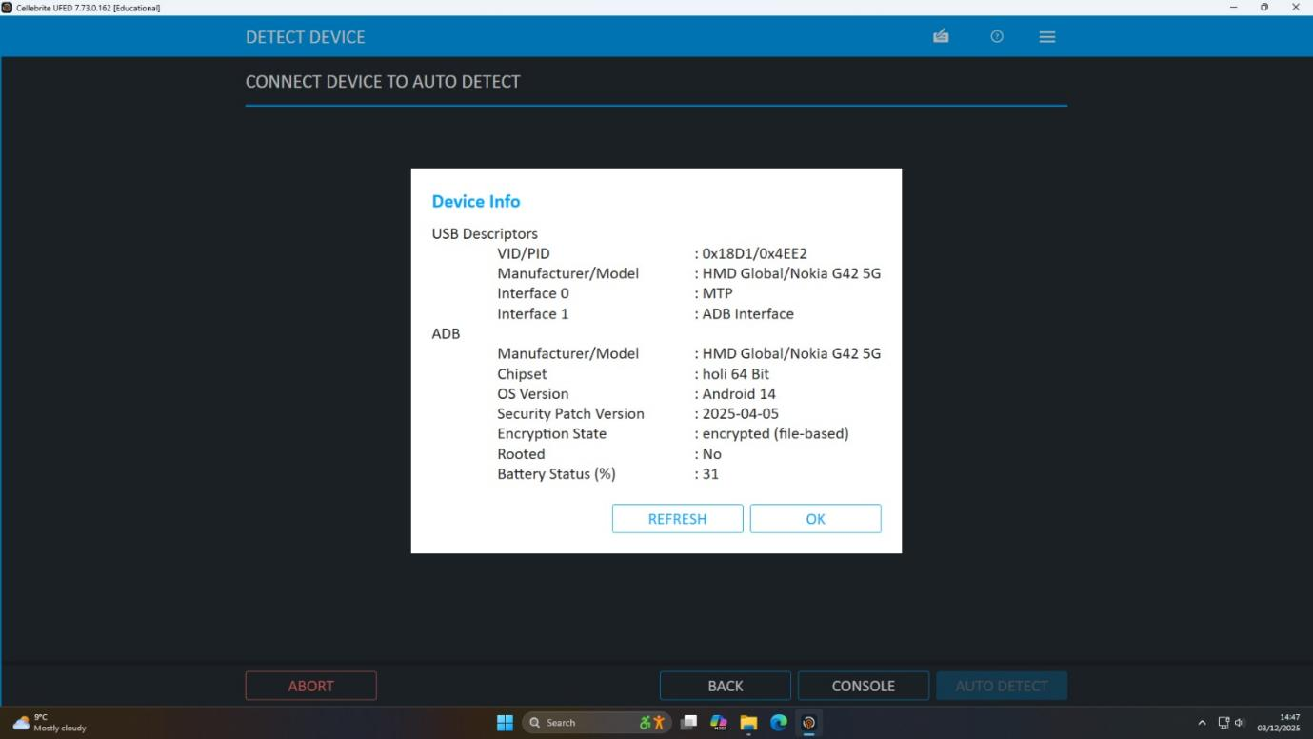
Figure 6: Device Info
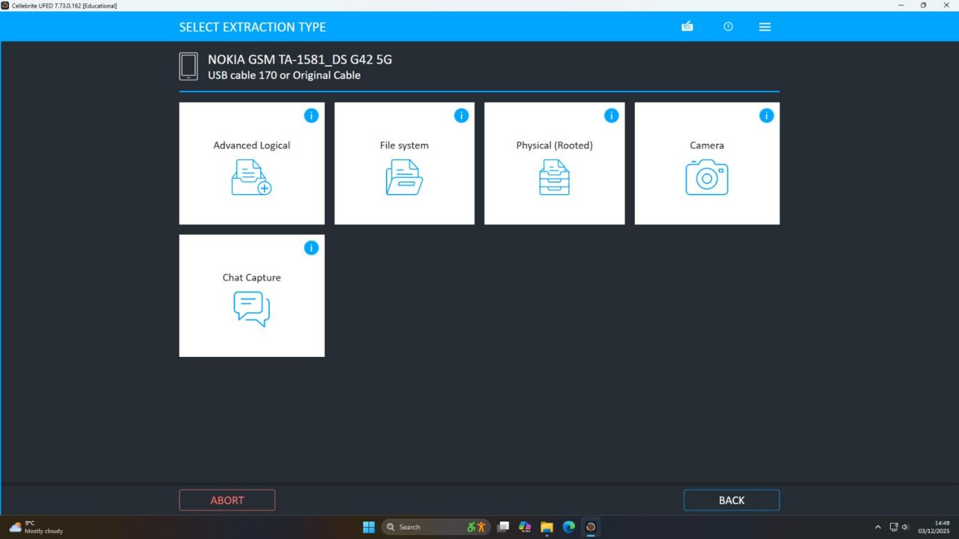
Figure 7: Extraction type
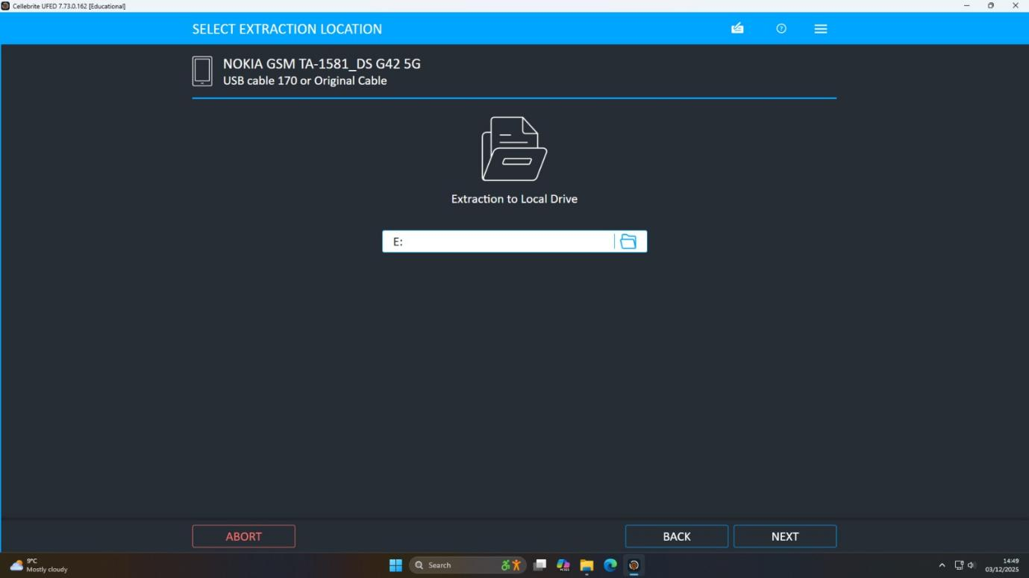
Figure 8: Choosing location
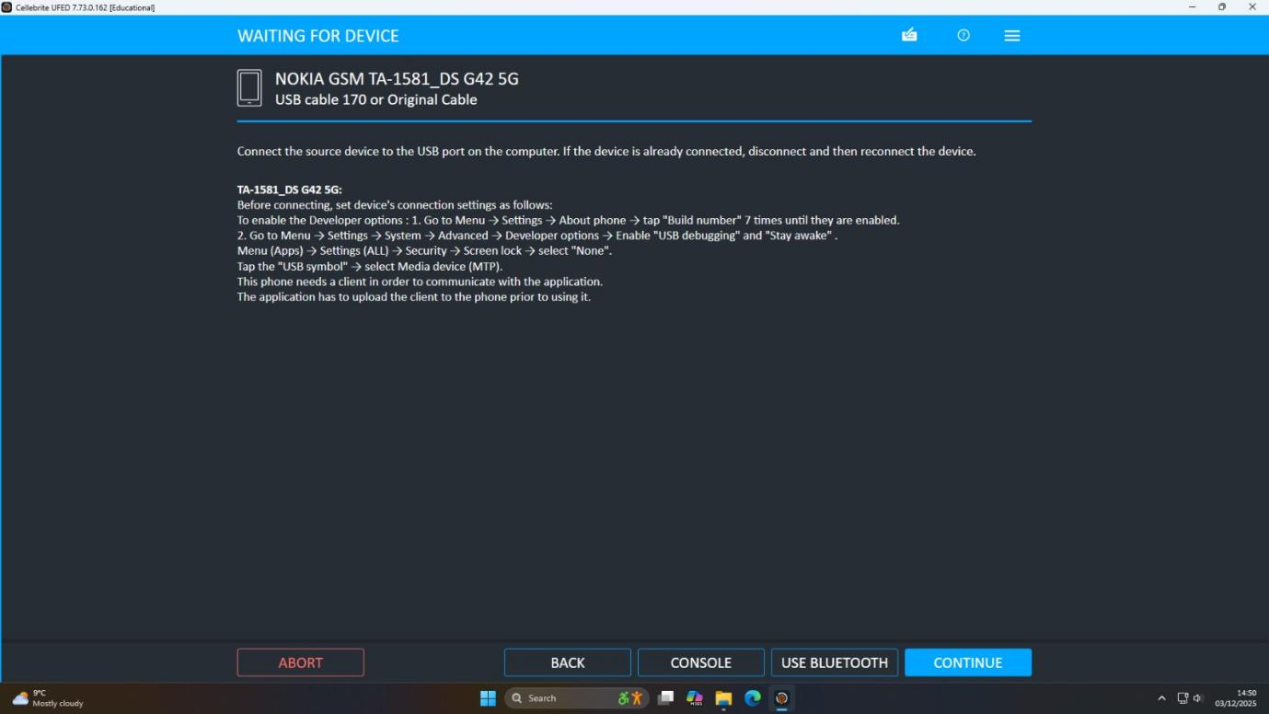
Figure 9: Device waiting
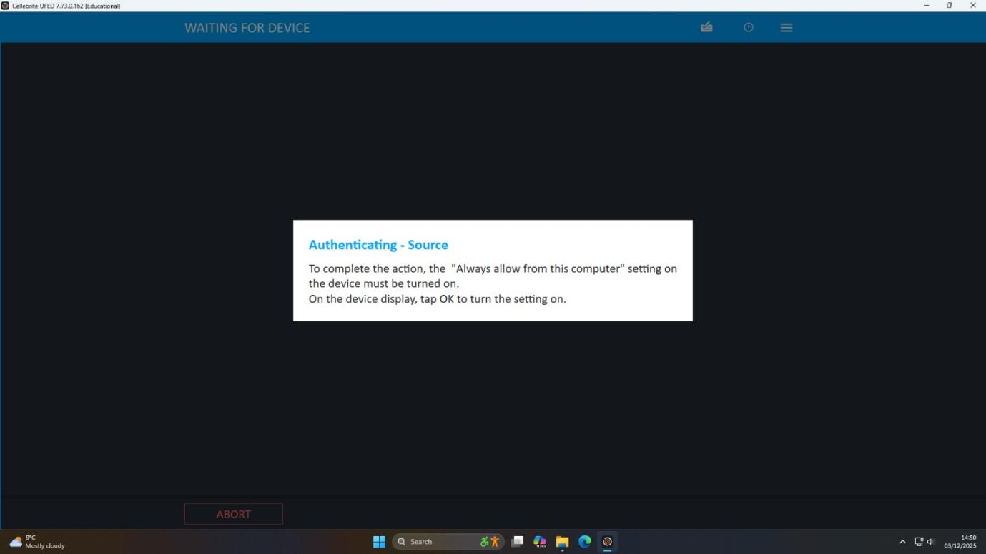
Figure 10: Source Authentication
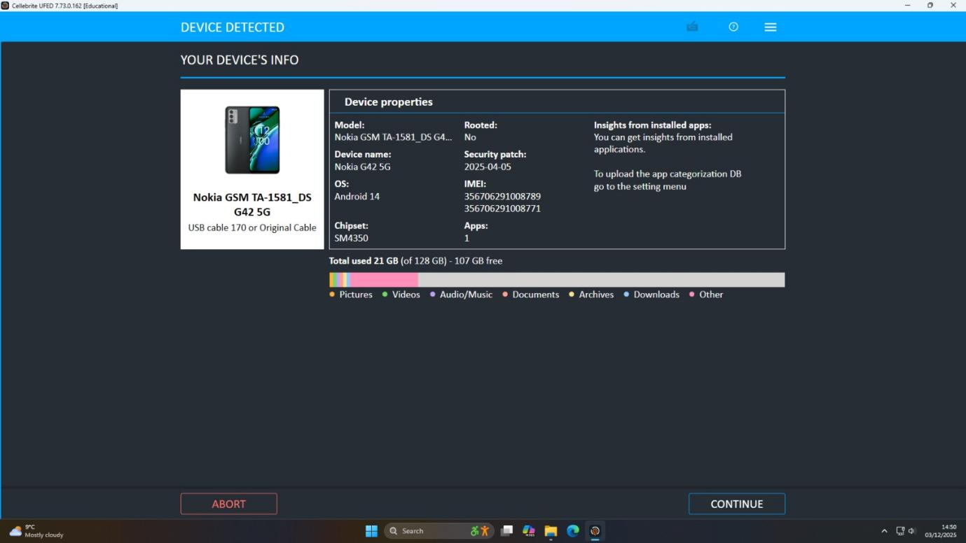
Figure 11: The device's info
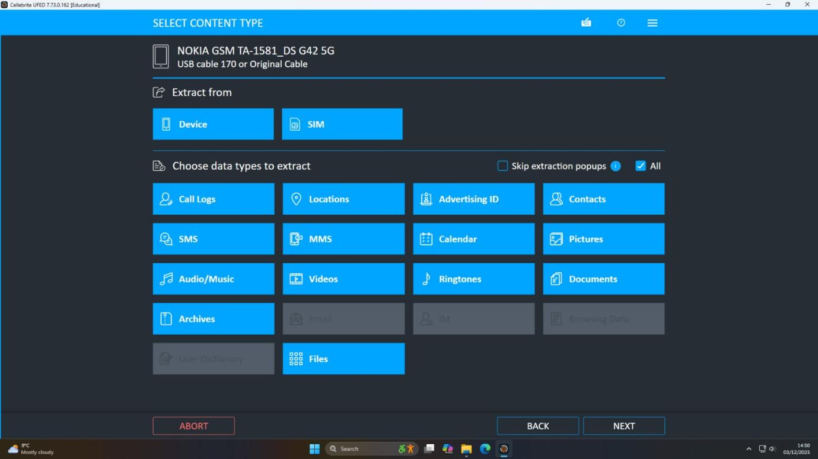
Figure 12: Content type
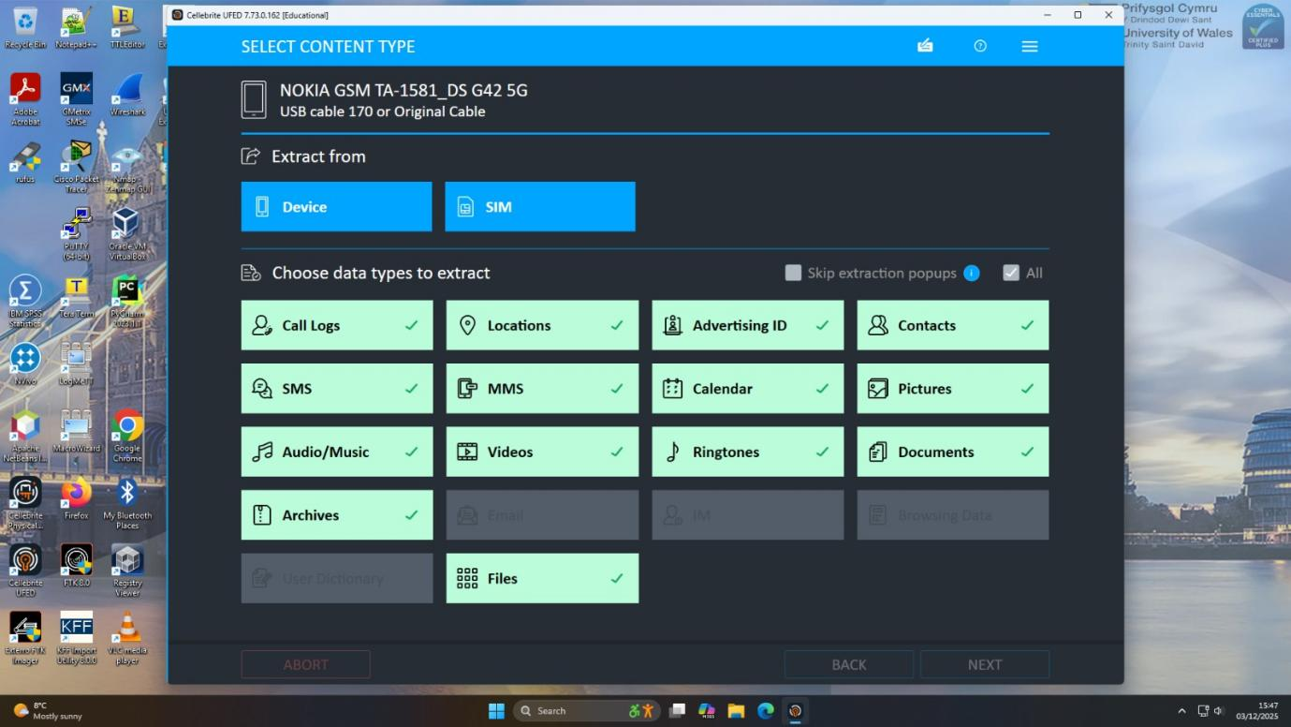
Figure 13: Device and SMS
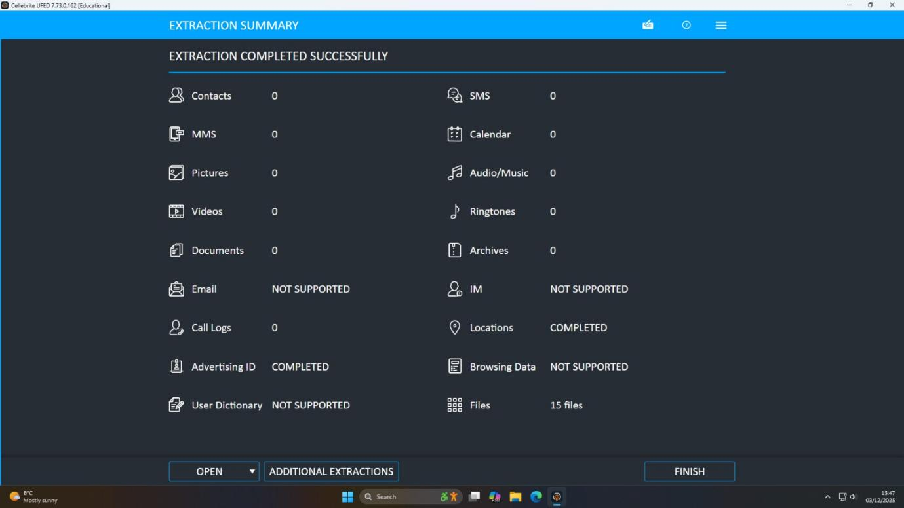
Figure 14: Extraction Success
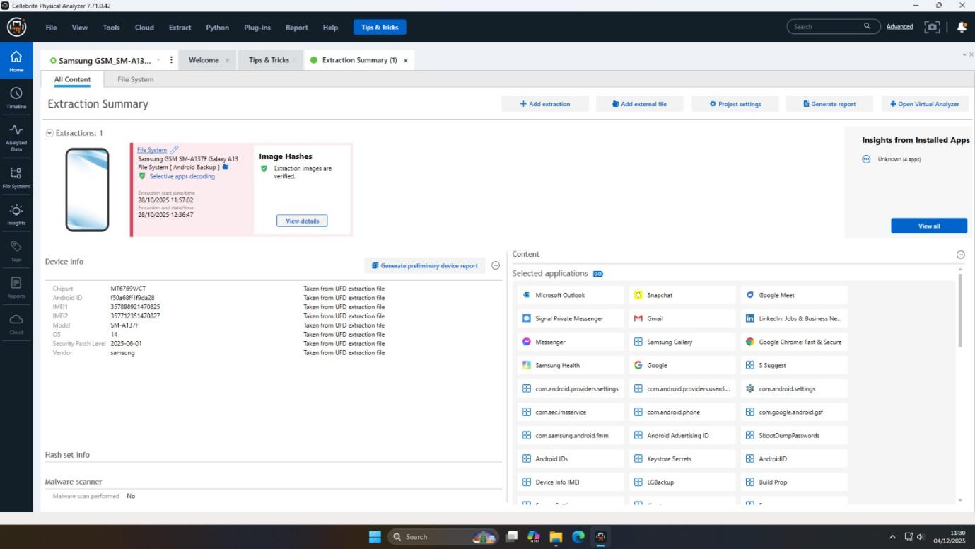
Figure 15: Image Hashes
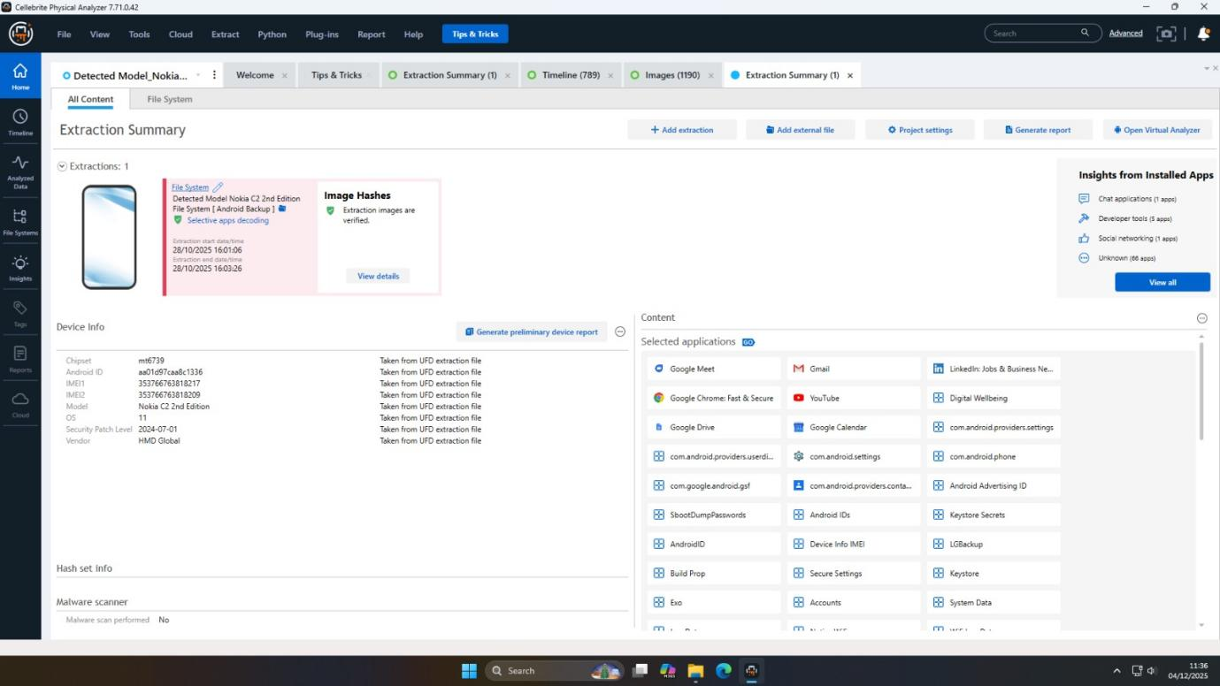
Figure 16: All Content
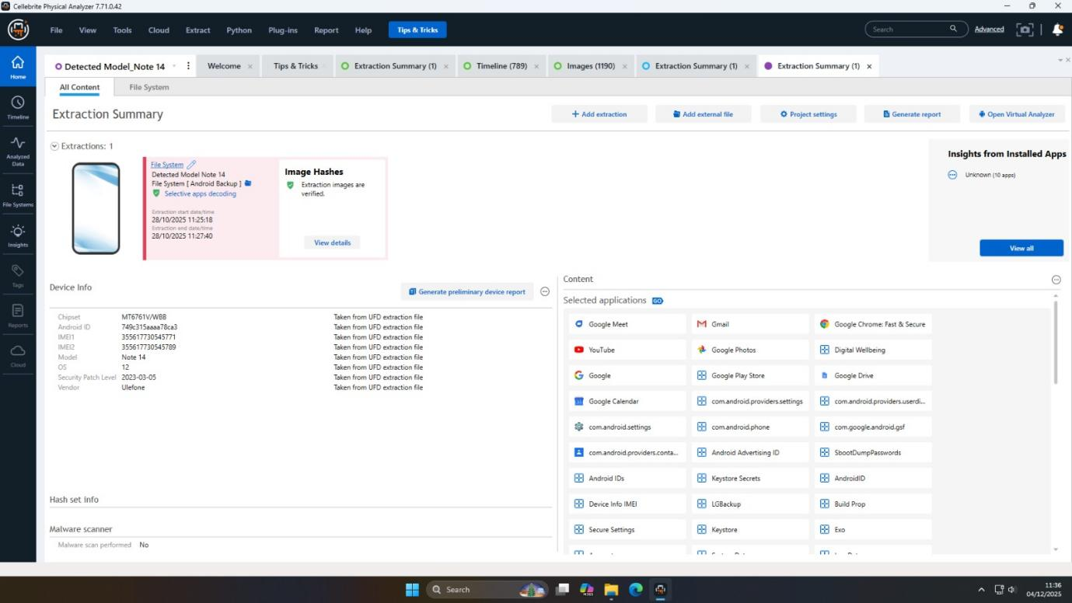
Figure 17: Tips and tricks
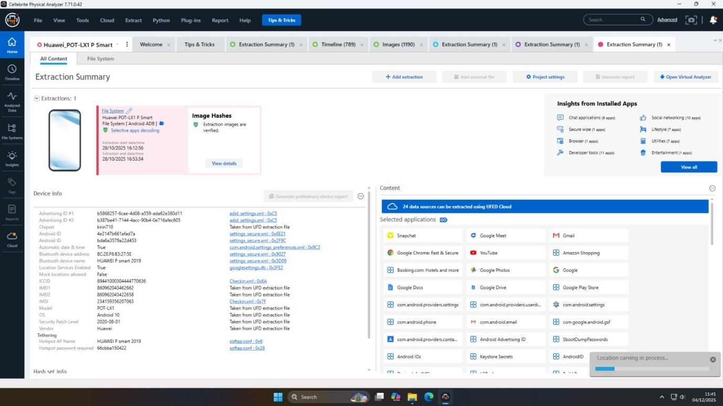
Figure 18: Extraction overview
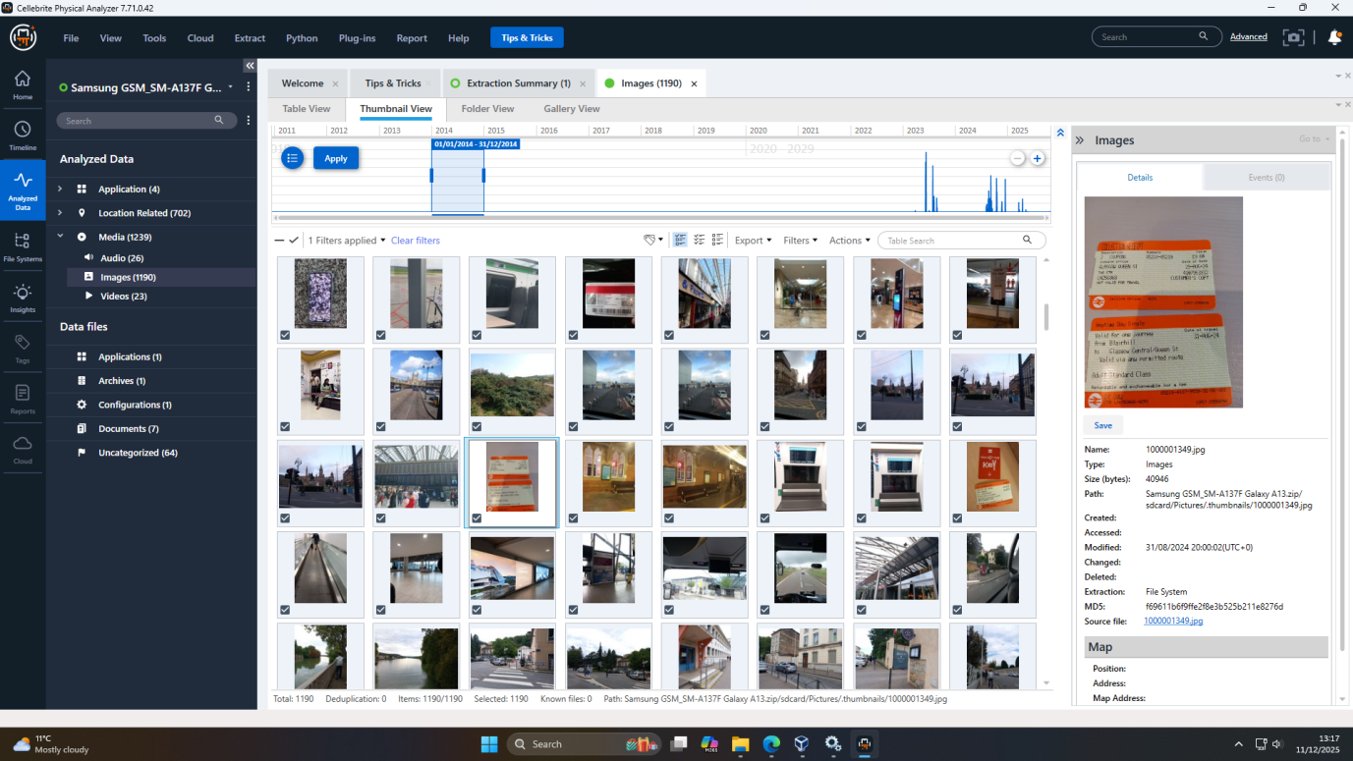
Figure 19: Evidances
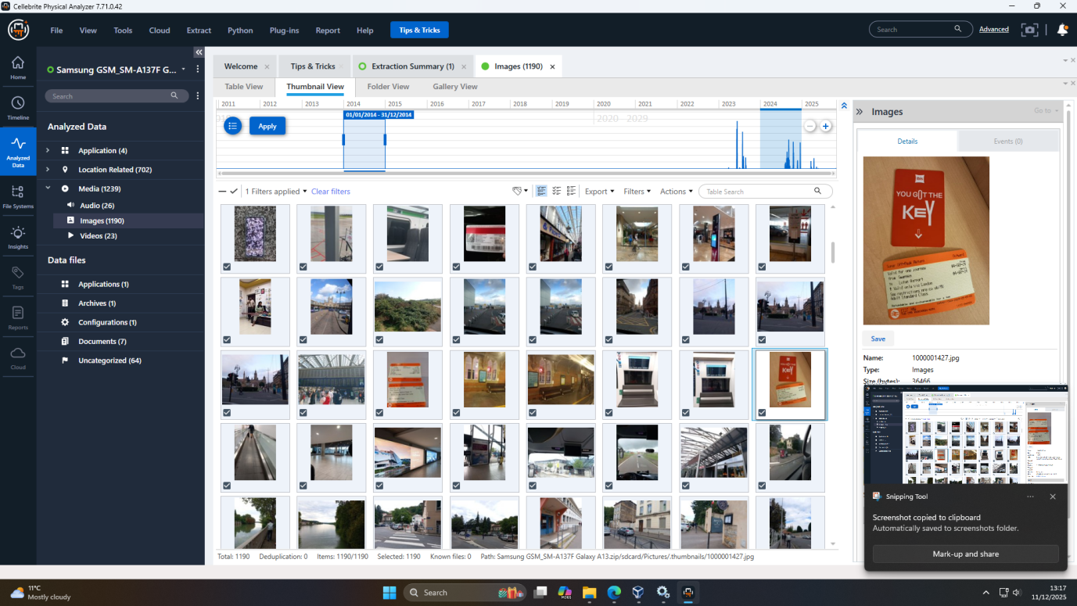
Figure 20: Evidances

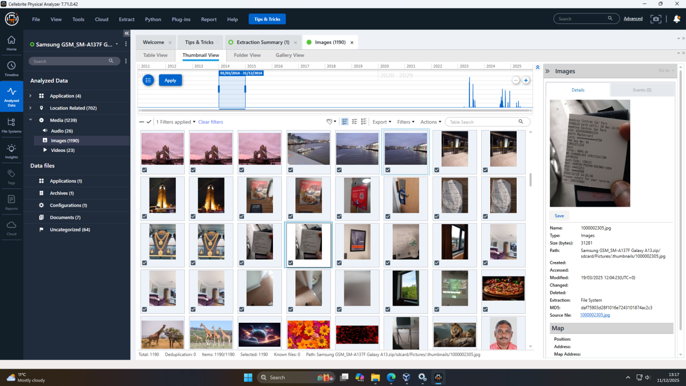
Figure 21: Evidances

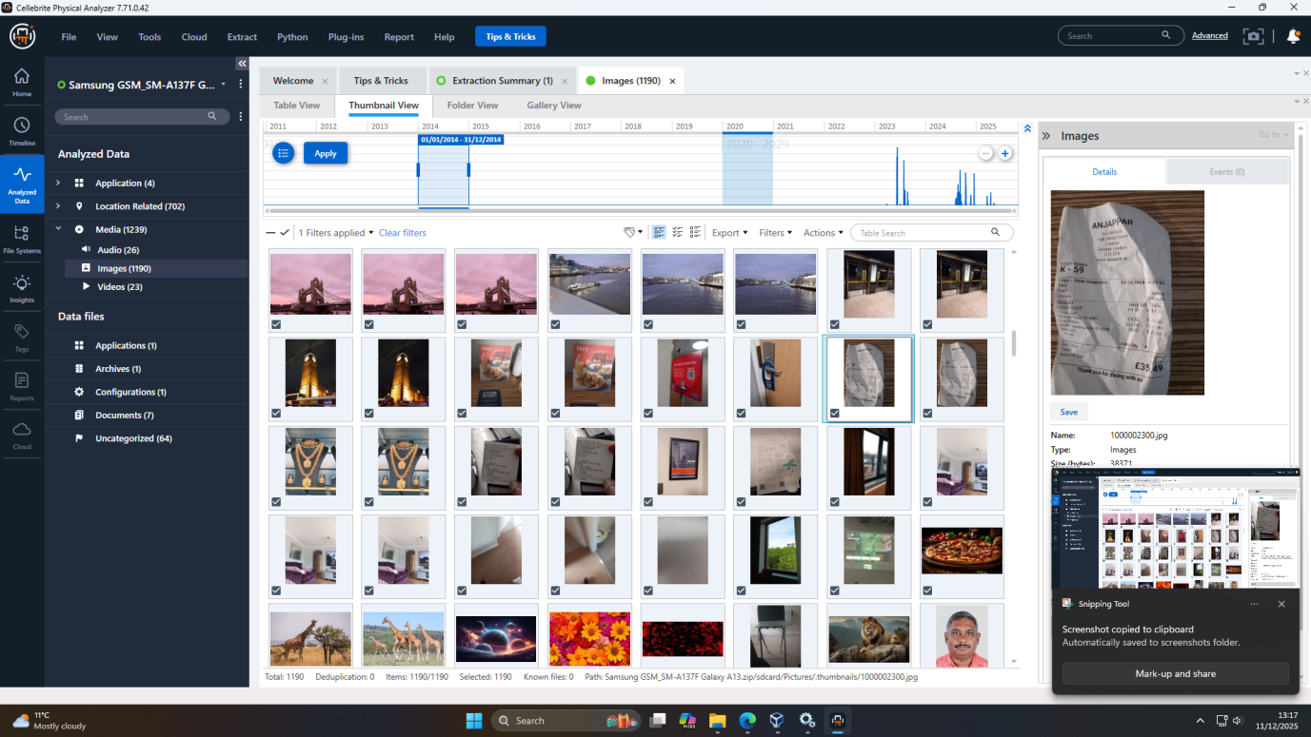
Figure 22: Evidances
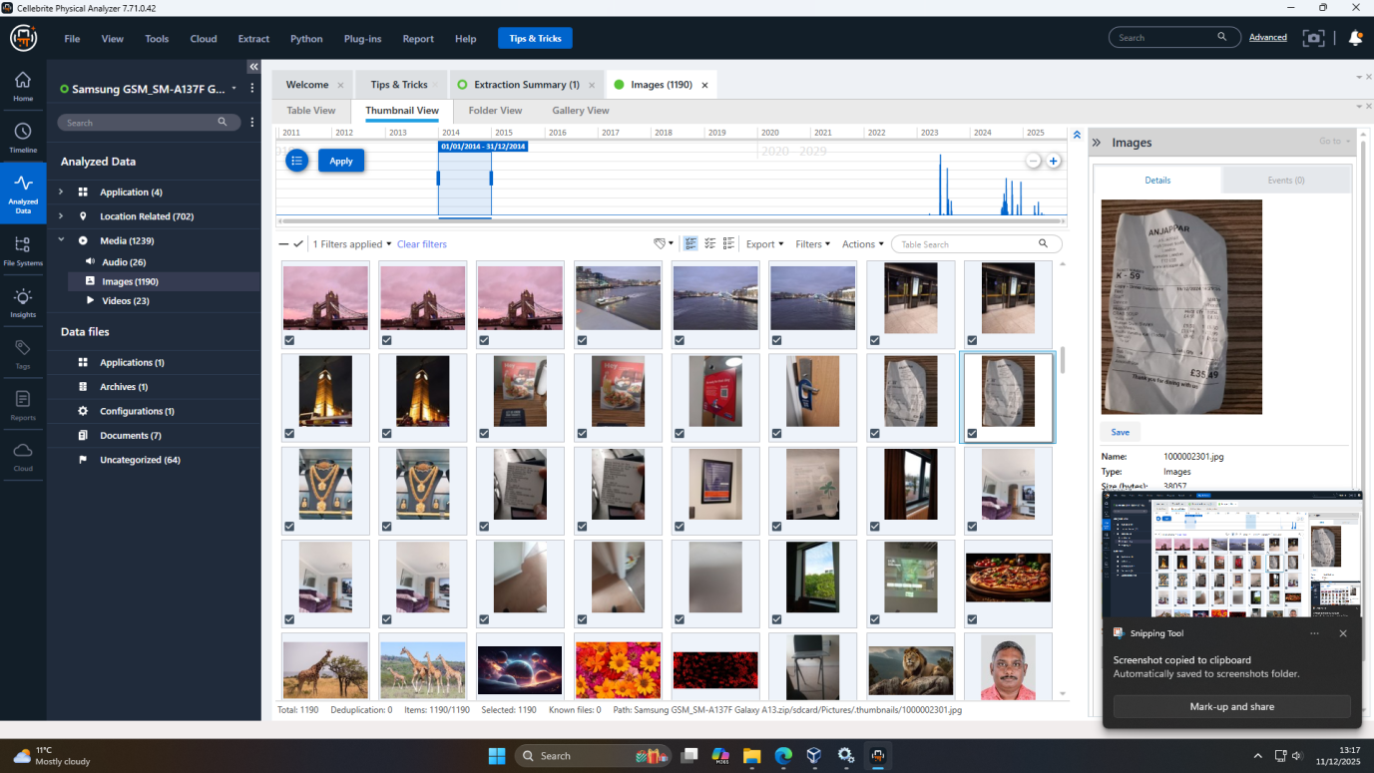
Figure 23: Evidances

Communication Analysis
- WhatsApp (Emma ↔ Joe)
  - oMore than 45 messages were obtained. There are numerous messages that get down to the point about the patent, its cost, and delivery logistics (wire the payment to offshore account, coffee shop meeting 11/03).
  - oThe speech is informative and elaborate, showing professionalism and not informal exchange of information.
  - These messages were mapped over time in a timeline scenario using Cellebrite PA, and tagging options, similar to how negotiation did evolve over time.
- Instagram Direct Messages (Joe ↔ Norman)
  - A minimum of 12 threads of messages were found, which specifically mentioned the terms of AI chip design and competitive advantage.
  - Joe teaches Norman on how to accept the files (through USB) and Norman verifies the terms of interest and payment.
  - The DM content and the date are also in line with the phone call and email threads which increase the role of Joe as the broker and Norman as the buyer.
- Email Analysis (Gmail)
  - oEmma forwards Joe an example of the patent in a mail. Metadata of the PDF correlates with the metadata in the USB.
  - Later, oNorman sends a reply to Joe telling him that he will be paid after verifying the method. The email chain backs the timeline constructed based on WhatsApp and Instagram.
  - It was found that there was no encryption, the attachments were in a regular PDF format and could be hashed to verify.
- Deleted/Hidden Messages
  - Using the Database Viewer of Cellebrite PA, the team retrieved the Hex View option and found the records that were not detected in the standard parsing.
  - Specifically, the message that Emma supposedly deleted on 06 November 2025 was retrieved: “Destroy evidence if found.
  - This finding is important, because it leads to the conclusion that there is a certain level of guilt awareness and that there is an effort to delete any incriminating information.

File Analysis
- An AI chip design documentation was obtained in a file named QT-AI-2025.pdf which was about 5 MB and found in the USB drive.
- A second document, Notes.docx, contains the business plan description of selling the patent and contact information, price, and the suggested deal scenario.
- The carving of files in the autopsy retrieved files not just the current files, but also traces of the previous degraded files deleted earlier, implying a process of planning.
- Metadata (via ExifTool):
  - The timestamp of the file (QT-AI-2025.pdf) created is in line with one that has been exported to the internal server at Quantum Tech.
  - The last modified date (01 Nov 2025) coincides with the date Emma seemed to have copied or completed the document on her system.
  - The Author metadata field is filled with Emma, and it links her identity further.
- It was also discovered that a Contacts.list file was also recovered that had personal and business contacts of Norman bridging the relation between Emma and Norman.

Call Log and Correlation
- Call Frequency & Duration:
  - Emma and Joe were documented to have had eight calls, amounting to approximately 45 minutes.
  - Norman and oJoe had three calls, which summed up to approximately 20 minutes.
  - Temporal alignment: one of the most critical calls that Emma and Joe made on 20 October is a 10-minute one, which came after an earlier message of the negotiation and before a WhatsApp confirmation, which implies that this is a crucial moment in the deal.
- Cross-Device Correlation:
  - The phone call logs in the cell phone of Emma and Joe are identical in both the time and the length of the calls, which is a sign of real interaction and not fake logs.
  - After the calls, confirmation messages and instructions (to transfer) always follow thus it cannot have been incidental but rather part of the transaction structuring.

Suspect Role Profiling
Based on all collected data and correlation, the following profiles and motivations become clear:
- Emma (Senior Engineer, Quantum Tech)
Emma becomes the instigating power and the main actor. She used her internal patent repository to get at Quantum Tech and stole sensitive design documents and started negotiating to sell them. Her communication is deliberate, profit-driven (in terms of huge amounts such as $500k), and cautious. That she is the author of the file, copied it onto a USB and organized an encounter with intermediaries highly accuses her of causing the theft instead of chances of exposure.
- Joe (Intermediary / Broker)
Joe is the intermediary, having the ability to negotiate, transfer files and coordinate between Emma and Norman. He seems to interfere in all phases: price fixing, logistics (USB transfer), and payment system. Negotiation messages indicate that he was likely to receive a commission or a payoff to mediate the deal.
- Norman (R&D Director, NexGen Circuits)
The buyer is Norman in view of his role and his communications. His Instagram messages reveal that he realized the importance of the AI chip design, and the fact that he was ready to pay only after confirmation (through the email) depicts that he was purchasing carefully, but intentionally. The fact that he accepted receiving the file on USB and made confirmation is a sign of his complicity.
- Consciousness of Guilt
The fact that one of the messages that Emma deleted, with a note that she is meant to destroy evidence in case she is found, was recovered on her device is a strong sign of the knowledge of exposure and legal outcomes. This is in favor not only of intent, but of premeditation.

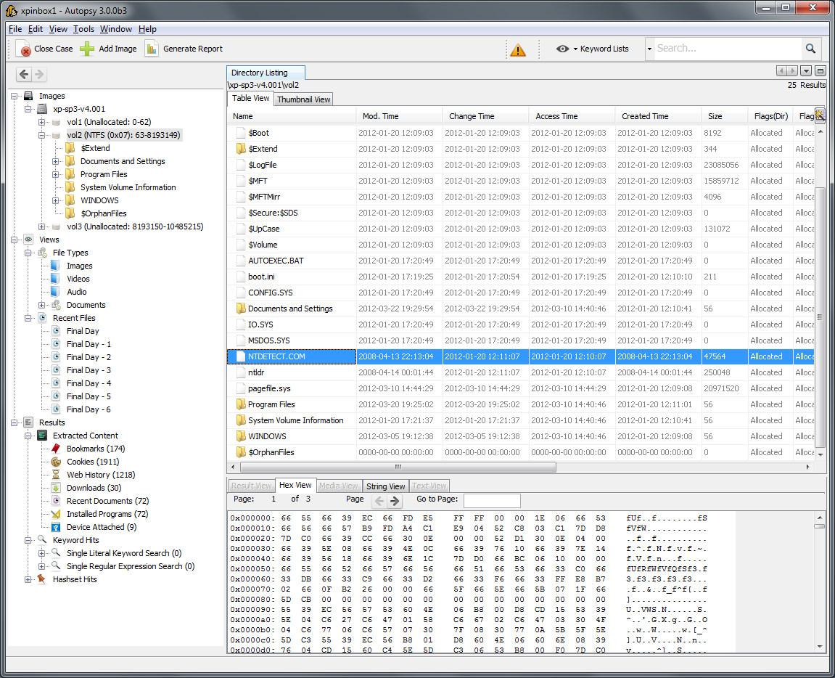
Figure 24: Autopsy Timeline View
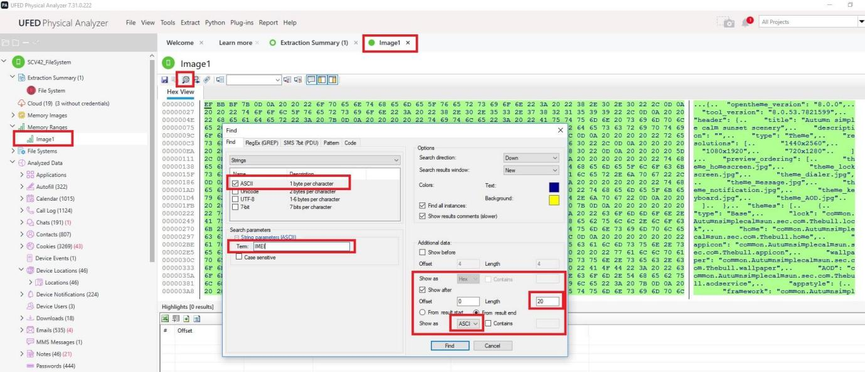
Figure 25: Autopsy Content Viewer
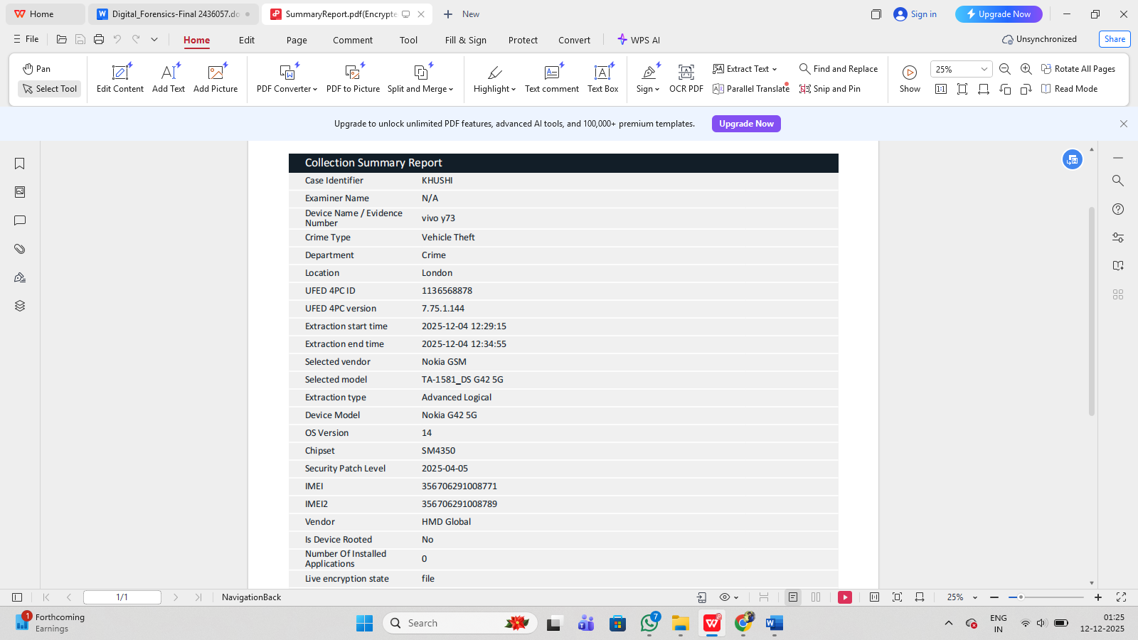
Figure:26 Report

Analysis & Interpretation

Forensic Significance of the Timeline
The timeline of Autopsy and the reconstruction of events provided by Cellebrite will help the investigation to have a multi-layered temporal view. The Autopsy chronology (Counts view) was able to identify high points of action, such as when Emma probably filed the patent file, and when there was significant communication. In Autopsy, when the Details/List view is zoomed into, every event will be placed into a context: file creation, access, or modification, communication events are timestamped and classified (Modified, Accessed, Created, Changed).
This two-level (general perspective and detail by detail) strategy was essential. Considering the fact that Emma had edited the QT-AI-2025.pdf file on her USB (01 Nov 2025, 18:45) this event was visible in the Autopsy details view, which corresponded to the time when the negotiations were going on. Through such correlation, the investigation builds a logical sequence; negotiation --> call --> file preparation --> transfer instructions --> confirmation of receipt.

Forensic Validity of Recovered Data
It is essential to use Cellebrite Database Viewer, and, in particular, its hex representation, to prove that deleted or even hidden records were actually on the machine, and not made up. The hex view displays the unprocessed byte data available in the SQLite database cells that may include timestamps, Base64 strings, or even binary large objects (BLOBs).
The investigator can search using Hex Diving but in this situation, was applied to search and match deleted message contents (such as “Destroy evidence if caught”), searching on particular ASCII words (such as IMEI). The level of analysis achieved by such a degree of analysis removes ambiguity: the message has not just been pulled out of a visible row, but has been reconstructed during the process of its actual extraction and confirmed by its raw hex representation - which makes it far more effective in legal practice.

Role Attribution & Behavioral Inferences
The role assignment in the current investigation is justified by a set of communication patterns, metadata discoveries, file-handling operations, and behavioral evidences extracted out of all devices that were confiscated. A sense of clear hierarchy of intent, responsibility, and operational role between the three suspects can be identified when the elements are correlated using proven forensic tools including those suggested by NIST and SWGDE.
In this conspiracy Emma plays the most important and active part. Being a senior engineer with Quantum Tech, she had valid access to the proprietary patent files, and the forensic evidence proves that she used the privileged access to the files to illegally exfiltrate them. The QT-AI-2025.pdf metadata with author fields and last-modified timestamps makes the connection between this document and Emma and her device and profile clear, as it proves that it was not only the author who accessed the internal system but also created the final exfiltrated variant (Outpost24, n.d.). Her WhatsApp messages with Joe also support her position as an initiator, since she gave her prices, delivery schedules, and clear instructions on how to transfer them (FCT, 2025). Her actions, which are so sophisticated and deliberate, negotiating payment, making the USB drive, etc., emphasize the intent, but not an act of opportunity. The fact that she recovered a deleted command to destroy evidence in case she was caught, which was confirmed in hex-level database access, is particularly incriminating as it shows a conscious sense of guilt and an attempt to cover it up [9]. This conduct is consistent with the known psychological pointers of planned corporate espionage [15].
The role that Joe plays is that of the middle man who helped in almost all the processes involved in the espionage process. The flow of communication and logistics between Emma, the content source, and Norman, the buyer was played by Joe, unlike Emma, who sourced the content, and Norman, who represented the buyer. The arrangement of the frequency, length, and the time of time Joe receivers the call and messages made by the two individuals depicts his central position in the scheme. His WhatsApp chats reveal him haggling and setting dates and arranging an exchange the USB-based type of transfer- which is typical of classic corporate brokerage behavior in previous espionage cases[4]. As well, his Instagram messages with Norman show operational planning, where he does not only relay the instructions of Emma but also promises that he would deliver the files to him. This triangulated communication arrangement depicts Joe as an insider-complicit in a knowingly strategic and forward-looking position on commission or monetary reward, which is typical of facilitator positions in espionage [2].
The calculated buyer and the ultimate beneficiary of the stolen intellectual property is the role of Norman. His engagement can be seen in Instagram DMs, emails confirmation, and records of calls that indicate not only was he interested but also agreed to be paid on the condition of verification an activity that is associated with illegal actions in the IP market, reported in studies in corporate espionage[11]. He was not just receiving information and passively but actively arranging terms, validating the sample submitted on 05 October, and confirming the receipt of the USB-transferred file. This shows appetite and consciousness of the criminality of the transaction.
The actions of all the three suspects combined, the initiation of Emma by Joe and the acquisition of the goods by Norman, constitute a single and fully functioning conspiracy, with digital forensics evidence and models of behavioral inference, applied in the investigation of corporate espionage[7].

Evidence Integrity & Admissibility
Protecting the integrity and admissibility of digital evidence is considered to be one of the most significant elements of any forensic investigation, in particular, the one related to the corporate espionage and intellectual property theft. In this study, special care was taken to ensure that the case was conducted on the basis of industry standards and best practices as outlined by NIST and SWGDE so that all evidence gathered in the case would stand up in court and be accepted as valid and credible.
One of the elements of integrity preservation was the utilization of cryptographic hash verification. The MD5 and SHA-256 hashes were computed immediately after acquisition in every device that was imaged, namely smartphones of Emma, Joe, and Norman, and the USB drive of Emma. These values were checked and compared with the original media in all the cases, the hashes were identical and it was stated that no changes, corruption, or manipulation took place in the course of imaging and analysis. Hashing is also one of the core concepts of digital forensics since it offers mathematical guarantees that the evidence is the same as it used to be[5].
Another fact was the strict observance of the chain-of-custody, a document that records all manipulations with evidence since the time of seizure to the end of analysis. Faraday bags were used to secure all the devices at the time of acquisition in order to avoid their remote intervention which is in line with the best practices in mobile forensics[9]. All the evidence transfers that involved the person who touched it, the time and the circumstances, etc. were closely registered. The documentation level is so detailed that each individual who came in contact with the evidence can be traced to avoid the accusations of contamination or unauthorised alteration.
Standardized and internationally accepted forensic tools, i.e. Cellebrite UFED/Physical Analyzer and Autopsy, also increase admissibility. These tools are highly validated, have widespread applications in law-enforcement and corporate investigations, and have been proven to be reliable in parsing mobile databases, re-creating timelines, and analyzing the file system[3]. The fact that they are accepted in the courts gives more force to the evidence generated.
Reproducibility is also another important dimension of admissibility. Every investigative action such as acquisition processes, extraction tools, database parsing, and timeline rebuilding, and hex-level analysis were all documented. This implies that an independent investigator with the same tools and images would be able to repeat the process and get the same results. This is necessary to achieve transparency and eliminate an investigator bias, which is in line with the principles of digital forensics methodology [13].
Lastly, the analysis showed a cross-event linkage on devices, which is a potent approach that helps prove the evidentiary coherence. The similarity in timestamps on the phone, phone of Joe and the USB drive provided a coherent chronological account of Emma. When more than two independent devices indicate the same time when related events occurred, e.g. call and subsequent WhatsApp instructions, or USB file alterations, the chance of coincidence has been greatly reduced. This adds to the evidences weight by demonstrating interrelated actions and not independent artifacts.
All these together prove that whatever evidence is presented is genuine, untouched, and forensically-acceptable thus passing the test of admissibility in both a criminal and a civil case.

Conclusion:
The inquiry produces a good, logical, and legally sound story: Emma, a senior staff engineer at Quantum Tech, along with Joe and Norman, had agreed to steal and commercialize highly sensitive trade secrets of the company AI-chips (patent QT-AI-2025). The facts indicate that she has stolen the design out of the internal system of her employer and she negotiated with the buyer to sell the design, she used USB to transfer the file, and she ensured that the buyer has received the file. The application of forensic devices (Autopsy and Cellebrite) made it possible to recreate the events accurately and to restore deleted information, as well as define the roles and motives.
It was not an accidental breach of data: the communications, metadata of files and call logs prove the premeditation, organization, and awareness of risks. This finding of the deleted message (Destroy evidence if caught) brings out the sophistication and guilt consciousness of the conspirators.

Recommendations
Based on the findings, the following actions are strongly recommended:
- Legal Prosecution
  - Bring criminal charges against Emma, Joe, and Norman based on applicable criminal law (e.g., stealing trade secrets, corporate spying).
  - Make a case file with forensic photos, metadata, logs of communication, hex-view evidence to prove the prosecution or civil suit.
- Strengthened Security at Quantum Tech
  - Ienable multi-factor authentication (MFA) on any access to sensitive internal repositories.
  - Establish the least-privilege access: restrict access to high-value IP/design documents.
  - Implement Data Loss Prevention (DLP) systems to oversee and prohibit unauthorized file export particularly to USB.
- Improved Forensic Readiness
  - Develop forensic preparedness policy, such as periodic system baseline snapshots, imaging of employee devices (with employee consent), and current logging.
  - Train security and IT personnel should be trained about the forensic procedures to ensure that any occurrences in the future can be easily captured and recorded.
- Ongoing Monitoring & Audit
  - Conduct a complete audit of NexGen Circuits in order to determine whether this was a one-time event or a larger scheme of IP theft.
  - Implement real-time surveillance of sensitive communication (legal and ethical protection), email and messaging between staff with access to valuable IP.
- Policy & Culture Reform
  - Develop a security-aware culture, teaching the employees the legal and ethical consequences of IP theft.
  - Put up effective whistleblower procedures to use internally when reporting suspicious activities.

References:
[1] Belkasoft, “WhatsApp Forensics on Computers,” n.d. Available: https://belkasoft.com/whatsapp_forensics_on_computers. Accessed: Nov. 16, 2025.
[2] Bond Rees, “Corporate Espionage Investigation for a UK-Based Technology Firm,” n.d. Available: https://www.bondrees.com/case-study-corporate-investigations-new-york-and-tokyo/. Accessed: Nov. 16, 2025.
[3] Cellebrite, “How to Prepare an Android Device for Acquisition in Cellebrite UFED,” n.d.a. Available: https://cellebrite.com/en/how-to-prepare-an-android-device-for-acquisition/. Accessed: Nov. 16, 2025.
[4] CurrentWare, “What Is Corporate Espionage? 5+ Shocking Cases,” 2025. Available: https://www.currentware.com/blog/corporate-espyonage-cases/. Accessed: Nov. 16, 2025.
[5] Exterro, “How to run FTK Imager from a flash drive,” n.d. Available: https://www.exterro.com/ftk-product-downloads/how-to-run-ftk-imager-from-a-flash-drive-imager-lite. Accessed: Nov. 16, 2025.
[6] FCT, “The Basics of WhatsApp Forensics: A Beginner's Guide,” 2025. Available: https://forensiccybertech.com/blog/the-basics-of-whatsapp-forensics-a-beginners-guide/. Accessed: Nov. 16, 2025.
[7] Fidelis Security, “Digital Forensic Strategies in White Collar and National Security Defenses,” 2024. Available: https://cybercentaurs.com/blog/digital-forensic-strategies-in-white-collar-and-national-security-defenses/. Accessed: Nov. 16, 2025.
[8] Forensic Science Journal, “Forensic Analysis of WhatsApp: A Review of Techniques,” n.d. Available: https://www.forensicscijournal.com/jfsr/article/view/jfsr-aid1059a. Accessed: Nov. 16, 2025.
[9] Group-IB, “All about WhatsApp forensics analysis,” n.d. Available: https://www.group-ib.com/blog/whatsapp-forensic-artifacts/. Accessed: Nov. 16, 2025.
[10] IRJET, “Computer Forensics And Investigating Corporate Espionage,” 2023. Available: https://www.irjet.net/archives/V10/i6/IRJET-V10I6154.pdf. Accessed: Nov. 16, 2025.
[11] Leppard Law, “Corporate Espionage Investigations Under US Federal Guidelines,” n.d. Available: https://leppardlaw.com/federal/white-collar/corporate-espionage-investigations-under-us-federal-guidelines/. Accessed: Nov. 16, 2025.
[12] Medium, “Forensic: Analysis Flash Disk with FTK Imager & Autopsy,” 2024. Available: https://medium.com/@yogasatriautama/forensic-analysis-flash-disk-with-ftk-imager-autopsy-49b6a2809762. Accessed: Nov. 16, 2025.
[13] NIST, “Digital Evidence Preservation: Considerations for Evidence Handlers,” 2022. Available: https://www.nist.gov/itl/ssd/software-quality-group/computer-forensics-tool-testing-program-cftt/digital-evidence. Accessed: Nov. 16, 2025.
[14] Outpost24, “How to analyze metadata and hide it from hackers,” n.d. Available: https://outpost24.com/blog/metadata-hackers-best-friend/. Accessed: Nov. 16, 2025.
[15] Securonix, “A Case of Corporate Espionage,” 2015. Available: https://www.securonix.com/blog/a-case-of-corporate-espionage/. Accessed: Nov. 16, 2025.
[16] SWGDE, “Best Practices for Digital Evidence Acquisition,” 2025. Available: https://www.nist.gov/standard/3351. Accessed: Nov. 16, 2025.
[17] UpGuard, “What is Corporate Espionage?” 2025. Available: https://www.upguard.com/blog/corporate-espionage. Accessed: Nov. 16, 2025.

Appendix:

Installed Apps List:
com.google.android.wifi.resources.overlay
com.google.android.providers.media.module
com.qti.phone
com.google.android.overlay.modules.permissioncontroller.forframework
com.android.calllogbackup
com.hmdglobal.app.legalinformation
com.android.email.partnerprovider
com.qualcomm.qti.lpa
com.qualcomm.atfwd
com.qualcomm.qti.cne
android.autoinstalls.config.hmdglobal.shadow
com.android.systemui.accessibility.accessibilitymenu
com.google.android.overlay.gmsconfig.comms
com.android.providers.contacts
com.hmdglobal.memorycleaner
com.qualcomm.uimremoteserver
com.qti.pasrservice
com.android.dreams.basic
com.android.companiondevicemanager
com.android.cts.priv.ctsshim
com.google.android.calendar
com.google.android.contacts
com.android.mms.service
com.google.android.cellbroadcastreceiver
com.android.providers.downloads
com.android.bluetoothmidiservice
com.android.credentialmanager
com.google.android.printservice.recommendation
com.google.android.captiveportallogin
com.google.android.networkstack
com.android.keychain
com.google.android.accessibility.switchaccess
com.google.android.overlay.gmsconfig.asi
com.google.android.tag
com.qti.service.colorservice
com.google.android.apps.wellbeing
com.qualcomm.qti.qms.service.connectionsecurity
com.qualcomm.qti.confdialer
com.qualcomm.qti.devicestatisticsservice
com.android.virtualmachine.res
com.android.shell
com.google.android.adservices.api
com.google.android.wifi.dialog
com.android.inputdevices
com.google.android.ondevicepersonalization.services
com.hmdglobal.app.fotaclient
com.google.android.apps.customization.pixel
com.qti.qualcomm.datastatusnotification
com.android.bookmarkprovider
com.hmdglobal.support
com.qti.dpmserviceapp
com.google.android.onetimeinitializer
com.hmdglobal.app.bokeheditor
com.google.android.permissioncontroller
com.google.android.setupwizard.overlay
com.android.sharedstoragebackup
com.android.imsserviceentitlement
com.qualcomm.qti.uimGbaApp
com.android.providers.media
com.android.providers.calendar
com.android.providers.blockednumber
com.google.android.documentsui
com.qualcomm.qti.ims
com.google.android.overlay.modules.documentsui
com.google.android.keep
com.android.proxyhandler
com.google.android.overlay.modules.permissioncontroller
com.android.cellbroadcastreceiver.overlay.common
com.android.managedprovisioning
com.android.emergency
com.google.android.gms.location.history
com.google.android.apps.googleassistant
com.qualcomm.location
com.google.android.gm
com.hmdglobal.app.omacp
com.android.carrierdefaultapp
com.android.backupconfirm
com.google.android.hotspot2.osulogin
com.google.android.deskclock
com.android.carrierconfig.overlay.common
com.android.mtp
com.google.android.gsf
com.android.internal.display.cutout.emulation.double
com.android.theme.font.notoserifsource
com.qualcomm.qti.remoteSimlockAuth
com.qualcomm.qtil.aptxui
com.google.android.health.connect.backuprestore
com.android.server.telecom.overlay.common
com.qti.ltebc
com.android.systemui
com.android.wallpapercropper
com.google.android.wifi.resources.overlay.common
com.google.android.dialer
com.google.android.overlay.gmsconfig.geotz
com.qualcomm.qti.uceShimService
com.android.internal.systemui.navbar.gestural
com.android.role.notes.enabled
com.netflix.mediaclient
com.qti.xdivert
com.google.mainline.adservices
com.google.android.calculator
com.android.settings.intelligence
com.qualcomm.timeservice
com.android.hotwordenrollment.okgoogle
com.hmdglobal.app.setupwizardext
com.qti.confuridialer
com.google.android.overlay.gmsconfig.personalsafety
com.qualcomm.wfd.service
com.cnce.sarservice
com.google.android.apps.wallpaper
com.google.android.federatedcompute
com.google.android.webview
com.qualcomm.qti.lsarservice
com.google.android.sdksandbox
com.hmdglobal.app.activation
com.google.android.cellbroadcast.overlay
com.android.wallpaperbackup
com.google.android.cellbroadcastservice
com.google.android.networkstack.overlay
com.android.internal.systemui.navbar.threebutton
com.android.egg
com.android.localtransport
android
com.qualcomm.qtil.aptxals
com.android.rkpdapp
com.google.android.overlay.modules.modulemetadata.forframework
com.android.hotwordenrollment.xgoogle
com.qualcomm.qti.dynamicddsservice
com.google.android.packageinstaller
com.android.se
com.hmdglobal.app.settings.provider
com.android.pacprocessor
android.cutout.overlay
com.google.android.safetycenter.resources
com.google.android.overlay.gmsconfig.searchselector
com.google.android.apps.youtube.music
com.android.stk
com.hmdglobal.app.activation.overlay
com.android.internal.display.cutout.emulation.hole
com.android.settings
com.android.bips
com.qualcomm.qti.telephonyservice
com.google.android.partnersetup
com.android.internal.systemui.navbar.gestural_narrow_back
com.android.internal.display.cutout.emulation.tall
com.google.android.networkstack.tethering
com.hmdglobal.app.camera
com.google.android.projection.gearhead
com.android.carrierconfig
com.android.internal.systemui.navbar.gestural_wide_back
com.qualcomm.qti.simcontacts
com.google.android.apps.carrier.carrierwifi
com.google.android.videos
com.google.android.ext.shared
com.google.android.feedback
org.codeaurora.ims
com.android.chrome
com.qualcomm.qcrilmsgtunnel
android.overlay.common
com.google.android.apps.maps
com.android.devicelockcontroller
com.google.android.as
com.android.musicfx
com.android.partnerbrowsercustomizations.example
com.android.internal.systemui.navbar.transparent
com.google.android.inputmethod.latin
com.android.smspush
com.google.android.marvin.talkback
com.google.android.overlay.gmsconfig.searchlauncherqs
vendor.qti.hardware.cacert.server
com.google.android.uwb.resources
com.android.providers.downloads.ui
com.google.android.wifi.resources
com.android.ons
com.google.android.healthconnect.controller
com.android.intentresolver
com.google.android.apps.docs
com.hmdglobal.app.customizationclient
com.android.certinstaller
com.google.android.setupwizard
com.google.android.apps.safetyhub
com.qualcomm.uimremoteclient
com.google.android.googlequicksearchbox.overlay
com.google.android.apps.restore
com.qti.snapdragon.qdcm_ff
com.qualcomm.atfwd2
com.android.simappdialog
com.android.providers.telephony
com.android.wallpaper.livepicker
com.android.systemui.overlay.common
com.qualcomm.qti.callfeaturessetting
com.qualcomm.qti.poweroffalarm
com.android.internal.display.cutout.emulation.waterfall
com.android.providers.settings
vendor.qti.iwlan
com.qualcomm.qtil.aptxalsOverlay
com.android.protips
com.android.phone
com.google.android.overlay.modules.ext.services
com.android.internal.systemui.navbar.gestural_extra_wide_back
com.android.traceur
com.google.android.as.oss
com.google.android.as.overlay
com.google.android.apps.messaging
com.qualcomm.qti.services.systemhelper
com.android.location.fused
com.android.vpndialogs
com.android.cellbroadcastreceiver
com.android.systemui.plugin.globalactions.wallet
com.google.android.overlay.gmsconfig.photos
com.google.android.tts
com.hmdglobal.app.fmradio
com.google.android.googlequicksearchbox
com.google.android.modulemetadata
com.android.settings.overlay.common
com.android.wifi.resources.overlay.common
com.qualcomm.qtil.btdsda
com.android.phone.overlay.common
com.android.htmlviewer
com.android.vending
com.google.android.ext.services
com.google.android.configupdater
com.google.android.overlay.modules.captiveportallogin.forframework
android.qvaoverlay.common
android.overlay.target
com.google.android.apps.turbo
com.android.apppredictionservice
com.google.android.gms.supervision
com.google.android.overlay.gmsconfig.gsa
com.android.wallpaperpicker
com.android.providers.userdictionary
com.hmdglobal.app.myphonehelper
com.android.launcher3
com.google.android.overlay.gmsconfig.common
com.android.cts.ctsshim
com.google.android.euicc.overlay
com.google.android.apps.photos
com.android.bluetooth
com.google.android.wfcactivation
com.qualcomm.qti.workloadclassifier
com.android.internal.display.cutout.emulation.corner
com.google.android.gms
com.android.storagemanager
com.hmd.face.service
com.android.printspooler
com.google.android.apps.setupwizard.searchselector
com.qualcomm.qti.uim
com.android.providers.partnerbookmarks
com.android.soundpicker
com.amazon.appmanager
com.google.mainline.telemetry
com.google.ambient.streaming
com.qualcomm.qti.qms.service.trustzoneaccess
com.android.dynsystem
com.hmdglobal.android.gmsintegration
com.google.android.connectivity.resources
com.google.android.youtube
com.android.externalstorage
vendor.qti.imsdatachannel
com.android.server.telecom
com.qualcomm.qtil.aptxacu

