
Skills for the Workplace
Module Assignment Submission
Student Name: | Sara Griffiths
Student Number: | 1302902
Module No: | BMSK4002
Module Title: | Effective Team Working and Communication  Part 2

Statement of Confirmation of Authenticity
By the act of making this submission, the student declares that this is the work of the student named above. The work has not, in whole or in part, been knowingly presented elsewhere for assessment, or where assessment has been built on a previous assessment, this has been identified. Where materials have been used from other sources it has been properly acknowledged. If this statement is untrue, the student acknowledges that an assessment offence has been committed.
Attention is drawn to the plagiarism and unfair practice policies of both the University and of ILM.

Table of Contents
Part 2 Communication 3
1.0 3
Communication Cycle 3
2.0 5
Assessing Own Communication Skills 5
Gap Analysis 6
PDP 6
References 7
Appendix A 7
Skills You Need Communication Quiz 7
Mind Tools Communication Quiz 9

Part 2 Communication

1.0

Communication Cycle

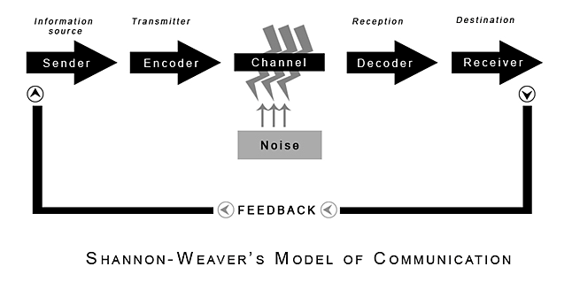
(Shannon and Weaver, 1940

2.0

Assessing Own Communication Skills

It is important to give the correct information that you are sending to the receiver. Communication can be mistaken or misunderstood if not understood correctly received properly. The ability to speak or explain to a co-worker or training a new team member is vitally important. The above cycle is a six-step process that processes your message. It is important for the message to be clear, precise, and easy to comprehend.
The table above by (Shannon and Weaver) 1940 is an easy table to ensure the message you are trying to send is that you do not forget anything. It is important that you send the exact message you send first time correctly to the receiver. By using this cycle, it elaborates the feedback as to improve on your communication for future times of needing to send the message, presentation or public speaking. This table is valuable for future self-development in communicating correctly.
Managers can sometimes communicate in a negative way by telling what to do without leaving an opening for the employee to able to ask questions if they are not totally confident in what they have been asked to do. This has a negative effect to the employee as they want to complete the task to their best ability but cannot complete the task as they fear they will look foolish to approach the manager to question further because the body language and tone of voice by the manager isn’t approachable. This makes the employee anxious when meeting a manager who doesn’t understand emotional intelligence. The manager can be giving an aggressive or body language that they are powerful or too important to help explain menial tasks.
Poor communication in the workplace is a knock-on effect. It doesn’t produce a good workplace. Fearing higher ackee in the workplace is common. Emails can also be ambiguous unless there is enough information that is accurately written and in the correct context. An email can come across angry or not enough meat on the bone to understand it in the correct manner. A simple thank you or ending the email with ‘kind regards can change the interpretation of the whole email.
Knowing how you have communicated is important that the receiver has received it in the way you wanted to be interpreted. A simple smile, nod or a sigh are all body languages you can sense how you have communicated. The receiver needs to be able to communicate back as not to have cross wires in one way or another.
Communication and evaluation are critical. Whilst giving a presentation it was assessed and evaluated where it was noted that the presenter could have been clearer when speaking, that the voice sounded angry or too loud. It is important to sound interesting whilst speaking and changing a tone of voice can keep the listeners interested. Speaking calmly and softly and giving not giving open ended questions help engage with the receiver. Communication must be a two-way system. Asking prompting questions is a way of communicating with another to ask if something isn’t understood to give clarification. If giving negative feed back it is also important that it is given in a respectful way and respect other peoples feelings.
In organisations they will give the employee and the manager a time to discuss and communicate 1-2-1 in their one to one meeting. This is to explain what the employee has been achieving, health & safety, negative impacts, training and what they would like to over come to make the job thrive or grow possibly more. During the employees one to one it can be unpleasant time if the manager ignores them whilst reading emails for ten minutes and not engaging in eye contact. This can make an employee very restless and lack confidence. Sitting in a room in silence whilst their manager carries on their tasks automatically gives them a feeling of inferiority. During the time discussing through all their tick list of training etc it can be a time for the employee to show how much time and experience they put into practice to their job. Unless both employee and the manager communicate correctly then neither of them are giving themselves justice. An organisation will not have a good reputation if managers and employees have a good understand of one another and can discuss what needs to be done to one another.
After completing the quiz, it was felt that in order to communicate better the author would need to learn how to communicate better in groups. Having better listening skills and communication skills would help these future settings. In group synarios it can be overwhelming as almost always when entering a room with a group of people there is a cluster of people together who take the centre stage in the room with the leader who is overly confident with too much to say. Automatically a person who is feeling out of their comfort zone will take a back step in the situation by silently observing. Whilst being spoken to will feel that they lack confidence, or they will say something that will sound stupid. The way to over come this is to speak clearly, breath and to participate in community gatherings as to gain confidence.
When someone is speaking sometimes the author feels they over talk the person. This can be really irritating for the person who is trying to express what they are saying. Listening is equally important in communication. There are different types of listening, active listening, which is eye contact, doesn’t talk over and will ask questions to engage. The detached listener which the author explained previously in the essay about the manager who didn’t give eye contact and was bored in listening to their employee in the one to one.

Many examples in team meetings we have one member of the group who is easily identified as a detached listener who lacks eye contact and is bored. There are some students who fakes attention who’s a passive listener and is laid back in class. We all in different ways have different ways of communicating, listening and learning.
The author feels that after many quizzes undertaken that she has very good emotional intelligence and has an easy way of identifying people’s moods, body language and has great empathy. Understands the needs of areas to improve such as confidence building, public speaking and giving presentations. These can be overcome by having public speaking lessons, practicing reading in front of other family members or friends. Having constructive feed back is a way of learning to develop new skills to gain more confidence and the ability to do it once do it right.
One section of the quiz says that the author doesn’t have good listening skills which was partly true but would argue it as she is a silent learner and that is her learning style by which she listens and reflects.
Clarity and good communication is saying something that is just enough. Having a happy medium of saying not too much or too little in as few words as possible. Speaking clearly and directly, this is by means of email, phone, person to person. Talking too much will simply bore the listener.
Have you ever walked into a room where you have been invited to complete training, a presentation, a classroom for study? The one thing that will make you want to stay is simply the presenter or lecturer will be friendly. Having a friendly demeanour is a good start to someone wanting to engage and communicate with you. It can make everyone at ease. A friendly tone, a simple smile, a personal question and it will encourage co workers to engage in open and honest communication with you. It is always important to be polite in all your workplace communications. Written and face-to-face communication can be personalized when you can on times. An email to co- workers can break the formality by simply asking ‘How are you? Or ‘Hope you have a nice time on your annual leave’. It can make the recipient feel more appreciated.

Gap Analysis

Objective | Current Position | Deficiency | Action
What do I want to do? | What can I already do? | What am I lacking? | How do I fix this?
Presentations | Good at reading | Confidence in speaking Infront of others | Public speaking lessons
Chair meetings | Can read through agenda | Read to fast and hesitates | Practice aloud to myself and Infront of friends. Take advise from others who have experience.
Public Speaking | Passionate about my job. Understand thoroughly the procedure of the job and what can be achieved. | Nervousness speaking in front of others in large groups. | Confidence building course. Breathing exercises.  Learn and development course on public speaking.

PDP

Objectives | Tasks | Success Criteria | Time Frame | Resources
List your Goals | What do you need to do to achieve these goals? | How will you identify your success? | When do they need to be done by? | Who or what do you need to help you?
Presentations | Learn how to take notes, Microsoft power points and speak confidently | Complete assignment ILM4 presentation communications teams | May 18th 2020 | Tutor  Notes  Listen to iPod given by my tutor  Read articles explaining how to give a good presentation
Public Speaking | Confidence  Good tone of voice  Engaging | Feed back and evaluation  Questionnaires | December 2020 | Elocution lessons  Confidence building coach  Online videos  Reading books on public speaking
Chair Meetings | Learn how to read an agenda  Reading with confidence  Knowing when to stop someone from over talking someone in a meeting firmly but politely. | Confidently accepting positions in committees that offer me to become their chair. | May 2021 | Learn and listen how other Chair of the committee reads the agenda. Ask the chair to explain how to chair the meeting.  Google articles how to chair meetings.  Watch on U tube how to chair a meeting.

References

Blenkinsop, P. (2010) The Communication Cycle. [online] Available at: http://manyana-education.blogspot.com/2010/10/communication-cycle.html Accessed: 17.05.19
MindTools (2019) How good are your communication skills? [online] Available at: https://www.mindtools.com/pages/article/newCS_99.htm Accessed: 17.05.19
Shannon, C. and Weaver, W. (1949) The Mathematical Theory of Communication. Urbana: University of Illinois Press.
Skills You Need (2019) Interpersonal Skills Self-Assessment. [online] Available at: https://www.skillsyouneed.com/ls/index.php/343479 Accessed: 17.05.19

Appendix A

Skills You Need Communication Quiz
Skills You Need (2019) Interpersonal Skills Self-Assessment. [online] Available at: https://www.skillsyouneed.com/ls/index.php/343479 Accessed: 17.05.19

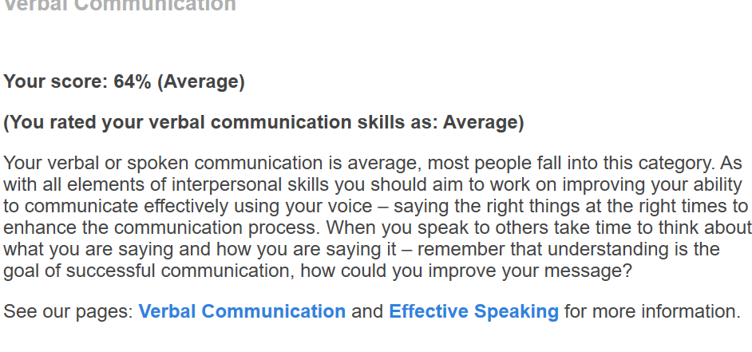
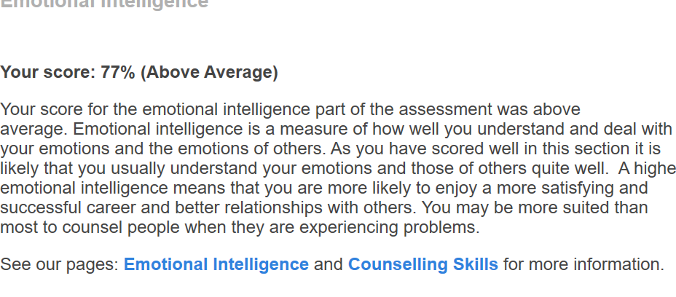
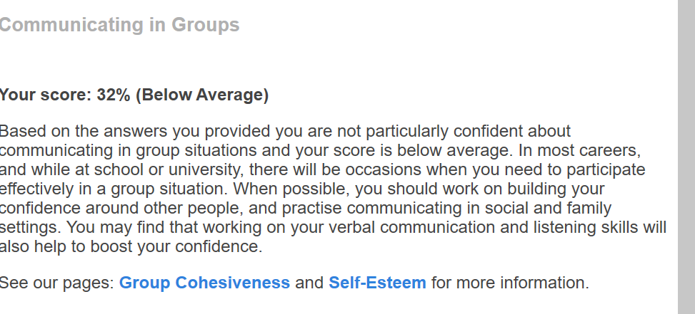

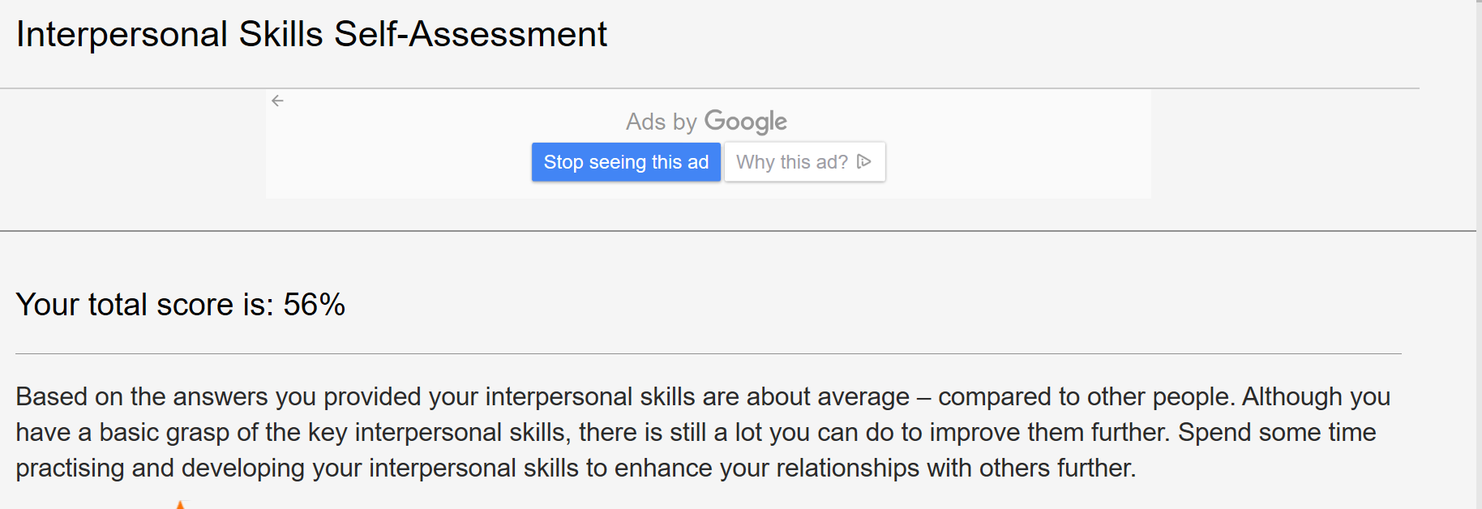
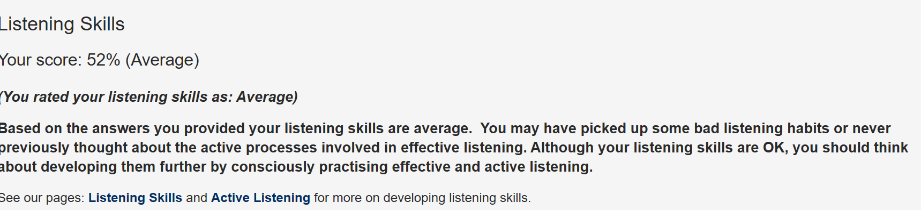

Mind Tools Communication Quiz

https://www.mindtools.com/pages/article/newCS_99.htm

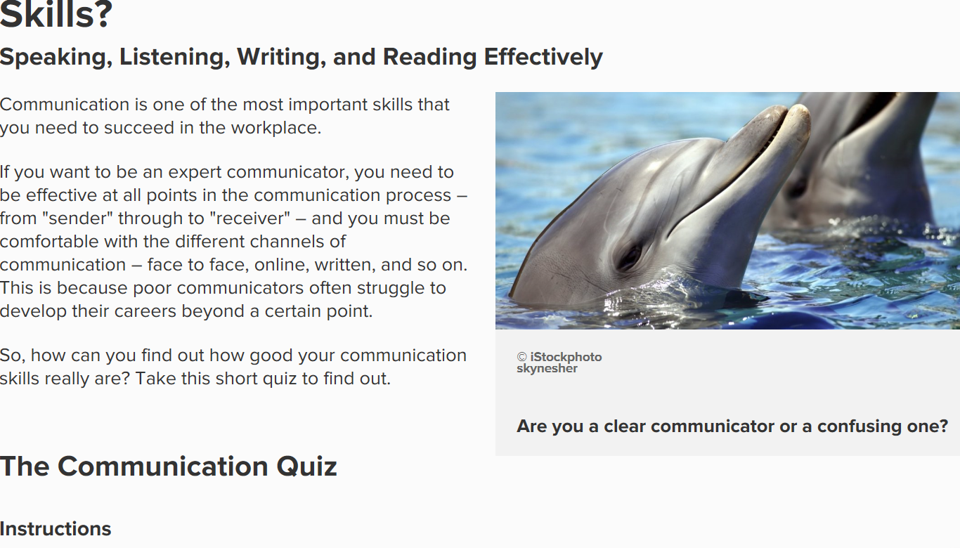

BMSK4002 Part 1: Presentation Plan and Evaluation

Table of Contents
BMSK4002 Part 1: Presentation Plan and Evaluation 1
Name of Presenter 1
Aim: 1
Objectives: 1
Presentation Content 1
Evaluation of presentation and feedback: 2
Appendix A 3
Presentation Evaluation Sheet 3
Evaluation by viewers 4

Name of Presenter

Student Name: Sara Griffiths - Effective Team Working & Communication Part 1

Aim: Introduction, what makes an effective team? key theorists, Belbin and Tuckman, team roles, categorised into 3 groups, Tuckman model, Geese, Coronavirus 2020 working as teams NHS, Pobl working as teams.

Objectives:

- Introduce Dr Meredith Belbin and his team roles.
- Identify and explain how they contribute to today’s presentation and the importance of team working, the strengths and weaknesses.
- Brief Introduction to Tuckman’s Team Development
- Brief Overview of High Performing Team
- Comparisons of teams NHS & Pobl

Presentation Content

Slide | Content
1 | Introduction
2 | Aims & Objectives
3 | What makes an effective team work?
4 | Belbin
5 | Slide 5-7 Roles -For reference
6 | Slide 18 -Tuckman’s Team Development – High Performing Teams
7 | Slide 19-21 Team working with Geese
8 | Slide 22- 24 – NHS Covid 19
9 | Slide 25 – Pobl organisation working in teams
10 | Slide  Questions?
11 | References
12 | Conclusion and the future of teams

Evaluation of presentation and feedback:

Feedback from the audience was analysed and it would suggest it was a colourful interesting presentation with lots of different fonts. Many slides and was spoken confidently.

Areas to improve are that I could speak slightly slower with a softer tone and change occasionally the range of tones to keep it of interest rather than monotone.

The evaluation sheet that was used to evaluate presentation skills and define the areas that need improving is attached at Appendix A.

