UWTSD
Adidas – Europe’s leading manufacturer of Sportswear
26th November 2018
Amy Williams – P151979
Strategic Management and Sustainability - M3X9111

Contents
Table of figures 2
1. Executive Summary 3
2. Introduction 4
2.1. Background of Adidas 4
2.2 Definitions of major concepts 5
2.2.1 Strategy 5
2.2.2 Business level strategy 6
2.2.3 Competitive advantage 6
2.2.4 Porter’s Generic Strategies 6
3. Main Body 10
3.1 Implementation of the strategy 11
3.1.1 Brand Differentiation 11
3.1.2 Product Differentiation 12
3.1.3 Service Differentiation 13
3.2 Advantages & Disadvantages of the strategy 13
3.2.1 Advantages 13
3.2.1.1 Customer Loyalty 14
3.2.1.2 Ability to Charge a premium price 14
3.2.1.3 Reduces threat of competitors/substitution 14
Disadvatages 3.2.2 14
3.2.2.1 Imitation 14
3.2.2.2 Change in customer needs 14
4. Conclusion 14
4.1 Recommendations 15
5. References 16

Table of figures
Figure 1- Porters generic strategies model 5

1. Executive Summary

The purpose of this report is to analyse Porters generic strategies and come to a conclusion as to which strategy Adidas implements. The report will then analyse this strategy and look at how Adidas is actually implementing it. The report will provide advantages and disadvantages of the strategy itself and then provide recommendations on how an organisation could overcome these disadvantages.
Adidas was founded by Adi Dassler who was a German cobbler. His dream was to supply athletes with high quality equipment; he started his journey with his brother in 1924 where they ran a small shoe making business. The brothers fell out resulting in Adi Dassler creating Adidas and his brother creating Adidas’ rival Puma. Adidas journey truly began in 1949.
Porter (1980) has developed generic strategies which organisations can implement in order to achieve competitive advantage.
This report analysed all of Porters generic strategies and then found that Adidas use the differentiation strategy in order to compete within the industry. The report found there were three main advantages of this strategy which were increased customer loyalty; ability to charge a higher price and less threat of competition. The report did find three main disadvantages of the strategy which was imitation; change in customer needs and higher costs.
This report has made three recommendations to overcome these disadvantages which to summarise are firstly to never underestimate competition and to stay ahead. The second is to stay up to date with technology and allow different channels for consumers to communicate with the company. The final recommendation is to buy materials in bulk to cut production costs.

2. Introduction

The main aim of this report is to establish and critically analyse the competitive strategy that Adidas use in order to develop their current position. The report will provide examples of actions Adidas have taken to accomplish this strategy. The analysis will provide advantages and limitations of the strategy. Finally the report will make suitable recommendations based on its findings.

2.1. Background of Adidas

Adidas was founded by Adi Dassler who was a German cobbler. His dream was to supply athletes with high quality equipment; he started his journey with his brother in 1924 where they ran a small shoe making business. The brothers fell out resulting in Adi Dassler creating Adidas and his brother creating Adidas’ rival Puma. The true milestone for Adidas occurred in August 1949:

‘Adi Dassler started over again at the age of 49, registered the Adi Dassler Adidas Sportschuhfabrik and set to work with 47 employees in the small town of Herzogenaurach. On the same day, he registered a shoe that included the registration of the soon-to-become-famous Adidas 3-Stripes’’ (Adidas, 2018, N.P).

Different to other brands Adidas aimed to create products from advice and feedback from athletes. During the 1954 world cup the German team, who won the cup, modelled lightweight Adidas boots which were equipped with studs. The boots went viral, further pushing Adidas out from the crowd.

“Adi Dassler’s secret to success had an additional personal ingredient: he met with athletes, listened carefully to what they said and constantly observed what can be improved or even invented to support their needs’’ (Adidas, 2018, N.P).

Adidas flourished as a business throughout the 1960s and had worldwide success. Unfortunately during 1978 Adi Dassler passed away. The company was first run by Adi Dasslers wife and then passed on to the son until he also passed away. After this the company would not be run by a family member, a first for Adidas. ‘Under the new leadership, Adidas fell into an existential crisis. The market for sport shoes had become saturated and competitors had grown stronger’ (Adidassler.org, 2018, N.P). Since this Adidas has gone back to its routes and core beliefs and want to resume Adi Daslers legacy.

Today, Adidas state they are ‘‘on a clear mission, we want to be the best sports company in the world’’ (Adidas, 2018, N.P). Adidas also state ‘‘Creating the New’ is not only the attitude that leads us into the future, it is also the name of our strategic business plan until the year 2020 to accomplish our mission’’ (Adidas, 2018,N.P). In 2017 Adidas had around 57,000 employees. Adidas are global and recently ‘‘Arsenal have announced a new £300 million kit deal with German sportswear giant Adidas which will commence at the beginning of the 2018/19 season’’ (The Independent, 2018, N.P)

2.2 Definitions of major concepts

2.2.1 Strategy

There are lots of definitions of strategy, mostly in agreement with one another, however, for the purpose of this report, the following working definition will be utilised. Strategy is the overall direction a business plans to take over an extended period of time in order to meet its aims. It can also be referred to as being able to meet both customer and organisations requirements in order to be successful within a competitive environment (Johnson, Scholes and Whitington, 2018).

2.2.2 Business level strategy

Business level strategy is different in that it is specified to how particular organisations should compete within their target segments (Johnson, Whittington and Scholes, 2011).

2.2.3 Competitive advantage

Competitive advantage is where an organisation utilises its resources to gain an advantage over competitors within the same industry (Christensen and Fahey, 1984).

2.2.4 Porter’s Generic Strategies

Porter (1985) defines there are two fundamental types of competitive advantage the first being cost leadership and the second differentiation. With cost leadership an organisation will try to decrease their costs lower than other organisations in the target segment in order to gain an advantage. Differentiation strategy is where the organisation creates unique products that stand out from the crowd. ‘Competitive advantage grows fundamentally out of value a firm is able to create for its buyers that exceeds the firm's cost of creating it’ (Porter, 1985, p.3).

This report will be applying Porters generic strategies model. Michael Porter was previously a professor at Harvard Business School and founded Harvard’s institute for strategy and competitiveness. Porter is seen as a main influential figure when it comes to strategic management (Huggins and Izushi, 2012).

1980s Professor Michael Porter argued there are only four fundamental strategies which are cost leadership; differentiation; cost focus and differentiation focus.

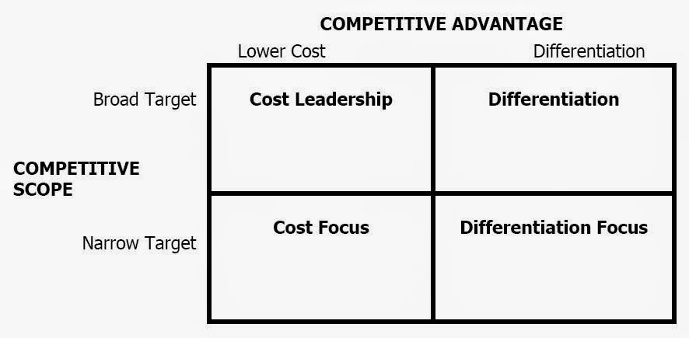
Figure 1- Porter’s generic strategies model – Source: Porter (1985)

Porter states it is vital that companies understand their position within their industry. The position of the company controls whether their profit is above or below the average. Organisations in an attractive industry can possibly not attain above average profits if they select a poor competitive position. It is also possible for organisations with a brilliant competitive position to not have above average profits due to being in an unattractive industry (Porter, 1985).

Porter’s model can be applied by organisations to plan their way to competitive advantage, each one of the generic strategies is a different route to competitive advantage (Porter, 1985). Porter states there are five competitive forces which challenge a company during its route to competitive advantage, these are; threat of a new entry; buyer power; threat of substitution; supplier power and competitive rivalry. ‘In coping with the five competitive forces, there are three potentially successful generic strategic approaches to out performing other firms in the industry these are overall cost leadership; differentiation and focus’ (Porter, 1980).
The first strategy this report will cover is cost leadership, this strategy was most popular in the 1970s. With cost leadership it is essential the organisation has cost-efficient facilities; drive their costs as low as possible and closely monitor all overheads. Resulting in areas of the organisation such as sales, advertising and more having to cut prices (Porter, 1980). For this strategy to be successful a manager must concentrate on cost control, low cost compared to the other companies in the industry is key to success but it is important while doing this to maintain a high level of service, quality and delivery. ’A low-cost position defends the firm against powerful buyers because buyers can exert power only to drive down prices to the next most efficient competitor’ (Porter, 1980). The main advantage with this strategy is that the company can still price products at a competitive rate but due to having lower costs compared to its rivalry it will make more profit than the rivalry. The high margins can then be reinvested in to the company on such things as new equipment which in return will help them maintain cost leadership.

The second strategy to cover is differentiation, aim of this strategy is for the company to produce products that are different and seen as unique compared to other products offered in the industry. ‘Differentiation, if achieved, is a viable strategy for earning above-average returns in an industry because it creates a defensible position for coping with the five competitive forces, albeit in a different way than cost leadership’ (Porter, 1980). The advantage with this strategy is that it creates customer loyalty due to the unique products that are not offered elsewhere and because of this customers are willing to pay higher prices which results in higher profits.

The third strategy to cover is focus, which contains two parts. This strategy is different from the above because it makes choices based on a narrow scope within the particular industry. The aim with this strategy is to select and focus on smaller groups within the target industry and tailor the strategy to best serve them. The segments targeted need to be customers with unique needs or the company needs to provide production and delivery which is different and more appealing to the target group. The main aim of this strategy is to achieve competitive advantage within smaller segments rather than a competitive advantage overall in the industry.
‘The focus strategy has two variants. In cost focus a firm seeks a cost advantage in its target segment, while in differentiation focus a firm seeks differentiation in its target segment. Both variants of the focus strategy rest on differences between a focusers target segment and other segments in the industry’ (Porter, 1985, p.15).

Companies can also unintentionally become ‘stuck in the middle’ (Porter, 1985). A company can become stuck in the middle by not being successful in any of the above strategies. The companies that end up in this scenario are often bringing in below average profits and need to make a big strategic decision in order to change it and become more successful within the industry.

Porter’s theory has been questioned, for example, Knights (1992) conducted research within the financial sector and found the model difficult to apply due to the fact the firms operations were not calculable never mind calculating their competitors. Pitelis and Taylor (1996) state it is becoming clear that value for money is the way forward to success and that porters generic strategies are no longer needed to help achieve competitive advantage.

McGrath (2013) wrote a book titled ‘The end of competitive advantage’ within the book she argues that ‘competitive advantage should be transient rather than sustainable’. Within the book she also introduces the term of creative economy stating that organisations in this modern day are much better at realising what customers want and need, resulting in them designing better experiences without the use of generic strategies.

Denning (2010) agrees with McGrath and disagrees with sustainable competitiveness believing it is ineffective. ‘It is a bit like surfing a wave, where companies look at what happened, figure out how to do it better next time and move on’ (Denning, 2010). Denning believes organisations learn from their mistakes and this is more effective than following one of the generic strategies.

Klein (2001) agrees with Knights (1992) and also mentions the model is extremely difficult to follow within the financial sector. Klein dedicated an article to critiquing competitive advantage mentioning that competitive advantage is actually under-defined. Klein believes firms are successful because they have competitive advantage which in his opinion can be defined simply as a quality that results in success.

Although the model has critiques it is still seen as a fundamental piece of work which has helped develop market-based opportunities and will be applied in this report.

3. Main Body

From the strategy plan Adidas have provided on their website it is clear to see Adidas are following differentiation focus. Adidas state that they concentrate on three main aspects to be successful. The first aspect is to offer fast delivery; the second to deliver globally and third to provide unique products.
‘We know that, in order to be successful, we need to get closer to our consumers than ever before. To achieve that, our plan is based on three strategic choices: Speed, Cities and Open Source’ (Adidas, 2018, N.P).

Porter (1980) defines differentiation focus as being a strategy that targets and focuses on a particular group and then tailors the strategy to best suit them. Porter also mentions the customers within the particular group need to have unique needs or the organisation needs to have delivery or production that is different to others within the industry.

Differentiation focus is based on the product features. The organisation needs to produce a product or service that customers want and need; it needs to be unique and include enhanced features. This strategy hopes to develop customers who are not price conscious and are willing to pay. Due to the customer wanting the unique product and not watching price this will relieve the competitive and cost pressure for the organisation (Thomas, 2006).

3.1 Implementation of the strategy

3.1.1 Brand Differentiation

Bennett (1988, p. 18) definition of brand is ‘A brand is a name, term, design, symbol or any other feature that identifies one seller’s goods or service as distinct from those of other sellers’. Adidas as a brand target sports lovers and state that since the start their aim was to enhance athlete’s performance and that will never change. They are different from other brands due to focusing on creating their products around enhancing athlete’s performance and their logo is unique and well known. The distinctive 3 stripes are on all of Adidas products.
‘The Adidas brand’s mission is to be the best sports brand in the world, by designing, building and selling the best sports products in the world, with the best service and experience’(Adidas, 2018).

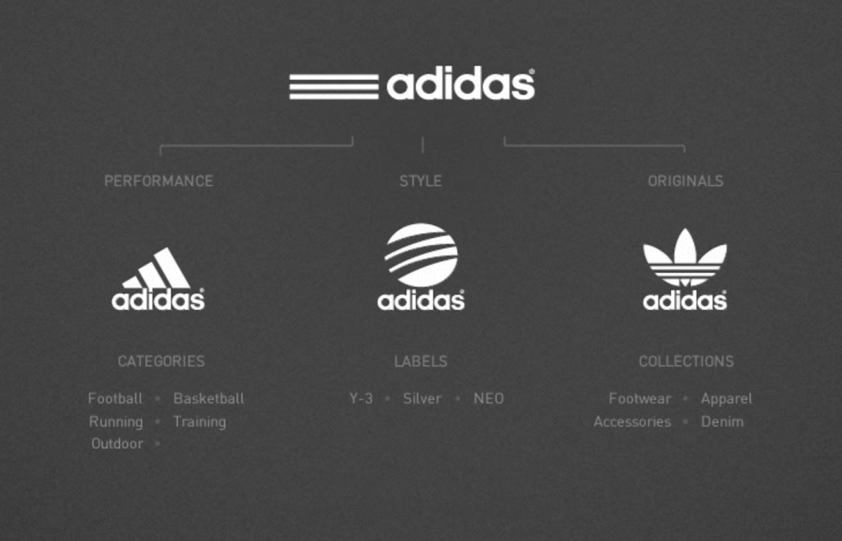
Figure 2- Adidas Branding - Source - Adidas (2018)
Adidas have three different branding logos, all of which include the distinctive three stripes. Adidas logo labelled ‘performance’ in figure 2 is the branding used for the athletic clothing which is aimed at sports enthusiasts. Adidas have branched out and started to market towards consumers who wear sports clothes for fashion rather than competing. The logo used for these products is the logo labelled originals in figure 2.
‘In 2001, Adidas introduced Originals – a lifestyle brand marked by the iconic Trefoil logo that draws inspiration from Adidas’ rich archives and legacy. Combining contemporary youth culture with the kind of creativity and courage found on courts and in sporting arenas’ (Adidas, 2018, NP).
There has been a sharp rise in recent years of sportswear being worn for fashion. Alexander Wang a famous New York designer even designed a collection of sportswear in collaboration with Adidas which was modelled in New York fashion week (Armstrong, 2016, NP).
Active wear is being labelled the fastest growing sector within women’s fashion retail (Rogers et al., 2016). Adidas used this to their advantage and to increase their brand reputation and market their new women’s apparel website, Adidas launched an iconic women’s brand operation which ended up being successful in 2009 (Skibetti, 2009). The aim of the me, myself campaign was to empower and inspire women around the world and Adidas got famous women athletes involved. By Adidas doing campaigns such as this they market themselves and gain respect from consumers.

Adidas use social media daily and constantly drive their brand using the top athletes in the world. These athletes have a fan following who idolise and look up to all that they do, including what they wear. This then creates a high brand reputation which makes customers want to wear the clothing. Adidas use celebrities such as David Beckham who is arguably one of the most famous football stars, Adidas have even brought out a collection inspired by David Beckham. Academics have found that by using celebrities to advertise particular products that it positively impacts both the revenue of the organisation and the overall branding (Amos, Holmes, & Strutton, 2008).

3.1.2 Product Differentiation

Product differentiation is a strategy where organisations create an advantage over competitors by providing special or unique products which then get customers to accept the higher prices they charge (Swink and Harvey, 1998).

Adidas have created fun, fashion forward and high quality clothes which are all differentiated with the three stripes making all their clothing unique. Adidas also offer extras such as being able to customise some of their clothing, allowing people to personalise the product and put initials on for example. This allows customers to feel like their clothing is personal and unique within a mass brand. Hankinson (2012) states how important it is for a brand to develop uniqueness not only for the brand itself but also the products they sell, thus will create a higher custom and revenue.

Adidas boast a long history with sport and state their clothing is there to help athlete’s improve performance and that they are constantly looking for new ways to enhance athlete’s performance (Adidas, 2018). This is made stronger by all Adidas clothing being worn by top athletes around the world in the biggest events. This makes Adidas clothing not just ordinary but an athlete must have if they want to look the part. For example Adidas created ‘ForMotion’ clothing which contains several fabrics and is designed to enhance athletes movements in specific sports. The clothing transports heat and moisture away from the body and provides ventilation, while enhancing muscle movements. This was first modelled by top class tennis player Alicia Molik in the Hopman cup (Hanlon, 2004). Using celebrities in advertisement is seen to affect the buyer’s decision process. It most often encourages them to purchase due to consumers feeling it brings them closer to the celebrity (Brandchannel, 2006).

‘Right at that border of sport and creativity we constantly strive to come up with the next innovation and original product to make athletes better’ (Adidas, 2018).

Adidas aim to be a unique sort after brand that tailors themselves to their customer’s wants and needs and offer high quality and high service for that extra money. This creates loyalty to the company due to customers not finding the same clothes elsewhere and being treated with high quality service that they prefer over lower price. Adidas do not provide cheap affordable clothing that offers average service; they boast long lasting quality clothing with a high quality service.

3.2 Advantages & Disadvantages of the strategy

3.2.1 Advantages

3.2.1.1 Customer Loyalty

By providing the customer with a differential service and product strategy it will provide the customer with a pleasant feeling, making the customer prefer the cooperation and its products thus creating loyalty (Zineldin, 1996). When the customers are loyal it means they will keep coming back to buy more products from the organisation in the future (Oliver, 1997). Thus will result in relieving pressure from competitors and will increase profits. It is far more expensive to acquire customers than to retain them. A recent study conducted by Earl Sasser of the Harvard business school had results that showed a five percent increase in customer retention can increase profits by around 25 to 95 percent (Harvard Business Review, 2018).

3.2.1.2 Ability to Charge a premium price

Loyal customers bring many benefits to an organisation, one of these being willing to pay finest prices and ignoring competitors offers (Ganesh, 2000). By consumers ignoring competitors and being willing to pay high prices the organisation can increase profit by increasing prices and it also reduces pressure from competitors.

3.2.1.3 Reduces threat of competition

By offering unique products that are not offered elsewhere the company has less competition due to the customer having to go to the organisation to get what they want.
AHHHHHH look at starred page

Disadvatages 3.2.2

3.2.2.1 Imitation

Businesses are now using imitation to just tweak and improve on other organisations products; this means they are producing similar products with similar benefits (Levitt, 2018). Thus creating more competition within the industry, resulting in a lower market share. It is known that market share has a huge impact on profitability (Buzzell, 2018). So by imitation creating a lower market share it will result in a lower profit margin.

3.2.2.2 Change in customer needs

Customer’s expectations are changing and growing higher daily. For example customers now expect service much faster and expect service available 24.7 (Solomon, 2014). This can become difficult to keep up with and meet. Things such as technology is driving consumers expectations higher than ever before and it is becoming increasingly difficult for organisations to keep up and meet these needs (Meehan, 2015). This can result in higher costs for the company and if they cannot keep up they may lose consumers to rival organisations.

3.2.2.3 Higher cost of production

In order to achieve differentiation strategy the products need to be unique and high quality. This will cost the company more to achieve. The organisations often offer unique service such as delivery. This can also cost the company more to be able to offer this to its consumers.
IMPROVE THIS

4. Conclusion

The main aim of this report was to establish and critically analyse the competitive strategy that Adidas use in order to develop their current position. This report analysed all of Porters generic strategies and then found that Adidas use the differentiation strategy in order to compete within the industry. The report found there were three main advantages of this strategy which were increased customer loyalty; ability to charge a higher price and less threat of competition. The report did find three main disadvantages of the strategy which was imitation; change in customer needs and higher costs. This report has made three recommendations to overcome these disadvantages below.

The next aim of the report was to provide examples of actions Adidas have taken to accomplish this strategy. The report found there was two main ways in which Adidas implements the strategy the first was brand differentiation and the second product differentiation.

4.1 Recommendations

The first recommendation this report would like to make is to never underestimate competition and that it is important to stay ahead. In order to do this it is a good idea to stay close to consumer’s, constantly checking if they have new needs and if so the need needs to be fulfilled as quick as possible. This will keep consumers happy and prevent them from going to the imitating competition.
In order to keep up with changing consumer needs it is important to stay up to date with technology advancements due to consumers expecting quicker results and wanting self service. It is also a good idea to have different channels in which consumers can contact the company, this helps consumers trust the organisation.
The final recommendation is to buy materials in bulk, this will lower production costs. By creating good relationships with suppliers the organisation can then begin to make deals with the supplier and hopefully decrease prices of materials. If a supplier is not willing to do this perhaps the organisation should consider looking at other suppliers who are willing to offer the same quality at a lower price.

5. References

Adidas. (2018). History. [online] Available at: https://www.adidas-group.com/en/group/history/ [Accessed 22 Oct. 2018].

Adidas. (2018). History. [online] Available at: https://www.adidas-group.com/en/group/history/ [Accessed 22 Oct. 2018].

Adidassler.org. (2018). Chronicle and Biography of Adi Dassler & Käthe Dassler. [online] Available at: https://www.adidassler.org/en/life-and-work/chronicle [Accessed 22 Oct. 2018].
Adidas. (2018). Strategy. [online] Available at: https://www.adidas-group.com/en/group/strategy-overview/ [Accessed 22 Oct. 2018].
Christensen, K. and Fahey, L. (1984), “Building distinctive competences into competitive advantage”, Strategic Planning Management,

The Independent. (2018). Arsenal announce new kit deal with adidas. [online] Available at: https://www.independent.co.uk/sport/football/premier-league/arsenal-kit-adidas-deal-how-much-latest-news-premier-league-epl-a8573776.html [Accessed 22 Oct. 2018].
Johnson, G., Scholes, K. and Whitington, R. (2018). Exploring corporate strategy. 8th ed. Prentice Hall, p.3.
Johnson, G., Whittington, R. and Scholes, K. (2011). Fundamentals of strategy. 2nd ed. Pearson Education, p.6.
Porter, M. (1985). Competitive advantage. New York: Free Press, p.5.
Huggins, R. and Izushi, H. (2012). Competition, Competitive Advantage, and Clusters. Oxford university press, p.1.
Porter, M.E (1980). Competitive strategy. New York: Free Press, p.35.
Porter, M.E (1985). Competitive advantage. New York: Free Press, p.15.
McGrath, R. G., 2013. The End of Competitive Advantage. 1st ed. Boston: Harvard Business School Publishing
Denning, S., 2010. Forbes. [Online] Available at: http://www.forbes.com [Accessed 31 Oct 2018].
Klein, J., 2001. A Critique of Competitive Advantage. Manchester, Critical Management Studies Conference.
Adidas. (2018). STRATEGY. [online] Available at: https://www.adidas-group.com/en/group/strategy-overview/ [Accessed 31 Oct. 2018].
Knights, D (1992) ‘Changing spaces: the disruptive impact of a new epistemological location for the study of management’ Academy of Management Review.
Pitelis, C. and Taylor, S. (1996). From Generic Strategies to Value for Money in Hypercompetitive Environments. Journal of General Management, 21(4), pp.45-61.
Morgan Swink, W. Harvey Hegarty, (1998) "Core manufacturing capabilities and their links to product differentiation", International Journal of Operations & Production Management, Vol. 18 Issue: 4
Adidas. (2018). Adidas. [online] Available at: https://www.adidas-group.com/en/brands/adidas/ [Accessed 25 Nov. 2018].
Bennett, P., 1988. Dictionary of Marketing Terms. Chicago: The American Marketing Association, pp18.
Vargo, S.L. and Lusch, R.F. (2004), “Evolving to a new dominant logic for marketing”, Journal of Marketing, Vol. 68 No. 1, pp. 1‐17.
Mosad Zineldin, (1996) "Bank‐corporate client “partnership” relationship: benefits and life cycle", International Journal of Bank Marketing, Vol. 14 Issue: 3
Oliver, Richard L (1997), Satisfaction: A Behavioral Perspective on the Consumer. New York: Aldine DeGruyter.
Ganesh, J., Arnold, M.J. and Reynolds, K.E. (2000) Understanding the Customer Base of Service Providers: An Examination of the Differences between Switchers and Stayers. Journal of Marketing, 64, 65-87
Armstrong, A. (2016). The rise of athleisure: how the high street is cashing in on office-to-gym wear. [online] The Telegraph. Available at: https://www.telegraph.co.uk/business/2016/09/17/the-rise-of-athleisure-how-the-high-street-is-cashing-in-on-offi/ [Accessed 26 Nov. 2018].
Skibetti, R. (2009). “Me, Myself” Campaign from Adidas. [online] The Business of Sports. Available at: http://www.thebusinessofsports.com/2009/02/02/me-myself-campaign-from-adidas/ [Accessed 26 Nov. 2018].
Rogers, C., Hounslea, T., Bearne, S., Sutherland, E. and Geoghegan, J. (2016). The rise of women's activewear. [online] Drapers. Available at: https://www.drapersonline.com/retail/the-rise-of-womens-activewear/7003299.article [Accessed 26 Nov. 2018].
Amos, C., Holmes, G., & Strutton, D. (2008). Exploring the relationship between celebrity endorser effects and advertising effectiveness: A quantitative synthesis of effect size. International Journal of Advertising: The Quarterly Review of Marketing Communications, 27(2), 209-234.

Hankinson, G. 2012. The measurement of brand orientation, its performance impact, and the role of leadership in the context of destination branding: An exploratory study. Journal of Marketing Management. Vol. 28 Issue 7/8
Hanlon, M. (2004). Adidas Formotion clothing technology. [online] Newatlas.com. Available at: https://newatlas.com/go/3573/ [Accessed 26 Nov. 2018].
Brandchannel (2006). Celebrity endorsements: Reach for the stars. www.brandchannel.com (accessed 26 Nov 2018)
Gallo, A. (2018). The Value of Keeping the Right Customers. [online] Harvard Business Review. Available at: https://hbr.org/2014/10/the-value-of-keeping-the-right-customers [Accessed 26 Nov. 2018].
Levitt, T. (2018). Innovative Imitation. [online] Harvard Business Review. Available at: https://hbr.org/1966/09/innovative-imitation [Accessed 26 Nov. 2018].
Buzzell, R. (2018). Market Share—a Key to Profitability. [online] Harvard Business Review. Available at: https://hbr.org/1975/01/market-share-a-key-to-profitability [Accessed 26 Nov. 2018].
Solomon, M. (2014). 10 Trending Changes In Customers and Customer Service Expectations. [online] Forbes. Available at: https://www.forbes.com/sites/micahsolomon/2014/08/08/10-trending-changes-in-customers-and-customer-service-expectations/#541c27147c38 [Accessed 26 Nov. 2018].
Meehan, M. (2015). Customer Expectation Trends: They Want It All. So Get Out Of The Way. [online] Forbes. Available at: https://www.forbes.com/sites/marymeehan/2015/08/12/customer-expectation-trends-they-want-it-all-so-get-out-of-the-way/#6359021196e3 [Accessed 26 Nov. 2018].

