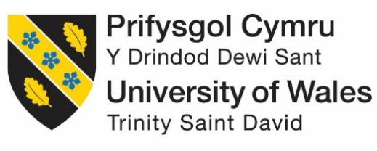

Corporate Finance (LCMB7005)

Assessment Title - Unilever PLC: A Critical Analysis of Financial Performance, Capital Structure, and Strategic Investments (2019-2023)

Student name: Sakshi Soni
Student Number: 2320592
Lecturer: Jia Miao
Word count: 5000
Submission Date: 21th August 2024

Table of Contents
Introduction 3
Key Corporate Events (2018 - 2023) 3
Financial performance and alternative capital structure considerations 4
Liquidity Ratios 4
Leverage Ratios 5
Comparison of Ratios 6
Strategic Implications 8
Capital Structure Theories and Unilever's Performance: A Critical Analysis 9
Theoretical Framework 9
Modigliani and Miller (1958) Proposition 9
Modigliani and Miller (1963) with Taxation 10
Trade-Off Theory 10
Pecking Order theory 10
Variation in Capital Structure and Share Returns 10
Capital Structure 10
Share Returns 11
Association Between Leverage and Return 12
Critical Review of Unilever's Major Investment Activities 13
Research and Development (R&D) Investments 13
Digital Transformation and E-commerce 13
Mergers and Acquisitions (M&A) 14
Sustainability Initiatives 14
Geographical Expansion and Emerging Markets 14
Critical Review of Unilever's Dividend Decisions (2019-2023) 15
Profitability and Dividend Sustainability 15
Cash Flow Management 16
Capital Structure and Financial Leverage 17
Investment and Growth 17
Market Signalling and Shareholder Expectations 18
Economic Conditions and Risk Management 18
Alternative Shareholder Returns 18
Conclusion 19
References 20

Introduction
Unilever PLC is a British multinational organization founded in United Kingdom and has its central base in London. The firm has its origin around 1872, where two butter making families from Holland by the name of Jurgens and Van den Bergh outgrew the prospect of consolidating and started what was to be known as Unilever (Unilever, 2023a). The company which is in its current structure was formed in 1929 from the merger between British soap maker Lever Brothers and Dutch margarine maker Margarine Unie (Jones 2005). This global company with over 400 brands in the food and refreshment, home and personal care products has evolved from a small-scale venture over the decades. Among the well-known sub brands within the company include Dove, Knorr, Hellmann’s, Lipton, Ben and Jerry’s (Unilever, 2023b). It was founded in 1979 and is in London, England; to be specific, it has been floated on the London Stock Exchange where it is categorized under the FTSE 100 Index (London Stock Exchange, 2023).

Key Corporate Events (2018 - 2023)
- Headquarters Consolidation (2018): Unilever abandoned its dual Anglo-Dutch structure and consolidated its headquarters in London, unifying into a single parent company, Unilever PLC (Unilever, 2018).
- Appointment of Alan Jope as CEO (2019): Alan Jope succeeded Paul Polman as CEO, marking a significant leadership change (Unilever, 2019a).
- COVID-19 Response (2020-2021): Unilever contributed over €100 million through donations of soap, sanitizer, bleach, and food, and offered €500 million of cash flow relief for vulnerable suppliers and customers during the pandemic (Unilever, 2020b).
- Failed Bid for GSK Consumer Healthcare (2022): Unilever made an unsuccessful £50 billion bid for GSK's consumer healthcare division, which was rejected as undervaluing the business (Unilever, 2022a).
- Strategic Acquisitions and Divestments: From GlaxoSmithKline it bought the beverage portfolio of Health Food Drinks which includes Horlicks for €3. 3 billion in 2018.
- Organizational Restructure (2022): The company announced a major reorganization, moving from a matrix structure to five distinct business groups: Beauty & Wellbeing, Personal Care, Home Care, Nutrition, and Ice Cream (Unilever, 2022b).
- Appointment of Hein Schumacher as CEO (2023): Unilever appointed Hein Schumacher to succeed Alan Jope as CEO, effective July 1, 2023 (Unilever, 2023c).
These events also show that Unilever as being responsive to change in the environment through strategic growth and restructuring and social responsibility and sustainability.

Financial performance and alternative capital structure considerations
Data is taken from the consolidated financial statements of Unilever (2023) & Unilever (2021) annual reports.

Liquidity Ratios
Current Ratio- Formula: Current Assets / Current Liabilities
- 2023: 17,902 / 23,507 = 0.76
- 2022: 19,157 / 25,427 = 0.75
- 2021: 16,157 / 20,592 = 0.78
- 2020: 16,157 / 20,592 = 0.78
- 2019: 16,430 / 20,978 = 0.78
A current ratio is an indicator of the company’s capacity to meet its short-term obligations, which can be observed at Unilever. A ratio below 1 means that the company may not be able to meet its short-term obligations; however, this is standard in industries with intensive inventory turnovers.
Quick Ratio (Acid-Test Ratio)
Formula: (Current Assets - Inventory) / Current Liabilities
- 2023: (17,902 - 5,119) / 23,507 = 0.54
- 2022: (19,157 - 5,931) / 25,427 = 0.52
- 2021: (16,157 - 4,462) / 20,592 = 0.57
- 2020: (16,157 - 4,462) / 20,592 = 0.57
- 2019: (16,430 - 4,164) / 20,978 = 0.58
Compared to the current ratio it is a more conservative measure of liquidity which excludes inventory. From the Unilever’s balance sheet, it can be observed that quick ratio is lower than the current ratio because the company relies on the inventory in its current assets.
Cash Ratio
Formula: Cash and Cash Equivalents / Current Liabilities
- 2023: 4,159 / 23,507 = 0.18
- 2022: 4,326 / 25,427 = 0.17
- 2021: 5,548 / 20,592 = 0.27
- 2020: 5,548 / 20,592 = 0.27
- 2019: 4,185 / 20,978 = 0.20
Cash ratio depicts likelihood of a firm to pay short-term liabilities with cash that is easily accessible to the firm. Another thing that needs to be pointed out is that the value of the cash ratio is not high for Unilever, for many companies the effective management of cash is characteristic.

Leverage Ratios
Debt-to-Equity Ratio- Formula: Total Liabilities / Shareholders' Equity
- 2023: 54,502 / 18,102 = 3.01
- 2022: 56,120 / 19,021 = 2.95
- 2021: 50,004 / 15,266 = 3.28
- 2020: 50,004 / 15,266 = 3.28
- 2019: 50,920 / 13,192 = 3.86
This ratio shows how much of it is generated through shareholders’ funds and how much through credit. Thus, Unilever ratio shows that it has been experiencing a trend of decline in its balance sheet funded by financial leverage.
Debt-to-Assets Ratio - Formula: Total Liabilities / Total Assets
- 2023: 54,502 / 75,266 = 0.72
- 2022: 56,120 / 77,821 = 0.72
- 2021: 50,004 / 67,659 = 0.74
- 2020: 50,004 / 67,659 = 0.74
- 2019: 50,920 / 64,806 = 0.79
This ratio indicates the part of the company’s assets funded by capital obtained through borrowing. Unilever’s ratio has slightly gone down implying that there is a small reduction in the level of assets that is funded by the debt.
Interest Coverage Ratio - Formula: EBIT / Interest Expense
- 2023: 9,758 / 1,038 = 9.40
- 2022: 10,755 / 818 = 13.15
- 2021: 8,702 / 491 = 17.72
- 2020: 8,303 / 728 = 11.40
- 2019: 8,708 / 821 = 10.61
This ratio reflects how the company is placed to meet its interest obligation on the taken loans. Unilever’s interest coverage ratio has not remained constant, but it still reveals good measures in terms of interest obligation.

Comparison of Ratios
For the competitor chosen Proctor & Gamble and collected the data from the annual report (Proctor & Gamble, 2021; Proctor & Gamble, 2023).
Liquidity Analysis: Current ratios of both Unilever and P&G are less than 1 meaning that the values are an indication of solvency short term liquidation problems. Nonetheless, the current ratio that shows the usability of the current assets to meet the near-choices liability is lower in case of P&G comparing to Unilever for the last five financial years of concern.
Current Ratio (Current Assets / Current Liabilities)
- 2023: 22,648 / 35,756 = 0.63
- 2022: 21,653 / 33,081 = 0.65
- 2021: 27,987 / 32,976 = 0.85
- 2020: 27,987 / 32,976 = 0.85
- 2019: 22,473 / 30,011 = 0.75
For example, current ratio of P&G in 2023 was 0.63 compared to Unilever 0.76. For this reason, Unilever may appear to have a slightly better short-term liquidity position.
The result of calculation based on the cash ratio is as follows the cash ratio has a different story to tell. Again P&G has a higher cash ratio than Unilever as shown over the period.
Cash Ratio (Cash and Cash Equivalents / Current Liabilities)
- 2023: 8,246 / 35,756 = 0.23
- 2022: 7,214 / 33,081 = 0.22
- 2021: 16,181 / 32,976 = 0.49
- 2020: 16,181 / 32,976 = 0.49
- 2019: 4,239 / 30,011 = 0.14
In the FY ended 2023, P&G records a cash ratio of 0.23, while Unilever’s was 0. 18. This means that P&G has more liquid funds available to meet its current obligation, this can be a plus in a time of economic downturn.
Leverage Analysis
Analyzing the ratio, P&G shows leaner Leverage ratio than what Unilever has depicted.
Debt-to-Equity Ratio (Total Liabilities / Shareholders' Equity)
- 2023: 73,764 / 47,065 = 1.57
- 2022: 70,354 / 46,854 = 1.50
- 2021: 73,822 / 46,878 = 1.57
- 2020: 73,822 / 46,878 = 1.57
- 2019: 67,516 / 47,579 = 1.42
The total amount of long-term debt of P&G represented 45% of the equity at the end of year 2023 and thus its debt/equity ratio was 1.57 which was lower than the Unilever’s 3.01. This means that P&G relies more on equity than on debt which may depict a more cautious approach regarding the financing and might depict lower financial risk than the models imply.
Debt-to-Assets Ratio (Total Liabilities / Total Assets)
- 2023: 73,764 / 120,829 = 0.61
- 2022: 70,354 / 117,208 = 0.60
- 2021: 73,822 / 120,700 = 0.61
- 2020: 73,822 / 120,700 = 0.61
- 2019: 67,516 / 115,095 = 0.59
Thus, the debt-to-assets ratio also testifies to this statement. Here is what the above ratio implies for P&G in 2023 is 0.61 & Unilever is 0.72. This means that comparatively smaller percentage of P&G’s assets is funded through debt, which could help in having more kind of flexibility over its financial decision-making.
As for interest coverage, again P&G is much better off that Unilever.
Interest Coverage Ratio (EBIT / Interest Expense)
- 2023: 18,134 / 756 = 23.99
- 2022: 17,813 / 439 = 40.58
- 2021: 17,986 / 502 = 35.83
- 2020: 15,706 / 465 = 33.78
- 2019: 5,487 / 509 = 10.78
As of end of 2023, P&G’s ratio was 23.99, while Unilever total current assets are 9.40. This also indicates that P&G has a much higher capability for payment of its interest that may make creditors and investors take a positive look at the firm.

Strategic Implications
Working Capital Management: Current ratio is also kept rather low by both companies, it is quite typical for consumer goods manufacturers because of integrated supply chain management and spare parts purchasing competencies. However, this strategy should be a subject to close monitoring to prevent potential problems with liquidity (Darun et al. , 2015).
Cash Management: P&G’s a higher cash ratio indicates a better safety margin for the organization in management of its cash, this can be used as a safety net in case of market fluctuations. This corresponds with research that shows that higher amounts of cash are in fact healthy in incidences of economic volatility (Bates et al. , 2009).
Capital Structure: Higher leverage of Unilever may imply that it has more lucrative growth plan or more ambitious buyback-attractive plan. However it also enhances the financial risk in this business and more so when the rates of interest are gradually changing and turning upwards (Frank & Goyal 2009).
Operational Efficiency: P&G has a higher interest coverage ratio which implies that the company is likely to be more efficient in making earnings to meet her obligations especially that of the debt. This could give P&G more financial manoeuvring capability in terms of investing in new structures for the future or paying out more cash to the shareholders (Damodaran, 1997).
Regarding the ratios of financial analysis, Unilever and P&G: while being close competitors on the consumer goods market, they have opposite trends in the sphere of financial management. As it can be seen, P&G has lower financial leverage and more cash, which can indicate the company has a more conservative financial strategy. Yet Unilever occupies a higher level of leverage and therefore points to more powerful growth effect, at the same time, more obvious financial risk.

Capital Structure Theories and Unilever's Performance: A Critical Analysis
Capital structure choices are central to theories of corporate finance, determining a firm’s cost of capital, its value and expected returns to shareholders. The paper focuses on the evaluation of the capital structure of Unilever and return on its capital, with a view to determine whether there is any link between the chosen measure of capital structure and the performance of the company’s shares.

Theoretical Framework

Modigliani and Miller (1958) Proposition
Modigliani & Miller (1958) presented and argued that in perfect capital structure markets the overall value of a firm is not in any way affected by the capital structure. This also referred to as the ‘‘irrelevance proposition’’ anticipates that the sourcing of funds through debt and or equity should not alter the firm’s market value or the cost of capital.
Critical Analysis: Although the M&M proposition may sound very theoretically sound, the assumptions of perfect markets as postulated for the analysis never are in this world. For example, taxes, information asymmetry, and transactions costs make a strong impact on capital structure decisions in the Myers (2001) real world.

Modigliani and Miller (1963) with Taxation
Understanding that corporate taxes are a going-concern and that interest is tax-deductible, Modigliani and Miller (1963) added the tax factor to the original theory. This way the revision argues that firms should opt for debt financing to be able to benefit from the tax shield.
Critical Analysis: The tax shield benefit manifests with specificity in practice, but many firms fail to optimally use this benefit; Graham (2000) argues that there are factors other than this favouring the use of debt.

Trade-Off Theory
Trade-off theory in the words of Kraun & Litzen Berger (1973) extends that firms maximise the net benefits of utilizing debts which entail tax shields with the cost which encompasses financial distress and bankruptcy cost.
Critical Analysis: While theoretically even more attractive as an analytically feasible theory as compared to the growth option theory, the practical evidence for the trade-off theory is still rather weak. The other weakness of theory is that Fama & French (2002) notice that leverage has an inverse relationship with level of profitability in firms.

Pecking Order theory
Myers & Majluf (1984) wrote the paper on pecking order theory arguing that due to the presence of information asymmetry, the firms like to use internal funds if available, if not, they like to use debt and if required, then equity.
Critical Analysis: Despite the shortcomings, the pecking order was one of the most significant theories expounding financing behaviour and was supported robustly by Shyam-Sunder & Myers (1999), especially among firms that were already set up. However, Frank & Goyal (2003) dismissed this argument particularly in the later years, and in case of small companies.

Variation in Capital Structure and Share Returns

Capital Structure
Unilever's capital structure, as indicated by its leverage ratios, has shown some variation over the 2019-2023 period:
Debt-to-Equity Ratio: This ratio reduced from 3.86 in 2019 to 3.01 in 2023 to show a decline in financial leverage ratio. This has pointed to the fact that over time Unilever has been reducing on the level at which it depends on debt as a source of funds as compared to equity.
Debt-to-Assets Ratio: This metric reduced marginally from 0.79 in 2019 to 0.72 in 2018, as a result giving a slightly lower figure in the ratio of assets funded by debt.
Interest Coverage Ratio: This ratio however was not constant over the period and it was at its high of 17.72 in 2021 and then decreasing to 9.40 in 2023. The trend reveals a comparatively better capacity in terms of interest coverage compared to the FY 2019 though it has declined recently.
This implies that Unilever has been gently reducing the proportion of debt in its balance sheet during the last few years, perhaps for the purpose of seeking a precisely optimal capital structure.

Share Returns
Unilever's annual returns have shown significant volatility: Data is Collected From Yahoo Finance (Yahoo finance, 2024)
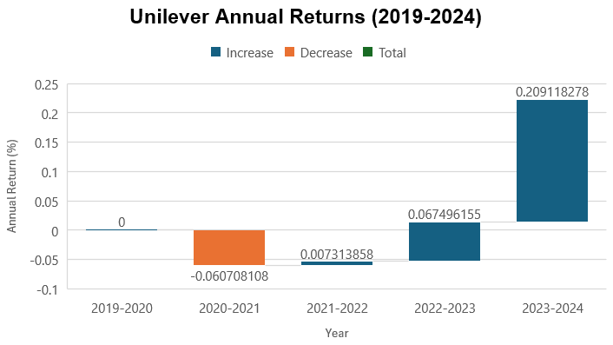
Figure 1: Unilever Annual Returns
The average annual return over this period is 4.46%, masking considerable year-to-year variations. Unilever had a poor year in the period 2020-2021 and this could be attributed to the impacts of the COVID -19 on the global economy. But returns have also been on the rise since then, with a great boost in each subsequent year, including a spectacular 20.91% return in 2023-2024.

Association Between Leverage and Return
The behaviour of leverage ratios and return on equity for Unilever provides an interesting consideration of the management of corporations finances. Following the decrease in the company’s financial leverage from the year 2019 to 2023 as would be depicted by the Debt-to-Equity and the Debt-to-assets ratios below, the element of share returns generally indicated a rising trend from year 2021 onwards. This pattern is consistent with the trade-off theory of capital structure which explains that the company seeks to offset the advantage of paying less tax through use of debt against the costs that arise from financial distress (Kraus & Litzenberger, 1973). Although there is a positive relationship, it is not direct since the highest average returns were achieved with additional deterioration after the first signs of deleveraging. This delay effect, may be explained, using the market efficiency and information asymmetry theory developed by Myers and Majluf, 1984 and the investors may take some time before they revise their model and price the reduction in financial risk appropriately. Higher Interest Coverage Ratio over the period also suggests better debt management which also contributed to the improved shareholder value in line with Jensen’s (1986) free cash flow hypothesis. However, to avoid overly attributing Unilever’s success to social marketing, it remains necessary to examine this seemingly correlation with certain degree of skepticism, although social marketing very likely has contributed a lot to it, the other factors as such post-pandemic business recovery, operations optimization, and generally favourable market conditions cannot be ruled out by any means. Leverage and returns trends depicted here are consonant with empirical evidence initially popularised by Fama & French (1992) which cast aspersion on difficulty risk-returns functional character argued in early capital structure theories.

Critical Review of Unilever's Major Investment Activities

Research and Development (R&D) Investments
Unilever has always invested heavily on research and development this is because the company has always aimed at being at par with its innovations within the FMCG industry. In the year 2022, this company used € 1.1 billion on R&D, representing approximately 1.8% of its turnover (Unilever, 2023). This level of investment which has been outlined below has remained almost constant in the last few years; it shows the seriousness of Unilever in innovation even under the top most economy considerations.
However, when comparing it to some of its rivals such as Procter & Gamble; the later spends approximately 2.2% of its net sales in R&D in the same period (Proctor & Gamble, 2023). This leads to some questions, regarding the fact whether Unilever investing enough money today to remain an innovative company in the highly competitive environment. According to the company these research and development expenses have paid off and have spearheaded the introduction of several products especially in the beauty and personal care division. For instance, the new product of Dove that is the reusable deodorant is an example of sustainable innovation. There is so much ambiguity regarding the long-run effects that are good for the general sales’ growth and the market share. This may imply that there is space between the investment in R&D and market outcome, as observed by Knott & Vieregger (2020) in their study on the effectiveness of R&D.

Digital Transformation and E-commerce
To address changed consumers’ behaviour and especially by the influence of the COVID-19, Unilever stepped up the investments in digital competencies and in e-commerce. The company disclosed that e-commerce has made up of 14% of its revenues and has grown by 20% in 2022 (Unilever, 2023). To enable this growth, Unilever has had to invest in digital, new technologies especially in areas like automation with sophisticated digital marketing USP and analytic, as well as DTC channels.
One of the most significant programs is establishing the Unilever’s People Data Centers and their usage of artificial intelligence and machine learning for the consumers. Although such investments have positively affected digital sales they may not necessarily improve the company overall profitability. According to Verhoef et al., (2021), large traditional companies are not always able to fully realize the digital investments because of the large organizational structures and systems.

Mergers and Acquisitions (M&A)
The multinational company has established its M&A strategy on the acquisition of businesses with creative, and socially responsible products. Among them, the latest was Paula’s Choice, a skincare brand based on an online sales model, which was acquired for $ 2 billion at the beginning of 2021 (Unilever, 2022). This is in line with Unilever’s plan to deepen its positioning in the space of premium skincare products and build up its digital strength.
However, the acquisition price is considered high and this makes them concern of over acquisition price and return. Entrant disruption troubles of digital-native brands into the conventional form of business are widely known. In addition, Unilever’s prospective large-scale acquisition of GlaxoSmithKline worth £50 billion in 2022 failed badly and it caused lots of shareholder criticism; large-scale M&A activities are risky. (Financial Times, 2022).

Sustainability Initiatives
Unilever has gone deep into the pockets to secure sustainable growth, and from 2020 to 2030 alone, the company set aside €1 euros for the nature-based solution and another €1 for the Climate & Nature fund. The following investments are in line with the company’s Unilever Compass approach.
The importance of commitment to sustainability can be seen in these initiatives, but as to the effect on financial performance, it is not as straightforward. Eccles et al., (2014) opine that sustainability investments lead to specific brand value over the long-term, as well as customer loyalty. However, the high initial investment required for sustainable solutions can stress the firm to aggressively meet quarterly earnings targets, making sustainable solution investments a problem on how to meet shareholder demands for quick returns.

Geographical Expansion and Emerging Markets
The company has also upped its investment into the emerging markets as they constitute approximately 58% of Unilever business. At the beginning of the year 2022, the company presented rather impressive growth rates to the countries of the Asia-Pacific region, including India, Indonesia, and Brazil (Unilever, 2023). Major transactions are €150 million for construction of manufacturing plant in Pakistan in 2021.
These investments have been a source of growth to Unilever but have put the company in a position where facing more risks than before such as fluctuations in foreign currency, instabilities in political systems, and unfavourable regulatory systems. The fluctuations that can be observed on the example of emerging markets are evident in the recent economic slowdown in China. According to Khanna & Palepu (2010), while gaining entry to and network positioning within a foreign country is good news for multinational champions, this is bad news for their investment returns especially because they are often competed out of the market by more knowledgeable and nimble local players.
Unilever investment activities paints a picture of a company that aims to embrace more of innovation, digitization, sustainability, and growth in emerging economy markets. However, these investments as with the strategic postures they support, these investments do not always have positive short to medium-term implications on performance and shareholder returns. It is therefore important that it proves that it can generate high returns on its digital and sustainable investments to shareholders. In the future, Unilever has several tasks to perform and the main one is to enhance the efficiency of investment management to continue the company’s growth and increase its profitability in a global environment that becomes more challenging and competitive all the time. The company may need to make further increases in R&D intensity, be even more disciplined about M&A, and concentrate on digital-product initiatives that generate high returns to create and sustain superior performance and superior returns to shareholders. Managing these priorities along with its acceptable sustainability strategies will help Unilever to become sustainable in the future consumer goods industries.

Critical Review of Unilever's Dividend Decisions (2019-2023)
In this review, it includes a critical view on Unilever’s dividend pay-outs that has been made from 2019 to 2023 with particular emphasis on factors explaining the dividend strategy. It is essential to have informed dividend policy to maximize shareholders’ value as well as financial position of organizations (Baker et al., 2018).

Profitability and Dividend Sustainability
Unilever's dividend payments and net profits (in millions of euros) were:
Year | Dividend | Net Profit | Payout Ratio
2023 | 4,327 | 6,487 | 66.7%
2022 | 4,356 | 7,642 | 57%
2021 | 4,458 | 6,049 | 73.7%
2020 | 4,300 | 5,581 | 77%
2019 | 4,223 | 5,625 | 76.1%
Table 1: Profit and Dividend sustainability
The payout for each year has been above 70% which is unhealthy for sustaining the dividend policy in the future. It was, however, established that sustainable dividends may indicate financial health (Lintner, 1956) though Unilever seems to have been extreme on this aspect. The company was constantly paying out relatively high proportions of its profits, which may have restricted its financial manoeuvrability.
Formula for Dividend Growth Rate = (D0 / D1)^{1/n} – 1 = (4,327/4223)^{1/4} – 1 = 0.61%
- D_{1​} = Dividend in the most recent period (e.g., this year)
- D₀​ = Dividend in the base period (e.g., last year)
- n = Number of years over which the growth is being measured
The average dividend growth rate of 0.61% in the five-year period is so low and indicates that there is little movement in the shareholder remunerations. This goes against the dividend growth model which Gordon (1959) proposed that one component of the firm’s worth is expected growth in dividend payments.

Cash Flow Management
Analyzing the Unilever’s cash flow management in the relation to the company’s dividend policy it is possible to note that the company has a rather worrying approach to maintaining dividends at the cost of the sound financial management. The company's net cash flow from operating activities demonstrates significant volatility: It was €9,426 million in 2023 and €7,282 million in 2022, €7,972 million in 2021, €9,058 million in 2020, and €8,109 million in 2019. It is pertinent to point out that the figure of 8.65% down from 2021 to 2022 where the operating cash flow declined by €690 million. Despite such a reduction, the company’s dividend payout was nearly the same (€4,356 million in 2022 and €4,458 million in 2021); the difference being a mere 2.3%. Such strict dividend policy in relation to cash flow volatility may be counterproductive and raises a lot of questions over the company’s risk management strategies. On the one hand, sustaining high dividends may be necessary to assure investors that the firm’s has a solid financial base (Lintner, 1956), on the other hand, Unilever does not appear to exercise flexibility when it comes to changing dividends significantly in response to large changes in the cash flow rate, which hints at short-term focus on earnings per share performance at the expense of a long-term orientation towards the firm’s financial needs for growth Such an approach could reduce the company’s capacity to reestablish itself in future volatility in the economy or take advantage of eventual growth prospects, because a greater proportion of seemingly unpredictable cash flows is expected to go into dividends rather than retained to cater for operational requirements or other profitable ventures.

Capital Structure and Financial Leverage
Unilever's financial liabilities (in millions of euros):
- 2023: 29,622
- 2022: 29,488
- 2021: 23,713
- 2020: 22,844
- 2019: 23,566
The realized incidence of debt has also risen immensely to 24.4% increase from 2021 to 2022. when high leverage is used concurrently with high dividend payout, it opens a firm to a lot of risks (Fama & French, 2002) From debt-equity-ratio calculated in section 2 has increased from 1.70 in 2019 to 1.84 in 2023, indicating increased reliance on debt financing.

Investment and Growth
Unilever's turnover (in millions of euros):
- 2023: 59,604
- 2022: 60,073
- 2021: 52,444
- 2020: 50,724
- 2019: 51,980
CAGR = (Ending Value / Beginning Value)^{(1/n)} – 1 = (59,604 / 51,980)^{(1/4)} – 1 = 0.0349= 3.49%
The average yearly growth of turnover from the year 2019 to 2023 is 3.49% This is not bad for a global consumer goods company, but still seems a bit low. This implies that appropriate levels of dividend payouts could be limiting investment on growth options. The pecking order theory developed by (Myers & Majluf, 1984) provides that internal funds should be a company’s first source of funding for investments and Unilever’s high payouts may be preventing it.

Market Signaling and Shareholder Expectations
This behaviour of Unilever is supported by the theory on dividend smoothing as suggested by Leary & Michael (2011). This approach, however, may lead to a formation of high expectations among shareholders and at the same time concealing several significant problems in the financial statements.

Economic Conditions and Risk Management
The years between 2019 to 2023 were crowned with severe economic risks and threats such as the COVID-19 pandemic and inflation. Analyzing Unilever’s key financial ratios during this period, it is possible to notice that though the company has obviously been managing risks well, high dividends also create questions. As, Brav et al., (2005) stated that companies should change in dividends, in favour or against, in proportion to sustainable changes in earnings.

Alternative Shareholder Returns
Unilever's share repurchases (in millions of euros):
- 2023: 1,507
- 2022: 1,509
- 2021: 3,018
- 2020: 0
- 2019: 9,416 (cancellation)
Especially the 2019 and 2021 maxed out share buybacks combined with high dividend pay-outs can be seen as inefficient capital allocation. Although buybacks are in their flexibility (Jagannathan et al., 2000), over extension in returns is indicated by high dividends and large repurchases when leverage is on its rise. The dividend policy of Unilever that was highlighted from the financial year ending 2019 to that of 2023 shows a company’s commitment to shareholder returns, but it is troubling for the future financial stability of the business. Considering this analysis, Unilever should possibly maintain a more adjustable payout ratio if its financial capacity is to fund the growth objectives it wants to achieve, possibly lower leverage, strike a balance between the shareholder returns and the spending on growth projects.

Conclusion
Unilever's financial story from 2019 to 2023 tells a company trying to steer through turbulent global waters while delivering shareholder value and, at the same time, growing in a sustainable manner. The report indicates a slow decline in leverage, consistent with a shift towards a more equity-like capital structure. Together with better-than-expected post 2021 share returns, this movement is consistent with the trade-off theory of capital structure, where we can see some financial risk and tax benefit optimization.
That said, Unilever's investment practices, on R&D, digital transformation and sustainability, are a wash. Though these efforts will help to ensure the company's long-term success its temporary effect on earnings is unclear. The high payout ratio of dividends, and share buybacks, in the face of cash flow uncertainties, cast doubts on the company's long-term financial flexibility and growth investment.
In the longer term, Unilever's challenge is to deliver on the needs of shareholders while investing in growth that is sustainable. The company would be well-served by a more relaxed dividend policy, higher R&D intensity and narrowed digital efforts to drive longer term value creation.

References
Bates, T.W., Kahle, K.M. and Stulz, R.M., 2009. Why do US firms hold so much more cash than they used to?. The journal of finance, 64(5), pp.1985-2021.
Baker, H.K., Kapoor, S. and Jabbouri, I., 2018. Institutional perspectives of dividend policy in India. Qualitative Research in Financial Markets, 10(3), pp.324-342.
Brav, A., Graham, J.R., Harvey, C.R. and Michaely, R., 2005. Payout policy in the 21st century. Journal of financial economics, 77(3), pp.483-527.
Damodaran, A., 1997. Corporate Finance. Theory and Practice, John Wiley&Sons. Inc. Newyork.
Darun, M.R., Roudaki, J. and Radford, J.J., 2015. The evolution of working capital management research.
Eccles, R.G., Ioannou, I. and Serafeim, G., 2014. The impact of corporate sustainability on organizational processes and performance. Management science, 60(11), pp.2835-2857.
Fama, E.F. and French, K.R., 1992. The cross‐section of expected stock returns. the Journal of Finance, 47(2), pp.427-465.
Fama, E.F. and French, K.R., 2002. Testing trade-off and pecking order predictions about dividends and debt. Review of financial studies, pp.1-33.
Financial Times, 2022. Unilever rules out increasing £50bn bid for GSK unit after backlash. [online] Available at: https://www.ft.com/content/1f7f4dfd-ebbf-466a-92ae-5b2e4eb5827c [Accessed 2 August 2024].
Frank, M.Z. and Goyal, V.K., 2003. Testing the pecking order theory of capital structure. Journal of financial economics, 67(2), pp.217-248.
Frank, M.Z. and Goyal, V.K., 2009. Capital structure decisions: which factors are reliably important?. Financial management, 38(1), pp.1-37.
Gordon, M.J., 1959. Dividends, earnings, and stock prices. The review of economics and statistics, pp.99-105.
Graham, J.R., 2000. How big are the tax benefits of debt?. The journal of finance, 55(5), pp.1901-1941.
Jagannathan, M., Stephens, C.P. and Weisbach, M.S., 2000. Financial flexibility and the choice between dividends and stock repurchases. Journal of financial Economics, 57(3), pp.355-384.
Jensen, M.C., 1986. Agency costs of free cash flow, corporate finance, and takeovers. The American economic review, 76(2), pp.323-329.
Jones, G., 2005. Renewing Unilever: Transformation and Tradition. Oxford: Oxford University Press.
Khanna, T. and Palepu, K.G., 2010. Winning in emerging markets: A road map for strategy and execution. Harvard Business Press.
Knott, A.M. and Vieregger, C., 2020. Reconciling the firm size and innovation puzzle. Organization Science, 31(2), pp.477-488.
Kraus, A. and Litzenberger, R.H., 1973. A state-preference model of optimal financial leverage. The journal of finance, 28(4), pp.911-922.
Leary, M.T. and Michaely, R., 2011. Determinants of dividend smoothing: Empirical evidence. The Review of Financial Studies, 24(10), pp.3197-3249.
Lintner, J., 1956. Distribution of incomes of corporations among dividends, retained earnings, and taxes. The American economic review, 46(2), pp.97-113.
London Stock Exchange, 2023. Unilever PLC (ULVR). [online] Available at: https://www.londonstockexchange.com/stock/ULVR/unilever-plc [Accessed 3 August 2024].
Modigliani, F. and Miller, M.H., 1958. The cost of capital, corporation finance and the theory of investment. The American economic review, 48(3), pp.261-297.
Modigliani, F. and Miller, M.H., 1963. Corporate income taxes and the cost of capital: a correction. The American economic review, 53(3), pp.433-443.
Myers, S.C., 2001. Capital structure. Journal of Economic perspectives, 15(2), pp.81-102.
Myers, S.C. and Majluf, N.S., 1984. Corporate financing and investment decisions when firms have information that investors do not have. Journal of financial economics, 13(2), pp.187-221.
Proctor & Gamble, 2021. Annual Report and Accounts 2020. [online] Available at: https://us.pg.com/annualreport2021/ [Accessed 5 August 2024].
Proctor & Gamble, 2023. Annual Report and Accounts 2022. [online] Available at: https://us.pg.com/annualreport2023/ [Accessed 5 August 2024].
Shyam-Sunder, L. and Myers, S.C., 1999. Testing static tradeoff against pecking order models of capital structure. Journal of financial economics, 51(2), pp.219-244.
Unilever, 2018. Unilever to acquire Horlicks and other consumer healthcare nutrition products from GSK. [online] Available at: https://www.unilever.com/news/press-releases/2018/unilever-to-acquire-horlicks-and-other-consumer-healthcare-nutrition-products-from-gsk/ [Accessed 1 August 2024].
Unilever, 2019a. Unilever announces CEO succession. [online] Available at: https://www.unilever.com/news/press-and-media/press-releases/2018/unilever-ceo-announcement/#:~:text=London%20%2F%20Rotterdam%20%2D%20Unilever%20today%20announced,first%20half%20of%20the%20year. [Accessed 2 August 2024].
Unilever, 2020b. Unilever contributes €100m to help the fight against the pandemic. [online] Available at: https://www.unilever.com/news/press-and-media/press-releases/2020/helping-to-protect-lives-and-livelihoods-from-the-covid-19-pandemic/#:~:text=%E2%80%9CWe%20hope%20that%20our%20donation,mind%20during%20these%20uncertain%20times. [Accessed 3 August 2024].
Unilever, 2021. Unilever Annual Report and Accounts 2020. [online] Available at: https://www.unilever.com/files/92ui5egz/production/75f31d18a2219004f4afe03e37ccd2a3b383472f.pdf [Accessed 4 August 2024].
Unilever, 2021a. Unilever announces sale of its Tea business, ekaterra, to CVC Capital Partners Fund VIII for €4.5bn. [online] Available at: https://www.unilever.com/news/press-and-media/press-releases/2021/unilever-to-sell-its-tea-business-ekaterra-to-cvc-capital-partners-fund-viii-for-45-bn/#:~:text=London%2C%2018%20November%202021%20%E2%80%93%20Unilever,free%2C%20debt%2Dfree%20basis. [Accessed 4 August 2024].
Unilever, 2021b. Unilever commits to help build a more inclusive society. [online] Available at: https://www.unilever.com/news/press-releases/2021/unilever-commits-to-help-build-a-more-inclusive-society/ [Accessed 1 August 2024].
Unilever, 2022a. Update on GSK Consumer Healthcare acquisition proposal. [online] Available at: https://www.unilever.com/news/press-and-media/press-releases/2022/unilever-update/ [Accessed 6 August 2024].
Unilever, 2022b. Unilever to create new organisation. [online] Available at: https://www.unilever.com/news/press-and-media/press-releases/2022/unilever-simplifies-organisation/ [Accessed 5 August 2024].
Unilever, 2023. Unilever Annual Report and Accounts 2022. [online] Available at: https://www.unilever.com/files/92ui5egz/production/0daddecec3fdde4d47d907689fe19e040aab9c58.pdf [Accessed 7 August 2024].
Unilever, 2023a. Our history. [online] Available at: https://www.unilever.com/our-company/our-history-and-archives/1800s/ [Accessed 1 August 2024].
Unilever, 2023b. Our brands. [online] Available at: https://www.unilever.com/brands/ [Accessed 1 August 2024].
Unilever, 2023c. Unilever announces CEO succession. [online] Available at: https://www.unilever.com/news/press-and-media/press-releases/2023/unilever-appoints-hein-schumacher-as-new-ceo/ [Accessed 1 August 2024].
Verhoef, P.C., Broekhuizen, T., Bart, Y., Bhattacharya, A., Dong, J.Q., Fabian, N. and Haenlein, M., 2021. Digital transformation: A multidisciplinary reflection and research agenda. Journal of business research, 122, pp.889-901.
Yahoo Finance, 2024. Historical Data. [online] Available at: https://uk.finance.yahoo.com/quote/ULVR.L/history/ [Accessed 9 August 2024].

Appendix 1: Revenue of Unilever Group
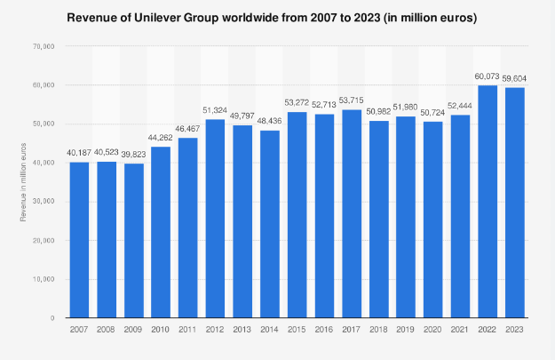
Figure 2: Revenue of Unilever Group

Appendix 2: PE Ratio
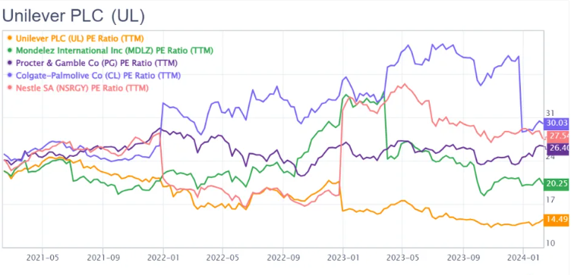
Figure 3: PE ratio of Unilever and its competitors

Appendix 3: Appointment of New CEO downplays Purpose
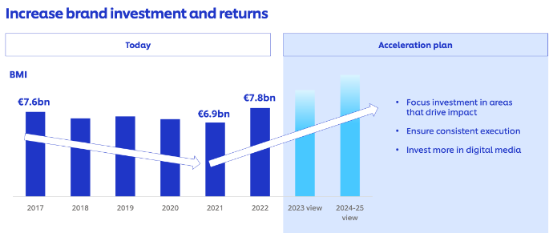
Figure 4: New Unilever CEO downplays purpose and hikes adspend

Appendix 4: Unilever Net Operating Income
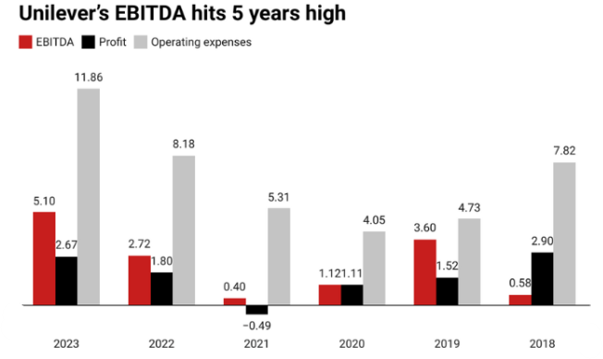
Figure 5: Unilever's net operating income hits N5.1bn, highest in six years

Appendix 5: Net Cashflow Comparisons
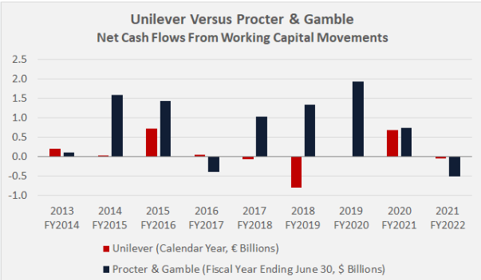
Figure 6: Unilever, P&G Net Cashflow Comparisons

