  Islamic Finance  A success and sustainable story? | Executive Summary Although Islamic finance is experiencing exponentially high growth in recent years and the number of fully Sharia’a compliant banks and financial products continues to grow worldwide. Due to strict compliance to Islamic principles, the Islamic banks were not severely affected by the 2008 banking crisis, but they were eventually affected by the real economy such as the deflation of real-estate prices. Many of the IsF institutions suffered loss of profit after the recession. Furthermore, IsF is perceived to be more ethical because it stipulates profit sharing but no interest charging. It prohibits gambling and usury which could prevent financial crisis. This paper postulates how IsF is innovating and adopting better practices and oversight so as to attract mainstream banking market. However, IsF must improve the oversight as the oversight board consist of theology clerics. If the ethical view of IsF is adopted by the conversional banks, it could reduce poverty and create wealth.  Adekoyejo Sobola (1601748)  INTERNATIONAL FINANCIAL MANAGEMENT (SBUS6113)

Contents
An Introduction to Islamic Finance (IsF) 2
Principles to IsF 2
The Analyses of success of Islamic finance 4
No interest-based (Riba) transactions 4
Monumental Issuances in the Sukuk Market 6
Retail Demand and Government Support is Helping Boost Growth 8
Establish justice, Create wealth, employment and ethical 10
Islamic finance in economic boom and bust 11
Financial stability and risk management in Islamic finance 16
Recommendations 21
References 22
Bibliography 28

An Introduction to Islamic Finance (IsF)

Islamic finance has been around for over 1400 years, it has its foundation in Islam. According to Deloitte (2018), the first Islamic finance (IsF) was started in Egypt and Malaysia in the 1960s. Whilst the UKTI (2014), suggested that the modern IsF was established in 1975. Still, Rudnyckyj (2017) and MIFC (2017) suggested that the first Islamic bank in Malaysia was established in 1983.

Principles to IsF
Muslims believe that Shari’ah gives a clear instruction on commands, prohibitions, guidance, and principles that all believer must follow (Cimaglobal, 2011; Richardson, 2011). Ross (2018) argued that IsF is a financial system through which Muslim world, raise capital in accordance with Sharia law and Cimaglobal (2011) suggested that IsF is not a religious product. Nonetheless, Authors such as Rudnyckyj (2017), ACCA (2016) and Warde (2010) claimed the IsF experts and Scholars are calling for tighter sharia compliance, unlike conventional finance, Cimaglobal (2011) asserted that the elements of interest and risk are prohibited under Shari’ah law therefore, the developments in IsF has allowed Muslims to invest savings and raise finance in a religious and ethical way (Siddiqi, 2006).
Ross (2018) concluded that risk sharing is an important part of raising capital and the avoidance of Riba and Gharar under Sharia-law. Additionally, to Islam, lending with interest payments only favours the lender, thereby exploiting the borrower. Income should not be received from money ie interest on money lent (Marifa Academy, 2014; figure 1). Islam considers money as just a measuring tool for value and not an asset, currency is just a medium of exchange rather than as a commodity-for exchange-therefore, hence, paper currency has no value unless it is invested in a productive activity or asset. Irfan (2014) claimed that if real assets are bought and sold as opposed to the trading of intangible pieces of paper then, the 2008 financial crisis that collapsed the Northern Rock and Lehman Brothers could have been avoided (Ross, 2018; Richardson, 2011; Siddiqi, 2006; The Economist, 2014). In fact, many commentators describe the industry as “banking without interest” (Ilieva, et al., 2017; Islamicinformationhub, 2018).
Malik and Khaki (2015) stated the four major foundational principles of IsF industry, the principles are: La-Riba (no-interest), La-Gharar (no-uncertainty), La-Maisir (no-speculation), and La-Haram (no-unlawful) (figure 1).
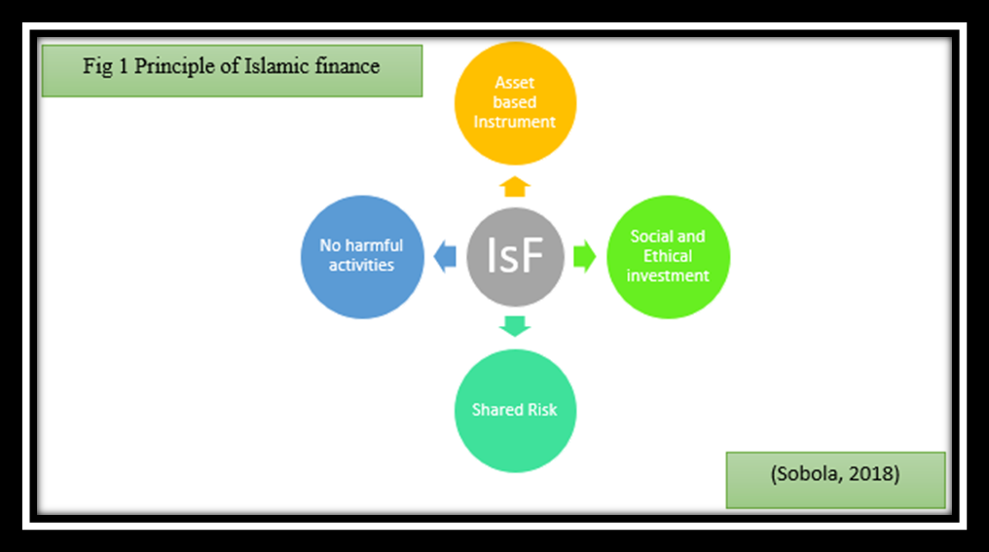

The Analyses of success of Islamic finance
Although IsF has always being criticized for being conservative in relation to financial innovation, despite this, ACCA (2016); Warde (2010) and Suleiman (2001) proposed that IsF is ethical finance because of its principles.

No interest-based (Riba) transactions
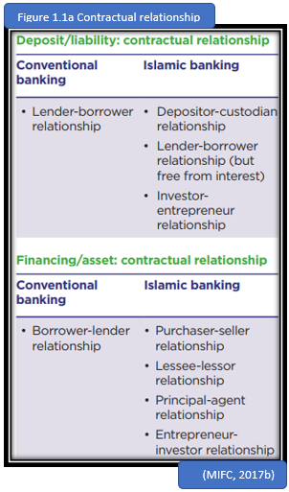
Furthermore, Islamic-banking is comparable to conventional banking (CB) because both serves as financial intermediaries and trustees of the money of other people. The big difference between the two is that IsF share profit and loss with their depositors (Mudarabah). However, in the case of genuine failure the financer must bear the loss. Under IsF, the depositors are customers with some ownership rights (Dar & Presley, 2000; Malik & Khaki, 2015; Ross, 2018). Hence, if IsF is to create wealth, investors will be interested in the businesses performance and the arrangement is such that all the customers become shareholders and creditors of firms (Bashir, 2003; Yudistira, 2004). Debt is not permitted under Islamic law, see the contractual relationship (figure 1.1a), unlike under the CB, where the objectives are profit maximisation. For that reason, IsF avoids excessive use of credit and debt financing that could result in financial crisis (Cimaglobal, 2015).

There are over 1.8 billion Muslims in the world, spending about $2.1 trillion in 2017 and the Islamic-economy is growing at 10-12% annually and IsF has emerged as an effective finance tool. Meanwhile, in 2017, the IsF sector has US$2.4 trillion worth of total assets (Salaamgateway, 2018; The World Bank, 2015). Naturally, some factors have been responsible for the IsF success (figure 1a) including the need to invest the excess liquidity of Oil and Gas Wealth of the Gulf Cooperation Council (GCC) region in Sharia compliant funds coupled with the Muslim populations now embracing Islamic-banking. In addition, many Muslim investors are also looking for quality sharia investment (Lebdaoui and Wild 2016b; Sukuk.com, 2018).
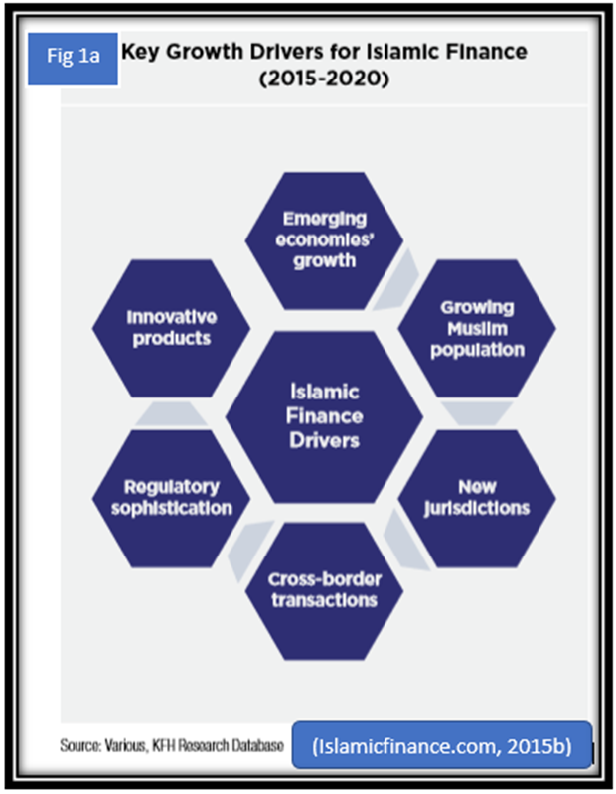

Monumental Issuances in the Sukuk Market
More and more governments are embracing Sukuk especially countries in Africa and Europe to finance infrastructure development because Sukuk has gained huge importance for long-term finance. Even the World Bank (WB) suggested that IsF could fill the global infrastructure gap because the Islamic-bank’s Sukuk market is providing a new supply of higher-yielding assets or new funding opportunities (Securities Commission Malaysia, 2018; figure 1b).
Indeed, the United Kingdom (UK) seeks to be a hub for IsF after issuing sovereign £200 million Sukuk in 2014, the first non-Islamic nation to do so which was 10 times oversubscribed. Besides, over 65 Sukuk have been issued in the UK proving growth (figure 1c; Islamicfinance, 2015d; Islamicfinance, 2018; Warde, 2010).
Again, by embracing continuous innovation, the IsF industry is experiencing advancements in product design. Progress is being driven by the growth of Basel III-compliant sukuk a Shariah-compliant Murabahah instrument (Cliffordchance, 2015; Islamicfinance, 2015c).
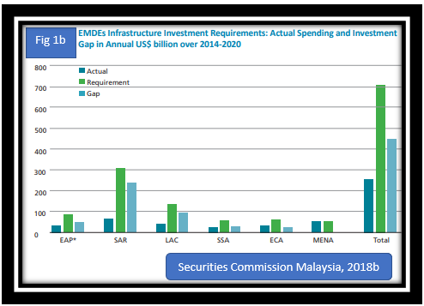

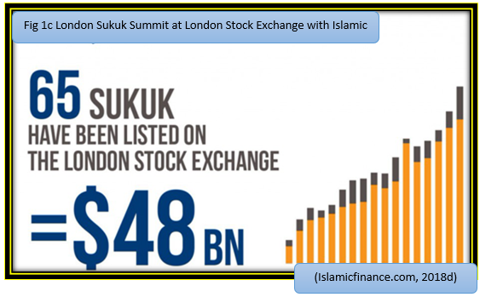

Regulatory and Innovative products
Because of the success of the Sukuk in Malaysia for over twenty years, it has transformed IsF. The improved regulatory oversight of the IsF has strengthened the credibility of the IsF system as a sustainable alternative to the mainstream financial system (Cimaglobal, 2015; MIFC, 2017). The regulatory advancements in key jurisdictions in countries like Malaysia and the GCC is driving the industry to continue to innovate its products (Appendix 1; Islamicfinance, 2015c). Another contributing factor to growth is the adaptation of English Common Laws to govern most International IsF contracts (Sukuk.com, 2018).
Furthermore, the IsF industry are now developing innovative Sharia-compliant products that are sustainable equivalents to mainstream financial instruments (Cimaglobal, 2015). Additionally, by achieving the AAA rating by Moody-investor-service and the benchmarking against international-standards-International-Organisation-of-Securities-Commission (IOSCO) is attracting more investors and customers. Moreover, having a body as Islamic-Financial-Service-Board (IFSB) and the Accounting-and-Auditing-Organisation for Islamic-Financial-Institution (AAOFI) in Bahrain legislating on the Core Principles for IsF Regulation will give investor confidence (Islamicfinance, 2015c; MIFC, 2017; 2018; Securities Commission Malaysia, 2018a). Nor et al. (2015) warned of the differences in schools of Islamic jurisprudence that is hindering the adoption of AAOIFI standards in the Malaysia for example.
Ahmed, et al., (2014) claimed that IsF in Malaysia are deploying the same internal control standard as applied by KPMG as a benchmark for their Sharia-audit. However, Barnes (2013) would rather have professional and not divinity scholars providing regulatory oversight on the IsF.
Islamic-banking
Islamicfinance (2015c) claimed that the total Islamic-banking assets is increasing and growing across the world. IsF accounts for less than 2 percent of global finance. Significantly, Saudi Arabia and Malaysia control over 68% of global Shariah-compliant Islamic fund market, and there are now over 275 Islamic financial institutions in the world, managing 915 Islamic funds, operating in over 75 countries, and the projected value of IsF by 2020 is US$4 trillion (Eurekahedge, 2018; Islamicfinance, 2015d; Statista, 2018a; figure 2).

Retail Demand and Government Support is Helping Boost Growth
Malaysia was the first country to create Islamic-banking system alongside the CB and have utilised IsF in funding economic-growth, digital and technological infrastructure (Warde, 2010). So, Islamic-banking has contributed more to economic growth in Malaysia and Indonesia compared to the GCC countries (Yosof & Bahlous, 2013 MIFC, 2017).
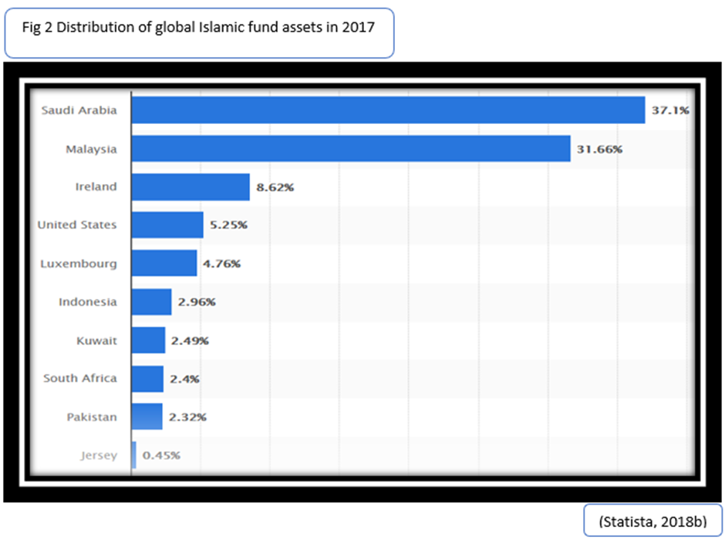
Equally, the increased retail customer demand is driving growth for the entire IsF industry and this trend is expected to continue (Islamicfinance, 2016). Likewise, IsF is attracting new deposits through Private Banking, they are now offering commercial retail Premier and Private Banking, and relevant products in Europe, US, etc (Islamicfinance, 2015d). In America; a Dow Jones Islamic Index has been constructed, sharia-compliant mortgages are provided by Freddie Mac and Amana Mutual Funds have invested more than $3bn in accordance with Islamic investment restrictions (Spangler, 2015). Figure 2a shows Development of IslamicFinancial Institutions in the UK.
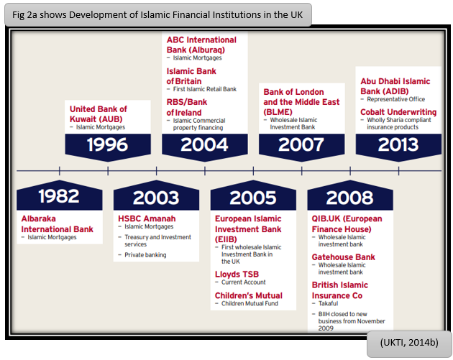
Cross border transaction
Cross-border transaction is increasing, and international Islamic-banks are cooperating, and Malaysia and Indonesia have established a Sharia-Stock-Market Centre in Indonesia. This exchange will be a global benchmark for Islamic capital markets for various financial products (Islamicfinance, 2018e; 2016; 2015c; MIFC, 2017). In Malaysia, the Labuan offshore centre was created as offshore banking centre and the GCC are promoting a policy of greater integration in the regional economy (Warde, 2010). Malaysia continue to experience strong international trade the country’s GDP is almost 1.5 times the country’s international trade (MIFC, 2017).

Establish justice, Create wealth, employment and ethical
According to (Bashir, 2000; Cimaglobal, 2015) Islamic banks seek a just, ethical and equitable distribution of resources. The WB and Islamic Development Bank recognised the potential of IsF to reducing global inequality, and IsF could be a catalyst for share prosperity and the SDG (The World Bank, 2017b).

Islamic finance in economic boom and bust
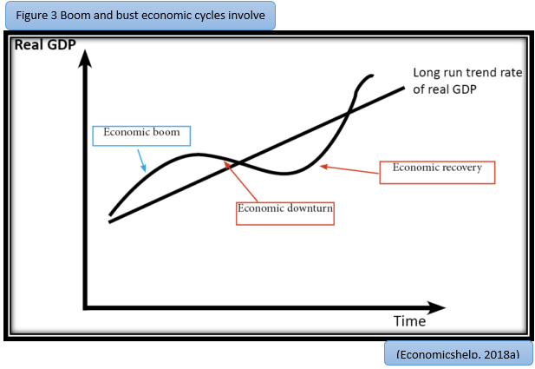
Economist agree that Boom and Bust Cycle involve the rapid economic-growth or expansion that leads to inflation called boom while bust is a period of economic contraction or recession, and this will result in rise in unemployment and a fall in GDP (figure 3a, see Appendix 2; Bordo and Jeanne, 2002; Investopedia, 2018b).
Islamic banks showed stronger resilience to the 2008 global financial crisis, however the crisis exposed the weaknesses in risk management that eventually hurt Islamic bank profitability in 2009. Furthermore, during the 2008-2010 financial crisis, the GCC and Malaysia all suffered a dip in GDP, hence they were not totally immune from the crisis. Figures 3a.1 and 3a.2 clearly shows that the GDP of Malaysia and the GCC were negatively impacted by the 2008 financial crisis as the prices of goods and service fell. The GCC countries were affected through trade and financial channels, the declining oil price and declining oil demand, over-dependence on foreign finance, and deflated real-estate prices led to liquidity shortages and deleveraging. Prior to the crisis, the GCC enjoyed oil boom between 2003- 2008, which led to excessive credit inflation and asset price increases. Nonetheless, the GCC addressed the crisis by restructuring like Saudi-Arabia utilising fiscal stimulus and other GCC lowering interest rate. Even the government of Dubai restructure the Dubai-World debt to halt the spill-over effect of the Dubai-World debt, consequently, the crisis led to increased oversight of the banking sector by the GCC (Khamis and Senhadji, 2010)
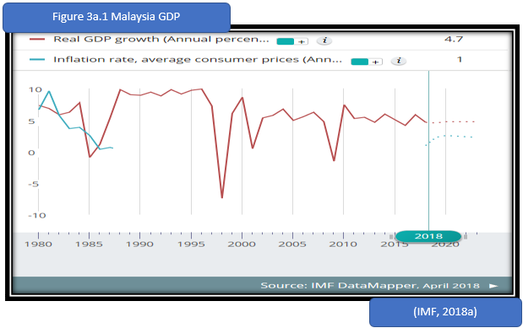
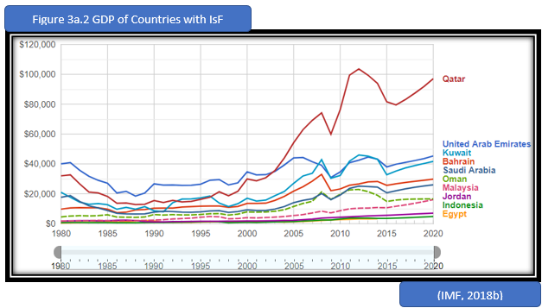
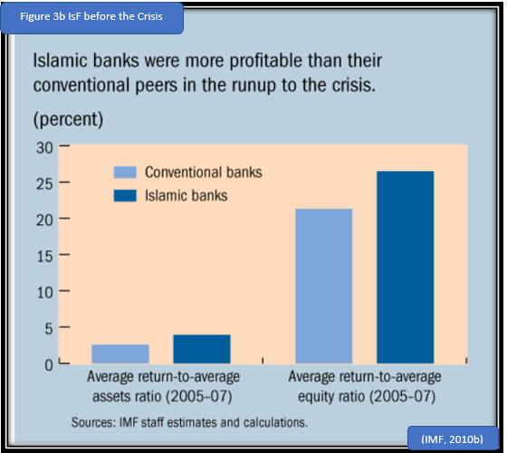
The IsF-banks were more profitable prior to the crisis (see figure 3b). The IsF have higher return-to-average assets ratio and higher average return-to-equity ratio between 2005-2007. By adhering to IsF principles and maintaining smaller investment portfolios and lower leverage initially contained the financial-crisis. However, Figure 3c shows the minor effect on IsF-banks during the crisis, but (figure 3d) show the decline in profit of IsF as the crisis goes beyond financial institutions but into the real economy like the deflation of real-estate prices and other things that also affected the GDP as mentioned above (IMF, 2010a).

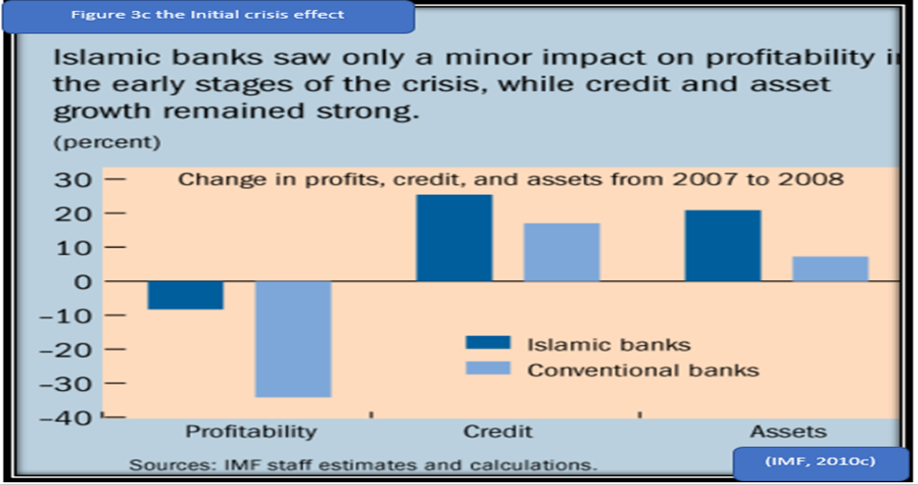
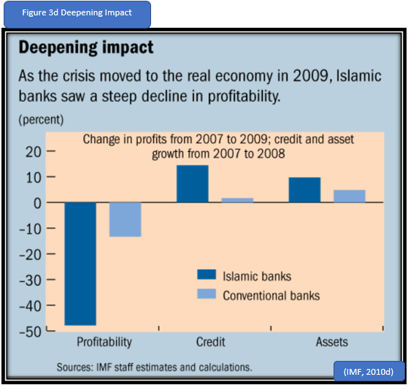
Under IsF, usury is prohibited and in the case of IsF mortgage, IsF allows three models of Home Purchase Plans (HPPs): Ijara, which means 'lease' in Arabic; Musharaka, which means 'partnership' where customers are co-owners with the bank from the start; and Murabaha, meaning 'profit'. In any of these three models, the lender levy rent or add profit to the amount costumers pay back instead of charging interest. Due to the sharing in business risks, including losses, thereby making defaults much unlikely. Also, during a worsening financial economic time, and when IsF-bank is facing a diminishing profit, dividends to shareholders will be
reduced and less profit will be paid out shareholders and revenue will not be paid to depositors. If losses occur, pay-outs are financed from the profit equalisation reserve that most IsF-banks maintain (Ahmed, et al., 2014). But, Cimaglobal (2009) warned against ‘profit equalisation reserves’ to compensate depositors.
Furthermore, IsF pursues Sustainable Development Goals, social enterprise through Zakat. Muslims are commanded to give Zakat, a 2.5% donation of their wealth, this could contribute to ending poverty. Generally, the consumer is favourably disposed to products with social benefit (Noor and Pickup, 2017).
Ahmad (2013) asserted that IsF and a ‘more-ethical-capitalism’ could go together because IsF is promoting sustainability. Spangler (2015) and Alawode, et al., (2018) suggested that the WB supports the IsF principles that people should not profit purely from loans and IsF principles will contribute towards a sustainable eco-system by reducing poverty etc.
In contrast, Irfan (2014) contended that the ideals of Sharia were not actually reflected in the IsF and argued that the IsF is dominated by CB who are addicted to cheap credit that are deploying ‘reverse engineering’ of conventional financial products into their sharia-compliant. Irfan (2014) then concluded that Islam may be guilty of the same thing the Christian financiers in the Middle Ages created to circumvent the Church’s ban. Similarly, other critics like
Rudnyckyj (2017) and Warde (2010) insisted that IsF is not really Islamic or insufficiently Islamic. Barnes (2013) while writing for (Financial Times, 2013) argued that IsF is faith-based and its principle is against modern business school. Barnes (2013) contended, that Islamic-banking principle are unfeasible and that IsF charge interest under the guise of commissions, fees, penalties or profit shares, he reckons the penalty is equivalent to interest. Warde (2010) expounded the view that most major international financial institution now has Islamic operations, thereby forcing the IsF to adapt their strategy.

Financial stability and risk management in Islamic finance
Lebdaoui and Wild (2016a) disclosed that Sharia-compliant banks were mobilising and attracting new funding into financial sector and increasing the variety of financial products available in the market , thereby increasing the financial stability and efficiency of the banking system.
Ali and Izhar (2015) argued that Financial stability is the stability of the entire financial industry and the financial stability of individual financial institutions. The IMF (2010a) agreed that Islamic banks were less affected by the financial crisis because they lent a larger part of their portfolio to the consumer sector, a sector that was not as affected as others.
More still, IsF demands all banking business sale or lease to have an underlying asset therefore, financial crisis is avoided by integrating debt creation with wealth creation, and IsF enssures that finance is always serving economic activities. This integration prevents the creation of an inverted debt pyramid and thus prevents recurrent financial instability (Islamicfianance, 2015a; appendix 3).
In 2008, many financial institutions were in financial crisis which was instigated my subprime crisis which resulted in the collapse of many lending institutions and hedge funds (Investopedia, 2018a). Furthermore, IsF’s products are conservative and they avoid the infinite leverage model, financial gambling (Cimaglobal, 2015; 2009 and Munir, 2013; Appendix 3a). Nonetheless, in 2010, some investment institutions defaulted on their debts including Gulfinvest International, Abu Dhabi Commercial Bank, and International Investment Group that defaulted on $200 million IsF bond. It was the high oil prices and government support for the financial institutions in the GCC that ensures their stability, for example, the government backing in the case of Dubai World debt standstill prevented a triggered of catastrophic chain of event in the region. ‘Standstill’ is equivalent of default under CB (Busler, 2011; Khamis and Senhadji, 2010).
Munir (2013) proposed that IsF allows investment in ethical projects. Again, (Islamicinformationhub, 2018 and Munir, 2013) expounded the view that IsF is based on equity and investment in the real economic projects, thereby ensuring that there is no artificial product.
In addition, Levy 2018 suggested that IsF is suitable for infrastructure development, and the IsF is being used in financing many projects including the Hajj terminal at Medinas airport in Saudi Arabia among others (Levy and Iqbal, 2018; UKTI, 2014a).
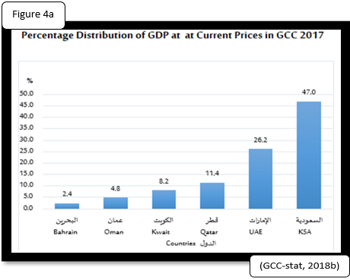
Interestingly the Kingdom of Saudi Arabia account for 47% of the GDP of the GCC region (GCC-stat, 2018; figure 4a). Nonetheless, cheap oil is constraining the economic-growth of the Region. The PwC reports revealed that the GCC regions GDP is very dim (Gulfnews, 2018; figure 4b). WB warned that Bahrain is very vulnerable to financial risk, because the country’s is undergoing slow economic-growth due to huge fiscal deficit (WorldBank, 2017b; appendix 4).
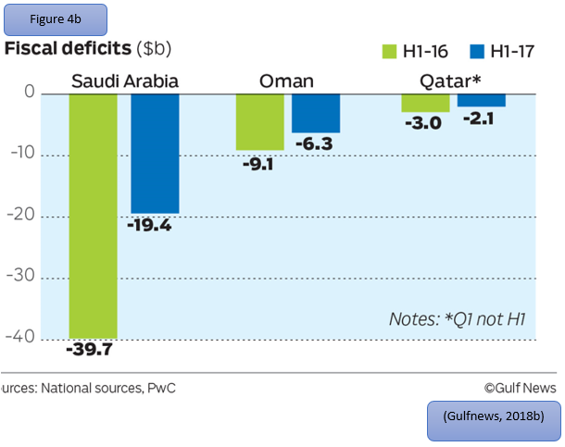
More still, Djennas, et al., (2015) proposed that IsF could be vulnerable in some crisis situations identical to conventional. Recently a UK court ruled that, Dana Gas must repay $700 million (£529.6 million) of Islamic bonds. Dana Gas had claimed it was under no obligation to pay bondholders. This could have set a bad precedent for holders of Islamic bonds (Salaamgateway, 2018; Reuters, 2017). Besides under Mudarabah, the financier has no provision to control (the Islamic bank in this case) and they may suffer loss due to ineptitudes of fund managers. Dar and Presley (2000) warned of management and control imbalances impacting profit Loss Sharing in IsF. In another development, IsF credentials took a hit when UAE and Bahrain were debarred for failing to meet the tax governance standards. These countries were blacklisted for shifting profit to places without economic activities to take advantage of low or no-tax (Islamicfinance, 2017). Many of the customers in GCC, Malaysia, Indonesia, Turkey were dismayed by poor customer service and poor digital presence by those IsF banks (EY, 2015; Islamicfinance, 2017).
Conclusions

IsF appeal is increasing even to CBs and customers and therefore experiencing high growth, it is equity-based, it must be asset-backed, ethical, sustainable, environmentally and socially-responsible finance. In IsF, risk is shared, it promotes social welfare and financial inclusion. It offers greater stability than the conventional financial because speculation is prohibited. IsF does not see money as a commodity unless it is backed by an asset because money is not allowed to create more money, but Islamic financial institutions could only provide service to ‘earn’ its profits. Thus, interest is not allowed but the share of profit and loss. IsF creates wealth as profit and loss are shared, and the 2.5% Zakat, is a way of eliminating poverty in the community.

Recommendations
If CB adopts the under listed, there will be more financial stability.
- IsF pursues SDG as it seeks a just, ethical and equitable distribution of resources. The WB and IMF believed it could be effective in reducing global inequality, and IsF principles could be a catalyst for share prosperity
- Under IsF because there is no speculation or artificial investment, all investment must be backed by economic asset thus the integration prevents the creation of an inverted debt pyramid and thus prevents recurrent financial instability.
- Islam prohibits Interest and trading of debt, this will protect against usury but rather there is joint sharing of profit and loss therefore there won’t be defaulting hence preventing economic collapse.
- IsF can support global infrastructure development as many governments are utilizing Sukuk to fund development, it is a cheaper option therefore, government can invest more in infrastructure.

References
ACCA, 2016. Islamic finance edges towards the mainstream. [Online]
Available at: https://www.accaglobal.com/uk/en/member/member/accounting-business/2016/02/insights/islamic-finance.html
[Accessed 13 11 2018].
Ahmad, S., 2013. How Islamic finance and a more ethical capitalism go hand-in-hand. [Online]
Available at: https://www.theguardian.com/social-enterprise-network/2013/jan/24/islamic-finance-ethical-capitalism-social-enterprise.
Ahmed, H., Astay, M. & Wilson, R., 2014. Islamic-banking and financial crisis reputaion, stability and risks. Edinburgh : Edinburgh University Press Ltd .
Alawode, A., Abdul Aziz, A. H. s. & Maria Aviles, A., 2018. Sustainable Development Goals and the role of Islamic finance. [Online]
Available at: http://blogs.worldbank.org/eastasiapacific/sustainable-development-goals-and-role-islamic-finance
Ali, S. S. & Izhar, H., 2015. Financial Stability and Risk Management in Islamic Financial Institutions. Bloomsbury Qatar Foundation Journal, pp. xii-xvi.
Barnes, W., 2013. Islamic finance sits awkwardly in a modern business school. [Online]
Available at: https://www.ft.com/content/ee2a2b36-9de5-11e2-9ccc-00144feabdc0#axzz3Qlujrt5w
[Accessed 13 11 2018].
Bashir, A.-H. M., 2003. Determinants of Profitability in Islamic Banks: Some evidence from Middle East. Islamic Economic Studie, 11(1), pp. 1-27.
Bordo, M. D. & Jeanne, O., 2002. Boom-Busts in Asset Prices, Economic Instability, and Monetary Policy. International Finance, 5(2), pp. 139-164.
Businessgateways, 2018. Oman to have fastest GDP growth in GCC. [Online] Available at: https://businessgateways.com/news/2018/04/25/Oman-to-have-fastest-GDP-growth-in-GCC
[Accessed 28 11 2018].
Busler, M., 2011. The financial crisis - Western banking versus Islamic banking. World Journal of Entrepreneurship, Management and Sustainable Development, 7(1), pp. 1-16.
Cimaglobal, 2011. An introduction to Islamic finance. [Online]
Available at: http://www.cimaglobal.com/Documents/Islamic%20finance/2011/Guides/Introduction.pdf
Cimaglobal, 2009. Islamic finance could provide much-needed stability in the banking sector. [Online]
Available at: https://www.cimaglobal.com/Documents/Islamic%20finance/The%20Financing%20Challenge.pdf
[Accessed 14 11 2018].
Cimaglobal, 2015. An introduction to Islamic finance. [Online]
Available at: https://www.cimaglobal.com/Documents/Islamic%20finance/Rebrand%20Brochures/Islamic%20Introduction%20brochure_Mar2015.pdf
[Accessed 14 11 2018].
Cliffordchance, 2015. Clifford Chance advises on the first Basel III compliant Tier 2 sukuk issuance out of Turkey by Albaraka Türk Katılım Bankası Anonim Şirketi. [Online]
Available at: https://www.cliffordchance.com/news/news/2015/12/clifford-chance-advises-on-the-first-basel-iii-compliant-tier-2-.html
[Accessed 19 11 2018].
Dar, H. & Presley, J. R., 2000. Lack of Profit Loss Sharing in Islamic-banking :Management and Control Imbalances. international journal of ISLAMIC FINANCIAL SERVICES, 2(2).
Deloitte, 2018. The International Islamic Financial Market. [Online]
Available at: https://www2.deloitte.com/lu/en/pages/islamic-finance/articles/islamic-finance-niche-mainstream-market.html
[Accessed 13 11 2018].
Department for International Trade, Foreign & Commonwealth Office, and HM Treasury , 2014. What is Islamic Finance?. [Online]
Available at: https://assets.publishing.service.gov.uk/government/uploads/system/uploads/attachment_data/file/367154/UKTI_UK_Excellence_in_Islamic_Finance_Reprint_2014_Spread.pdf
Djennas , M., Benbouziane, M. & Djennas , M., 2015. Currency-banking crises and economic downturns: A comparison between Islamic and conventional banks. Bloomsbury Qatar Foundation Journal, pp. 87-99.
Economicshelp, 2018a. Causes of Boom and Bust Cycles. [Online][Picture] Available at: https://www.economicshelp.org/blog/5030/economics/causes-of-boom-and-bust-cycles/
[Accessed 22 11 2018].
Economicshelp, 2018b. Causes of Boom and Bust Cycles. [Online][Picture]Available at: https://www.economicshelp.org/blog/5030/economics/causes-of-boom-and-bust-cycles/
[Accessed 22 11 2018].
Eurekahedge, 2018. Global Islamic Fund Database. [Online] Available at: http://www.eurekahedge.com/Products/islamic-fund-database
[Accessed 21 11 2018].
EY, 2015. World Islamic-banking Competitiveness Report 2014-15. [Online]
Available at: https://www.ey.com/em/en/industries/financial-services/banking---capital-markets/ey-world-islamic-banking-competitiveness-report-2014-15
[Accessed 21 11 2018].
Gccstat, 2018a. Gross Domestic Product at Current Prices. [Online] Available at: https://gccstat.org/en/statistic/statistics/national-accounts
[Accessed 21 11 2018].
Gccstat, 2018b. Gross Domestic Product at Current Prices. [Online] [Picture] Available at: https://gccstat.org/en/statistic/statistics/national-accounts
[Accessed 21 11 2018].
Gccstat, 2018c. Gross Domestic Product at Current Prices. [Online] [Picture] Available at: https://gccstat.org/en/statistic/statistics/national-accounts
[Accessed 21 11 2018].
Gulfnews, 2018. GCC economic growth prospects to improve in 2018. [Online] Available at: https://gulfnews.com/business/gcc-economic-growth-prospects-to-improve-in-2018-1.2104323
[Accessed 28 11 2018].
Hasan, M. & Dridi , J., 2010. The Effects of the Global Crisis on Islamic and Conventional Banks: A Comparative Study, s.l.: International Monetary Fund.
Ilieva, J., Ristovska, N. & & Kozuharov, S., 2017. BANKING WITHOUT INTEREST. UTMS Journal of Economics, 8(2), pp. 131-139.
IMF, 2010a. IMF Survey: Islamic Banks: More Resilient to Crisis?. [Online] Available at: https://www.imf.org/en/News/Articles/2015/09/28/04/53/sores100410a
[Accessed 5 12 2018]. IMF, 2010b. IMF Survey: Islamic Banks: More Resilient to Crisis?. [Online] [image]Available at: https://www.imf.org/en/News/Articles/2015/09/28/04/53/sores100410a
[Accessed 5 12 2018].
IMF, 2010c. IMF Survey: Islamic Banks: More Resilient to Crisis?. [Online] [image]Available at: https://www.imf.org/en/News/Articles/2015/09/28/04/53/sores100410a
[Accessed 5 12 2018].
IMF, 2010d. IMF Survey: Islamic Banks: More Resilient to Crisis?. [Online] [image]Available at: https://www.imf.org/en/News/Articles/2015/09/28/04/53/sores100410a
[Accessed 5 12 2018].
IMF, 2018a. Malaysia. [Online]Available at: https://www.imf.org/en/Countries/MYS#countrydata
[Accessed 9 12 2018].
IMF, 2018b. GDP per capita, current prices. [Online] Available at: https://www.google.com/publicdata/explore?ds=k3s92bru78li6_#!ctype=l&strail=false&bcs=d&nselm=h&met_y=ngdpdpc&scale_y=lin&ind_y=false&rdim=world&idim=world:Earth&idim=country:BH:EG:ID:MY:QA:SA:AE:JO:KW:OM&ifdim=world&hl=en_US&dl=en_US&ind=false
[Accessed 6 12 2018].
Investopedia, 2018a. Subprime Meltdown. [Online]
Available at: https://www.investopedia.com/terms/s/subprime-meltdown.asp
[Accessed 14 11 2018].
Investopedia, 2018b. Boom And Bust Cycle. [Online] Available at: https://www.investopedia.com/terms/b/boom-and-bust-cycle.asp
[Accessed 23 11 2018].
Irfan, H., 2014. Could Islamic finance save capitalism?. [Online]
Available at: https://www.theguardian.com/sustainable-business/2014/dec/04/could-islamic-finance-solution-capitalism
Islamicfinance, 2017. Blacklist Could Curtail Free Flow of Islamic Financial Funds to UAE and Bahrain. [Online] Available at: https://www.islamicfinance.com/2017/12/eu-finance-ministers-blacklist-uae-bahrain/
[Accessed 12/10/2018 5 12]
Islamicfianance, 2015a. Islamic vs Conventional Finance. [Online]
Available at: https://www.islamicfinance.com/2015/02/islamic-finance-vs-conventional-finance/
[Accessed 12 10 2018].
Islamicfinance, 2015b. A landmark year for global Islamic finance industry. [Online]
Available at: http://www.islamicfinance.com/wp-content/uploads/2015/01/MIFC-INSIGHT-REPORT-ISLAMIC-FINANCE-SOPHISTICATED-FRAMEWORK.pdf
[Accessed 14 11 2018].
Islamicfinance, 2015d. Islamic Finance Seminar. [Online]
Available at: https://www.islamicfinance.com/wp-content/uploads/2015/12/Islamic-Finance-Seminar-Manchester-Chamber-of-Commerce.pdf
[Accessed 15 11 2018].
Islamicfinance, 2016. Islamic-banking Growth Outstripping Conventional Banking. [Online]
Available at: https://www.islamicfinance.com/2016/09/islamic-banking-growth-outstripping-conventional-banking-growth/#Retail_Demand_and_Government_Support_is_Helping_Boost_Growth
[Accessed 15 11 2018].
Islamicfinance, 2018. Moody’s: UK’s first asset-backed Sukuk is credit positive for Al Rayan Bank and Islamic financial institutions. [Online]
Available at: https://www.islamicfinance.com/2018/03/moodys-uks-first-asset-backed-sukuk-credit-positive-al-rayan-bank-islamic-financial-institutions/
[Accessed 14 11 2018].
Islamicinformationhub, 2018. Islamic Products. [Online]
Available at: http://islamicinformationhub.com/2018/11/07/banking-without-interest-and-islamic-finance-context/?i=1
[Accessed 16 11 2018].
Khan, K. A., 2013. Emerging Islamic-banking : Its Need and Scope in India. Pacific Business Review International, 5(7).
Lebdaoui, H. & Wild, J., 2016a. Islamic-banking presence and economic growth in Southeast Asia. International Journal of Islamic and Middle Eastern Finance and Management, 9(4), pp. 551-569.
Lebdaoui, H. & Wild, J. (2016b). Islamic-banking and Financial Development. Review of Middle East Economics and Finance, 12(2), pp. 201-224.
Levy, J. & Iqbal, Z., 2018. How Islamic finance can boost infrastructure development. [Online]
Available at: http://blogs.worldbank.org/voices/how-islamic-finance-can-boost-infrastructure-development
[Accessed 21 11 2018].
Malik, B. A. & Khaki, G. N., 2015. SCOPE AND FEASIBILITY OF ISLAMIC-BANKING AND FINANCE MODEL KAZAKHSTAN & INDIAN PERSPECTIVE. The Journal of Central Asian Studies, 22(1), pp. 83-111.
Marifa Academy, 2014. ISLAMIC-BANKING & FINANCE: PRINCIPLES AND PRACTICES. s.l.:MarifaAcademy.com.
MIFC, 2017a. Malaysia: An Islamic Finance Marketplace for Expertise, Innovation and Deal Flow. [Online] Available at: http://www.mifc.com/index.php?rp=future_finance_report
[Accessed 3 12 2018].
MIFC, 2017b. Malaysia: An Islamic Finance Marketplace for Expertise, Innovation and Deal Flow. [Online] Available at: http://www.mifc.com/index.php?rp=future_finance_report
[Accessed 3 12 2018]
Munir, K., 2013. slamic finance: the way forward. [Online]
Available at: https://insight.jbs.cam.ac.uk/2013/islamic-finance-the-way-forward/
[Accessed 16 11 2018].
Noor , Z. & Pickup, F., 2017. TheGuardian.com. [Online]
Available at: https://www.theguardian.com/global-development-professionals-network/2017/jun/22/zakat-requires-muslims-to-donate-25-of-their-wealth-could-this-end-poverty
Nor, F. M., Fadzlina, M. F. & Asyaari, E. A., 2015. The influence of AAOIFI Accounting Standards in Reporting Islamic Financial Institutions in Malaysia. Procedia Economics and Finance, Volume 31, p. 418 – 424 .
PNA.gov.ph, 2018. House approves bill on regulation of Islamic banks. [Online] Available at: http://www.pna.gov.ph/articles/1054433
[Accessed 21 11 2018].
Reuters, 2017. UK court finds for Dana Gas creditors in $700 million Islamic bond case. [Online]
Available at: https://uk.reuters.com/article/uk-dana-gas-sukuk/judge-rules-in-favour-of-creditors-in-dana-gas-islamic-bond-case-idUKKBN1DH1BY
[Accessed 16 11 2018].
Richardson, E., 2011. Islamic Finance for Consumers in Ireland: A Comparative Study of the Position of Retail-level Islamic Finance in Ireland. Journal of Muslim Minority Affairs, p. 536.
Ross, M. L., 2018. Working With Islamic Finance. [Online]
Available at: https://www.investopedia.com/articles/07/islamic_investing.asp
[Accessed 15 10 2018].
Rudnyckyj, D., 2017. Debating Form, Consuming Substance: Halal Authenticity in Malaysian Islamic Finance. Practicalmattersjournal.org, Spring(10), pp. X-XXX.
Securities Commission Malaysia, 2018a. Islamic Finance and Public-Private Partnership: Viability, Opportunities and Recommendations, Kuala Lumpur, Malaysia: Securities Commission Malaysia.
Securities Commission Malaysia, 2018b. [image] Islamic Finance and Public-Private Partnership: Viability, Opportunities and Recommendations, Kuala Lumpur, Malaysia: Securities Commission Malaysia.
Salaamgateway, 2018. Report: State of the Global Islamic Economy 2018/19. [Online]
Available at: https://www.salaamgateway.com/en/story/Report_State_of_the_Global_Islamic_Economy_201819-SALAAM06092018061914/
[Accessed 14 11 2018].
Salaamgateway, 2018. UAE’s Dana Gas says has $434 million in cash after sukuk restructuring. [Online]
Available at: https://www.salaamgateway.com/en/story/uaes_dana_gas_says_has_434_million_in_cash_after_sukuk_restructuring-SALAAM14112018072340/
[Accessed 14 11 2018].
Siddiqi, M. N., 2006. ISLAMIC-BANKING AND FINANCE IN THEORY AND PRACTICE: A SURVEY OF STATE OF THE ART. Islamic Economic Studies, 13(2).
Spangler, T., 2015. Could principles of Islamic finance feed into a sustainable economic system?. [Online]
Available at: https://www.theguardian.com/sustainable-business/islamic-finance-sustainable-economic-system
Sobola, A. (2018a). Principles of Islamic Finance . Carmarthen: University of Wales Trinity St David.
Statista, 2018a. Distribution of global Islamic fund assets in 2017, by domicile. [Online]
Available at: https://www.statista.com/statistics/649320/distribution-of-islamic-fund-assets-by-domicile/
[Accessed 15 11 2018].
Sukuk.com, 2018. The Islmic Finance. [Sound Recording] (Sukuk.com).
Suleman, M. N., 2001. Corporate Governance in Islamic Banks – Society and Economy in Central and Eastern Europe. Journal of Budapest University of Economic Sciences and Public Administration, 22(3).
The Economist, 2014. Big interest, no interest. [Online]
Available at: https://www.economist.com/finance-and-economics/2014/09/13/big-interest-no-interest
[Accessed 15 10 2018].
The World Bank, 2015. Islamic Finance. [Online] Available at: http://www.worldbank.org/en/topic/financialsector/brief/islamic-finance
The World Bank, 2017a. New Report Outlines Actions to Leverage Islamic Finance for Development. [Online] Available at: http://www.worldbank.org/en/news/feature/2017/02/21/new-report-outlines- actions-to-leverage-islamic-finance-for-development
[Accessed 12 10 2018].
World Bank, 2017b. GCC: Economic Outlook- April 2017, s.l.: The World Bank.
Warde, I., 2010. Islamic Finance in the Global Economy. 2 ed. Edinburgh: Edinburgh University Press.
Yosof, R. M. & Bahlous, M., 2013. Islamic-banking and economic growth in GCC & East Asia countries: A panel cointegration analysis. Journal of Islamic Accounting and Business Research, 4(2), pp. 151-172.
Yudistira, D., 2004. Efficiency in Islamic-banking : an empirical analysis of eighteen banks. Islamic Economic Studies, 12(1).

Bibliography

Appendices

Appendix 1
Other countries like Nigeria, Pakistan, are changing regulations to allow conventional players
to establish IsF especially takaful (Islamicfinance, 2015c).

Appendix 2
When malinvestment effects sets in, property values decrease, investors lose money, demand
of consumer product falls as consumers reduce spending resulting in companies downsizing.
The culmination of the above is the unwillingness of lenders to give credits and borrowers
begin to default (Bordo and Jeanne, 2002; Investopedia, 2018b).

Appendix 3
Furthermore, Ahmed, et al., 2014) claimed IsF economic growth is similar to conventional
banks and then concluded that Islamic banks may face less pro-cyclical financing if they
relied more on profit and risk sharing.

Appendix 3a
Also, the global financial crisis of 2008 was exacerbated by because of the failure of risk
assessment and management at the institutional. Again, Islam prohibits Interest and if the IsF
continue to adhere to the prohibition of Gharar when drafting-contracts, and avoid Riba with
strong ethical regulatory body, they could be effective in preventing financial crisis (Ahmed,
et al., 2014)

Appendix 4
The GCC countries have had to introduce tight spending regime and introduce VAT, Custom
& Excise duties, to reduce the deficit (Businessgateways, 2018).

