James Hunt (2215832)
2215832@student.uwtsd.ac.uk
Changemakers
ACCA5033
Assignment Two

Contents
Link to e-Portfolio 2
Task One 3
Task Two 4
Task Three 4
Participation marks 5

Link to e-Portfolio
Link to Microsoft Sway
https://sway.office.com/7YVwR7FVaXdE3Agq?ref=Link



Task One
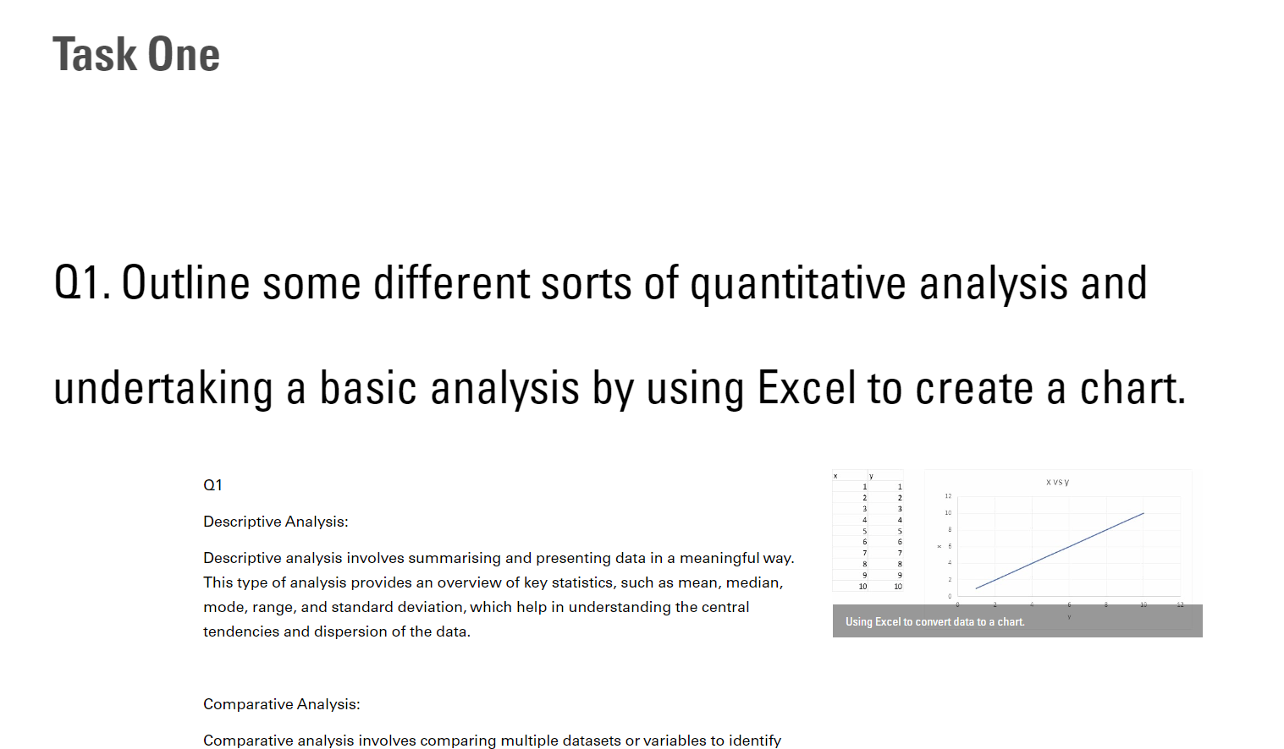

Task Two
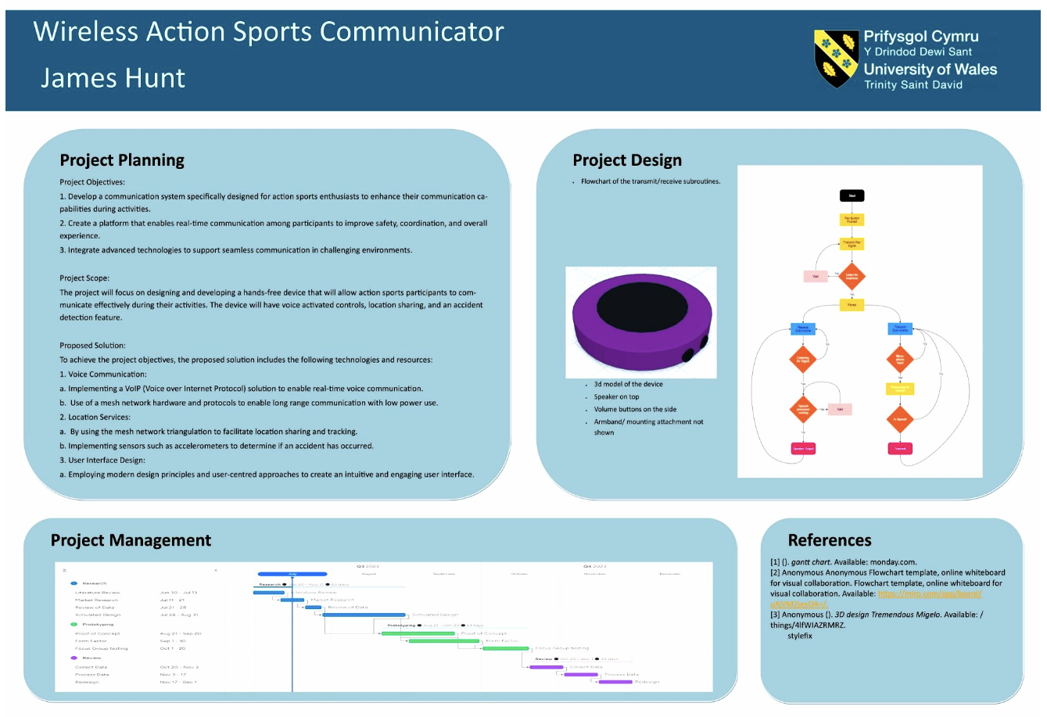

Task Three
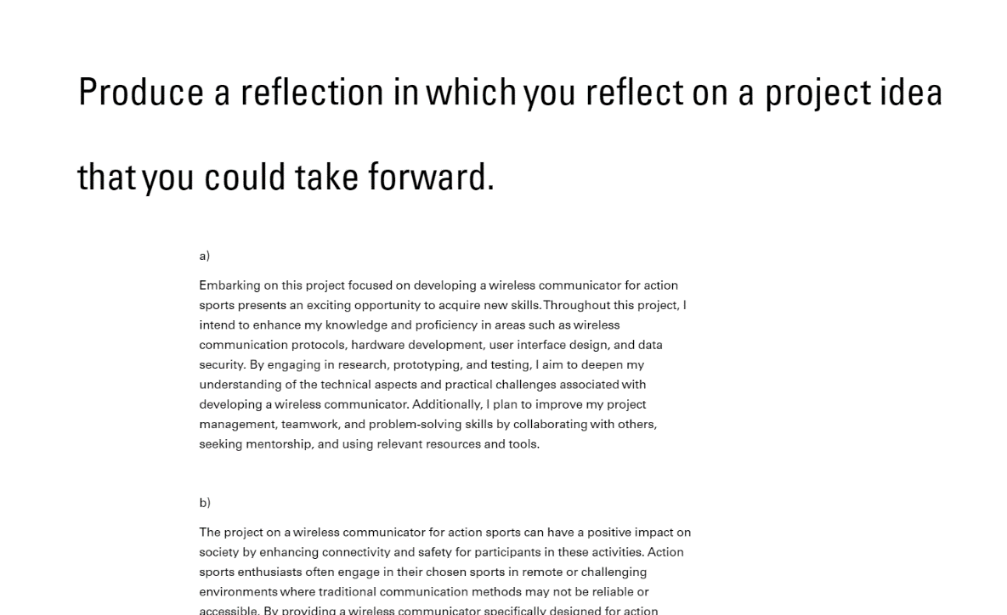

Participation marks
Ref Unit 4
https://uowtsd-my.sharepoint.com/:o:/g/personal/2215832_student_uwtsd_ac_uk/EqaKmsTNzXlJuLyY6L21PTcBOxxEklmVu-54dVTiMpApYA

