Name: Cory Sibley

Student Number: 2507186

Module: Fundamentals of Construction Technology

Word Count: 2186

Table of Contents
Introduction and Site Details 3
Historical Appraisal 4
Geological Appraisal 5
Environmental Appraisal 8
Archaeology Appraisal 9
Conceptual Ground Model 10
Recommendations for Detailed Site Investigation 12
Codes of Practice, Regulations and Stakeholders 13
Foundation Recommendation 13
References 14

Introduction and Site Details
This report presents a preliminary desktop study and foundation appraisal for a proposed mixed-use development on Swansea foreshore, located between Swansea Civic Centre, formerly County Hall, and Delta Hotels by Marriott Swansea in the Maritime Quarter. The proposed scheme comprises a restaurant, cafe/bar and ice-cream parlour at ground floor level, with upper-floor accommodation and staff welfare facilities, positioned within a constrained urban waterfront setting.

The purpose of the report is to support the feasibility stage by identifying the main ground-related risks likely to affect the development, and by outlining the information needed before a detailed site investigation and final foundation design can be completed. The assessment uses available historical, geological and environmental information, together with representative borehole data from the wider Swansea marina area.

A desktop study is a critical first step in ground investigation because it establishes an understanding of previous land use, likely ground conditions, groundwater factors and physical site constraints before intrusive works are planned (BSI, 2015a). Given the site's coastal location, proximity to existing buildings and long history of waterfront change, a site-specific appraisal is necessary to guide the later investigation and reduce construction uncertainty (BSI, 2015a; BSI, 2015b).

Figure 1 supports this location appraisal by showing the relationship between Swansea Civic Centre, the bay frontage and the wider urban waterfront setting.
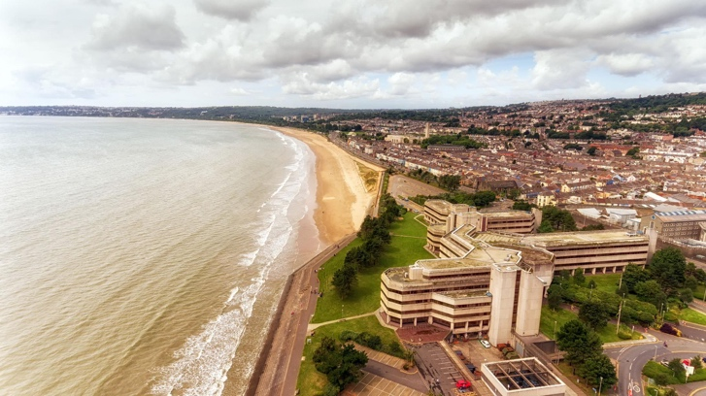
Figure 1. Aerial view of Swansea Civic Centre and Swansea Bay frontage, showing the coastal and urban context of the proposed development area.

Historical Appraisal
The proposed site forms part of a coastal area that has undergone considerable transformation since the nineteenth century. Historically, the Burrows comprised of sandy coastal meadows between Swansea and the sea, before the town expanded westwards and the foreshore became increasingly formalised (Swansea Council, 2024). This background is important because former coastal margins are often affected by reworking, reclamation and variables near-surface deposits, which can influence excavation stability, bearing capacity and groundwater movement.
During the mid-nineteenth century, Swansea's industrial and maritime growth reshaped the waterfront. The opening of the North Dock and South Dock in 1859 altered the coastline and strengthened the Maritime Quarter's role in dock, transport and commercial activity (Swansea Council, 2025; History Points). Although the site lies west of the main dock basins, it formed part of the same wider coastal zone influenced by urban expansion, transport infrastructure and changing shoreline use. Historic aerial evidence of the civic seafront also shows that engineered development progressively replaced open ground during the twentieth century (Britain from Above, 1935).
The foreshore corridor was also associated with the Swansea and Mumbles Railway, which operated along the bay until closure in 1960 (People's Collection Wales). Former transport corridors can leave buried obstructions, localised made ground or disturbed strata beneath later redevelopment, making them relevant to site investigation planning.
A further phase of change occurred in the late twentieth century, when the former dockland environment was redeveloped into Swansea Marina and the Maritime Quarter, shifting the area toward leisure, residential and commercial use (History Points). More recently, Swansea Council has identified the Civic Centre waterfront as part of a regeneration area, confirming the continued redevelopment pressure affecting the site (Swansea Council, 2026).
Overall, the site should be treated as a historically modified coastal environment, rather than undisturbed natural ground. Its history increases the likelihood of anthropogenic deposits, buried obstructions and variable subsurface conditions that must be addressed within the detailed investigation strategy.
Figure 2 supports this historical appraisal by illustrating the twentieth-century development of the civic waterfront and the transition from open foreshore to engineered urban land.
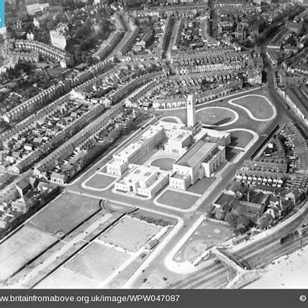
Figure 2. Historic aerial view of Swansea Civic Centre and surrounding foreshore context, illustrating twentieth-century development of the waterfront.

Geological Appraisal
The geological conditions at the proposed site are likely to be variable because of its coastal setting, glacial history and later urban development. The Swansea district is underlain by carboniferous strata, while superficial deposits in the wider area include glacial till, sands, gravels and locally reworked coastal materials (BGS, 2011). Such deposits can vary significantly in strength, density and permeability, particularly where later redevelopment has introduced made ground or altered the natural shoreline profile.
The supplied representative borehole from the Swansea marina area provides the most direct indication of likely local stratigraphy. The log records approximately 4.95 m of made ground, including ash, sand, clay, brick shale and dense bricks, overlying very dense sandy gravel and sand with some gravel. Below this, stiff to very stiff gravelly boulder clay extends to approximately 18.60 m, with grey mudstone encountered beneath and the hole completed to 22.0 m. A standpipe was installed after completion, indicating that groundwater monitoring was considered necessary in this ground profile.
This sequence is significant for foundation appraisal. Made ground is commonly heterogeneous and may contain construction debris, voids or zones of variable compaction, making it unsuitable to assume consistent bearing performance without testing. The dense granular deposits may provide improved resistance, but their permeability could allow groundwater movement, which may affect excavation stability and contaminant migration. The deeper boulder clay and mudstone may provide more competent founding conditions, although their depth and continuity must be verified beneath the actual footprint rather than inferred from one nearby record.
The geological appraisal therefore suggests that shallow foundations placed within near-surface deposits could be vulnerable to differential settlement. Intrusive investigation is needed to confirm the thickness and composition of made ground, the lateral continuity of natural strata, groundwater behaviour and the depth to suitable bearing layers before a final foundation solution is selected.
Figure 3 supports this geological appraisal by presenting the representative borehole sequence used to inform the preliminary interpretation of made ground, natural strata and deeper bearing layers.
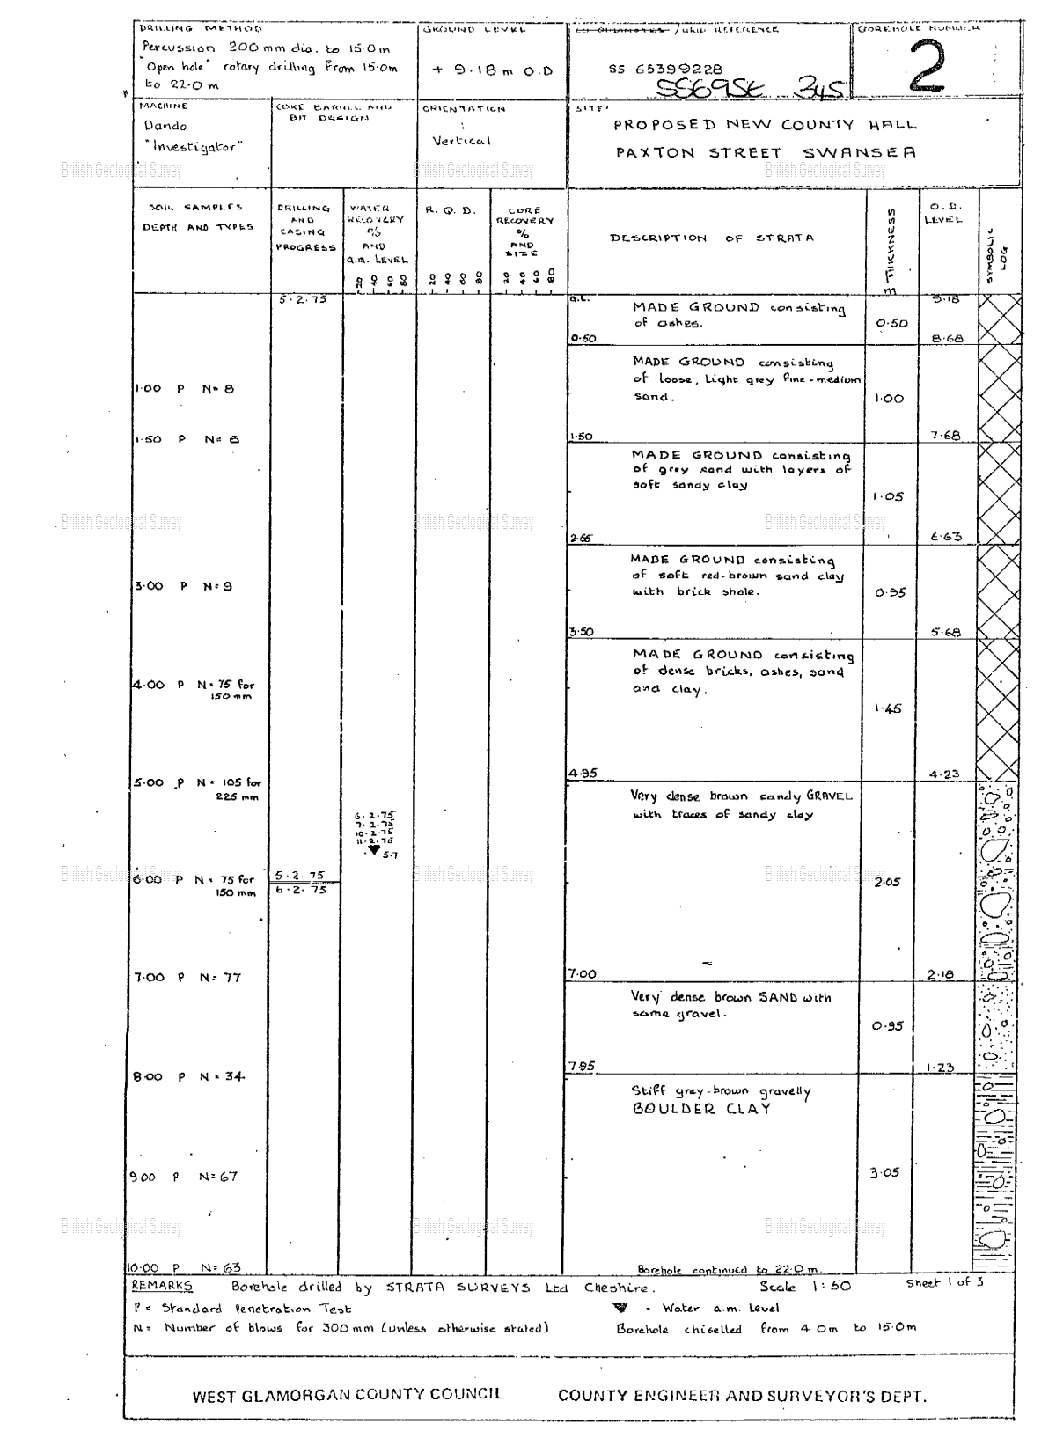
Figure 3. Representative borehole log from the Swansea marina area, used to inform the preliminary stratigraphic interpretation for the proposed foreshore site.

Environmental Appraisal
The environmental context of the proposed development is strongly influenced by its coastal position on Swansea foreshore and its location within a heavily urbanised waterfront setting. Sites of this nature require careful consideration of contamination, groundwater behaviour and potential impacts on surrounding receptors. The historical appraisal indicates repeated redevelopment, meaning that made ground, buried infrastructure and disturbed deposits are credible environmental concerns.
Potential contamination is a key issue. Historic dockland, transport and urban activities around Swansea waterfront may have introduced hydrocarbons, heavy metals, ash, brick fragments and other construction debris into near-surface deposits. BS 10175 identifies previous land use as a primary indicator of contamination risk, particularly on reclaimed or redeveloped urban land (BSI, 2017). This is relevant because the representative borehole records made ground at shallow depth, suggesting that soil testing should be included within the later intrusive investigation.
Groundwater and hydrology are also significant. The site's proximity to Swansea Bay suggests the possibility of a shallow or fluctuating water table, while permeable granular layers may allow groundwater movement through the ground profile. This could affect excavation stability, dewatering requirements and contaminant migration (Freeze and Cherry, 1979). Environmental receptors include construction workers, future occupants, adjacent buildings, buried services and the nearby marine environment. Therefore, targeted contamination testing and groundwater monitoring should form a key part of the detailed investigation.
Figure 4 supports this environmental appraisal by illustrating the site's coastal context and the potential relevance of marine conditions to groundwater behaviour.
Figure 4. Swansea Bay/coastal setting used to illustrate the environmental context of the proposed foreshore site.

Archaeology Appraisal
The potential for archaeological remains must be considered because the proposed site lies within a long-established Swansea foreshore setting. However, the significance of this risk is influenced by previous ground disturbance. The historical appraisal indicates substantial urban redevelopment, including civic construction, transport infrastructure and waterfront regeneration, which may have removed or disturbed earlier deposits.
Despite this, developed coastal sites can still retain buried features associated with earlier shoreline use, land reclamation, sea defences or historic transport routes. Remnants of the Swansea and Mumbles Railway or earlier foreshore structures may survive beneath made ground. Historic England (2017) notes that urban sites can retain archaeological remains where earlier features are sealed below later development.
The archaeological risk is therefore considered moderate but site-specific. Consultation with the local planning authority should be undertaken before intrusive works, with an archaeological assessment completed if required. This would help ensure that buried remains or historic obstructions are identified and managed appropriately during investigation and construction.
Figure 5 supports this archaeological appraisal by illustrating the historic foreshore context and the potential for buried features linked to shoreline and transport-related development.
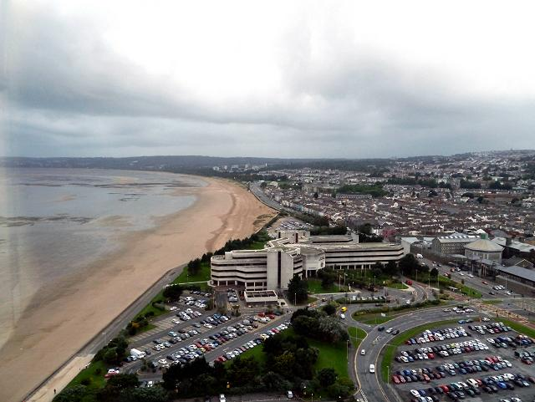
Figure 5. Historic Swansea foreshore context illustrating long-term coastal and transport-related development.

Conceptual Ground Model
The conceptual ground model (CGM) provides a preliminary interpretation of ground-related risks by identifying potential sources, pathways and receptors. At this stage, the model is based on the historical, geological and environmental appraisals, together with the representative borehole information from the Swansea marina area. It should therefore be treated as an initial working model that requires confirmation through intrusive investigation.
The main sources of risk are likely to include made ground linked to historic redevelopment, possible contamination from former waterfront and transport-related activities, and variable natural deposits such as granular soils and boulder clay. Anthropogenic materials are often inconsistent in composition, density and strength, which can make their engineering behaviour difficult to predict (BGS, 2011). Groundwater influenced by the coastal setting is also a potential source of risk, particularly where permeable granular layers allow movement through the ground profile.
Potential pathways include direct contact with contaminated soils during excavation, migration of pollutants through groundwater, and load transfer through variable strata. From a geotechnical perspective, these conditions may create uneven bearing resistance and increase the risk of differential settlement if foundations are placed in unsuitable near-surface material (BSI, 2015).
The main receptors are construction workers, future building users, nearby buildings including Swansea Civic Centre and the Marriott hotel, buried utilities and the adjacent marine environment. Overall, the CGM highlights three priority risks; variable made ground, groundwater behaviour and possible contamination. These uncertainties justify a targeted intrusive investigation before finalising the foundation design.
Figure 6 supports the conceptual ground model by visually summarising the relationship between possible sources, pathways and receptors.
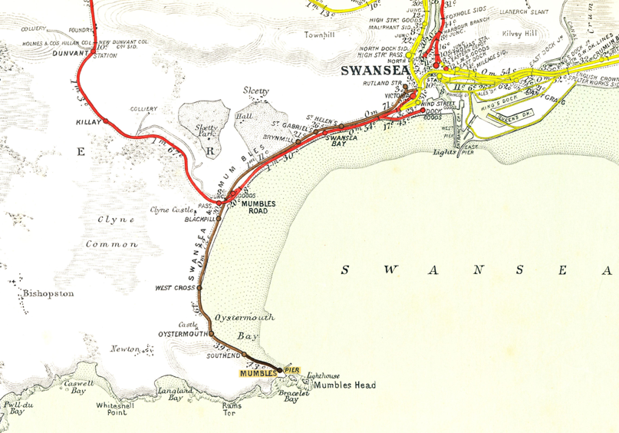
Figure 9. Conceptual ground model diagram showing source-pathway-receptor relationships.

Recommendations for Detailed Site Investigation
Based on the preliminary desktop study and conceptual ground model, a detailed intrusive site investigation is required to confirm ground conditions and reduce uncertainty prior to foundation design. The scope of investigation should be proportionate to the scale of the proposed development and the identified risks, in accordance with BS 2015, which emphasises that investigation strategies must obtain sufficient geotechnical and environmental data for safe and economical design (BSI, 2015).
A series of boreholes should be distributed across the proposed building footprint to determine stratigraphy, groundwater conditions and the depth to competent bearing strata. Borehole spacing should reflect the building size and anticipated variability of ground conditions, with additional exploratory points located near existing structures and areas where made ground is expected. Trial pits should also be undertaken where access permits to allow direct inspection of near-surface materials and identification of buried obstructions.
Sampling should include both disturbed and undisturbed samples to enable assessment of strength, compressibility and permeability. Laboratory testing should include classification tests and shear strength analysis, while in-situ testing such as Standard Penetration Tests (SPT) should be carried out to provide indicative strength parameters for granular soils.
Due to the coastal setting, groundwater monitoring is essential. Standpipes should be installed to assess groundwater levels and potential tidal influence. Where contamination is suspected, chemical testing of soils and groundwater should be undertaken in accordance with BS 10175:2017 (BSI, 2017).
The most significant risks requiring investigation are the thickness and variability of made ground, groundwater behaviour, and confirmation of the depth and continuity of competent bearing strata.

Codes of Practice, Regulations and Stakeholders
The recommendations within this report are informed by established UK standards relating to ground investigation and foundation design. BS 2015 provides guidance for the planning and execution of ground investigations, ensuring that sufficient data is obtained to assess ground conditions and associated hazards (BSI, 2015). BS 2015 outlines the general requirements for foundation design, including considerations of bearing capacity, settlement and variability of ground conditions (BSI, 2015). In addition, BS 2017 provides guidance for the investigation and assessment of potentially contaminated land (BSI, 2017).
At a local level, Swansea Council will be responsible for planning approval and building control. Natural Resources Wales may also be consulted regarding environmental protection, groundwater and flood risk. Utility providers must be engaged to identify and protect existing underground services prior to intrusive works.
Foundation Recommendation
Based on the available preliminary evidence, a piled foundation system is considered the most suitable solution for the proposed development, subject to confirmation through intrusive investigation. This recommendation reflects the building scale, its coastal location and the presence of variable near-surface ground conditions.
Shallow strip or pad foundations are generally suitable only where competent bearing strata occur at shallow depth. However, the representative borehole indicates approximately 4.95 m of made ground overlying denser natural deposits. Made ground is typically heterogeneous and variable in strength, making it unsuitable as a reliable bearing layer and increasing the risk of differential settlement (BSI, 2015).
A piled foundation system would allow structural loads to be transferred through the variable upper deposits into deeper, more competent strata, thereby reducing settlement risk. This is particularly important for a building with a relatively large footprint located adjacent to existing structures. Ground beams or pile caps would distribute loads effectively across the pile system.
Raft foundations may also be considered, as they spread loads over a wide area. However, they may still be susceptible to settlement if constructed over variable made ground or groundwater-sensitive deposits. Therefore, a piled solution is considered the most appropriate preliminary option, with final design dependent on confirmation of ground conditions, groundwater levels and bearing strata through detailed site investigation.

References
BGS (2011) Geology of the Swansea district: a brief explanation of Sheet 247 Swansea. Nottingham: British Geological Survey.
Britain from Above (1935) WPW047087 Wales: view of newly built civic centre, Swansea, oblique aerial view.
British Standards Institution (2015a) BS 5930:2015 Code of practice for ground investigations. London: BSI.
British Standards Institution (2015b) BS 8004:2015 Code of practice for foundations. London: BSI.
British Standards Institution (2017) BS 10175:2017 Investigation of potentially contaminated sites - Code of practice. London: BSI.
Freeze, R.A. and Cherry, J.A. (1979) Groundwater. Englewood Cliffs: Prentice Hall.
Historic England (2017) The Setting of Heritage Assets: Historic Environment Good Practice Advice in Planning Note 3. 2nd edn. London: Historic England.
History Points Swansea marina. Available at: History Points website.
People's Collection Wales (no date) The Mumbles Railway. Available at: People's Collection Wales website.
Swansea Council (2024a) Archives - The Georgian Guildhall in the Maritime Quarter. Available at: Swansea Council website.
Swansea Council (2025a) Conservation area - Maritime Quarter (including Cambrian Place). Available at: Swansea Council website.
Swansea Council (2026) Regeneration projects: Civic Centre site. Available at: Swansea Council website.

