  Component One: Student Journal (learning log) 750 words +/- 10%  Contribution to Overall Module Assessment: 25% | Student No: | 2245646
 | Module Title: | Hotel Administration  and Front Office  Operations
 | Module Code: | BMIH4004
 | Lecturer: | Natalie Brailsford,  Dan Payne, Lisa  Bassler Giulia  Chifari, Ben Chong  Scott James.
This reflection is based on the well-known Gibbs Model of Reflection, an established framework that is recognised for its structured way of achieving deep introspection and critical analysis.
1. Description
As a placement in the reception at Maldron Hotel, some of the tasks that I was supposed to perform included admitting guests, checking out guests, and responding to guests’ inquiries and complaints. I also had to coordinate with the housekeeping and other departments to ensure the rooms were ready for guests at the appropriate time. My job was to give some information to the guests regarding the hotels’ services and other places of interest (Heyes, 2017). Though this reflection was done based on housekeeping, I will write based on my tasks in the front office as needed.
As the front office played the most critical role in terms of guest interactions, my position was pivotal in moulding the guest experience. Despite there were some moments when I felt much pressure working with several guests or faced difficult situations, I can state that it was rather interesting, and I have a lot of things to learn (Sturman et al., 2011).
2. Feelings
At first, I had a positive attitude towards the position, but I did have a bit of apprehension about assuming front office responsibilities. As much as I would wish to go out there and gain work experience, I had some fears as to how I could cope with challenging events, especially when it comes to managing disgruntled customers or guests. I sometimes became stressed during the busy time by the end of the month, when there was a need to check in customers and at the same time attend to complaints or requests from the guests. But as I progressed through my work, I gained confidence in my communication skills and found a particular satisfaction in the fact that all guest issues can be resolved without much time(Sturman et al., 2011).
At the end of the placement, I was proud of how I handled these issues, though I was nervous at the beginning of the placement and wanted to do a better job in handling all these challenges(Hammer, 2019).
3. Evaluation
Another of the assets that I highlighted during my placement was communication with the guests. I also reported to guests with a friendly and professional attitude, even if the guests were unpleasant or displeased. This skill assisted me in making sure that any guests who had issues throughout their stay could be sent off a happy camper (Simonsen). I realised that my multitasking skills needed improvement. At some point, I seriously realised that I could not manage many activities at the same time, and this caused delays and stress. Also, my conflict-solving skills were more or less optimal, and this is quite evident in the scenarios described below. While being able to deal with anger from the guests, I was able to cool them down, but it made me understand that I needed to learn how to solve those conflicts in a more professional and assertive manner (Tesone, 2012).
4. Analysis
Guest front office area is considerately the most important portion of the hotel. It is the first and possibly the only point of interaction with the guests, which makes first impressions and final impressions very important. While I was working in this field, I found that communication skills, problem-solving, and teamwork are crucial to delivering good service. I also learned the need to collaborate with other departments, most importantly the housekeeping department. The major output of the front office and housekeeping communication was the timely preparation of the rooms to avoid clients’ discomfort. That experience taught me how related all the departments are in providing a smooth interface to the customers (Tewari, 2009).
5. Conclusion
I have learnt that the front office reception is one of the most important subsectors of the total hotel operation. I also learned various key competencies required for the performance of this position such as communication, time management, and conflict solving. While working on this project, I was able to approach communication and problem-solving more efficiently than before, however I recognise that I have less efficiency when it comes to managing my time and conflicts.
This experience helped me learn about the hospitality industry and the value of keeping guests satisfied. It has also led to motivation towards the areas that one should enhance so that whoever is hired to occupy the other positions within the industry can be well-equipped.
6. Action Plan
In the future, I will work on my multitasking and conflict resolution abilities through utilizing training and gaining as many practical experiences as possible. I will improve my confidence in handling guest complaints because I will attend workshops or courses in conflict management (Stevenson).
Further, I plan on enhancing self-organizing during periods of high stress by focusing on organizing skills along with time management. In improvements of these areas, I wish to improve with my overall performance in front office positions, and thereby provide a constant progression and success in my future hospitality career.

Component Two
Contribution to Overall Module Assessment: 25%
Trip Advisor Review Response 150 words +/-10%
Dear Susanj R,
Thank you for such a detailed description of your stay at Maldron Hotel Newcastle. Thank you for sharing your thoughts with us; we are glad that you were satisfied with our service and facilities. We pride ourselves on offering the best guest experience, and knowing that our team was recognized for the effort they put in to deliver this promise is highly valued, especially to Scotty and Sandra from Edwards Coaches. I am glad that it was great to learn that you considered our hotel clean, convenient and up to date, for those are aspects that we endeavour to keep optimum at all times.
Feedbacks that you have given concerning our housekeeping team has also been passed to them, and they are over joyed to be recognised by you. Such comments make us want to maintain our high standards in service delivery and we appreciate your generous feedback. We are also looking forward to hosting you again soon at Maldron Hotel Newcastle.
Warm regards,
Guest Relations Manager
Maldron Hotel Newcastle

Screen shot of referenced Trip Advisor review used:
Susanj, R., 2024. TripAdvisor Review – Maldron Hotel Newcastle. [online] Available at: https://www.tripadvisor.co.uk [Accessed 26 Oct. 2024].
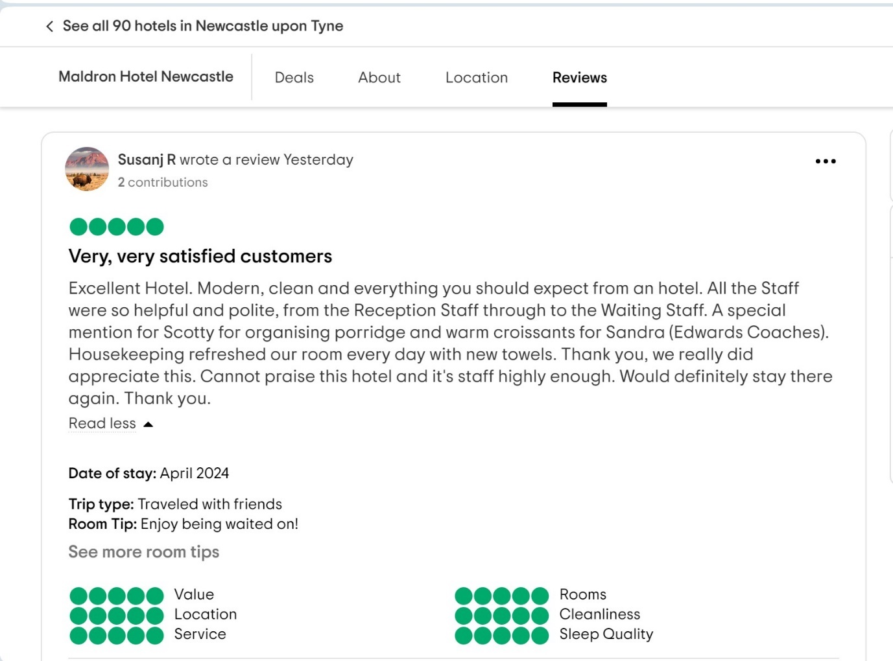
Letter of complaint response 500 words +/- 1-%
Mrs. Joanna Blake
558 Longford Road
Swansea
SA1 2AR
October 27, 2024
Subject: Response to Your Concerns (Stay at Room 330)
Dear Mrs. Blake,

Thank you for providing us with your valuable feedback regarding your recent stay at our hotel. We deeply regret that your experience fell short of the high standards we aim to deliver, and I sincerely apologize for any inconvenience caused during your visit.
First, I am genuinely sorry to learn that the cleanliness of your room was not up to the level that we promised to our guests. We recognize that cleanliness is a fundamental aspect of guest satisfaction, and it is entirely unacceptable that your room was not properly cleaned (Fernandes & Fernandes, 2018). Stained and dirty bed sheets, along with the poor condition of the bathroom, are serious oversights that should never occur. We have already addressed this issue with our housekeeping team and have implemented stricter cleaning protocols. Additionally, management is enhancing our room inspection procedures to ensure that rooms are thoroughly checked and meet our cleanliness standards before being made available to guests (Cavalieri & Corrizzato, 2022). Furthermore, we are introducing additional training for our housekeeping staff to prevent such incidents in the future.
We will make sure that our Wi-Fi connection is something that you can count on, especially if you’re in town for work. To remedy the situation, we are presently in constant communication with our internet service provider with the aim of seeking the necessary means with which we can attain a much faster and more stable connection in the future.
Concerning the noise problem, we are reassessing the guest’s accommodation distribution and possible measures that we can take in order to minimise noise levels during peak times (Hwang & Mattila, 2020).
Finally, we would like to apologise to the individuals concerned that our staff failed to exercise proper comportment. This is being dealt with by offering enhanced staff training in customer relations and conflict management in order to have a better encounter in the future (Koc, 2020).
Consequently, we would like to assure you that your next stay in our hotel will be as positive as we envision it to be, and your faith in our services will be regained. We regret that our staff failed to produce the professional demeanour that our guests deserve during your stay here. Here, they appointed staff training in customer service as a solution since it is one of our company’s values that deals with communication with guests and solving their issues (Gursoy, 2018).
Dear Mrs Blake, thank you for your honest opinion. We would like to invite you back to our hotel at our company’s expense to show you that we do care for our guests. If you wish to make any bookings or have any questions about your accommodation, please do not hesitate to get in touch with me. Thank you for your patronage, and we shall ensure that you return to your trusting us with your accommodation needs.
Yours sincerely,
Hotel Management.

Reference List

Cavalieri, S., & Corrizzato, S. (2022). “We’re sorry for any inconvenience caused”: Pragmatic aspects of handling complaints in customer-airline company tweets. Lingue e Linguaggi, 53, 101-115.
Fernandes, T., & Fernandes, F. (2018). Sharing dissatisfaction online: analyzing the nature and predictors of hotel guests negative reviews. Journal of Hospitality Marketing & Management, 27(2), 127-150.
Gursoy, D. (2018). The Routledge handbook of hospitality marketing. Routledge Abingdon.
Hammer, J. (2019). This is Revenue Management: How the Best Revenue Managers Create Massive Value. Johan Hammer.
Heyes, A. (2017). Hotel front office management. In Hotel Accommodation Management (pp. 57-69). Routledge.
Hwang, Y., & Mattila, A. S. (2020). The impact of customer compassion on face-to-face and online complaints. Journal of Hospitality Marketing & Management, 29(7), 848-868.
Koc, E. (2020). Cross-cultural aspects of tourism and hospitality: A services marketing and management perspective. Routledge.
Simonsen, D. Social Skills Required for Exercising the Role of Host: A.
Stevenson, R. ASET Exploration and Enhancement Bursary.
Sturman, M. C., Corgel, J. B., & Verma, R. (2011). The Cornell school of hotel administration on hospitality: cutting edge thinking and practice. John Wiley & Sons.
Tesone, D. (2012). Principles of management for the hospitality industry. Routledge.
Tewari, J. R. (2009). Hotel front office: operations and management. Oxford University Press.

