  The gateway to employment  BMLC5005 | Hollie-Marie Barfoot  2405227

Table of Contents
Placement hours log 2
First 40 hours; A Reflection 4
Overall reflection 6
Specific questions 8
Reference list 10
End Page 11

Placement hours log
In this section, please record your placement hours, including dates and the number of hours completed on each day. Please note that this should also be signed by your placement provider to confirm that the recorded hours are correct.

Date | Hours completed
4th December (Starter training) | 5 hours
5th December (Starter training) | 5 hours
11th December (Starter training) | 5 hours
12th December (Starter training) | 5 hours
14th January (shadowing calls) | 1 hour
19th January (shadowing calls) | 30 minutes
28th January (shadowing calls) | 20 minutes
9th February (being shadowed) | 50 minutes
10th February (being shadowed) | 2 hours
12th February (being shadowed) | 2 hours
12th February (own calls from this point on) | 1 hour 53 minutes
19th February | 1 hour 55 minutes
20th February | 1 hour 4 minutes
20th February | 10 minutes
21st February | 22 minutes
25th February | 13 minutes
25th February | 50 minutes
1st March | 17 minutes
4th March | 7 minutes
4th March | 44 minutes
5th March | 13 minutes
11th March | 8 minutes
12th March | 50 minutes
13th March | 1 minute
16th March | 45 minutes
19th March | 41 minutes
19th March | 15 minutes
23rd March | 31 minutes
23rd March | 40 minutes
27th March | 55 minutes
1st April | 21 minutes
2nd April (Homicide Timeline training) | 30 minutes
2nd April | 36 minutes
3rd April | 1 hour 10 minutes
3rd April (Homicide Timeline training) | 50 minutes
6th April (Homicide Timeline training) | 1 hour 10 minutes
6th April (Homicide Timeline training) | 1 hour 30 minutes
6th April (Homicide Timeline training) | 50 minutes
6th April (Homicide Timeline training) | 50 minutes
7th April (Domestic Abuse course) | 6 hours
7th April | 14 minutes
8th April (Domestic Abuse course) | 6 hours
8th April | 14 minutes
9th April (Sexual Violence course) | 6 hours
10th April (Sexual Violence course) | 6 hours
13th April | 34 minutes
14th April | 51 minutes
14th April (Domestic Abuse course) | 2 hours 30 minutes
15th April (Domestic Abuse course) | 3 hours 45 minutes
16th April (Sexual Violence course) | 6 hours
17th April (Sexual Violence course) | 6 hours
21st April | 18 minutes
21st April | 30 minutes
23rd April | 18 minutes
27th April | 6 minutes
1st May | 1 hour 2 minutes

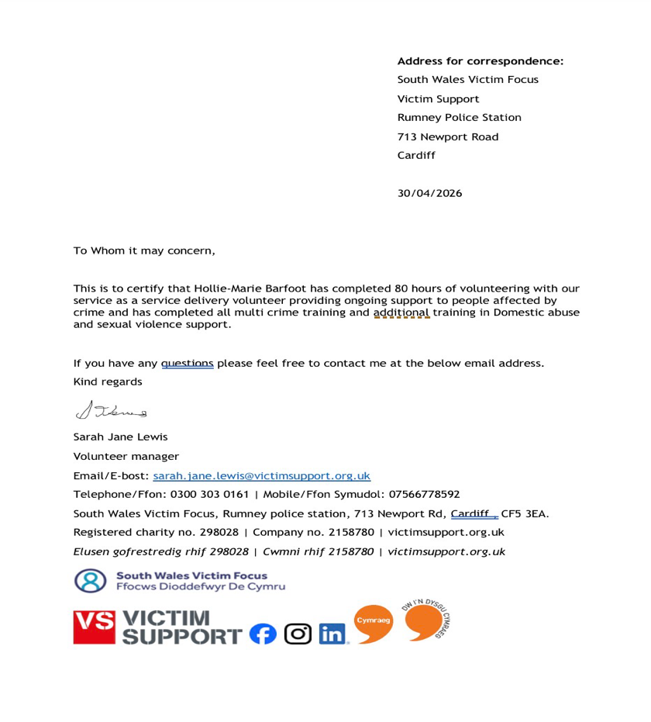
Confirmation of hours completed

First 40 hours; A Reflection
In this section, you are to reflect on the first 40 hours of your placement. You are to utilise the Gibbs Reflective cycle in order to do so. The word count for this section is 750 words.

This reflection of my time with Victim Support uses Gibbs Reflective Cycle (Gibbs, 1988) to overview my experience as a volunteer from December of 2025.
Description -
I became a volunteer with Victim Support in December 2025; I chose to volunteer with Victim Support as their company’s ethos aligns with my values as a person. I like to think of myself as a supportive and kind soul who loves to help those in need. My role within Victim Support as a multi-crime support worker is to provide a shoulder to cry on, a pair of ears to listen with and advocacy for those who need it. Victim Support allows me to help victims across the UK and give these victims a shining hope towards who they can be. With this opportunity I ensure that my clients come away from our chats with a boost of confidence and a feeling of certainty confirming they are not restraint to their label of ‘victim.’
Feelings -
The start of my journey with Victim Support was nerve wrecking. Going through the initial training was difficult, I knew I needed to be professional yet relaxed to do the best I could, and this gave me anxiety. During my time completing calls, I gained confidence. I allowed myself the space to have these emotions, nervousness, excitement, and relief. As I have progressed on my journey, I feel an indescribable joy being able to support these victims, it is a feeling difficult to describe. Knowing that I am helping each individual and making a difference to their lives gives me a sense of hope and happiness.
Evaluation –
My individual experiences with service users has been interesting and educational. I make sure that I get feedback after every call from my clients to see how I am performing as a support worker. All the feedback I have received has been extremely positive, but of course no one is perfect. My communication skills have been massively improved, my professional behaviour has shifted to fit individual needs instead of a broad reaction, and my emotional handling has been something to work on. To evaluate myself, I have needed to work on my open-mindedness, talking to each service user has provided me with a new story, new perspectives that I did not expect or consider before.

Analysis –
Looking back on my experience so far, I can see that my struggle with being completely open-minded and separating my emotions in the right way came from a lack of experience in dealing with situations like this. I found that I was making initial assumptions and stereotyping these victims or crimes by reading their case files before talking to them. Which affected how I understood the situation at first. At the same time, I felt emotionally affected by what they were sharing, as in reality it was more than ‘just an ASB case.’ I found it difficult to separate my own feelings about their victimisation from my role as their support system. This made me realise that although I was trying to be empathetic, I needed to develop better emotional control and remain more neutral so I can support my clients in a more professional and effective way. This is something for me to continue to work on throughout my time with Victim Support.
Conclusion –
I have learnt that crimes affect people in more ways than I once assumed. And while doing training I have realised how many barriers some people face when being victims, whether that is reporting the crime or how they become victims. I would change the way that I view each crime, each victim, and each perpetrator. I have learnt that there is a reason for everything and nothing should go unnoticed or unspoken.
Action Plan –
In the future, I aim to improve my open-mindedness and emotional handling by continuing to build my experience. I have booked myself onto a domestic abuse course and a sexual violence course in aim to build my knowledge and my professional handling skills. I plan to become more aware of my own assumptions by consciously approaching each client without judgement and focussing on listening rather than forming early conclusions. To strengthen my emotional resilience, I will make use of supervision and the training they have to offer as well as applying techniques such as pausing and self regulation during emotionally challenging conversations.
I am planning to pursue a career within Victim Support or as a family liaison officer, developing these skills is particularly important. I recognise that both roles require a prominent level of professionalism, empathy, and emotional control, and I am committed to continuing my personal and professional growth to provide effective support to vulnerable individuals.

Overall reflection
In this section, using the Gibbs Reflective Cycle you are to reflect on your placement after it has been completed. It is important to ensure that this reflection is not a direct copy of the one in the previous section. But it is understandable and acceptable for you to mention/discuss some of the same elements. The word count for this section is 750 words.
This reflection of my time with Victim Support uses Gibbs Reflective Cycle (Gibbs, 1988) to overview my experience as a volunteer from December of 2025.
Description –
Over the course of completing my hours with Victim Support as a multi crime volunteer advocate, I have been involved in supporting a range of individuals. These service users have been affected by multiple crimes, but mainly I focussed on Anti-Social Behaviour clients. My role has involved communicating with service users, offering emotional support, and helping them navigate available resources. All the clients that I have had each have displayed how crime can affect each person differently. Volunteering with Victim Support has broadened my view on the world we live in, supporting these clients on weekly scheduled calls alongside text message ‘check-ins,’ I have come to build strong relationships with each individual. I am eternally grateful for this opportunity.

Feelings –
At the beginning of my volunteering, I felt relatively confident in my ability to support individuals but now recognise that I lacked awareness and openness. I had the preconceived conception that because I have worked in care before that it would be similar and easy to handle, and that only serious and severe crimes, such as rape or murder, would have a profound impact on victims. This led me to approach cases of antisocial behaviour with a more limited perspective. Over time, I began to feel increasingly surprised and overwhelmed by the realities of the service users' experiences. For example, dealing with a certain service user and her case, hearing her experiences develop overtime was both shocking and eye-opening, and some calls gave me anxiety. I also found myself becoming emotionally invested service users, which made it difficult to maintain professional boundaries.

Evaluation –
Overall, this experience has been highly valuable in developing my personal and professional skills. Through this I have become more confident in speaking with a range of individuals in sensitive situations, my communication skills have significantly improved thanks to this. Additionally, being able to listen without judgement and having patience for those moments of silence have strengthened. A key positive has been my increased open-mindedness, where I would make assumptions and stereotype crimes before I have learnt that the type of crime does not correlate to the severity of the crime. However, maintaining professional boundaries is still a challenge I continue to face. When service users are experiencing ongoing upset and distress, I have found myself becoming emotionally involved in their cases. This is still an area of skill that I need to develop, and I continue to try everyday.
Analysis –
This experience has demonstrated the importance of avoiding assumptions when working with victims of crime. Reflecting on my experience, I recognise that my initial difficulty with open-mindedness and emotional control stemmed from a limited exposure to complex cases. However, through a continued experience, I am now actively challenging these assumptions by using a more reflective approach, allowing each individual that I get the privilege to support to shape my perspective. This has been particularly evident in cases involving anti social behaviour, where I am understanding the significant and often underestimated impact on victims' daily lives. I have improved my awareness of needing to balance empathy with professionalism. I am now more conscious of maintaining appropriate boundaries to provide the best support for my service users. Although, my open-mindedness is still an area for continued development.
Conclusion –
Overall, this experience has developed my understanding of how crime affects individuals in more complex and varied way than I previously expected. I recognise that each victims experience is shaped by personal circumstances and barriers now, particularly when accessing support or reporting incidents. Through both training and practical experience, I have developed a more balanced and open-minded approach, allowing me to see each case without judgement. I have also become aware of the importance of understanding the wider context surrounding victims, crimes, and perpetrators, recognising that every situation is unique. Moving forward, I aim to develop this perspective and continue to use my professional judgment so I can support my service users effectively.

Action Plan –
Moving forward, I aim to continue developing my professional boundaries and emotional resilience through ongoing practical experience, training, and reflective practise. I have now completed 2 courses to improve my knowledge and skills and I aim to complete more, The course that I completed as part of my journey were domestic abuse and sexual violence training, of which I have certifications for and hope to be working with victims of such crimes soon. I will continue to challenge my own assumptions, approaching each service user with the same blank slate, and keep a non-judgemental mindset to provide the best support possible. These developments are important as I work towards a career in victim support or as a family liaison officer.

Specific questions
In this section you are to answer the following questions. Please note that the word count for these questions overall is 500 words, it is your choice how many words you afford to each question.

- Explain a situation during your placement were you demonstrated resilience.
During my placement, I demonstrated resilience while support an older service user experiencing ongoing harassment from a neighbour who was deliberately playing loud bass music through shared walls, causing them to vibrate and leave her without sleep. Due to her age, I saw her as particularly vulnerable, which made the situation more emotionally challenging for me. I found myself feeling frustrated and protective, and my initial instinct was to react personally rather than professionally. However, I recognised that responding emotionally would not be appropriate within my role. I took a step back, took a breath, and reminded myself of my responsibility as a support provider. I remained calm, listened to her, and offered appropriate guidance without letting my personal feelings take over.
This experience showed resilience though my ability to manage my emotions and continue supporting the service user effectively, despite my strong feelings towards the situation. It also reinforced the importance of maintaining professional boundaries, especially when working with vulnerable individuals. As a result, I have become more aware of how to balance empathy with professionalism, allowing me to provide consistent and appropriate support.

- Explain a situation during your placement where you were required to be honest and open.
During my placement, I had to be honest and open when supporting an older gentleman who was experiencing ongoing issues with his neighbours. He believed they were involved in drug-related activity and became increasingly frustrated that his case did not seem to be progressing. When realistically, the situation was much more complex than he was allowed to know, the neighbours were in fact victims themselves of cuckooing, but I was unable to share this due to confidentiality. This meant I had to communicate openly while still respecting that I can not tell him what is really going on. I explained that there were underlying issues being addressed, but that I could not go into detail. Although this was difficult, as he was looking for clear answers, being honest about what I could and could not say helped manage his expectations.
Overtime, he became more understanding of the situation, and it gave him some reassurance and a sense of closure. This showed me how important transparency is, even when full disclosure is not possible.

- How did you demonstrate professionalism during your placement?
I demonstrated professionalism in my placement through applying my training, maintaining boundaries, and being reliable in my role. Fore example, I used knowledge from domestic abuse and homicide timeline training in a case that was initially related to those areas.this helped me recognise underlying issues and created a safe space where the service user felt comfortable sharing past trauma, showing the value of informed and sensitive practise. I also developed professionalism by recognising when boundaries need to be reinforced. In one case, I became too accommodating and started helping a service user beyond my role. After reflecting on this, I addressed it by clearly explaining my role and setting appropriate limits.
In addition, I maintained strong reliability, staying organised with my caseload and communication. This helped build trust with my supervisor, leading to increased responsibility and further training opportunities.

Reference list

Gibbs, G. (1988). Learning by doing, a Guide to Teaching and Learning Methods. [online] Oxford Brookes University. Available at: https://thoughtsmostlyaboutlearning.wordpress.com/wp-content/uploads/2015/12/learning-by-doing-graham-gibbs.pdf [Accessed 5 May 2026].

End Page

