Site Investigation
case study
Fundamentals Assignment 1
Tom McGaw (2305689)

Contents
Figure list 1
A. Site Investigation 2
1. Site Details 2
1. Historical Appraisal 3
2. Geological Appraisal 7
3. Environmental Appraisal 9
4. Archaeology Appraisal 10
5. Conceptual Ground Model 10
6. Site Investigation 10
B. Foundation Design 10
Reference list 13

Figure list
- SA1 Swansea Waterfront
- Victorians Prince of Wales Dock in Progress (1880)
- Ordinance Survey Plan 21/6792 NW (1949)
- Swansea Docks (1969)
- British Geological Survey Borehole record map (Swansea Dock)

Site Investigation

Site Details

The site of the proposed development of a three-storey University classroom and lecture hall structure (‘the Site’) lies on the south side of the disused Prince of Wales Dock near to the mouth of the River Tawe in Swansea, on ground cleared for redevelopment. The Site is within the SA1 Swansea Waterfront brownfield development area in the northern part of Swansea Docks. It is designated as plot E9. It is near to plots E8, E7, and E6 which will eventually complete the ring of redevelopment around the Prince of Wales Dock.

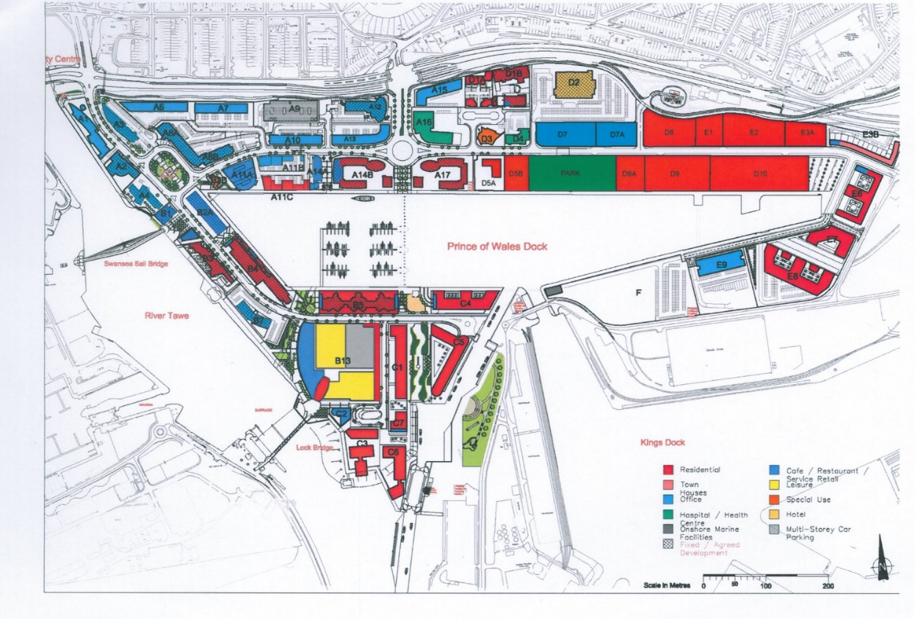Fig.1

The Site is flanked to the west by a disused swing bridge over a channel connecting the Dock with the larger King’s Dock to the south. Planning permission was granted in May 2024 for the bridge’s removal and the filling in of the channel, to enable the connection of King’s Road on the west side to a proposed Marina Road on the east, to facilitate the redevelopment of the dockyard area which began some five decades ago. A drawing forming part of the planning application depicts the road continuing east along the edge of the Dock, separated by a pedestrian walkway, and for a 170-space parking lot to be established immediately to the right of the filled-in channel, in Lot F, for which permission was granted in March 2018. Further west along the south side of the Dock is a three to six-storey block of 80 flats of recent construction.

The Site is located immediately to the east of the parking lot. There is planning permission for a mixed use development of near plots further to the east, E7 and E8, which is currently the subject of a revised application contemplating the creation of 108 residential units near to the old terminus of the Tennant Canal. Continuing further to the east and south is the Associated British Ports dockyard lands, totalling 521 acres, handling over 520,000 tonnes of cargo per year, capable of handling vessels of up to 30,000 dwt and offering berths and facilities for most types of cargo.

A site visit carried out for the purpose of this report provided little further information. The Site is fenced off and is generally covered in gravel and self-seeded vegetation. No structures were visible.

Historical Appraisal

The Prince of Wales Dock, opened in 1881 and extended in 1898, encloses a 28-acre body of water. Figure 2 shows how the Prince of Wales Dock was superimposed by its Victorian builders on the mud, gravel and sand of Fabian’s Bay (by then sheltered further south by piers on either side of the River Tawe) and, at its eastern end, close to the terminus dock of the Tennant Canal from Swansea to Neath.

The new Dock added to the existing Swansea port facilities comprising the South Dock, located on the other side of the river (the present Marina), and the old North Dock (now filled in to become the Sainsburys and Parc Tawe) located on a bend in the original course of the river, which, to a design by Thomas Telford, placed locks at either end to create a so-called ‘floating dock’, in combination with shifting the main channel of the river, via a ‘New Cut’, to where it flows today.

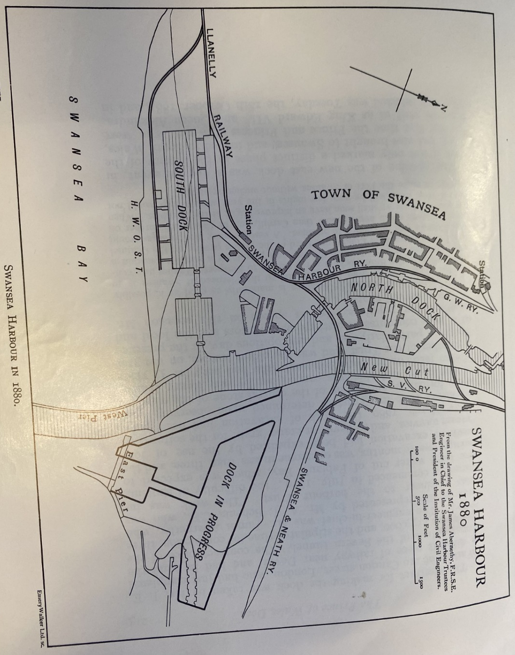
Fig.2

The construction of this port infrastructure reflected Swansea’s navigational advantages over Cardiff and Newport, with vessels coming up the Bristol Channel able to ‘save a tide’. Swansea was booming: in the three decades before completion of the Dock, the population of Swansea had increased from 30,000 to 100,000. At the same time, dredging of a 7000 foot channel out into Swansea Bay, likened at the time to the scale of the undertaking of the Suez Canal, facilitated the passage of vessels of large tonnage.

As of the 1920s, the Site was occupied by rail tracks and sidings and moveable hydraulic cranes, track-side vehicular activities and associated goods and materials storage, especially coal for the Electric Light and Power Station immediately to the west of the Site and the Cambrian Fuel Company warehouse immediately to the east, as well as grain for the massive ‘sky-scraping’ Grain Storage No. 1 Shed to the south. As can be seen from Figures 2 and 3, the tracks and sidings along the south of the Prince of Wales Dock were led across a swing bridge a short distance to the west of the Site, which spanned a narrow channel connecting the Prince of Wales Dock with the larger King’s Dock and Queen’s Dock to the south, completed in 1909 and 1920 respectively to accommodate vessels of modern, larger tonnage with deeper drafts. This channel enabled navigation from the Prince of Wales Dock basin, through a lock forming part of the King’s Dock works, to the Entrance Channel to the River Tawe and onward to the Bristol Channel. The rail tracks, once over the swing bridge, continued west toward the river, then north along and up the new course of the river, to join the main line taking goods and materials to and from the rest of Wales and Britain. The whole area was a vital part of the United Kingdom’s port infrastructure and in the port’s heyday, a hive of commercial and transportation activity. The movement of coal and grain vied for space with the shipment of tinplate, iron, steel, chemicals, oil and timber, and the activity of the dock fish market and smaller industries such as tin-stamping and creosoting.

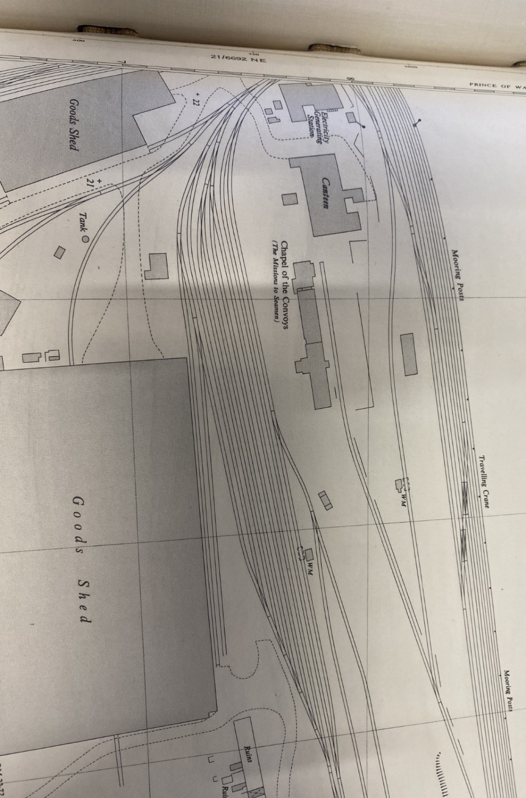Fig.3

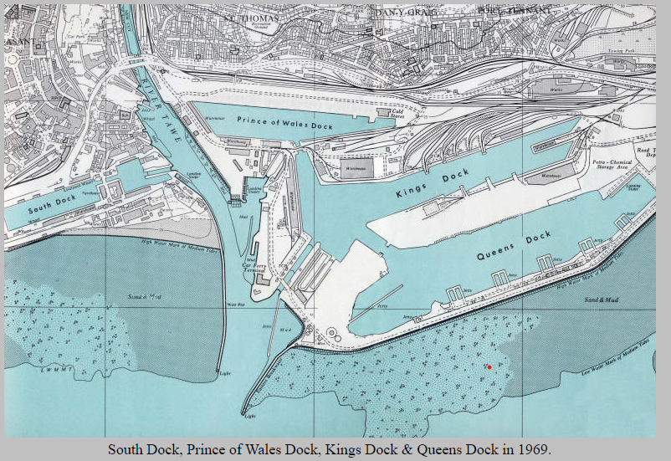
Fig.4

Apart from the wartime period in which Swansea was of vital national importance in receiving shipment of war materiel (and thus attracted the attention of German bombers), the pattern of activity in the Swansea port was general downward, reflecting the wider pattern of de-industrialisation, although the decline up to 1970 was far less than experienced in Cardiff, Newport and Barry; harbours capable to taking the huge ore, oil and container shipping of the modern era went elsewhere. By 1968 the bulk of traffic flows at Swansea port were petroleum from the nearby LLandarcy refinery, to which the Queen’s Dock was largely devoted, but the refinery closed in 1998.

By 1930 the North Dock was closed for shipping and filled in in 1969, and the South Dock ceased commercial operation in 1972, being subsequently converted into a leisure marina. Removal of coal hoists lining the north side of the Prince of Wales Dock in the 1960s marked the beginning of the opportunity for the release of land for development, although the South Dock area was more promising as a starting point. The creation of a maritime industrial development area, as was successfully done in places like Antwerp, was constrained by the lack of adequate acreage compared to other sites.
An Ordinance Survey plan from 1949 provides good information as to the activity at the Site at the time of nationalisation of the port after the war. To the west, near to the swing bridge, there was the Western Electricity Generating Station, built in 1908 to power locks, which was substantially demolished in the 1950s. A canteen building and the Chapel of the Convoys (known as ‘The Flying Angel’) were approximately within the footprint of the proposed University lecture hall building. Both were of lightweight construction and low level. The latter had only recently been relocated there, in 1947, to replace the chapel serving the same purpose elsewhere, destroyed by enemy action in 1941. Both structures have been removed, the latter in 2010.

Although Swansea sustained serious damage from enemy bombing during the second world war, the dock area, the principal target, mostly escaped damage. However the presence of unexploded ordinance cannot be entirely discounted, although none of the handful of instances in Swansea of their discovery in the past two decades have been in or in the vicinity of the port, and most discussions of the risk are by commercial organisations seeking engagement to carry out a risk assessment. That said, there is a record of two high explosive bombs landing on King’s Road near to where Trinity St Davids campus now is, about 150 m from the Site, on 7 January 1941. The site may pass the threshold for an assessment in accordance with CIRIA C681 unless one has already been carried out for an near site.

Geological Appraisal

The soils of the lower Swansea valley through to the mouth of the River Tawe were formed from stony glacial drift originally derived from Devonian and Carboniferous strata of the South Wales coalfield basin. The influence of subsequent erosion of the valley sides produced imperfectly and poorly drained sandy clay loams. Geologists described the valley as glaciated and filled with glacial debris deposited by the retreating glaciers. The actual bedrock is some 600 feet below the present seabed. The coastline itself, including the Swansea Dock area, is describe as drift-covered, a mixture of clay and boulders dumped by the retreating glaciers. However the Prince of Wales Dock area comprises fill placed by Victorian contractors, and we should expect that borehole information would reflect that.
As is apparent from Figure 5 below, there are numerous borehole records available from the British Geological Survey in the vicinity of the Dock, including two apparently immediately north of the Site along the edge of the Dock.

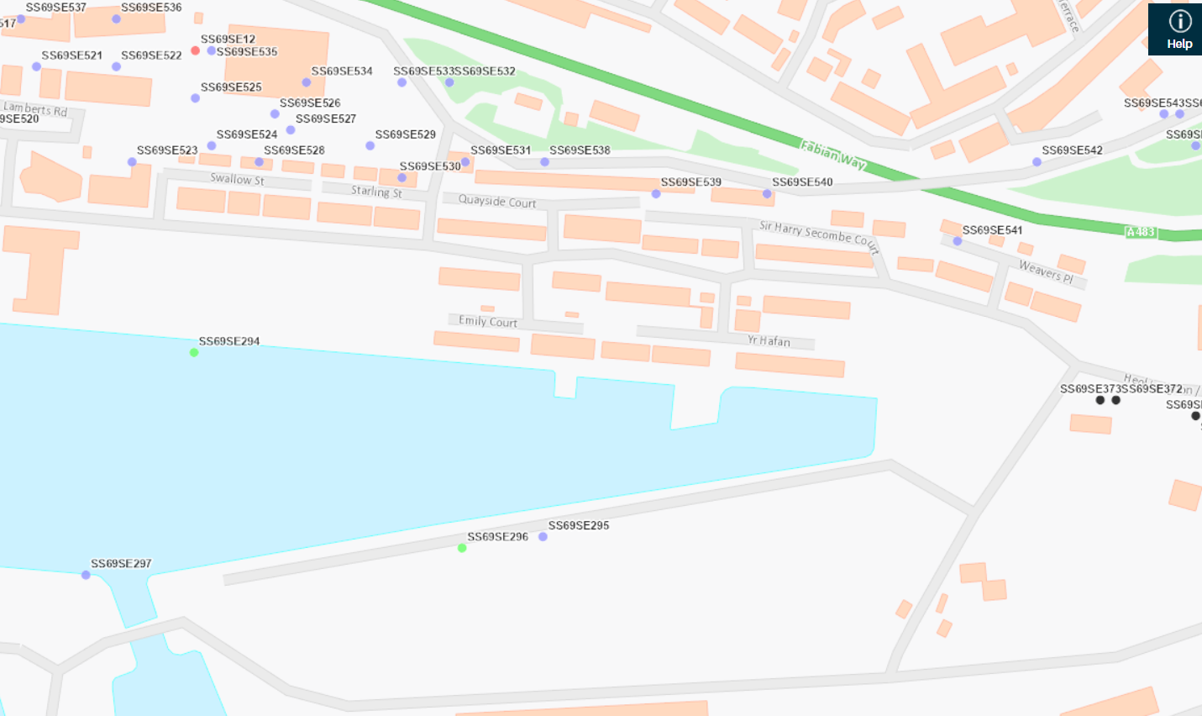
Fig.5

Although Figure 5 depicts boreholes locate around the Dock perimeter, dating from 1880 (ie in connection with the building of the Dock), it is not entirely clear which of the 14 borehole logs relate to which location, which undermines their usefulness. In most cases, scans of all records are attached to all locations. Two are indicated to have been drilled directly north of the Site. The first, SS69SE296, recorded as no.5, indicates, if that is meant to refer to borehole no.5, that there was encountered successive layers of clay, peat, blue clay, and clay and sand with stones to a depth of 27 ft. The other, SS69SE295, recorded as no.4, about 20 metres to the east, encountered ‘tipped ashes from works’, peat, sand and sandy clay to a depth of 20 ft. As presumably these boreholes would have been drilling into Fabian Bay ground as it existed before the works were carried out, one must allow for the many metres of fill subsequently added on top.

There are no records of modern boreholes in the British Geological Survey that are not confidential, but site investigations were carried out in connection with the construction of the Tawe River Barrage several hundred metres to the west, and ‘Alcan Access’ works beyond the east end of the Dock.

To the north of the Dock perhaps 100 m away from the Site there are various 1993 trial pits to a depth of about 3.5 m which show fill comprising sand, gravel, clay and cobbles. These shallow depths were sufficient for the housing to be built there. Perhaps of interest although several hundred metres to the east are boreholes drilled in 1921 in preparation for the construction of the power station. They seem to indicate 13.5 ft of made ground, below which lay 10.5 ft of coarse dirty sea sand and shells (‘old beach’), and further below, so far as I can judge from the handwriting, various qualities of clay down to a depth of 126 ft. Finally, a borehole or well was dug in 1900 for an engine shed in the vicinity of Fabian Way showing layers of drift ie sand, gravel, and clay to a depth of 121 ft before rock was encountered.

All of this is generally consistent with the summary set out in the geo-environmental study in respect of the planning application to remove the swing bridge, that the Site is likely underlaid by made ground, superficial deposits of blown sands, marine beach deposits and raised storm beach deposits (clayey silts, sandy graves, sandy clays, sandy sits, sands and gravels), and solid geology of mudstones, sandstones, and siltstones of the South Wales Middle Coal Measures, with low groundwater vulnerability. The report also sets out the results of modern site investigations from 2005-6 (not (yet) provided to the British Geological Survey) either side of the swing bridge channel including one to a depth of 20 m consistent with the pattern of results – layers of clay, gravel, cobbles and sand down to a mudstone from 12 m below ground. The foundations for the contemplated E9 academic building need to be designed accordingly.

I have also accessed a site investigation for the UWTSD Innovation Matrix building currently under construction on the south side of King’s Road about 200 m west of the Site. The consultant’s conclusions align with my own. That site is ‘underlain by made ground which in turn is underlain by Blown Sand and Beach Deposits over the South Wales Middle Coal Measures….generally compris[ing] dense silty sandy GRAVEL…which was interpreted as Marine Deposits…No significant soil contamination’.

Environmental Appraisal

There are potential pollutant linkages from the composition of the Victorian ‘made ground’ around the Dock which comprises the first layer of the Site, presumably extending down to the levels from which the 1880 borehole surveys were carried out. The former use of the Site for transportation of commodities like coal and oil may have left residues that can impact on humans and wildlife. However, studies carried out in respect of nearby sites, during and after construction, have concluded that these risks can be regarded as low. Noise and dust generated by the construction of the proposed academic building would not present significant issues not resolvable by modern construction and site management methods.

Archaeology Appraisal

I cannot see that archaeological issues are raised by the proposed development on site E9. Nothing of this sort has been raised in near planning applications.

Conceptual Ground Model

The Site has ground conditions broadly similar to those at every other site at the Dock already developed. In all likelihood the way forward for foundations will be as pursued for the near buildings – removing, cleaning and replacing the top 2 m of made ground and installing concrete piles to support a concrete base at low level and a steel frame above.

Site Investigation

I would note that in relation to the Innovation Matrix development currently under way, the engineers, by taking comfort from the more comprehensive site investigation for the library building (which I was unable to access), were content to recommend merely five trial pits to a depth of 2.3 mbgl and six ‘window sample’ boreholes down to a maximum depth of 5m bgl.

As the UWTSD library is considerably further way from the Site, I would recommend that it would be prudent to commission several new boreholes to a depth of approximately 20 metres to confirm that the ground conditions at the Site are continuous with the rest of the Dock area.

Foundation Design

Foundation and structural engineering design is aided by and dependent upon an understanding of the materials at the Site on which the design will be built, their compressibility and other properties bearing on their load-bearing capacity. For example, igneous, limestone and metamorphic rocks in massive form have a presumed bearing value of 10,000 kN/m2 or more, fine-grained mudstone 5,000, whereas for dense sand and gravels, for a 1 m foundation width, the corresponding figure is 300-600 and loose sands and gravels 50-150. Clays have bearing values in the same range as sand and gravel. The choice between strip, pad and piled foundations, and if piled, what type, is largely dictated by this.

A successful foundation design is one that is carried to a minimum depth and width without exceeding the allowable bearing pressure of any soil layer beneath it, have settlement consistent with the supported structure and its function, and having regard to the ability of the available contractors to construct it.

On the back of the site investigation, for the Innovation Matrix, a foundation of piles was the obvious solution, ‘likely to extend into the underlying dense Marine Deposits encountered from around 10mbgl….and a suspended floor slab.’ The report noted the results of the ground investigation for the UWTSD library building, with Made Ground to 8 mbgl, beach/tidal flat deposits to approximately 20 mbgl and South Wales Middle Coal Deposits below that. For the library, the foundations solution was ‘Driven steel piles … for a foundation solution with a ground bearing floor slab providing made ground excavated and replaced down to 0.5m.’

I have some concerns about the noise generated by driving piles in an environment where there is residential and teaching accommodation, but evidently from the decisions taken in relation to the Innovation Matrix these are not to be considered decisive. It is however clear that in view of the non-cohesive nature of the ground at the site, friction piles of one sort or another are called for.

To produce a satisfactory foundation design for the proposed lecture building would involve expertise and calculations beyond the scope of this course. I have only been asked to advise on a foundation type. The attached foundation design is presented for only indicative purposes. It is clear that due to the non-cohesive nature of the ground at the Site, and the likely weight of the steel-frame structure above, piles are the only option, and that a piling system and array falling within the ‘friction’ category of pile is required. The specifics of the pile caps and the ground slab supported by the piles is beyond the scope of the assignment.

Tom McGaw
July 2024

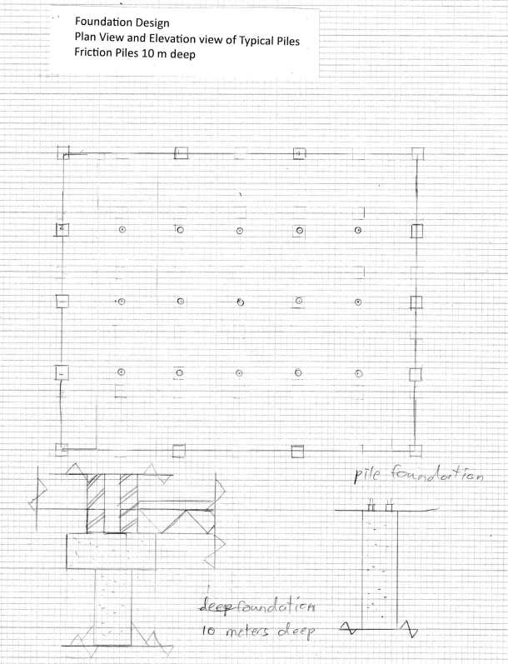

Reference list
Anonymous. ‘A Stroll along the prom – Swansea Bay’. Accessed at: https://www.geolsoc.org.uk/GowerTour1 .

Alban JR. (1994) pp.7, pp.38. The ‘Three Nights’ Blitz’. Select Contemporary Reports Relating to Swansea’s Air Raids of February 1941.

Barclay WJ. (2011). pp.6 et seq. ‘Geology of the Swansea district — a brief explanation of the geological map’. Sheet Explanation of the British Geological Survey. 1:50 000 Sheet 247 Swansea (England and Wales).

CN Waters et al. ‘Urban Geology of Swansea and Port Talbot’, Accessed at: https://nora.nerc.ac.uk/id/eprint/504837/1/Swansea%20NORA%20entry.pdf

Earth Science Partnership. ‘UXO and Development Risk’. Accessed at: https://www.earthsciencepartnership.co.uk/projects/uxo-and-development-risk/.

Francheteau SE. (MA thesis 1994) pp.127. History of the Industrial Hinterland and Port of Swansea from 1700 to 1925.

Hallett G and Randall P. (1970). pp.43. Maritime Industry and Port Development in South Wales.

Jones WH. (Carmarthen 1922). History of the Port of Swansea.

Museum Wales. Amgueddfa Cymru - National Museum Wales Preparing for the Global Citizenship Mini Challenge. Accessed at: https://museum.wales/media/38762/Swansea-source.pdf (pp. 3, 4).

RDF Bromley and G Humphreys edd. (1979) pp.23-24. Dealing with Dereliction. The Redevelopment of the Lower Swansea Valley.

Rees DM. (1975) pp.211. The Industrial Archaeology of Wales.

Swansea Council Planning Department.

Planning decision 2007/0151
Planning decision 2007/2848
Planning decision ref 2013/1543
Planning decision 2018/2481/FUL
Planning application 2017/2682/RES
Planning application 2022/1134/ES, to vary outline permission 2015/1584, varying permission 2008/0996, varying 2002/1000
Planning decision ref no 2023/1964/FUL

Swansea docks. Retired Section Swansea Docks Available at: http://www.swanseadocks.co.uk/oldsite/Maps.htm . (Accessed: 5 January 2024)

Stewart J. (2022) pp.69. From Fabian’s Bay to Fabian Way. The Development of Kilvey, St Thomas, Danygraig, and Port Tennant in Victorian Swansea.

Swansea.gov.uk. Accessed at: https://swansea.gov.uk/media/6864/Tir-John---PRA-Appendix-E---Zetica-UXO-Risk-Map/pdf/Tir_John_-_PRA_Appendix_E_-_Zetica_UXO_Risk_Map.pdf?m=1647898346013.

The meister. History of the Coals of Swansea & Cornish tin & Copper. Available at: https://www.themeister.co.uk/hindley/swansea.htm#:~:text=Initially%2C%20it%20was%20copper%20that,for%20expertise%20and%20skilled%20labour. (Accessed: 15 July 2024)

See Fig.1. Planning permission was granted in 2008, and renewed in October 2013, to change the permitted use of the Dock from operational dock to commercial marina, to commence within five years and subject to completion of a new channel feature: Swansea planning decision ref 2013/1543.
Swansea planning decision ref no 2023/1964/FUL. The only site survey information in the application relates to the depth of the channel. In the area immediately to the east of the channel a ‘shaft – UTS chamber’ is depicted in drawing 8-1SL but the nature and purpose of this feature is unclear. See also planning application 2017/2682/RES (granted December 2017) detailing the section of the road continuing east from the channel, adjacent to the parking lot. Permission had been granted in December 2014 for a pedestrian/cyclist footbridge over the channel but presumably is not being pursued, in preference for filling the channel in: Swansea planning application 2007/0151.
Planning granted in March 2018 (2017/2481/FUL), to begin not later than five years from decision (ie March 2013) but not to be operated until the pedestrian link and vehicle crossing is provided and in use.
Plot D1B. Swansea planning permission 2007/2848 granted January 2008. Drawings forming part of the application are not available on line, which might have provided useful information about site investigation and foundation design.
Swansea planning application 2022/1134/ES, to vary outline permission 2015/1584 (May 2016) which varied permission 2008/0996, which varied permission 2002/1000.
WH Jones History of the Port of Swansea (Carmarthen 1922) (hereinafter Jones (2022)) Map XII. Until the New Dock and New Cut development, the ‘Harbour of Swansea’ was merely the tide-dependent navigable length of the river, along which unlocked docking and dry-docking facilities were built, but with protection at the mouth of the river afforded by the construction in the late 18th and early 19th century of the West Pier and East Pier shielding Fabian Bay, once the opposition of the Duke of Beaufort’s local Agent, Gabriel Powell, known as ‘The King of Swansea’, was overcome (the Duke owned the coast of Fabian’s Bay) and the 1791 Swansea Harbour Act was enacted: Jones (1922) pp.81-103, 128-38; J Stewart From Fabian’s Bay to Fabian Way. The Development of Kilvey, St Thomas, Danygraig, and Port Tennant in Victorian Swansea (2022) 69.
Jones (1922) 213.
Jones (1922) 215.
Jones (1922) 217.
SE Francheteau History of the Industrial Hinterland and Port of Swansea from 1700 to 1925 (MA thesis 1994) p.127.
Jones (1922) Map XIII, pp.208-33.
Jones (1922) pp.226-27, 324-29.
G Hallett and P Randall Maritime Industry and Port Development in South Wales (1970) (hereinafter Hallett and Randall (1970)) p.43.
Hallett and Randall (1970) p.106.
Hallett and Randall (1970) pp.68-69.
DM Rees The Industrial Archaeology of Wales (1975) p.211.
Hallett and Randall (1970) pp.72-73.
OS Plan 21/6792 NW, accessed at Swansea Archives.
JR Alban The ‘Three Nights’ Blitz’. Select Contemporary Reports Relating to Swansea’s Air Raids of February 1941 (1994) pp.7, 38.
See eg https://swansea.gov.uk/media/6864/Tir-John---PRA-Appendix-E---Zetica-UXO-Risk-Map/pdf/Tir_John_-_PRA_Appendix_E_-_Zetica_UXO_Risk_Map.pdf?m=1647898346013.
https://www.earthsciencepartnership.co.uk/projects/uxo-and-development-risk/.
RDF Bromley and G Humphreys edd Dealing with Dereliction. The Redevelopment of the Lower Swansea Valley (1979) pp.23-24.
https://www.geolsoc.org.uk/GowerTour1.
Barclay, W J. 2011. Geology of the Swansea district — a brief explanation of the geological map. Sheet Explanation of the British Geological Survey. 1:50 000 Sheet 247 Swansea (England and Wales); CN Waters et al ‘Urban Geology of Swansea and Port Talbot’, accessed at https://nora.nerc.ac.uk/id/eprint/504837/1/Swansea%20NORA%20entry.pdf p.6 et seq.
See eg SS69SE523.
https://api.bgs.ac.uk/sobi-scans/v1/borehole/scans/items/370090.
Swansea planning application 2023/1964/FUL: Geo-environmental study and controlled waters assessment A081259-8 dated Sept 2023.
Geo-environmental study and controlled waters assessment A081259-8 dated Sept 2023 p. 14.
Swansea planning application 2023/1964/FUL: Geo-environmental study and controlled waters assessment A081259-8 dated Sept 2023.
Swansea planning application 2023/1964/FUL: Geo-environmental study and controlled waters assessment A081259-8 dated Sept 2023.
Jubb (2020) p. 19.
A Hodgkinson Foundation Design (1986) pp.10-13; M Riley and A Cotgrave Construction Technology 2: Industrial & Commercial Building 3rd ed (2014) p.94.
Jubb (2020) p.6.
Jubb (2020) p.11.
Jubb (2020) p.11.
M Riley and A Cotgrave Construction Technology 2: Industrial & Commercial Building 3rd ed (2014) pp.115-16

