

Changemakers: Building your Personal Brand for Sustainable Employment

BMHP5015

Component 2: Assignment (Report)

Student name: Rafia Farooq

Student Number: 2325948

Lecturer Name: Parese Ahmed

Contents
Introduction. 3
Job Advertisement. 3
Job Role Employability Skills 5
Evaluation of My Skills. 6
My Action Plan and Timeline. 7
Building My Personal Brand. 8
Promoting My Professional Identity. 9
Building a Network for Successful Employment. 10
Conclusion. 11
Refences. 12

Introduction.
Vulnerable families in the UK are facing significant challenges in receiving the help they need. Many families are struggling to access essential services, including healthcare, mental health support, and childcare. According to a recent survey by UNICEF UK (2022), Over 50% of British parents with young children face financial or mental health issues, with many struggling to access support.
In this report, I will be discussing the role of a family support worker and outline the reasons for selecting this profession as my intended future career. Family support workers provide practical and emotional support to help families overcome challenges such as financial hardship, health issues, and parenting difficulties (Birmingham City University, no date).
I chose this role because I am motivated to support families experiencing difficulties, with a particular focus on improving the wellbeing of children. My aim is to provide meaningful assistance and contribute to making their lives more manageable.

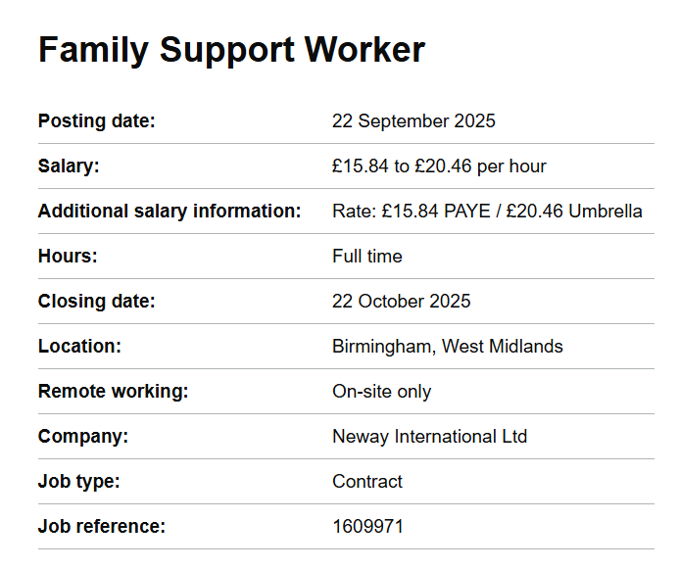
Job Advertisement.

Screenshot 1 (Family Support worker, 2025).
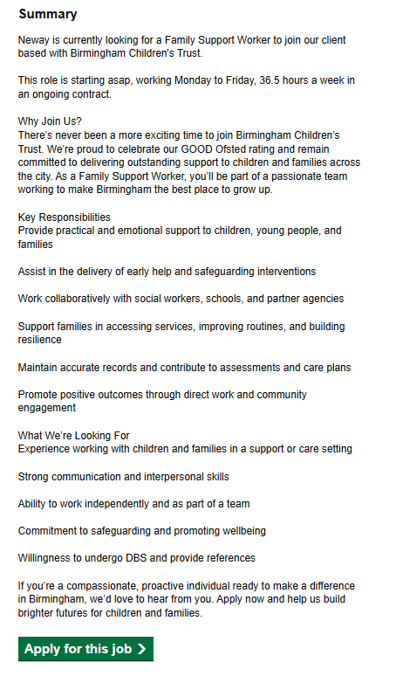
Screenshot 2 (Family Support worker, 2025).

Job Role Employability Skills
Family Support Workers require a diverse set of skills to deliver effective support to children, young people, and families. The following section outlines some of the key skills highlighted within the job advertisement.
Providing practical and emotional support to children, young people, and families.
Providing practical and emotional support is essential, as it addresses immediate needs while also building trust and rapport, which are the foundations of effective intervention. Perceived family support plays a crucial role in enhancing emotional, social, and psychological well-being, highlighting the importance of practical and emotional assistance for families (An et al., 2024).
Supporting in early help and safeguarding measures.
Assisting in the delivery of early help and safeguarding interventions ensures that concerns are identified and addressed promptly, reducing risks and preventing escalation into more serious issues (NSPCC, no date).
Collaboration.
Collaborative partnership working enhances safeguarding by ensuring that law enforcement, social services, healthcare providers, and educational institutions coordinate effectively. This integrated approach enables a comprehensive response to child protection, addressing the diverse and complex needs of children and promoting their safety and wellbeing (Care Learning, 2024).
Record keeping and care plans.
Accurate record-keeping in family support work is essential for ensuring diligent care, fulfilling legal and professional duties, promoting continuity of care, and providing evidence for accountability and audits (SCIE, no date). These records provide evidence-based insights that inform future interventions.
Promoting positive outcomes.
Promoting positive outcomes through direct work and community engagement fosters inclusion and strengthens social networks, which are key to sustainable family wellbeing. Collectively, these skills ensure Family Support Workers can deliver meaningful, effective, and child-centred support.

Evaluation of My Skills.
As a dedicated and versatile individual, I possess a unique blend of skills and experiences that make me an ideal candidate for roles supporting children and families. With strong multitasking, socializing, punctuality, and time management abilities, I am well-equipped to navigate dynamic environments. My experience volunteering in children's centres has instilled a passion for working with children and supporting parents in their physical and emotional development. Moreover, my role as a teaching assistant has provided valuable experience in supporting children with Special Educational Needs (SEN).
A key strength of mine is creating nurturing environments that foster healthy growth and relationships, allowing me to establish trust and rapport with children quickly. This skill will be particularly valuable in my role as a Family Support Worker, enabling me to build strong relationships with families and provide effective support. I possess strong empathy for others and feel a deep commitment to supporting them during their most critical moments. According to Gerdes and Segal (2011), in social work practice, empathy plays a crucial role, as clients who receive it during treatment are more likely to achieve positive outcomes.
I am currently pursuing a Bachelor of Science degree, building on my existing Level 4 Certificate in Health and Social Care. This academic progression reflects my commitment to advancing my knowledge and skills in the field, enabling me to provide more effective support and care to individuals and communities. I hold a DBS (Disclosure and Barring Service) certificate, which allows me to work with children in a safe and trusted capacity. I am currently volunteering at a children's centre, working with children aged 0-3 years and their parents. Additionally, I am employed as a part-time Teaching Assistant in both primary and secondary school settings, where I provide one-to-one support to children, including those with Special Educational Needs and Disabilities (SEND). By combining my skills, experience, and education, I am confident in my ability to make a positive impact in roles supporting vulnerable populations.
Although I possess various skills and abilities, there are areas that require further development. To enhance my effectiveness, I recognize the need for additional experience working with children to deepen my understanding of their needs. Furthermore, I aim to complete my Level 6 course in Health and Social Care to expand my knowledge and expertise. Improving my communication skills and building confidence are also essential areas for growth. Notably, I acknowledge that decision-making is a weaker aspect of my abilities, requiring focused attention and development. To overcome my weaknesses, I will take certain actions by Indeed Editorial Team (2025), such as identifying my areas of weakness, writing down my objectives, asking for assistance, looking into educational possibilities, putting new tactics into practice, tracking my progress, getting feedback, and never stop trying to get better.
The university will provide me with the opportunity to complete my Level 6 certificate in Health and Social Care, enhancing my knowledge and skills. The university also offers resources to enhance my confidence and problem-solving skills such as, workshops to build confidence, develop skills, craft a strong CV, and prepare for interviews. Additionally, leaders at the children's centre can offer valuable guidance on supporting families in need. Furthermore, teachers in schools can provide training on effective strategies for working with children and managing their behaviour, enabling me to develop my professional capabilities.

My Action Plan and Timeline.
I have created a detailed PDP table below to guide my progress, including specific strategies, timelines, and resources to reach my goals. The Personal Development Planning tool supports career progression by providing a structured framework for evaluation, growth planning, and development activities (NHS Scotland Workforce, 2025).
Development Goal | Actions / Strategies | Resources / Support | Timeline | Review / Measure of Success
Gain more experience working with children | Volunteer at children’s centres, take part-time childcare/family support roles | Children’s centres, schools, supervisors | Start now – Review 6 months | Feedback from supervisors; hours of experience gained
Complete Level 6 in Health & Social Care | Complete Level 6 course | University lecturers, academic resources | January 2027 | Successful completion of Level 6 certificate
Improve communication skills | Attend workshops, practise active listening, seek feedback | University resources, mentors | Ongoing – Review each semester | Increased confidence in presentations, positive feedback
Build confidence | Join discussions, take leadership in group work, attend confidence-building sessions | University workshops, tutors, supervisors | 6–12 months | Self-assessment and tutor feedback
Enhance decision-making skills | Practise in work settings, use reflective journals, request supervisor feedback | Supervisors, reflective practice guides | 6–12 months | More independent, effective decisions at work
Strengthen problem-solving skills | Engage in problem-based learning, attend training on child behaviour strategies | University, teachers, training programmes | 12 months – Review annually | Case studies, assignments, and feedback
Develop professional capabilities with guidance | Seek mentorship from children’s centre leaders, shadow professionals | Leaders, senior staff in family support | 6–18 months | Mentor evaluation, ability to apply strategies

Building My Personal Brand.
According to Gorbatov, Khapova and Lysova (2018), personal brand is about crafting and sharing your authentic self, showcasing strengths and passions to stand out and connect with others. I build my personal brand on compassion, empowerment, respect, safety, and integrity. I show compassion by supporting families in need, seeing that self-compassion can reduce parental burnout and improve well-being in caregivers (Gerber, Davidovics and Anaki, 2021). I believe in empowerment by helping people find their strength and agency like in school programs that improve mental health through giving children participatory power (Li et al., 2025).
I will establish a professional online presence through LinkedIn, and social media, showcasing my skills, experience, and achievements. This will enhance my visibility, networking opportunities, and career prospects. Regular updates will ensure consistency and relevance. By leveraging these platforms, I will maintain a strong digital footprint, increase my online presence, and stay connected with industry professionals, potential employers, and like-minded individuals, ultimately boosting my career opportunities.

Promoting My Professional Identity.
To effectively communicate my skills and experiences to potential employers, I will maintain a strong online presence. I can optimize my profile, connect with industry professionals, and showcase my work to strengthen my online presence (LinkedIn, no date). I will ensure my LinkedIn profile is up-to-date, complete, and showcases my professional brand. I will also create a personal website to display my portfolio, highlighting my accomplishments and experiences. This website will serve as a central hub for my professional online presence, allowing employers to easily access and view my work.
On these platforms, I will use clear, concise language to describe my skills, qualifications, and achievements. Using clear, concise language, tailoring content with relevant keywords, and regularly updating profiles will enhances my employability and professional success. By having a professional online presence, I will increase my visibility, credibility, and chances of getting noticed by potential employers. This will enable me to effectively communicate my value and showcase my expertise.
Below are my CV and cover letter that effectively showcase my skills and experience, making me an attractive candidate to potential employers.
CV
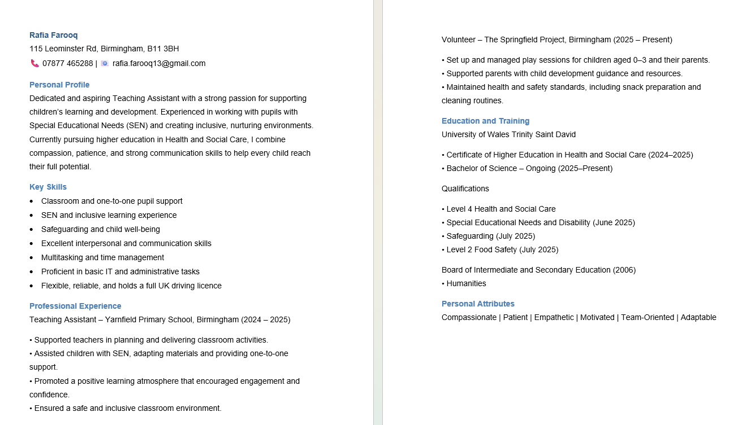
Cover Letter
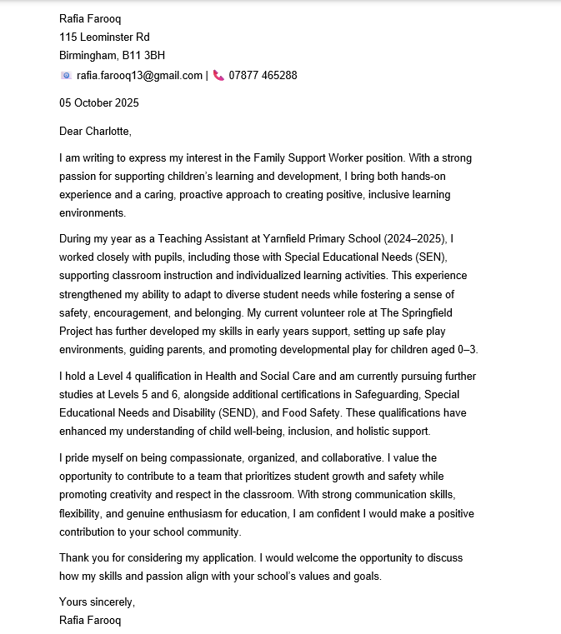

Building a Network for Successful Employment.
Networking in health and social care is essential for delivering high-quality, person-centred services. It facilitates collaboration among professionals, agencies, and community organizations, allowing for the sharing of knowledge, expertise, and best practices. This collaboration ensures continuity of care, reduces service duplication, and addresses gaps in provision, ultimately benefiting individuals who rely on these services (Care Learning, 2025). Networking also supports professional development by providing opportunities for learning, mentorship, and skill-building, which strengthens ethical practice and resilience among staff (Grills et al., 2014). Moreover, effective networking fosters innovation by enabling organizations to exchange ideas and implement innovative approaches to care. For service users, it broadens access to resources and personalized support, improving outcomes and overall well-being. Collaborative networks enhance organizational sustainability by pooling resources, promoting efficiency, and expanding reach within the community. Therefore, networking is a vital component of an effective health and social care system, impacting both professionals and service users positively.
I can leverage support from various professionals to achieve my career goals. University lecturers can provide job references and guidance. Employability workshops can enhance my CV, cover letter, and job search. Leaders at children's community centres can offer training and certifications in areas like first aid, child safety, and childcare. Additionally, primary school teachers can provide valuable experience working with children with special needs, behavioural insights, and autism support, helping me build expertise and confidence in my field.

Conclusion.
In conclusion, the role of a Family Support Worker is both challenging and rewarding, requiring a diverse set of skills, knowledge, and personal attributes to effectively support vulnerable families. Through this report, I have analysed the employability skills necessary for this position, including providing practical and emotional support, collaborating with professionals, promoting positive outcomes, and maintaining accurate records.
Evaluating my own skills has highlighted strengths such as empathy, communication, and experience working with children, alongside areas for development, including decision-making, confidence, and advanced qualifications. By creating a structured action plan with clear strategies and timelines, I have outlined how I will address these areas, gain practical experience, and enhance my professional capabilities through further education and mentoring opportunities.
Building my personal brand and professional identity will enable me to demonstrate my values, ethics, and commitment to family support work. Additionally, networking within health and social care will expand my knowledge, provide mentorship opportunities, and facilitate access to career opportunities. Overall, by actively developing my skills, experience, and professional presence, I am confident in my ability to make a meaningful impact in the lives of families and achieve a successful career as a Family Support Worker.

Refences.
An, J., Zhu, X., Shi, Z. and An, J. (2024) ‘A serial mediating effect of perceived family support on psychological well-being’, BMC Public Health, 24, p.940. Available at: https://pmc.ncbi.nlm.nih.gov/articles/PMC10986067/ (Accessed: 27 September 2025).
Birmingham City University (no date) What does a Family Support Worker do? Birmingham City University. Available at: https://www.bcu.ac.uk/blog/education-and-teacher-training/what-does-a-family-support-worker-do (Accessed: 27 September 2025).
Care Learning (2024) '2.4 Analyse the benefits of partnership working in the context of safeguarding, protection and welfare of children', Care Learning. Available at: https://carelearning.org.uk/qualifications/level-3-diploma-eyp/unit-22-legislation/2-4-analyse-the-benefits-of-partnership-working-in-the-context-of-safeguarding-protection-and-welfare-of-children/ (Accessed: 27 September 2025).
Care Learning (2025) 1.5 Evaluate how Networking and Working Collaboratively With Other Agencies and Community Groups Benefits: Individuals; the Sustainability and Reach of the Organisation. [online] Available at: https://carelearning.org.uk (Accessed 5 October 2025).
Family Support Worker (2025) [Screenshot]. Available at: Family Support Worker | Job details | Find a job (Accessed: 27 September 2025).
Gerber, Z., Davidovics, Z. and Anaki, D. (2021) ‘The relationship between self-compassion, concern for others, and parental burnout in child’s chronic care management.’ Mindfulness, 12(12), pp.2920-2928. Available at: The Relationship Between Self-Compassion, Concern for Others, and Parental Burnout in Child's Chronic Care Management - PubMed (Accessed: 05 October).
Gerdes, K.E. and Segal, E. (2011) ‘Importance of empathy for social work practice: Integrating new science.’ Social work, 56(2), pp.141-148. Available at: Importance of empathy for social work practice: integrating new science - PubMed (Accessed: 02 October 2025).
Gorbatov, S., Khapova, S. N. and Lysova, E. I. (2018) ‘The Impact of Personal Branding on Career Success’, Frontiers in Psychology, 10, p. 2212. Available at: Frontiers | Personal Branding: Interdisciplinary Systematic Review and Research Agenda (Accessed: 11 October 2025).
Grills, N.J., Kumar, R., Philip, M. and Porter, G. (2014) ‘Networking between community health programs: a team-work approach to improving health service provision.’ BMC Health Services Research, 14(1), p.297. Available at: Networking between community health programs: a team-work approach to improving health service provision | BMC Health Services Research | Full Text (Accessed: 05 October 2025).
Indeed Editorial Team (2025) How to Start Improving Your Weaknesses (With Steps and Tips). Indeed. Available at: https://www.indeed.com/career-advice/career-development/improving-weaknesses (Accessed: 2 October 2025).
Li, J., Wang, L., Liu, J. and Cheng, X. (2025) ‘The impact of school empowerment on the mental health of left-behind children in China: exploring the mediating role of psychological empowerment.’ BMC psychology, 13(1), p.1001. Available at: The impact of school empowerment on the mental health of left-behind children in China: exploring the mediating role of psychological empowerment | BMC Psychology | Full Text (Accessed: 05 October 2025).
LinkedIn (no date) How Can You Use Your Online Presence to Network with Potential Employers? LinkedIn Advice. Available at: https://www.linkedin.com/advice/1/how-can-you-use-your-online-presence-network-potential-p8sde (Accessed: 11 October 2025).
National Health Service Scotland Workforce. (2025). Personal Development Planning and Performance Review Policy: Guide for Employees. Available at: https://workforce.nhs.scot/supporting-documents/guide/personal-development-planning-and-performance-review-policy-guide-for-employees/ (Accessed 2 Oct. 2025).
National Society for the Prevention of Cruelty to Children (no date) What is Safeguarding in Early Years? NSPCC Learning. Available at: What is safeguarding in early years? | NSPCC Learning (Accessed: 27 September 2025).
Social Care Institute for Excellence (no date) Social work recording. Available at: https://www.scie.org.uk/social-work/recording/ (Accessed: 27 September 2025).
UNICEF UK (2022) Over Half of all Families in Britain with Children Under 5 Struggle Financially or with their Mental Health: New Survey Reveals Over 2 Million Families are Struggling, as 1 in 3 Struggle to get Professional Support. UNICEF UK, 18 October. Available at: https://www.unicef.org.uk/new-survey-reveals-over-half-of-all-parents-with-young-children-in-britain-over-2-million-families-are-struggling-financially-or-with-their-mental-health-as-1-in-3-struggle-to-get-profess/ (Accessed: 27 September 2025).

