

Financial Management for the Hotel Industry
Student Name: Ella Daniela Mirea
Student ID number: 2246573
Programme: BA International Hotel Management
Module code: BMIH5007
Lecturer: Tristan Hawkins
Assignment Title: Report Case Study: The City Hotel

Acknowledgement
I hereby acknowledge that the content presented in this report is my own original work. Any ideas or materials sourced from external references have been cited.

Introduction
The City Hotel has had a big drop in productivity over the past few years. It is located in a city area and offers facilities like restaurants, bars, and spaces for meetings and events (Raras, 2021). The hotel’s income has gone down as more people choose to stay in hotels with higher standards, which has hurt both occupancy rates and customer satisfaction. This has also caused the hotel to lose market share (Wieczorek, 2021).
This report will look at the financial performance of The City Hotel over the last three years—2021, 2022, and 2023. It will use different financial indicators, including revenue, expenses, profits, liquidity, and solvency. The goal is to find the main reasons for the financial issues and to create a plan to restore the hotel’s financial health and reputation.
Hotels Financial Performance
1. Revenue
The City Hotel’s income went down a lot over three years, from £5,248,290 in 2021 to £2,325,440 in 2023. This drop was likely due to outside factors, like changes in the economy and specific conditions in the hotel industry (Chambers and Cifter, 2022).

Figure 1: Revenue Trend Analysis (2021-2023)
Source: Chambers and Cifter (2022)

2. Expenses
The City Hotel’s main costs are sales, employee pay, and outsourcing. Even though some business costs, like the cost of goods and employee pay, went down a little in 2023, outside costs dropped a lot. This shows the hotel is trying to save money since income is lower (Alvarez et al., 2021). However, money from social insurance also dropped a lot because income went down faster than costs, which means profits got smaller.
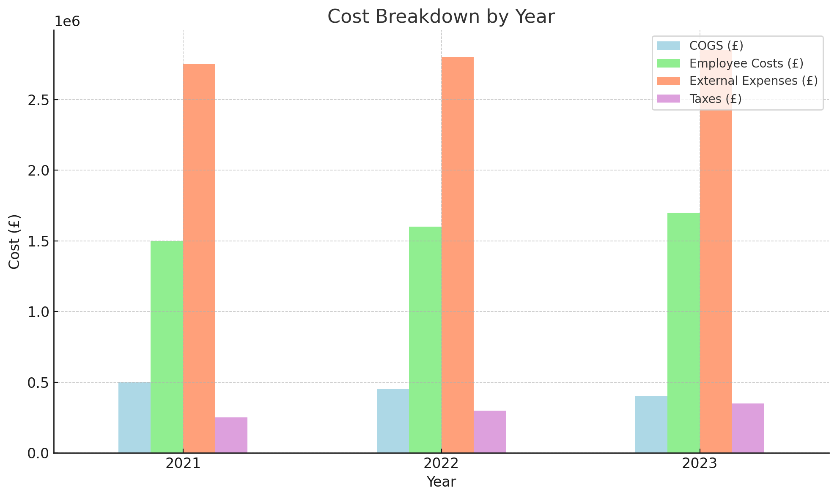
Figure 2: Expense Breakdown for The City Hotel (2021-2023)
Source: Alvarez et al (2021)

3. Profitability
Looking at income and costs shows that The City Hotel is having problems. Income is going down, and fixed costs are high. The hotel’s profit margins are lower than last year, which means income losses are bigger than the money saved by cutting costs (Menicucci, 2018)

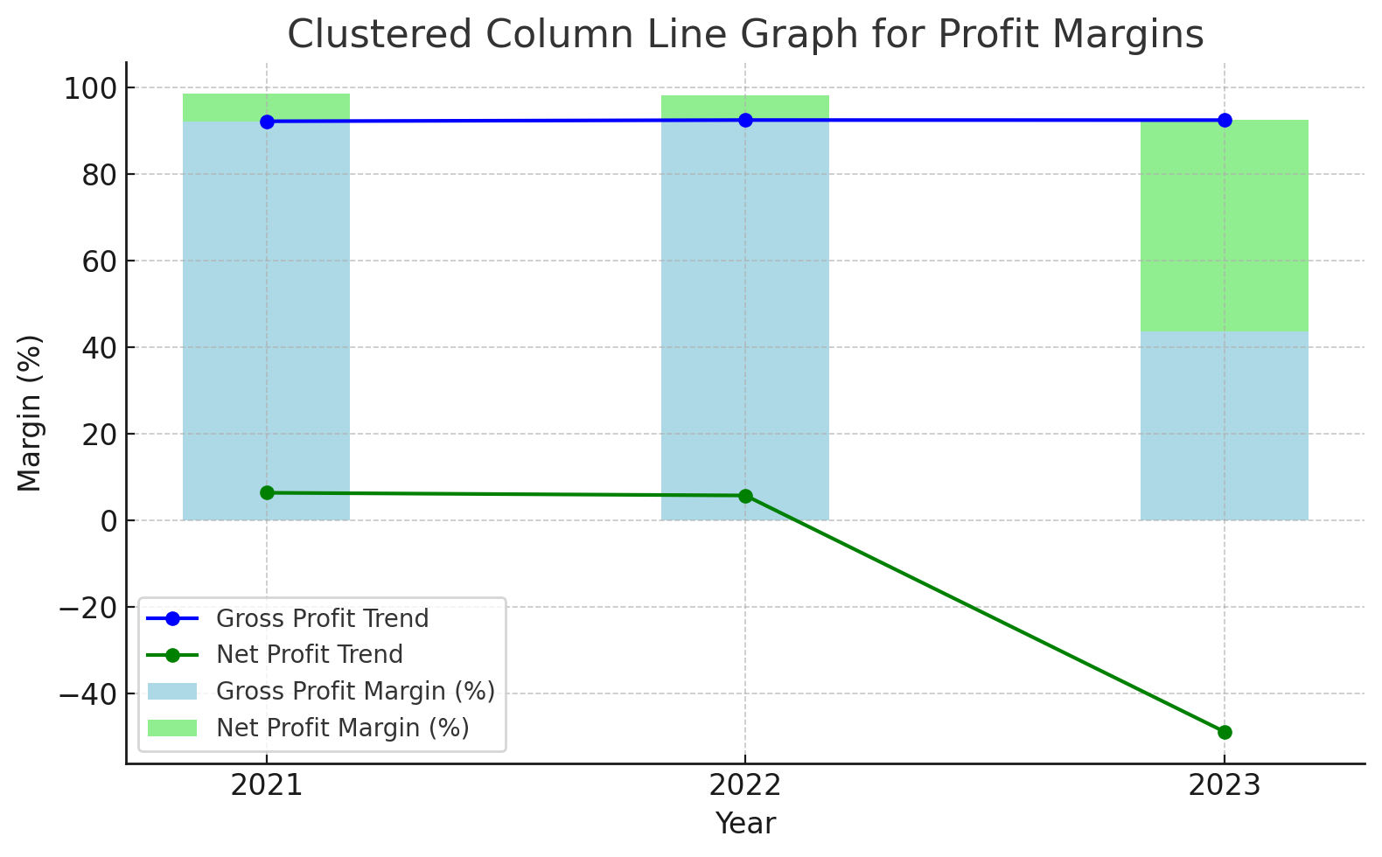
Figure 3: Gross Profit Margin and Net Profit Margin (2021-2023)
Source: Menicucci (2018)

4. Liquidity and Solvency Ratios
The hotel’s ability to pay its debts has gotten weaker. Current assets, which were £1,891,970 in 2021, are expected to be £1,285,880 in 2023. This makes it harder for the hotel to pay its short-term debts (Situm, 2023; Hayes et al., 2021). The current ratio has dropped, showing there may be less cash available. Lastly, the gearing ratio went up, meaning the hotel is relying more on borrowed money.

Table 1: Liquidity Ratios for The City Hotel (2021-2023) (Hayes et al., 2021)
Year | Current Assets (£) | Current Liabilities (£) | Current Ratio
2021 | 1,891,970 | 1,957,360 | 0.97
2022 | 1,965,340 | 2,107,750 | 0.93
2023 | 1,285,880 | 2,014,600 | 0.64

Key Reasons for Lower Profits
Here are the main reasons The City Hotel is seeing lower profits:
• Impact of COVID-19: One big reason for the hotel’s lower profits is external economic factors, like the effects of COVID-19 on the hotel industry. The pandemic led to a huge drop in demand for hotel services worldwide, as travel restrictions and new consumer habits meant fewer guests. As Crespi Cladera et al. (2021) explain, the pandemic has created long-term money challenges for hotels, especially with cash flow and income.
• Inflation and Interest Rates: The hotel is also affected by high inflation and changes in interest rates, as these make it harder for consumers to spend on hotel stays and leisure. Higher interest rates and low spending have hurt the hospitality industry (Nguyen et al., 2023). With rising costs for supplies and services, The City Hotel’s profits are lower (Raras, 2021).
• High Operational Costs and Outdated Systems: The hotel also faces high costs and relies on old information systems that don’t work well with modern needs. This makes it harder for the hotel to make quick, effective decisions, control costs, and keep up with the market. Jawabreh et al. (2022) suggest that using updated technology could help the hotel improve financial performance by better managing resources and making faster, more accurate decisions.
• High Fixed Costs: The hotel’s large fixed costs, such as staffing, maintenance, and utilities, add to its financial struggles. These costs don’t change much even when revenue drops, leading to more losses. Poor management of resources and a lack of performance tracking make these issues worse.
In summary, The City Hotel faces both external and internal challenges. Outside factors like COVID-19 and economic issues have reduced demand and increased costs. Inside the hotel, outdated systems and high fixed costs make it hard to adjust to these changes.
Using new technology could help the hotel manage costs and plan better. Milton (2024) also suggests that with tools like artificial intelligence, hotels can adjust prices, manage resources, and boost productivity. Using these tools could help The City Hotel reduce costs, increase efficiency, and grow in a sustainable way.
Turnaround Strategy
To fix The City Hotel’s financial problems, the following strategies are suggested: increasing revenue, reducing costs, restructuring the business, and improving the hotel’s image. This plan should help the hotel reach a more stable financial position and become more competitive again (Olorunsola, 2024).
1. Increasing Revenue
A key part of the strategy is improving revenue by attracting more customers and filling more rooms. Dimitrios et al. (2020) suggest that hotels need to adjust their management strategies based on the market needs to recover from difficult times. For The City Hotel, this could mean offering flexible pricing based on factors like how full the hotel is, the time of year, and competitor prices. Dynamic pricing can help the hotel earn more during busy seasons while offering better deals during slower periods (Mucharreira, 2019).
The hotel could also expand its services. For example, offering special event packages or themed attractions could attract more customers. Hosting local business events or corporate dinners and creating loyalty programs for returning customers can help keep demand steady. By adding new services and focusing on what customers want, the hotel can increase occupancy rates and overall revenue (Wieczorek, 2021).

2. Cost Reduction Measures
To help the hotel recover, it’s important to control costs, and data can help with this. Mnyakin (2023) says that using big data can show where the hotel is wasting money. If The City Hotel uses data, it can track spending and know when to buy more resources or use what it has carefully.
For example, the hotel can save on energy costs by using smart systems for lights, heating, and air conditioning. The hotel can also use software to schedule staff more efficiently, so there are fewer unnecessary labour costs (Raras, 2023).
Using data to better predict how much food, drinks, and supplies are needed can reduce waste and lower costs for storing extra items (Menicucci, 2018).
Table 2: Proposed Cost Reduction Tactics Using Big Data Analytics (Mnyakin, 2023)
Area | Action | Expected Outcome
Energy Management | Implement smart energy systems | Lower utility costs
Workforce Optimization | Use demand forecasting for staffing | Reduced labor costs
Inventory Management | Predictive ordering based on demand trends | Minimized waste and reduced inventory

3. Financial Restructuring Options
To solve the hotel’s money problems, The City Hotel can change its debts and find new ways to get the money it needs. This can be done by restructuring its finances to help the hotel pay off long-term debts. Mueller and Sensini (2021) say that companies with money problems need to manage their debts carefully.
The City Hotel could lower its debt payments by either getting a loan with a lower interest rate or by extending the time to pay back the debt. This would help the hotel have more cash to use for running the business and fixing its problems. The hotel could also look for government help or find private partners, like investors, to share the debt.
Another option is selling unused property or doing a sale and leaseback, where the hotel sells property but keeps using it. This would bring in money and lower debt, while also giving the hotel time to work on improving its business (Konovalova, 2018).
4. Reputation Restoration
In the hotel business, customers want to trust the brands they choose. One way The City Hotel can improve its image is by focusing on sustainability, as more people care about businesses that are good for the environment. Floricic (2020) says that “green” activities can help improve a hotel’s image and attract customers who care about sustainable travel.
The City Hotel can become more sustainable by using eco-friendly cleaning products, reducing plastic use, and installing water-saving devices. The hotel can promote these changes to attract guests who care about the environment. This can also help the hotel make extra money through eco-friendly tourism and certifications (Leontes, 2024).
Additionally, improving service quality and making sure guests are happy is important. Training staff on customer service and sustainable practices will help offer better service, which can attract more customers and lead to repeat business. These steps will help The City Hotel build a good reputation and keep customers coming back.

Table 3: Sustainable Practices to Restore Brand Reputation Floricic (2020)
Practice | Description | Expected Impact
Eco-friendly cleaning products | Switch to biodegradable, non-toxic cleaning agents | Improved brand perception
Reduced single-use plastics | Eliminate plastic straws, cups, and utensils | Appeal to eco-conscious consumers
Water-saving installations | Install low-flow showerheads and faucets | Lower utility costs and environmental impact

Conclusion and recommendations
1. Conclusion
The City Hotel is facing big financial problems, like lower income, high fixed costs, and challenges from the economy. The hotel’s financial situation over the last three years shows it has less cash, lower profits, and some areas where it is not running efficiently. The hotel needs a complete plan to fix these problems. This report suggests solutions like flexible pricing, using data to cut costs, changing the financial model, and focusing on sustainability to improve the hotel’s image (Arquero, 2024). These steps will help improve the hotel’s finances and position in a competitive market.
2. Recommendations
The City Hotel should (Hole, 2019):
• Use flexible pricing to set room prices for busy and slow times.
• Use data to track and reduce costs, especially for energy and staffing.
• Talk to lenders to get longer repayment periods or lower interest rates to ease cash flow.
• Reduce environmental impact by offering services that appeal to eco-conscious travellers.
• Improve efficiency and customer satisfaction by training employees in customer service and sustainability.

References
Arquero, J.L., Fernández-Polvillo, C. and Jiménez-Cardoso, S.M., 2024. Financial literacy in tourism and management & business administration entry-level students: A comparative view. Journal of Hospitality, Leisure, Sport & Tourism Education, 34, p.100474.
Chambers, N. and Cifter, A., 2022. Working capital management and firm performance in the hospitality and tourism industry. International Journal of Hospitality Management, 102, p.103144.
Crespí-Cladera, R., Martín-Oliver, A. and Pascual-Fuster, B., 2021. Financial distress in the hospitality industry during the Covid-19 disaster. Tourism Management, 85, p.104301.
Dimitrios, B., Christos, P., Ioannis, R. and Vasiliadis, L., 2020. Strategic management in the hotel industry: Proposed strategic practices to recover from COVID-19 global crisis. Academic Journal of Interdisciplinary Studies, 9(6), pp.130-130.
Floričić, T., 2020. Sustainable solutions in the hospitality industry and competitiveness context of “green hotels”. Civil Engineering Journal, 6(6), pp.1104-1113.
Hayes, D.K., Hayes, J.D. and Hayes, P.A., 2021. Revenue management for the hospitality industry. John Wiley & Sons.
Hole, P., Hole, Y., Khedkar, E.B. and Pawar, S.P., 2019. Challenges and solutions to the development of the tourism and hospitality industry in India. African Journal of Hospitality, Tourism and Leisure, 8(3), pp.1-11.
Konovalova, E.E., Yudina, E.V., Bushueva, I.V., Uhina, T.V. and Lebedev, K.A.E., 2018. Forming approaches to strategic management and development of tourism and hospitality industry in the regions. Journal of environmental management and tourism, 9(2), pp.241-247.
Leontes, N.I., Kibatta, J. and Hoole, C., 2024. Enhancing Work Engagement in the Hospitality Sector: The influence of Human Capital Management Practices. Asian Journal of Management, Entrepreneurship and Social Science, 4(01), pp.1-25.
Menicucci, E., 2018. The influence of firm characteristics on profitability: Evidence from Italian hospitality industry. International Journal of Contemporary Hospitality Management, 30(8), pp.2845-2868.
Milton, T., 2024. Exploring the Synergy of Artificial Intelligence and Financial Management in the Hotel Industry: A Critical Review of Innovations, Challenges, and Strategic Implications for Enhancing Operational Efficiency and Competitive Advantage. International Journal for Multidimensional Research Perspectives, 2(2), pp.79-95.
Mnyakin, M., 2023. Big Data in the Hospitality Industry: Prospects, Obstacles, and Strategies. International Journal of Business Intelligence and Big Data Analytics, 6(1), pp.12-22.
Olorunsola, V.O., Saydam, M.B., Arici, H.E. and Köseoglu, M.A., 2024. The predictive roles of financial indicators and governance scores on firms’ emission performance in the tourism and hospitality industry. Tourism Economics, 30(6), pp.1382-1403.
Raras, P., Migliaccio, G. and Simonetti, B., 2023. Investigating financial statements in hospitality: a quantitative approach. Quality & Quantity, 57(Suppl 3), pp.383-407.
Raras, P.N., Oktaria, E.T., Iskandar, A.A., Barusman, A.R.P. and Habiburahman, H., 2024. Hospitality Management Competence. International Journal Of Education, Social Studies, And Management (IJESSM), 4(2), pp.613-624.
Situm, M., 2023. Financial distress in the Austrian tourism industry: hotels and restaurants analysis. European Journal of Tourism Research, 34, pp.3411-3411.
Wieczorek-Kosmala, M., 2021. COVID-19 impact on the hospitality industry: Exploratory study of financial-slack-driven risk preparedness. International Journal of Hospitality Management, 94, p.102799.

