Database documentation

I began building my database using the Table functionality, I did this by ensuring each tab was appropriate for the table in question.
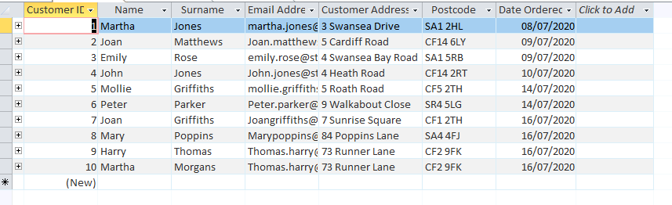
For this particular database I created 4 tables which I thought were relevant to the bookshop database needs. I filled each table with a small amount of data for testing purposes.
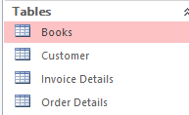
Table breakdown
- Books, I began by creating the books table, this is for the bookshop to keep a note of what stock is available and the item type for example is the book a first edition book or not.
- The second table I created was the customer table, this is where all customer profiles will be stored, when creating this table it was important to factor in as much detail as possible to ensure the book store has an adequate amount of data for each customer.
- Invoice Details the invoice details allows for the order date, customers email address, order number and order total. This is a simple breakdown and an easy way to send automated confirmation to customers.
- The last table completed was the order details – similar to the invoice details however this has no personal information and makes it simple to find a customers order.

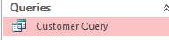

I created a customer query this is for the book store owners to keep track on where orders are going and what date they were ordered.

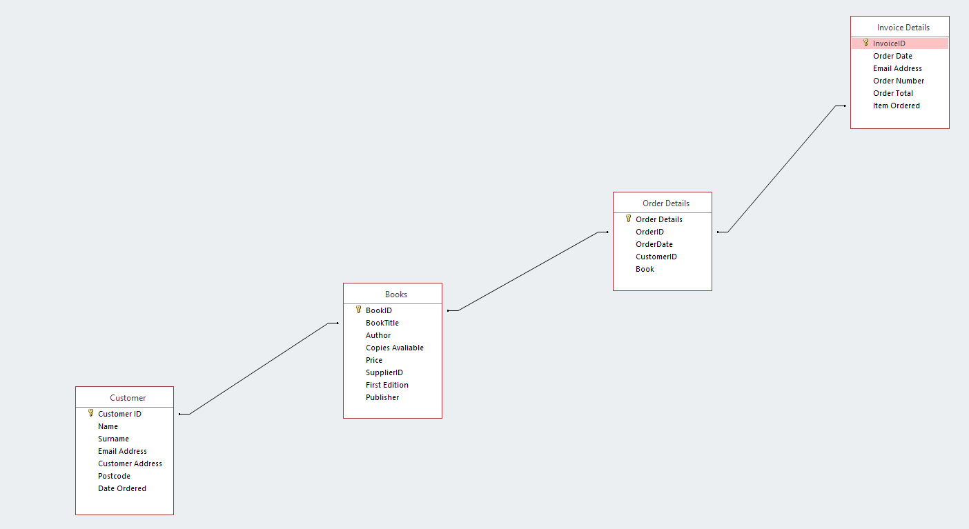

Above is the relationships between tables.

Main Menu
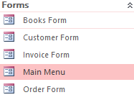

Although I am aware that the Main menu that I have created isn’t particularly pretty my aim was to ensure the functionality worked. The main menu is broken down to;

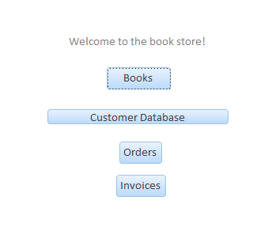
Each button then takes the user to their desired page.

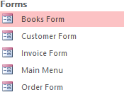
Each form consists of their own functionality buttons. The books form allows the user to fund a book and a record in one push of a button, once the book of choice has been selected all the relevant information is then displayed as seen below.
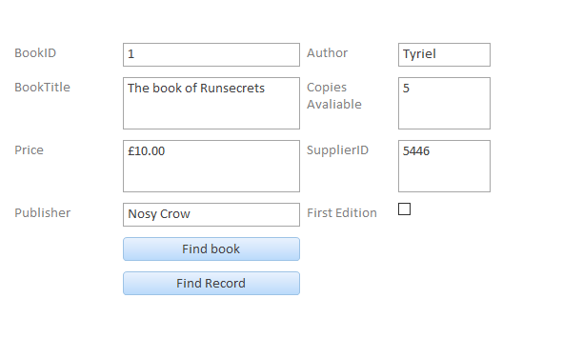
The customer database form allows the user to find a record, add a new record or delete a record. This makes the database really user friendly as all the functionalities needed are on one page rather than having to search or access the relevant table to add the customer information.
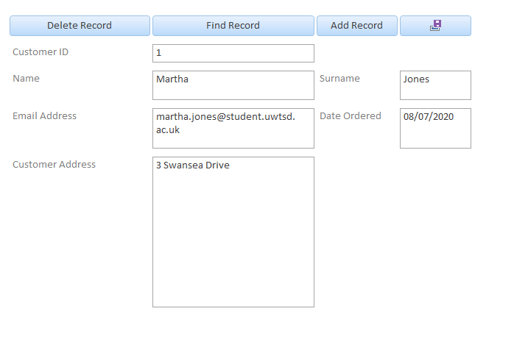

The order form is simplistic with only one search option which is ‘find order’ this makes it easy for the book store staff to keep tabs and find orders without the hassle of struggling around a database. I have also included a ‘print invoice’ section on this page.
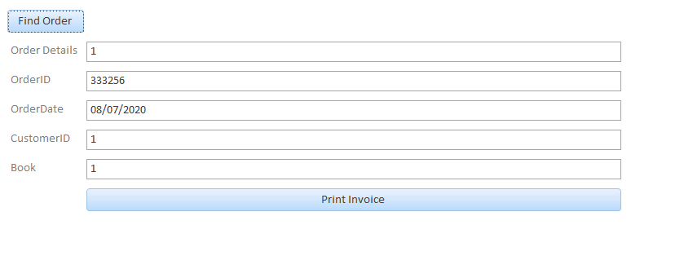
Last but not least the last option from the main menu is the invoice section, for the book store this will be perfect for book keeping it has the clients email address, order date, item ordered and price the customer paid. This functionality also allows the staff members to find orders, print orders and add records.

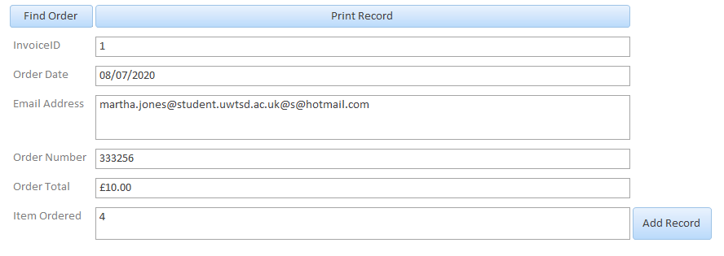

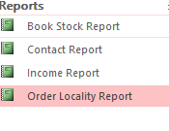
The last function that I added is the report section within the database. I have chosen carefully what I include in this section. As shown above I chose book stock report, contact report, income report and order locality report..

For the book store I think it is important to keep tabs on stock, therefore this report can be run regularly to ensure that any stock which needs to be replenished or removed from advertisement can be done so in a timely manner.
I added a contact report so that if the book store needs to contact a customer for any reason they can run this report and specify dates, this will then provide them with the information of who ordered on a specific date this makes it easy to contact one or more customers if needed.
Income report – as a business income is one of the main priorities this will have to be monitored monthly and annually. This report allows a fast and reliable calculation which then means that it doesn’t take hours of admin work to work out monthly incomes. This also makes it very simple at the end of a tax year.
Lastly I added a section for locality, this is for the book store to keep tabs on where their items are going. For this section I used random addresses to allow for testing.

Overview

Overall this database is simple and user friendly, it has all of the functionality that it needs without the need for training for use. It has a main menu and 4 options each option is clearly labelled and user friendly.

