UNIVERSITY OF WALES:  TRINITY SAINT DAVID |  |  | PRIFYSGOL CYMRU:  Y DRINDOD DEWI SANT
LOCATION: LAMPETER |  | LLEOLIAD: LLAMBED
LEVEL 5 |  | LEFEL 5
October 2019 |  | Hydref 2019

HPAH5037
Murder, Mayhem and Megalomania: The Life and Times of the Emperor Nero

QUIZ 1

Write your name here:
Write your Student number here:

TIME: 20 minutes

ATTEMPT TO ANSWER ALL OF THE FOLLOWING 20 QUESTIONS:

In the case of multiple-choice questions indicate your answer by circling either A, B, C or D (as you think is correct). Giving more than one answer to a question will result in a zero mark (if you wish to change your answer make this clear). For other questions write your answer.

1) Who among these is a Flavian era historian who wrote about Nero?
A – Cluvius Rufus
B – Eusebius of Caesarea
C – Cassius Dio
D – Lactantius

2) Who is the emperor that banished Agrippina the Younger from Rome in 39 CE?
A – Augustus
B – Tiberius
C – Caligula
D – Claudius

3) In what year did Claudius marry Agrippina the Younger?
A – 47 CE
B – 48 CE
C – 49 CE
D – 50 CE

4) Who is generally credited by most recent Classicists/Historians with being the author of the Apocolocyntosis?
A – Seneca the Elder
B – Seneca the Younger
C – Pliny the Elder
D – Pliny the Younger

5) The Apocolocyntosis is a difficult work to categories, but to which genre is this work commonly associated?
A – Elegy
B – Panegyric
C – Menippean satire
D – Hagiography

6) What does the title Saturnalicius princeps loosely refer to?
A – Lord of Heaven
B – Lord of Light
C – Lord of the Empire
D – Lord of Misrule

7) In which of these works of Tacitus does he give a history of the Julio-Claudian Dynasty from the death of Augustus in 14 CE?
A – Histories
B – Annals
C – Dialogus de oratoribus
D – Germania

8) From which work does the following (translated) passage of Tacitus come from?
“Some of the men are said to have hesitated, looking back and inquiring:— "Where was Britannicus?" Then, as no lead to the contrary was forthcoming, they acquiesced in the choice presented to them: Nero was carried into the camp; and, after a few introductory words suited to the occasion, promised a donative on the same generous scale as that of his father, and was saluted as Imperator.”
A – Annals
B – Histories
C – Agricola
D – Germania

8)
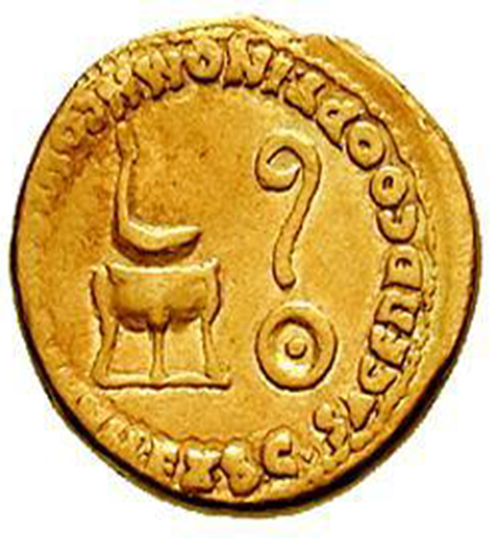
Give the name of the religious symbol – pointed to by the arrow – that appears on this Nero as Caesar aureus (minted during the last few years of Claudius’ reign).
A – Simpulum
B – Litus
C – Tripod
D – Patera

9) Name the author of this passage?
“…you visit Tartarus and hear far away the whipping of the guilty and behold Nero pale at the sight of his mother's torch…”
. .

9) Name the author of this passage?
“On the tour through Greece, among the companions of Nero, he bitterly offended the emperor by either going out often while Nero was singing, or falling asleep, if he remained. Being in consequence banished, not only from intimacy with the emperor but even with his public receptions, he withdrew to a little out‑of-the‑way town, until a province and an army were offered him while he was in hiding and in fear of his life.”
. .

10) Name the individual whose bust appears on the obverse of this Sestertius (struck 50-54 CE).
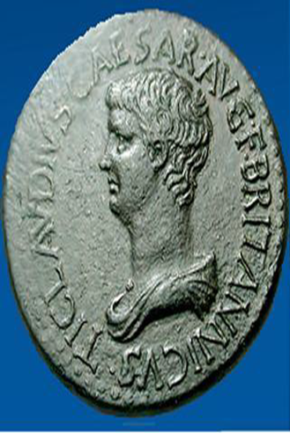
A – Nero
B – Octavia
C – Britannicus
D – Claudius

11) What is the name of the author of the De Clementia?
A – Statius
B – Juvenal
C – Seneca the Younger
D – Martial

12) From which Greek city in Caria (Anatolia) does this relief of Agrippina crowning Nero derive?
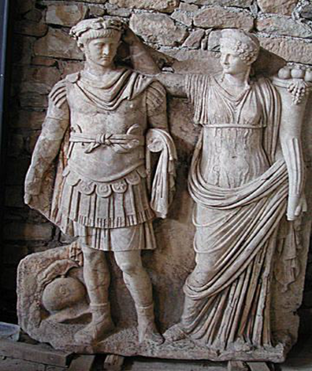
A – Aphrodisias
B – Didyma
C – Halicarnassus
D – Mylasa

13) Which historical figure is being referred to in this passage of Tacitus’ Annals?
“His sisters, Antonia and Octavia, she similarly detained. She had barred all avenues of approach with pickets, and ever and anon she issued notices that the emperor's indisposition was turning favourably: all to keep the troops in good hope, and to allow time for the advent of the auspicious moment insisted upon by the astrologers.”
A – Agrippina the Elder
B – Agrippina the Younger
C – Livia
D – Poppaea Sabina

14) What is the name Nero’s Praetorian Prefect from 54-62 CE (he held the office from 50 CE, i.e. initially served in the role under Claudius)?
A – Sejanus
B – Macro
C – Burrus
D – Tigellinus

17) Who is the historical figure being pointed to in the arrow?
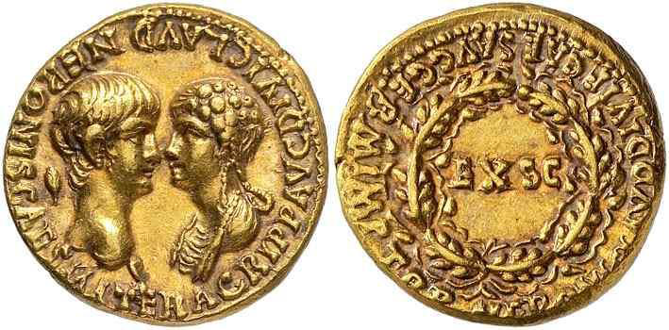
. .

17) Who is the historical figure being pointed to in the arrow?
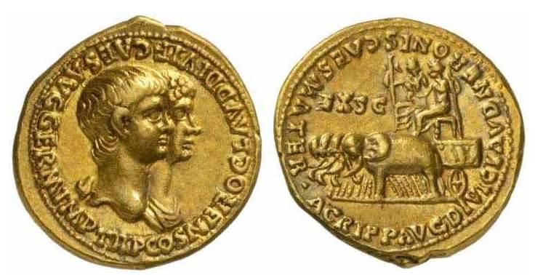
. .

19) In what year did Britannicus die (he was purportedly murdered)?
A – 54 CE
B – 55 CE
C – 56 CE
D – 57 CE

20) In what year was Agrippina the Younger killed?
A – 56 CE
B – 57 CE
C – 58 CE
D – 59 CE

