
Individual written report
Problem Solving and Decision Making – BMSW4004

Certificate of higher education – health and social care
University of wales – trinity saint david
Lecturer: Menstesnot Mengesha
Student: Tea Shchepanovich 2026173
Table of Contents

Introduction 2
Decision – making process 3
Decision – making techniques 4
SWOT Analysis 4
PMI Technique 4
Porter’s Five Force Analysis 4
Fishbone 5
Problem at Workplace 6
Identifying the problem 6
Cause and effect 6
SWOT analysis of team 7
Solutions 7
References 8

Introduction

The path we choose in life is the result of a series of decisions that we have made and implemented so far. This does not mean that these were just the right ones, or just the wrong ones.
It is very difficult to know which is the ideal job for us or which of the two risky solutions to choose. Everything has its strengths and weaknesses and that is why it is not unexpected that we sometimes make mistakes. It is important that in the key moments, those that leave great consequences for each of us, we choose the right decision. Decision-making is a process in which we are faced with several options, and it’s needed to choose the right one by taking a series of actions to implement that decision.
Making decisions can sometimes be a difficult task, especially if the decisions relate to important aspects of life and if what has been decided will have long-term outcomes. At times deciding is extremely easy and unambiguous, while sometimes it can be a very complex process.
In the continuation of the report, a complex problem in the workplace will be described, its impact, possible solutions, decision-making technique will be used in order to find most appropriate solution to given problem, implementing plan and monitoring will be used.

Decision – making process

Lunenburg was writing about these six steps:

Identifying the problem – awareness of the importance of problem and understanding the problem situation. According to Kepner and Tregoe this is the most important step, because the quality of decision depends on a good definition of problem. (Kepner, 2005)
Generating alternatives – notice the different outcomes of the set alternatives.
Evaluating alternatives – the generated alternatives are evaluated; it is considered whether the alternatives are satisfactory and whether they bring the necessary results.
Choosing an alternative – in this step most of the alternatives are eliminated, in order to choose the best one.
Implementing the decision – effective communication is very important while implementing the decision.
Evaluating decision effectiveness – we monitor whether this solution achieves a result, or a new decision is needed.

Management in Healthcare

Managers in health facilities must become the driving force of their institutions, thus creating the basis for the activities that are related to quality.
The process of managing and managing a health institution is very complex task, given that the health institution is affected by various external and internal factors. It is impossible to determine the individual factors that act positively and which negatively on health institution, health managers, in this context, must establish cooperation and communication within the institution, between institutions and sectors outside health care.

Decision – making techniques

Managers and business leaders make numerous decisions every day, many of them affect the success of the business. Therefore, one of the most valued skills of managers is the ability to make efficient and timely business decisions.

SWOT Analysis

SWOT analysis is a strategic management technique for the analysis of strengths, weaknesses, opportunities, and threats from the environment, in order to find an adequate strategy of behaviour in the business environment. Advantages of SWOT analysis are numerous; it can be used individually or in team, it can be used in different complexity, etc. Disadvantages are that it depends on opinions, perceptions, and beliefs (Sarsby, 2016).

PMI Technique

PMI or Plus, Minus, and Interesting it consists of three columns and is evaluated on the basis of positive, negative, and neither positive nor negative sides (Maryam, 2012).

Porter’s Five Force Analysis

This model was developed 1979 by Harvard professor Michael Porter, and the focus is the force of existing competition.

Fishbone

Ishikawa diagram is a tool found by Kaoro Ishikawa which, due to its appearance, is also called herringbone diagram. The goal of this tool or method is to systematize knowledge and enable cause-and-effect analysis.
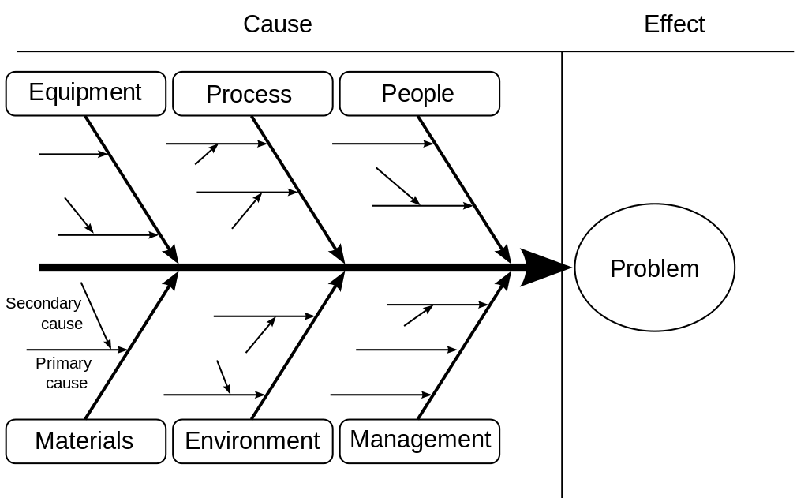

Problem at Workplace

Before making any decision, there should be a clearly defined problem situation. Therefore, the problem should be clearly stated, as well as all its aspects, causes and consequences.
Until 8 months ago, I worked in a private gynaecology and obstetrics clinic in Serbia. In addition to gynaecology and obstetrics, we had various specialists in the field of urology, internal medicine, cardiology, gastroenterology, and dermatology.
When I started working, the rules were pretty clear. We had two teams and we worked in two shifts that we changed weekly. Duties were implemented before the start of the shift, so that everything was covered.
After the change of the head nurse, problems slowly arose. After some time, the clearly assigned duties of nurses were lost. Most of the jobs fell on new employees, who over time became overburdened. The nurses, who have been employed at the clinic for a long time, started ordering what should be done instead of them. Nurses who do dermatological treatments have started scheduling their patients during their working hours, which was not the case before, which again leads to a reduction in the workforce for daily obligations in the clinic. Changes in shifts also started, so some nurses worked all day or in most cases there was a transition to the opposite shift, although we were equally in both shifts so that all the work would be finished. In addition, the nurses also assist the doctors during the examination. All this has led to unfinished tasks, dissatisfaction among new workers, reduced concentration, lack of motivation and increased levels of stress. We had several conversations with the head nurse, emphasizing the problems and its effects. The answer we would get every time was: ‘I will talk to everyone, it will be resolved.’ However, nothing has changed.
Identifying the problem
The problem is bad management.

Cause and effect

Measurements
Method
Equipment
People
Bad Management
People – lack of motivation, dissatisfaction, reduced concentration, overburdened, availability
Equipment – computers, lasers, sterilizer
Method – lack of planning, poor prioritization
Measurements – number of satisfied patients, no short-term goals

SWOT analysis of team

Solutions

References

Kepner, C. H., Tregoe, B. B. (2005). The new rational manager (rev. ed.). New York,
NY: Kepner-Tregoe. (Accessed January 6, 2022)
Lunenburg, Fred C. (2010). The decision-making process. National forum of educational administration and supervision journal vol.27, number 4, 2010. Available at http://nationalforum.com/Electronic%20Journal%20Volumes/Lunenburg,%20Fred%20C.%20The%20Decision%20Making%20Process%20NFEASJ%20V27%20N4%202010.pdf (Accessed January 6, 2022)
Maryam Temitayo, A. Habeeb, O. (2012) Theories and Strategies of Good Decision Making. International Journal of Scientific & Technology Research vol. 1, issue 10, November 2012. Available at http://citeseerx.ist.psu.edu/viewdoc/download?doi=10.1.1.299.7445&rep=rep1&type=pdf (Accessed January 6, 2022)
Sarsby, A., 2016. SWOT Analysis - A guide for SWOT for business studies students. s.l.:The Lidership Library. Available at https://books.google.co.uk/books?id=Yrp3DQAAQBAJ&lpg=PA1&ots=ODnb1ut23A&dq=swot%20analysis%20in%20decision%20making&lr&pg=PR4#v=onepage&q=swot%20analysis%20in%20decision%20making&f=false (Accessed January 6, 2022)

