Chapter three: Methodology

Introduction
As shown in the previous chapter, there is a literature gap in the mental health of police officers, specifically within South Wales police force. As a result of this, my project will include primary data, with the aim of reducing the literature gap. To obtain a better understanding of the research method, this chapter will include the intended methodology of this research project. Research is the process of increasing an individual’s awareness and knowledge surrounding a specific topic (Collis and Hussey, 2014). This was achieved during the previous chapter, titled Literature review.

Research Philosophies
Research philosophies “show how a research can collect, analyse and report data” (Charlotte, 2021). There are two commonly used research models, which researchers can utilise to assist them with their research project. The first is the ‘Honeycomb Model’ and the second is the ‘research onion’. Research philosophies is the first stage in both of these models because it aids the researcher in choosing the correct research approach (Charlotte, 2021).
Research philosophies generally have three elements, ontology, epistemology and axiology. During this project, I am going to be focusing on epistemology, which offers a wider range of methods. Included in this is positivism, interpretivism, realism and pragmatism. This research will follow a pragmatism as it is best suited with the other research approaches that have been selected for this research.

Research Onion
The research onion was developed by Saunders et al (2016), it describes the stages that must be included by a researcher to achieve an effective methodology. The research onion acts as a guide for researchers to follow. Should a researcher include each layer of the onion they are increasing the effectiveness of their methodology. The research onion is also used to depict the issues underlying the choice of data collection techniques and analysis procedures (Saunders et al, 2015). Below is a diagram of the “Research onion model”:

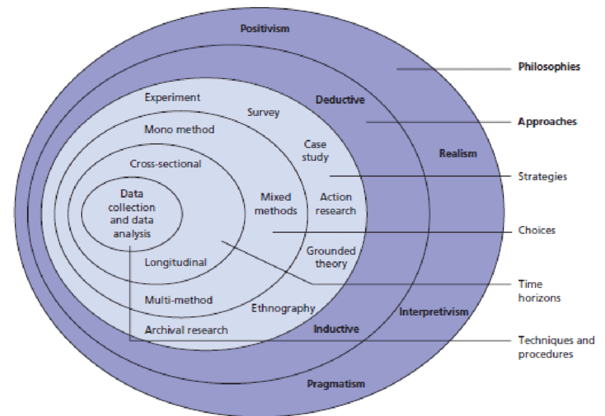
Fig 1 Diagram of research onion (Saunders et al, 2009)

Research approach
There are two main approaches that have to be considered prior to conducting any kind of research. A researcher has to establish which approach is best to achieve their research question. One approach is a deductive approach, which is “concerned with developing a hypothesis based on existing theory, and then designing a research strategy to test this hypothesis” (Wilson, 2010)
However this research will contain an inductive approach, which involves a research question along with research objectives being identified and achieved throughout the research project (Business research methodology, n.d). An Inductive approach can contribute to the creation of new theories and generalisations based of the research conducted (Business research methodology, n.d)

Ethical considerations
This project will not include any personal details of the participants due to the delicate nature of the research. All participants are voluntary and will be informed of the confidentiality of the research. Each participant will be briefed and all rights explained to them. I am going to inform every participant of their right to withdraw from the study at any time and explain the process of how to withdraw should they wish to. By completing the above, participants will not be able to be identified, resulting in all results collected being anonymous.

Research strategy and choice
The research strategy defines how the researcher intends to carry out the work (Saunders et al, 2007). The chosen research strategy for this project is going to be using questionnaires, which will allow multiple variables to be explored such as gaining information on the police officer, their mental health and whether they believe their occupation has had an effect on their mental health. The questionnaire is going to include a range of different questions, such as open, closed, scaled and multiple choice. Questionnaires are most commonly used when there is one or more variables to explore (Hernandez, Fernandez and Baptosta, 2008).
This method is beneficial as is the most cost-effective way of obtaining a large amount of data. It is also an easy way to obtain results meaning individuals of all ages will be able to answer the questions without difficulty.
I aim to encourage police officers to participate by the questionnaire being available via a hyperlink. The topic of mental health is extremely sensitive and certain individuals may not be comfortable answering it whilst in work therefore by providing every participant with the hyperlink they are able to fill it in out of work hours should they wish to. This also eliminates face-to-face contact, which could also assist I participation rates (Lelkes et al, 2011).

This research is going to utilise a mixed method approach, which was first identified by Grover (2015). The correct approach to your research is essential to determine the correct procedure of date collection, data analysis and interpretation (Grover, 2015).

Similarly, Newman and Benz (1998) suggested that quantitative and qualitative methods should be utilised alongside each other. Their research reveals a mixed method approach is effective as it contains positivism, constructivism, transformative and pragmatism elements which were identified by Guba (1990)
Based on my research question and the research objectives, I’ve identified that a mixed method approach is going to be most effective for this type of research. A mixed method approach means using both quantitative date and qualitative date, this will result in my research containing data that can be expressed using numerical values (Quantitative data) and data that is descriptive (qualitative data). For example, my research will include the amount of calls that officers perceive to be traumatic (Quantitative data) and the how the officer would describe their mental health.

This will also ensure that my research is credible because I will be using different methods to collect data on the same subject.

Time horizon and sample
Longitudinal studies include researchers repeatedly examining the same individuals to detect any changes that might occur over a period (Thomas, 2020).
A Longitudinal study would not be appropriate for this type of research project due to having a short time frame to get obtain the data. Instead, a cross-sectional approach going to be utilised. Cross sectional studies include collecting data from different individuals at a single point in time, which is how the data for this research is going to be obtained.
Cross-sectional studies are also beneficial to establish if there’s a pattern or trend within a certain topic. For example, a direct link between police officers and poor mental health.

Due to the sensitive nature of the chosen subject (mental health) the questionnaire is going to be conducted online. There is still a stigma around mental health whereby certain individuals may not wish to disclose their mental health to individuals face to face. The questionnaire will also be anonymous so this should assist with participation rates and honestly whilst completing the questionnaire.
This research will also include sickness records of South Wales Police officers in the recent years. This has been requested by the researcher completing a general data protection regulation form to South Wales Police requesting reasons for absence, how often and how long they were absent.

The data collected will then be analysed and displayed using graphs and charts to show the findings. This will also help identify any patterns or trends in the research conducted.

Another consideration is the sampling technique in which your research will include. The term “sampling is the process of selecting predetermined number from a larger population” (Mishra, 2021). This allows researchers to generalise the results from specified focus groups to the population without having to study the entire population as it would be too large to allow for comparison (Ghauri et al, 2020).

This research is going to include voluntary sampling method, meaning individuals who wish to participate by themselves can do so. I am going to present my questionnaire to a range of front line officers at different stations and provide everyone with a hyperlink, should they wish to participate. This is the most appropriate way for my research to be conducted and ensure that all results are anonymous.
I aim for my sample size to include 80 participants, meaning eighty front line police officers will need to voluntary participate. I think this is an efficient sample size as it’s large enough that I will be able to generalise it to all police officers within South Wales Police force however it’s not too small that the results would not be reliable.
This will also minimise the bias of respondent variants, as I will only be presenting the questionnaire to front line police officers. moreover, this will increase the reliability of the project “Reliability refers to the consistency of a research study” (Mcleod, 2013). A research study can be classed as reliable if the findings are replicated consistently. However, validity refers to “whether a test measures what it is supposed to measure” (Galaczi, 2020) for example, the mental health of South Wales police officers.

Limitations
All research projects have their limitations but it’s the responsibility of the research to be aware of them and to consider how they can affect the overall research project.
One limitation that I have identified is that by using a voluntary sampling method, there’s no evidence that this sample is representative to the wider population that the research aims to make generalisations about, such as all front-line police officers in South Wales Police force (Trochim, 2006).
Moreover, another limitation is whether the participants with be truthful. Despite “mental health problems being very common in the United Kingdom there is still a strong negative stigma around mental health” (Mental health foundation, n.d). Some individuals have experienced negative treatment (negative treatment) because of their mental health problems (Mental health foundation, n.d). With this in mind, some participants may not wish to disclose that they suffer with mental health problems out of fear of being discriminated against. I aim to eliminate this issue by making the questionnaires anonymous and by eliminating any personal details.

Conclusion
This chapter has identified and described all aspects of this research and explained why specific methods have been chosen. The next chapter will include the analyse of results obtained as a result of using this methodology.

REFERENCES
- Business Research Methodology (n.d) Research approach. Available at: https://research-methodology.net/research-methodology/research-approach/ (Accessed on 13.11.2022)

- Charlotte, E (2021) Types of research philosophies used in dissertation methodology. Available at: https://www.masterdissertationhelp.co.uk/2021/12/types-of-research-philosophies-used-in.html (Accessed on 25.11.2022)

- Collis, J and Hssey, R (2014) Business Research: a practical guide for undergraduate and postgraduate students, fourth edition. Available at: Basungstoke: Palgrae Macmillan Higher Education (Accessed on 14.11.2022)

- Galaczi, E (2020) What is validity? Available at: https://www.cambridgeenglish.org/blog/what-is-validity/ (Accessed on 25.11.2022)

- Grover, V (2015) Research approach: an overdue. Available at: Golden research thoughts, volume four, issues 8 (Accessed on 13.11.2022) ISSN 2231-5063 Impact Factor : 3.4052(UIF

- Guba, E (1990) The paradigm dialog. Available at: https://psycnet.apa.org/record/1990-98838-000 (Accessed on 13,.11.2022)

- Hernández, R., Fernández, C., & Baptista, M (2008). The investigation of methodology. Available at: https://revistes.ub.edu/index.php/REIRE/article/view/reire2019.12.227010/29285https://revistes.ub.edu/index.php/REIRE/article/view/reire2019.12.227010/29285 (Accessed on 13.11.2022)

- Lelkes, Y (2011) Available at: http://pprg.stanford.edu/wp-content/uploads/Anonymity-JESP-FINAL-June-2012.pdf (Accessed 14.11.2022)

- McLeod, S (2013) What is reliability? Available at: https://www.simplypsychology.org/reliability.html (Accessed on 25.11.2022)

- Mishra, P (2021) 8 types of sampling techniques. Available at: https://towardsdatascience.com/8-types-of-sampling-techniques-b21adcdd2124 (Accessed on 13.11.2022)

- National alliance of mental illness (n.d) Law enforcement. Available at: https://www.nami.org/Advocacy/Crisis-Intervention/Law-Enforcement (Accessed on 13.11.2022)

- Newman, I and Benz, R (1998) Available at: Qualitative-quantitative research methodology: Exploring the interactive continuum (Accessed on 13.11.2022)

- Saunders, M., Lewis, P. and Thornhill, A (2007) Research methods. Available at: Research methods for business students, sixth edition. London: Pearson (Accessed on 13.11.2022)

- Saunders, M., Lewis, P. and Thornhill, A (2015) Understanding research philosophy and approaches to theory development. Available at: Research Methods for Business Students. Harlow: Pearson Education, pp. 122–161 (Accessed on 14.11.2022)

- Thomas, L (2020) Longitudinal study: definition, approaches and examples. Available at: https://www.scribbr.com/methodology/longitudinal-study/#:~:text=Longitudinal%20vs%20Cross-Sectional%20Studies (Accessed on 14.11.2022)

- Trochim, W (2006) Probability sampling. Available at: http://www.socialresearchmethods.net/kb/sampnon.php (Accessed on 14.11.2022)

- Wilson, J (2010) Research approaches. Available at: Essential of Business research: a guide to doing your research project” SAGE publication, page 7 (Accessed on 14.11.2022)

