
University Name: Prifysgol Cymru Y Drindod Dewi Sant University of Wales Trinity Saint David

Programme: Master’s of Business Administration

Module ID: LCMB7026

Assignment Title: Report of International Marketing of Pizza Hut

Student Name: Md Ahmed Al Zayed

Student ID: 2516697

Tutor Name: Tushara Balendran (London), Dian Mayasari (Birmingham)

Word Count: 5000 words

USE OF GENERATIVE AI IN ASSESSMENT

RESEARCH | For this assessment, you can use Generative AI to support you in research and data analysis. | Yes ☒  No ☐
STRUCTURE | For this assessment, you can use Generative AI to support you in structuring your submission, including creating a draft argument structure, identifying parts  and headings, etc. | Yes ☐  No ☒
PROOFREADING | For this assessment, you can use Generative AI to check your own text/creation for grammatical and syntactical mistakes, including getting suggestions to  rephrase your work. | Yes ☒  No ☐
WRITING | For this assessment, you can use Generative AI to create text for submission. | Yes ☐  No ☒
CREATIVE | For this assessment, you can use Generative AI to create creative materials, such as images. | Yes ☒  No ☐
PROGRAMING | For this assessment, you can use Generative AI to create and check code. | Yes ☐  No ☒
NONE | For this assessment, you are not allowed to use any type of Generative AI support. This includes research support, structure support, writing/proofreading  support and creative support. | ☐

Abstract
The USA, Pizza Hut's home country, and India, its host nation, will be the main subjects of this report's analysis of the company's global business strategy. The study will employ a number of frameworks, including PESTEL, the Hofstede model, STP, and the 7Ps marketing mix, to give a thorough comparison of this business. However, because of the diverse cultures and consumer tastes of the two nations, the business faces a number of difficulties. As a worldwide brand, Pizza Hut needs to use digital technologies to improve product quality, forecast customer purchasing power, and conduct thorough market research in order to enter new foreign countries, according to some of the recommendations made in this report. Additionally, the business must be adaptive and flexible enough to modify its plan in response to demands. All these criteria should be maintained well enough because failing to do the ethical considerations well damages their brand image. However, despite these challenges, Pizza Hut successfully implemented several positive ethical initiatives, such as investing significantly in renewable energy, being certified that they maintain biodiversity protection, and also engaging in carbon reduction programs.

Table of Contents
Section-1 5
Introduction 5
Comparative Analysis of the Market: 6
PESTLE Comparison Between India and the USA: 6
Cultural Factors In Both Countries: Hofstede Cultural Dimension. 9
Comparative Analysis of STP and Marketing Mix: 12
STP Analysis: 12
Segmentation: 12
Targeting: 12
Positioning: 14
7Ps Marketing Mix: 15
Product: 15
Price: 15
Place: 16
Promotion: 16
People: 16
Process: 17
Physical Evidence: 17
Market Entry Strategy for Pizza Hut in India 17
Advantages and disadvantages of the franchise model 20
Ethical issues related to this brand marketing mix: India 20
Recommendation: Move forward with their international marketing strategies. 21
Section 2 23
Gibbs Reflective Cycle 23
Reference: 26

Section-1

Introduction
The multinational organisation's trip becomes more crucial as a new nation is added, and they must choose how to market and provide their product in the foreign market. Therefore, before entering a foreign market, businesses must develop an entry plan. International marketing should be one of every organisation’s major goals because it enables businesses to expand beyond their domestic markets by adapting their product, service, and marketing strategies. Understanding local communities is easier, but customers in different countries have different cultures and different tastes. Along with entering the global market, the competition also gets higher, but the organisation will also get market opportunities. This report will assess and compare the business tactics of Pizza Hut, one of the most well-known quick-service restaurant businesses, in its native country of the United States and a host country of India. A good analysis of how a global brand operates and balances its business operations to penetrate a new market can be obtained by looking at its strategy in two separate countries. Pizza Hut must deal with a number of positive and negative circumstances in both nations, particularly in India, where consumer preferences and the size of the American market are completely different. This report is divided into multiple sections. Initially, it will use Hofstede's theory and the PESTEL framework to analyse the macro-environmental aspects and cultural dimensions. In the second segment, the report will provide an evaluation of Pizza Hut's STP strategies along with a 7Ps marketing mix. Furthermore, this report will also provide a detailed examination of the market interest strategy in India and evaluate the ethical issues with their marketing mix. Finally, this report will recommend some strategies to strengthen their international marketing.
The aim of this report is basically to provide a comparison of Pizza Hut's international marketing strategy to the different needs and expectations of consumers in the US and Indian markets.

Comparative Analysis of the Market:

PESTLE Comparison Between India and the USA:

Figure 1: The PESTEL situation of the country is showing how favourable it is for Pizza Hut. Here, 5 is very favourable, and 0-1 is not at all favourable.
Political Comparison: The political situation in a foreign country significantly influences the expansion of businesses. Depending on political decisions, entering a country becomes easy or difficult for foreign companies. Like in India, recently 100% FDI and an automatic route permit have been given in the quick-service restaurant sector (Lokhandwala and Parekh, 2024). Foreign brands such as Pizza Hut are therefore receiving the greatest investment and profit potential in India. Political situations affect businesses even in their home countries. For instance, in the United States, restrictions on the arrival of immigrants have been made stricter. As a result of strict immigration policies, in 2025, every month, 900k+ job positions were vacant in the country's restaurant industry, and companies are facing a worker shortage (Varzally, 2023). This comparison shows that while the Indian government's policies impact Pizza Hut's business expansion, policies of the United States directly affect its daily operations.
Economic Comparison: People spend a significant portion of their income on food and drink. People from the Indian subcontinent, in particular, consider food and drink to be one of their primary needs (Sen, 2004). However, if food prices rise, fast food like pizza goes to the very bottom of people's menus. But if prices of raw materials rise, unless menu prices are raised, the profit margin of Pizza Hut has to be sacrificed. So, being forced, they have to increase prices; as a result, the organisation is failing to take advantage of Indians' love for food. The picture of the United States is even more terrible. Here, prices of food have increased at a faster rate than general inflation (Scheid, 2026). In the United States, not only have the prices of raw materials increased, but so have labour costs, insurance, and taxes. Therefore, in the same inflation, even if Pizza Hut could make up a bit by raising prices in India, in the United States they are having to be extra careful about operational costs too.
Social Comparison: The urbanisation of India is increasing rapidly, and along with it, the food habits of its people are changing. Where previously the main food of Indians was traditional food cooked at home, today dining out is a regular occurrence. Indians now are welcoming foreign cuisine with open arms, and Indian-style pizza is quite popular here. This trend has created a big opportunity for Pizza Hut. On the other hand, in the United States, young people now do not go to restaurants just to eat; rather, nowadays a restaurant is a popular place for friendly chats or business meetings too (Mathews and Mattox, 2026). Pizza Hut's dine-in environment receives widespread praise. Therefore, they are capable of giving consumers an extraordinary experience.
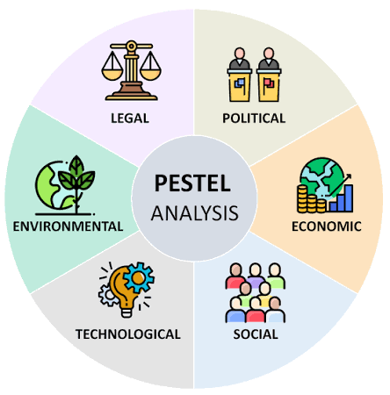
https://www.istockphoto.com/illustrations/pestel-analysis
Figure: PESTEL framework
Technological Comparison: The internet is easily available, and the market of online food delivery is growing rapidly in India today. Especially within a single app, customers are checking restaurant menus and comparing multiple menus, and because they are getting the opportunity of online payment, its convenience is attracting them more. Pizza Hut delivers food through its own website in India. On the other hand, in restaurants in the United States, self-service kiosks are a common trend. As a result of technological development, AI technology has now been included in kiosks. So QSR brands like Pizza Hut are putting these to use to give fast service to customers (Zaitouni and Murphy, 2025). Although kiosks are seen in India on a small scale, mostly in big branches, they have not been adopted on a massive scale like in the United States yet. Therefore, in India, Pizza Hut is placing most emphasis on online sales, because installing expensive kiosks here might fail, since people are not accustomed to using them yet.
Environmental Comparison: Overcoming the COVID-19 pandemic, people have now started returning to restaurants. The restaurant industry is growing, but the risk of environmental pollution has increased. People are now conscious not just about food but also about where every ingredient is coming from. So restaurants in India are putting more emphasis on sourcing ingredients from local farmers. Especially, they are offering specific menus centring on specific seasons according to seasonal vegetables which are available only in those seasons. So Pizza Hut also has to provide seasonal variations. In the United States too, environmental consciousness in the same way is forcing restaurant businesses to be sustainable. Young people especially look down on restaurants that waste food or use harmful packaging materials. Therefore, environmental consciousness is now not just country-specific; rather, it is growing across the world in the same way.
Legal Comparison: To do restaurant business in India, a valid FSSAI licence is mandatory. Without this, no restaurant will be able to do business in India. The FSSAI licence is a specific law which forces businesses to maintain food quality and hygiene (Dhara et al., 2021). Under this law, Pizza Hut always has to keep the environment improved in kitchens and maintain health rules. The FDA Food Code influences restaurants in the United States. From assigned duties of a manager to ensuring food quality, detailed guidelines are present for every single matter in this food code (VanEpps et al., 2016). The difference from India's FSSAI is that FSSAI mainly grants licences to organisations based on the restaurant environment and food quality. On the other hand, complete guidelines for the daily operations of an organisation are present in the FDA, meaning literally everything from A to Z. Therefore, in the United States, the FDA Food Code is like a bible for Pizza Hut, the FDA Food Code is like a bible.

Cultural Factors In Both Countries: Hofstede Cultural Dimension.

https://www.studocu.com/en-us/document/southern-new-hampshire-university/global-dimensions-in-business/cultural-comparisons-india-vs-usa-as2-analysis/152180624
Figure 2: Comparison of global average score and scores between India and the US according to Hofstede's dimensions.
This world is full of diverse cultures. Cultures at the edges of the earth exhibit contrasts. When a business takes initiative to expand in multiple countries, having knowledge of these contrasting cultures is essential. Geert Hofstede has brought out cultural contrasts through six dimensions (Hofstede, 2009). The contrasting cultures of India and the United States are explained by this framework:
- Power Distance (PDI): Division of power is understood by the PDI dimension. In India, the division of power is comparatively higher than in the United States. Indians are accustomed to being loyal and accepting authority. Here, applying power on a lower level does not mean force; rather, subordinates accept this authority willingly. In contrast, in American society, people are often unwilling to accept the exclusive authority of those in power. Everyone has the mindset to challenge the wrong decisions made by those in authority. The boss and workers collaborate closely. Higher-ups also see this equality naturally.
- Individualism vs. Collectivism (IDV): This dimension expresses the importance that family and society hold for an individual within a culture. In India, family bonds are given the highest importance. Teamwork stays strong in the workplace. Group achievement is given preference over personal achievement. But the United States is a highly individualistic country. Turning 18, children will leave home to stay elsewhere and live life according to their choices; such behaviour is considered normal. Even when working in teams, personal achievement is valued separately. The low Power Distance Index (PDI) in the United States contributes to the high Individualism (IDV) score, whereas India exhibits opposite scores in both dimensions.
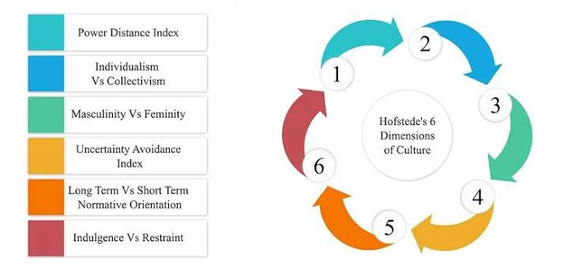
https://www.istockphoto.com/illustrations/pestel-analysis
Figure: Hofstede Model
- Masculinity vs. Femininity (MAS): This dimension expresses the kinds of values that drive society. India and the United States are close in scores in this case. In both countries, the values of success, competition, and the mindset to surpass others are prevalent. But the clear difference is in expression style. Behind this, mainly previous dimensions influence quite a bit. As a collectivist culture, if someone succeeds in India, it is considered the success of the family, whereas in the United States, the achievement of a successful person is only his own. People want to be successful in India, but expressing that nakedly is seen as arrogant, whilst in the United States, everyone sees a successful person boasting about himself as normal.
- Uncertainty Avoidance (UAI): This dimension expresses how easily people in a country accept uncertainty. India and the United States have similar positions in this dimension. But influenced by PDI, the UAI situation in the two countries becomes entirely different. Indians accept uncertainty because they tend to avoid speaking up in front of their boss. Their mindset is that if the boss makes a sudden decision, no matter how difficult it may be, it must be accepted and adapted to. But the low UAI of the United States means taking risks is bravery. They value innovation. In the same problem, where Indians adapt, Americans put emphasis on finding ways to solve the problem.
- Long-Term Orientation (LTO): The scope of people's planning is explained through this dimension. In India, future planning is given importance, whereas in the United States, immediate results are expected. Indians endure hardship year after year, holding onto the belief that something beneficial will eventually come. But Americans emphasise quarterly results. If results do not come in 3 or 6 months, they do not hesitate to cancel plans either.
- Indulgence vs. Restraint (IVR): This dimension shows how much people in society can indulge their desires. In this case, India stays in quite a restrained position. Here, IDV and LTO dimensions directly affect Indians. According to IDV, Indians think more about family, so spending money on personal luxury is seen by them as selfishness. On the other hand, according to LTO, Indians are believers in long-term planning. Therefore, to secure the future, they sacrifice today's joy without hesitation. In the United States, a successful person does not hesitate to spend on personal luxury because they do not have family obligations. Going to clubs at weekends and having fun is seen as a right by them.

Comparative Analysis of STP and Marketing Mix:

STP Analysis:

Segmentation:
In both India and the United States, the customers of Pizza Hut are young people. In India, middle-income family consumers who see dining out as an opportunity to spend quality time and in the United States, middle- and high-income professionals who hold business meetings in restaurants. In India, modern urbanites will be attracted to Pizza Hut, and in the United States, their customer base can be in cities or suburbs as well, since fast food is a normal meal there. Indians place importance on home delivery, so Pizza Hut's dedicated app is for them, whereas in the United States, they will place more emphasis on self-service kiosks.

Targeting:
Family customers will be the primary target in India due to the country's collectivist culture. Everyone in the family and friends celebrate together in someone's success. The secondary target will be students, because interest in foreign cuisine is growing among the young. Here too, there will be a touch of collectivist culture, as students usually do not go to eat pizza alone.
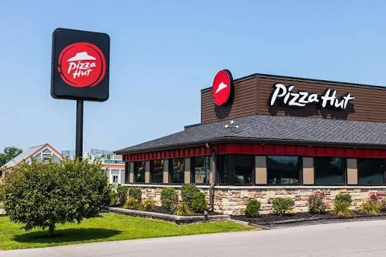
Source: ©JETCITYIMAGE – STOCK.ADOBE.COM
The main target in the United States is busy working professionals. They do not set aside time for cooking at home. Sitting down to cook after a busy day is tiring and annoying for them. Besides, they do not just go to eat in restaurants like Pizza Hut; important business meetings also happen in such an environment. To make clients happy, many people offer treats. Therefore, these customers will be the primary target for Pizza Hut. Family customers can also be kept in secondary positions, who step out on weekends to eat somewhat better food and have a good time.

https://www.meatpoultry.com/articles/33662-yum-brands-to-sell-pizza-hut-business-for-27-billion

Positioning:
Delivery Focused
Premium
Affordable
Dine-in Experience
Domino;s
Pizza Hut
Oven Story
●
La Pino'z
●
Chicago Pizza
●
Perceptual Map of Major Pizza Brands in India
Figure 3: Pizza Hut's position in the Indian market based on price and dine-in experience.
Pizza Hut positions itself as a family restaurant in India, where families will come to enjoy themselves. Within reach combo packs will be offered for Indians, because a nagging worry about price still works among them.
Pizza Hut occupies a somewhat higher-end position in the United States. Here, they present themselves as a digital-first restaurant. Customers will order digitally, collect through kiosks, and enjoy the service with speed. To consumers, the service will be wrapping up the food part as fast as possible amidst a busy schedule. That means the food will not be a time-wasting part of time waste.

7Ps Marketing Mix:

Product:
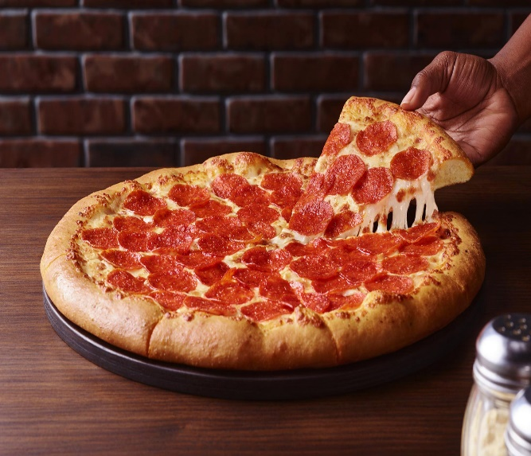 | 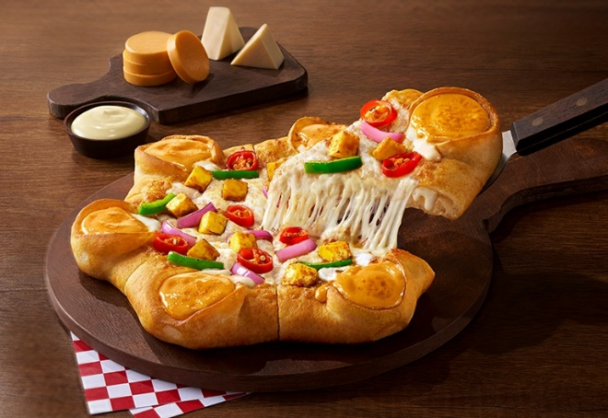
Pepperoni Pizza from Pizza Hut USA | Tandoori Paneer Pizza from Pizza Hut India
https://www.meatpoultry.com/articles/33662-yum-brands-to-sell-pizza-hut-business-for-27-billion
Based on the taste profile of India and the United States, Pizza Hut designs different types of products for the two countries. The main attraction on the Indian menu is vegetarian pizza. The number of people who eat non-veg is relatively low in India. People in India avoid beef or pork, especially beef, due to religious beliefs. So, there are mainly more veggie items on the menu. On the United States menu, meat-based toppings are seen. BBQ chicken, beef, and ham are the main attractions here.

Price:
American pizza is sold in dollars and Indian pizza in rupees. If the dollar price of a pizza in the United States is directly converted into Indian rupees, it can be seen that the price of American pizza is 2-3 times higher than that in India. However, the income of Indians is much lower than that of the United States. The income of an American citizen is almost 30 times higher than that of Indians. In India, Pizza Hut mainly arranges its pricing strategy based on local purchasing power. The pricing strategy in the United States is positioned in the premium range, primarily competing with other high-end brands. There are combo offers in both countries, but in India the purpose is to attract price-sensitive buyers, whereas in the United States it is to call buyers to the store with a base combo price and later sell additional items.

Place:

In both countries, customers can mainly go to the restaurant and eat pizza. However, differences are seen in pick-up and home delivery. Pizza Hut sells online through its own website, but partners like Zomato in India and DoorDash in the United States provide support as distribution channels. Besides, the drive-thru option is quite popular in the United States, which is not yet prevalent in that way in India.

Promotion:
The promotional campaigns of Pizza Hut in the United States and India reveal a subtle difference. In the 80s and 90s, Pizza Hut was at the top position in the market in the United States. Domino's has occupied that place for a long time. Pizza Hut is therefore running various campaigns to revive old nostalgia in the minds of customers. The purpose is to bring back those aged 35-45 who used to go to Pizza Hut with their parents in childhood by promising them that feeling (Murphy, 2026). In India as well, Pizza Hut is behind Domino's, but here they are targeting the youth more. Taking advantage of the active presence of Indians on social media, promotion is being carried out with memes and humorous content (Shastri, 2021).

People:
350k+ staff work at Pizza Hut worldwide. Among them, many staff are working in Pizza Hut franchises. The primary goal of employees in the United States is to provide customers with the quickest service possible. As the use of kiosks is prevalent here, staff do not take orders themselves but rather put emphasis on food quality and rapid service. But Indians want a bit more of a warm experience. So, waiter service is popular here. Staff go to tables and take orders personally.

Process:
If there are complaints about Pizza Hut's service or food quality, there is an opportunity for customers to lodge complaints in both countries. In India, delivery-related complaints can be made by calling a designated hotline number, such as claiming a refund if it arrives later than the scheduled time or if an item is missing in the parcel. Almost the same process exists in the United States, but if complaints are not resolved, a difference is seen in the next stage. In India, customers can approach a government agency (Central Consumer Protection Authority), whereas in the United States, there is a private platform for dispute resolution (Better Business Bureau).

Physical Evidence:
Pizza Hut currently promotes a uniform logo worldwide, and India is no exception to that. Store layouts in India are different from those in the United States. Several outlets of Pizza Hut in Mumbai and Ahmedabad are completely non-vegetarian-free. There is no presence of non-veg anywhere there, starting from the kitchen to the dining table. However, there are no fully vegetarian outlets in the United States.

Market Entry Strategy for Pizza Hut in India
Pizza Hut entered the Indian market in 1996 and opened its first restaurant in Bangalore; since then, it has captured a dominant and significant share of the pizza market and has maintained an impressive growth rate of over 40% (Agastine and Chotai, 2026). The company grows rapidly in the Indian market, and within a few decades it already has 95 outlets across 24 cities in India. The company initially faced several challenges because there were several fast food items available in India and pizza was a new item for the local populations. Besides, Pizza Hut is relatively high-priced, which is why, as a complete meal, this food was not fully matched to local consumer preferences, or some of them would think that pizza is a waste of money. So the company started expanding its business through franchising, and approximately 99% of the company's restaurants are franchised. This demonstrates that the company totally relies on franchise partners for its international expansion into the Indian market.
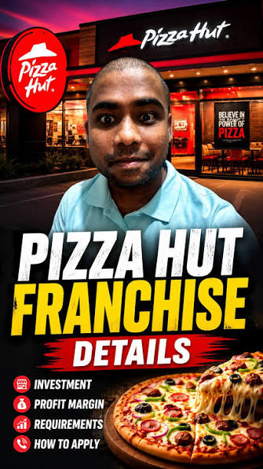
https://lexpress-franchise.com/en-us/news/yum-brands-sells-pizza-hut-for-2-7-billion-to-longrange-capital-and-yum-china/

Advantages and disadvantages of Franchise model
Advantages | Disadvantages
Due to the franchising method, Pizza Hut does not need to spend heavily on the restaurants, and also they do not need to operate them by themselves, so the initial investment is relatively lower. | One of the most brutal disadvantages is the company has less control over its foreign outlets, so because of franchising, Pizza Hut won’t have any direct control.
Due to the franchise method, the company uses franchise partners who are local partners, so they are more knowledgeable about the customer preferences, their taste differences, and the overall business environment (Juliuse, 2011). | As the company does not oversee the operation itself, there might be differences in the food quality and customer service from the franchise outlets.
Even if the company initially had several market conditions and failed operations, they did not need to worry about the total risk because they had a franchise partner who had a huge shared risk of the total operation. | There is a huge brand reputation risk in franchising because if the outlets provide bad service to the consumer, it will impact totally on the Pizza Hut brand reputation and minimize consumer loyalty (Robert et al., 2018).
Through this market entry model, Pizza Hut can open several outlets in more cities, which means it enables faster expansion. | Pizza Hut needs to share the total profit with the franchise partner, and this way the revenue might decrease.

Ethical issues related to this brand marketing mix: India
Ethical issue 1: product
In the Indian market, Pizza Hut adapted its menu in a totally different way according to local preferences because in India the spices are different, taste preferences are different, and even most of the Indians are vegetarian. This approach is considered ethical because Pizza Hut respects the local dietary preferences, and the consumers have the greater priority because it gives them a greater choice.
Ethical issue 2: price
The price of their pizza is relatively higher than the local pizza, but they provide several value-based offers. For example, in India, there is a current deal which is buy one get 3 free, or there is another ongoing offer which is if the consumer orders a medium thin crispy pizza, they will get cheesy sprinkled fries and Pepsi absolutely free (Chowdhary and Avila, 2001). It is a very great strategy and ethical business practice because different consumer groups get access to the product.
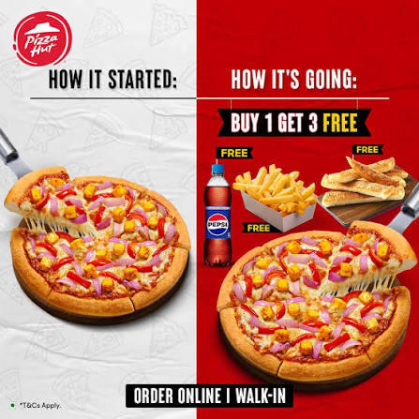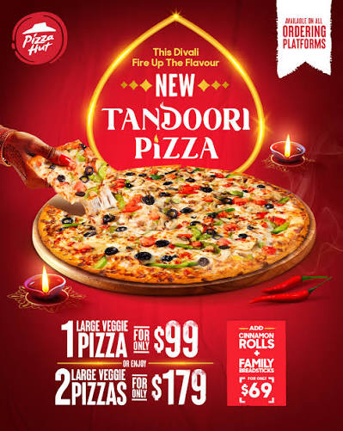
Figure: Pizza Hut Indian offerings and flavours
https://www.pbs.org/newshour/economy/pizza-hut-struggling-with-delivery-competition-sold-for-2-7-billion

Potential unethical issue: promotion
If the company does not clearly communicate about important condition exclusions or additional charges along with the low price or attractive deal, it may lead to negative consequences, and the company could face ethical concerns. Pizza Hut needs to disclose all the terms and conditions along with offering these attractive deals.
Pizza Hut's food options could include high-calorie, high-fat, and allergenic properties, and the company should provide full information about these things because there are several health-conscious consumers who could make a wrong decision about their food, and this can lead to health issues. Due to the potential for unethical issues, Pizza Hut should offer equitable pay, favourable working hours, training, and working conditions in its franchised restaurants. The business can employ sustainable items instead of plastics in its packaging (Bhalla et al., 2026). Pizza Hut is particularly well-known among kids, and in order to attract their attention, the company shouldn't use cartoon toys or visually appealing promotional content because they deal with unhealthy food and limited high-calorie, nutrient-dense foods, and it is unethical to promote this type of food due to children's health concerns.

Recommendation: Move forward with their international marketing strategies.
USA | India
In the USA the physical dining units are very expensive to rent, so the company should evaluate the retail fleet by model type rather than brand nostalgia, and most importantly, the company also needs to evaluate and make a decision on closing old dining units that cannot function efficiently to reduce their unnecessary operational costs. | In India, Pizza Hut is a very attractive option, so the company can increase its presence beyond major metropolitan areas because the company will get consumer attraction even in the emerging cities and towns.
The company should work on improving the pizza box and using thermal packaging to prevent soggy crust, as this will guarantee that the quality of the pizza is intact, since occasionally the delivery man makes a mistake during the home delivery option and the pizza loses its original texture and shape. | The franchise restaurant should not compromise on the quality of their food and consumer service, so they need to strengthen the franchise training and quality control and ensure their food and service quality are standard enough in the Indian outlets.
In the USA the consumers are more likely to use the Pizza Hut app and their official website, so the company should aggressively optimize and boost e-commerce metrics like search to cart to improve the consumers' experience in the digital platform. | In terms of online food delivery, the company can form partnerships with several food delivery platforms like Swiggy or Zomato, which deliver food very carefully.
In the USA, consumers are not very conscious about what they are eating, and offering very high-calorie food is unethical, so what Pizza Hut can do is introduce a high-protein crust where the amount of protein will be more and the calories will be reduced. So in the USA, people love to enjoy non-vegetarian food, and the high-protein pizza will be both attractive and ethical. | Indian people are very health-conscious; most of them are vegetarians and prefer spicy food, so Pizza Hut should continue developing products and mixing their pizzas according to Indian tastes and including vegetarian options.

Section 2

Gibbs Reflective Cycle
Gibbs' reflective cycle is a structured approach to reflective learning that helps individuals learn from their experiences by critically analysing their actions and reactions (Markkanen et al., 2020). The initial stage involves describing the experience, followed by expressing feelings associated with the situation (Beldar, 2025).
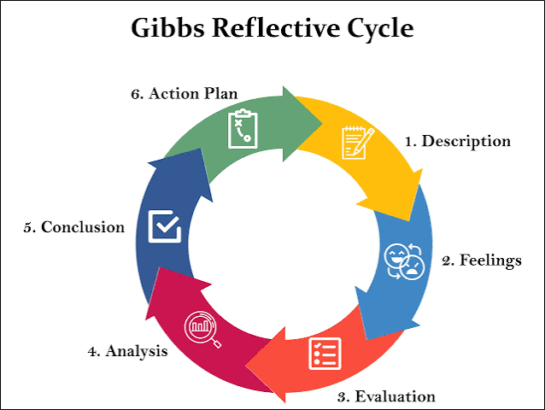
Figure: Gibbs Reflective cycle
https://reflection.ed.ac.uk/reflectors-toolkit/reflecting-on-experience/gibbs-reflective-cycle
Description: While I was doing this assignment, I came to an understanding of Pizza Hut's international marketing strategies in the USA and India. The main purpose of this assignment was to analyse the global food service brands and their strategies in two different international markets. This report conducted an analysis of the USA and Indian markets so that I could understand how international businesses are dealing with the challenges and differences in culture, economy, and consumer behaviour in two different nations. During this analysis, I used several frameworks to understand the internal and external business environment of Pizza Hut, such as the PESTLE analysis, Hofstede's cultural dimensions, STP, and the 7P's marketing mix. In the last few segments, I also analysed Pizza Hut's market entry strategy, which is the franchising method, but there were both advantages and disadvantages, which I included. I also evaluated the potential ethical issues that Pizza Hut can face, which can affect their marketing activities, so I have included a separate recommendation for both the USA and Indian markets.
Feeling: At first, I believed that the PESTEL and Hofstede's cultural frameworks were just theoretical concepts, but applying them to a real organisation was difficult for me initially. The main thing that was confusing me was the difference between segmentation and targeting, but after doing this assignment, I got a clear concept of both of these concepts while applying them to Pizza Hut. Now I am more confident and realise that these frameworks are not just theoretical tools, but I could also apply them to my real market analysis. Although there were various obstacles at first, I was apprehensive, but this experience boosted my confidence level, and I am confident enough that I will be able to implement all of this knowledge of marketing ideas to real-world organisations.
Evaluation: Let’s say, about the positive side first, which is that I gained practical knowledge about how an international brand adapts its marketing strategy in different cultures with different types of people. I came to an understanding that Pizza Hut adapted and modified its whole marketing mix, which means its products' prices, promotional activities, and consumer experience are according to Indian culture. It means an international organisation needs adaptability to change according to local preferences. I completed the research, and I believe the procedure was fantastic because I got various pieces of material from credible academic and corporate sources. There is information available from which I conducted thorough analysis using quicker frameworks: Hofstede, STP, and the seven Cs. Using the facts available, I successfully prepared my report and compared Chanel's strategy for entering and conducting business in various areas. However, it was not easy. There were both positive aspects and some challenges to completing this assignment. The challenges that I faced were reliable and country-specific information. I needed the exact data on the employees' pricing compliance procedures, which was not so easily available on the online platform, so I needed to take help from ChatGPT for the basic research.
Analysis: On the analysis stage, I believe that this assignment was very helpful. I think that there should be a balance between global standardisation and local adaptation because different cultures and different kinds of people are there in the world, and companies like Pizza Hut need to fulfil the local consumer expectations if they want to be recognised as a global brand. For example, the company needs to change their menu according to local food preferences, such as including vegetarian choices and increasing the spice level and affordability. In contrast, the US market is totally different because consumers here do not like spicy or vegetarian food. Moreover, in the US, they prefer digital ordering and customisation. I also understand that franchising is very important for international markets in order to enter a totally new country. It was the franchising method that helped Pizza Hut gain local knowledge and foster expansion, yet there were several challenges, like losing total control and sharing total revenue.
Conclusion: This assignment improved my knowledge, as well as my research, analytical, and referencing skills. But finishing this assignment was not easy because I encountered some difficulties, as the company did not provide detailed information about their marketing strategy, which is obvious. So I needed to face the challenges of using a wider range of academic resources, which helped me either way, as I could develop stronger critical analysis skills.
Action plan: Furthermore, I want to improve my citing skills by using Google Scholar to ensure that the real writer receives credit, as well as ensuring that my ideas are supported by acceptable academic proof. I also wish to learn more about foreign marketing methods, as I just covered a few key subjects here. I'd like to learn more about this issue, and I've taken online classes, so I'll describe my understanding further in future tasks. For future assignments, I want to start the research earlier to get extra time in forming the writing process and research plan. There were several frameworks that I’ve used which needed evidence specifically related to each country, and for future assignments, I would like to identify the basic information about these frameworks to avoid collecting unnecessary information. I need to understand reliable academic sources, official company reports, and credible industry sources because depending only on the general website will not bring me the actual data and country-specific statistics.

Reference:
Beldar, P.R., 2025. Case Study: Enhancing Learning in C Programming Through Gibbs Reflective Cycle. Journal of Engineering Education Transformations, pp.61-68.
Agastine, A. and Chotai, N.A., 2026. Dine-In or Deliver? Pizza Hut’s Strategic Dilemma in a Delivery-Driven Market. International Journal of Economic Practices and Theories, 2026, pp.2650-2663.
Chowdhary, N. and Avila, N.G., 2001. Comparative Study of Fast Food Outlets.
Dhara, D., Biswas, S., Das, S.K. and Biswas, O., 2021. Status of food safety and food security in India from the perspective of FSSAI. Indian Journal of Animal Health, 60(2), pp.167-173.
Hofstede, G., 2009. Geert Hofstede cultural dimensions.
Juliuse, D., 2011. Study of Effect of Franchising on Brand Identity of Pan Indian Brands (Master's thesis, MICA (Mudra Institute of Communications, Ahmedabad)(India)).
Lokhandwala, M. and Parekh, M. (2024) FDI in restaurants: A gateway to enhanced customer experience, Lexology. INDUSLAW. Available at: https://www.lexology.com/library/detail.aspx?g=bdbed71c-054f-40c4-bdc9-312a5f04f180 (Accessed: August 2, 2026).
Markkanen, P., Välimäki, M., Anttila, M. and Kuuskorpi, M., 2020. A reflective cycle: Understanding challenging situations in a school setting. Educational Research, 62(1), pp.46-62.
Mathews, B. and Mattox, K. (2026) What US consumers want from restaurants in 2026, McKinsey & Company. Available at: https://www.mckinsey.com/industries/retail/our-insights/what-us-consumers-want-from-restaurants-in-2026 (Accessed: August 2, 2026).
Murphy, N. (2026). Big changes are coming to Pizza Hut in 2026. [online] Mashed. Available at: https://www.mashed.com/2137897/pizza-hut-big-changes-2026/ [Accessed 5 Aug. 2026].
Robert, B., Chib, S.S. and Jena, P.K. (2018) Effect of Branding on Customer Satisfaction: A Comparative Study of Domino's and Pizza Hut in Asia. Enhancing Organisational Growth Through Innovation and Creativity: Issues, Opportunities and Challenges, p.272.
Scheid, B. (2026) Restaurant inflation stays hot, forcing shift in American dining, S&P Global Market Intelligence. Available at: https://www.spglobal.com/market-intelligence/en/news-insights/articles/2026/2/restaurant-inflation-stays-hot-forcing-shift-in-american-dining-98800980 (Accessed: August 2, 2026).
Sen, C.T., 2004. Food culture in India. Bloomsbury Publishing USA.
Shastri, A. (2021). Exclusive study on marketing strategy of Pizza Hut: 2023. [online] IIDE. Available at: https://iide.co/blog/pizza-hut-marketing-strategy/ [Accessed 5 Aug. 2026].
VanEpps, E.M., Roberto, C.A., Park, S., Economos, C.D. and Bleich, S.N., 2016. Restaurant menu labelling policy: review of evidence and controversies. Current obesity reports, 5(1), pp.72-80.
Varzally, A., 2023. Immigrants run the restaurants: Normalising dining out and defining the immigration reform and Control Act. Pacific Historical Review, 92(4), pp.610-641.
Zaitouni, M. and Murphy, K.S., 2025. Self-Service Technologies (SST) in the US Restaurant industry: An evaluation of consumer perceived value, satisfaction, and continuance intentions. Journal of Foodservice Business Research, 28(2), pp.245-276.

