Jessica Cox
1901525
15th November 2019
SH*T IS F*CKED UP & BULLSH*T
“Get comfortable with being uncomfortable”

“Get comfortable with being uncomfortable”
For this topic I have decided to look at the stigma of mental health. I have decided to look at this because I feel that mental health doesn’t get enough recognition, meaning that too many people suffer in silence and does not get the help they deserve. When looking at the negativity surrounding mental health I have looked at a few different slogan’s that I feel are strong and catches people attention. I have added a few different mottos in my work such as “metal health is not a luxury” I think this this is an empowering slogan because it makes you think deeper about the issue at hand. Another slogan that I have added into my work is “more money for mental health”. I have added this slogan because it raises awareness that there is not enough money funded to help people with mental health leaving people untreated. I think this this is empowering message because when it makes people realise that mental health needs more support. The stigma to metal health is worth protesting because if you was to protest repeatedly then it would make people realise that mental health is normal and would also allow people to get better treatment.
The theme for the 2019 Mental health Awareness week is body image, hence the title for my work. According to Plato “beauty is the object of love”¹ , my work depicts a mother with her children in a loving pose. She is looking down over her children looking quite happy and if it stood alone could be considered a beautiful image. The images that overlap the ‘loving’ family portrait reveals a darker reality. This is why I composed these in black and white. The images are of the same mother but in a much darker place. Her face is not lit and is very much hidden and her body language is shut off. This relates to the work of Meredith Adelaide in Creative Review (fig 1.). She uses portraiture and shadow to explore mental health through photography.
If we also take into consideration the work of Cindy Sherman she photographs herself within her images using different personas. This has heavily influenced my work as this young mother in my collage clearly shows her with different identities. (Fig 2 & 3). I have taken inspiration from both Sherman and Dada and brought both ideas together. The different personas from Shermans work and collage for Dadas work to present my ideas.

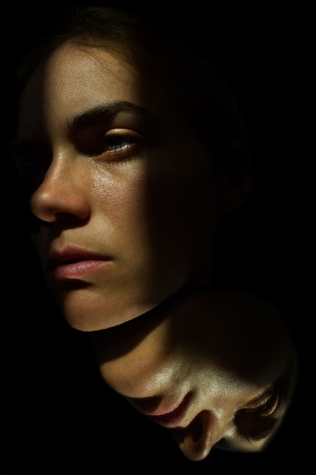
Figure 1 Meredith Adelaide “Untitled”


Figure 2 Cindy Sherman “Untitled #92”

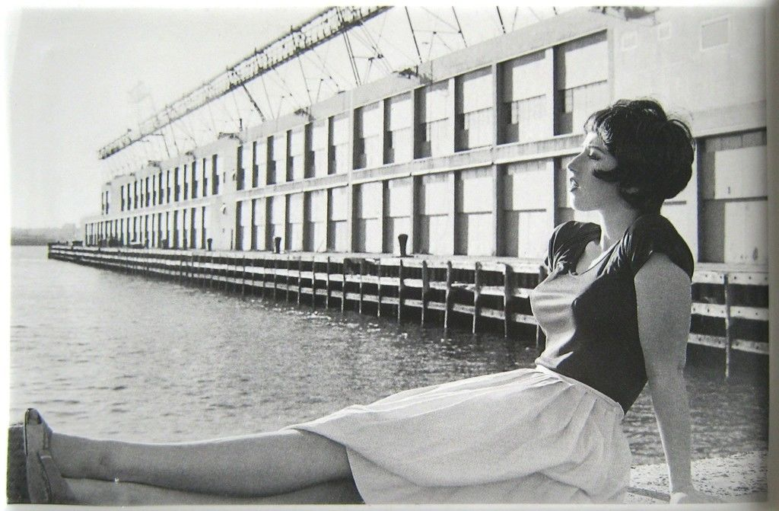
Figure 3 Cindy Sherman “Untitled Film Still”

Figure 4 DADA “The Art Critic”

Bibliography
¹ George Dickie, Introduction to Aesthetics an Analytical Approach (New York: Oxford university press . Inc. 1997) pg6

Illustrations
Figure 1 Meredith Adelaide “Untitled”. Creative Review. “Exploring Mental Health through Photography”
Figure 2. Cindy Sherman, Untitled #92, 1981, chromogenic colour print, 24 x 48 inchesThe Eli and Edythe L. Broad Collection, courtesy of the artist and Metro Picture
Figure 3. Cindy Sherman, Untitled Film Still, 1978-2014
Figure 4 DADA “The Art Critic” 1919–20

