Task 1
Essential Skills for Academic and Career Success

Achieving success in academics and professional careers requires individuals to develop a combination of important skills. These skills support effective learning, clear communication, and the ability to adapt to challenges. Some of the most essential skills include time management, critical thinking, communication skills, and teamwork.

Time management is a vital skill for ensuring productivity and avoiding stress or burnout. It involves setting priorities, organizing tasks, and meeting deadlines efficiently. For students, this skill helps balance academic assignments, exams, and extracurricular activities. In the professional world, particularly in fields like engineering or business, managing time effectively ensures that projects are completed on schedule and resources are used wisely [1].

Critical thinking is the ability to analyze, evaluate, and solve problems by thinking logically. This skill is crucial for making sound decisions and generating innovative solutions. For example, in careers like data analysis or software development, critical thinking is essential for interpreting data or designing algorithms [2].

Communication skills are another cornerstone of success. Being able to express ideas clearly and confidently, whether in written or verbal form, is crucial. In academic settings, students must write reports, essays, and give presentations. In the workplace, good communication skills enable professionals to convey their ideas effectively, negotiate, and collaborate with teams or clients [3].

Teamwork is equally important, as collaboration helps individuals achieve shared goals. Many careers, including my chosen field of software engineering, rely heavily on teamwork. Professionals must work with diverse teams to design, test, and launch products or services. Strong teamwork fosters mutual respect and ensures projects run smoothly [4].

Developing these skills ensures that individuals are prepared to navigate the challenges of both academia and the workplace. They also enhance career readiness by enabling individuals to learn continuously and adapt to changes in industries or technology. For me, these skills will be essential in becoming an efficient and innovative software engineer.

References
[1] C. Adair, The 7 Habits of Highly Effective People, 25th ed. New York: Free Press, 2020.
[2] J. Dewey, “How We Think,” Journal of Educational Psychology, vol. 8, no. 1, pp. 35-52, Mar. 2023.
[3] J. Smith, “Mastering Academic Writing,” The Writing Journal, vol. 10, no. 2, pp. 45-50, 2021.
[4] “Teamwork and Collaboration,” Online Source: www.skillsyouneed.com, accessed: Dec. 12, 2024.
[5]
Visuals
- Diagram showing how time management, teamwork, and communication skills overlap in contributing to success.

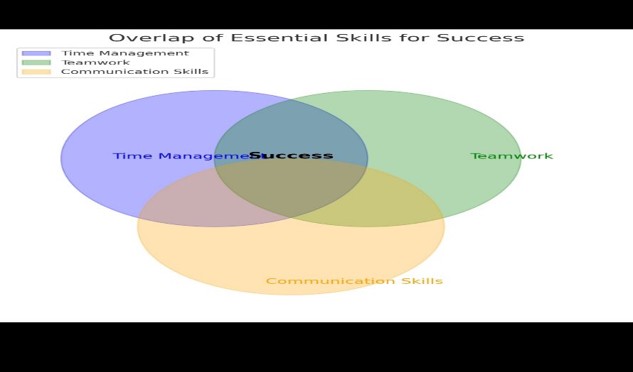
- Flowchart depicting the role of critical thinking in solving complex problems.
[ ]

[ ] 

