Student Name: Ameera Ahmed
Student Number: 2132308
Lecturer Name: Farah Islam
Module Code: LCHS4005_BIRM
Module Title: Professional Development within Health and Social Care
Assignment Title: Personal Development Portfolio

Table of Contents:

Curriculum Virtue 3
Screen shot of job advert 5
Cover letter 6
SWOT Analysis 7
Personnel Development Plan 8
Personal Statement 9
Reflection on presentation.……………………………………………………………………… 10
References………………………………………………………………………………………….. 11

Ameera Ahmed
Birmingham, B11 3AN
07771 396567
ameera.ahmed@hotmail.co.uk

Personal Profile

I am a highly motivated and committed individual who relishes a challenge, possessing excellent communication and organisational skills. I am confident in working both independently and as part of a team and have had experiences where I’ve demonstrating multitasking abilities required to meet demanding deadlines while maintaining the highest of standards. With over 10 years administration, reception, and customer service experience I understand the importance of going that extra mile to deliver a high level of service. I am very attentive and a positive thinker always offering support to those in need. I can quickly adjust to new surroundings and gain confidence within my position. I am currently in my last term studying Health and Social Care level 4 and would love to pursue a career working with young children as a youth support worker or counsellor.

Key Skills:

- Computer Skills – Ms Word, Power Point, Excel, Sage 50
- Excellent customer and organisational skills
- Confident in communicating.
- Self-motivated, can work on own initiative.
- Positive approach, attentive and
calming.
- Committed and go the extra mile to achieve the best result.

Employment History

Finance Assistant, Voiceboxx, Feb 2018 – Jun 2018

- Acted as first point of contact – Welcoming visitors, communicating on the phone, building a good rapport with customers and suppliers.
- Compiling and recording company expenses – to be filed Quartey to the accountant.
- Uploading customer invoices on to Sage for work they have received and request for payment within 30days of invoice.
- Referring to purchase orders before submitting for payment, ensuring all details match.
- Ensuring purchase orders numbers are authorised before providing staff with number.
- Recording all incoming and outgoing payments, scheduling proposal dates of payments and monitored regularly.

Administrator/Finance Assistant - Noemalife UK Ltd Oct 2017- Dec 2017

- Finance Administration - Accounts payable and receivable tracking system including invoice management.
- Order processing and monthly reporting to General Manager
- Process bank payments to pre-authorisation stage.
- Update cash flow with accounts payable items.
- Creation and tracking of staff timesheets to process expenses.
- Record keeping – consistency and accountability when referring to correspondence.
- Travel logistics for the General Manager – organising overnight stays and transport.
- Administration tasks, any other relevant tasks instructed by the General Manager.

Health Care Assistant - St. Andrews Nov 2013 - Jul 2014

- Maintaining high standards of patient care
- Carrying out observations and report within a timely manner
- Assisting in the preparation of meals ensuring all patients have eaten.
- Respect boundaries and recognise when patients require space.
- Encouraging and motivating service users to participate in varying activities and education for their wellbeing.
- Developing and maintaining therapeutic relationships with patients

From the period of 2005 – 2012, I have worked as a receptionist, administrator and customer service advisor throughout these positions I gained confidence in communicating and how to liaise with people professionally and effectively. I gained knowledge how to prioritise and implement a better working system for the office to operate more smoothly. During my time in these roles, I understood the importance of consistency and good record keeping. Working in customer services allowed for me to communicate more effectively and professionally enabling me to diffuse situations and resolve issues quickly and respectfully.

Education & Further Training

- Health and Social Care Level 4 UWTSD, Birmingham 05-2022 to 06-2023
- Employability Skills Hagley Training Centre 06-2017 to 06-2017
- Accounting AAT Level 2 South City College 09-2015 to 06-2016
- Health and Social Care Level 2 Bournville College 09-2013 to 06-2014
Preparing to work in adult social care 09-2013 to 06-2014
- Business Administration Level 2 OCR 09-2002 to 06-2004

Hobbies and Interests

I enjoy reading non-fiction books practically those of crime or that have a plot twist. I love to cook inspired by my grandmother from a very young age, she taught me the creativity behind food and to explore with ingredients. I have a keen interest in learning how to draw so maybe that can be my next hobby.

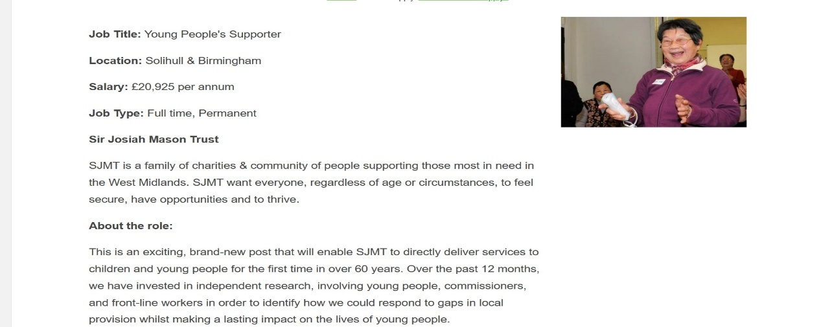

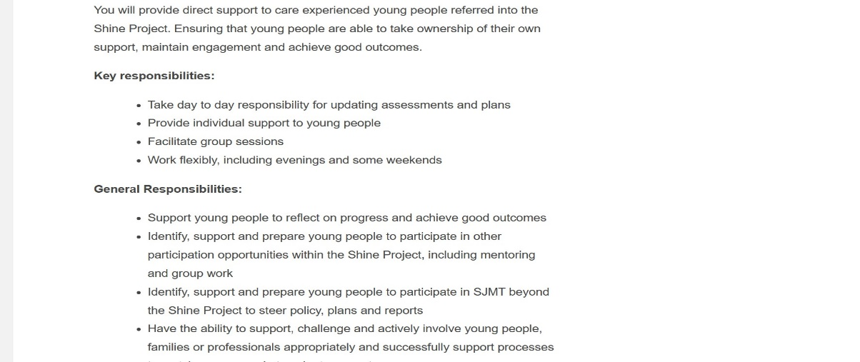

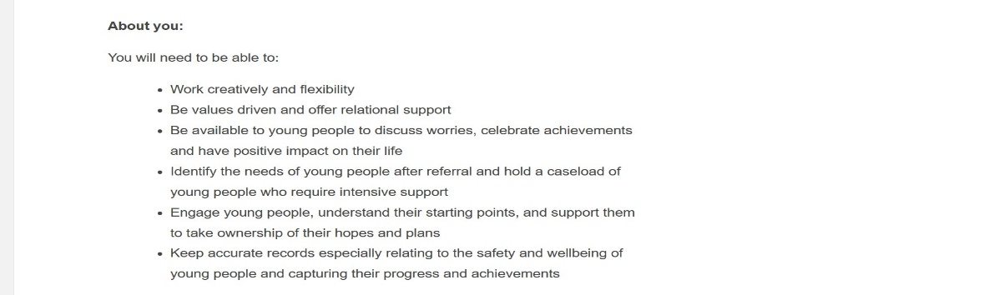

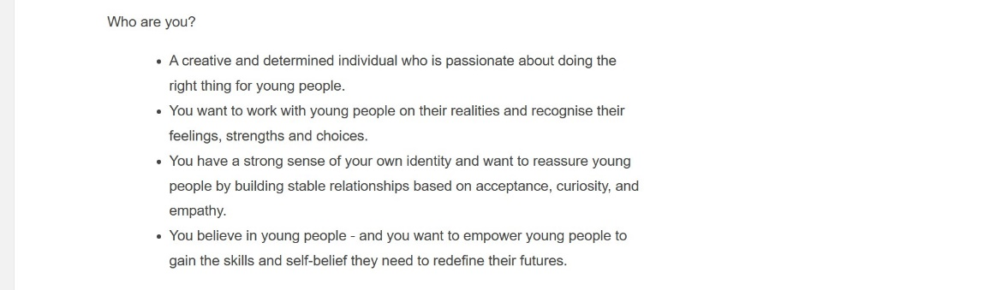

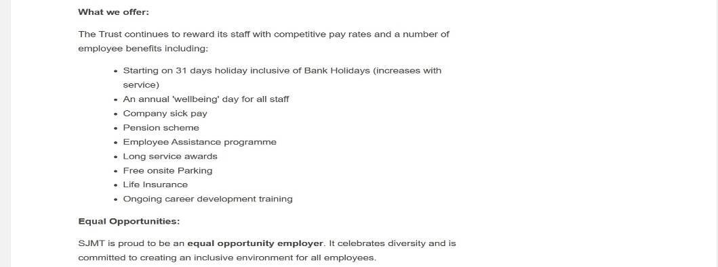

Ameera Ahmed
Ameera.ahmed@hotmail.co.uk
07771396567
Dear hiring manager,
I am interested in applying for the role of young people’s supporter currently available at Sir Josiah Mason Trust, Solihull. I am a driven, imaginative person who is enthusiastic about encouraging children to achieve their aspirations, working through circumstances they may find challenging, recognising their emotions, strengths, and decisions are all important in contributing to a positive outcome. I am approachable and offer great support by actively listening and allowing for others to express their views.
With over 15 years administration and office experience I understand the importance of effective record keeping and storing confidential files. I have experience liaising with other departments to collaborate on projects, reports and events. I gained confidence by communicating with a wide range of people which allowed me to become confident in speaking and expand my vocabulary. I have 12 months experience working at St Andrews Healthcare, a medium secure acute for men with complex needs and forensic history. I can build good rapports with patients while maintaining professional relationships and knowing the boundaries, not feeling intimidated to reiterate behaviours. I understand the importance of encouraging positive behaviour nevertheless its paramount that respect is given, and people make their own decision. I am confident that I would be suitable for this job role as I’m naturally a kind and compassionate person who looks out for others and has great joy watching others achieve their goals. I am enthusiastic in supporting and being able guide others into a bright future. I have two children whom I advise that the sky is the limit and encourage them to take the leap to get a step closer to their goals, if there is anything I can do to contribute to their success I’m happy.
I am currently in my last term studying Health and Social Care level 4. I have a passion for wanting to work with children and would love to help children visualise their dreams and aspirations to turn them into realities. I am seeking a varied and challenging position that will enable me to consolidate my professional experience, expand my knowledge and provide opportunities for personal and professional growth.
Thank you for taking the time out to read my cv and cover letter. I look forward to hearing from you, my contact details can be found at the top this letter.
Yours faithfully
Ameera Ahmed
SWOT Analysis.

STRENGTHS:  - COMMUNICATION  - APPROCABLE | WEAKNESSES:  - TAKE ON TOO MUCH  - SELF-DOUBT
OPPORTUNITES:  - PSYCOLOGY COUNSELLING COURSE  - VOLUNTRY WORK | THREATS:  - TIMING  - CHILD CARE

A SWOT analysis is a strategy tool used to by organisations to determine Strengths, Weaknesses, Opportunities, and Threats. It serves as a framework for aligning the objectives, initiatives, and capabilities of an organisation with the context in which it works. It allows for accountability and helps work towards professional growth identifying the advantages and disadvantages (CIPD, 2021).

Personal Development Plan:

OBJECTIVE: | HOW WILL IT BE ACHIEVED? | WHEN BY?
Progress on to Psychology course | Pass all assignments for level 4 Health & Social care.  Apply to Arden university | July 2023
Improve study time | Plan and structure a study schedule.  Prioritise | 2023-2024

According to Putter, (2021) a personal development plan is a great tool utilised by many to set and achieve goals, the framework is designed to state objectives clearly and how and when they are likely to be achieved. It helps to identify areas of strengths and improvement. It is great to visualise and manifest what you would like to achieve and resolve any challenges that may be preventing you from moving forward. Aiming for fewer goals at a time are more realistic in achieving.

Personal Statement:

A little bit about me
I was born and raised in the black country for 10 years before going to Egypt in 1995 to visit my biological father, the initial visit should have only been for 2months however I extended my stay lasting 2 years, up on returning to the UK in 1995, I moved in with my mother and stepfather in Redditch. Redditch was my home for the best part of 10 years here I attended secondary school and straight after I enrolled on to apprenticeship course studying Business Administration. In 2005 I wanted a complete change, and I went to work for Butlins (Minehead) where I worked as a children’s entertainer. I returned in 2006 and within months I recognised Redditch was small for me and held very little job opportunities at the time. I moved to Birmingham in 2008 and made a life for myself. I have two beautiful children, 10 years between them they have a fantastic relationship, and my son is great support. I come from a Multicultural background therefore I’ve grown up with many traditions and celebrations. Overall, I’m committed, enthusiastic and ambitious person who wants to build a successful career and work with some fun and remarkable people along the way.
Career History
I completed a 2-year apprenticeship in Business level 2 while at a company called MKM Advertising an independent contract however linked to Redditch Standard Newspaper. On completing my apprenticeship, I gained the ability to communicate with others effectively, I gained an interest in collaborating with people to complete projects and my skills and confidence grew. My attributes were quickly noticed, offering me a permanent role as an administrator. After a year within the company, I got promoted to Personal Assistant working closely with the directors. I gained a huge insight and a lot of knowledge working within this company and it led me to pursue further roles in business, reception customer service and accounting. I have expanded my education to include Heath and Social Care level 4 with the interest of working with young children in I’m excited for a new challenge and looking forward to taking the next step in my career.
My approach
I am courageous, resilient and pay attention to detail, I try to work on one task at a time, according to importance, working as quickly but efficiently as possible to achieve the highest results. I like to be organised to ensure that all deadlines are met each day. I also think that with delegation comes collaboration because sometimes it takes a team to get a project completed successfully. I recognise when support is required and go the extra mile to support the team, as well as the business.
What’s important to me.
I’m an honest and consistent person who has a strong passion for providing efficient communication. I quickly build a solid rapport with fellow peers and colleagues. I am a great listener and on many occasions, have been the voice of reason amongst family and friends. I enjoy working with other people towards a common goal to achieve the very best outcome not only for myself but for the company and customers.
Passion is important to me, having the motivation to go the extra mile to contribute to a company’s success. I enjoy working with people who also share the same passion and determination to achieve results. I also like to be a part of a positive culture where all contributions are embraced, valued, and appreciated.
Reflection of presentation:

On the day I presented my powerpoint, I was thinking how it would play out as it was to be presented online via teams, myself being the first candidate to present things I felt a little apprehensive however I did practice and go over the presentation a few times during the week of. Things were not completely ready and we encountered an obstruction that restricted the view of my slides and I lost focus. To start the slides were okay keeping it brief, however during slide 5 is where I added a little more literature to explain reflecting in the work place and the achievements that can be obtained by reflecting however I couldn’t see fully and my time ran out, I hadn’t covered the remaining of the two slides but I managed to give a quick recap what was left and answered the question given regarding my chosen skill, reflection.
I was happy with the powerpoint initially however following how I felt on the day and the feedback from my lecturer it inspired me to follow the Gibbs Reflective model and I reflected on the whole experience identifying areas of strengths and what needed altering. I went and made those changes to the powerpoint for my own growth and confidence and I feel a lot better for utilising the Gibbs tool to reflect on this experience. I am happy overall with the mark given.

References:

CIPD (2021). SWOT Analysis | Factsheets | CIPD. [online] CIPD. Available at: https://www.cipd.co.uk/knowledge/strategy/organisational-development/swot-analysis-factsheet. Accessed on (22/03/2023)
Putter, M. (2021). What is a personal development plan? [online] CPD Online College. Available at: https://cpdonline.co.uk/knowledge-base/business/what-are-personal-development-plans/#:~:text=A%20personal%20development%20plan%2C%20which, Accessed on: (27/03/2023)

