

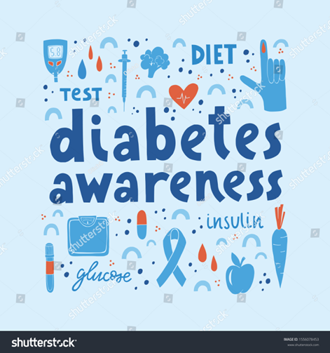
Figure 1: (Shutterstock, 2024)

Module title: Community Care and Management of Longer-term Conditions
Module code: LCHS7003
Student name: Elena Draghici
Student ID: 2214911
Lecturer name: Muhammed Khan
Date of submission: 14th November 2025
Component 1: Information Booklet

Acknowledgement of the use of AI tools
I confirm that I have not used any AI tools in the research and creation of this assignment. I confirm that I have not presented any AI-generated materials as my work. I confirm I have copies of my drafts, notes, and other resources I used, which I may be asked to provide in evidence.

TYPE 2 DIABETES

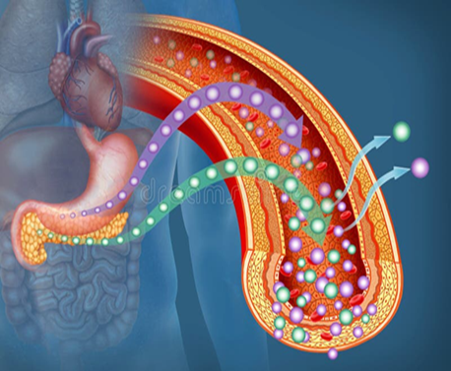
Figure 2: Glucose and insulin illustration (Dreamstime, 2025)

1. Introduction
Living Well with Type 2 Diabetes:
This booklet aims to help people with type 2 diabetes, to provide clear and understandable information to anyone in this situation, because it is hard to admit you have a long-term condition. Diabetes does more than reason anguish and sickens the body.
Showing what Type 2 diabetes is, how it works in the system and on the body, and how to avoid both mental and physical harm. Also, the booklet raises social problems that are expected when people have long-term conditions (in this case, diabetes).
The booklet also outlines NHS help with things like personal care plans and self-management.
Type 2 diabetes is a long-term disease, but it can still be managed well. With correct care, keeping an active lifestyle and getting help where needed, people can keep going in good health (NICE, 2022).
Diabetes can become too much to bear sometimes, but along the way, this paper will show that support will always be offered. As this booklet stresses that care should be centred on the patient, which means making decisions based upon needs, wishes and goals (NHSEngland,2022).
Figure 3: How to prevent, treat and manage Type 2 Diabetes Mellitus (Say Media, n.d.)
2. Understanding Type 2 Diabetes
2.1 What is Type 2 Diabetes?
It is a chronic disease in which insulin production becomes insufficient or ineffective for regulating the body's blood sugar properly. A hormone called insulin assists in moving the sugar that is glucose from our bloodstreams into cells scattered throughout our bodies. Improper action by insulin causes a build-up of glucose in the blood, bringing with it high blood sugar levels (NHS 2024). Over time, important levels of blood sugar can harm the body's blood vessels and nerves, damaging key organs including the kidneys, heart, eyes, and feet (WHO, 2024). The gradual development of type 2 diabetes is in large part influenced by genetic, environmental, and lifestyle present condition factors.
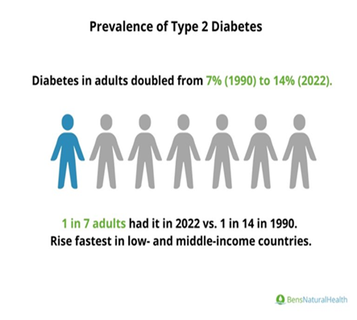
Figure 4: Prevalence of Type 2 diabetes – statistics chart (Ben’s Natural Health, 2025)
2.2 How Common is Type 2 Diabetes? (Prevalence and Burden)
By far, the chronic illness in the world with the fastest growth rate is type 2 diabetes. Should that prove correct, there will be 589 million people with diabetes around the world in 2025, according to the International Diabetes Federation (Diabetes Atlas,2025). This figure might rise and keep on going up, particularly among younger age brackets (Xu, Sun & Xiang,2025).
In the UK, there are over 4.3 million diabetics, of whom the vast majority fall into the type 2 diabetes category (NHS England,2023). Pre-diabetes is a state in which a person's blood sugar levels are higher than normal, but not actually in the range for diabetes. There are also millions more at significant risk of becoming or already with it.
Type 2 Diabetes is more serious among the elderly, who are also most at risk for the disease. Similarly, people of Middle Eastern, South Asian, Caribbean, and African origin are also seriously affected by this disease. (Pham et al., 2019; Diabetes UK, 2020) Furthermore, people in deprived communities are especially prone to becoming diabetic. (Bush et al., 2023).
2.3 Risk Factors and Causes
Type 2 diabetes does not have a single cause. Instead, it develops through a combination of:
Risk factors:
- Lifestyle factors: Low physical activity, poor diet in sugar and fats, and obesity (NICE 2025).
- Genetics and family history: More likely to develop diabetes if a close family member also has it (WHO, 2024).
- Ethnicity: Higher risk in South Asian, African, and Caribbean populations due to genetic and cultural influences (Diabetes UK, 2020).
- Age: Risk increases after 45 (Xu, Sun, and Xiang 2025).

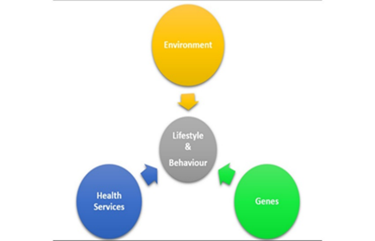

Figure 5: Lifestyle & behaviour model (Kay Hector Consulting Ltd, 2022).

3. Impact of Type 2 Diabetes on Daily Life
The Effects of type 2 diabetes are not only cholesterol also symptoms. It has an impact on the lives of those infected in ways that cannot be imagined. Social status, mental health, and physical well-being are affected. The family member who helps provide care or make lifestyle changes may be affected as well. If patients know about the social costs, they can pinpoint problems and get care earlier.
3.1 Effects on the Body Over time.
Persistently elevated blood sugar levels may lead to systemic adversity in the body (NICE, 2022). Typical physical symptoms experienced by people: tiredness and poor energy levels, thirst that does not go away and therefore drinking more fluids; weight changes that could happen intermittently over the course of a week or even just overnight, rather than producing long-term trends like liquid diets for obesity (NHS, 2024).
Possible long-term complications include:
- Heart disease and stroke
- Kidney disease
- Nerve damage
- Eye damage
- Foot ulcers,
(WHO, 2024)
These complications develop slowly, often over years. Regular health checks, blood tests, eye screenings, foot care, and medication can prevent or delay these complications.
3.2 Psychological Impacts
For individuals, the constant attention to diet, drugs, and glucose levels is irritating or nerve-racking. This emotion has been termed diabetes burnout (Vieira, 2014).
People may experience:
- Worry about future health.
- Feelings of guilt or self-blame
- Stress from constant planning around meals
- Constant vigilance related to blood sugar highs and lows.
When people feel that their lifestyle or weight is being evaluated, recent research shows, a stigma attached to having diabetes can cause emotional discomfort. This underlines the need for a gentle, understanding approach. (Akyirem et al., 2024).

3.3 Social and Lifestyle Impacts
Diabetes type 2 can affect a person's daily life, work, and relationships. It means always having to order meals and snacks whenever dining out; it denotes allocating time for exercise, daily physical care, as well as medical checkups (Diabetes UK, 2020)
Communally shared meals and leisure activities, or going on a journey, cannot suit them. People might feel embarrassed to talk about their illness in public.
3.4 Impact on Families and Carers
Frequently, family members help with household chores, such as cleaning, cooking, shopping for food and other daily necessities, and taking care of children.
Sometimes there is more help than is needed, and sometimes not enough.
Family support can be helpful, but family can also have doubts about how to do it:
- What will fate be in such a culinary environment?
- Why worry about weight when there are so many other things to worry about?
- It was explained how a sense of dependence can be created by dependence on others.
The best method should usually involve a team approach, with the diabetic taking charge of their choices.

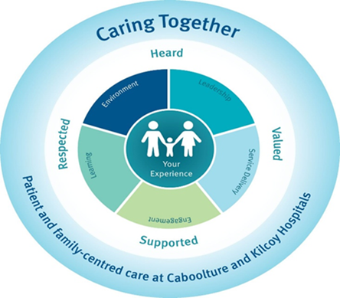
Figure 6: Diagram illustrating quality improvement in diabetes management (BMJ Open Quality, 2020).

4. Treatment and Management of Type 2 Diabetes in the UK
The aims of managing Type 2 diabetes are to avoid complications and keep blood sugar at a reasonable level. Experiences with diabetes are different; treatment should be tailored to the patients. (NHS England, 2022) The vast majority of care for diabetes in the UK is provided by primary care (GP) practices. Nurses, dietitians, pharmacists, and specialist diabetes teams are all available to help with any necessary additional support.
4.1 Healthy Lifestyle and Self-Management
Initial treatment of type 2 diabetes becomes a question of changing lifestyles. These changes bring long-term health benefits and help the body respond better to insulin (NICE, 2022).
The Lifestyle Approach to Well-being:
Good eating habits help keep blood sugar stable and weight down.
Exercising together regularly. It can increase the body’s insulin sensitivity and have multiple health benefits.
Weight control. Easy weight loss is a safe way to control blood sugar levels (NHS, 2022).
With structured education programs such as DESMOND (Diabetes Education and Self-Management for Ongoing and Newly Diagnosed), people can take control of their diabetes and manage it confidently (Penn et al., 2018).

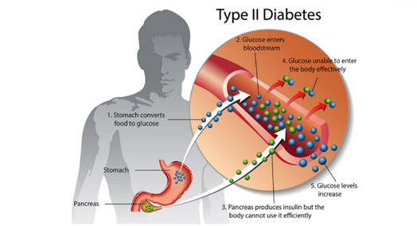
Figure 7: How to prevent, treat and manage Type 2 Diabetes Mellitus (Say Media, n.d.)

4.2 Medication
Medication is used to help lower blood glucose levels. Treatment is often started at lower doses of both medications (NICE, 2022).
- Metformin medicine
The first-line drug works by making the body use insulin more effectively and reducing the amount of glucose produced by the liver. Its advantages are a lower chance of gaining weight and side effects that are common early on.
- SGLT2 Inhibitors (e.g., Empagliflozin, Dapagliflozin)
Helps the kidneys excrete excess glucose in urine and has the following benefits: it reduces body weight and protects the heart and kidneys (NICE, 2022).
- Agonists for GLP-1 Receptors (e.g. Dulaglutide, Semaglutide)
Are function by increasing insulin release after meals and reducing appetite.
Advantages of controlling blood sugar and causing significant weight loss.
- Insulin
Modern insulin pens make it simpler to use at home and are used during illness or when other therapies are insufficient.
Together with a doctor or diabetes nurse, determine which combination best fits lifestyle and medical requirements.
4.3 Technology and Monitoring
Watching blood sugar levels can help better understand how the food, exercise, anxiety, and any drugs might be on interact with each other.
- Finger-prick testing for glucose regularly is a common way to do that.
- Opportunity to wear a continuous glucose monitoring system.
- System called Freestyle Libre, which provides round-the-clock blood sugar readings automatically (Diabetes UK, 2024).
Technology can help learn these patterns over time, alleviate anxiety associated with fluctuations in blood sugar measurement levels and give self-management confidence a boost at any point of need.
4.4 The NHS Diabetes Prevention Programme (NHS DPP)
The NHS DPP provides group education, nutrition support, and lifestyle coaching to individuals at substantial risk of Type 2 diabetes. Weight and blood glucose levels have improved, according to early assessments (Penn et al., 2018; NHS England, 2023).

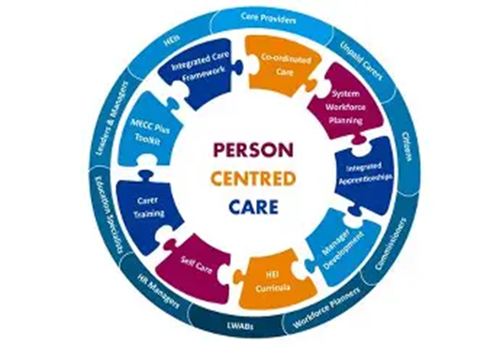

Figure 8: Integrated Care Model (Integrated People-Centred Health Services, n.d.)
5. Personalised Care in Managing Type 2 Diabetes
5.1 What is Personalised Care?
The patient participates in the care instead of having it imposed on them by a third party. Because every person's experience with type 2 diabetes is unique, care should be specific to individual needs, preferences, lifestyle, priorities, and objectives (NHS England, 2022).
In personalised care, the following factors are considered:
- What is most important for the individual?
- Family background and cultural heritage.
- Emotional health.
- Daily activities and obstacles requiring practical, real-world solutions.
Rather than treating the individual with diabetes as someone who simply accepts an order or plan, this method gets them involved in decision-making.
5.2 Why Personalised Care is Important
Bommel et al. (2024) demonstrate that people with diabetes are better when:
- Are familiar with the fact.
- Feel that are understood.
- Are free to choose.
Akyirem et al. (2024) claim that personal care, according to NHS England (2022), can:
- Build up people's inclination to take drugs.
- Decrease the stress and trouble that diabetes brings.
- Add to their sense of emotional well-being.
- Increase confidence in self-management.
- Stop admissions to the hospital and subsequent problems.
Personalised care would also help these people to feel less of the object-blaming and judgment (Akyirem et al., 2024).
5.3 The Comprehensive Model for Personalised Care (UK Model)
An organised framework offered by the NHS Comprehensive Model for Personalised Care can benefit sick people.
In 2022, NHS England published the above six points as components of Personalised Healthcare.
What It Means for Patients:
Shared Decision-Making: making choices with medical experts about what action to take, according to what is most appropriate for individual needs and preferences.
Customised Care and Support Planning: The Care plan is written with priorities and personal goals in mind.
Supported Self-Management: Acquire the knowledge, skills, and confidence to look after diabetes every day.
Community Support and Social Prescribing: Get support such as local exercise programs, walking groups, diet groups, or stress management.
Personal Health Budgets: Funding might occasionally be adapted to meet individual needs.
Choice and Control: Have the right to always be involved in decision-making about medical treatment.
5.4 The International Perspective: The Chronic Care Model
Globally, one of the most recognised frameworks for long-term condition management is Wagner’s Chronic Care Model (CCM). This model focuses on improving the organisation of healthcare systems to better support long-term conditions (Al-Qahtani, 2024).
The Chronic Care Model includes:
- Strong primary care support
- Team-based approaches (GPs, nurses, dietitians working together)
- Patient education programmes
- Community resources
The goal is to create informed patients working in partnership with prepared healthcare teams.
5.5 How the UK and International Models Work Together

NHS Comprehensive Personalised Care Model (UK)
- Focuses on the person and what matters to them.
- Encourages shared decision-making and choice.
- Prioritises wellbeing, lifestyle, and social support.
Chronic Care Model (International)
- Focuses on the healthcare system and how it can better support patients.
- Encourages high-quality, well-organised clinical care.
- Prioritises coordinated team-based medical care.

6. National and Local Health and Social Care Policies for Diabetes Management
Type 2 diabetes is not only a medical condition but also a public health priority in the UK. National strategies aim to improve prevention, early diagnosis, treatment access, and health outcomes, while local services support day-to-day community care.

6.1 The NHS Long Term Plan (2019)
Improving treatment for people with long-term conditions like type 2 diabetes is a core part of the NHS Long Term Plan.
- early detection and better access to formal instruction.
- community-based and integrated help. (NHS England, 2019)
There are also legislative changes within the international context of diabetes and globalisation.
According to Bush et al. (2023), type 2 diabetes is more common in poorer areas and among certain ethnic groups. The Plan also seeks to reduce health outcomes disparities through prevention initiatives (NHS Confederation, 2023).
For patients, this means:
- More help with at-home diabetes management
- Fewer hospitalisations
- More individualised treatment programs
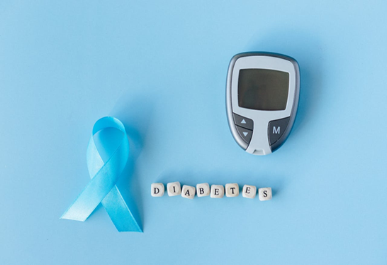
Figure 9: Blood-glucose monitor and diabetes ribbon (365 Days of Positivity, 2024).
6.2 Integrated Care Systems (ICS) and Community Support

Integrated care systems, in which local institutions (like GPs, hospitals, councils and charities) work together to provide connected care (NHS England, 2019). This is particularly important for long-term conditions, in which continuous care is more important than episodic treatment.
Community-based diabetes clinics, local walking or exercise groups and culturally appropriate dietary aid (Diabetes UK, 2020).
This ensures that diabetic care looks at psychological well-being as well as the physical side.
6.3 Addressing Health Inequalities
Socioeconomic conditions can affect people with type 2 diabetes, and interrelated with low-income area residents face more obstructions because of the restricted supply of wholesome food.
ONS (2021), as well as Richards et al. (2022), found that the levels of stress among people with financial difficulties were going up. Diversifying services to improve access to screening and preventive programs, the Office for Health Improvement and Disparities (OHID) encourage culturally responsive education.
This implies that to manage diabetes, aspects of life need to be kept in mind, not just medication.
6.4 NHS Diabetes Prevention Programme (NHS DPP)
Among those considered substantial risk of developing Type 2 Diabetes, the NHS DPP offers group education, meal planning support, and well-structured life coaching (NHS England, 2023).
Through early evaluation:
- Better eating habits
- More exercise.
- Felt blood sugar (Penn et al., 2018)
Early intervention and prevention in this way helps to lower long-term damage.
6.5 Digital Health and Technology in Policy
UK (2024) reports that a recent NHS policy advocates using digital instruments like Freestyle Libre or continuous glucose monitoring.
- Remote consultations with General practitioner surgeries.
- Apps for monitoring blood sugar, calories, and exercise.
With digital tools, people can be given greater freedom, fewer clinic visits. With real-time self-management, trust rising, too! (van Bommel et al., 2024) Still, access is uneven as patients lack digital literacy or device funding. This underscores the need for treatment that focuses on equity (NHS Confederation, 2023).

7. Recommendations for Person-Centred Care and Self-Management
Living well with Type 2 diabetes, the thing to do is to experience it first-hand. Self-care in dealing with these diseases is not the same thing as self-management. Rather, it involves having the wherewithal to understand what is going on in the body, make choices that are special to each, and feel confident in making those decisions all on own. (NHS, 2022)
The following recommendations aim to promote well-being, independence, and control.

7.1 Making Self-Management Work
Begin to believe that modifying the way one lives in a fashion that seems acceptable to others.
Techniques for Optimal Self-Management:
- Checking blood sugar levels regularly, looking for trends.
- Making small, lasting dietary changes.
- Building movement into daily activities
- Taking part in educational programs on diabetes, such as DESMOND.
- Seeking refuge when feeling distressed or overwhelmed.
Studies show that when people feel informed and involved in their care, their control of diabetes and mental disease becomes greater. (van Bommel et al., 2024)
7.2 Eating Well Without Feeling Restricted
We live in a world filled with food, family meals, social gatherings, and cultural expressions. Instead of following a rigid diet, strive for balanced meals.
The Balanced Plate Guide displays:
- Half salad or vegetables
- Lean protein in quarters
- Wholegrain carbs in quarters
Blood sugar can be improved by small steps, like eating more vegetables or cutting down on sugary drinks. These local dietitians can help modify the eat to fit in with the ethnic group's dietary preferences and foods (Diabetes UK, 2020).
7.3 Physical Activity for Everyday Life
- Walking to and from work or the stores
- Sitting up in a chair with legs crossed, or dancing and gardening.
Small improvements add up; 10 minutes of exercise per day does make quite a difference in one's health.
7.4 Emotional Well-being and Diabetes Burnout
It is a common experience to feel overwhelmed from time to time, but if it becomes unmanageable, the ongoing demands of diabetes are an invitation to diabetes burnout (Vieira 2014).
Techniques to further emotional well-being include:
- Having honest conversations with family members and physicians
- Going to GP for a referral or social prescribers to address everyone's needs.
- Join diabetes support groups in the local area.
The emotional burden of proof or panic can add to the blame for oneself. According to Akyirem et al. (2024), supportive care should never be judgmental.
7.5 Involving Family and Social Support
With a Little Help, Families need help in getting going:
- Creating Social Role Models.
- Eating a balanced, wholesome diet.
- Family involvement may cut distress further.
7.6 Planning for the Future
Since diabetes changes as time passes, the treatment will have to be adjusted. After a while, people may have to turn to insulin or particular care. An early discussion of future care prevents later tension.
8. Conclusion
However widespread it may be, Type 2 diabetes does not stop people from living well; so long as the patient receives proper care, life can still be active and fulfilling. Effective care needs to understand not only the medical aspects of diabetes but also the emotional, cultural, and social difficulties which individuals may have. By placing the individual at the centre of decision-making, personalised care ensures that treatment is flexible, considerate, and directed towards their most important needs.
With technical superiority in medicine:
- Encouragement of lifestyle changes
- Support for overall social and emotional well-being
- Professionals and the patients are getting together to draw up a plan.
People can feel that their diabetes is controlled, enabling them to be confident and achieve freedom from disease.

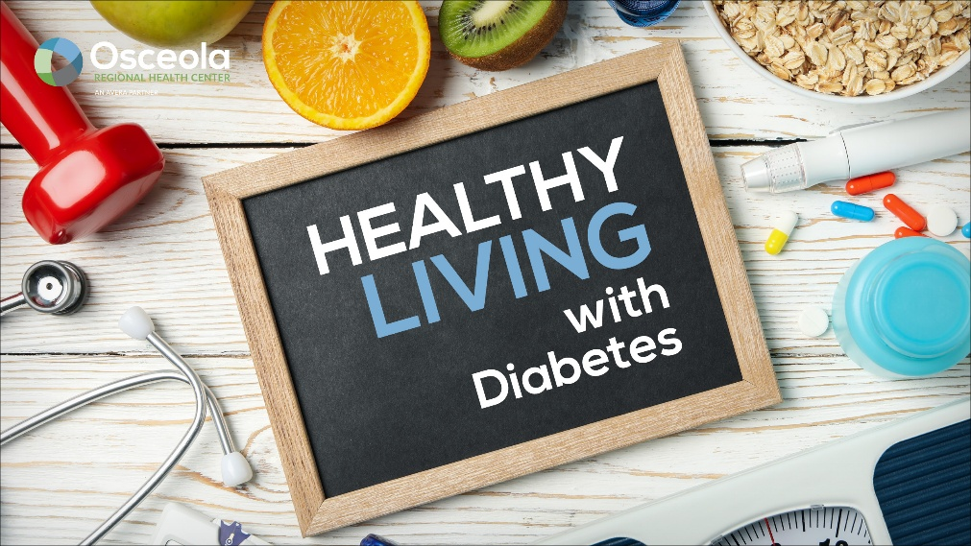

Figure 10: See the event cover photo (Osceola Regional Health Centre, 2024).

9. References



Akyirem, S., Ekpor, E., Batten, J., and Brady, V. (2024) ‘Reducing health-related stigma in adults living with chronic non-communicable diseases: A systematic review and meta-analysis’, Social Science & Medicine, 356, p.117153. https://doi.org/10.1016/j.socscimed.2024.117153. (Accessed: 04 November 2025).
Al-Qahtani, A.A. (2024) ‘Improving outcomes of type 2 diabetes mellitus patients in primary care with the Chronic Care Model: A narrative review’, Journal of General and Family Medicine, 25(4), pp.171–178. https://doi.org/10.1002/jgf2.659. (Accessed: 06 November 2025).
Bommel, H. van, Raaijmakers, L.H.A., Maria, Schermer, T., Burgers, J.S., Loenen, T. van and Bischoff, E. (2024) ‘Patient experiences with person-centred and integrated chronic care, focusing on patients with low socioeconomic status: a qualitative study’, British Journal of General Practice. https://doi.org/10.3399/bjgp.2024.0400. (Accessed: 10 November 2025).
Bush, K.J., Papacosta, A.O., Lennon, L.T., Rankin, J., Whincup, P.H., Wannamethee, S.G. and Ramsay, S.E. (2023) ‘Influence of neighbourhood-level socioeconomic deprivation and individual socioeconomic position on risk of developing type 2 diabetes in older men’, BMJ Open Diabetes Research & Care, 11(5), e003559. https://doi.org/10.1136/bmjdrc-2023-003559. (Accessed: 02 November 2025).
Civilservice.gov.uk. (2021). Using Census 2021 data to improve diabetes prevalence estimates – Government Analysis Function. Available at: https://analysisfunction.civilservice.gov.uk/blog/using-census-2021-data-to-improve-diabetes-prevalence-estimates/. (Accessed 07 Nov. 2025).
Department of Health (2012) Long Term Conditions Compendium of Information: Third Edition. Available at: https://assets.publishing.service.gov.uk/government/uploads/system/uploads/attachment_data/file/216528/dh_134486.pdf. (Accessed: 03 November 2025).
Diabetes Atlas (2025) 11th Edition - Global Figures. Available at: https://diabetesatlas.org. (Accessed: 11 November 2025).
Diabetes Atlas (2025) United Kingdom Data. Available at: https://diabetesatlas.org/data-by-location/country/united-kingdom/. (Accessed: 10 November 2025).
Diabetes UK (2017) Life with diabetes. Available at: https://www.diabetes.org.uk/living-with-diabetes/life-with-diabetes. (Accessed: 11 November 2025).
Diabetes UK (2020) Ethnicity and type 2 diabetes. Available at: https://www.diabetes.org.uk/about-diabetes/type-2-diabetes/diabetes-ethnicity. (Accessed: 08 November 2025).
Diabetes UK (2024) Implementation of Freestyle Libre prescribing guidance. Available at: https://www.england.nhs.uk/london/wp-content/uploads/sites/8/2019/07/dia-London-FreeStyle-Libre-Implementation-Guidance-for-London052018.pdf. (Accessed: 11 November 2025).
Halefom, K.H. and Fenta, T.G. (2025) ‘Magnitude, risk factors and economic impacts of diabetic emergencies in developing countries: A systematic review’, PLoS ONE, 20(2). (Accessed: 09 November 2025).
HFMA (2019) Summary of NHS Long Term Plan Implementation Framework. Available at: https://www.hfma.org.uk/. (Accessed: 11 November 2025).
International Diabetes Federation (2021). Diabetes now affects one in 10 adults worldwide. Available at: https://idf.org/news/. (Accessed: 09 November 2025).
International Diabetes Federation (2021) IDF Diabetes Atlas 10th Edition. Available at: https://diabetesatlas.org. (Accessed: 04 November 2025).
Johnson, L., Kirk, H., Clark, B., Heath, S., Royse, C., Adams, C., and Portillo, M.C. (2023). Improving Personalised care, through the Development of a Service Evaluation Tool to assess, understand and Monitor Delivery. BMJ Open Quality, 12(3). Available at: https://doi.org/10.1136/bmjoq-2023-002324.(Accessed: 07 November 2025).
Moien Abdul, B.K. et al. (2020) ‘Epidemiology of Type 2 Diabetes – Global Burden of Disease and Forecasted Trends’, Journal of Epidemiology and Global Health, 10(1), pp.107–111. (Accessed: 10 November 2025).
NHS (2024) Type 2 diabetes overview. Available at: https://www.nhs.uk. (Accessed: 11 November 2025).
NHS (2025) Treatment for Type 2 diabetes. Available at: https://www.nhs.uk/conditions/type-2-diabetes/treatment/. (Accessed: 10 November 2025).
NHS Confederation (2023) Health inequalities. Available at: https://www.nhsconfed.org/topic/population-health/health-inequalities. (Accessed: 11 November 2025).
NHS England (2019) Integrated Care. Available at: https://www.england.nhs.uk/integratedcare/. (Accessed: 11 November 2025).
NHS England (2019) NHS Long Term Plan. Available at: https://www.england.nhs.uk/long-term-plan/. (Accessed: 09 November 2025).
NHS England (2021). Comprehensive model of personalised care. [online] NHS England. Available at: https://www.england.nhs.uk/personalisedcare/comprehensive-model-of-personalised-care/. (Accessed: 08 November 2025).
NHS England (2023) NHS Diabetes Prevention Programme (NHS DPP). Available at: https://www.england.nhs.uk/diabetes/diabetes-prevention/. (Accessed: 08 November 2025).
NHS England (2023) Incidence and prevalence of diabetes, 2017–22. Available at: https://digital.nhs.uk. (Accessed: 11 November 2025).
NICE (2024). Diabetes - type 2: How common is it? [online] NICE. Available at: https://cks.nice.org.uk/topics/diabetes-type-2/background-information/prevalence/. (Accessed: 11 November 2025).
NICE (2022) Type 2 Diabetes in Adults: Management. Available at: https://www.nice.org.uk/guidance/ng28.(Accessed: 10 November 2025).
NICE (2024) Diabetes – type 2: prevalence. Available at: https://cks.nice.org.uk/.(Accessed: 10 November 2025).
NICE (2025) Overweight and Obesity Management. Available at: https://www.nice.org.uk/guidance/ng246.(Accessed: 11 November 2025).
Osceola Regional Health Centre (2024) Healthy Living with Diabetes – FB event cover photo [Image] 11 April. Available from: https://www.osceolarhc.org/wp-content/uploads/23-0411-Healthy-Living-with-Diabetes-FB-Event-Cover-photo-GENERIClr.jpg [Accessed 13 November 2025].
Office for Health Improvement & Disparities (2022). Health disparities and health inequalities. Available at: https://www.gov.uk/government/publications/.(Accessed: 05 November 2025).
Office for National Statistics (ONS) (2021) Health inequalities. Available at: https://www.ons.gov.uk/.(Accessed: 05 November 2025).
Penn, L. et al. (2018) ‘NHS Diabetes Prevention Programme in England: formative evaluation’, BMJ Open, 8(2), e019467. (Accessed: 10 November 2025).
Pham, T.M. et al. (2019) ‘Ethnic differences in the prevalence of type 2 diabetes diagnoses in the UK’, Clinical Epidemiology, 11, pp.1081–1088. (Accessed: 11 November 2025).
Richards, S.E., Wijeweera, C. and Wijeweera, A. (2022) ‘Lifestyle and socioeconomic determinants of diabetes’, PLOS ONE, 17(7), e0270476. (Accessed: 05 November 2025).
Shutterstock (2024) Diabetes awareness poster vector lettering. Stock vector 1556078453 (Image/vector) Available at: https://image.shutterstock.com/shutterstock/photos/1556078453/display_1500/stock-vector-diabetes-awareness-poster-vector-lettering-diabetes-awareness-month-poster-with-hand-drawn-1556078453.jpg (Accessed 13 November 2025).
Unwin, N. (2020). Socio-economic position and risk of type 2 diabetes. NICE Evidence Review. Available at: https://www.nice.org.uk/.(Accessed: 03 November 2025).
Vieira, G. (2014). Dealing with diabetes burnout. New York: Demos Medical. (Accessed: 11 November 2025).
Weber, I. et al. (2025) ‘NICE guideline review: type 2 diabetes in children and young people’, World Journal of Paediatrics. https://doi.org/10.17863/CAM.111455,(Accessed: 10 November 2025).
World Health Organisation (WHO) (2024) Diabetes Fact Sheet. Available at: https://www.who.int/news-room/fact-sheets/detail/diabetes,(Accessed: 10 November 2025).
Xu, S.-T., Sun, M., and Xiang, Y. (2025) ‘Global and national trends in type 2 diabetes among young people’, World Journal of Paediatrics. https://doi.org/10.1007/s12519-024-00861-8, (Accessed: 11 November 2025).

