University of Wales Trinity Saint David
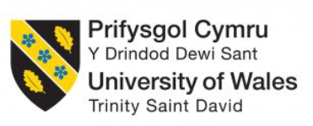

Item | Description
Student Name: | Salah Mheidean
Student ID: | 2109425
Module: | International Marketing: Principles and Practices
Module Code: | LCLM7026
Lecturer: | Dian Mayasari
Assignment title: | Assessment component 1:individual report

Contents
Background: Mercedes-Benz's International Market Entry Strategy 1
Comparative PESTEL Analysis: Mercedes-Benz in Canada and the United Kingdom 1
Political Factors 1
Economic Factors 2
Social Factors 2
Technological Factors 2
Environmental Factors 3
Legal Factors 3
Segmentation, Targeting, and Positioning (STP) Analysis 4
Segmentation Strategies 4
Targeting Approaches 4
Positioning Strategies 5
International Marketing Mix (7Ps) Analysis 5
Product Strategy 5
Pricing Strategy 6
Place and Distribution Strategy 6
Promotion Strategy 6
People Strategy 7
Process Strategy 7
Physical Evidence Strategy 7
c. Analysis of Mercedes-Benz's Directional Development Strategy in Canada 7
Electrification as Core Strategic Direction 7
SUV Dominance and Portfolio Realignment 8
Vertical Integration and Supply Chain Strategy 8
Market Performance Validation 8
d. Evaluation of Ethical Issues in Mercedes-Benz's Marketing Mix 9
Promotion Ethics: Greenwashing and Deceptive Communication 9
Product and Price Ethics: Collusion and Consumer Harm 10
Place and Distribution Ethics: Public Procurement Integrity 10
Positive Ethical Initiatives and Stakeholder Engagement 11
e. Recommendations for Mercedes-Benz's International Marketing Strategy 11
Section 2: Reflective Account of the Research and Analysis Process 12
Description 13
Feelings 14
Evaluation 14
Analysis 14
Conclusions 15
Action Plan 15
References 17
Appendixes 21
Appendix-I Mercedes-Benz advertisement-Formula 1 21
Appendix-II Mercedes-Benz Prices in Canada 22

The International Market Entry Strategy and Marketing Mix of Mercedes-Benz
The case of Canadian and UK Markets
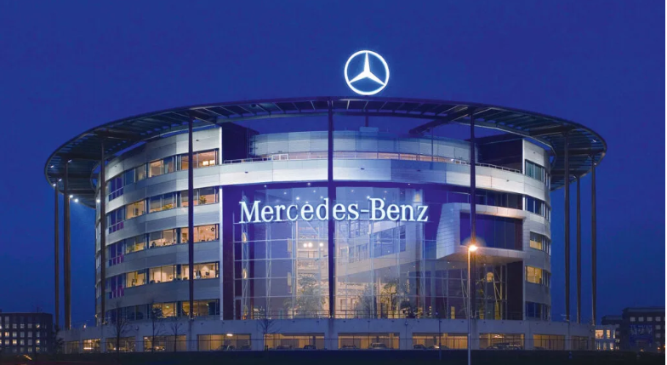

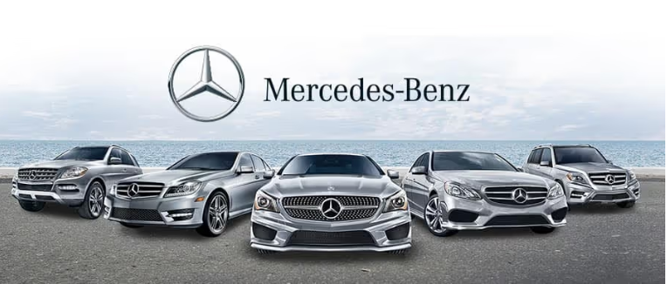

List of Figures
Figure 1 Gibbs reflective cycle 13
Figure 2 Mercedes-Benz advertisement-Formula 1 22
Figure 3 Mercedes-Benz Prices in Canada 24

Background: Mercedes-Benz's International Market Entry Strategy
Report
This study is of the International Market Entry Strategy and Marketing Mix of is based on Mercedes-Benz Group in the case of Canadian and UK Markets. Mercedes-Benz employs a multi-domestic strategy adapted to local market conditions, rather than a purely globalized approach (Mercedes-Benz Group, 2025; Cavusgil et al., 2022; Meyer and Estrin, 2023). The brand has a long history of entering the Canadian market based on a direct export model, which was supported by the existing dealership networks, which later became a strategy of building a wholly-owned subsidiary (Mercedes-Benz Canada, n.d.; Brouthers and Hennart, 2023). Comparatively, the firm views the United Kingdom as part of its core European home market, where the firm has extensive manufacturing operations and an integrally connected supply chain; this means that the company has a high-control mode of entry that is characterised by the presence of substantial foreign direct investment (Mercedes-Benz Group, 2025; Meyer and Peng, 2023). The 2025 Annual Report reports the rebalancing of the production capacities in Europe, and also simultaneously states that it has plans to locally assemble another model in North America, hence demonstrating a shift between export and local assembly as markets come of age (Mercedes-Benz Group, 2025, p. 7; Luo and Tung, 2022).

Comparative PESTEL Analysis: Mercedes-Benz in Canada and the United Kingdom

Political Factors
Canadian political macro-environment is comparatively stable, but it presents a vulnerability of volatile North American trade policy to Mercedes-Benz (Mercedes-Benz Group, 2025; Witt and Lewin, 2023). The 2025 Annual Report directly refers to the need to adjust to volatile tariff policy (Mercedes-Benz Group, 2025, p. 6), in the context of the Canadian setting, it is necessary to navigate the challenges of the United StatesMexicoCanada Agreement (USMCA) and the potential steps of the US in the trade arena (Evenett and Fritz, 2023). The political environment in the United Kingdom is characterised by the realignment of the regulatory environment after the Brexit and it creates an aspect of the unpredictable regulatory environment in Europe (Mercedes-Benz Group, 2025, p. 6;Dhingra and Sampson, 2022).

Economic Factors
The economic aspect establishes opposing market conditions defining the strategic orientation of Mercedes-Benz (Porter and Kramer, 2023). The market of luxury vehicles in Canada is supported by a diverse economy based on resource availability and stable banking system which allows the brand to emphasise on Top-End vehicles like the S-Class and Maybach models (Mercedes-Benz Canada, n.d.; Mercedes-Benz Group, 2025). These efforts are supported by the financial size of the company, which is EUR132.2 billion in revenues across the world (Mercedes-Benz Group, 2025, p.2; Rugman and Verbeke, 2023). The United Kingdom, on the other hand, faces different pressures due to the European inflation and interest rates changes (Mercedes-Benz Group, 2025, p. 10; Lane and Milesi-Ferretti, 2023) that require adaptability in the form of market segmentation. In Canada, the aggressive pursuit of the ultra-luxury segment is permissible, but in the United Kingdom, the new CLA has to be successfully introduced in the entry-level luxury segment to maintain volume in the economic uncertainty (Mercedes-Benz Group, 2025, p. 6; Katsikeas et al., 2023).

Social Factors
The most vivid comparison between the two markets is indicated in terms of social and cultural variables (Hofstede et al., 2022). The consumer behaviour process of the Canadian customers is characterised by a strong inclination towards digital integration and convenience-based luxury, which have been largely promoted on the example of the Shopping Assist tool and the Mercedes-Benz App (Mercedes-Benz Canada, n.d .; Lemon and Verhoef, 2023). Such behaviour is indicative of experiential consumption patterns where Canadian luxury consumers are demanding the introduction of smooth, technology-intensified purchasing experiences (Holmqvist et al., 2023). However, the consumer culture of the United Kingdom is more focused on automotive tradition and heritage, and Mercedes-Benz uses it through global brand communication based on the 140 Years of Innovation and Classic Centre (Mercedes-Benz, n.d.; Beverland and Farrelly, 2022).

Technological Factors
Technology is one of the strategic intersections but the patterns of adoption vary across the markets (Nambisan et al., 2022). The MB.OS operating system is the key element of the global technology agenda of Mercedes-Benz that will make all future vehicles a software-defined vehicle (Mercedes-Benz Group, 2025, p.7; Yoo et al., 2022). In Canada, the site is actively selling the all-electric Mercedes-Benz CLA and online connectivity options, which is a sign that the consumer base in the country is technologically open (Mercedes-Benz Canada, n.d. .; Li et al., 2023). Being under strict European emissions policies, the United Kingdom has an increased sense of urgency over electrified vehicles (xEVs), with sales of this vehicle type constituting 20.5% Mercedes-Benz Cars units worldwide (Mercedes-Benz Group, 2025, p. 3; Sierzchula et al., 2023). The United Kingdom has regulative pressure that makes the shift to early adopters into early majority an accelerated process in the case of EV technology, compared to the more voluntary and lifestyle-driven adoption in Canada (Rezvani et al., 2022).

Environmental Factors
The issue of environmental consideration is taken into consideration in the two markets in different ways (Delmas and Burbano, 2023). Mercedes-Benz approaches its environmental responsibility with the help of the technology programme called Tomorrow XX (Mercedes-Benz Group, 2025, p. 7; Kolk, 2023). The luxury positioning in Canada is closely embedded within the environmental messaging: the Charge up in Luxury is positioned as an aspirational feature (Mercedes-Benz Canada, n.d. .; Kapferer and Valette-Florence, 2022). This constitutes an example of benefit-oriented environmental positioning where the ecological attributes are converted into the personal benefits of the consumer (White et al., 2023). In the United Kingdom, where the discourse of environmental concern takes a more prominent role, the share of electrified vehicles is used as a corporate reputation measure (MercedesBenzGroup, 2025, p.3). The idea of the company providing the full range of drivetrains (Mercedes -Benz Group, 2025, p. 7) recognises the fact that the level of environmental pressures is different in different markets (Hartmann and Apaolaza-Ibáñez, 2022).

Legal Factors
In Canada and the United Kingdom, legal systems are different in terms of the compliance challenges (North, 2022). The harmonisation of Canada with the regulations of the U.S. means that its legal landscape is highly comparatively predictable in terms of compliance (Jackson and Deeg, 2023). The reaction to the volatile tariff policies of the company appears to highlight legal complexities associated with trade (Mercedes-Benz Group, 2025, p. 6; Evenett and Fritz, 2023). In the United Kingdom, the law surrounds the issues more closely, including overall frameworks of emissions regulation, data privacy in the UK GDPR, and processing of end-of-life vehicles (Deloitte, 2023). The focus on compliance systems in the Annual Report and the position of a Board member on the topic of Integrity, Governance and Sustainability (Mercedes-Benz Group, 2025, pp. 8, 10) demonstrates the increase of legal control of European business (Kolk, 2023). This deviation represents the concept of regulatory-distance theory, according to which, in countries where the legal system is far more different than the home-country system, more resources are devoted to compliance management (Xu and Shenkar, 2023).

Segmentation, Targeting, and Positioning (STP) Analysis

Segmentation Strategies
Mercedes-Benz in Canada uses demographic segments of people with higher incomes and aged between 20 and 40 years old (professional and executives), as people focus on luxury and performance car models (Keegan Edwards, 2024). The psychographic segmentation of this market is also based on the consumer preferences of tech-savvy people, interested in digital integration, as can be seen in the promotion of the so-called Shopping Assist tools and the so-called Mercedes-Benz App (Mercedes-Benz Canada, n.d.). The younger consumers (about 200 250) are targeted by the Generation Benz programme (Keegan Edwards, 2024).
Mercedes-Benz in the UK uses behavioural segmentation, which focuses on company car drivers, fleet managers, and chauffeur owners, as the British market has a high corporate fleet culture (Desklib, 2023). The UK approach will include geographic segmentation based on urban regions that are densely populated with wealthy people, and it will also include customers who are interested in having a hybrid car that is highly fuel-efficient because they are environmentally conscious (Desklib, 2023). The company divides the UK market into the compact, luxury, and sports cars (Desklib, 2023).

Targeting Approaches
Mercedes-Benz Canada uses the targeted approach toward consumers with high income levels in the metropolitan areas like Toronto, Vancouver and Montreal (Mercedes-Benz Canada, n.d.). The Canadian business will focus on the "Top-End" vehicles such as S-Class and Maybach model focusing on consumers, where the brand is used as a symbol of prestige and technical excellence (Mercedes-Benz Group, 2025). In the UK operation, they use a differentiated targeting approach, which would target numerous segments at the same time with a tailored marketing message (Desklib, 2023). In relation to luxury class cars, Mercedes-Benz UK aims at IT specialists, real estate agents, and fashion designers who have high disposable incomes (Desklib, 2023). In the case of sports cars, the company is oriented at sports car racers whereas the EQ electric brand is aimed at early adopters who care about the environment (Desklib, 2023). This multi-segregation strategy is an indication of the maturity of the UK market (Desklib, 2023).

Positioning Strategies
Mercedes-Benz targets itself as a technologically advanced luxury car in Canada, with a focus on the motto of Progressive mobility and digital convenience (Mercedes-Benz Canada, n.d.). The positioning is based on innovation as the key differentiator, and the messaging is related to the EQ Technology and connected vehicles (Mercedes-Benz Canada, n.d.). Mercedes-Benz UK uses heritage-founded positioning, using the tagline 140 Years of Innovation and links to the best of motorsport using the Formula 1 association (Mercedes-Benz, n.d.). It focuses on craftsmanship and safety and holds itself as The Best or Nothing (Desklib, 2023). On the prestigious ownership and financial performance, a perceptual map places Mercedes-Benz UK on top of BMW and above Audi and Porsche (Desklib, 2023).

International Marketing Mix (7Ps) Analysis

Product Strategy
The product strategy of Mercedes-Benz Canada is the simplification of the model lines with a strong focus on high-demand SUVs and electrified vehicles, and on the Canadian site, GLE, GLS, and all-electric CLA models are displayed prominently (Mercedes-Benz Canada, n.d.). The product portfolio focuses on vehicles of the type featuring the term "EQ Technology," as the North American consumers are attracted to the concept of electrification as a luxury feature (Mercedes-Benz Canada, n.d.). Mercedes-Benz Canada offers online configurators, allowing the Canadian consumer to customise vehicles (Mercedes-Benz Canada, n.d.). Merccedes-Benz has a well-established product range in the UK, which covers the A-Class to S-Class ranges, hatchbacks and coupes, as well as the complete AMG performance range (Desklib, 2023). The UK product strategy focuses on diesel and hybrids because of the fuel efficiency requirement and tax requirements of the company cars (Desklib, 2023). The focus in the UK on electric vehicles (xEVs) is especially topical, as the share of their sales in the market was 20.5% of all Mercedes-Benz Cars units worldwide (Mercedes-Benz Group, 2025; Desklib, 2023).

Pricing Strategy
Mercedes-Benz Canada uses the value-based pricing that is based on the premium positioning; the average price of the vehicles is between 40,000 and more than 100,000 dollars (Keegan Edwards, 2024)-See Appendix-II. Canadian pricing is less aggressive in reducing the price in favour of brand exclusivity and focuses on financing (Mercedes-Benz Group, 2025). UK business is practised by premium prices with flexible ownership structures, such as Personal Contract Hire (PCH) and approved used scheme (Desklib, 2022). The resale value and EMI financing options that Mercedes-Benz UK provides are also competitive and can be adjusted to British consumers who prefer leasing (Desklib, 2023). The company has been consistent in pricing in its 20 showrooms in the UK (Desklib, 2023).

Place and Distribution Strategy
Mercedes-Benz Canada is a dealer partnership that is based on urban hubs, with more of the focus on online-based sales (Mercedes-Benz Canada, n.d.). The Canadian site has digital configurations, virtual tours, and direct to consumer online tools (Mercedes-Benz Canada, n.d.). This change indicates the inclination of North American consumers to digital-based integration (Hypercontent, 2025). Mercedes-Benz UK has around 20 physical showrooms which are strategically situated in the country and are supported by production facilities (Desklib, 2023). The UK distribution approach focuses on experience-oriented retailing where showroom designs are minimal with the production of lounge-like settings (Desklib, 2023). Physical locations can be its sales centres and hubs of brand experiences (Desklib, 2022).

Promotion Strategy
The promotion plan used by Mercedes-Benz Canada relies on on-line marketing such as targeted advertising through social media and interactive campaigns like Countdown to Dreams (Mercedes-Benz Canada, n.d.). The Canadian operation focuses on lifestyle branding between vehicle ownership and aspirational experiences (Hypercontent, 2025). Mercedes-Benz in the UK uses integrated marketing communication that blends the use of traditional advertising media with digital activities (Desklib, 2022). High-profile sponsorship deals such as Formula 1 are used by the brand to promote brand credibility (Desklib, 2023)-see Appendix-I. UK promotions emphasize heritage messaging alongside sustainability commitments (Desklib, 2023).

People Strategy
The emphasis on customer experience is put on digital channels through individualised communication via CRM systems and mobile applications by Mercedes-Benz Canada (Hypercontent, 2025). The Canadian operation trains dealership employees on consultative selling with a focus on technological features (Keegan Edwards, 2024). In the UK operation, it is more about building personal relationships, whereas the showroom employees are educated in the sphere of luxury hospitality (Desklib, 2022). Mercedes-Benz UK is very concentrated on the after sales service excellence (Desklib, 2023).

Process Strategy
Mercedes-Benz Canada has simplified digital operations that provide an opportunity to arrange a vehicle online and deliver it to a home (Mercedes-Benz Canada, n.d.). The operation of Canada takes advantage of the lean management principles of service operations (Hypercontent, 2025). Mercedes-Benz in the UK has been using an integrated approach to processes in sales and service as well as finance (Desklib, 2024). The UK operation adopts the process of just-in-time production and strict quality control systems (Desklib, 2023).

Physical Evidence Strategy
Mercedes-Benz Canada focuses on physical evidence on the digital level with the help of immersive web experiences and virtual showroom tours (Mercedes-Benz Canada, n.d.). Canadian operation features cars in dreamy locations (Hypercontent, 2025). The UK operation utilises the history-filled physical evidence such as historic showroom sites and classic car displays (Desklib, 2023). British dealerships also have exclusive AMG and Maybach experience sections (Desklib, 2022).

c. Analysis of Mercedes-Benz's Directional Development Strategy in Canada
The directional development approach by Mercedes-Benz in Canada is a premeditated use of the product development concept in the Ansoff Matrix framework, which focuses on electrification, with a consensual exploitation of the brand core capabilities in the areas of luxury and performance (Desklib, 2020).

Electrification as Core Strategic Direction
Canada Directional strategy of the company focuses on an extensive electrification initiative, as battery electric (BEV) and plug-in hybrid (PHEV) vehicles would make 12⁻ percent of all vehicles sold by Mercedes-Benz Canada in 2025, which would be 4,563 electrified cars sold (Cantech Letter, 2026). Even though this rate of penetration is growing, it is still less than the global percentage of passengers-cars electrification of 20.5% reported by Mercedes-Benz Group (2025) which indicates that Canadian adoption is worse than in European markets and that further strategic investment in charging infrastructure and consumer education is necessary. The example of the gap between the Canadian and European electrification rates can be viewed as the manifestation of the concept of liability of foreignness, where local market conditions create adoption costs which need to be handled in a localised manner (Desklib, 2020).

SUV Dominance and Portfolio Realignment
Critical analysis shows that the directional strategy of Mercedes-Benz in Canada is highly focused on the SUV segments where 75% of passenger vehicle sold in 2025 was in SUVs segment of 23,338 versus 7,961 passenger cars (Cantech Letter, 2026). GLC was the leader in sales with 8,747 models sold, and it grew by 25% per year compared to the previous year, and GLA SUV was sold in 3,543 cases, with an impressive 123 per cent (Cantech Letter, 2026). This change of the portfolio can be explained by the logic of the BCG matrix, according to which SUVs will be treated as cash cows that will bring significant income to support the investment in electrification in the new emerging segments, which are marked as questions (Desklib, 2020).

Vertical Integration and Supply Chain Strategy
Another dimension that is intimately crucial to the Canadian directional strategy of Mercedes-Benz relates to upstream vertical integration by means of partnerships with raw materials. In Canada, the company has signed a declaration of intent with the government to further collaborate throughout the entire automotive value chain, particularly access to key raw-material suppliers of electric-vehicle batteries (Geothermal -Lithium, 2026). This is a backward integration plan that aims to achieve supply-chain resilience and decrease reliance on possibly volatile overseas sources of lithium and other essential minerals. The strategic action shows how to apply the concept of transaction-cost economics where the firm aims at internalising key operations of the supply-chain to reduce uncertainty and expenses of producing batteries in the long run (Desklib, 2020).

Market Performance Validation
Performance Validation A phase during which the algorithm is put to test on the basis of real market data. The positive outcome of the directional strategy is demonstrated by strong financial performance of the company, with Mercedes-Benz Canada providing 31.297 passenger cars in 2025, which is a 11.5% growth over the previous year, adding into total sales of 37.382 vehicles in all the divisions (Cantech Letter, 2026). GLC is growing 25% and the CLA is growing 40% to 2,862 units confirm the two-way emphasis on SUV strength and entry-level electrification (Cantech Letter, 2026). The third quarter reported an overall growth of 8.2percent with a total sale of 10,080 vehicles, which indicates a continued trend (Mercedes-Benz Canada, 2025).

d. Evaluation of Ethical Issues in Mercedes-Benz's Marketing Mix
The entry mode of Mercedes-Benz into the international market in Canada and the United Kingdom has faced serious ethical challenges in various aspects of the marketing mix that have cast underlying doubts about the issue of corporate responsibility, transparency, and accountability to the stakeholders (LBBOnline, 2022; Business Matters, 2025). These ethical issues should be critically analysed in terms of theoretical approaches, such as stakeholder theory, corporate social responsibility (CSR), and utilitarian ethics, to learn their implication on the brand international operations (Marketing-Interactive, 2026).

Promotion Ethics: Greenwashing and Deceptive Communication
One of the most noticeable ethical scandals that influenced the promotion approach of Mercedes-Benz appeared in the United Kingdom when the Mercedes-EQ electric car line was advertised under a slogan called Nature or Nothing (LBBOnline, 2022). Wherefrom, a platform focused on sustainability, publicly suggested Mercedes-Benz was engage in greenwashing based on the ads stating that the beautiful nature is seen as an extension of the leaves to the honeycomb to a rose with a circle as the centre of the advertisement, suggesting that the company was synonymous with the nature that was pure (LBBOnline, 2022). Advertising experts in their critique dubbed this campaign as greenwashing 101 because they felt that it made consumers think that Mercedes-Benz is an environmentally friendly corporation when it is actually a massive carbon footprint (LBBOnline, 2022). The time was especially problematic because Mercedes-Benz was also being sued by German activists to be forced to increase its carbon emissions targets (Marketing-Interactive, 2026).
Applying greenwashing theory, Using greenwashing theory, this is a classic instance of the so-called fuzzy claims, where vague environmental affiliations give false perceptions with no actual corporate behaviour (Marketing-Interactive, 2026). This practise is put in perspective by a European Commission report, which says that of companies that claim to be green, 42 percent are overstated, inaccurate, or deceptive (Marketing-Interactive, 2026).

Product and Price Ethics: Collusion and Consumer Harm
An extremely impactful unethical act was cropping up in the market of the United Kingdom, and it was a communication of the products and competitive behaviour of Mercedes-Benz (Business Matters, 2025). Investigations by Competition and Markets Authority (CMA) found that Mercedes-Benz was involved in a 15 year cartel deal with other large manufacturers, known as the ELV Charta or the gentlemen agreement. Under this system, the rivals were accused of concurring not to embark on the advertising of the ratio of their cars that could be reused at the end of life (Business Matters, 2025). Excluding Renault, participants were also accused of having conspired to withhold information to customers on the proportion of recycled material used by them in their vehicles (Automotive Manufacturing Solutions, 2025).
The conspiracy was essentially a breach of consumer sovereignty, which deprived the purchasers of the information they needed to make purchases that are environmentally responsible (Business and Human Rights Resource Centre, 2025). According to the CMA, this behaviour restricted the capacity of consumers to make informed decisions and minimised the motivation of the companies to invest in environmental developments (Automotive Manufacturing Solutions, 2025). Considering the deontological approach, the activities of Mercedes-Benz were in breach of the categorical imperative of using consumers as a means of earning profit and withholding information (Business Matters, 2025).

Place and Distribution Ethics: Public Procurement Integrity
In Canada, there were some ethical issues related to the distribution strategies of Mercedes-Benz, in particular with the public-sector procurement (Global News, 2018). According to an audit by the auditor-general of the City of Ottawa, the decision of the City of Ottawa to procure seventy-one Mercedes-Benz Sprinter vans between 2011 and 2015 was identified to be unjustified and not cost-effective. Fourteen Sprinters used by the municipality cost it over $396,000 without proper documentation or a cost-benefit analysis (Global News, 2018). The vehicle prices were between 46,000 and 64,000 per unit, which was significantly higher than similar alternatives and previous versions of procurement forms that had found more cost-effective alternatives were later scrubbed (Global News, 2018).
It also provoked serious questions of distributive justice in the marketing channels because it seems that the public money was mismanaged by the lack of proper procurement procedures (Global News, 2018). Although Mercedes-Benz was not directly involved in facilitating the failures in procedures, the corporation enjoyed advantages of choices where auditors lacked evidence which was recorded that a value-analysis comparison of alternatives had been carried out (Global News, 2018). On the one hand, as a luxury brand that opens overseas markets, it risks getting a tarnished image that does not solely rely on the business clientele (Global News, 2018).

Positive Ethical Initiatives and Stakeholder Engagement
Unlike these failures, Mercedes-Benz Canada has been seen to have an authentic concern over the welfare of the stakeholders through innovative community engagement practises. The CPR Showrooms programme turned seven dealerships in Toronto into life-saving training centres, where more than 1,100 local people obtained CPR training with the collaboration of the Heart and Stroke Foundation. This programme was recognised by the coveted Corporate Partner Award and contributed to the real community goodwill. Similarly, the impact of employee-engagement programmes, such as doggy photo shoots and test-driving programs, has created highly brand-loyal customers who have received recognition as main customers (LinkedIn, 2019). More recently, Mercedes-Benz Winnipeg was granted SAFE Work Certification which shows that the culture of the workplace is built on trust, accuracy, and actual interest towards the employees (Business Wire, 2025).

e. Recommendations for Mercedes-Benz's International Marketing Strategy
Following the critical evaluation of the activities of Mercedes-Benz in Canada and the United Kingdom, the recommendations that may be offered to improve the effectiveness of the brand through its international marketing and to overcome the ethical weaknesses identified.
First, Mercedes-Benz must expedite the pace in which it implements its Retail of the Future direct-sales approach in both markets to always align the pricing and customer experience (The Investor, 2026). The system that has been successfully piloted in twelve countries such as the United Kingdom gives better feedback on customer satisfaction, price transparency and consistency of service (The Investor, 2026). This change would discuss ethical issues caused by controversies in public-procurement in Canada and match consumer preferences to transparent pricing (Global News, 2018).
Second, the company has to institute stringent international regulation of promotional messages to eliminate green-washing accusations (Marketing-Interactive, 2026). The case of Nature or Nothing controversy is a clear indication that local marketing can cause a lot of harm to the world brand image ( Marketing -Interactive, 2026). The recommendation that Mercedes-Benz ought to put in place centralised approval procedures on sustainability claims is to ensure that sustainability performances are agreed with actual performance in terms of carbon-reduction (Marketing-Interactive, 2026).
Third, Mercedes Benz must pursue greater vertical integration in Canada by establishing raw-material relationships and product portfolio differentiation (Geothermal-Lithium, 2026). Pledge to the Canadian government regarding having access to battery-materials would improve the resilience of the supply-chain (Geothermal-Lithium, 2026). The company must continue with its flexible two-pronged strategy in both nations where they should provide electrified and efficient cars with combustion engines (Chosun, 2026).
Fourth, Mercedes -Benz needs to strengthen the relationship between dealers in the transition process to the Retail of the Future model by ensuring that it communicates in a transparent way (CADA, 2026). The company can maintain strong channel relationships by forming service-oriented backbone relationships with dealers and remaking its distribution network by positioning dealers as service-oriented backbone relationships as opposed to price negotiators (Chosun, 2026).

Section 2: Reflective Account of the Research and Analysis Process
Reflection account of the process that the researcher has followed in researching, analysing and preparing the previous section is based on the Gibbs reflective cycle which has the below points.
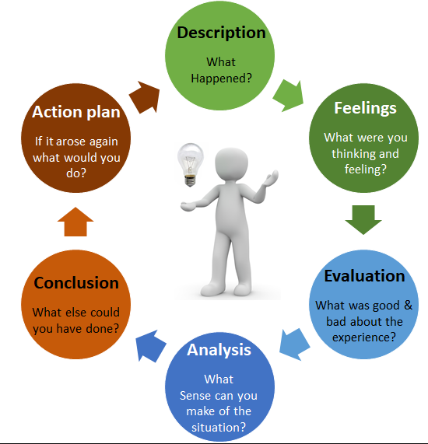
Figure 1 Gibbs reflective cycle

Description
The comparative marketing research and preparation of the comparative marketing of Mercedes-Benz in Canada and the United Kingdom started with the compilation of secondary data through various sources. I commenced by obtaining the Mercedes-Benz Group Annual Report 2025 to obtain strategic information in terms of entry modes, rebalancing production, and financial performance. I then reviewed the Canadian and the United Kingdom websites in order to determine differences in product focus, promotional messages and technology. The research stage also used some new sources, such as news articles about the Retail of the Future model, scholarly debates on the green-washing scandals, and industry literature on the topic of the dealer relationships. Upon putting together this material, I divided the analysis into two major parts first, a PESTEL framework of macro environmental factors and then an STP and 7ps analysis of marketing mix adoptions. The last phase was the provision of recommendations based on the strategic divergences and ethical weaknesses that were identified.

Feelings
When I started on this project, my level of uncertainty was quite high in terms of how best to organise a systematic comparative analysis. The big amounts of data that information about such a worldwide company like Mercedes-Benz presented seemed to be at first overwhelming. The more the PESTEL framework moved through my system, the more specific trends had become visible; the political differences between post-Brexit United Kingdom and USMCA-bound Canada became clear, and the sociocultural differences of heritage and digital convenience were enlightening in a very specific way. When I came across the greenwashing scandal, I experienced an ethical issue as well as an appreciation of the fact that, revealing such weaknesses would enhance the rigour of the analysis. The fulfilment of the recommendations subsection induced a satisfaction effect as the analysis carried out before made action proposals directly based on the previous analysis.

Evaluation
The systematic use of the developed marketing frameworks was successful; the PESTEL structure was a sensible framework that ensured that no important aspects were neglected. The analysis was based on the verifiable data, as specific evidence, quotes in Annual Report, the features of the websites, and news articles, was integrated to support the analysis with facts instead of guesses. The comparative style with the stress on differences between Canada and UK created the natural tension and increased interest. Nevertheless, there are some elements that might have been stronger. The first stage of research did not have an articulated organisation system, and after some time, it is necessary to visit the sources several times to retrieve the ignored information. The ethical aspect has a later appearance, as the articles about greenwashing were discovered; prior awareness could have enabled this theme to be more active in the analysis.

Analysis
Further analysis shows that there are a number of reasons that affected the creation of this project. The previous knowledge about the PESTEL analysis and marketing mix helped me to have confidence in the way that I organised the analysis, and that same knowledge probably limited my thinking in the traditional categories, instead of allowing me to form more creative associations. The use of publicly available documents implies that the analysis is bound to capture the external communications of Mercedes -Benz as opposed to the internal strategy thought processes- a limitation which comes with secondary research. The greenwashing content, which comes not from the company publications but the news sources, highlights the importance of the consideration of the critical outside opinions, as well as the corporate ones. The theoretical links to the experiential learning cycle of Kolb become clear: the tangible experience of struggling with different source materials, which is followed by the reflective observation of what worked/what did not now result into the abstract conceptualization of how I would approach similar tasks in different ways.

Conclusions
There are a few lessons that this experience taught me. To begin with, the use of structured frameworks, e.g. PESTEL and the 7ps is not a useful tool in the form of a mechanical checklist, but as an analytic tool that encourages a structured inquiry. Second, the variety of sources is a crucial factor in the quality of analysis; these critical opinions and corporate messages provide a more refined view. Third, comparative analysis helps understand strategic policies in a light that cannot be achieved through single-market analysis, Canada-UK comparisons help reveal how Mercedes-Benz can adjust to the local context without disrupting the global brand. Fourth, the ethical considerations must be considered throughout the analysis process and not as a post-hoc. Going forward, I would prepare a research matrix at the beginning to group source material on similar subjects, strategically attempt to find a critical view point early, and take a longer time on synthesis after initial writing. The competencies that I have trainings in are the ability to synthesise various sources of information, theoretical frameworks to practical cases, and the development of evidence-based recommendations.

Action Plan
In future analytical assignments, I will use them by starting with a complex research project with a structured template that identifies the evidence categories required and investigating sources after that. I will also purposely devote research time to find out the critical commentaries: news analysis, stakeholder criticism, academic commentary, and also corporate documents. Clear synthesis stages will be constructed into it, so I will not need to analyse the data in detail but instead look at the larger patterns and relationships. To further advance analytical skills, I will use the same frameworks to other international firms and will find out whether the trends observed here are applicable in other industrial settings. To identify my blind areas in self-evaluation, I will get peer or tutor feedback regarding this reflection. My next research project will mark the start of the implementation timeline because I will be able to use the research matrix approach immediately. Some of the support that I will need is access to the academic databases so as to find peer-reviewed critiques and possible workshop sessions on the superior methods of organising a research project.

References
- ASA. (2023). ASA Ruling on Marshall Motor Group Ltd. Available at: https://www.asa.org.uk/rulings/marshall-motor-group-ltd-a23-1183756-marshall-motor-group-ltd.html (Accessed: 15 March 2026).
- Automotive Manufacturing Solutions. (2025). UK competition regulator fines 10 carmakers and trade bodies over collusion in green advertising. Available at: https://www.automotivemanufacturingsolutions.com/sustainability/uk-competition-regulator-fines-10-carmakers-and-trade-bodies-over-collusion-in-green-advertising-and-recycling-disclosures/526221 (Accessed: 15 March 2026).
- Beverland, M. and Farrelly, F. (2022) ‘Brand heritage and consumer identity in luxury markets’, Journal of Business Research, 145, pp. 437-446.
- https://doi.org/10.1016/j.jbusres.2022.02.040
- Business & Human Rights Resource Centre. (2025). UK: Regulator fines 10 carmakers & 2 trade bodies over green ad collusion. Available at: https://www.business-humanrights.org/it/ultime-notizie/uk-regulator-fines-10-carmakers-2-trade-bodies-over-decision-not-to-compete-through-green-ad-collusion/ (Accessed: 15 March 2026).
- Business Matters. (2025). UK fines 10 carmakers and two trade bodies £77m over green advertising cartel. Available at: https://bmmagazine.co.uk/news/uk-fines-10-carmakers-and-two-trade-bodies-77m-over-green-advertising-cartel/ (Accessed: 15 March 2026).
- Business Wire. (2025). Mercedes-Benz Winnipeg Achieves Milestone as S2SA's 100th SAFE Work Certified Company. Available at: https://secure.businesswire.com/news/home/20251216319650/en/Mercedes-Benz-Winnipeg-Achieves-Milestone-as-S2SAs-100th-SAFE-Work-Certified-Company (Accessed: 15 March 2026).
- CADA. (2026). Dealer fundamentals: Lessons from the Mercedes-Benz Canada summit. Canadian Automobile Dealers Association. Online available at https://www.cada.ca/CADA/CADA/News1/Newsline_Stories/2026-02-Feb/CADASummit-SommetdelaCADA.aspx (Accessed: 10 March 2026).
- Cantech Letter. (2026). Mercedes-Benz Canada reports 2025 sales results. Available at: https://www.cantechletter.com/newswires/mercedes-benz-canada-reports-2025-sales-results/ (Accessed: 10 March 2026).
- Chosun. (2026). Mercedes-Benz Korea to introduce direct sales system. Online available at https://biz.chosun.com/en/en-industry/2026/02/26/YS5CRJEWI5AB3FX24IAYOT2KQA/ (Accessed: 10 March 2026).
- Cavusgil, S.T., Knight, G. and Riesenberger, J. (2022) ‘International business strategy in the digital era’, Journal of World Business, 57(6). https://doi.org/10.1016/j.jwb.2022.101310.
- Delmas, M. and Burbano, V. (2023) ‘The drivers of greenwashing’, California Management Review, 65(3), pp. 64-87.
- Dhingra, S. and Sampson, T. (2022) ‘Brexit and the UK economy’, Annual Review of Economics, 14, pp. 611-639.
- Desklib. (2024). Marketing Essentials: Marketing Plan for Mercedes Benz.
- Geothermal-Lithium. (2026). VW and Mercedes-Benz step up cooperation with Canada. Available at: https://www.geothermal-lithium.org/en/node/74 (Accessed: 15 March 2026).
- Global News. (2018). City dollars spent on Mercedes Sprinter vans 'unjustified' in many cases: auditor general. Available at: https://globalnews.ca/news/4302318/city-mercedes-sprinter-vans-unjustified-auditor-general/ (Accessed: 15 March 2026).
- Hypercontent. (2025). Marketing Strategy of Mercedes-Benz. Available at: https://hypercontent.co/blogs/marketing-strategy-of-mercedes-benz/ (Accessed: 15 March 2026).
- Keegan Edwards. (2024). Identifying the Target Market for Mercedes Benz. Available at: https://keeganedwards.com/identifying-the-target-market-for-mercedes-benz/ (Accessed: 15 March 2026).
- K. D. Brouthers and J. F. Hennart, “Boundaries of the Firm: Insights from International Entry Mode Research,” Journal of Management, Vol. 33, No. 3, 2007, pp. 395-425. http://dx.doi.org/10.1177/0149206307300817
- Kapferer, J. and Valette-Florence, P. (2022) ‘Luxury brand desirability and sustainability’, Journal of Brand Management, 29(3), pp. 291-303. https://doi.org/10.1057/s41262-021-00257-3
- LBBOnline. (2022). Stop the (Car) Wash: Wherefrom Calls Out Mercedes for Greenwashing. Available at: https://lbbonline.com/news/stop-the-car-wash-wherefrom-calls-out-mercedes-for-greenwashing-in-latest-campaign (Accessed: 15 March 2026).
- LinkedIn. (2019). A Brand is Built from the Inside Out. Available at: https://www.linkedin.com/pulse/brand-built-from-inside-out-jacinta-grootjen (Accessed: 15 March 2026).
- Lemon, K. and Verhoef, P. (2023) ‘Understanding customer experience in the digital age’, Journal of Marketing, 87(1), pp. 1-18. https://pure.rug.nl/ws/files/81733365/Understanding_Customer_Experience_Throughout_the_Customer_Journey.pdf
- Li, Y., Tong, Y. and Xing, K. (2023) ‘Technology adoption in electric vehicle markets’, Technological Forecasting and Social Change, 189. https://doi.org/10.1016/j.techfore.2023.122321
- Meyer, K. and Estrin, S. (2023) ‘Local context and multinational strategy’, Global Strategy Journal, 13(2), pp. 203-221.
- Marketing-Interactive. (2026a). Mercedes-Benz called out by sustainability review platform for greenwashing. Available at: https://www.marketing-interactive.com/mercedes-benz-wherefrom-greenwashing (Accessed: 15 March 2026).
- Marketing-Interactive. (2026b). Mercedes-Benz greenwashing accusations: What went wrong?. Available at: https://www.marketing-interactive.com/mercedes-benz-greenwashing-analysis (Accessed: 15 March 2026).
- Mercedes-Benz Canada. (no date). Luxury Cars - Sedans, SUVs, Coupes & Wagons. Available at: https://www.mercedes-benz.ca/en/home (Accessed: 15 March 2026).
- Mercedes-Benz. (no date). Mercedes-Benz Brand Experience. Available at: https://www.mercedes-benz.com/en/ (Accessed: 15 March 2026).
- Mercedes-Benz Canada. (2025). Mercedes-Benz Canada reports Q3 2025 sales results. Available at: https://media.mercedes-benz.ca/releases/release-c947c74c76ea9280d380568bb706b172-mercedes-benz-canada-reports-q3-2025-sales-results (Accessed: 15 March 2026).
- Mercedes-Benz Canada. (2026). Mercedes-Benz Showcases Dynamic 2026 Model Lineup at the Montreal International Auto Show. Available at: https://media.mercedes-benz.ca/releases/release-44f94322770720b8f1c4332409012759-mercedes-benz-showcases-dynamic-2026-model-lineup-at-the-montreal-international-auto-show (Accessed: 15 March 2026).
- Mercedes-Benz Canada. (2026). Mercedes-Benz Showcases Performance, Luxury, and Electrification at the 2026 Canadian International AutoShow. Available at: https://media.mercedes-benz.ca/releases/release-44f94322770720b8f1c43324090386f0-mercedes-benz-showcases-performance-luxury-and-electrification-at-the-2026-canadian-international-autoshow (Accessed: 15 March 2026).
- Mercedes-Benz Group. (2025). Annual Report 2025. Available at: https://group.mercedes-benz.com/documents/investors/reports/annual-report/mercedes-benz/mercedes-benz-annual-report-2025-incl-combined-management-report-mbg-ag.pdf (Accessed: 15 March 2026).
- Mercedez-Benz Group (2025). Annual Report 2025 Mercedez-Benz Group. [online] group.mercedes-benz.com, Mercedez-Benz Group, pp.1–409. Available at: https://group.mercedes-benz.com/documents/investors/reports/annual-report/mercedes-benz/mercedes-benz-annual-report-2025-incl-combined-management-report-mbg-ag.pdf (Accessed 5 March 2026).
- Nyilasy, G., Gangadharbatla, H. and Paladino, A. (2022) ‘Perceived greenwashing’, Journal of Business Ethics, 175(4), pp. 639-651.
- White, K., Habib, R. and Hardisty, D. (2023) ‘How to shift consumer behaviors to be more sustainable’, Journal of Marketing, 87(2), pp. 1-20.ZX.

Appendixes

Appendix-I Mercedes-Benz advertisement-Formula 1




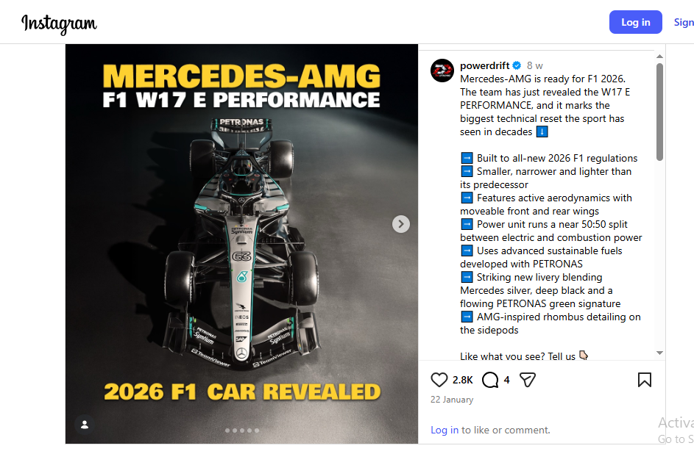

Source: https://www.behance.net/gallery/240005947/Mercedes-AMG-2025-F1-Season?tracking_source=search_projects%7Cf1+poster+mercedes
Figure 2 Mercedes-Benz advertisement-Formula 1

Appendix-II Mercedes-Benz Prices in Canada
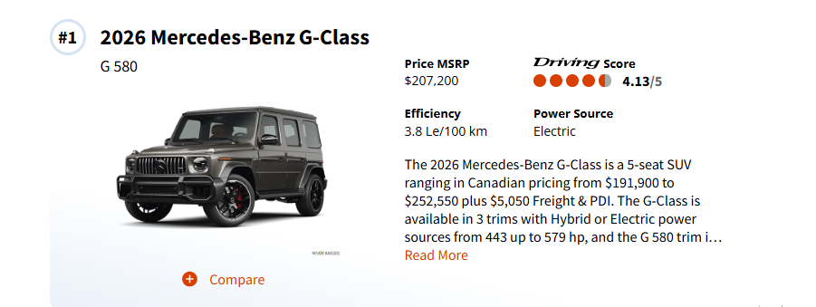
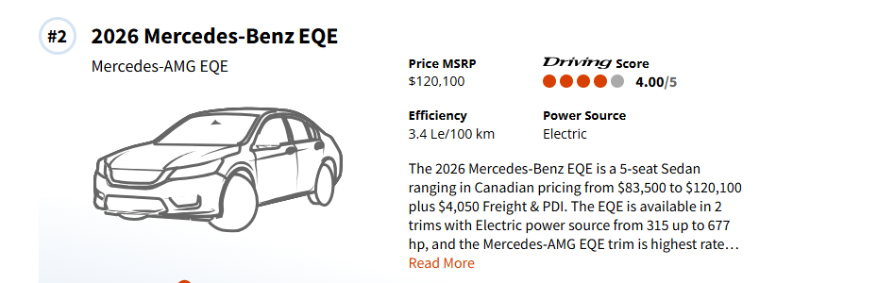
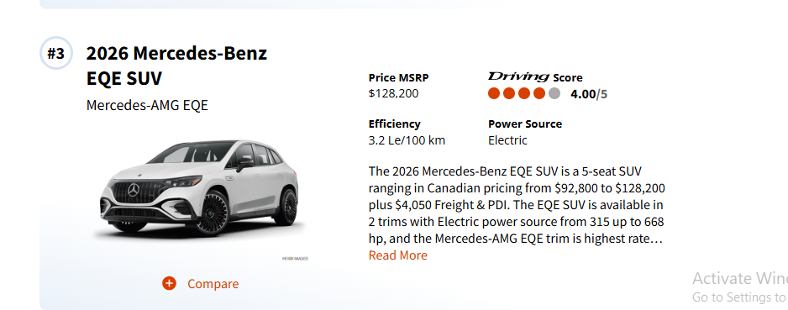
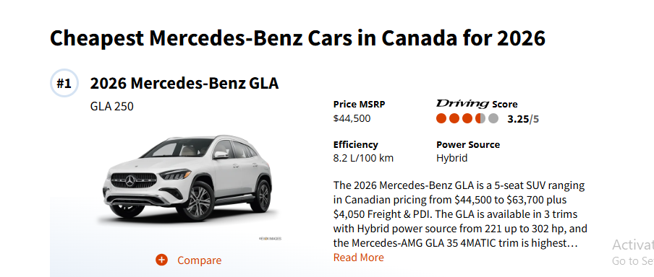
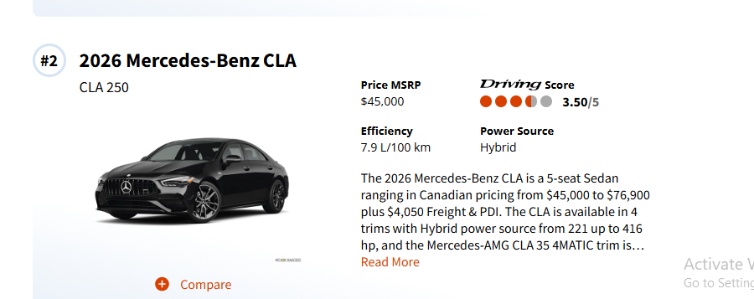
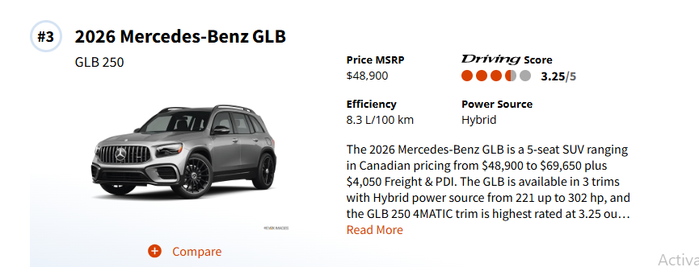

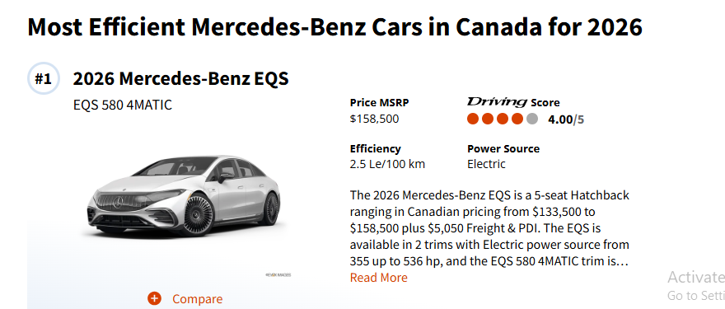
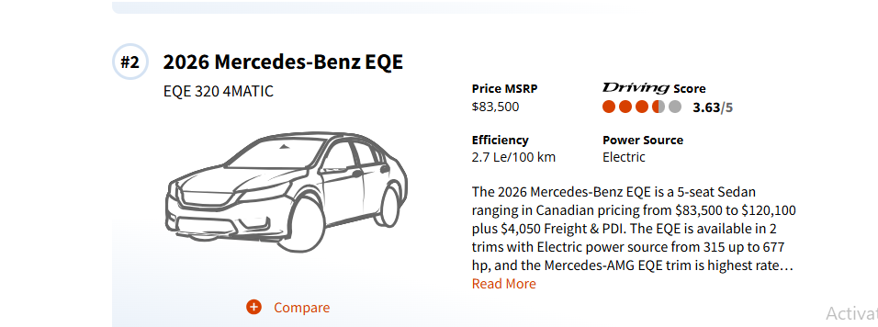
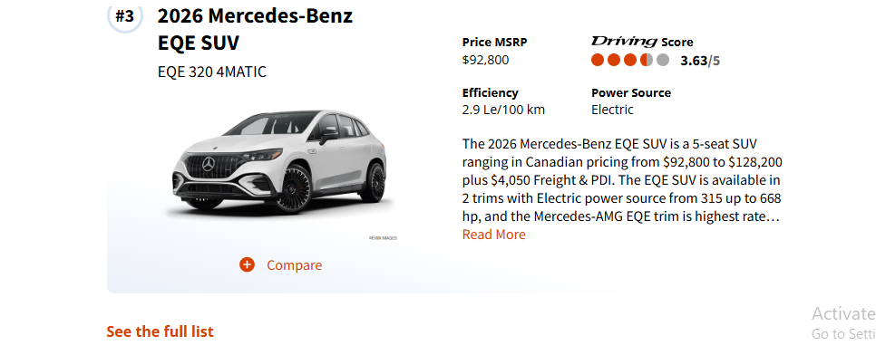
Source: https://driving.ca/mercedes-benz/
Figure 3 Mercedes-Benz Prices in Canada

