Dylan Yeates

Information engineering assignment 2

Introduction
Throughout this document I will cover how to create a usable database using the SQL features built into access. I will also discuss the importance of steps and features of my database as will as fill in my database with information and create forms and reports. The goal of the database is to make is user friendly enough that the users do not have to use the sidebar or ever have to touch the normal tables. Users should be able to navigate to everything they need to access only using the push buttons.

Entity Relationship Diagram
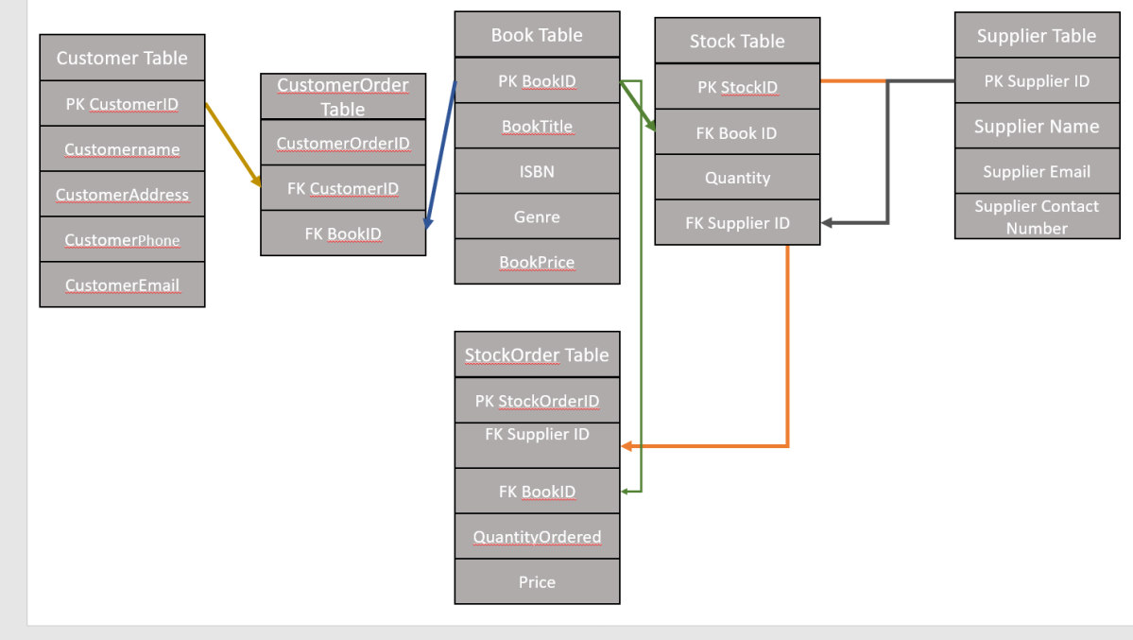
I had issues with installing Visio at home and after several hours of attempts I decided to focus on the bulk of the assignment and use PowerPoint to create something like what Visio would produce.
In this diagram I have made appropriate links in a way that would let a user use the database like a real bookstore system. If a system is created wrong, it could result in relationships being set that are incompatible such as if book table needed stock id and stock table needed book id. This would result in being able to populate neither tables as they are needed to be filled in order to fill the one on the other side. As a whole it just creates a creation paradox as both sides need to be filled before you can fill either side.

Table Creation
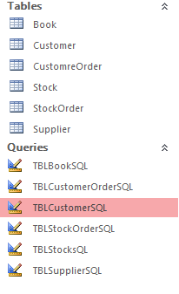
Here I have created tables using the SQL feature in access. All the relationships were created using SQL in order to maintain a consistency. I went through a clear planning stage before I even thought about creating the access to ensure the database will flow smoothly
TBLBookSQl
Create table Book(
BookID Text(15) constraint BookID_pk primary Key,
BookTitle Text(20),
ISBN Text(20),
Genre Text(20),
BookPrice Text (10 ));

TBLCustomerSQL
Create table Customer(
CustomerID text(15) constraint CustomerID_pk primary Key,
CustomerName Text(20),
CustomerAddress Text(20),
CustomerPhone Text(11),
CustomerEmail Text(25));

TBLCustomerOrderSQL
Create table CustomreOrder(
CustomerOrderID Text(15) constraint CustomerOrderID_pk primary Key,
CustomerID Text(25) constraint fk_CustomerID References Customer (CustomerID),
BookID Text(25) constraint fk_BooksID References Book (BookID ));

TBLStockOrderSQL
Create table StockOrder(
StockOrderID Text(15) constraint StockOrderID_pk primary Key,
SupplierID Text(25) constraint fk_SupplierID References Supplier(SupplierID),
BookID Text(25) constraint fk_BookingID References Book (BookID),
QuantityOrdered Text(20),
Price Text(20));

TBLStockSQL
Create table Stock(
StockID Text(15) constraint Order_ID_pk primary Key,
BookID Text(20) constraint fk_BookID References Book (BookID),
Quantity Text(20),
SupplierID Text(25) constraint fk_SuppliersID References Supplier (SupplierID ));

TBLSupplierSQL
Create table Supplier(
SupplierID Text(15) constraint SupplierID_pk primary Key,
SupplierName Text(20),
SupplierEmail Text(20),
SupplierContactNumber Text(20));

SQLInsertData
INSERT INTO Book ( BookID, BookTitle, ISBN, Genre, BookPrice )
SELECT 1 AS Expr1, 'Rainbow Six' AS Expr2, '9788408039242' AS Expr3, 'Thriller' AS Expr4, '12.99' AS Expr5;

The creation of a table in SQL goes through a simple process of creating the table using the create table [table name]( ); function and filling in each process with the data type you want filled in followed by the length if applicable, if it’s a primary key you must mark it using the constraint [primary key name] primary key, function.

Appropriate Table Relations
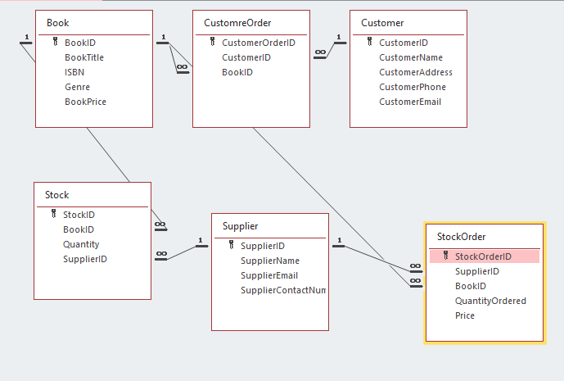
Here are my relations. This matches my ERD as I used it as a guide in creating my database. These were created by using the foreign keys in other tables to create the link to begin with. This will link certain fields amongst tables and act as a form of data verification so that users cannot enter part of the information

Populating Tables
I have populated each table with a couple of results each to ensure that my database is completely functional.

Appropriate Menus
I have created a functional menu with all buttons allowing the user to view everything that would be displayed in the table. I have used this to make it so that a user on the system will never have to touch the actual tables and if they want to go through the records, delete a record or add a new records they can do so from the push buttons available on every single form of the menu.

Appropriate Report
I have created a report that displays everything that have only been in the database for this quarter of they year. The user unticks it after the newsletter has been sent. This will allow the end user to automate the process of sending out the newsletter of new books as it will fill in the report with every single book that has been added in this current quarter. It will take the tediousness out of the mundane task.

Relationships of SQL
Due to me creating every table using SQL all of my relationships were created using SQL. I have created several one to many relationships using the SQL features in access.

Records SQL
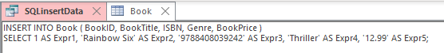
Here I have created a record using SQL. It is split into two parts. Defining what I want to fill and then the second part is filling what information goes where I have entered my data. To do it through SQL whilst is different I find it to be a bit more convenient as you can fill all of the fields at once. This can allow me to proofread before submitting my data into the system. I find this way, whilst less user friendly, to be the most convenient way to fill in data in a system.

Foreign Key SQL
An example of using a foreign key in SQL would be the following code:
SupplierID Text(25) constraint fk_SuppliersID References Supplier (SupplierID ));
This code creates a text foreign key that allows users to only enter data from other tables such as if you needed a stock order table, you’d need to know which supplier the stock is coming from so that you can keep track and log any issues in case a supplier becomes unreliable. Foreign keys are the systems way of allowing the system to link up in several places to avoid data replication and ensure data stays consistent. If data is not consistent it will cause issues when automating reports and queries as it will be finding information to not be correct and can result in an inaccurate newsletter being sent out.

Query Report
To create my query report, I used the query function to only display books which are new into the store. Then I used this query to create a report of all new additions to the stores collection. This is used to alert customers of any books they may want to purchase now. The information displayed in the report is the book title, ISBN, genre and price. This way a user can get all relevant information about a book from the newsletter. These queries will become essential in maintaining contact for customers. It will also be used to generate order confirmations and receipts for online purchases . Using a query to make a report more specific is a very powerful tool if used correctly as it can automate almost every single tedious task and allow a system to work clearer become more user friendly.

Calculation in a Report
For my calculation in a report I have made it so that the stock table adds up all the books that are currently in stock and displays the total in the footer so that it does not repeat after every single item in stock. This will make it easier for employees to monitor what books are running low and how much space they will have left to store books they might want to purchase more of. It’s important to keep an eye on these in case a customer comes in looking for a book from a newsletter but no more have been ordered and the book is completely sold out of stock. If they are not ordered the customer will end up waiting for as significant amount of time lower than if the shop keepers ordered more books when the stocks first started to get to the point of being sold out.

Producing Reports and Forms
I have produced 9 forms and 2 reports whilst creating the system. All of these are fit to use and are completely accessible to a standard user. It will allow the users to complete the following acts through reports alone:
Browse through every single record in a database, skip to a certain record number instead of manually pressing next record until they stumble across the record they are looking for. It also allows user to go backwards though the records as well as delete a record using the provided push button and add a record by pressing the button and appropriately filling in the details. The biggest part of creating forms is ensuring everything is consistent. If the logo is used it should always be in the same spot. This will allow a uniformed appearance on the database which gives it a professional feel. If the logo switches from top left to top right it looks unorganized appearance. If the button at the bottom gets moved around it can cause disorientation as well as negatively impact a users muscle memory on a site. I personally find it incredibly frustrating when a small change is made between sites that make it hard to click on the buttons. Especially when I have been suing the site for a while and my hand automatically guides towards the button without thinking. It just ruins the seamless flow and consistency that the database is trying to achieve.

Start-up Menu
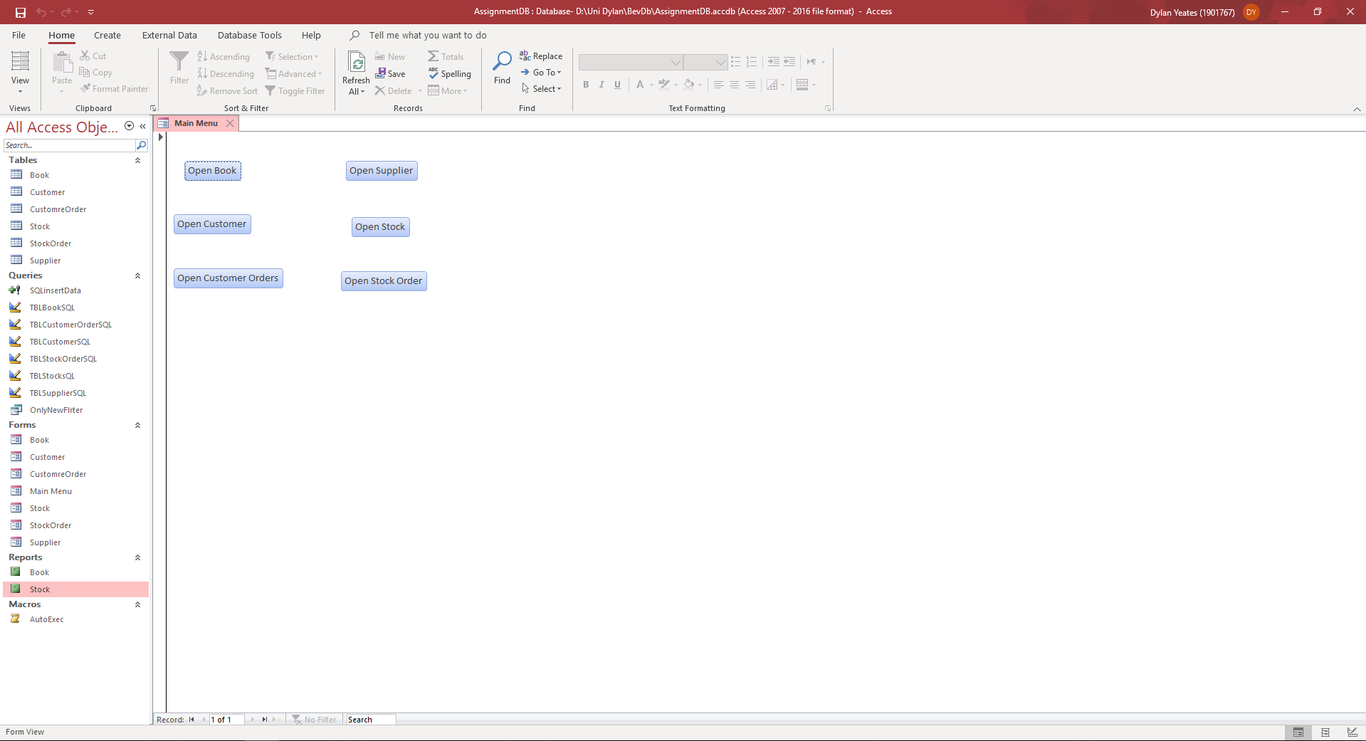
Here shows the main menu which opens on launching the software. It also shows all the form buttons so that a use can access all the essential information in the database. To create these buttons, I have had to bind each button to the form they represent. Otherwise the push button becomes useless and will not do anything upon being clicked. The main menu launching at software is an important part of creating a user-friendly service. It allows a user to have context straightaway rather than guessing what they should open on the left side of their screen. It also allows the system to be completely contained to push buttons rather than using more complicated functions such as right clicking the delete old records such as a supplier who no longer stocks what the company needs. This button however could lead to accidental deletion and misclicks due to the fact that there is not any form of confirmation before it deletes the record. This could cause a malicious user to be able to completely cripple the system by just clicking that button over and over which leads onto the important of regular backups. If a system is backed up regularly it can help reduce the damage of an otherwise catastrophic event. Whilst backing up is important, backing up to a separate site is just as important. Otherwise an event like a fire will still cause a catastrophic amount of damage as they will have to replace their system as well as their books.

