Student number: :2009477
Module: Marketing Fundamentals
Module code: LCBB4004
Lecturer: Efua Adams
Assignment Title: Marketing Fundamentals
Analysis and Evaluation -
Submission date : 24th February 2021 15:00pm
Word count: 1427

Table of Contents
Introduction 3
Blog Posts 4
Conclusion 10
Reference List 11

Introduction
In today's digital environment, content creation is an integral part of large companies' marketing strategies. Blog it is a type of website focused mainly on creating content, also known as blog posts or posts. Different types of blogs are differentiated - informational, news, personal and corporative (Housden, 2010).
A direct connection with the reader is one of the main advantages of creating a blog. This connection allows you to share an idea with people who think like you. After all, this is the easiest way to build trust and loyalty in your followers (Scott, n.d.). Therefore, more and more businesses are turning to content marketing and in particular the creation of a blog. Through it, they can easily communicate and influence their potential customers.
Blogs include groups of people with common interests from different areas and backgrounds.
Audiences spread out and engage more and more individuals through blog interaction.
Blogs promote thoughts and provide environments for like-minded individuals or others who want to be open to various viewpoints (What Is Blogging?, 2021).
Furthermore the report is focused on the blogs and creating and increasing awareness as well as stimulating a dialogue between the chosen company ant the audience.

Blog Posts
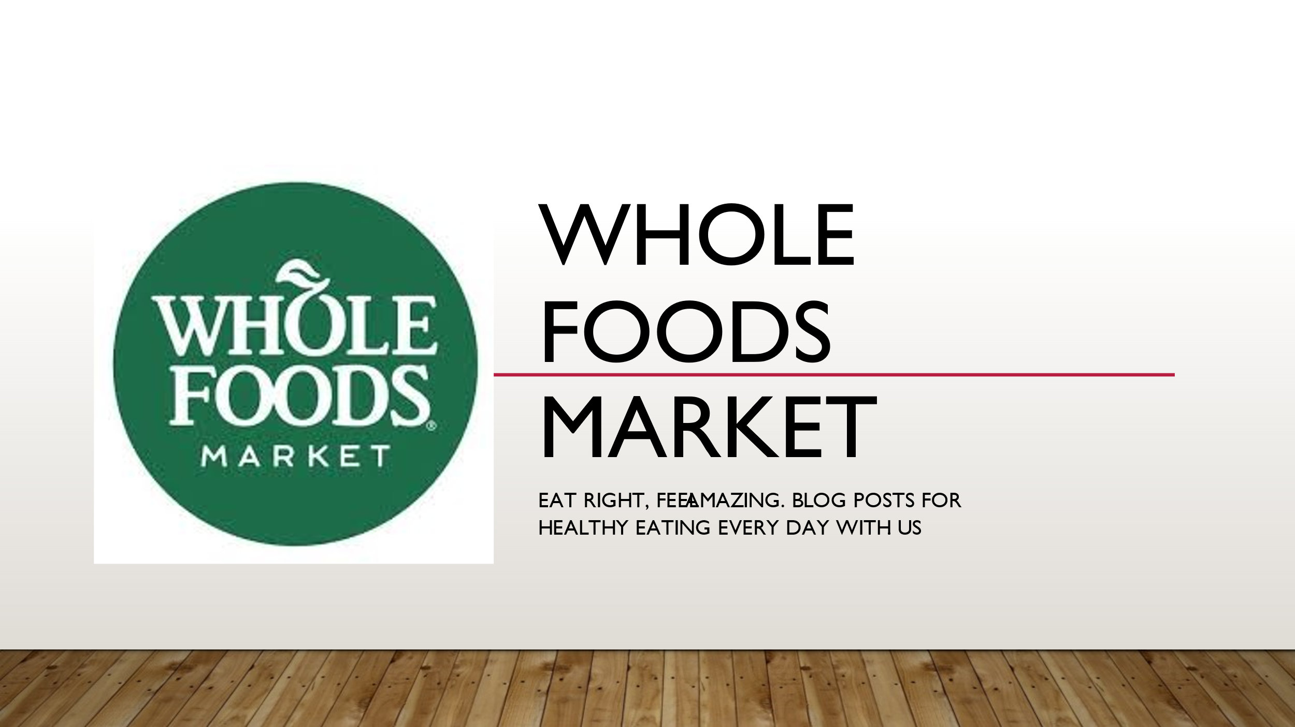
Whole Foods Market.
Eat Right, feel amazing. Blog posts for Healthy Eating every day with us.
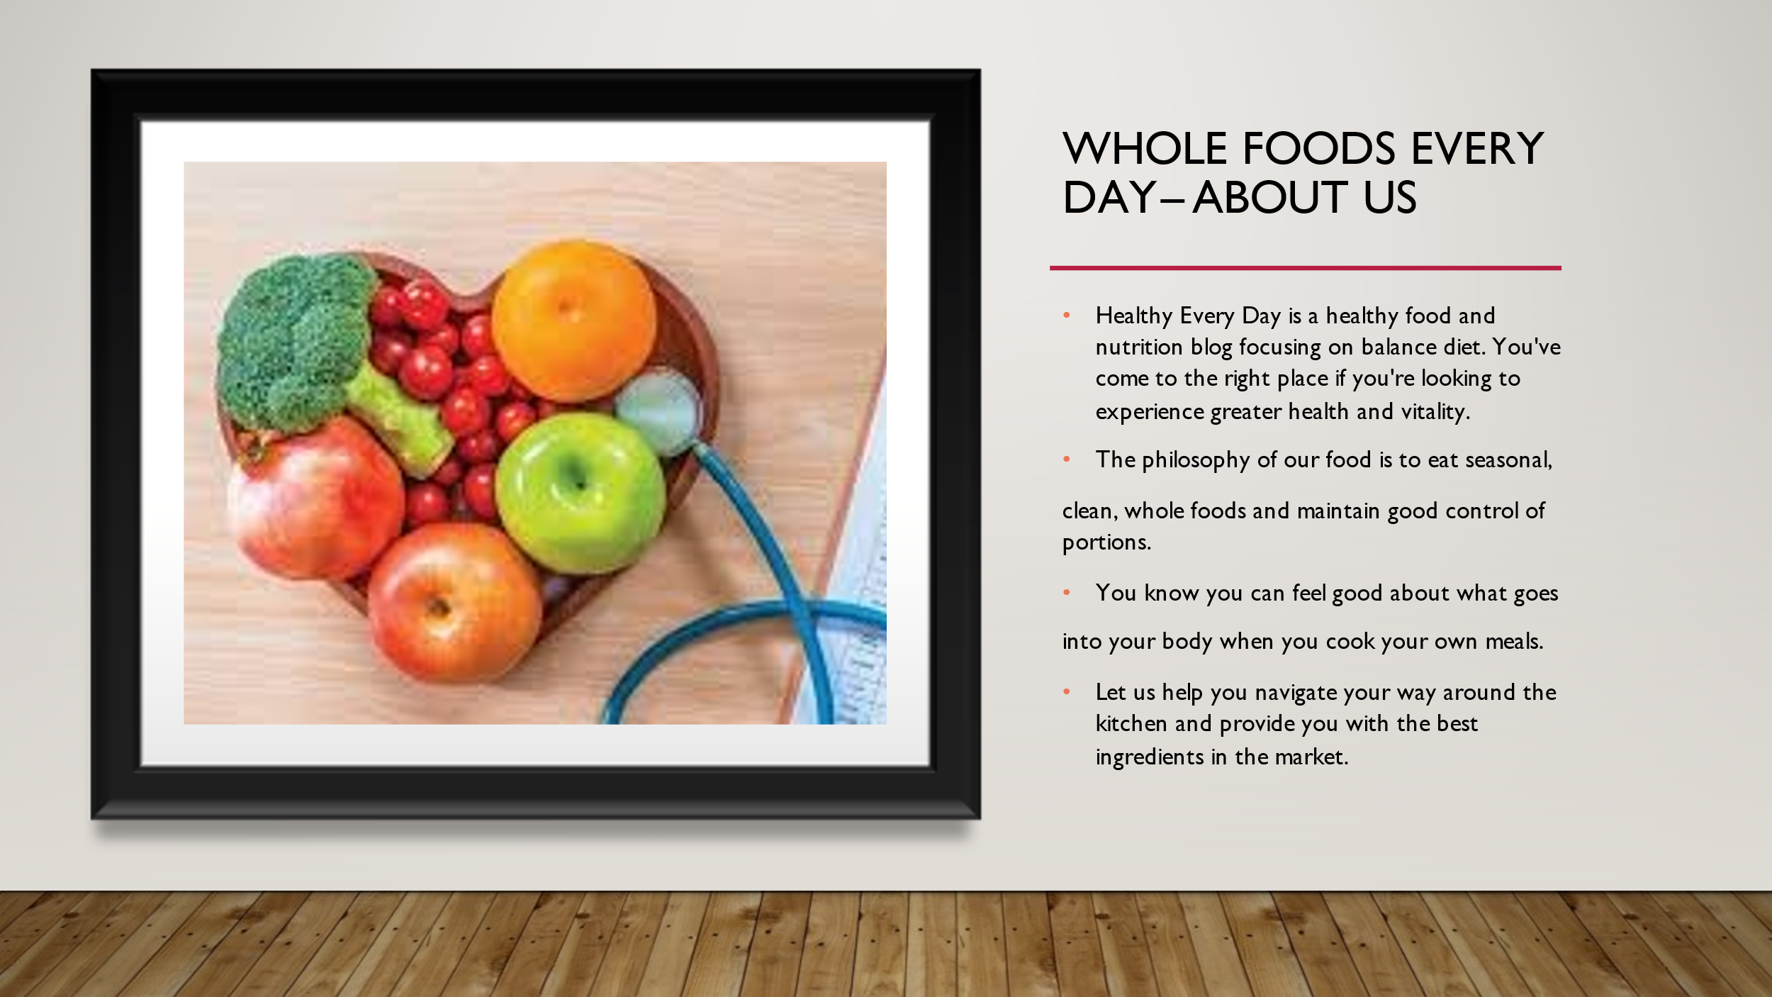
Whole Foods Every Day – About Us
Healthy Every Day is a healthy food and nutrition blog focusing on balance diet. You've come to the right place if you're looking to experience greater health and vitality.
The philosophy of our food is to eat seasonal, clean, whole foods and maintain good control of portions. You know you can feel good about what goes into your body when you cook your own meals (Whole Foods UK, 2021). Let us help you navigate your way around the kitchen and provide you with the best ingredients in the market.
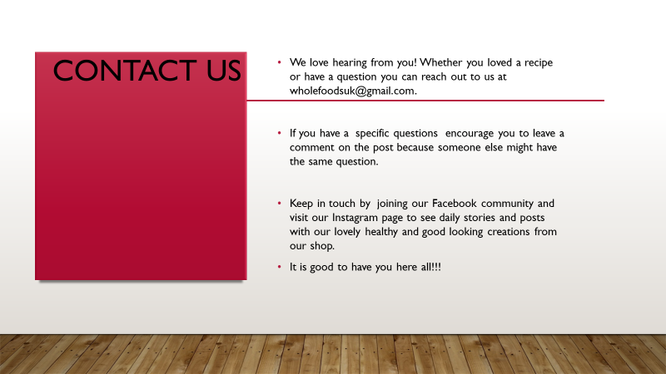
Contact Us
We love hearing from you! Whether you loved a recipe or have a question you can reach out to us at wholefoodsuk@gmail.com.
If you have a specific questions encourage you to leave a comment on the post because someone else might have the same question.
Keep in touch by joining our Facebook community and visit our Instagram page to see daily stories and posts with our lovely healthy and good looking creations from our shop.
It is good to have you here all!!!
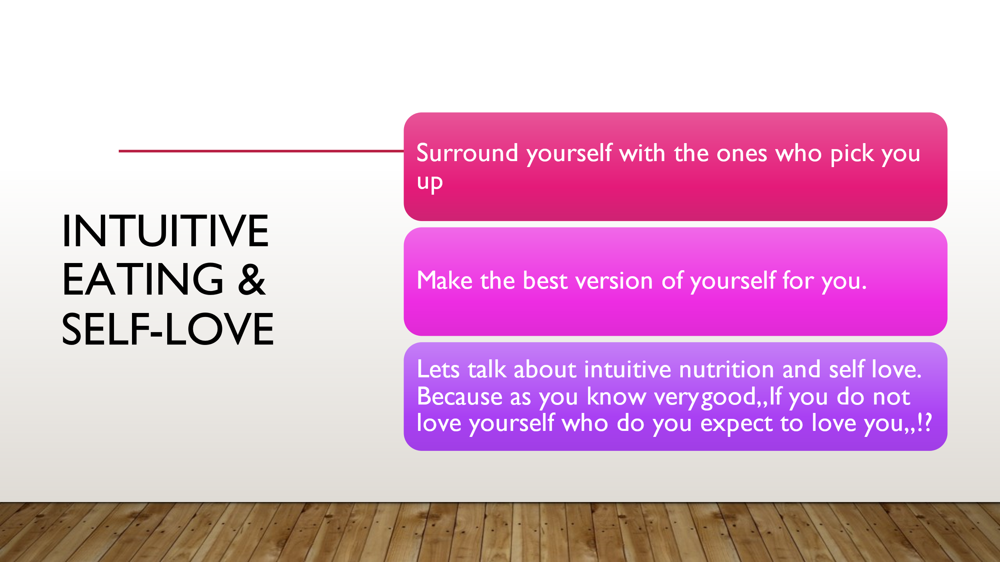

Intuitive Eating and Self-love
Surround yourself with the ones who pick you up. Make the best version of yourself for you. Lets talk about intuitive nutrition and self love. Because as you know very good, If you do not love yourself who do you expect to love you,,!?
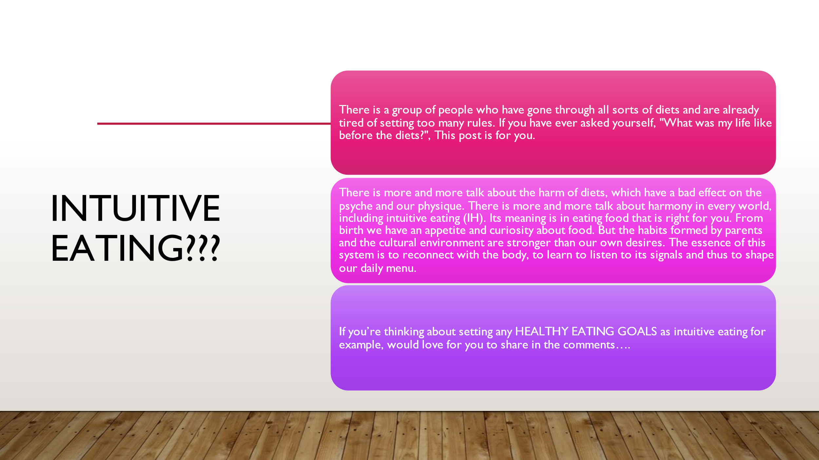
Intuitive Eating???
There is a group of people who have gone through all sorts of diets and are already tired of setting too many rules. If you have ever asked yourself, "What was my life like before the diets?", This post is for you.
There is more and more talk about the harm of diets, which have a bad effect on the psyche and our physique. There is more and more talk about harmony in every world, including intuitive eating (IH) (TRIBOLE, 2020). Its meaning is in eating food that is right for you. From birth we have an appetite and curiosity about food. But the habits formed by parents and the cultural environment are stronger than our own desires. The essence of this system is to reconnect with the body, to learn to listen to its signals and thus to shape our daily menu.
If you’re thinking about setting any HEALTHY EATING GOALS as intuitive eating for example, would love for you to share in the comments….
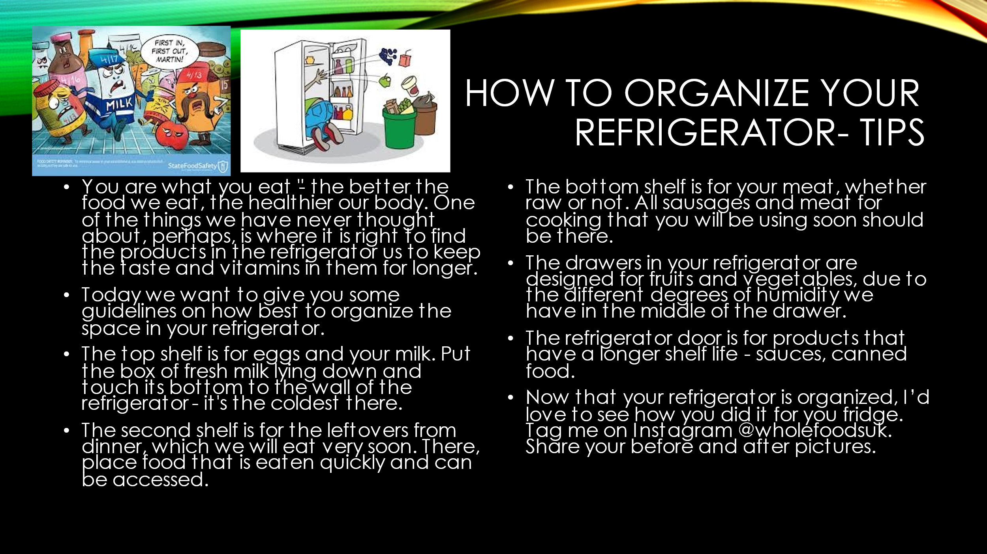
How to organize your refrigerator- tips
You are what you eat "- the better the food we eat, the healthier our body. One of the things we have never thought about, perhaps, is where it is right to find the products in the refrigerator us to keep the taste and vitamins in them for longer.
Today we want to give you some guidelines on how best to organize the space in your refrigerator (How to organise your fridge, 2021).
The top shelf is for eggs and your milk. Put the box of fresh milk lying down and touch its bottom to the wall of the refrigerator - it's the coldest there.
The second shelf is for the leftovers from dinner, which we will eat very soon. There, place food that is eaten quickly and can be accessed.
The bottom shelf is for your meat, whether raw or not. All sausages and meat for cooking that you will be using soon should be there.
The drawers in your refrigerator are designed for fruits and vegetables, due to the different degrees of humidity we have in the middle of the drawer.
The refrigerator door is for products that have a longer shelf life - sauces, canned food.
Now that your refrigerator is organized, I’d love to see how you did it for you fridge. Tag me on Instagram @wholefoodsuk. Share your before and after pictures.
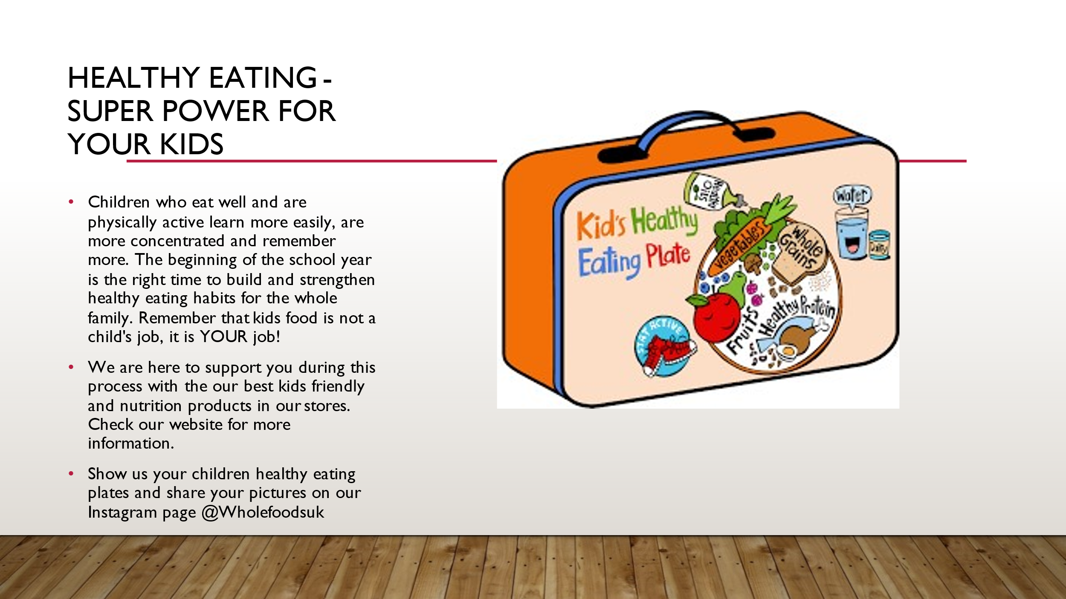
Healthy eating – super power for your kids
Children who eat well and are physically active learn more easily, are more concentrated and remember more (Hahn, 2009). The beginning of the school year is the right time to build and strengthen healthy eating habits for the whole family. Remember that kids food is not a child's job, it is YOUR job!
We are here to support you during this process with the our best kids friendly and nutrition products in our stores. Check our website for more information.
Show us your children healthy eating plates and share your pictures on our Instagram page @Wholefoodsuk.
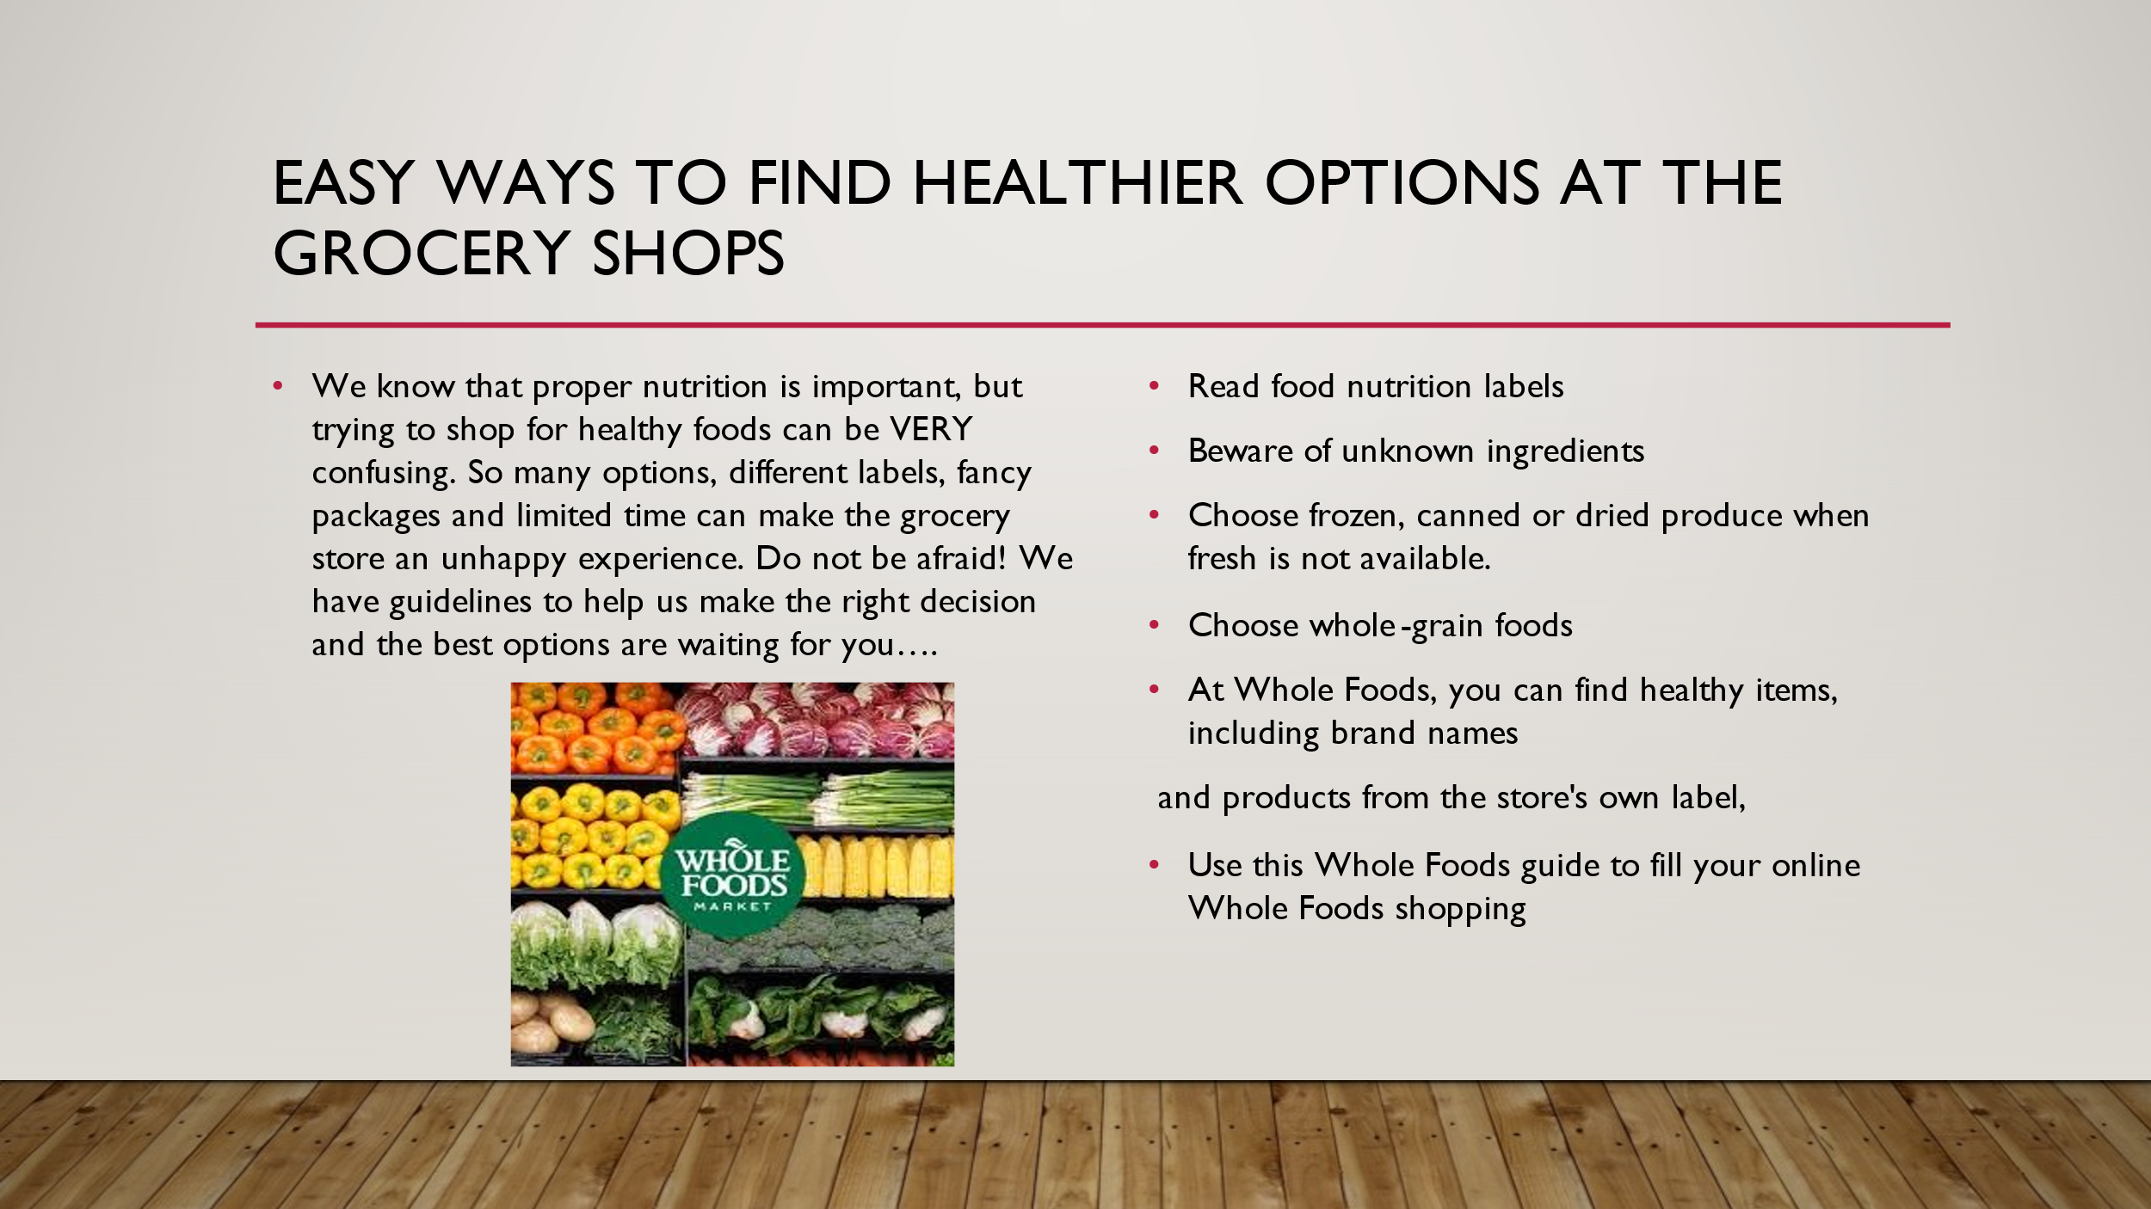
Easy Ways to Find Healthier Options at the Grocery Shops
We know that proper nutrition is key factor, but trying to shop for healthy foods can be VERY confusing. So many choices, different labels, fancy boxes and limited time can make the grocery store an unhappy experience. Do not be afraid! We have suggestions to help us make the right decision and the best options are waiting for you….
Read food nutrition labels
Beware of unknown ingredients
Choose frozen, canned or dried produce when fresh is not available.
Choose whole-grain foods
At Whole Foods, you can find healthy items, including brand names and products from the store's own label. Use this Whole Foods guide to fill your online Whole Foods shopping(Whole Foods UK, 2021).
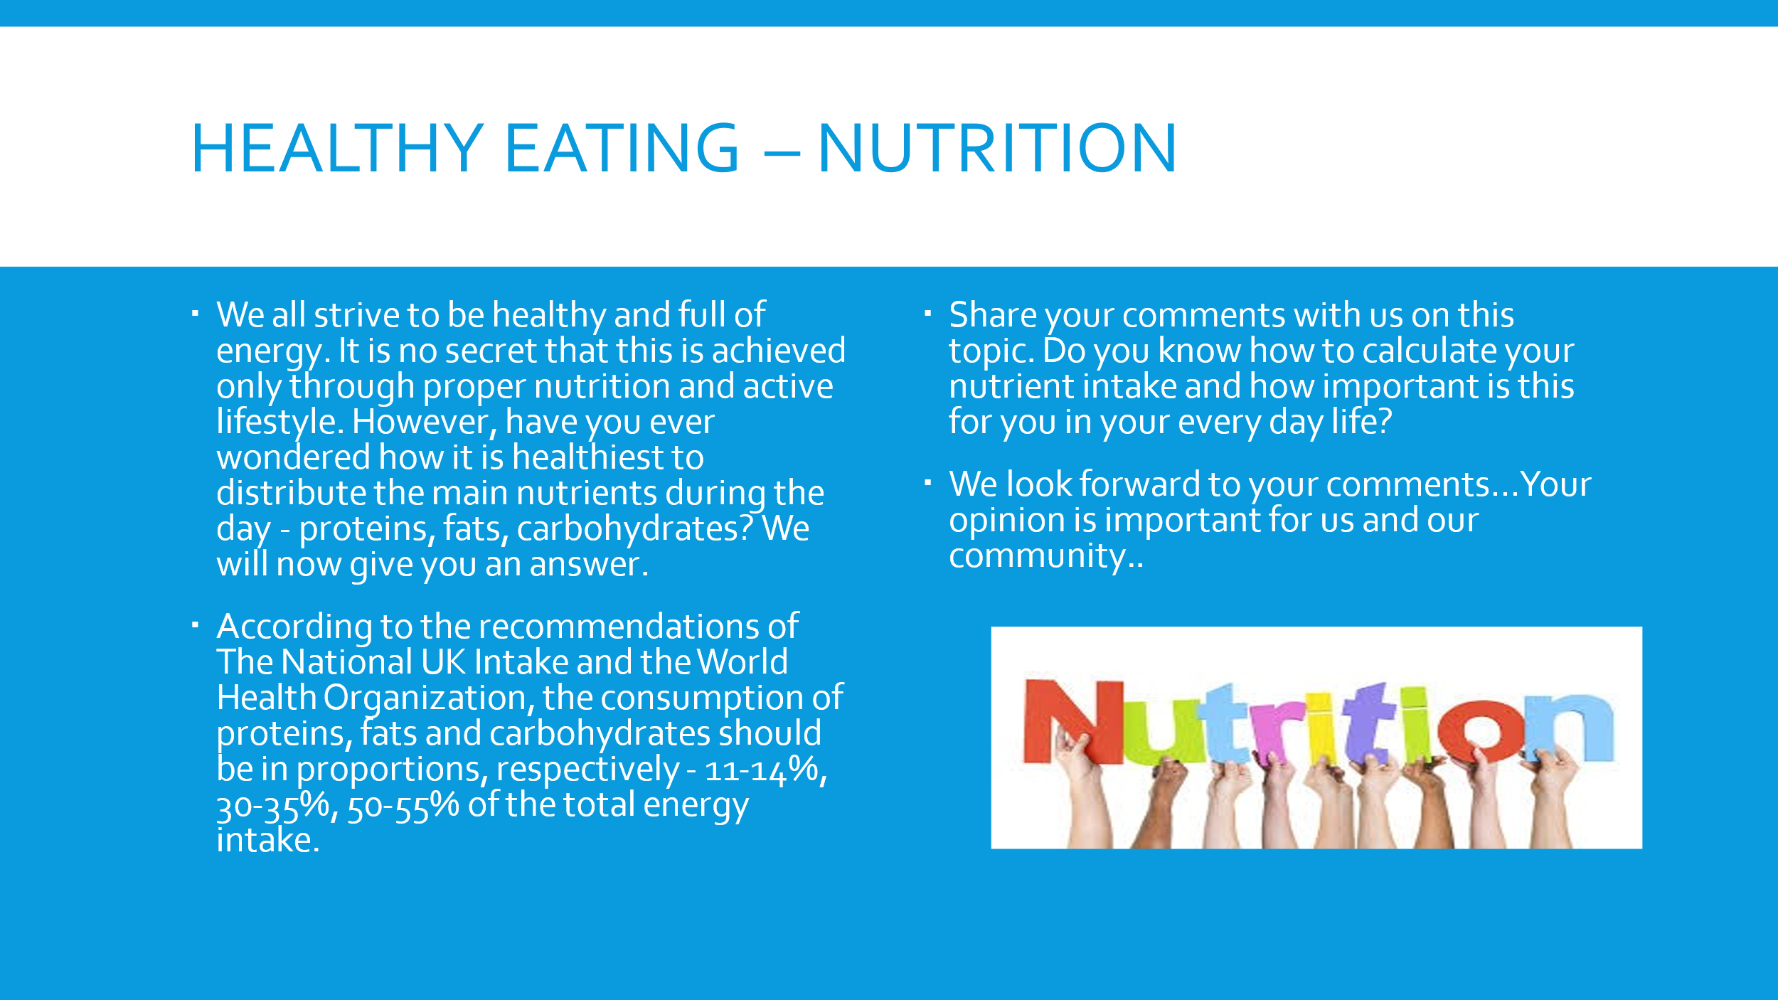
Healthy Eating - nutrition
We all strive to be healthy and full of energy. It is no secret that this is achieved only through proper nutrition and active lifestyle. However, have you ever wondered how it is healthiest to distribute the main nutrients during the day - proteins, fats, carbohydrates? We will now give you an answer.
According to the recommendations of The National UK Intake and the World Health Organization, the consumption of proteins, fats and carbohydrates should be in proportions, respectively - 11-14%, 30-35%, 50-55% of the total energy intake (Reference intakes explained, 2021).
Share your comments with us on this topic. Do you know how to calculate your nutrient intake and how important is this for you in your every day life?
We look forward to your comments…Your opinion is important for us and our community..
Conclusion
From the above can be concluded that interactive marketing depends on clients voicing their desires so that more particular marketing messages can be develop by marketers. Interactive marketing simplifies a two-way dialogue between a company and its customers, compared to the outbound marketing of the past. Advertising is a complex process that leads clients instead of guiding them. They provide information that advertisers can use to direct their promotional campaigns if a client is invited to provide input, share their personal interests, or provide demographic information(The Economic Times, 2021).
Interactive marketing offers consumers opportunities to help create and expand their favourite products and brands. In online forums, blogs and social networking sites, the more consumers talk about a brand, the more their expectations and ideas for that company reach the consciousness of the company(Journal of research in interactive marketing, volume 9, issue 2, 2015). Businesses can use this data to improve the goods that their consumers are most likely to purchase, enhancing the sense of respect and future profits of a customer.
Reference list

2015. Journal of research in interactive marketing, volume 9, issue 2. London: Emerald Group Publ.
Good Housekeeping. 2021. How to organise your fridge. [online] Available at: <https://www.goodhousekeeping.com/uk/food/a552355/organising-your-fridge-right/> [Accessed 19 February 2021].
Hahn, F., 2009. Strong kids, healthy kids. New York: AMACOM.
Housden, M., 2010. Market information and research. Oxford: Elsevier.
nhs.uk. 2021. Reference intakes explained. [online] Available at: <https://www.nhs.uk/live-well/eat-well/what-are-reference-intakes-on-food-labels/> [Accessed 19 February 2021].
Scott, D., n.d. The new rules of marketing & PR.
The Balance Small Business. 2021. What Is Blogging?. [online] Available at: <https://www.thebalancesmb.com/blogging-what-is-it-1794405> [Accessed 19 February 2021].
The Economic Times. 2021. What is Advertising? Definition of Advertising, Advertising Meaning - The Economic Times. [online] Available at: <https://economictimes.indiatimes.com/definition/advertising> [Accessed 22 February 2021].
TRIBOLE, E., 2020. INTUITIVE EATING. [Place of publication not identified]: ST MARTINS ESSENTIALS.
Wholefoodsmarket.co.uk. 2021. Whole Foods UK. [online] Available at: <https://www.wholefoodsmarket.co.uk/> [Accessed 19 February 2021].

