COMPONENT 2 INTRODUCTION

NAME | Uzma Mehtab
STUDENT NUMBER | 2330366
MODULE CODE | BMHP5014 (Creativity & Value Creation)
LECTURER | Precious Igbinigie
PROGRAMME | BSc Health & Social Care

Healthy Futures UK – A National Initiative to Combat Obesity  Innovation Overview  As an example of innovation, we have Healthy Futures UK, which is a digital-community hybrid program that combines artificial intelligence-powered weight-management technologies, community nutrition hubs, and behavioural coaching, therefore. The National Health Service Long Term Plan and the Health and Social Care Act of 2012 are aligned with this program, which reframes obesity as a chronic condition that relapses. This initiative is also aligned with NHS England, 2023. In addition to this, it provides individualised and ongoing assistance rather than treatments that are only performed sometimes (NICE, 2022).  The Issue / Gaps in Health and Social Care  Moreover, we have in England, about 26 % of adults who are obese, and this led to rates are rising fastest in deprived areas (OHID, 2024; House of Commons Library, 2025). Obesity is linked to type 2 diabetes, cancer, cardiovascular disease, and depression, costing the NHS over £6.5 billion per year (Nuffield Trust, 2023; Institute for Global Change, 2023). Current approaches fail because obesity is still treated as a lifestyle issue rather than a long-term condition with biological, psychological, and environmental roots (WHO, 2023; PMC, 2020). Government efforts like Healthy Weight, Healthy Lives have lacked continuity and digital integration (Public Health England, 2020).  Target Audience and Impact  In addition, the core target consists of persons between the ages of 25 and 60 who live in neighbourhoods with low incomes and high risk. This includes ethnic minorities as well, whose rates are under-reported therefore (NESTA, 2025). Health professionals, local authorities, and policymakers are the secondary audiences for this presentation.  Expected impact:  Reduce BMI and obesity prevalence by 15 % within 5 years (Taylor et al., 2024).  Lower diabetes incidence by 20 % through early intervention (The Guardian, 2024).  Improve self-esteem and community wellbeing by enhancing access to structured support (Marmot, 2020).  This contributes to the common good by narrowing health inequalities (NICE, 2022). |   Implementation  Where: Community GP clinics, pharmacies, local authorities, and public health centres.  By whom: NHS weight-management teams, pharmacists, and certified digital health coaches.  How:  Patients referred via the NHS App or GP.  In addition, we have AI generates tailored nutrition/exercise plans that are integrated with NHS records (Mak et al., 2024).  Clinicians monitor progress using the platform dashboard (Hanson et al., 2023).  Timeline  Research & Pilot (2025–2026) will build Healthy Futures UK app's AI. It will be evaluated in five NHS Trusts to determine its usability, cultural compatibility, and engagement. Users and doctors can remark before the platform starts. The platform adapts to input.  A 2027-2028 National Rollout is planned. GPs, chemists, and digital teachers will gain knowledge. The project will be phased in to guarantee accessibility.  The Evaluation phase will evaluate BMI, HbA1c, user compliance, and cost-effectiveness from 2029 to 2030 to decide whether to adopt the policy.  Development and Regulations  The following is a list that provides a summary of the components that make up this software, which are as follows:  According to the CG189 that was published by the NICE in 2022, this information is included in the document. | According to the General Data Protection Regulation (2018) (NHS, 2025), the process of establishing data protection is carried out in accordance with the applicable regulations.  It has been stated by Hanson et al. (2023) that the National Health Service Digital Standards are the ones who are responsible for ensuring that the standards are implemented in the appropriate manner.  It is vital to get ethical approval from the Health Studies Authority to guarantee the patients' sense of security and to protect their identity throughout the entirety of the research procedure.  Technology Integration  According to Teke (2025), there are now artificial intelligence systems that are available to the public. These systems are able to determine the likelihood of a recurrence and personalise therapies to the specific needs of each unique patient. According to Hinchliffe and Feenie (2022), it is possible to maintain continuous data tracking by synchronising wearable devices with the New Zealand Health Service app. This is a practical method. It has been established by Hanson et al. (2023) that it is possible to experience real-time empathy and motivation through the use of virtual coaching sessions.  The combination of care and technology results in the construction of a support system that is both flexible and adaptive, as opposed to a program that had already been predetermined.  Dissemination / Promotion  Promotion will use a national #HealthyFuturesNow media campaign:  NHS Digital and BBC Health features.  To add on, we have partnerships with Change4Life, Tesco Health and Slimming World, Influencer campaigns on TikTok and Instagram to normalise health literacy (The Food Foundation, 2023). We have professional promotion through PHE bulletins and BMJ Public Health articles to reach clinicians (The Financial Times, 2024).  Conclusion  Healthy Futures UK is working towards the goal of bringing obesity care into the current mainstream by utilising technology, expert supervision, and community engagement. This is the organization's primary objective. This objective is being successfully accomplished by the application of cutting-edge technology, which is the way that is being utilised. Since obesity is a chronic condition that needs long-term care and customisation that is driven by data, it is treated as if it were a chronic illness. This is since obesity is a disorder that calls for continuous medical attention. The National Health Service (NHS) can better fulfil its preventative duty as a direct result of this reduction, and the incidence of socioeconomic health disparities is decreased as a direct consequence of this reduction. Both outcomes are directly related to one another.  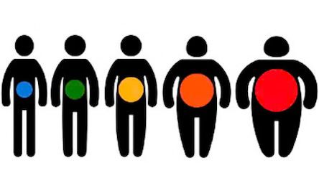  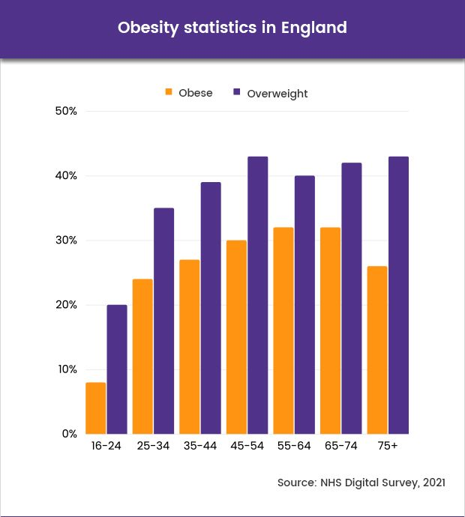

PITCH

Introduction
Despite decades of awareness efforts, the UK faces its highest obesity rates ever (OHID, 2024). Traditional weight-loss programmes are episodic and stigmatising, ignoring the reality that obesity is a chronic disease requiring continuous support (Hanson et al., 2023). Our initiative fuses AI-driven personalisation with community-based human connection to break that cycle.
The Problem
One in four UK adults live with obesity (NHS Digital, 2022). To add on, this is not merely an issue of diet but as a result a multi-factor condition which has been influenced by environment, stress, and genetics (WHO, 2023; PMC, 2020).A big public health issue, linked to other long term condition like cardiovascular disease and type 2 diabetes. We have minoritised groups and to add on low-income households that are affected severely (NESTA, 2025). Moreover, we have even obesity which now as a whole costs the UK economy over an estimated £98 billion annually (The Food Foundation, 2023) which is quite severe as this can cause long term impacts for the UK economy. On the other hand, without a chronic-care model we now have millions who now remained stuck in yo-yo cycles of weight loss and relapse (Teke, 2025). So, the solution to this is what is known as Healthy Futures UK which will help enable a better tomorrow.
Our innovation creates a joined-up system to enable digital self-management and professional guidance as a result.
Core Elements:
AI-Enhanced App: Delivers dynamic plans using machine learning to predict relapse (Hinchliffe & Feenie, 2022; Mak et al., 2024).
Community Health Hubs: Provide dietitian consultations, cooking classes, and support groups (NHS, 2025).
Behavioural Coaching: Licensed digital coaches offer 24/7 chat support to sustain motivation (Hanson et al., 2023).
Data Analytics: Aggregated anonymised data informs local public-health planning (Nuffield Trust, 2023).
By treating obesity like asthma or hypertension, these conditions can now be managed with constant care sustainably and to do this is by addressing the root causes and to sustain efficient results reliably as a whole.
Impact on Target Population
Healthy Futures UK can now directly benefit working-age adults (25–60) in areas that are urban and where fast-food density and sedentary jobs are at its highest (The Guardian, 2024). We have a modelling known as Pilot modelling which showcases a projected 15 % reduction in BMI and even a20 % fewer in. type 2 diabetes diagnosed over a span of three years (Taylor et al., 2024). The programme also targets psychological health, reducing stigma and improving self-esteem (PMC, 2022). This will lessen health inequalities and boost economic productivity (The Financial Times, 2024).
Legislation and Policy Alignment
Healthy Futures UK supports:
NICE CG189 guidelines (NICE, 2022).
Health and Social Care Act 2012 — integrated preventive care (NHS England, 2023).
Equality Act 2010 — ensuring fair access (NESTA, 2025).
UK GDPR 2018 for data privacy (NHS, 2025).
Levelling Up Health Agenda (Marmot, 2020).
Technology and Innovation
Furthermore, we have AI models that can now analyse BMI, sleep, and mood data which now in turn produce predictive insights (Teke, 2025). We have wearables link to the NHS App, these can now enable real-time alerts for clinicians (Hinchliffe & Feenie, 2022). Also, Gamification elements award “Health Credits” that are redeemable for gym and grocery discounts, this as a whole now increasing adherence (Mak et al., 2024).
Implementation Strategy
Pilot (2025–2026): Birmingham, Leeds & Manchester with NHS Trusts.
Training (2026): Dietitians and pharmacists trained on digital platform.
National Rollout (2027–2028): Expansion to 20 cities.
Evaluation (2029–2030): Mixed-methods research assessing BMI reduction, user satisfaction & cost-savings (Hanson et al., 2023).
Promotion and Public Engagement
According to The Food Foundation (2023), there will be a partnership between the #HealthyFuturesNow campaign and educational institutions, as well as BBC Health and Men's Health UK, with the intention of disseminating and promoting the sharing of real-life stories. TikTok and Instagram videos are two examples of social media technology that may soon be utilised to address some of the misconceptions that people have about their weight. The applications that are accessible for social media come in a broad range of forms. Additionally, in order to foster trust, local councils will soon be doing pop-up events that will feature dietitians and community champions (Public Health England, 2020). These activities will be held in the near future. These events are scheduled to take place in the foreseeable future.
Conclusion
In general, Healthy Futures UK, which is a model that is known for being forward-thinking and has the propensity to make long-term care accessible, empathetic, and data driven. In addition, it has the tendency to make things more data driven. This results in the narrative shifting from one of blame to one of support, which is a consequence of the situation. As a result of this, it can bring about change that is long-lasting by integrating community with technology. The National Health Service (NHS) has the potential to save hundreds of millions of dollars in care costs associated to obesity by the year 2028. Additionally, it has the potential to improve the lives of millions of individuals in the United Kingdom in a dependable and effective manner.

REFERENCES

Office for Health Improvement & Disparities (OHID) (2024) Obesity Profile: short statistical commentary May 2024. Available at: https://www.gov.uk/government/statistics/update-to-the-obesity-profile-on-fingertips/obesity-profile-short-statistical-commentary-may-2024 (Accessed: 9 Nov 2025).
House of Commons Library (2025) Obesity statistics: Research Briefing SN03336. Available at: https://researchbriefings.files.parliament.uk/documents/SN03336/SN03336.pdf (Accessed: 9 Nov 2025).
NHS Digital (2022) Adult overweight and obesity. Available at: https://digital.nhs.uk/data-and-information/publications/statistical/health-survey-for-england/2022-part-2/adult-overweight-and-obesity (Accessed: 9 Nov 2025).
NHS (2025) Obesity – overview. Available at: https://www.nhs.uk/conditions/obesity/ (Accessed: 9 Nov 2025).
The Food Foundation (2023) ‘New report reveals toll of diet-related illness on UK productivity’. Available at: https://foodfoundation.org.uk/press-release/new-report-reveals-toll-diet-related-illness-uk-productivity (Accessed: 9 Nov 2025).
N Hinchliffe & J Feenie (2022) ‘The potential role of digital health in obesity care’, Advances in Therapy, 39, pp. 2345-2357. (pdf)
J Teke (2025) ‘Artificial intelligence for obesity management: a narrative review’, Digital Health, [Pre-print]. Available at: https://ray.yorksj.ac.uk/id/eprint/13192/1/1-s2.0-S2451847625000776-main.pdf (Accessed: 9 Nov 2025).
Institute for Global Change (2023) ‘Unhealthy Numbers: The Rising Cost of Obesity in the UK’, briefing. Available at: https://institute.global/insights/public-services/unhealthy-numbers-the-rising-cost-of-obesity-in-the-uk (Accessed: 9 Nov 2025).
PMC (2020) ‘Body mass index and risk of obesity‐related conditions in a cohort of 2 8 million adults’, International Journal of Obesity, 44(4), pp. 719-729. Available at: https://pmc.ncbi.nlm.nih.gov/articles/PMC8019280/ (Accessed: 9 Nov 2025).
Cancer Research UK (2022) ‘How does obesity cause cancer?’, Available at: https://www.cancerresearchuk.org/about-cancer/causes-of-cancer/obesity-weight-and-cancer/how-does-obesity-cause-cancer (Accessed: 9 Nov 2025).
PMC (2022) ‘Changing the narrative around obesity in the UK: a survey of people living with obesity’, Clinical Obesity, 12(5), e12447. Available at: https://pmc.ncbi.nlm.nih.gov/articles/PMC8246368/ (Accessed: 9 Nov 2025).
Taylor, K. et al. (2024) ‘Early outcomes of referrals to the English National Health Service digital weight management intervention’, Obesity. Available at: https://onlinelibrary.wiley.com/doi/full/10.1002/oby.24024 (Accessed: 9 Nov 2025).
The Guardian (2024) ‘Sharp rise in type 2 diabetes among people under 40 in UK’, 22 May. Available at: https://www.theguardian.com/society/article/2024/may/22/type-2-diabetes-uk-rise-obesity-health-inequalities-junk-food (Accessed: 9 Nov 2025).
NESTA (2025) ‘England’s national obesity rates likely significantly higher for minoritised ethnic groups than previously thought’, press release. Available at: https://www.nesta.org.uk/press-release/englands-national-obesity-rates-likely-significantly-higher-for-minoritised-ethnic-groups-than-previously-thought/ (Accessed: 9 Nov 2025).
Mak, V. et al. (2024) ‘How AI can help tackle obesity’, research insight article by Cambridge Judge Business School, 18 Jun. Available at: https://www.jbs.cam.ac.uk/2024/how-ai-can-help-tackle-obesity/ (Accessed: 9 Nov 2025).
Marmot, M. (2020) Health Equity in England: The Marmot Review 10 Years On. London: Institute of Health Equity.
The Financial Times (2024) ‘“Misguided fears” of nanny state to blame for obesity crisis, peers warn’, 23 Oct. Available at: https://www.ft.com/content/e2168d2b-2282-4eac-84c2-6f9187456b21 (Accessed: 9 Nov 2025).
Hinchliffe, N. & Feenie, J. (2022) ‘The potential role of digital health in obesity care’, Advances in Therapy, 39, pp. 2345-2357.
Nuffield Trust (2023) ‘Obesity’, resource. Available at: https://www.nuffieldtrust.org.uk/resource/obesity (Accessed: 9 Nov 2025).
Hanson, P. et al. (2023) ‘Implementation of a Digital Health Tool for Patients Awaiting Specialist Weight Management’, JMIR Human Factors, 10, e41256. Available at: https://humanfactors.jmir.org/2023/1/e41256/ (Accessed: 9 Nov 2025).

