Portfolio (Poster + Essay)
Name: Azhar Khan
Student number: 2225240
Module code: LCHS4003
Title: Introduction to Health and Social care
Lecturer name: Dr Helen Parson
Component 1

Task 1 -POSTER
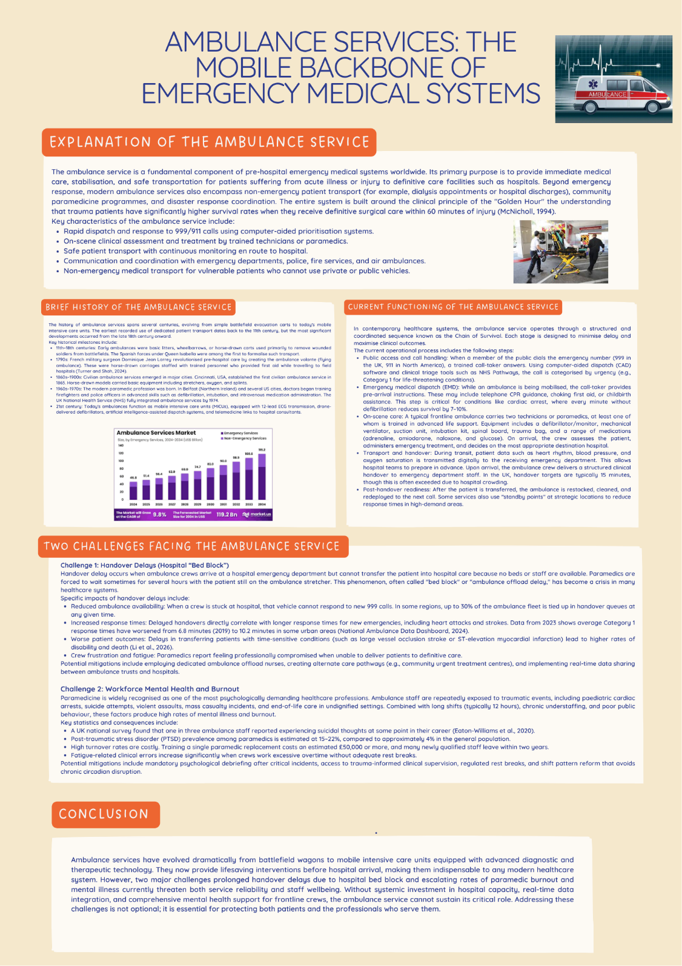

TASK 2

ESSAY TOPIC:

RESIDENTIAL CARE HOMES

Introduction
Residential care homes for elderly people are one of the most important, but historically contentious, areas of social care in contemporary Britain. Today they provide care for around 400,000 people of retirement age in the UK but have evolved significantly since their beginnings in the workhouse system of the nineteenth century. This essay explores the history of residential care, examines its effectiveness in the contemporary regulatory framework, and considers its value in improving the lives of service users.

The History of Residential Care
Residential care for older people in England has strong historical foundations in the Poor Law Amendment Act 1834 and the workhouse system. In pre-1900s days, the elderly with a life expectancy of less than 60 years were mainly maintained by their families or, in the most severe cases, parish relief. In 1834 this was drastically altered by the act, which established a punitive, deterrent system and saw the elderly poor, vagrants, the ill, and those with mental illness all housed together in large prison-like institutions (Thomson, 1983).
This punitive building tradition continued into the twentieth century. Many local authority dwellings after the war were just converted workhouses and are documented by Hayashi (2015). Built as the Freebridge Lynn Union workhouse in 1836, Eastgate House was still in use with a ‘strictly utilitarian' construction and institutional practices that reflected the ‘Poor Law legacy, stigma, and pre-war measures and mentalities' long after the workhouse system was officially abolished (Hayashi, 2015). This institutional culture was based on cost containment, regimentation, and separation of married couples, all of which the Poor Law Commissioners explicitly argued was essential to the preservation of order (Thomson 1983).
The final break came with the National Assistance Act 1948, which officially ended the Poor Law and also imposed a statutory obligation on local authorities to provide residential provision for 'aged and disabled persons' who were unable to deal with the demands of their own care. (Scottish Government, 2014). It signaled the shift in philosophy that took place in relation to residential care from being a punishment for poverty to being a welfare entitlement.

Current Functioning of Residential Care Homes
Today's residential care homes are held to a new standard of care and regulation and are funded in a very different way than previous generations. Since the 1980s successive governments have favoured a market-based approach to care, which has led to a "mixed economy of care, but with private sector predominance", in the words of the Scottish government (2014).
The regulatory framework is based around the Care Quality Commission (CQC), who register and inspect all residential care homes in England under the Health and Social Care Act 2008. The Health and Social Care Act 2008 (Regulated Activities) Regulations 2014 make it a requirement that settings have adequate numbers of suitably qualified, competent, skilled and experienced staff in place that can meet the needs of people using the setting at all times (UK Parliament, 2025).

Improving Quality of Life: Evidence from the Field
There is ongoing research that challenges negative perceptions about care homes as 'places of last resort' to highlight their contribution to the quality of people's lives in a more complex way. Substantial qualitative research by Brett et al. (2024), carried out in partnership with My Home Life England through extensive and detailed interviews with older residents, families and care staff, identified that "older people reported significantly more benefits to living in a care home than challenges". In a recent Spanish case study, 77% of residents aged 65 and up found the satisfaction level in their dining services to be high, but the same study revealed that 40 residents had a very low satisfaction rate in the category of "lack of participation in management suggestions" (Gil-Lacruz et al., 2026). Most importantly, the study found that "more educated and autonomous residents rated the care home less favourably", meaning that the interpretation of the quality of life was closely related to the residents' autonomy and their capacity to make choices in the care home (Gil-Lacruz et al., 2026).
This discovery is consistent with other work on the conflict between institutional security and the autonomy of the residents. Bland (2005) showed that the orientation of care home staff is generally "safety and the avoidance of risk", which, "although benevolent in intention", is at odds with residents' wishes to be able to exercise independence, to be able to make choices and to maintain privacy. Börjesson and Torgé (2021) describe this as the basic paradox of residential care, the desire to provide a "home" in which individual and group care is embedded, yet where individual routines and schedules inevitably need to be sacrificed for group routines and schedules.

Conclusion
Residential care homes are no longer the harsh workhouses of the nineteenth century but are now subject to regulation and operate within a marketized system of welfare. Despite marked advances, including the end of the most humiliating institutional practices, and the introduction of enforceable measures of quality, there are still some tensions between safety and autonomy, between home hopes and institutional realities, and between private provision and public accountability. As the evidence indicates, the most successful homes are not only looked after but also actively encourage residents to participate, respect their independence and promote true communities, not just simply storage areas for those unable to live independently.

Essay References
- Bland, R. (2005) Senior citizens, good practice and quality of life in residential care homes. PhD thesis. University of Stirling.
- Börjesson, U. and Torgé, C.J. (2021). ‘They say this is a home’: the challenge of ‘home’ in residential care settings for old and young. Journal of Housing and the Built Environment, 37(3), pp.1093–1108. doi:https://doi.org/10.1007/s10901-021-09877-2.
- Brett, M., Ryan, A., Owen, T., Thompson, S., Davis, L. and Hewitt, E. (2024). Thriving in residential care: The voices of older people, families and care teams. City.ac.uk. [online] doi:https://openaccess.city.ac.uk/id/eprint/36708/1/Thriving-in-Residential-Care-Full-Report%20%281%29.pdf.
- Gil-Lacruz, M., Leché-Martín, E.A., Henning, M.A. and Gil-Lacruz, A.I. (2026). Older adults’ perspectives on their residential care homes: a case study. Frontiers in Public Health, 14. doi:https://doi.org/10.3389/fpubh.2026.1698646.
- Hayashi, M. (2015). The Care of Older People. Routledge. doi:https://doi.org/10.4324/9781315654560.
- Thomson, D. (1983) 'Workhouse to nursing home: Residential care of elderly people in England since 1840', Ageing & Society, 3(1), pp. 43-69.
- UK Parliament (2025) 'Written questions and answers: Continuity of care in retirement homes', 12 May 2025. Available at: https://questions-statements.parliament.uk/
Poster References:
- Eaton-Williams, P., Barrett, J., Mortimer, C. and Williams, J. (2020). A national survey of ambulance paramedics on the identification of patients with end of life care needs. British Paramedic Journal, 5(3), pp.8–14. doi:https://doi.org/10.29045/14784726.2020.12.5.3.8.
- Li, M., Zhong, X., Goldstein, J., Jensen, J.L., Hawco, T., Carter, A.J.E. and Vanberkel, P. (2026). An Empirical Analysis of the Effect of Ambulance Offload Delay on the Efficiency of the Ambulance System. Applied Sciences, 16(4), p.2074. doi:https://doi.org/10.3390/app16042074.
- McNicholl, B.P. (1994). The golden hour and prehospital trauma care. Injury, 25(4), pp.251–254. doi:https://doi.org/10.1016/0020-1383(94)90073-6.
- National Ambulance Data Dashboard (2024) Annual response time report – Urban category 1 performance 2019–2023. Available at: https://www.ambulancedata.nhs.uk/reports (Accessed: 10 March 2026).
- NHS England (2023) *Ambulance Quality Indicators: Operational report – Quarter 3 2022/23*. Available at: https://www.england.nhs.uk/statistics/ambulance-quality-indicators/ (Accessed: 10 March 2026).
- Turner, M.D. and Shah, M.H. (2024). Dominique-Jean Larrey (1766-1842): The Founder of the Modern Triage System. Cureus, [online] 16(6). doi:https://doi.org/10.7759/cureus.62375.

