A Critical Evaluation of the Impact ‘Quality’ Processes have on Customer Relationship Management

BMSK 5003

Lecturer 1705204
Maria Heffernan Anila Shrestha

UWTSD
29th March 2019
Swansea

EXECUTIVE SUMMARY
This report presents ethics, sustainability and quality in business and how ethics, sustainability and quality impact on to improve the quality of the customer relationship management system. This report reveals about Tesco and Facebook in relation to the development to improve on ethics, sustainability and quality in their business.
Tesco is committed to recycle and renewable its waste product. It encourages customers and as well as urge Government to move to a single nationwide approach to waste collection. As it targets, Tesco is recycling percentage is 83% and by 2025 Tesco will be fully recyclable (tescoplc.com, 20, March 2019). Tesco also committed to improve empowerment of women at workplace. In Assam, Tesco works with UNICEF to protect women from exploitation. Tesco also has 31% of women are in board members. Apart from that, Tesco works on wellbeing and mental health issues of their employees to make better working environments and their lives and donating its unsold food to communities to sustain environments.
Similarly, Facebook is also committed aggressively on goal to meet a 100 percent renewable energy by 2020 urge to fight against climate change. Facebook also cares their employee providing full parenting leave and any serious illness including family members.
In summary, Tesco and Facebook is committed to improve ethical and sustainability standards in their business taking into consideration customer relationship management but they are badly failed in some incidents on Turkey meat scandal about Tesco and Cambridge Analytica about Facebook.

Contents page

Executive Summary

- Terms of Reference……………………………………………….1

- Procedure……………………………………………………………1

- Finding…………………………………………………………….2-13

- Conclusion

- Recommendation

- Appendices

- Acknowledgements

- TERMS OF REFERENCE

The report has been requested by the Chief Executive Officer of Marketing Week on 13th March 2019. The purpose of this report to assist the CEO regarding to publish an online journal ‘the influence of ethical trading and sustainable resources and it’s possible impact on the quality of the customer relationship’. The report compiled by Anila Shrestha. This report highlights current malpractices on ethical trading and sustainability in the business. The submission of report date is 29th March 2019.

- PROCEDURE

This report is prepared by varieties of materials including companies’ websites, E-journals, online newspapers, articles, websites and books.

1

3.0 FINDINGS

3.1 DEFINITION OF BUSINESS ETHICS

“Business ethics as the study of business situation, activities and decisions where issues of right and wrong are addressed”
(Crane and Matten, 2016, p.5).
The main purpose of any business is to make a profit or maximise of their profit. Thus, in business, human resources and goods are the main ingredients of any business. But businesses are out there not only for making profit but also comply with their ethical responsibilities regarding its impact on societies. Therefore, business should also run with ethical duties.
In other words, business ethics is a crucial analytical tool for understanding, conceptualizing, and legitimizing whether the actions and behaviour of company is morally right or wrong. Thus, business ethics guides the organisations to operate an appropriate ethical behaviour consensually. Without that, different people take a meaning in different way to determine whether a practice or behaviour is ethical or unethical.
Business ethics can be divided into two branches: (a) Normative business ethics focus on understanding and justifying moral or immoral in a particular situation and it also roots in theoretical philosophy (b) Descriptive business ethics is rooted in a wider range of disciplines such as psychology, anthropology and organisational behaviour and it analyse a moral decisions in the context of process and outcomes (Visser et al. 2007)

2

3.2 DEFINITION OF BUSINESS SUSTAINABILITY

“Business sustainability is the management and coordination about environmental, social and culture, political, economic and resource.”
(Rouse,2013).
There are lots of definitions of sustainability but from Brundtland Commission is one of the most used. Brundtland Commission definition aimed at business
“for the business enterprise, sustainable development means adopting business strategies and activities that meet the needs of the enterprise and its stakeholder today while protecting, sustaining and enhancing the human and natural resources that will be needed in the future”
(Weybrecht,2014, p-15).
Therefore, the sustainability is a key in the 21st century business in sense not primarily with a goal of making utmost profit but also taking into consideration the negative impact on this earth. However, sustainability is about balance and interaction between social, environmental and economic.
In a business, social, environmental and economic are the three main pillars of sustainability and is also known as the “triple bottom line”. The concepts were introduced in 1994 by John Elkington and in 1997 he used in his book “Cannibals with Forks: The Triple Bottom Line of 21st Century Business” (Kenton,2019). So, the triple bottom line is a way of expressing a company’s impact and sustainability. In the triple bottom line; the social describes the need for firms to consider their impact on society which refer to issues such as human rights, peace, gender etc. Environment describe and about preservation of natural resources such as water, energy, forest, air etc. (Peattie,1995). Similar, economic describes the business profit not only goes to CEO and shareholders but also, it’s empowered and sustain the community (mindtools.com, 15, March,2019).

3

3.3 DEFINITION OF BUSINESS QUALITY

The studies have shown that the ‘Quality’ is not able to define precisely. Thus, quality is itself gives a broad sense of meaning. Therefore, it is important to understand under different circumstances. For example, quality is a conformance to specifications (Shewhart, 1931), value (Feigenbaum,1951), fitness for use (Juran, 1974), conformance to requirements (Crosby, 1979), also defined in a sense as excellence (Tuchman, 1980), product desirable attributes (Leffler,1982) loss avoidance (Taguchi,1987) and meeting customer experiences (Ryall and Kruithof,2001).
According to Deming, quality should not break down into different stages. It is a holistic process from start to the end. For example, it covers whole process from all stages of product of goods to serve the customer at the end. Deming created 14 points regarding to improve quality constantly and forever(britishlibrary.uk,2019).
In business, it is their priority on the quality of their products or service. Thus, all organisations used quality models and theories to improve their quality. Among quality models, Deming’s 14-point philosophy is one of the popular quality models in this globalisation and technological advances in this 21st century.
One of the giant grocery supermarkets, Tesco also uses Deming’s Total Quality Management quality model to improve their quality. Tesco always focused on quality in the whole process as efficiency and effectiveness to succeed at the top in supermarket business. For example, Tesco introduces every time so many product and services. Thus, Tesco always relied on quality of product and services with defect-free, generates fewer wastes and free of accidents. For this, Tesco employed only highly skill workers to improve best quality products and services. In addition, Tesco conducts an everyday meeting on the agenda total quality management of their products and services (Haerifar, 2013). Tesco also has another team particularly to supervise quality of each product that is sold by Tesco at every store (Cushman and Burke, 2014). Apart from that, Tesco also deal with quality of services to their loyal customers and way to improve on daily basis. In general, Tesco applies two main methods such as inspecting and testing goods and human resource management for overall quality regarding their product from selection of raw material goes through this process to quality deliver to the customers in the store with best quality relationship in every layer with its associates and employees (Goetsch and Davis 2014).

4

3.4 ETHICS, SUSTAINABILITY AND QUALITY IN CRM SYSTEM

In this 21st century, everything is rapidly changing, and business cannot be exceptional. Thus, business management has been to place the customer at the centre of business strategy (Martin,2010). So, in any business they are focusing on CRM (customer relationship management). CRM is a strategy that companies use to manage interactions with customers and potential customers. It helps organisations and streamline processes, builds customer relationship, increase sales, improves customer service and increases profitability (www. Salesforce.com,14 March,2019).
Every business focusing on CRM. Herewith below, there are some CRM models which help to learn how to manage customer.
1. IDIC Model
2. QCI Model
3.CRM Value Chain Model (Schneider, 20, March).
All these models detail see on Appendices 1.

Ethics, sustainability and quality are key on any business in this progressive civilized societies around the world. Without incorporating these policies on their business strategies, business cannot be sustained in the long run. In this 21st century customers are not only interested buying goods and services from the business but also, they are more aware and concern regarding the business and it impacts on societies and environment.
Due to an increasing awareness and concerns trend of customers on issues like ethics, sustainability and quality. CRM should integrate ethical, quality, and sustainable strategy to attract and retain those customers in their business. For example, on the ethical issues about business, customers are not only interested on values for money (brand) but also concerns how the business treats their labour forces such as employee wages, working environment, gender pay gap, child labour and paying back to the society (charity activities).

5
Therefore, businesses should carefully draw their strategy to improve their quality relationship with customers on all these ethical issues. Otherwise, it negatively impacts
on their quality relationship to their customer. For example, the news broke out about Primark business ethics shocked the customer and it negatively impacts on relationship to customers and risks of losing future customers. The incident was a Mrs Wisinsk bought the trousers from Primark store and she found a note in a pocket in allegation to Primark about it treats their workers likes (oxen) and were given food on feed for animals. This news shocked to the customer and she did not like feel to wear that trouser. This case clearly indicates that if the business not able to operates on ethical standards caused negative relationship with customers (bbc.co.uk, 15, March,2019). Thus, ethics is an important part of customer relationship management system.
Sustainability is also becoming more important for all kinds of business. In a simple way sustainability is a operating in a business taking into consideration in the economic, social and environment (Haanaes,k, 2016).
Nowadays, most of the customers keen on sustainability issues like business are environment friendly or not, business is paying fairly or not and how they contribute to society. For example, how do they manage their waste product (target of recycle), effect on climate change (Muller, L. A 2014). If any business does not comply the standard of sustainable policies, business going to lose their customer. Because customers are taking sustainability matters very serious causing it effects on this blue planet. For example: Costa Coffee has said it will recycle as many disposable cups as it sells by 2020 in a “cup recycling revolution.” Under this programme it would be recycled 500 million cups a year. So, environmental campaigners have welcome Costa’s move (www.bbc.co.uk, 20, March,2019).
In final, like ethics and sustainability, quality also part of CRM because quality is the key in the CRM system. Quality is all about satisfying the customer with flawless products and retaining them now and in the future. Quality is like a brand of any companies and by improving quality, company can reduce their expenses and increasing their productivity and market share. Quality is helping to maintain customer satisfaction and it helps to cost of replacing faulty goods (smallbusiness.chron.com, 2019, March,20). For example: In social media Apple had a complaint about keyboard for how much noise they made while typing and for malfunctioning unexpectedly. Which keyboard Apple introduced in laptop in 2015. When Apple had an issue about it quality than after Apple offer free replacement for the keyboard in some MacBook and MacBook Pro models (www.cnbc.com,20,March.2019).
At the end, Apple changed the design of the keyboard. Therefore, this shows the quality is so important in business caused of the low-quality product of Apple got complaints from customers and Apple gave free service and changed their design for satisfy to their customers. So, this case has clearly shown quality effect and impact on customer relationship management system.

6
In this technology era specially, the World Wide Web is the opportunity to build better relationship with customer than possible in the offline world (before technology era). Cause of technology revolution companies can contact directly with their customer therefore, companies have a greater ability to establish, nurture, and sustain long term relationship than before (Fozia, R, 2014, 19, March,2019). Thus, if business works on ethical and sustainability standards and its quality product caused it creates positive impacts on the customers relationship management.

3.5 ORAGANISATIONS CRM SYSTEMS

In this section, a candidate research about how Tesco and Facebook using ethics and sustainability to improve their quality of the customer relationship management system.

3.5.1 TESCO’S CRM SYSTEM
Tesco is a one of the largest companies in the UK and second largest retail in the world measured by profit and third by revenue. So, the reason behind this success is its marketing policy and one of the important things is their CRM strategies. In their CRM system, Tesco is using Multi-channel Client Management to recognize an individual customer (customer-centric) to improve a customer satisfaction of existing as well as potential customers. Multi-channel client management is about a design, coordination, deployment as well as an assessment of channel to improve the value of customers.
Tesco has one of the most successful Loyalty Schemes which is knows by Tesco club card. Which card gives customer point, coupon and extra voucher where they go shop and other hand Tesco can collect the customers data. In other side Tesco has a market segmentation and it has different schemes for different family members: Tesco kids, Tesco baby and Toddler club, Tesco Health Living club, World of Wine club. Also, Tesco has a comment cards where customer can question Time sessions are held twice each year. Where 12,000 customers participate. So, this kind of CRM system Tesco is applying in their CRM (expertmarket.co.uk, 20, March,2019).
In the following, a candidate describes about how Tesco use Ethics and Sustainability to improve quality of the customer relationship management system.

7

3.5.2 SUSTANABILITY POLICIES IN TESCO

In sustainability, a candidate focuses on packing and people of Tesco business.

3.5.2(a) PACKING

In reducing the use of packing, Tesco introduced ‘bring your own container to store’ last year only in 10 stores but it was popular, and customer really appreciated then now using in 700 stores and it’s continue growing. It’s encouraged to their customers to bring their own plastic reusable containers to fresh meat and cheese counters. Thus, Tesco help to encourage and educate customers on bringing their own containers.
To improve their customer relationship system, Tesco commitment to their customer is about to do everything to make it simple as possible to reused and recycle and they continue to work, with their supplier, partners, and the recycling industry to innovate to find ways to remove, reduce and recycle packing. Tesco also target to use minimum of packing even use package material made by sustainable sources and goes on to be reused or recycled. Tesco is recycling percentage is 83% and by 2025 Tesco will be fully recyclable (tescoplc.com, 20, March 2019).

3.5.2 (b) PLASTIC BOTTLES
Tesco trials money back on returned plastic bottles. To encourage customers to recycle plastic bottles. When customer returns their plastic bottles, Tesco will pay 10p for bottles. So, in this type of plan help to Tesco improve on customers relationship management system even more, Tesco urge the government to move to a single nationwide approach to waste collection (tescoplc.com, 20, March 2019).

8

3.5.2 (c) PEOPLE
Tesco helps their employees in different way such as providing them a reward package and a variety training, providing opportunities to help young people who can develop their employability skills and start their careers. Even, Tesco continue to build an inclusive culture where everyone has an opportunity to get on. Furthermore, Tesco signs up to the UN Women’s Empowerment Principles to commitment to achieving gender equality. In other hand Tesco signs up to the UN Women empowerment Principles to reaffirm Tesco commitment to achieving gender equality.
In Tesco, 31% of Board Member are female. To help develop future female leaders Tesco established a targeted development community supporting talented female employee. To reduce gender equality Tesco is partnering with NGO’s and the wider industry to address challenges facing women in Tesco supply chain. It worked with UNICEF on the Assam Tea Project which protects girls and young women from exploitation (tescoplc.com, 20, March 2019).

3.5.3 ETHICAL POLICIES IN TESCO
In business ethics, a candidate focuses on food and health and safety in Tesco.

3.5.3 (a) FOOD
Tesco, it has a ‘little helps plan’. In that plan Tesco, staff sort the food which hasn’t been sold so it can be donated to local Charites to feed people in need. In 2017, Tesco provided 48 million meals globally to feed people in need. Therefore, this kind of activities give on positive impact on the Tesco customer relationship management system (tescoplc.com, 20, March 2019).

9

3.5.3 (b) HEALTH AND SAFETY
Tesco is trying to support all their employees and customer to help make healthier food choices every time they do shop in Tesco. For employees, Tesco look after their physical and mental wellbeing through their works experts and partners. Who helps to Tesco employees’ sustainable changes for both physical and mental wellbeing with their health charity partners, the British Heart Foundation, Cancer Research, UK, and Diabetes UK? Tesco also provide mental health awareness training to all UK employees, so this kind of plan also help to improve Tesco’s customers relationship management(tescoplc.com, 20, March, 2019)
All this kind of ethical works or plans make influence their relationship to customer having a good image about Tesco and gives a brand value with recognition Tesco takes ethical and sustainability standards policies seriously and comply the law.

3.5.4 FACEBOOK

Facebook is a social networking service and it is a global company. It has a more than 2.2 billion monthly active users and Facebook users can use Facebook for post and comments, share photographs and post link to news or other interest content in the web, chat live and watch short videos. The companies use Facebook as it is marketing tools to reach out its global network users.

3.5.4 (a) SUSTAINABILITY IN FACEBOOK
“Facebook believe sustainability is about more than operating responsibility. It’s an opportunity to support the communities and make a bigger impact on the world.”
Facebook is aggressively on goal to meet a 100 percent renewable energy by 2020. It has already achieved a 51 percent target in the year 2017 which is a year ahead of the schedule. Facebook has already committed a 3000 megawatt of renewable energy to support Facebook facilities globally (sustainability.fb.com,2019, March,23).

10
3.5.4 (b) CARBON
Facebook is commitment to fight climate change. So, it has set a science- based target to reduce by 2020, greenhouse gas emissions 75 percent by 2020 from 2017 levels.
Electricity use has been Facebook biggest source of emission historically comprising 63 percent of its footprint in 2017, this percentage is decreasing as they increase it use of renewable energy. Another side Facebook factoring in things like the impact of the building material they choose and how fakebook employees get work (sustainability.fb.com,2019, March,23).

3.5.5 BUSINESS ETHICS IN FACEBOOK

3.5.5 (a) COMMUNITY
Facebook is a global social network service user of 2 billion people around the globe. Therefore, Facebook considers it business ethics very serious as consequences of negative image as well as its potential harms to users, in communities and by large around the globe. Due to users from around the globe with different cultures and languages, it sets a community standard to protect service users being harm from any kinds of hate speech and bullies. Thus, community standards outlines what is and is not allowed in Facebook content and its contents rooted on Facebook policies like safety ( protect users being harm and injuries), voice ( form to express view without breaching law with no objectional expression) and equity ( with service users of global and diverse treats fairly and consistently with respect to religions, cultures and languages)(facebook.com,2019, March,23).

3.5.5 (b) EMPLOYEE BENEFITS
Facebook always commitment to make their employee happy. So, in Facebook they provided their employee different benefits such like leave policy, which gives new moms and dads four months to leave at 100% pay. Similarly, Facebook also paid leave for six weeks to care for any family member with a serious illness (Mayer,2018).

11

GAP ON CUSTOMER RELATIONSHIP MANAGEMENT SYSTEM
Above, the candidate discusses about the CRM system in Tesco and Facebook and how ethics and sustainability help to improve the quality of the CRM system. but there are some gaps on the CRM system. so, in this section the candidate going to talk about its gaps based on its ethical and sustainability.

3.6.1 TESCO

3.6.1 (a) ETHICS
Tesco always says they look after their employee’s physical and mental well -being but in 2014, a Guardian Investigation found slave labour who had escaped from boats, told the Guardian of horrific story. Men told a Guardian he need to work 20-hour shifts, regular beating, torture and execution style killing.so, in this case showed Tesco need to improve on its ethics policy (www.ethicalconsumer.org, 25, March,2019).
Tesco always says they provide good quality and service for customer but lot of problem in a home delivery services and customer service also (www.trustpilot.com, 25, March 2019).

3.6.1 (b) ENVIRONMENT
Tesco received worst rating Ethical Consumer in 2016 for its lack of policy on the use of toxic chemical for its electrics products. Tesco had a pledge for zero discharge of hazardous by 2020 but this did not include electrics only agriculture, textiles and leather. Another side, Tesco also received a worst rating for Palm Oil Policy. A ‘UK Palm Oil policy dated from 2016 did not cover its non-UK markets and only applies for its own brand products( www.ethicalconsumer.org, 25, March 2019).

3.6.1 (c) QUALITY
Tesco always says Tesco expert team of developers work hard to bring great quality, innovative and good value production to the market but on 2017, Christmas Tesco has pledged to investigate after customer claimed on social media that they had bought “rancid rotten” turkeys and had had to order takeaway after discovering that the meat had gone off. After series of complaints Tesco has apologised and offered them a refund (Badshah,2017).

12

3.6.2 FACEBOOK
In the recent US president election in 2016, Facebook was alleged on intervene people power in democratic system. The news had shocked the public that as many as 87 million Facebook user’s data has been sold to Cambridge Analytica (UK based company) to influence in the US election. Donald Trump election campaigner also said that without Facebook, Donald Trump could not win in the president election. Therefore, Facebook was allegation with breaching Facebook users confidentially and first time, influenced in the people’s power system of Democracy. It shows that Facebook is questioned about its ethical standards (Newcomb. A. 25, March,2019).

In the future Facebook and Tesco should learn the lesson from the scandal and addresses their customer voice.

13

4.0 CONCLUSION

This report has revealed that ethical trading and sustainability agenda are in progress in the quality processes on the customer relationship management. There have been enough evidences that Tesco and Facebook are committed in their business to comply ethical and sustainability in their business policies and strategies. Even though, the news broke out about turkey meat scandals in Tesco and Cambridge Analytica scandals about Facebook indicates that Tesco and Facebook need to learn the lesson from all this incident to improve the quality processes have on customer relationship management.

5.0 RECOMMENDATIONS
TESCO
- Tesco should take care their employee not only UK but out of UK also.
- Tesco, ‘Palm Oil’ policy cover only in UK. In this case Tesco facing lots of issue on Palm Oil so Tesco Palm Oil policy need to change or cover to outside UK.
- Tesco should improve their quality in a meat section.

FACEBOOK
- Facebook should learn the lesson from Cambridge Analytica scandal to regain the trust from their users and maintain its ethical standards.
- Facebook have a problem to not protect data so need to save customer data
- Need to take an action quick about people put bad video and message

6.0 APPENDICES

IDIC Model

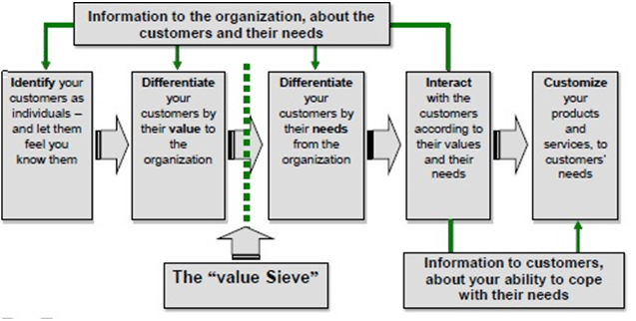

(ninjaoutreach.com, 2019, March,20).

QCI MODEL

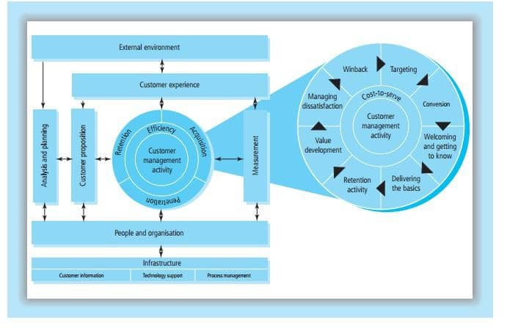

(ninjaoutreach.com, 2019, March,20).

CRM Value Chain Model

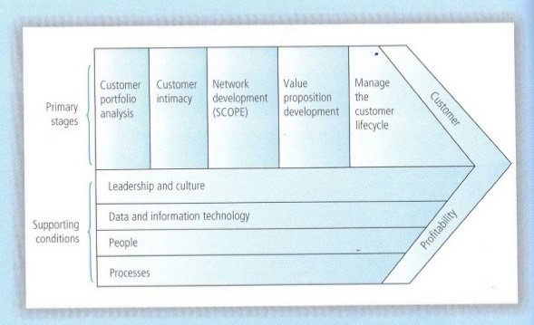
(ninjaoutreach.com, 2019, March,20).

Electricity Mix: Renewable energy made up over 50% of our overall electricity mix in 2017, up from only 14% in 2013.
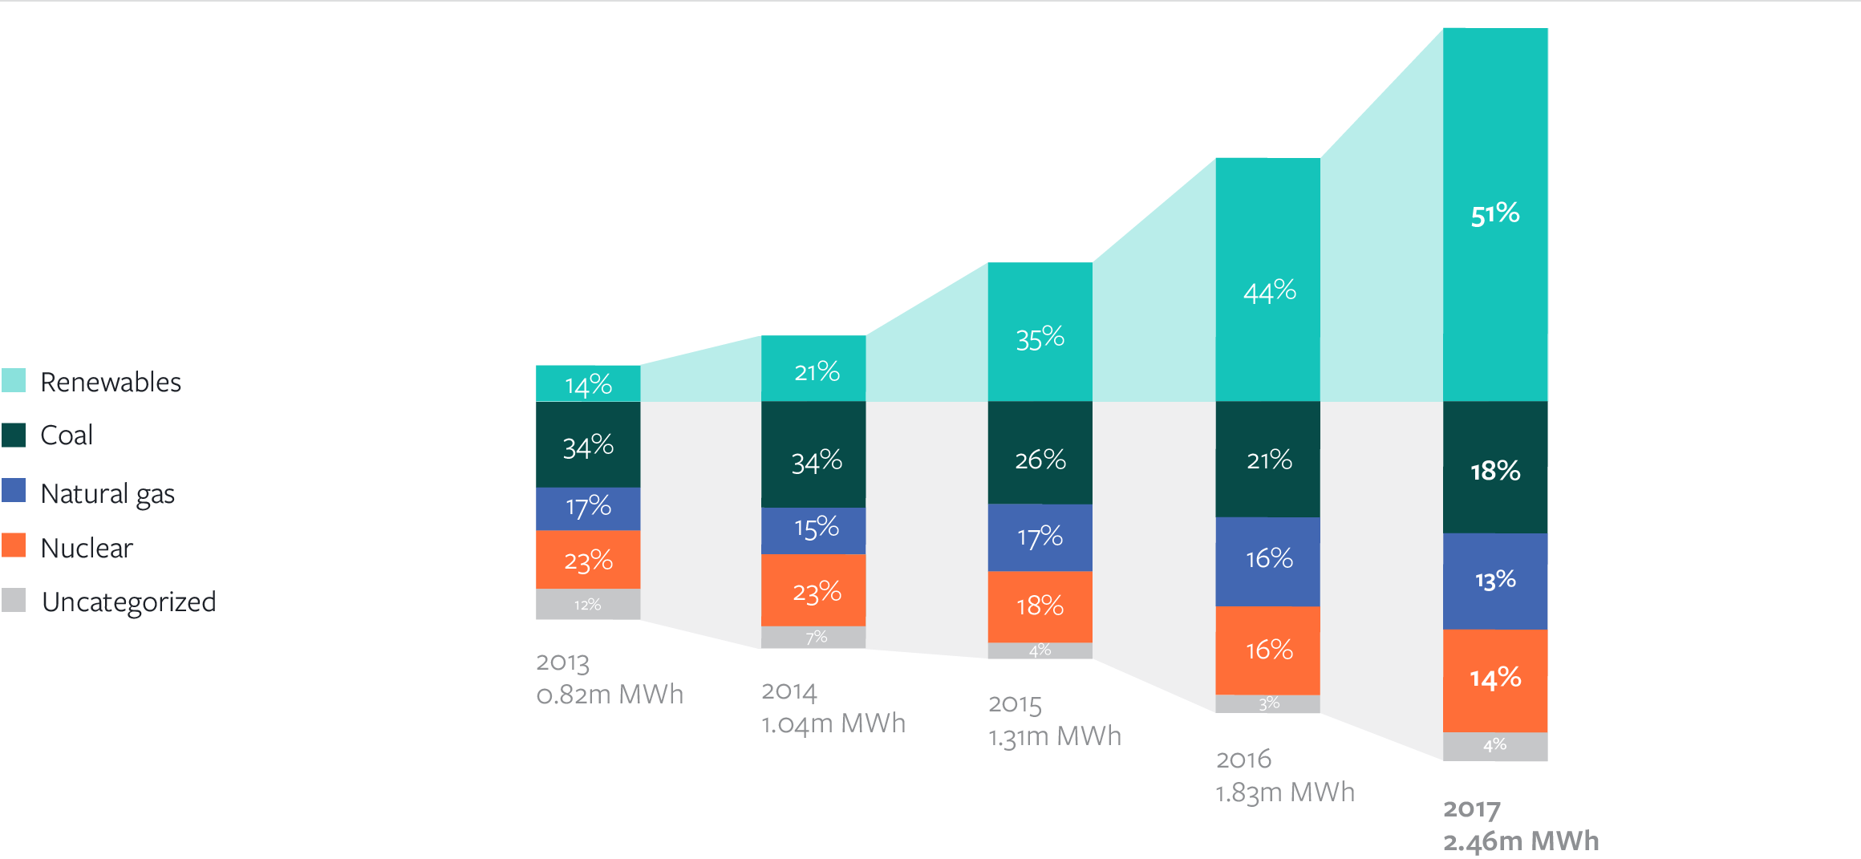

(sustainability. fb.com.,2019, March,23).

ANNUAL MARKET-BASED GREENHOUSE GAS EMISSIONS
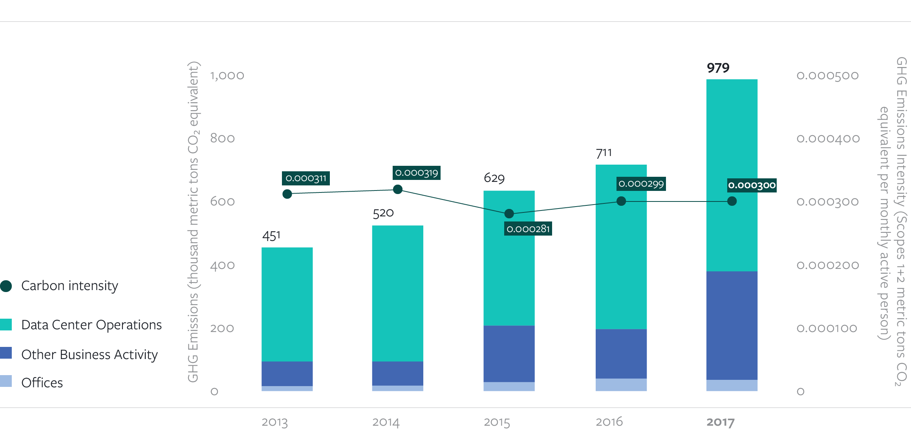

(sustainability.fb.com,2019, March,23).

- ACKNOWLEDGEMENT
This report would not be possible without my respected teacher, Maria Hefferman, who have been supportive and guides this assignment. Beside them, I would like to thank my friends having a constructive discussion about this assignment and librarians who helps me regarding necessary books. At last but not least thanks to my husband taking care of my son and giving enough time to do this assignment.
8.0 Reference List
Badshah, N. (2017) ‘ Tesco apologises after customer complain of ‘rancid, rotten’ turkeys’, Available: https://www.theguardian.com/business/2017/dec/26/tesco-apologises-after-customers-complain-of-rancid-rotten-turkeys( Accessed 25th March 2019).

Bbc.co.uk. (2018),’ Costa Coffee Vows ‘cup recycling revolution’, [Online]. Available: https://www.bbc.co.uk/news/business-43801491, [2019, March,20].

Bbc.co.uk. (2014),’Primark investigates claim of ‘Cry for help’ note in trousers’, [Online].Available: https://www.bbc.co.uk/news/uk-northern-ireland-28018137, [2019,March,15].

Blowfield, M and Murray, A. (2011), Corporate responsibility, (2nd Ed), UK: Oxford University Press.

Cnbc.com. (2018), ‘Apple says some iPhone X and MacBook models have quality issues’, [Online]. Available: https://www.cnbc.com/2018/11/10/apple-says-some-iphone-x-and-macbook-models-have-quality-issues.html, [2019,March,22].

Crane, A and Matten, D. (2016), BUSINESS ETHICS, (4th Ed), UK: Oxford University Press.

Cushman, D. and Burke, J., (2014). Introduction: Tesco PLC—an Open Business. In The 10 Principles of Open Business (pp. 10-23). UK: Palgrave Macmillan.

Ethicalconsumer.org.’ Tesco Plc’, [Online]. Available: https://www.ethicalconsumer.org/company-profile/tesco-plc, [2019, March,25].

Expertmarket.co.uk. ‘Tesco CRM Case Study’, [Online]. Available: https://www.expertmarket.co.uk/crm-systems/tesco-crm-case-study, [2019. March,20].

Facebook.com.’Community Standards’, [Online]. Available: https://www.facebook.com/communitystandards/introduction, [ 2019, March,23].

Fozia, R, Shiamwama, M, S and Otiso, N, K. (2014) ‘Impact of Customer Relatioship Management as a strategy for Competitive Advantage in Kenyan Public Universities: A Case Study of Moi Universitie’, International Journal of Business, Humanities and Technology, 4 July [Online]. Available: http://www.ijbhtnet.com/journals/Vol_4_No_4_July_2014/16.pdf, (Accessed: 19, March 2019)

Goetsch, D.L. and Davis, S.B., 2014. Quality management for organizational excellence.pearson.

Haanaes,K.(2016),’ Research & Knowledge’, Why all businesses should embrace sustainability,

Haerifar, P., 2013. Knowledge management within Tesco. GRIN Verlag.

Kenton,W.(2019),’Triple Bottom Line (TBL)’, [Online]. Available: https://www.investopedia.com/terms/t/triple-bottom-line.asp, [2019, March 15].

Mayer,k.(2018),’ Facebook raised the bar on employee benefits. Now it’s hoping to start a workplace revolution,’ [Online]. Available: https://www.benefitnews.com/news/facebook-boosts-employee-benefits-hopes-to-start-revolution, [ 2019,March,25].

Mindtools.com. (2019),’ The Triple Bottom Line’, [Online]. Available: https://www.mindtools.com/pages/article/newSTR_79.htm, [2019, March,15].

Muller, L, A. (2014) ‘Sustainability and customer relationship management: current state of research and future research opportunities’, Management Review Quarterly, 64:4, pp.201-224.

Newcomb.A.(2018), ‘A timeline of Facebook’s privacy issues- and its responses’, [Online]. Available: https://www.nbcnews.com/tech/social-media/timeline-facebook-s-privacy-issues-its-responses-n859651, [2019,March,25].

Rouse, M. (2013), ‘business sustainability’, [Online]. Available: https://whatis.techtarget.com/definition/business-sustainability, [2019, March,14].

Quains, S. (2019), ‘Why Is Quality Important for a Business’, [Online]. Available: https://smallbusiness.chron.com/quality-important-business-57470.html, [ 2019,March,20].

Salesforce.com.’CRM101: What is CRM?’, [Online]. Available: https://www.salesforce.com/crm/what-is-crm/, [2019, March,14].

Schneider,D. (2019), ‘CRM Models (Customer Relationship Management Model)’, [Online]. Available: https://ninjaoutreach.com/crm-models/, [2019, March,20].

Sustainability.fb.com. (2017), ‘Facebook Sustainability’, [Online]. Available: https://sustainability.fb.com/sustainability-in-numbers/#section-Carbon, [2019, March,23].

Tescoplc.com. (2018), ‘Little Helps Plan Progress Update’, [Online]. Available: https://sustainability.tescoplc.com/media/475570/little-helps-plan-report_2018_final.pdf, [2019.March,20].

Trustpilot.com.’ Tesco’, [Online]. Available: https://www.trustpilot.com/review/www.tesco.com?page=4, [2019, March,25].

visser, W., Matten, D., M. & Tolhurst, N. eds 2007, The A to Z of corporate social responsibility: a complete reference guide to concepts, codes and organisations, John Wiley & Sons, Chichester.

Weybrecht, G. (2014), The Sustainable MBA, (2nd Ed), United Kingdom: John Wiley & Sons, Ltd.

