
UWTSD Swansea
Application of maths for software development
Kemi Ademoye & Jamie Phillips
Daniel Algie 1706977

Table of Contents
Abstract 3
Chosen a topic 3
Implementation and design 4
Validating the website 7
Html validation and errors 7
CSS validation 8
Evaluation 9
Future development 9
References 10
Appendix 11
Index page 11
Hip-hop page 13
Pop Page 16
Punk Page 19
Rock Page 22
Style Sheet 24

Table of Figures
Figure 1-website layout 4
Figure 2-home page 4
Figure 3-rock n roll page 5
Figure 4-punk page 5
Figure 5-hip hop page 6
Figure 6-pop page 6
Figure 7- Html validation 8
Figure 8-Css style sheet validation 9

Abstract
The assignment will consist of showing how a website was created and will be going in depth of how it was constructed, the reason behind what was decided to do the website on and problems which occurred along the way. While showcasing the website using screen shots to show how the website was implemented.

Requirements
First part of designing the website was to decide on a topic to do the website on. There were many topics to choose from but was narrowed down to Football, Music and Travel. The chosen topic was music it was decided to do music as the topic for the website because it was felt that the would be more variety of users visiting the website over football and travel.
Once decided on the topic of the website was needed to be decided what topic of music was to be chosen for the website. It was considered on doing the music on one topic and having multiple pages with different artist from different countries of that topic but it was considered that this would be limiting the amount of traffic the website would receive by limiting it to one genre of music with this considered it was decided to build the website with multiple genres for each pages and showing a few of the biggest artist from the chosen genres. It was felt that this was the best option for the website to attract more user to visit the website and help grow the website popularity.

Implementation and design
In this section of the assignment it will be displaying the design and screen shots of the finished product of the website.

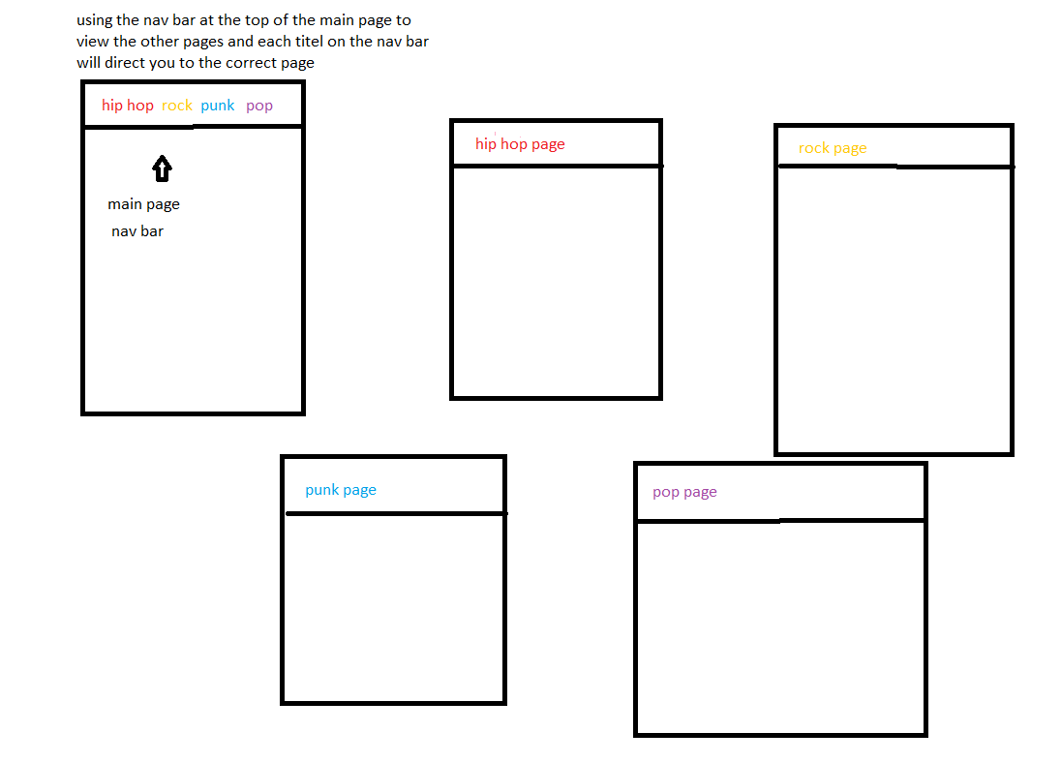
Figure 1-website layout

This is the design of how the website was wanted to be constructed. It demonstrates how the webpages would be linked to each other. The website used a variety of images [1] and text [2] to engage with the user.

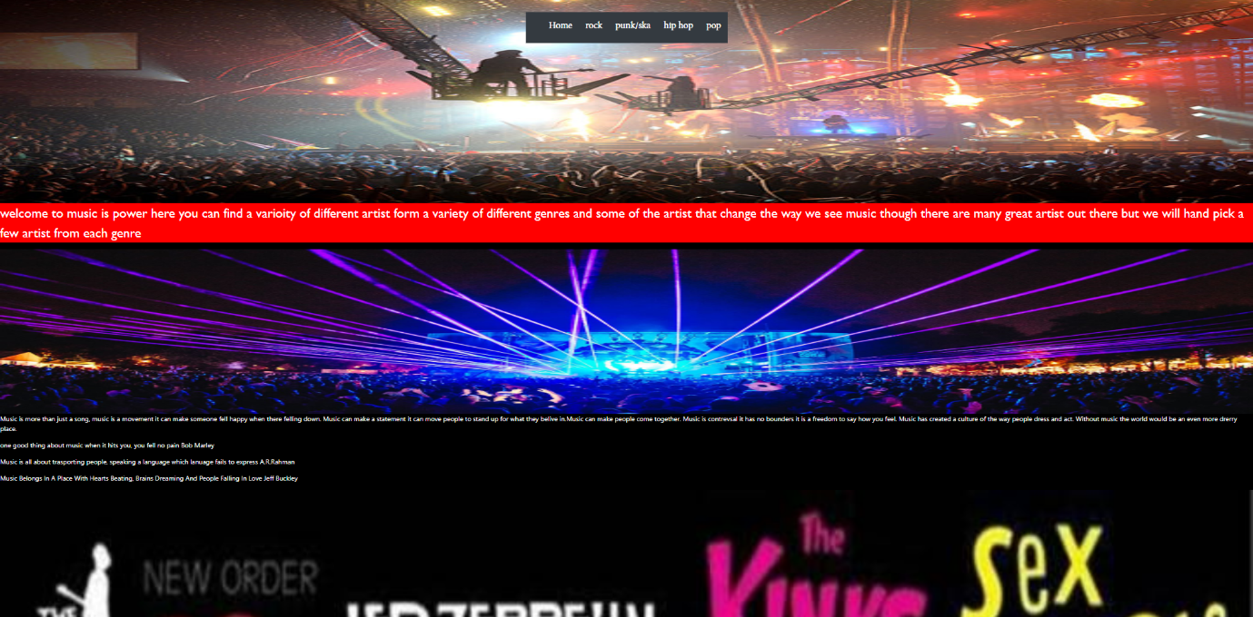
Figure 2-home page
This is the home page of the website created this is the first page the user will see from there they will choose the page for different genres they wish to view.

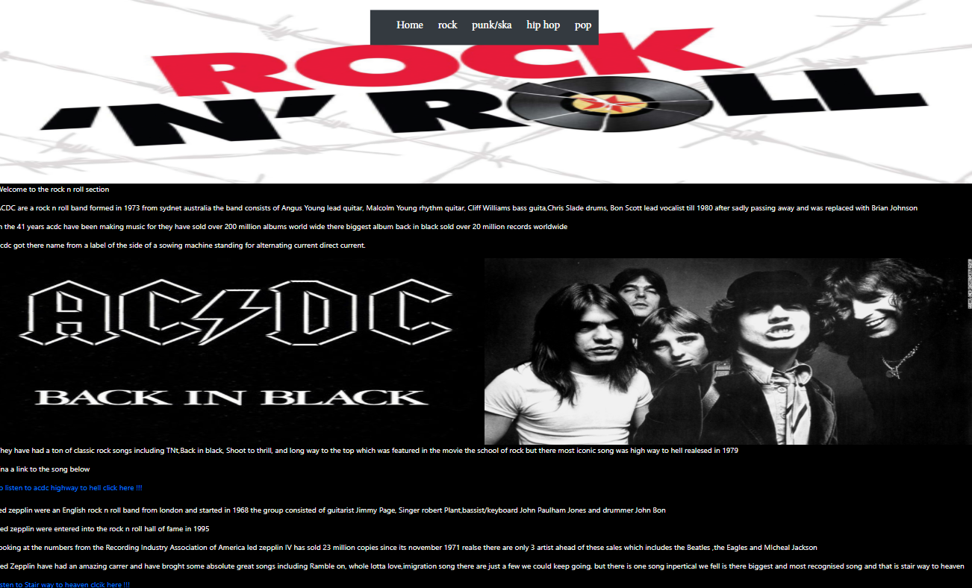
Figure 3-rock n roll page
This is the rock n roll section of the website where the user can find information on the bands ACDC and Led Zeppelin.
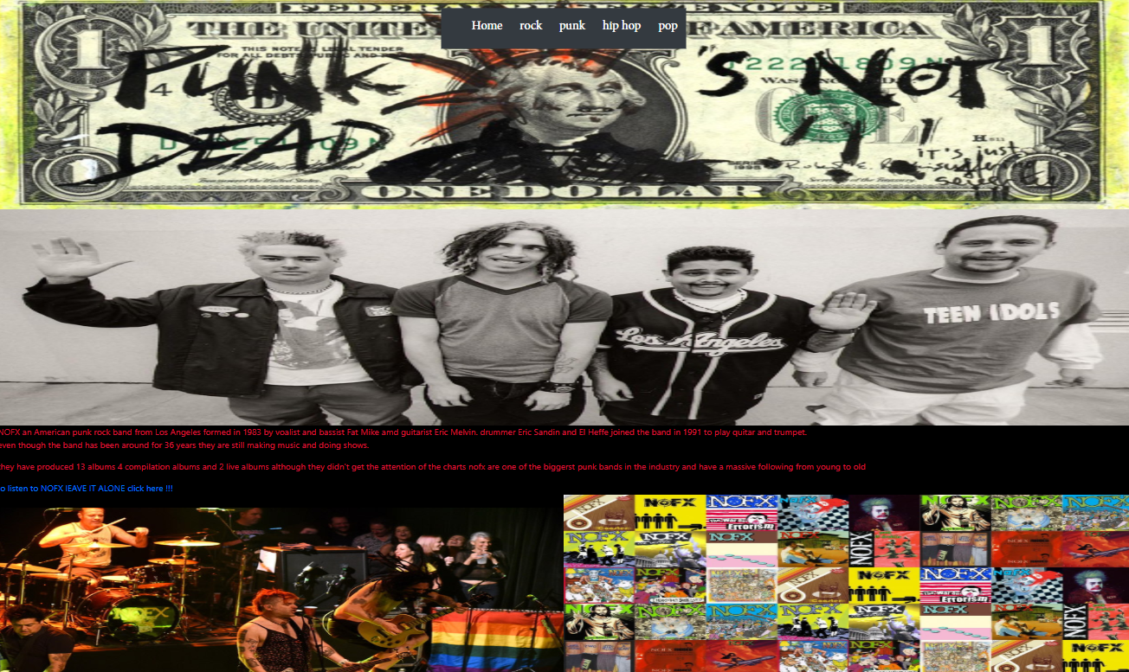
Figure 4-punk page
This is the punk page of the website where users can find out about artist Nofx and Rancid.

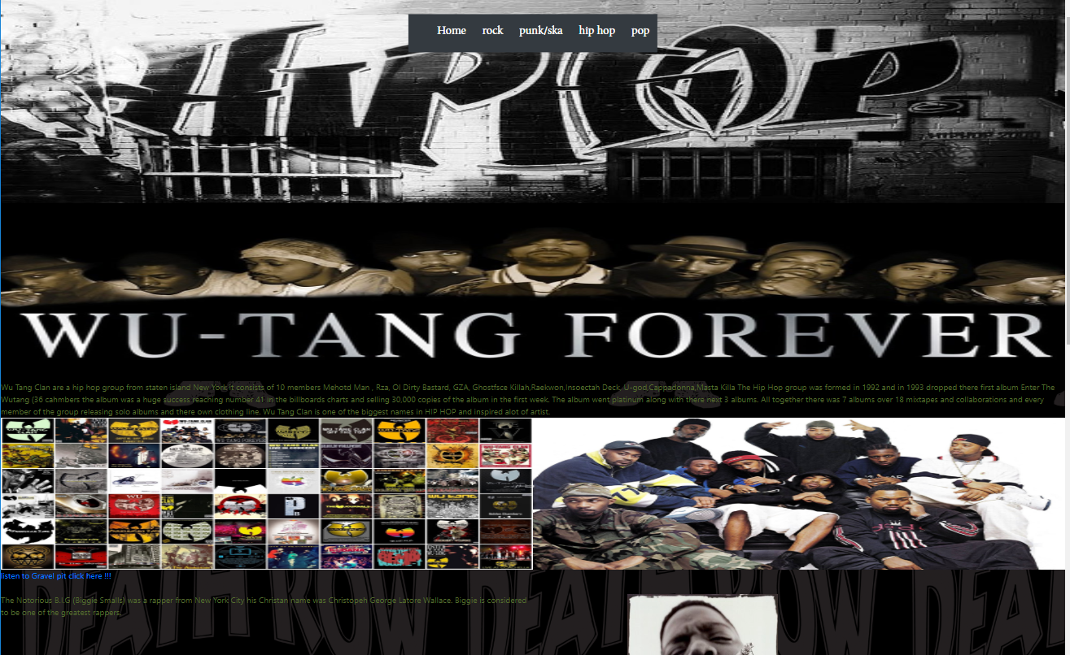
Figure 5-hip hop page
This is the Hip Hop page where users can find out about artist The Wu Tang Glan, Notorious BIG and Tupac Shakur.

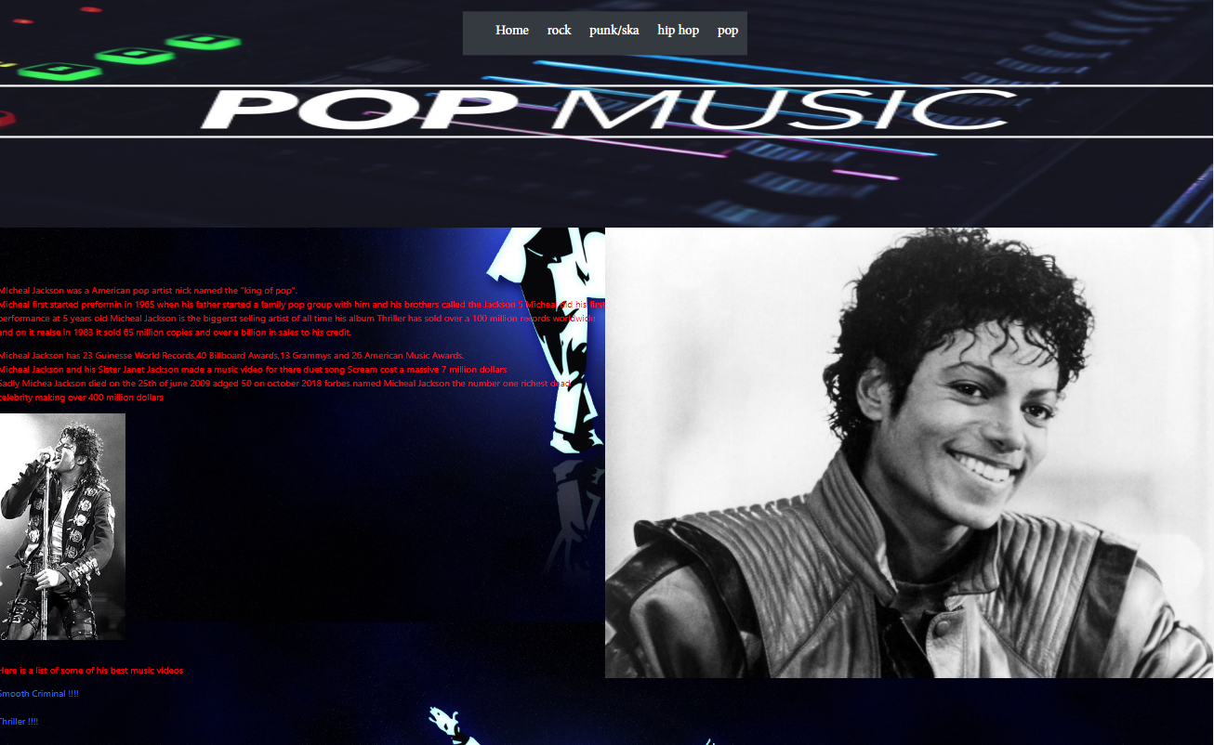
Figure 6-pop page
This is the POP page of the website where the user can find out about Michael Jackson.
Please find that the images used to showcase the website aren’t actually to size and there will be more content to see when viewing the website.

Validating the website

Html validation and errors
This part of the assignment will be going into depth of the errors which occurred when validating the website and how they were fixed.

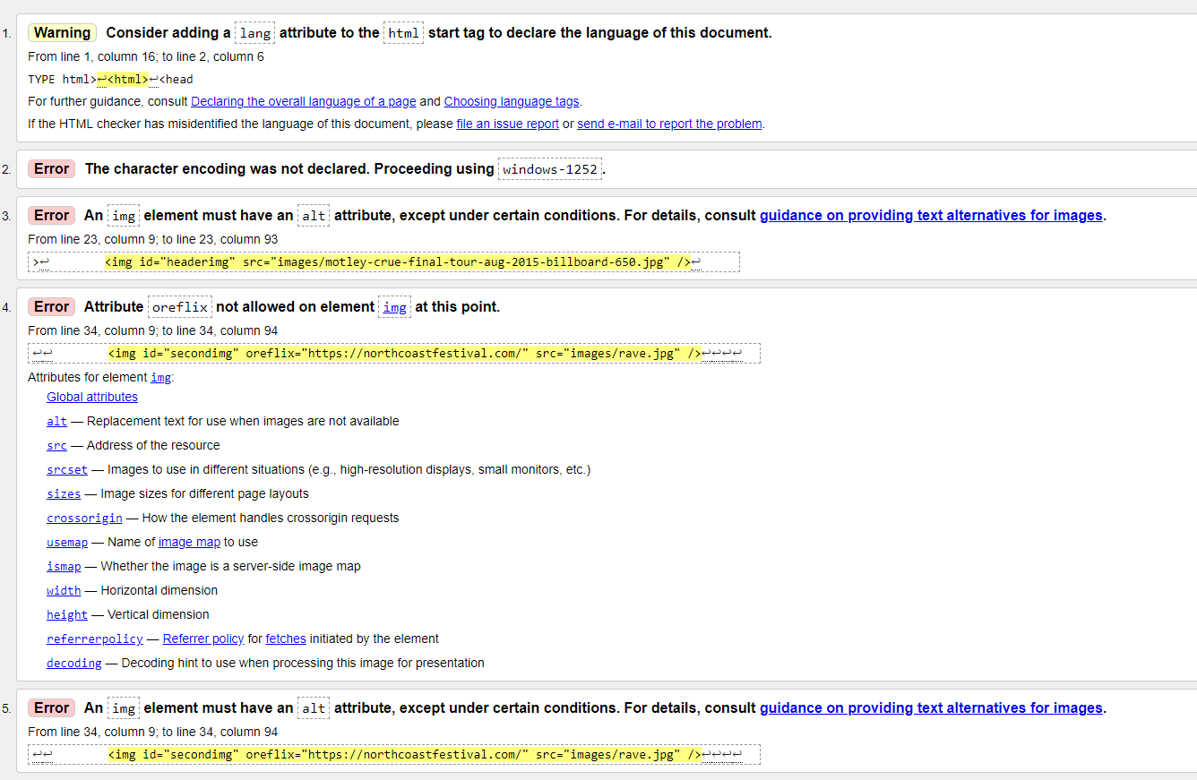
Figure 7- Html validation [3]

Error number 3 was rectified by adding alt tag and displaying the name of the image when validating the error kept coming up for all images and this why has more error the same in number 5 of the error list.
This was rectified by changing the code in my html page.
<img id="headerimg" src="images/motley-crue-final-tour-aug-2015-billboard-650.jpg" />

<img id="headerimg" src="images/motley-crue-final-tour-aug-2015-billboard-650.jpg" alt="motley" />

The first line of code was where the error would occur, and the second line of code is when the code was fixed.

Error 4 was a genuine spelling mistake when using references to show credit from where the source was taking from this was quickly rectified by correcting the grammar.

Error 2 The character encoding was not declared. Proceeding using windows-1252.
This error was fixed by adding a missing line to the code.
<meta charset="utf-8" />
The above code was the missing piece of the code to sort out the error.

CSS validation

First validation showed one error saying background colour of the navigation bar to none is not a colour so when changing the error it was shown that no error in the validation of the css style sheet
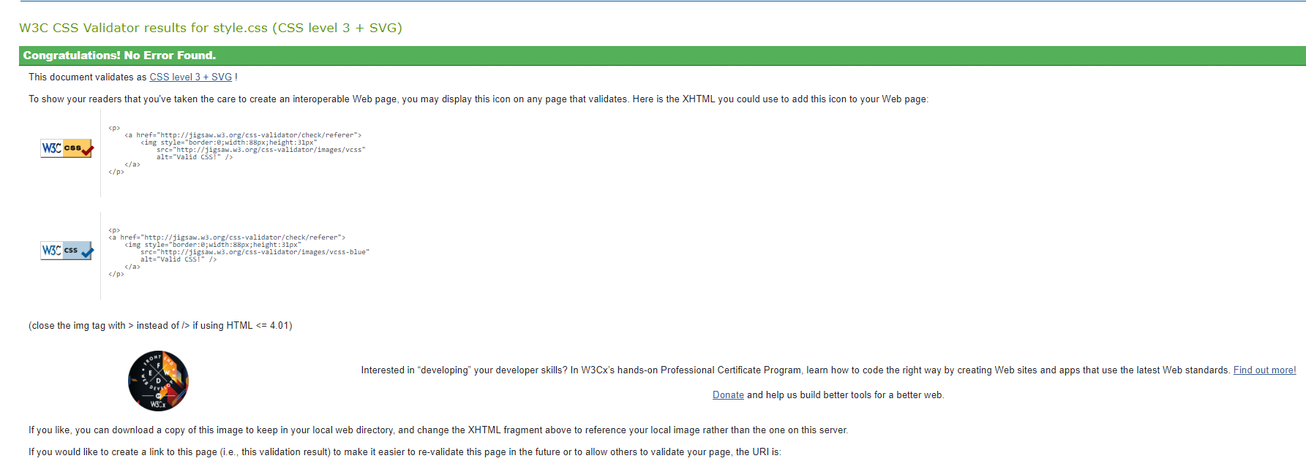
Figure 8-CSS style sheet validation [3]

Evaluation
When creating the website this was mad possible by using Microsoft visual studios this is a software used for creating programmes, websites it is a very powerful software capable of understanding and creating the programs and website using a range of different languages: which includes Html, Java, C++, C# and many more.
There are many great ways to work out the colour scheme when creating a website there are many different websites out there which will help you create a colour scheme for your website to be implemented into your style sheet a few to list are contrast checker and juicy studio although these websites are helpful for the purpose of this website the colour scheme was used choosing colours which were available with visual studios.
Wave Evaluation Tool was used to check how accessible the website was and how user friendly for the main user when visiting the website and multiple pages due to lack of knowledge and understanding the software was not used at this time but with time and knowledge this is definitely a tool which will be used to help progress the website.

Future development
While the website does what it is needed to do and shows a lot of content for the user there are still a few improvements that would be an asset to making this website better:
- Script font size: this is an important extra to be implemented into the website to help people with sight problems and give the user a better view of the writing they are reading.
- Font colour: having the adaptability to change the font colour of the website to help make it more visible for people with colour deficiency.
- Stationary navigation bar: The Navigation Bar will be fixed in place so that the user won’t need to keep scrolling to the top of the page to change to different webpages.

References

[1] | J. Duckett, “Images,” in HTML & CSS : Design and Build Websites, Indianapolis, Wiley, 2011.
[2] | J. Duckett, “Text,” in HTML & CSS : Design and Build Websites, Indianapolis, Wiley, 2011.
[3] | W3C, “CSS Validation Service,” W3C, [Online]. Available: http://jigsaw.w3.org/css-validator. [Accessed April 2019].
[4] | W3C, “Markup Validation Service,” W3C, [Online]. Available: http://validator.w3.org/. [Accessed April 2019].

Appendix

Index page
<!DOCTYPE html>
<html lang="en">
<head>
<meta charset="utf-8" />
<meta name="keywords" content="music" />
<title>MP (music is power)</title>
<link rel="stylesheet" href="css/bootstrap.min.css" />
<link href="css/style.css" rel="stylesheet" />
</head>
<body class="index" id="indexbody">

<header>
<nav class="navbar-dark bg-dark">
<ul class="navbar-expand navbar-expand-lg">
<li class="nav-item">
<a class="nav-link" href="index.html">Home</a>
<a class="nav-link" href="rock.html">rock</a>
<a class="nav-link" href="punkska.html">punk/ska</a>
<a class="nav-link" href="hiphop.html">hip hop</a>
<a class="nav-link" href="pop.html">pop</a>
</li>
</ul>
</nav>
<img id="headerimg" src="images/motley-crue-final-tour-aug-2015-billboard-650.jpg" alt="motley" />
<p id="intropar">welcome to music is power here you can find a variety of different artist form a variety of different genres and some of the artist that change the way we see music though there are many great artist out there but we will hand pick a few artist from each genre</p>

</header>

<main>
<!--reference "https://northcoastfestival.com/"-->
<img id="secondimg" src="images/rave.jpg"alt="rave"/>

<p id="mainpara">
Music is more than just a song; music is a movement it can make someone fell happy when there felling down.
Music can make a statement it can move people to stand up for what they believe in. Music can make people come together.
Music is controversial it has no bounders it is a freedom to say how you feel.
Music has created a culture of the way people dress and act. Without music the world would be an even more dreary place.
</p>
<!-- reference "https://www.brainyquote.com/topics/music"-->
<p id="bob">'One good thing about music is when it hits you, you feel no pain' Bob Marley</p>
<!-- reference https://www.wishberry.in/blog/8-quotes-by-famous-musicians-that-will-inspire-you-on-your-musical-journey/#/article-->
<p id="wish">'Music is all about transporting people, speaking a language which language fails to express' A.R.Rahman</p>
<p id="jeff"> 'Music Belongs in A Place With Hearts Beating, Brains Dreaming And People Falling In Love' Jeff Buckley</p>

</main>
<!-- reference https://www.zedge.net/wallpaper/1ed0070b-b5c0-3a20-a1c6-9cd8b9e27c08 -->
<img id="listofband" src="images/rock-background.jpg" alt="rock-background"/>

<footer>

<p>&copy;Majestic Donkey INC</p>
</footer>

<script src="js/bootstrap.min.js"></script>
<script src="js/jquery-3.3.1.min.js"></script>
</body>
</html>

Hip-hop page
<!DOCTYPE html>
<html>
<head>
<meta name="keywords" value="" />
<title>MP (music is power)</title>
<link rel="stylesheet" href="css/bootstrap.min.css" />
<link href="css/style.css" rel="stylesheet" />
</head>
<body class="hiphop">

<header>
<nav class="navbar-dark bg-dark">
<ul class="navbar-expand navbar-expand-lg">
<li class="nav-item">
<a class="nav-link" href="index.html">Home</a>
<a class="nav-link" href="rock.html">rock</a>
<a class="nav-link" href="punkska.html">punk/ska</a>
<a class="nav-link" href="hiphop.html">hip hop</a>
<a class="nav-link" href="pop.html">pop</a>
</li>
</ul>
</nav>

<img id="hiphoplogo" src="images/hiphop logo.jpg" />

<!-- https://thepreludepress.com/news/2017/12/11/wu-tang-clan-partners-with-pledgemusic-for-20th-anniversary-packages-of-wu-tang-forever -->
<img id="forever" src="images/wu tangclan forevero.jpg" />

</header>
<div id="aboutwu">
Wu Tang Clan are a hip hop group from Staten island New York it consists of 10 members Mehotd Man , Rza, Ol Dirty Bastard, GZA, Ghostfsce Killah,Raekwon,Insoectah Deck, U-god,Cappadonna,Masta Killa
<!-- reference https://en.wikipedia.org/wiki/Enter_the_Wu-Tang_(36_Chambers) -->
The Hip Hop group was formed in 1992 and in 1993 dropped their first album Enter the Wutang (36 cahmbers the album was a huge success reaching number 41 in the billboards charts and selling 30,000 copies of the album in the first week.
The album went platinum along with their next 3 albums.
All together there was 7 albums over 18 mixtapes and collaborations and every member of the group releasing solo albums and their own clothing line.
Wu Tang Clan is one of the biggest names in HIP HOP and inspired a lot of artist.
</div>

<!-- reference http://productoilicito2.blogspot.com/2017/06/wu-tang-clan-discografia-mediafire-mega.html -->

<img id="wucovers" src="images/wu covers.jpg" />
<!-- reference https://www.grailed.com/drycleanonly/wu-tang-clan-style-influence -->
<img id="wumembers" src="images/wueveryone.jpg" />

<!-- reference https://youtu.be/Of-lpfsBR8U-->
<a id="gravelpit" href="https://youtu.be/Of-lpfsBR8U">listen to Gravel pit click here !!!</a>

<br />
<br />

<main>

<p id="biggie1">
<!-- reference https://en.wikipedia.org/wiki/Life_After_Death ////// https://www.billboard.com/articles/columns/chart-beat/8100012/the-notorious-big-fifth-million-selling-album -->
The Notorious B.I.G (Biggie Smalls) was a rapper from New York City his Christan name was Christopeh George Latore Wallace.
Biggie is considered to be one of the greatest rappers.
<p>
<!--refrence https://genius.com/posts/131-Rip-biggie-smalls-the-rap-genius-->
<!-- reference https://youtu.be/_JZom_gVfuw-->
<a id="juicy" href="https://youtu.be/_JZom_gVfuw">listen to juicy click here !!!</a>
<img id="biggiesmoking" src="images/biggiesmoking.jpg" />

<p id="biggie5">
Biggies first album ready to die sold 3.87 million records in America.
His bestselling album was life after death selling 5.36 million copies in America although Biggie sadly past away 16 days before the release of the album from gun shoot dying at the young age of 24.
it was a sad for the industry and for his family even thou his career was short he is still considered one off the best hip-hop artist
</p>
<p>
<br />
<br />
<br />

<!--reference https://rateyourmusic.com/artist/the-notorious-b_i_g -->
<img id="ready" src="images/Ready_To_Die.jpg" />
<!-- reference https://www.biography.com/people/biggie-smalls-20866735 -->
<img id="biggie2" src="images/biggie.jpg" />

</main>

<br />
<br />

<!--refernce https://en.m.wikipedia.org/wiki/All_Eyez_on_Me-->
<p id="tpac1">
Tupac shakur was a rapper from Los Angeles going by his rapper name 2pac or makaveli is one of the biggest rappers in the world. tipac was knowing for his crazy antics and his speech against the police and the government. His mother Afeni Shakur was a member of the Black Panthers and organisation to give black people the rights the deserve.
Tupac was an artist under Death Row Records one of the greatest record company of their era they had a lot of the greatest west coast artist including Snoop Dogg,DR Dre,Nate Dogg,Kurpupt,Warren G.
All Eyez On ME was tupacs biggest album selling 566,000 copies in the first week and won the album of the year award in 1997 at the Soul Train Awards.
sadly, tupac passed away in 1996 from a drive by shooting in Las Vegas He died at the age of 25 years old another greater rapper taking too soon.
</p>

<!-- reference https://tribune.com.pk/story/1748567/4-tupacs-murderer-revealed-22-years-death/-->

<img id="tpac2" src="images/tupac1.jpg" />
<!-- reference http://hiphopgoldenage.com/list/top-20-west-coast-rappers/-->

<!-- reference https://youtu.be/5Ry3JIwCxhg-->
<a id="changes" href="https://youtu.be/5Ry3JIwCxhg">listen to changes click here !!!</a>
<footer></footer>

<script src="js/bootstrap.min.js"></script>
<script src="js/jquery-3.3.1.min.js"></script>

</body>
</html>

Pop Page
<!DOCTYPE html>
<html>
<head>
<meta name="keywords" value="" />
<title>MP (music is power)</title>
<link rel="stylesheet" href="css/bootstrap.min.css" />
<link href="css/style.css" rel="stylesheet" />
</head>
<body class="pop">
<header>
<nav class="navbar-dark bg-dark">
<ul class="navbar-expand navbar-expand-lg">
<li class="nav-item">
<a class="nav-link" href="index.html">Home</a>
<a class="nav-link" href="rock.html">rock</a>
<a class="nav-link" href="punkska.html">punk/ska</a>
<a class="nav-link" href="hiphop.html">hip hop</a>
<a class="nav-link" href="pop.html">pop</a>
</li>
</ul>
</nav>
<!-- reference https://pixers.uk/wall-murals/pop-music-retro-concept-vintage-poster-design-61840809 -->
<!--<img id="poplogo" src="images/pop logo.jpg" />-->
<!-- refrence https://www.youtube.com/watch?v=K55Ow7mCoho-->
<img id="poplogo" src="images/pop logo 2.jpg" />

</header>
<main>
<!-- reference https://www.unheardvoicesmag.com/2013/08/29/happy-55th-birthday-michael-jackson/ -->
<img id="micheal1" src="images/icheal jackson 1.jpg" />
<p id="micheal2">
<br />
<br />
<br />
<br />
Michael Jackson was a American pop artist nick named the "king of pop".
<br />
Michael first started preforming in 1965 when his father started a family pop group with him and his brothers called the Jackson 5
Michael did his first performance at 5 years old

<!-- reference https://www.billboard.com/articles/columns/pop/6812781/michael-jackson-thriller-30x-multi-platinum-album -->
Michael Jackson is the biggerst selling artist of all time his album Thriller has sold over a 100 million records worldwide and on it realse in 1983 it sold 65 million copies and over a billion in sales to his credit.
</p>
<p id="micheal3">

Michael Jackson has 23 Guinness World Records,40 Billboard Awards,13 Grammys and 26 American Music Awards.
<br />
Michael Jackson and his Sister Janet Jackson made a music video for their duet song Scream cost a massive 7 million dollars
<br />
Sadly Michael Jackson died on the 25th of June 2009 aged 50 on October 2018 Forbes named Michael Jackson the number one richest dead celebrity making over 400 million dollars

<p />

<img id="michealsing" src="images/micheal jackson siging.jpg" />
<br />
<br />
<p id="micheal5">Here is a list of some of his best music videos</p>
<!--reference https://youtu.be/h_D3VFfhvs4-->
<a id="smoothcriminal" href="https://youtu.be/h_D3VFfhvs4"> Smooth Criminal !!!!</a>
<br />
<br />

<!-- reference https://youtu.be/sOnqjkJTMaA -->
<a id="thriller" href="https://youtu.be/sOnqjkJTMaA">Thriller !!!!</a>
<br />
<br />
<!--reference https://youtu.be/1-7ABIM2qjU-->
<a id="rockworld" href="https://youtu.be/1-7ABIM2qjU">You Rock My World</a>
<br />
<br />
<br />

<!-- reference http://sfwallpaper.com/categories/michael-jackson-wallpaper.html-->
<img id="micheal6" src="images/michealmicheal.PNG" />

<br />
<br />
<br />
<br />
<br />
<br />
<br />
<br />
<br />

<br />
<br />
<br />
<br />
<br />
<br />
<br />

</main>

</body>

</html>
<footer>
<p>&copy; Majestic Donkey INC</p>
</footer>

Punk Page
<!DOCTYPE html>
<html>
<head>
<meta charset="utf-8" />
<meta name="keywords" value="" />
<title>MP (music is power)</title>
<link rel="stylesheet" href="css/bootstrap.min.css" />
<link href="css/style.css" rel="stylesheet" />
</head>
<body class="punk">

<header>
<nav class="navbar-dark bg-dark">
<ul class="navbar-expand navbar-expand-lg">
<li class="nav-item">
<a class="nav-link" href="index.html">Home</a>
<a class="nav-link" href="rock.html">rock</a>
<a class="nav-link" href="punkska.html">punk</a>
<a class="nav-link" href="hiphop.html">hip hop</a>
<a class="nav-link" href="pop.html">pop</a>
</li>
</ul>
</nav>
<!-- https://kamiel-proost.com/product/punks-not-dead-one-dollar-art/ -->
<!-- reference https://www.kisspng.com/png-punks-not-dead-punk-rock-t-shirt-the-exploited-pun-1976749/ -->
<!--<img id="punk" src="images/punks not dead.jpg" />-->

<img id="punk" src="images/pnk not dead 2.PNG" />

<!--reference http://melodic-punk-style.blogspot.com/2018/10/nofx-are-writingrecording-new-songs-new.html-->
<!--<img id="nofx1" src="images/nofx1.jpg" />-->
<!-- reference http://epitaph.com/artists/nofx/bio-->
<img id="nofx1" src="images/nofx full band.jpg" />
<div id="nofx2">
NOFX an American punk rock band from Los Angeles formed in 1983 by vocalist and bassist Fat Mike and guitarist Eric Melvin.
drummer Eric Sandin and El Heffe joined the band in 1991 to play guitar and trumpet.
</div>

<p id="nofx3">Even though the band has been around for 36 years they are still making music and doing shows.</p>
<p id="nofx4">they have produced 13 albums 4 compilation albums and 2 live albums although they didn't get the attention of the charts nofx are one of the biggest punk bands in the industry and have a massive following from young to old</p>
<!-- reference https://youtu.be/cuR12uCt61Q-->
<a id="nofx5" href="https://youtu.be/cuR12uCt61Q" />to listen to NOFX lEAVE IT ALONE click here !!!</a>
<!-- <iframe</iframe>-->
<br />
<!-- reference https://www.ebay.com/itm/NOFX-album-discography-magnet-4-5-x-3-5-punk-rock-/283211605047 -->

<img id="nofxalbum" src="images/nofx albums cover new.jpg" />
<br />
<!-- reference http://www.brooklynvegan.com/gdpr/consent/?redirect=/listen-to-a-snippet-of-nofxs-audiobook-with-tommy-chong-narrating/ -->
<img id="nofxgig" src="images/nofxgig.jpg" />
<br />
<br />

</header>

<main>
<!-- reference https://www.stereogum.com/1711656/rancid-already-dead/video/ -->
<br />
<br />

<img id="rancid1"src="images/rancid 6.jpg" />
<p>
Rancid are American punk band from California the band started in 1991 by Tim Armstrong and Matt Freeman.
the band consists of Tim Armstrong on Guitar and vocals, Matt frreman Bass Guitar and vocals, Lars Frederiksen on guitar and Brett reed on drums but was replaced by Brandon Steineckret in 2006
</p>
<p id="rancid2">Rancid have made 9 albums and have a great carrer.</p>
<!-- reference https://www.quora.com/What-is-the-highest-selling-Rancid-album -->
<p id="rancid3">Rancids biggest album was "and out come the wolves" even though it took nearly 9 years from the release of the album in 1995 but this album went platinum</p>
<!--reference https://www.reddit.com/r/punk/comments/9fpaex/if_you_had_to_listen_to_one_album_forever_which/ -->
<!-- reference https://youtu.be/DhKHAopx7D0-->
<a id="rancid 5" href="https://youtu.be/DhKHAopx7D0" />to listen to RANCID TIME BOMB click here !!!</a>
<br />
<br />
<img id="rancidcover" src="images/rancid album cover.jpg" />
<!--reference https://uproxx.com/music/rancid-and-out-come-the-wolves-anniversary/ -->
<!--<img id="rancidband" src="images/rancid4.jpg" />-->

</main>

<footer></footer>

<script src="js/bootstrap.min.js"></script>
<script src="js/jquery-3.3.1.min.js"></script>
</body>
</html>

Rock Page
<!DOCTYPE html>
<html>
<head>
<meta name="keywords" value="" />
<title>MP (music is power)</title>
<link rel="stylesheet" href="css/bootstrap.min.css" />
<link href="css/style.css" rel="stylesheet" />
</head>
<body class="rock" >

<header>
<nav class="navbar-dark bg-dark">
<ul class="navbar-expand navbar-expand-lg">
<li class="nav-item">
<a class="nav-link" href="index.html">Home</a>
<a class="nav-link" href="rock.html">rock</a>
<a class="nav-link" href="punkska.html">punk/ska</a>
<a class="nav-link" href="hiphop.html">hip hop</a>
<a class="nav-link" href="pop.html">pop</a>

</li>
</ul>
</nav>
<img id="rocknroll" prefix="https://wall.alphacoders.com/big.php?i=438357" src="images/rock n roll guitar.jpg" />
<p id="rockpara1">Welcome to the rock n roll section </p>

<p id="rockpara2">ACDC are a rock n roll band formed in 1973 from sydnet australia the band consists of Angus Young lead guitar, Malcolm Young rhythm guitar, Cliff Williams bass guitarist, Chris Slade drums, Bon Scott lead vocalist till 1980 after sadly passing away and was replaced with Brian Johnson</p>
<p id="rockpara3" prefix="https://en.wikipedia.org/wiki/AC/DC_discography">in the 41 years ACDC have been making music for they have sold over 200 million albums world wide there biggest album back in black sold over 20 million records worldwide</p>
<p id="rockpara3" prefix="https://whynameitthat.blogspot.com/2010/07/acdc.html">ACDC got their name from a label of the side of a sowing machine standing for alternating current direct current.</p>

<img id="backinblack" src="images/acdc-back-in-black-album-cover-650.jpg" prefix="https://www.billboard.com/articles/review/album-review/6642057/acdc-back-35-years-classic-track-by-track-album-review">

<img id="acdc" src="images/acdc band photo.jpg" prefix="https://edition.cnn.com/2016/04/19/entertainment/brian-johnson-ac-dc/index.html" />
<p id="highway">They have had a ton of classic rock songs including TNt, Back in black, Shoot to thrill, and long way to the top which was featured in the movie the school of rock but there most iconic song was high way to hell released in 1979 </p>
<p>find a link to the song below

<!--reference https://youtu.be/gEPmA3USJdI"-->
<a id="highway" href="https://youtu.be/gEPmA3USJdI" />to listen to acdc highway to hell click here !!!</a>

<br />

</header>

<main>
<br />
<p id="ledzepplinintro">Led Zepplin were an English rock n roll band from London and started in 1968 the group consisted of guitarist Jimmy Page, Singer Robert Plant, bassist/keyboard John Paulham Jones and drummer John Bon </p> <p id="ledrockhall">Led Zepplin were entered into the rock n roll hall of fame in 1995 </p>
<!--refrence https://www.cheatsheet.com/entertainment/what-is-led-zeppelins-best-selling-album-of-all-time.html/ -->
<p id="ledhits">looking at the numbers from the Recording Industry Association of America Led Zepplin IV has sold 23 million copies since its November 1971 release there are only 3 artist ahead of these sales which includes the Beatles ,the Eagles and Michael Jackson</p>
<p id="ledsong">
Led Zepplin have had an amazing career and have brought some absolute great songs including Ramble on, whole lotta love, migration song there are just a few we could keep going.
but there is one song inspirational we fell is there biggest and most recognised song and that is stair way to heaven
</p>
<!-- reference https://youtu.be/xbhCPt6PZIU -->

<a id="stair" href="https://youtu.be/xbhCPt6PZIU">listen to Stair way to heaven clcik here !!!</a>

<p>

image shows Led Zepplin album cover Iv
</p>
<img id="IV" src="images/led Iv.jpg" />
<img id="plane" src="images/ledzepplin plane.jpg" />
</main>

<footer></footer>

<script src="js/bootstrap.min.js"></script>
<script src="js/jquery-3.3.1.min.js"></script>
</body>
</html>

Style Sheet
body{
background-color:black;
margin:0;
padding:0;
}
.navbar-dark {
position:absolute;
top:5%;
left:50%;
transform:translateX(-50%) translateY(-50%);
background-color:dimgray;
}
li{
display:flex;
}
li a {
text-decoration:wavy;
text-emphasis-color:cadetblue;
text-decoration-color:red;
display:inline-block;
color:whitesmoke;
font-family:'Adobe Thai';
font-weight:lighter;
font-size:28px;
padding:0 20px;
}
.nav-link::after{
content:'';
display:block;
width:0;
height:2px;
background-color:burlywood;
transition:width .3s
}
.nav-link:hover::after{
width:100%;
transition:width .3s;

}

#intropar {
background-color: red;
font-family: 'Gill Sans', 'Gill Sans MT', Calibri, 'Trebuchet MS', sans-serif;
font-size: xx-large;
color: white;
}
#mainpara{
color:white;
}
#bob{
color:white;
}
#wish{
color:white;

}
#jeff{
color:white;
}

#headerimg{
width:100%;
height:500px;
margin-top:0;
}
#secondimg{
width:100%;
height:400px;
}
#listofband{
width:100%;

}

.rock {
color:whitesmoke;
background-color:black;

}

#rocknroll{
width:100%;
height:400px;

}

#backinblack{
width:50%;
height:400px;
}
#highway{

}

#acdc{
float:right;
width:50%;
height:400px;

}
#IV{
float:left;
width:50%;
height:300px;
}

#plane{
float:right;
width:50%;
height:300px;
}
.punk
{

background-color:black;
color: crimson;
}
#punk{
width:100%;
height:400px;

}

#nofx1{
width:100%;
height:400px;
}
#nofx5{

}
#nofxalbum{
float:right;
width:50%;
height:400px;
}

#nofxgig{
float:left;
width:50%;
height:400px;
}
#rancid1{
width:100%;
height:400px;
}
#rancid5{
float:left;
width:25%;
}
#rancidcover{
width:100%;
}
.hiphop {
color: darkolivegreen;
background-image:url('../images/Death_Row_Records.png');
}
#hiphoplogo{
width:100%;
height:400px;
}
#forever{
width:100%;
height:350px;
}
#wucovers{
float:left;
width:50%;
height:300px;
}
#wumembers{
float:right;
width:50%;
height:300px;
}
#biggie1{
float:left;
width:50%;

}
#biggiesmoking{

}
#biggie5{
float:left;
width:50%;

}
#biggie2{

}
#ready{

}
#juicy{

}

#tpac1{
float:left;
width:50%;
}
#tpac2{

}
#tpac3{

}
.pop {
/*reference www.4usky.com/download/164195951.html background-image:;*/
background-image: url('../images/164195951-dance-wallpapers.jpg');
color: red;
}
#poplogo{
width:100%;
height:400px;

}
#micheal1{
float:right;
width:50%;
}
#micheal2{
float:right;
width:50%;
}
#micheal3{

}
micheal4{
float:right;
width:50%;
}
#micheal6{
float:left;
width:40%;
}

