Trudi Meyrick

Student Number 2225279
2nd April 2023
OPERATIONAL lEADERSHIP
Programme: MSc (Operational and Strategic Leadership)

CONTENTS

1. INTRODUCTION 2
2. REFLECTIVE JOURNAL 4
3. WHAT (Overview /Description) 6
3.1 Command of the Incident 6
4. SO WHAT 8
4.1 Leadership 9
4.2 Community Cohesion 19
4.3 Media 23
4.4 Accountability / Public Trust and Confidence 25
5. NOW WHAT / RECOMMENDATIONS 27
6. CONCLUSION 29
7. APPENDICES 31
7.1 Appendix A – College of Policing- Critical Incident Definition 31
7.2 Appendix B – Action Table 32
7.3 Appendix C – Level 5 Coaching and Mentoring Certificate 34
REFERENCES 35

INTRODUCTION

Policing has faced significant and major challenges throughout its history and policing in the 21st century has proven to remain a challenge to law and order both nationally and internationally. Within the United States, policing faces ‘a crisis of legitimacy symbolised by the disproportionate use of lethal force and excessive surveillance of black communities’ (Ramshaw, et al., 2019). International matters have had a clear impact on policing in the UK, such as the public’s response to the death of George Floyd which catapulted racial injustice to the top of the corporate agenda resulting in protest and disorder. Police legitimacy remains further under threat as UK policing is feeling the impact of a decade of severe austerity, pressures of modern demand and non-crime demand all questioning if policing is ‘doing and meeting the needs of society to deliver effective public policing’ (Redgrave, et al., 2018).

Policing has been further impacted since the 2020 outbreak of the global COVID-19 pandemic. Economic instability, unemployment and the cost-of-living crisis, all contribute to an increase in crime and complexity. ‘This suggests that the next few years will present unique challenges in understanding what the long-term consequences are’ (Maskaly, et al., 2021). The situation is further impacted by the additional and various operational challenges as it become more intricate, including: -

Technology advancements: From cybersecurity threats, artificial intelligence, human profiling to the increasing use of technology by criminals across the digital landscape. There are over ‘80,000 reports of CSE material being shared every day and ‘policing is finding it difficult to stay ahead of developments, due to financial challenges and the requirement to have the right tools and technology creating new challenges for policing nationally and internationally’ (Police Professional, 2004); (College of Policing, 2020).

Demographic changes: As communities continue to become more diverse, policing requires a deeper understanding of the communities they serve, and the cultural competencies needed to build trust and legitimacy demonstrating adaptability to meet the needs of the changing populations (National Police Chiefs Council, 2016).

Public Trust and Confidence: The public's expectations for policing are constantly evolving. With a “downward trend from 62% in 2017 to 55% in 2020” (Mynenko & Ditcham, 2022), is policing able to respond to changing expectations while maintaining their commitment to the rule of law and the cultural challenges? National issues affect local policing impacting trust and confidence. This challenge requires a nuanced and informed approach to policing that balances the need for community trust and expectations, ‘rooting out toxic culture and misogyny enhancing public confidence and improved performance in tackling violence against women and girls and police culture’ (Casey, 2023).

Mental Health: Police do not always have the right resources or training to respond appropriately to complex mental health challenges. ‘The prevalence of mental health call outs is putting increasing demands on policing and criminal justice with a 20% increase in the last year’ (The Telegraph, 2023).

The policing landscape is complex. Policing faces fundamental existential challenges related to the nature and effectiveness of public policing. The word limitation prevents deeper examination of the many operational challenges in policing; however, this reflective report will focus on a critical incident that that took place in May 2021 that significantly affected the community of Mayhill. The report will reflect and incorporate operational leadership, taking cognisance of community cohesion, accountability and media challenges. It will further link practises on the ground to theories of leadership and will review the impact the critical incident had on the community, analysing the role of police and the subsequent action taken to create positive change from ‘lessons identified’.

REFLECTIVE JOURNAL

This reflective report is underpinned with academic theory and sources using the popular Driscolls reflective model, used within the nursing profession (NursingAnswers.net, 2018). This model is applied regularly in policing and whilst used within the report, there are several other popular reflective models that could have been utilised including:

Gibbs Reflective Cycle: This model consists of six stages: Description, Feelings, Evaluation, Analysis, Conclusion, and Action Plan.
Schön's Reflective Practice: This model focuses on the practitioner's experiences and how they can be improved to provide better outcomes. It involves self-awareness, reflection-on-action, and reflection-in-action.
Kolb's Experiential Learning Cycle: This model consists of four stages: concrete experience, reflective observation, abstract conceptualization, and active experimentation.
Boyden's Reflective Framework: This model consists of four elements: description, feelings, evaluation, and analysis.
Borton's Developmental Framework: This model consists of three stages: what happened, what it means, and what next.

Hereafter, I apply the Driscoll 2003, three step Model of Reflection to the leadership challenge I have experienced (Figure 1).

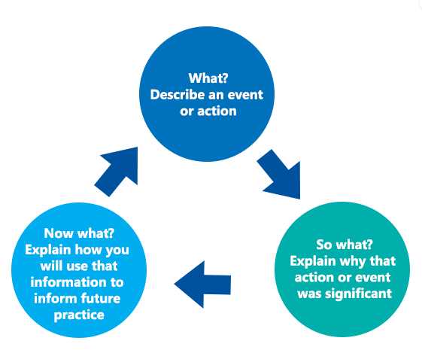
Figure 1 Driscoll’s model (2006)

WHAT (Overview /Description)

On the 20th May 2021 a spontaneous incident of large-scale mass disorder occurred on the outskirts of the Mayhill community in Swansea. Property including vehicles, street furniture and dwellings were damaged and destroyed. Community members came under threat and persons including police officers were injured. The impact on the community was significant as some were left to fend for themselves in fear for their lives. This was magnified by the intense media scrutiny and extensive sharing of images and footage on social media at the time of the disorder and immediately after. A criminal investigation was subsequently launched, with numerous charges and convictions of riot brought against those involved, which concluded with 31 offenders receiving custodial sentences or out of court disposal for younger offenders (South Wales Police, 2022). An independent review was concluded following the incident that recommended South Wales Police make an apology to the community of Mayhill and undertake a forensic examination to understand the wider issues and learning (Straw, et al., 2022).

3.1 Command of the Incident

On the evening of the incident a full command structure was on duty incorporating Gold, Silver and Bronze (GSB) commanders. As referenced by the CoP (2013, p. 1) “the GSB model offers flexibility and can be applied to any type of incident or operation”. This is a nationally recognised model in policing and an essential part of a commander’s role (Figure 2).
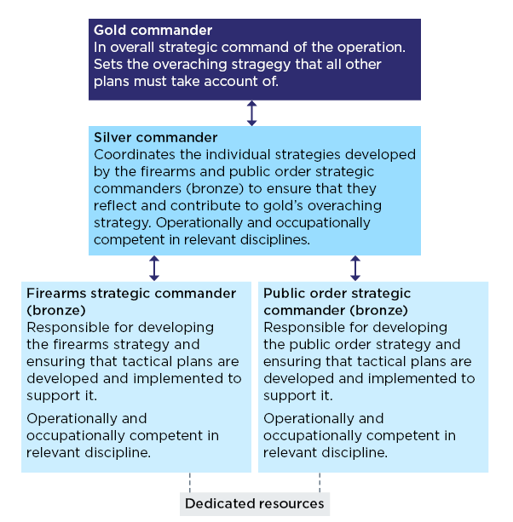
Figure 2 Command Structures (College of Policing, 2013).

To respond effectively to any organisational issue, criminal threat or complex event, commanders are required to know and understand the model, with clear application of what, how and when they are required to apply it to command a spontaneous or pre-planned incident. According to Fairholm (2009, p. 11) “situational theory argues that situations determine what leaders do and that behaviours must be linked to - be congruent with – the specific environment”. This supports my view that leaders must be flexible to adapt to situations, possessing the style, skill and knowledge to do so. This is important as early command leadership had an impact on the incident in Mayhill.

On early viewing of social media footage, I was deeply alarmed by the display of violence depicted. The footage and news articles illustrated officers under attack and withdrawing from the scene, clearly evidencing victims under threat and the community unprotected (BBC News, 2021). My foremost concern was to ensure the immediate safety of community members and all involved as well as mitigating potential backlash from the community.

SO WHAT

Considering the impact of the incident and the challenges it presented, it was evident significant trust and confidence within local policing had been lost over the course of the previous twelve hours. It was very clear the initial policing response and failure to protect had created wider implications with regards to early command and leadership.
Upon examination and considering the evidence, it was realistic to conclude that the GSB command structure was not fully adopted or correctly applied on the night of the incident. According to Roycroft & Roach (2019) ‘during serious incidents intuitive and analytical decision making can be made on the first available workable option, in quick time, exercising judgement and choosing between options’. Whilst careful not to make assumptions, it is reasonable to infer that this is correct as the lack of command at the scene was recognised as a contributory factor. Consequently, the reputation of the police who failed to respond appropriately was significantly damaged, corroborated by an independent learning review which concluded ‘significant failings are evident, despite a full investigation’ (Straw, et al., 2022).

I understood the success of regaining any trust relied on my ability to provide strong resilient leadership and clear direction, demonstrating my effectiveness as a leader and as the commander for the area. Taking full ownership, the next morning, I declared a CoP (2013) critical incident due to the ineffectiveness of the police response and the significant impact on victims and the community of Mayhill (Definition of a Critical Incident - Appendix A).

4.1 Leadership

Operational leadership in policing is a crucial aspect of ensuring efficient and effective policing. However, it is also a challenging role that requires a combination of robust decision-making, effective communication, and the ability to navigate complex and unpredictable environments of current and future strategic challenges. Availability of theoretical and empirical leadership research exploring contemporary and current leadership debates is vast and incomprehensible. As described by Curphy (2021) ‘there is no common definition of leadership’. However, whilst the subject is vast and definitions are different, they are all similar in that they revolve around three main elements of groups, processes and goals (Giblin, 2017).

Throughout my career I have undertaken many leadership courses facilitating my personal professional development. I have also undertaken Myers-Briggs (1962) assessments on two separate occasions, seven years apart, to assist in better understanding my interpersonal approach to the varied situations in policing. The results demonstrate my preference for Extraversion, Sensing, Thinking and Judgement (ESTJ) characteristics.

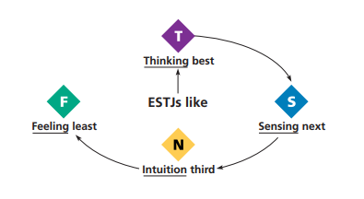

Figure 3 - Myers-Brigg Type Indicator Interpretive Report – Trudi Meyrick (MBTI, 2015)
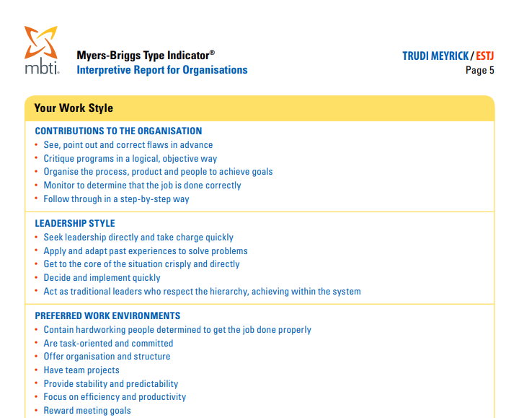

Figure 4 - Myers-Brigg Type Indicator Interpretive Report (Work Styles) – Trudi Meyrick (MBTI, 2015)
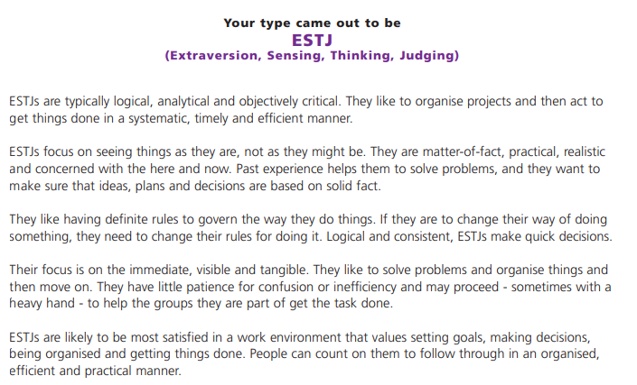
Figure 5 - Myers-Brigg Type Indicator Interpretive Report – Trudi Meyrick (MBTI, 2022)

Upon examination of results in figures three to five, whilst the ESTJ scalars have moved, I found my preferences have remained clear. Upon further examination I believe this has demonstrated that whilst you can undertake leadership development, your individual leadership style is hardwired within you with a preferred style.

To further develop my personal leadership, aligning my personal style and emotional intelligence, in January 2023, I undertook a 16PF (personality factor) exercise (16pf, 2023). This was relevant to provide insight into how 16 traits could summarise my personality characteristics.
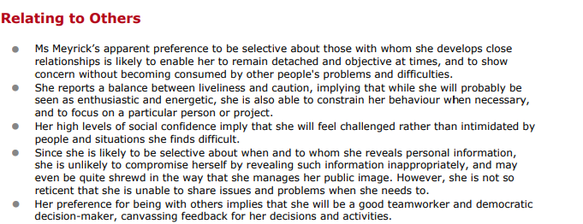
Figure 6 – Comprehensive Insights Report (Snapshot) – Trudi Meyrick (16pf, 2023)

I would consider that I know myself well, this is supported by Mullins (2019) theory ‘all leaders have behaviour traits known to them and not others’. Analysing all results, it seems that my primary trait and strength is to focus on efficiency, structure and results, leading by example and setting high expectations for myself and others. Likewise considering my personal development and reflecting on the structured and thorough approach I can see how some could find me inflexible or pedantic about minor details that do not fit with the plans I make. In comparison, my peers and those closest to me would describe me as an adaptive and a supportive leader. In conclusion I would describe my leadership as flexible and intuitive, who works well in a team, seeking feedback to improve. This comes through strongly in my 16pf report. ‘Ultimately a successful leader must be able to adapt a style to the situation and needs to the team or incident’ (Richardson, 2019).

Due to the nature and task of the Mayhill disorder, a flexible leadership style was required to remain effective and to achieve the desired outcomes. Dijk, et al (2015) describes ‘leadership as complex, due to the demanding landscape, various skills and the requirement to flex from everyday situations to emergency mode with the ability to lead with authority engaging values and holding accountability’. This illustrates the challenging situation I was faced with.

I considered many different leadership styles, contemplating the sensitivities surrounding the incident, the community and individuals involved (Birt, 2023) (Bobkiewicz, 2020). I immediately adopted an autocratic and transactional task style of leadership, giving orders and instructions and focused my leadership style on ‘influencing the team to achieve a common goal demonstrating a clear and mutual purpose’ (Northouse, 2019). I cogitated on the various factors as I knew I had to change the narrative making decisive early decisions, holding the belief that I could make a positive impact as ‘people deserve and are entitled to a positive experience’ Kouzes & Posner (2017). This was critical to regain the communities trust.

I recognised that whilst I was being extremely directive in my initial approach and tasked focused, this style was required to start a recovery phase of regaining community confidence, drive the investigation and strengthen partnership relationships.

At the beginning of the project, a task-oriented leadership type behaviour may be more appropriate for a project manager to use to provide more direction (i.e. a directing leadership style) because only the project manager knows the full extent of the work that must be done to plan the project successfully (Henkel, et al (2019, p. 8).

Whilst my autocratic leadership style of leading by power and control set the tone and drove the incident in the right direction, I recognised this style could only work for a short period of time as it impedes staff to exhibit creativity. ‘They do not feel valued, can lead to risk of employee rebellion’ (Kramer, 2020) it further ‘removes individual ownership and where team members feel little appreciation and powerless’ (Herrity, 2023).

Therefore, to form a guiding alliance, I selected officers who were highly skilled from different business areas. ‘No one individual can hold or have all the qualities it takes to be a good leader, but a team of individuals can’ Belbin (2010). I identified officers who had expertise and influence to drive my strategic direction and deliver results. My purpose and leadership style at this time remained task based, as the need to progress the investigation and recovery of community confidence was vital as evidenced in my Basic Command Unit (BCU) Action Plan (Appendix B).

Within the initial meeting, one officer did not demonstrate the high energy to achieve the task and lacked lustre. Whilst engaging there was no clear sense of urgency or appearance of understanding the bigger picture. They were competent, and ingenious; however, I believed I had to remain authoritarian in my leadership style to ensure the task was complete. Hence, I put a short timescale on delivery of outcomes adopting McGregor’s theory X concept, assuming that the ‘officer was lazy and unmotivated’ (Gosling, et al., 2012). At this point, my overarching aim was to re-establish control of the incident, with the aim of rebuilding community confidence in policing via my decisive decision making.

I was cognisant the plan laid had the requirement for high outcomes, however I realised that this could have a harmful impact on individuals and my own decision making. Reflecting on my authoritarian leadership style, at the earliest stage in the incident it clearly demonstrated my high concern for task and lower concern for people. This is reflected at the point of intersection within the below matrix (Figure 7):

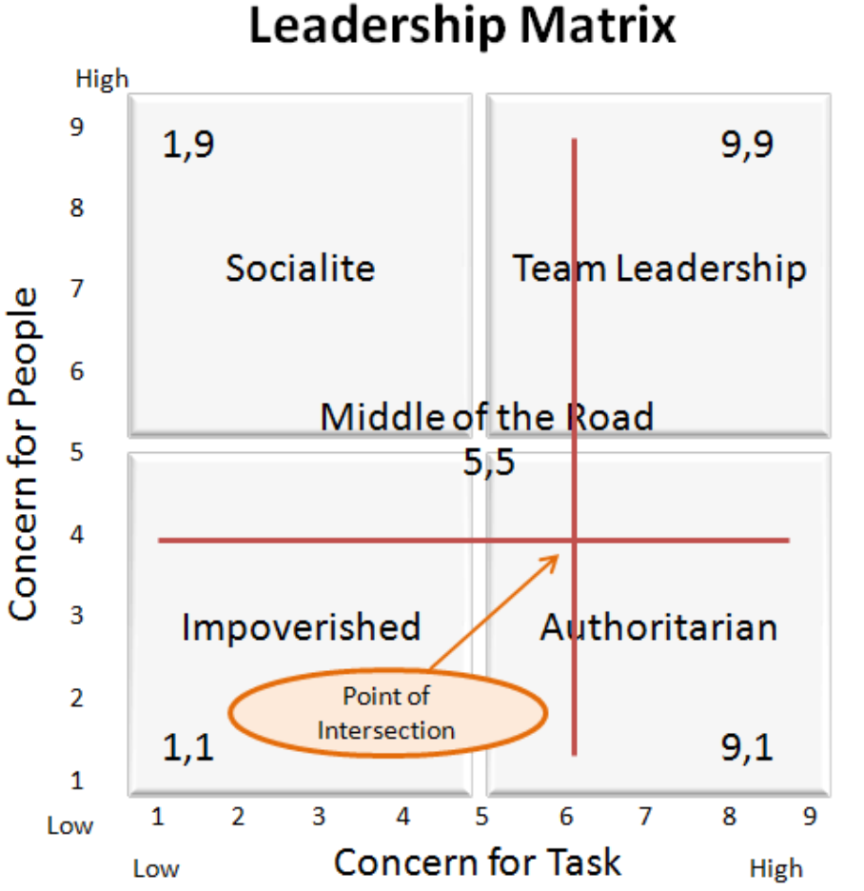
Figure 7- Leadership Matrix (Juxtaposition, 1995)

Reflecting on the officer who lacked lustre, I now wonder whether this was my assumption and whether implicit or hidden traits, which can shape behaviour existed without my conscious awareness. This might be that I was under pressure and considering the high levels of emotional intelligence that I ordinarily display in daily operations, my emotions or the ‘dark side of leadership’, could have been affected by the task undermining the officers ‘creativity and consequently dampening individuals attributions’ (Academy of Management Journal, 2012). In future situations, I will take cognisance of McGregor’s theory Y concept, assuming ‘staff are inherently motivated and will work towards goals if given the opportunity to do so’ (McGregor, 2006).

Following the initial tasking and actioning of the BCU plan I reconsidered my leadership style recognising that the implementation of a single leadership model would generally yield ineffective results. My aim is always to be a ‘high-high leader which encourages specific behaviours exhibiting simultaneously both work and relationships, inspiring all in consultation to set challenging and realistic goals that deliver quality outcomes seeking improvement’ Giblin (2017). Reflecting on the urgency of the incident, and being best positioned to provide the right leadership, I was confident I had selected the right team of leaders to drive the different elements of this incident, allocating responsibilities accordingly. Considering my knowledge of the task, people identified, the culture and individual skills, I thereafter adapted a situational leadership style to manage and lead the incident.

Reflecting on the four leadership styles of situational leadership as shown in (Figure 8), I applied predominantly S3 - ‘low directive and high supportive behaviour’. However, reflecting on the criminal investigation element and leadership displayed by the Senior Investigating Officer (SIO) who displayed high competence and commitment, I now feel my situational leadership direction was different and more reflective of S4 - ‘low directive and low support behaviour’. The significant and crucial concept drawn is ‘effective leadership stems from adapting to each situation or activity presented’ (Richardson, 2019). Both styles drove all elements of the task to be achieved through to conclusion.

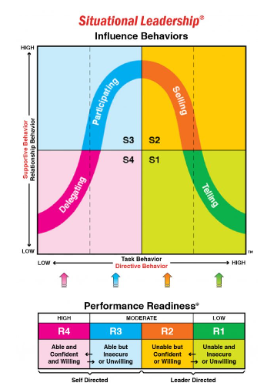
Figure 8 – Leadership Styles (The Centre for Leadership Studies, 2023)

Reflecting upon the incident and my leadership styles, the pendulum swung between task and relationship throughout and to achieve the best outcome I utilised a balanced team management approach. As outlined by the Center for Leadership Studies (2023) ‘as a leader, the most inconsistent thing is to treat or lead everyone in the same way. Each approach should consider the situation which dictates the leadership approach’. This remains relevant today and is important knowledge that all leaders should reflect upon to assist in the effective leadership of future operational and strategic leadership challenges.

One of the main operational leadership challenges in policing is balancing competing demands and priorities. Police leaders must have the ability to balance the needs of the community, the demands of their staff, and the expectations of their political leaders (Bowling, et al., 2019). However, reflecting on Mayhill, the operational response was inadequate. It must therefore be recognised that within police leadership there is always a need to further develop knowledge and continue learning. Learning from mistakes and learning to adapt to positions of higher authority is essential for all leaders and “leadership involves as much learning as it does teaching” (Perez & Barkhurst, 2012, p. 9).

4.2 Community Cohesion

Community Cohesion ‘happens in all communities to enable different groups of people to get on well, with a shared vision, people knowing their rights and trusting one another’ (UPSI Universities' Police Science Institute, 2009)’. The research however evidenced three quarters of the Welsh people sampled ‘considered a perceived absence of respect and consideration, which was viewed as an issue’. This is interesting as reflecting on this data, I would comment that also relevant at the time of the Mayhill disorder was the impact of the COVID pandemic on community dynamics. This presented harmful restrictions, which influenced the mind-set of the communities and young people. All of this I believe was a contributory factor to the behaviour and group dynamics witnessed on the night of the incident. Exploring the issue deeper, the situation was further impacted as there was a lack of police engagement, education and wider services resulting in some turning to their peers for support, having little discipline or structure within their lives, which became apparent following the incident. I did not fully realise the deep routed consequences of this, which impacted community engagement, cohesion and trust. This is reinforced by Skogan (2006) who emphasises ‘the potential impact of negative experiences with police on public perception and trust leads to lower levels of perceived legitimacy’. Thereby reflecting on my early leadership style, I changed from a traditional task focused leadership style to a supportive leadership style (Figure 9). This was important to develop teams, to deliver the BCU plan and change the narrative to a positive policing relationship with the community.

I helped and guided the Chief Inspector to develop a robust and meaningful cohesion and engagement plan with outreach activity that would reach into all community members, groups, key individual networks and partners. The overarching aim was to start repairing relationships and enhance cohesion. To develop and enhance the knowledge of the local policing Chief Inspector, I used a coaching leadership style and knowledge from my academic level five coaching and mentoring qualification. (Level 5 Coaching and Mentoring Certificate - Appendix C).

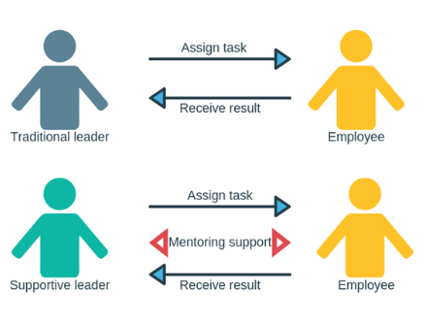
Figure 9 –Supportive Leadership - (Think Forward: Transforming Business Through People (2019)

This supportive leadership approach was important as via the mentoring support I provided, it assisted to align further meaningful results in line with the BCU plan, goals and my expectations. It further strengthened and emboldened teamwork utilising a balanced team approach, “once the goal is set, team building can begin” (Belbin, 2010, p. 101).

‘It remains that where approaches towards poling are less positive, communities are generally more critical of policing’ (Leroux & McShane, 2017). This approach showed that my teams were able to build trust through open and honest conversations with the community. Implementation of the BCU Mayhill Cohesion plan (Figure10) also delivered community-based problem-solving initiatives enhancing relationships and community resilience. This approach improved morale, increased community intelligence, and started to repair damaged trust thereby instilling confidence.

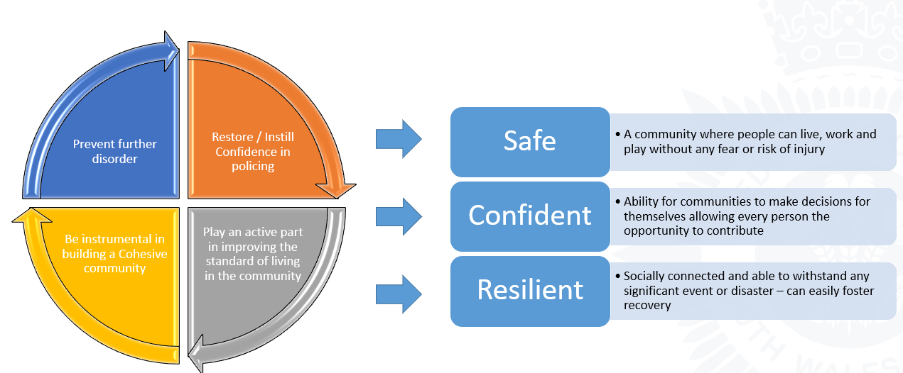

Figure 10 – Mayhill Community Cohesion Plan

As policing now operates outside of COVID and with greater investment in neighbourhood policing supported by Welsh Government funding for additional PCSOs, I have confidence engagement is improved. However, horizon scanning and considering the future challenges, I am aware of the cumulative impact of the economic downturn, the cost-of-living impact and a reduction in police budgets. This presents significant financial pressures and a resourcing challenge which could impact future trust, confidence and community cohesion within an increasing diverse community.

4.3 Media

The culture, practices and ethics of the media have been scrutinised as part of the 2011 Leveson inquiry which, ‘investigated relations between the police and press’ (Mawby, 2014). The actions of the media throughout the incident I found challenging as they offered monetary incentives for information and footage, sensationalizing the incident through clickbait headlines which inevitably drew the community into the fray.

I believe that the relationship with the media remains a daily challenge ‘since the 1990s evident is the escalating impact of the media and impact of social media and social networks’ (Dijk, et al., 2015). There are blurred lines of reality, realism and representation as witnessed in the Mayhill incident which presented a considerable challenge due to the pervasive and intrusive coverage and scrutiny of social media as footage was streamed into the homes of the community and across the area on social media platforms (Facebook, 2021).

Various theories have dominated and shaped the debate of criminology, the relationship and the changing dynamics between crime and the many media outlets. The extensive use of online platforms by the media for policing purposes has also become apparent over the past decade. This was again highlighted as a recent challenge following the disappearance of Nicola Bulley as experts claim “social media algorithms reward and encourage controversial content that fuelled the waves of online interest”’ (BBC News, 2023).

Whilst media and social media was used as a valuable communication aid and engagement tool during Mayhill, it is interesting that ‘there is no consistent amount of knowledge regarding this relationship’ (Walsh & O'Connor, 2019).

Reflecting deeper on Mayhill, pertinent was the careless use of words by a police spokesperson on the day following the incident. I did not expect the content to reflect how ‘officers placed a containment on the incident and de-escalated the situation’ and how ‘60 officers were present later on during the incident, but not deployed’ (Wales Online, 2021), which all media outlets reported upon. The significant aspect here is the defensive tone of the language and misrepresentation of words as they did not reflect the actions of the police initial response, which was clear in all the media footage. This caused a greater void between the police and the community in the early stages of the incident which I found challenging. Leadership is about being honest, I expressed my views over the content and the nominated police spokesperson’s connection to the community, which was absent and further damaged community relations.

I have learned a lot from this and in future situations my response to chief officers would be more open, honest and robust challenging truth to power, outlining early consequences as having the ability to understand local community reactions is essential. This has further challenged me to think more deeply about media relationships and interaction which remains a current and future challenge.

4.4 Accountability / Public Trust and Confidence

Following the incident public trust and confidence in Mayhill was shattered. Leadership on the ground had been ineffective, further exacerbated by recent high-profile scandals, policing incidents and criticisms of police action. The wider impact is that policing is under increasing scrutiny. Public expectations are higher than ever and police forces must always be transparent and accountable in its actions.

Throughout this report the impact of the Mayhill disorder and the impact it left on public trust and confidence was significant. The Independent Office for Police Conduct (IOPC) holds policing to account, its mission to ‘enhance public trust by holding police accountable for their conduct and learning from mistakes’ (Lockwood, 2020). When I compare accountability and public trust, they are intrinsically linked. Examining the relationship between the two, there are many layers of accountability that presents an individual and collective responsibility within policing as outlined by the University of Oxford (2006, p. 7), leaving the individual and organisation at risk or reputational harm, impeding community trust.

Many studies demonstrate learning can be improved through cooperation. Whilst South Wales Police co-operated with the public and the independent learning review, it took one year to issue an apology, despite identified failings on the evening of the incident. This is similar to the Manchester Arena Inquiry, with MI5 being ‘profoundly sorry’ for not stopping the attack (BBC News, 2023), further highlighting potential previous missed opportunities as outlined in the Manchester Inquiry (Saunders, 2023, p. 91). However, it took over five years to issue an apology.

Whilst I understand the complexities of such inquiries, Syed (2019) describes an ‘inability and reluctance to speak up in a hierarchical setting, which can have devastating consequence’. I therefore wonder it apologising is an organisation trait in all law enforcement agencies and seen as a weakness? Perhaps the starting point should be that to instil trust and confidence, when things go wrong policing should speak up and be honest from the outset.

When I reflect on the Mayhill incident and policing in the UK, it operates ‘by consent’, advocated from the Peelian Principals. When I carefully think about the words and principals of Schafer (2013) ‘trust pertains to individuals belief and confidence that those in charge of critical decisions will pursue desirable and fitting results’, I could clearly understand the community’s reaction of lack of confidence in policing as they were left unprotected. Upon deeper reflection of the incident and the words of Loader (2016) who argues ‘that the Peelian Principals no longer reflect or consider the challenges of complex policing’ I would remark that the idea that ‘the public are the police and the police are the public’ must remain fundamental to modern 21st century policing and the starting point should always be to ‘serve and protect’. Therefore, acknowledging this, my response to any police failures will be very different in the future as accountability and public trust and confidence remains a very real future challenge.

NOW WHAT / RECOMMENDATIONS

There are many learning points within this report, informing further practise that require action to deliver different outcomes and solutions. Adoption will enhance and improve early responses to critical incidents or serious disorder.

The organisation immediately reviewed its commitment to command training. Further training has been put in place, however, it is still to fully reach all comers of the organisation. Should there be future failures in command, some may blame organisation inertia.

Upon publication of the Mayhill independent learning review, one recommendation highlighted the requirement for a full forensic investigation and comprehensive learning review (Straw, et al., 2022). Leading this work and in collaboration with subject matter experts and the CoP, all areas of learning have been drawn down via a comprehensive report and an aligned measurable action plan. Due diligence is to be given to implementation of the plan.

A national operation training gap for spontaneous disorder training has been identified at commander level (GSB). Development of the training design has been adopted by the CoP following Mayhill. A first responder multi agency course is being trialled in Devon and Cornwall Police. Upon evaluation this will be delivered nationally across forces in England and Wales. It is strongly recommended that South Wales Police commit to early adoption of the training making it mandatory for all commanders.

Referencing my own personal leadership style, initially I focused on achieving quick time outcomes via delivery of task-based results, to deliver desired outcomes instilling confidence, not always considering the person. However, I recognise that every situation will bring different options and therefore I will take forward the leadership learning. This remains a continued areas of focus and reflection linked into my personal leadership style. To further support this theory, I am undertaking a Policing Horizons development programme for senior leaders in policing.

As witnessed in Mayhill, society is changing, communities are far more diverse. Strategic leadership and management in this space is a complex activity and challenge that is becoming more difficult and diverse. SWP has adopted and is driving cultural awareness training and ‘let’s talk about race’ sessions. This is necessary to enhance ‘leadership, shared values and training that enriches cross-cultural engagement. Further investment in ‘shared leadership will assist in the agility of leaders, to think on many different levels, improving team performance to deliver a robust response and lead effective high performing teams’ (Goodall, 2013) (de Cruz, 2019).

Accountability and public trust and confidence is a major challenge for operational leaders in policing. All police leaders must work to build and maintain positive relationships with the community and ensure that they are transparent and accountable in their dealings with the public. This requires effective communication and engagement with the community, as well as a commitment to transparency, accountability, and ethical behaviour. This involves a continued professional development approach with training aligned to each supervisor and command role.

Mandatory leadership programmes are now being delivered to enhance and improve operational leadership, taking the learning from Mayhill. This is further supported by JESIP training, which demonstrates the ‘importance of working together in partnership and collaboration, ensuring all agencies are fully prepared for any similar incidents’ (Brown & Trevino, 2006) (JESIP, 2012).

The above summarises some of the main learning points, actions and recommendations. This and other reflections throughout this report will ensure robust operational leadership foundations are laid down which must be driven with momentum to ensures sustainable outcomes are delivered to improve future responses. Learning is an essential part of professional practise, linked to ongoing professional development, ensuring ‘practitioners develop and broaden their skills remaining current’ (Bassot, 2016).

CONCLUSION

In conclusion there are many early failings with regards to the response to the disorder in Mayhill. This has been recognised by South Wales Police who has issued an apology to the community of Mayhill and accepted the need for a full forensic review of the incident to understand the extent of the failures.

Some leadership on the night was ineffective which fundamentally impacted the operational response and left the community vulnerable. The media played a significant part as the incident played out through the lens of social media and traditional media outlets. Early media releases and interviews were defensive, which created greater hostility amongst the community causing wider community tension.

However, in conclusion it must be recognised that there has been considerable work to strengthen community cohesion and an exceptional investigation that has brought justice for the victims and brought some closure to the Mayhill community (BBC News, 2022). Partnership working and collaboration with all agencies has strengthened and provided greater support. Engagement and outreach work is now richer in the community and implementation of the full action plan will further reinforce confidence and community relationships.

In conclusion, the future of policing will be shaped by the challenges posed by changing attitudes and expectations towards policing. Addressing these challenges requires a commitment to improving police leadership and ongoing investment in training, education, and support for officers.

My final thoughts and reflections are with the community of Mayhill. They are a tight knit community who did not deserve to witness the horrific scenes of disorder. The community have been deeply affected and have taken time to recover. However, they have displayed strength and resolve throughout. Whilst justice has been served the primary aim is to continue strengthening relations and building bonds of loyalty, trust and confidence. Only by meeting these challenges head-on can South Wales police continue to serve the public and maintain its position as a trusted and respected police service, that is fully prepared to meet current and future policing challenges.

APPENDICES

7.1 Appendix A – College of Policing- Critical Incident Definition

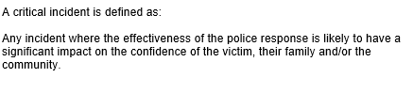

Appendix B – Action Table

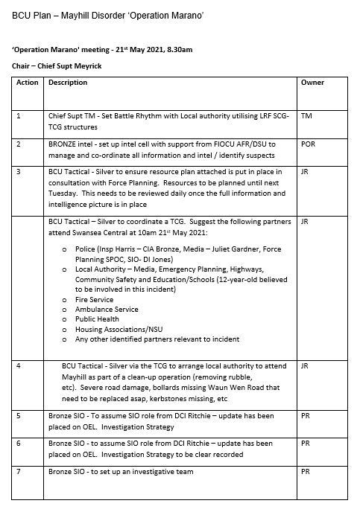

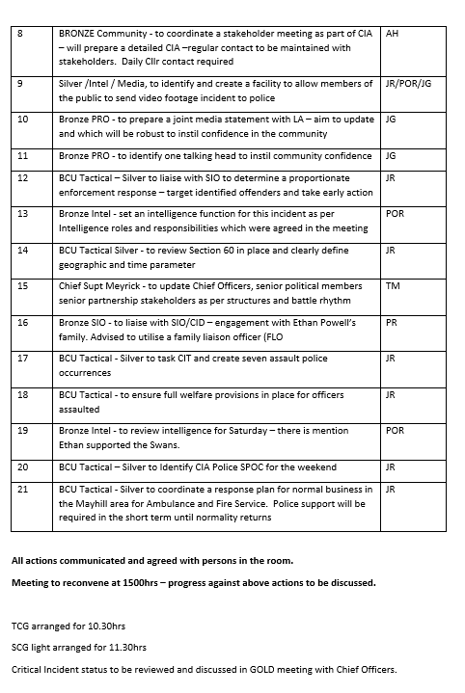

7.3 Appendix C – Level 5 Coaching and Mentoring Certificate

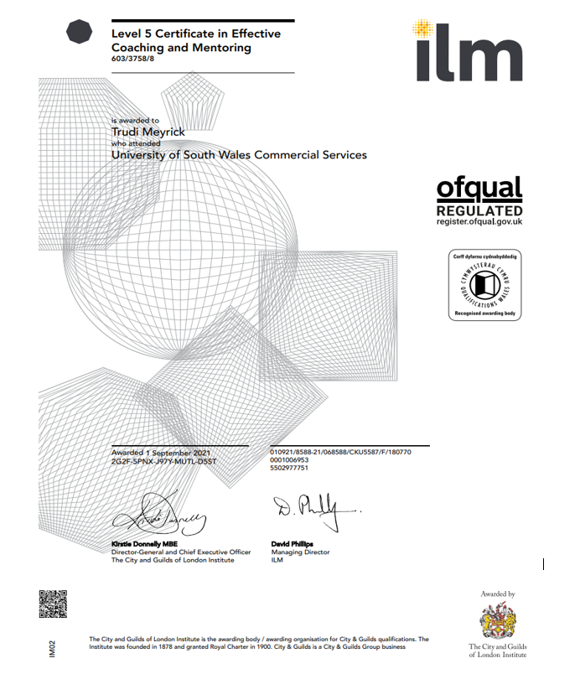

REFERENCES

16pf, 2023. 16pf Comprehensive Insights Report; prepared for Trudi Meyrick, Swansea: 16pf.
Academy of Management Journal, 2012. The Dark Side of Leadership. EBSCOhost, Volume 55, pp. 1187-1212.
Bassot, B., 2016. The Reflective Practise Guide - an interdisciplinary approach to critical reflection. Oxford: Routledge.
BBC News, 2021. Mayhill riot: 'I have two children inside, please come'. [Online]
Available at: https://www.bbc.co.uk/news/av/uk-wales-57258272
[Accessed 5th March 2023].
BBC News, 2022. Mayhill riots:closure for attacked man as 21 are sentenced. [Online]
Available at: https://www.bbc.co.uk/news/uk-wales-64045050
[Accessed 5th March 2023].
BBC News, 2023. Manchester Arena inquiry: MI5 'profundly sorry' for not stopping attack. [Online]
Available at: https://www.bbc.co.uk/news/uk-england-manchester-64815723
[Accessed 3rd March 2023].
BBC News, 2023. Nicola Bulley: Man, 34, arrested over police scene footage. [Online]
Available at: https://www.bbc.co.uk/news/uk-england-lancashire-64896952
[Accessed 9th March 2023].
Belbin, M. R., 2010. Managment Teams; Why they succeed or fail. 3rd ed. London: Routledge.
Belbin, M. R., 2010. Team Roles at Work. 2nd ed. London: Routledge.
Birt, J., 2023. Guide To 6 Top Leadership Theories and How To Apply Them. [Online]
Available at: https://www.indeed.com/career-advice/career-development/leadership-styles-and-theories#:~:text=Common%20leadership%20styles%20include%3A%201%20Coach%3A%20Recognizes%20strengths,Delegates%20tasks%20and%20provides%20little%20supervision.%20More%20items
[Accessed 19th March 2023].
Bobkiewicz, G., 2020. Ten Leadership Theories in Five Minutes. [Online]
Available at: https://onlineleadershipnetwork.com/ten-leadership-theories-in-five-minutes/
[Accessed 18th March 2023].
Bowling, B., Reiner, R. & Sheptycki, J., 2019. The Politics of the Police. 5th ed. Oxford: Oxford University Press.
Brown, M. E. & Trevino, L. K., 2006. Ehical Leadership: A review and future directions. Science Direct, 1(1), pp. 595-616.
Casey, B., 2023. An independent review into the standards of behaviour and internal culture , London: Baroness Casey of Blackstock DBE CB.
College of Policing, 2013. Command Structures. [Online]
Available at: https://www.college.police.uk/app/operations/command-and-control/command-structures#gsb-structure
[Accessed 1st March 2023].
College of Policing, 2013. Introduction and types of critical incidents. [Online]
Available at: https://www.college.police.uk/app/critical-incident-management/introduction-and-types-critical-incidents
[Accessed 11th March 2023].
College of Policing, 2020. Future Challenges - Future Operating Environment 2040. [Online]
Available at: https://assets.college.police.uk/s3fs-public/2020-08/Future-Operating-Environment-2040-Part3-Challenges.pdf
[Accessed 18th March 2023].
Curphy, D. G., 2021. Defining Leadership. [Online]
Available at: https://hstalks-com.ezproxy.uwtsd.ac.uk/t/4732/what-is-leadership/?business
[Accessed 5th March 2023].
de Cruz, N. P., 2019. A Conceptual Overview of Attaining, Maintaining, and Regaining Shared Leadership in High Performing Teams. Journal of Leadership Education, 18(1), pp. 213-226.
Dijk, A. V., Hoogewoning, F. & Punch, M., 2015. What matters in policing?: Change,values and leadership in turbulent times. Bristol: Bristol University Press: Policy Press.
Driscoll, J., 2006. Practising Clinical Supervision: a reflective approach for healthcare professionals. 2nd ed. London: Bailliére Tindall Elsevier .
Facebook, 2021. Terrified dad pleads for police help during Mayhill riots as cars burn out. [Online]
Available at: https://www.facebook.com/SwanseaOnline1/videos/terrified-dad-pleads-for-police-help-during-mayhill-riots-as-cars-burn-outside-a/161556112514111/
[Accessed 9th February 2023].
Fairholm, G. W., 2009. Understanding Leadership Perspectives: Theoretical and Practical Approaches. Richmond, Virginia: Springer.
Giblin, M. J., 2017. Leadership and Managment in Police Organizations. London: Sage Publications.
Goodall, J., 2013. Recruit for Attitude, Train for Skills: Creating High Performing Leadership Teams. Sage journals, 41(2), pp. 199-213.
Gosling, J., Jones, S. & Sutherland, I., 2012. Key Concepts in Leadership. London: Sage.
Henkel, G. T., Marion, W. J. & Bourdeau, D. T., 2019. Project Manager Leadership Behaviour: Task-Oriented Versus Relationship-Oriented. Journal of Leadership Education, p. 8.
Herrity, J., 2023. What Is Autocratic Leadership? Definition, Pros and Cons. [Online]
Available at: https://www.indeed.com/career-advice/career-development/what-is-autocratic-leadership
[Accessed 5th March 2023].
Higgs, M., 2003. How can we make sense of leadership in the 21st century?. ProQuest, 24(5/6), p. 273.
JESIP, 2012. JESIP Working together-Saving Lives. [Online]
Available at: https://www.jesip.org.uk/#
[Accessed 19th March 2023].
Juxtaposition, B. D. &. L. D. P., 1995. Leadership Matrix Survey. [Online]
Available at: http://www.nwlink.com/~%E2%80%89donclark/leader/matrix.html
[Accessed 2023 March 5th].
Kouzes, J. M. & Posner, B. Z., 2017. The Leadership Challenge: How to Make Extraordinary Things Happen in Organizations. 6th ed. San Francisco: Wiley.
Kramer, L., 2020. 5 Different Types of Leadership Styles. [Online]
Available at: https://smallbusiness.chron.com/advantages-drawbacks-autocratic-leadership-style-16616.html
[Accessed 5th March 2023].
Leroux, E. J. & McShane, K., 2017. Changing youth attitudes towards the police through community policing programming. Journal of Community Psychology, 45(6), pp. 685-822.
Loader, I., 2016. In Search of Civic Policing: Recasting the 'Peelian Principles. Ciminal Law and Philosophy, 10(3), pp. 427-440.
Lockwood, M., 2020. IOPC:Why independnet scrutiny of police matters. [Online]
Available at: https://www.policeconduct.gov.uk/news/our-podcasts-and-blogs/why-independent-scrutiny-police-matters
[Accessed 10th March 2023].
Maskaly, J., Kutnjak, S. & Neyroud, P., 2021. Policing the COVID-19 Pandemic: Exploratory Study of the Types of Organizational Changes and Police Activities Across the Globe. International Criminal Justice Review, 31(3), p. 281.
Mawby, R. C., 2014. The presentation of police in everyday life: Police–press relations, impression management and the Leveson Inquiry. Sage journals, 10(3), pp. 179-190.
MBTI, 2015. Myers-Briggs Type Indicator; Interpretive report for Organisations. Report prepared for Trudi Meyrick, Swansea: MBTI.
MBTI, 2022. Myers-Brigs Type Indicator; Interpretive Report. Report prepared for Trudi Meyrick, Swansea: MBTI.
McGregor, D., 2006. The Human Side of Enterprise,Annotated Edition. New York : Mc-Graw-Hill.
Mullins, L. J., 2019. Organisational Behaviour in the Workplace with Jacqueline McLean. 12th ed. Harlow: Pearson Education Limited.
Myers-Briggs, 1962. The Myers-Briggs Type Indicator. 1st ed. Palo Alto,CA: Consulting Pschologists Press.
Mynenko, K. D. & Ditcham, K., 2022. Public Confidence in the Police: A New Low for the Service. [Online]
Available at: https://www.rusi.org/explore-our-research/publications/commentary/public-confidence-police-new-low-service
[Accessed 17th March 2023].
National Police Chiefs Council, 2016. Policing Vision 2025. [Online]
Available at: https://assets.college.police.uk/s3fs-public/policing_vision_2025.pdf
[Accessed 18th March 2023].
Northouse, G. P., 2019. Leadership; Theory & Practice. 9th ed. Los Angeles: Sage Publications.
NursingAnswers.net, 2018. Driscoll's Model of Reflection. [Online]
Available at: https://nursinganswers.net/reflective-guides/driscoll-model-of-reflection.php
[Accessed 26th February 2023].
Perez, D. W. & Barkhurst, M., 2012. Paradoxes of Leadership in Police Management. New York: Delmar Cengage Learning.
Police Professional, 2004. Police Professional. [Online]
Available at: https://www.policeprofessional.com/news/new-global-data-institute-to-combat-pandemic-of-child-sexual-abuse/
[Accessed 22nd March 2023].
Ramshaw, P., Silvestri, M. & Simpson, M., 2019. Police Leadership: Changing Landscapes. 11th ed. Cham, Switzerland: Palgrave Macmillan.
Redgrave, H., Hadjipavlou, S. & Desroches, C., 2018. Rethinking Police Demand: A review of drivers, capability and capacity in partnership with the Dawes. [Online]
Available at: https://www.crestadvisory.com/post/rethinking-police-demand
[Accessed 25th February 2023].
Richardson, C., 2019. What is Situational Leadership. [Online]
Available at: https://www.effectiveretailleader.com/effective-retail-leader/what-is-situational-leadership
[Accessed 5th March 2023].
Roycroft, M. & Roach, J., 2019. Decision Making in Police Enquiries and Critical Incidents. London: Palgrave Macmillan.
Saunders, J., 2023. Manchestr Arena Inquiry Volume 3: Radicalisation and Preventability, London: UK Government.
Schafer, J. A., 2013. The role of trust and transparency in the pursuit of procedural and organisational justice. Journal of Polcicing , Intelligence and Counter Terrorism, 8(2), pp. 131-143.
Schön, D. A., 2016. The Reflective Practitioner - How Professionals Think in Action. London: Routledge.
Skogan, W. G., 2006. Asymmetry in the Impact of Encouters with Police. Policing and Society, 16(2), pp. 99-126.
South Wales Police, 2022. Police release footage inside carnge of Mayhill Riots. [Online]
Available at: https://www.facebook.com/WalesOnline/videos/police-release-footage-inside-carnage-of-mayhill-riots/704953567856108/
[Accessed 5th March 2023].
Straw, J., Jones, M. & Evans, E., 2022. Mayhill disturbance - Independendent Learning Review, Swansea: South Wales Police.
Syed, M., 2019. Rebel Ideas. London: John Murray.
The Centre for Leadership Studies, 2023. The Four Leadership Styles of Situational Leadership. [Online]
Available at: https://situational.com/blog/the-four-leadership-styles-of-situational-leadership/
[Accessed 5th March 2023].
The Telegraph, 2023. Thousands more police would be on beat if they did not have to attend mental health call-outs. [Online]
Available at: https://www.telegraph.co.uk/news/2023/02/27/thousands-police-would-beat-did-not-have-attend-mental-health/
[Accessed 28th February 2023].
Think Forward: Transforming Business Through People, 2019. The importance of supportive leadership. [Online]
Available at: https://thinkforwardconsulting.co.uk/the-importance-of-supportive-leadership/
[Accessed 8th March 2023].
University of Oxford, 2006. Police Governance and Accountability, Oxford: The police Foundation .
UPSI Universities' Police Science Institute, 2009. The Causes and Consequences of Community Cohesion in Wales: A Secondary Analysis, Cardiff: Cardiff Universtiy.
Wales Online, 2021. South Wales Police claim 60 officers were sent to quell Swansea riot but no arrest were made. [Online]
Available at: https://www.walesonline.co.uk/news/wales-news/south-wales-police-claim-60-20652589
[Accessed 5th March 2023].
Walsh, J. P. & O'Connor, C., 2019. Social media and policing: A review of recent research. Sociology Compass, 13(1).

