Chapter 10

Relevant Costs for Decision-Making
Questions

Questions

10-1 What is a relevant cost?

10-2 Define the following terms: incremental cost, opportunity cost and sunk cost.

10-3 Are variable costs always relevant costs? Explain.

10-4 The book value of a machine (as shown on the balance sheet) is an asset to a company, but this same book value is irrelevant in decision making. Explain why this is so.

10-5 ‘Sunk costs are easy to spot – they’re simply the fixed costs associated with a decision.’ Do you agree? Explain.

10-6 ‘Variable costs and differential costs mean the same thing.’ Do you agree? Explain.

10-7 ‘All future costs are relevant in decision making.’ Do you agree? Why?

Exercises

E10-1

Waukee Railroad is considering the purchase of a powerful, high-speed wheel grinder to replace a standard wheel grinder that is now in use. Selected information on the two machines is given below:

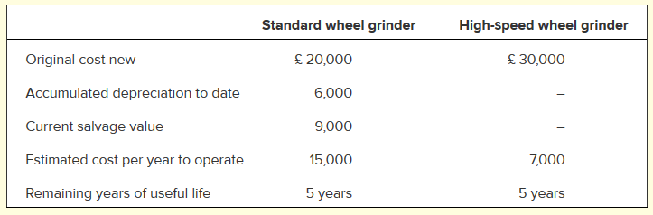
resale value
Required

Prepare a computation covering the five-year period that will show the net advantage or disadvantage of purchasing the high-speed wheel grinder. Use only relevant costs in your analysis.

Cost savings of buying a new machine
Cost of new machine
Any income?
Net advantage of purchasing the grinder

E10-2

Han Products manufactures 30,000 units of part S-6 each year for use on its production line. At this level of activity, the cost per unit for part S-6 is as follows:

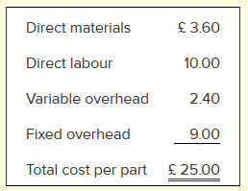

An outside supplier has offered to sell 30,000 units of part S–6 each year to Han Products for £21 per part. If Han Products accepts this offer, the facilities now being used to manufacture part S–6 could be rented to another company at an annual rental of £80,000. However, Han Products has determined that two-thirds of the fixed overhead being applied to part S-6 would continue even if part S–6 were purchased from the outside supplier.

 | Make (per unit) | Buy (per unit) | Make (30,000 unit) | Buy (30,0000 unit)
Cost of purchasing
Cost of making:
Direct materials
Direct labour
Variable overhead
Fixed overhead (1/3 is relevant)
Total cost

Required

Prepare computations to show the net advantage or disadvantage of accepting the outside supplier’s offer.

E10-3

Bill has just returned from a duck hunting trip. He has brought home eight ducks. Bill’s friend, John, disapproves of duck hunting and, to discourage Bill from further hunting, John has presented him with the following cost estimate per duck:
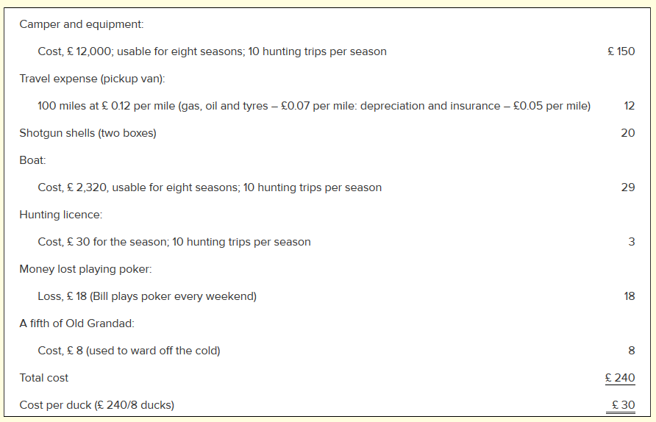
Required

- Assuming that the duck hunting trip Bill has just completed is typical, what costs are relevant to a decision as to whether Bill should go duck hunting again this season?

- Suppose that Bill gets lucky on his next hunting trip and shoots 10 ducks in the amount of time it took him to shoot 8 ducks on his last trip. How much would it have cost him to shoot the last two ducks?

- Which costs are relevant in a decision of whether Bill should give up hunting? Explain.

