Lowrie Proctor, 1903551

Lab – Understanding Ethernet Cable Standards
Topology
Addressing Table
Device | Interface | IP Address | Subnet Mask | Default Gateway
PC-A | NIC | 192.168.10.1 | 255.255.255.0 | N/A
PC-B | NIC | 192.168.10.2 | 255.255.255.0 | N/A
Objectives
Part 1: Analyze Ethernet Cabling Standards and Pinouts
Part 2: Build an Ethernet Crossover Cable
Part 3: Test an Ethernet Crossover Cable
Background / Scenario
In this lab, you will build and terminate an Ethernet crossover cable and test it by connecting two PCs together and pinging between them. You will first analyze the Telecommunications Industry Association/Electronic Industries Association (TIA/EIA) 568-A and 568-B standards and how they apply to Ethernet cables. You will then construct an Ethernet crossover cable and test it. Finally, you will use the cable you just constructed to connect two PCs together and test it by pinging between them.
Note: With autosensing capabilities available on many devices, such as the Cisco 1941 Integrated Services Router (ISR) switch, you may see straight-through cables connecting like devices.
Required Resources
- One length of cable, either Category 5 or 5e. Cable length should be 0.6 to 0.9m (2 to 3 ft.)
- 2 RJ-45 connectors
- RJ-45 crimping tool
- Wire cutter
- Wire stripper
- Ethernet cable tester (optional)
- 2 PCs (Windows 7 or 8)
- Analyze Ethernet Cabling Standards and Pinouts
The TIA/EIA has specified unshielded twisted pair (UTP) cabling standards for use in LAN cabling environments. TIA/EIA 568-A and 568-B stipulates the commercial cabling standards for LAN installations; these are the standards most commonly used in LAN cabling for organizations and they determine which color wire is used on each pin.
With a crossover cable, the second and third pairs on the RJ-45 connector at one end of the cable are reversed at the other end, which reverses the send and receive pairs. The cable pinouts are the 568-A standard on one end and the 568-B standard on the other end. Crossover cables are normally used to connect hubs to hubs or switches to switches, but they can also be used to directly connect two hosts to create a simple network.
Reflection:
Discuss (Max word count 500) various cable standards that are used in Today’s LAN.
Cable standards are required to ensure compatibility and lifespan.
TIA/IA 568 standards establishes a common cabling standard. Saunders [1] describes that there are 2 parts to the standards. The first outlines the topology, cable and connector types to be used and the second part provides minimum specifications for performance. These standards advise how a specific type of cable is to be crafted and consequently installed.
There are 2 cable wiring standards used in today’s LAN. T658A and T658B. These standards are used to create a cross-over cable (T658A on one end and T568B at the other) or a straight through cable (both ends would either be a T568B or T568A) [2]. It is supposed that the T568B standard, for straight through cables, is used by the majority of installations in the United States where as in the contrary the T568A standard is the majority standard used by European and Pacific Countries. Either can be used as long as the ends are consistent [2] . The illustration below demonstrates the order of the colour coded wires within these standards [2].
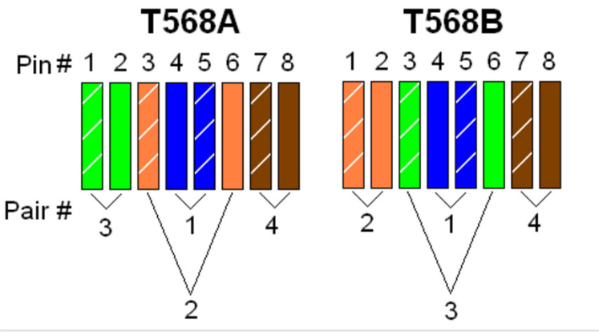
Within the 568 standards there are also various types of cable categories which are used in today’s LAN. The categories of cable differ in levels of performance.
The Cat 5e cable is “widely recognised as the industry standard” [3].The Cat 5e allows transmission parameters up to 100 Mbps over a maximum 100 meters [3]. The Cat 6 cable is comparable however features further specifications, in particular relation to crosstalk and also an increased performance of up to 250MHz, compared to 100 MHz for the Cat 5e [4]. The latest version is the Cat7, this most recent version allows greater transmission speeds and longer distances [5]. Rita Mailheau [6] Considers “Cat7 is suited for use in datacentres and large enterprise networks.” Although post Cat5e cables offer greater performance many LANs still choose to use Cat5e standard cables due to its cost effectiveness [6]
The image below demonstrates the distinctions between the categories [5].
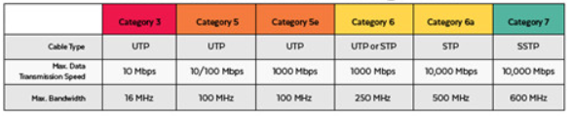
The Rj45 connector is used generally as the physical connector used on the cables, through from Cat3 to Cat6. Information suggests that Cat7 cables can be terminated with this connector however alternative specialised versions are often used [7].
In addition to the 568 cable standards there are also IEEE standards. IEEE 802.11 depicts the standards for information exchange between systems LAN’s [8] and IEEE 802.3 standards defining different aspects of Ethernet functionality and connectivity [9].
Standards are rapidly changing, with Cat8 already in the development stage [6]. Despite the increase in the use of wireless connections Ethernet cables are still being used and developed due to them being considered faster, reliable and offer greater stability and higher security [10]. The anonymous author of the newspaper article Future-proofing your home [11] recommends installing the newest cat7 cable.

References

[1] | S. Saunders, "Premises Wiring Gets the Standard Treatment," Data Communications, vol. 21, no. 16, 1995.
[2] | "fiber-optic-equipment," [Online]. Available: http://www.fiber-optic-equipment.com/distinguish-t568a-t568b-rj45-ethernet-cable-wiring.html. [Accessed 27 June 2019].
[3] | J. Ellis, "The Difference Between Cat5 and Cat6," 6 December 2018. [Online]. Available: https://www.comms-express.com/blog/the-difference-between-cat5-and-cat6/. [Accessed 27 June 2019].
[4] | "Category 6 cable," [Online]. Available: https://en.m.wikipedia.org/wiki/Category_6_cable. [Accessed 27 June 2019].
[5] | E. Twain, "Is it worthwhile to use Cat7 Ethernet cable?," [Online]. [Accessed 27 June 2019].
[6] | R. Mailheau, "Demystifying Ethenet Types - Difference between Cat5e, Cat6, and Cat7," [Online]. Available: https://planetechusa.com/blog/ethernet-different-ethernet-categories-cat3-vs-cat5e-vs-cat6-vs-cat6a-vs-cat7-vs-cat8/. [Accessed 27 June 2019].
[7] | "Ethernet Cable:Types, Perfomance & Pinout - Cat 5, 5e,6,6a,7,8 etc," [Online]. Available: https://www.electronics-notes.com/articles/connectivity/ethernet-ieee-802-3/cables-types-pinout-cat-5-5e-6.php. [Accessed 27 June 2019].
[8] | B. A. Hallberg, Networking, A Beginner's Guide, Fifth Edition ed., McGraw-Hill Osborne Media, 2009.
[9] | "Ethernet IEEE 802.3 Standards," [Online]. Available: https://www.electronics-notes.com/articles/connectivity/ethernet-ieee-802-3/standards.php. [Accessed 27 June 2019].
[10] | "The future of ethernet cables," [Online]. Available: https://www.cmple.com/learn/the-future-of-ethernet-cables. [Accessed 27 June 2019].
[11] | Future-proofing your home, Mackay, Qld.: APN Newspapers Pty Ltd, 2018.

  - Analyze diagrams and tables for the TIA/EIA 568-A standard Ethernet cable.
The following table and diagrams display the color scheme and pinouts, as well as the function of the four pairs of wires used for the 568-A standard.
Note: In LAN installations using 100Base-T (100 Mb/s), only two pairs out of the four are used.
568-A 10/100/1000Base-TX Ethernet
Pin Number | Pair Number | Wire Color | 10Base-T Signal  100Base-TX Signal | 1000Base-T Signal
1 | 2 | White/Green | Transmit | BI_DA+
2 | 2 | Green | Transmit | BI_DA-
3 | 3 | White/Orange | Receive | BI_DB+
4 | 1 | Blue | Not Used | BI_DC+
5 | 1 | White/Blue | Not Used | BI_DC-
6 | 3 | Orange | Receive | BI_DB-
7 | 4 | White/Brown | Not Used | BI_DD+
8 | 4 | Brown | Not Used | BI_DD-

The following diagrams display how the wire color and pinouts align with an RJ-45 jack for the 568-A standard.
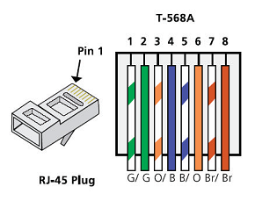
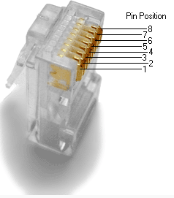
  - Analyze diagrams and tables for the TIA/EIA 568-B standard Ethernet cable.
The following table and diagram display the color scheme and pinouts for the 568-B standard.
568-B 10/100/1000-BaseTX Ethernet
Pin Number | Pair Number | Wire Color | 10Base-T Signal  100Base-TX Signal | 1000Base-T Signal
1 | 2 | White/Orange | Transmit | BI_DA+
2 | 2 | Orange | Transmit | BI_DA-
3 | 3 | White/Green | Receive | BI_DB+
4 | 1 | Blue | Not Used | BI_DC+
5 | 1 | White/Blue | Not Used | BI_DC-
6 | 3 | Green | Receive | BI_DB-
7 | 4 | White/Brown | Not Used | BI_DD+
8 | 4 | Brown | Not Used | BI_DD-
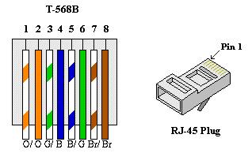

- Build an Ethernet Crossover Cable
A crossover cable has the second and third pairs on the RJ-45 connector at one end, reversed at the other end (refer to the table in Part 1, Step 2). The cable pinouts are the 568-A standard on one end and the 568-B standard on the other end. The two following diagrams illustrate this concept.
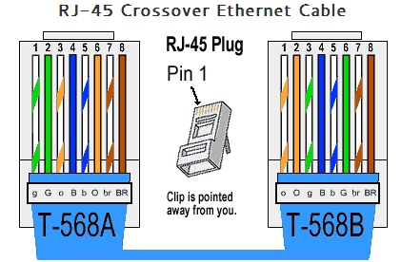
  - Build and terminate a TIA/EIA 568-A cable end.
    - Determine the cable length required. (Your instructor will let you know the cable length you should make.)
Note: If you were making a cable in a production environment, the general guideline is to add another 12 in. (30.48 cm) to the length.
    - Cut off a piece of cable to the desired length and using your wire stripper, remove 5.08 cm (2 in.) of the cable jacket from both ends.
    - Hold the four pairs of twisted cables tightly where the jacket was cut away. Reorganize the cable pairs into the order of the 568-A wiring standard. Refer to the diagrams, if necessary. Take as much care as possible to maintain the twists in the cable; this provides noise cancellation.
    - Flatten, straighten, and line up the wires using your thumb and forefinger.
    - Ensure that the cable wires are still in the correct order for the 568-A standard. Using your wire cutters, trim the four pairs in a straight line to within 1.25 to 1.9 cm (1/2 to 3/4 in.).
    - Place an RJ-45 connector on the end of your cable, with the prong on the underside pointing downward. Firmly insert the wires into the RJ-45 connector. All wires should be seen at the end of the connector in their proper positions. If the wires are not extending to the end of the connector, take the cable out, rearrange the wires as necessary, and reinsert the wires back into the RJ-45 connector.
    - If everything is correct, insert the RJ-45 connector with cable into the crimper. Crimp down hard enough to force the contacts on the RJ-45 connector through the insulation on the wires, thus completing the conducting path. See the following diagram for an example.
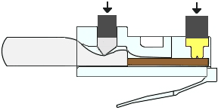
  - Build and terminate a TIA/EIA 568-B cable end.
Repeat steps 1a to 1g using the 568-B color wiring scheme for the other end.
- Test an Ethernet Crossover Cable
  - Test the cable.
Many cable testers will test for length and mapping of wires. If the cable tester has a wire map feature, it verifies which pins on one end of the cable are connected to which pins on the other end.
If your instructor has a cable tester, test the crossover cable for functionality. If it fails, check with your instructor first as to whether you should re-cable the ends and re-test.
  - Connect two PCs together via NICs using your Ethernet crossover cable.
    - Working with a lab partner, set your PC to one of the IP addresses shown in the Addressing Table (see page 1). For example, if your PC is PC-A, your IP address should be set to 192.168.10.1 with a 24-bit subnet mask. You partner’s IP address should be 192.168.10.2. The default gateway address can be left empty.
    - Using the crossover cable you made, connect the two PCs together via their NICs.
    - On the PC-A command prompt, ping the PC-B IP address.
Note: The Windows firewall may have to be temporarily disabled for pings to be successful. If the firewall is disabled, make sure you re-enable it at the conclusion of this lab.
    - Repeat the process and ping from PC-B to PC-A.
Assuming IP addressing and firewall are not issues, your pings should be successful if the cables were properly made.

Reflection
Which part of making cables did you find the most difficult?
When completing the task of making cables it became apparent that it was difficult to ensure straightness of the cables in order for them to remain in the correct order. Due to the difficulty I found in the cables remaining in the correct order it was often the case that when placing the cables in the RJ-45 connectors the wires were not positioned correctly at the end of the connector consequently causing a fault.

Why do you have to learn how to make a cable if you can easily buy pre-made cables?
The benefits of being able to make a cable, rather than buy a pre-made cable, include being able to be more specific with the length required whilst also being cost effective. Being able to make a cable also assist in repairing and rerouting if required, rather than having to replace.

